Permeable pavement
For permeable pavement, stormwater runoff captured by the BMP and stored below the underdrain is infiltrated into the underlying soil between rain events. All pollutants in the infiltrated stormwater are credited as being reduced. Pollutants in stormwater captured by the BMP but entering the underdrain are treated as they pass through the filter media and out the underdrain.

MIDS calculator user inputs for permeable pavement
For permeable pavement systems, the user must input the following parameters to calculate the volume and pollutant load reductions associated with the BMP.
- Watershed tab
  - BMP Name: this cell is auto-filled but can be changed by the user.
  - Routing/downstream BMP: if this BMP is part of a treatment train and water is being routed from this BMP to another BMP, the user selects the name of the BMP from the dropdown box to which water is being routed. All water must be routed to a single downstream BMP. The User must include the BMP receiving the routed water in the Schematic or the BMP will not appear in the dropdown box.
  - BMP Watershed Area: BMP watershed areas are the areas draining directly to the BMP. Values can be added for four soil types (Hydrologic Soil Groups (HSG) A, B, C, D) and for three Land Cover types (Forest/Open Space, Managed Turf and impervious area). The Impervious Cover includes the surface area of the permeable pavement and impervious area in the watershed that drains directly to the permeable pavement BMP. Units are in acres.
- BMP Parameters tab
  - Surface area at underdrain (A_{U}): This is the surface area of the BMP at the invert of the underdrain. If an underdrain is not present, it is the surface area of the permeable pavement. The user inputs this value in square feet. The calculator will display the surface area in acres for comparison with the watershed impervious cover acres entered for the BMP.
  - Bottom surface area (A_{B}): This is the surface area at the bottom of the engineered media. It represents the area where the engineered media changes to native soils. The user inputs this value in square feet.
  - Depth below underdrain (D_{U}): This is the depth below the underdrain to the native soils. If no underdrain is present, this is the thickness of the engineered media. The user inputs this value in feet.
  - Media porosity: This is the ratio of pore space in the engineered media to the total volume of the engineered media. Units are volume/volume (e.g., cubic centimeters per cubic centimeter). If various types of media are used in the BMP, this value should be an average of the media installed between the underdrain and the native soils. Values for porosity based on soil type can be found here.
  - Will subsoil require compaction?: This is a YES/NO question. Select YES if compaction of the soil subgrade is needed to support vehicular loads. This selection does not affect the calculation of volume or pollutant reduction credits, but will likely reduce the infiltration rates of the underlying soils and the associated volume and pollutant credits. The USER should consider selecting a lower infiltration rate if the subsoil is compacted.
  - Underlying soil - Hydrologic Soil Group: The user selects the most restrictive soil (lowest hydraulic conductivity) within 3 feet of the soil/media interface in the permeable pavement. There are 14 soil options that fall into 4 different Hydrologic Soil Groups (Hydrologic Soil Group (HSG) A, B, C, or D) for the user. These correspond with soils and infiltration rates contained in this Manual. Once a soil type is selected, the corresponding infiltration rate will populate in the “Infiltration rate of underlying soils” field. The user may also select “User Defined.” This selection will activate the “User Defined Infiltration Rate” cell allowing the user to enter a different value from the values in the predefined selection list. The maximum allowable infiltration rate is 1.63 inches per hour.
  - Required drawdown time (hrs): This is the time in which the stormwater captured by the BMP must drain into the underlying soil/media. The user selects from predefined values of 48 or 24 hours. The MPCA Construction Stormwater General Permit requires drawdown within 48 hours, but 24 hours is Highly Recommended when discharges are to a trout stream. The calculator uses the underlying soil infiltration rate and the “Depth below underdrain” to check if the BMP is meeting the drawdown time requirement. The user will encounter an error and be required to enter a new “Depth below underdrain” if the water stored in the BMP cannot drawdown in the required time.
- BMP Summary Tab: The BMP Summary tab summarizes the volume and pollutant reductions provided by the specific BMP. It details the performance goal volume reductions and annual average volume, dissolved P, particulate P, and TSS load reductions. Included in the summary are the total volume and pollutant loads received by the BMP from its direct watershed, from upstream BMPs and a combined value of the two. Also included in the summary, are the volume and pollutant load reductions provided by the BMP, in addition to the volume and pollutant loads that exit the BMP through the outflow. This outflow load and volume is what is routed to the downstream BMP if one is defined in the Watershed tab. Finally, percent reductions are provided for the percent of the performance goal achieved, percent annual runoff volume retained, total percent annual particulate phosphorus reduction, total percent annual dissolved phosphorus reduction, total percent annual TP reduction, and total percent annual TSS reduction.

Model input requirements and recommendations
The following are requirements or recommendations for inputs into the MIDS calculator. If the following are not met, an error message will inform the user to change the input to meet the requirement.
- The “Surface area at the underdrain” of the permeable pavement cannot be greater than the total impervious area routed to the permeable pavement.
- The total contributing impervious area cannot be more than 5 times the surface area of the permeable pavement. Since the permeable pavement itself is treated as an impervious surface in the calculator, the maximum run-on area to a permeable pavement system from traditional impervious surfaces must be equal to or less than four times the area of the permeable pavement. For example, a parking lot with 10,000 square foot of permeable pavement can also have a 40,000 square foot or less run-on area from a traditional parking lot. In this example, the maximum impervious area input to the calculator is 50,000 square feet.
- The water underneath the underdrain must meet the drawdown time requirement specified. The drawdown time requirement is checked by comparing the user defined drawdown time with the calculated drawdown time(DDT_{calc}) calculated using the following:

$${DDT}_{calc}=\frac{D_{U}}{I_{R}/ 12}$$
Where
D_{U} is the depth below the underdrain (ft); and
I_{R} is the infiltration rate of the native soils (inches/hr).
- Infiltration rates of the underlying soils are restricted to being below 1.63 inches per hour.
- The “Bottom surface area” cannot be greater than the “Surface area at underdrain.”

Methodology

Required Treatment Volume
“Required treatment volume,” or the volume of stormwater runoff delivered to the BMP, equals the performance goal (1.1 inches or user-specified performance goal) times the impervious area draining to the BMP, plus any water routed to the BMP from an upstream BMP. This stormwater is delivered to the BMP instantaneously following the Kerplunk method.

Volume Reduction
The volume reduction achieved by a BMP compares the capacity of the BMP to the required treatment volume. The “Volume reduction capacity of BMP” is calculated using BMP inputs provided by the user. For this BMP the volume reduction credit is equal to the amount of water that can be instantaneously captured by the BMP in the media below the underdrain. The capture volume (V) is therefore equal to the following:
$$V= \left[\frac{A_{U}+A_{B}}{2}*n*D_{U}\right]$$
Where:
A_{U} is the surface area at the underdrain in ft²
A_{B} is the surface area at the bottom of the basin in ft²
n is the media porosity of the soils
D_{U} is the depth of the media below the underdrain in ft
The “Volume of retention provided by BMP” is the amount of volume credit the BMP provides toward the performance goal. This value is equal to the lesser of the “Volume reduction capacity of BMP” calculated using the above method or the “Required treatment volume”. This check makes sure that the BMP is not getting more credit than necessary to meet the performance goal. For example, if the BMP is oversized the user will only receive credit for the “Required treatment volume” routed to the BMP, which corresponds with meeting the performance goal for the site .

Pollutant Reduction
Pollutant load reductions are calculated on an annual basis. Therefore, the first step in calculating annual pollutant load reductions is converting the “Volume reduction capacity of BMP,” which is an instantaneous volume reduction, to an annual volume reduction percentage. This is accomplished through the use of performance curves (add link to addendum) developed from multiple modeling scenarios. The performance curves use the “Volume reduction capacity of BMP”, the infiltration rate of the underlying soils, the contributing watershed percent impervious area, and the size of the contributing watershed to calculate a percent annual volume reduction. While oversizing a BMP above the “Required treatment volume” will not provide additional credit towards the performance goal volume, it may provide additional pollutant reduction.
A 100 percent removal is credited for all pollutants associated with the reduced volume of stormwater since these pollutants are either attenuated within the media or pass into the underlying soil with infiltrating water. Stormwater that is not infiltrated is assumed to flow through the filter media and out the underdrain. A 74 percent TSS, 82 percent particulate phosphorus, and 0 percent dissolved phosphorus removals are applied to the filtered stormwater. A schematic of the removal rates can be seen in the sidebar.
NOTE: The user can modify event mean concentrations (EMCs) on the Site Information tab in the calculator. Default concentrations are 54.5 milligrams per liter for total suspended solids (TSS) and 0.3 milligrams per liter for total phosphorus (particulate plus dissolved). The calculator will notify the user if the default is changed. Changing the default EMC will result in changes to the total pounds of pollutant reduced.

Routing
A permeable pavement BMP can be routed to any other BMP, except for a green roof and a swale side slope or any BMP that would cause stormwater to be rerouted back to the infiltration basin already in the stormwater runoff treatment sequence. All BMPs can be routed to the permeable pavement, except for a swale side slope.

Assumptions
The following general assumptions apply in calculating the credit for a permeable pavement system. If these assumptions are not followed, the volume and pollutant reduction credits cannot be applied.
- The permeable pavement is properly designed.
- The permeable pavement was properly constructed, consistent with the design criteria.
- The permeable pavement is properly maintained. The performance of the permeable pavement should be regularly assessed.

Images
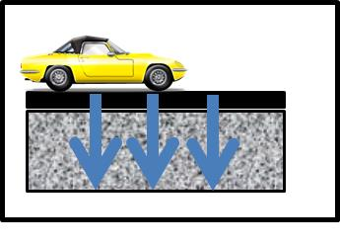
Symbol for Permeable pavement in MIDS calculator

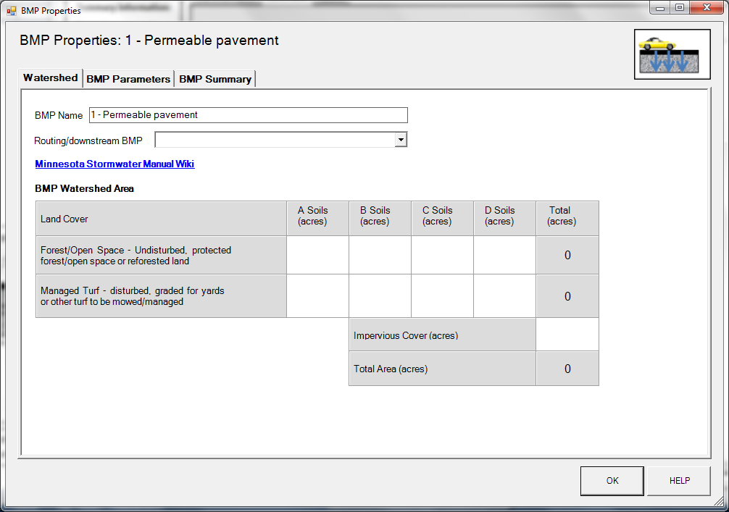
BMP watershed area parameters

Screen shot from MIDS calculator showing user inputs needed for permeable pavement.
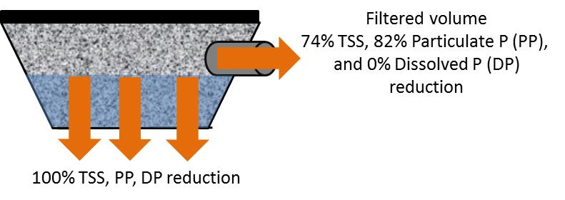
Schematic showing pollutant load reductions for infiltrated and overflow water

