Outfall Id: OF08-07 Outfall Inspection / Inventory Data Sheet

Inventory Data

Reference Point Number: Location Method: gps Year Built:

Location (North): 205505.164 (East) 558210.428 (Elevation) 946.571

Location Precision (horiz) 0.3 (Vertical) 0.3 (Elevation Desc) invert

Address: 1411 Hwy 96

Pipe Size: 15” Width: Shape: Arch Material: Concrete

Inspection Data

Inspection Date: 8/6/13 Inspected By: JMH Precip 0.0 Temp

General Condition (Excellent, Good, Fair, Poor): good

Damage: 50% clogged

Repairs Recommended: clean mud and sand

Notes: standing water

Illicit Discharge Indications

Volume: none Odor: none Color: none

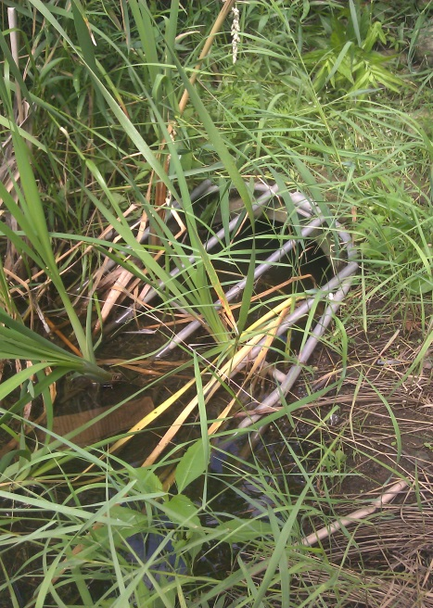
Photo:

