Minnesota Stormwater Manual Updates, Phase 2
<Note to MPCA: we recommended that hyperlinks to the applicable MPCA Construction Stormwater General Permit be included where appropriate on the stormwater Wikipedia page>

Temporary/Permanent Sediment Traps and Basins
Sediment traps and basins are settling ponds formed by excavation and/or an embankment that intercept and retain sediment-laden runoff from a construction site for a sufficient period of time to allow the majority of sediment to settle out prior to being released from the site. They may be constructed as smaller sediment traps – serving disturbed areas of less than five acres – or as larger sediment basins, handling mass grading runoff from subdivisions, commercial/institutional sites, or roadway projects. Proper use of these structures can greatly reduce sediment transport off-site; if properly designed, installed, and maintained, sediment removal efficiency of 80% or greater can be achieved, depending on soil particle size. Sediment traps are often temporary, and usually decommissioned after the disturbed area is stabilized (i.e., with vegetation or other cover). Temporary sediment basins can be converted to permanent stormwater management basins after construction is complete. Sediment traps and basins are very useful on construction sites with moderate to steep slopes, and the selection of traps versus basins primarily depends on the size of the contributing drainage area and plans for post-construction stormwater management, as discussed below.

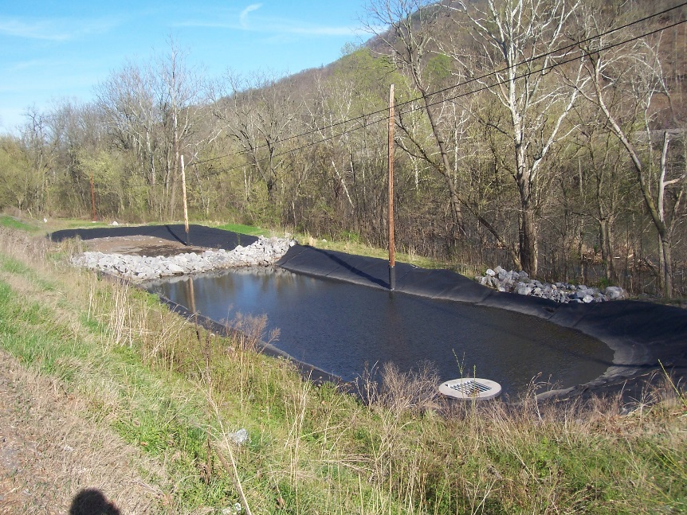
Example of a temporary sediment trap with forebay to remove initial inflows prior to final settling and discharge. Note extension of rock forebay berm up side slopes – to prevent bypass – and geotextile along banks to prevent erosion. (Source: Tetra Tech)

Purpose and function
Sediment traps and basins function by intercepting and detaining site runoff, which allows soil particles to settle out prior to discharge. Sediment traps may serve several small catchments on a site, retaining runoff using embankments and other barriers and discharging through an armored overflow or piped outlet to a vegetated swale or other drainage feature. Sediment basins typically serve larger areas than sediment traps and may feature earthen embankments that retain runoff for longer periods of time, releasing runoff via floating, perforated, or slotted risers or floating skimmers that draw clarified water from the surface.
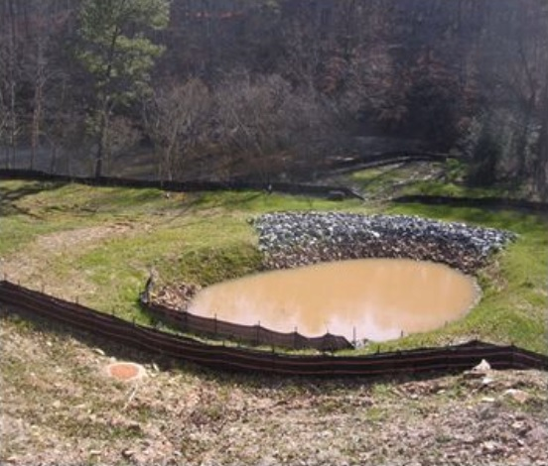
Example of a small sediment trap. Note the rock-lined overflow berm, stabilized banks, and silt fence protection along inflow section. Silt fence in foreground helps prevent excessive sediment flow into the trap, reducing maintenance dredging needs. (Source: Georgia SWCC)

Applicability
Sediment traps and basins are very similar in their siting, sizing, and design, with sediment traps serving areas of five acres or less and basins handling larger areas. They represent one of the most effective and reliable measures for treating sediment-laden runoff from construction sites. These structures are typically placed near the perimeter of the site, where flows concentrate in swales, ditches, or other low areas. Sediment traps and basins should be constructed prior to disturbance of upslope areas, if possible, and continue functioning until the contributing drainage area is fully stabilized. Specific considerations related to site applicability and permit applicability are discussed below.

Site applicability
Disturbed soils on a construction site have the potential to leave the site via stormwater runoff and negatively impact bodies of water, roadways, and neighboring property. Therefore, sediment traps and basins should be placed in such a way that they interrupt concentrated or sheet flows of stormwater discharge across a construction site. Sediment traps can be placed near the point of discharge and are often built in series to intercept and treat flow moving down long drainage paths through a site. Stormwater basins should be placed in low lying areas on the outer edge of a construction site where water naturally flows or is directed according to site plans. Sediment traps are extremely useful in perimeter control areas where silt fences will likely fail. Do not site sediment traps in high-velocity flow areas (e.g., culvert outlets, steep ditches) where excessive turbulence and scour erosion may interfere with sediment settling processes. Neither practice should be placed in surface waters (including intermittent streams) or within their required buffer zones. <MPCA, this should be linked to “Buffer Zones” wiki page>.
Siting and design considerations for sediment traps/basins
(Source: Created by Tetra Tech for US EPA and State of Kentucky)

Permit applicability
Section 14 (Temporary Sediment Basins) of the MPCA Construction Stormwater General Permit (2018) has several requirements regarding sediment basins, including:
- (Section 14.2) Sediment basins are required where ten (10) or more acres of disturbed soil drain to a common location. If the acreage of disturbed soil is reduced to less than ten (10) acres due to establishment of permanent cover, the temporary basin is no longer required. Temporary sediment basins may be converted to permanent basins after completion of construction.
- (Sections 14.3 and 14.4) For each acre of land that drains to the basin, the basin must provide sufficient live storage to hold runoff from a 2-year 24-hour storm event or provide 1,800 cubic feet of live storage, whichever is greater. If storm calculations are not conducted, the temporary basin must provide 3,600 cubic feet of storage for every acre drained.
- (Sections 14.5, 14.6, and 14.7) Outlet structures must be designed to prevent short-circuiting and discharge of floating debris, withdraw water from the surface of the sediment pond, and have sufficient energy dissipation for the outlet within 24 hours after connecting to a surface water.
- (Sections 14.8 and 14.9) Temporary basins must be located outside of surface waters and applicable buffer zone requirements, and temporary basins must be constructed prior to disturbance of ten (10) or more acres of soil draining to a common location.
- (Section 14.10) The general construction permit allows other effective sediment controls (e.g., a series of smaller sediment basins and/or sediment traps, silt fences, vegetative buffer strips, etc.) if sediment basin requirements are infeasible to meet on a particular site. This determination must be documented in the SWPPP.
Specific permit language
Applicability
Specifically, Section 14.2 of the MPCA Construction Stormwater General Permit (2018) states: “Where ten (10) or more acres of disturbed soil drain to a common location, permittees must provide a temporary sediment basin to provide treatment of the runoff before it leaves the construction site or enters surface waters. Permittees may convert a temporary sediment basin to a permanent basin after construction is complete. The temporary basin is no longer required when permanent cover has reduced the acreage of disturbed soil to less than ten (10) acres draining to a common location. “
Sizing
Section 14.3 states: “The temporary basin must provide live storage for a calculated volume of runoff from a two (2)-year, 24-hour storm from each acre drained to the basin or 1,800 cubic feet of live storage per acre drained, whichever is greater.”
Section 14.4 states: “Where permittees have not calculated the two (2)-year, 24-hour storm runoff amount, the temporary basin must provide 3,600 cubic feet of live storage per acre of the basins' drainage area”.
Outlets
Section 14.5 states: “Permittees must design basin outlets to prevent short-circuiting and the discharge of floating debris.”
Section 14.6 states: “Permittees must design the outlet structure to withdraw water from the surface to minimize the discharge of pollutants. Permittees may temporarily suspend the use of a surface withdrawal mechanism during frozen conditions. The basin must include a stabilized emergency overflow to prevent failure of pond integrity.”
Section 14.7 states: “Permittees must provide energy dissipation for the basin outlet within 24 hours after connection to a surface water.”
Location and timing
Section 14.8 states: “Permittees must locate temporary basins outside of surface waters and any buffer zone required in item 23.11 [of the general permit].”
Section 14.9 states: “Permittees must construct the temporary basins prior to disturbing 10 or more acres of soil draining to a common location.”
Alternatives
Section 14.10 states: “Where a temporary sediment basin meeting the requirements of item 14.3 through 14.9 is infeasible, permittees must install effective sediment controls such as smaller sediment basins and/or sediment traps, silt fences, vegetative buffer strips or any appropriate combination of measures as dictated by individual site conditions. In determining whether installing a sediment basin is infeasible, permittees must consider public safety and may consider factors such as site soils, slope, and available area on-site. Permittees must document this determination of infeasibility in the SWPPP”.
Additional information on basin drainage is provided in “Dewatering practices.” <MPCA, this should be linked to the Dewatering Practices wiki page>

Effectiveness
When designed, installed, and maintained properly, sediment traps and basins have relatively good sediment-trapping efficiencies (typically between 60 and 80%) and need little maintenance compared to other practices used to treat sediment-laden runoff as long as upland areas are brought to final grade and stabilized promptly. Sediment traps and basins provide good control of coarse sediment and are moderately effective for trapping medium-size sediment particles. However, they have a relatively low trapping efficiency for fine silt and clay particles suspended in runoff. Longer detention times, use of a flocculant (e.g., floc log contact with upstream incoming flows), or additional sediment control measures may be necessary for their removal. In general, the larger the storage volume and the longer the detention time of the stormwater, the more efficient sediment basins are at removing finer particles. Oil, grease, and other floatables may also be removed if an outlet pipe is used that features perforated openings, a screen, a skimmer, or other means to draw ponded water from just below the surface. Effectiveness in removing floatables is completely dependent on the outlet design. As a secondary design benefit, sediment traps and basins can also help control the flow rate and potentially the volume of runoff from a site.
Expected performance for temporary/permanent sediment traps and basins
Water Quantity
Flow attenuation | Secondary design benefit
Runoff volume reduction | Secondary design benefit
Water Quality
Pollution prevention
Soil erosion | Little or no design benefit
Sediment control | Primary design benefit
Nutrient loading | Secondary design benefit
Pollutant removal
Total suspended solids | Primary design benefit
Total phosphorus | Secondary design benefit
Heavy metals | Secondary design benefit
Floatables | Secondary design benefit
Oil and grease | Secondary design benefit

Planning considerations
Sediment Traps
In order to successfully prevent off-site migration of sediment, sediment traps need to be properly functioning and in the correct location on site. They should be installed early on in the project before the site clearing phase begins. The natural drainage of a construction site should be considered prior to planning sediment trap size and location. Locate areas of potential sediment runoff, determine the likely pathway for water draining from those sites, and place sediment traps between the source of sediment and the site perimeter or water body that will receive the runoff. For maximum effectiveness, sediment traps should be placed as close as possible to the source of sediment runoff. If the site configuration prevents the use of a single sediment trap, multiple smaller traps arranged in series can be used to meet the design requirement.
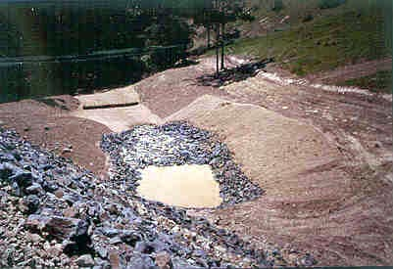
Sediment traps and basins are typically installed near the perimeter of sites in low areas. This newly constructed sediment trap in use on a disturbed site is lined with stone for stabilization rather than vegetation. (Source: Tetra Tech)
Sediment Basins
If sediment traps are not sufficient for stormwater and sediment control, sediment basins should be used due to their larger capacity. Basins have a larger footprint than sediment traps and should be sited at a low point on the construction site, where runoff converges. If stormwater does not naturally flow towards the sediment basin and cannot feasibly be directed to it, a series of sediment traps or other BMPs may be more appropriate for sediment control. It is recommended that the slopes that carry runoff to the basin be greater than 1% but no more than 25% to promote flow towards the basin. Similar to sediment traps, sediment basins should be installed early on in the project prior to soil disturbing activities wherever possible. When selecting an area to place a sediment basin, look for areas that meet the following recommendations:
- Capable of storing sediment and stormwater from as much of the planned disturbed area as practical,
- Provide access for maintenance throughout the project,
- Are far enough away (minimum of 20 feet of separation) from existing building foundations to preserve their integrity,
- Where groundwater levels will be lower than the basin bottom,
- Limit treatment to runoff from disturbed areas only, and
- Minimally interfere with the construction site.
Temporary sediment basins are often converted to permanent stormwater management structures once all disturbed contributory drainage areas have been permanently stabilized and approved by a stormwater inspection entity and all storm drains have been flushed. The outlet structure must be installed in accordance with an approved stormwater management design plan. Additional grading may be necessary to achieve the required storage volume of the basin. Prior to transition to a post-construction stormwater basin, the basin must be cleared of accumulated sediment, fully stabilized, and inspected to ensure that side slopes and the volume, containment berm, outlet, and inlets comply with stormwater basin design requirements.
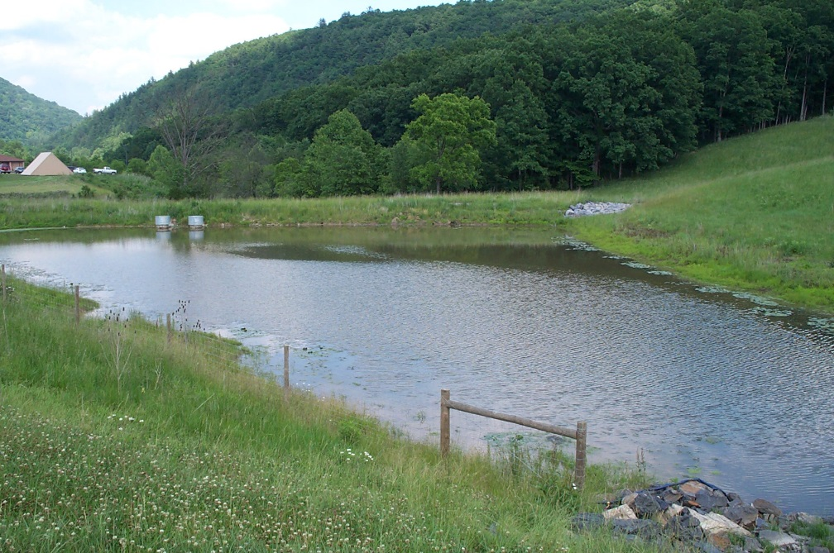
This sediment basin was converted to a permanent (post-construction) stormwater basin after the contributing drainage area was fully stabilized. Note the emergency overflow with rock lining at upper right. (Source: Tetra Tech)

Design
Designs for traps and basins should specify a minimum length to width ratio of 2:1 if possible. The surface area of a sediment trap or basin may range from approximately four to ten percent or more of the area draining to them, depending on their shape, depth, incoming soil particle size, use of flocculants, and other factors. In general, longer flow paths through the trap/basin and greater detention times results in higher rates of sediment removal via settling processes.
Sediment Traps
A temporary sediment trap should only be used in a location with a drainage area of five (5) acres or less, and where it will be used for two years or less.
Sediment traps must have an outlet to carry runoff from the structure. The outlet can be a pipe outlet, stabilized rock outlet, or other suitable structure. The outlet must be capable of handling the runoff from a 2-year-frequency, 24-hour-duration storm without failure or significant erosion. Overflow outlets should be stabilized with coarse aggregate and/or riprap and geotextile fabric.
Sediment trap sizing is dependent on the anticipated drainage area and volume of stormwater to treat. A side slope ratio of 2:1 or flatter is recommended for sediment traps. A minimum length to width ratio of 2:1 should be provided, and the distance between the inlet and outlet should be maximized to increase sediment removal efficiency. Where flow paths are shortened due to tight site conditions, silt fencing can be used as baffles within the trap to slow flows through the trap and increase sediment removal.
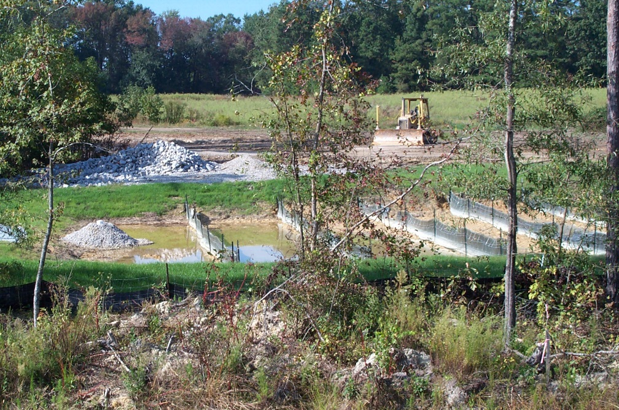
In this sediment basin, silt fencing has been installed to create baffles and increase flow path length to provide greater sediment removal efficiency. The perforated pipe outlet (left) has been encased in #57 stone to further slow the discharge rate, thereby increasing settling time. Note higher sediment accumulations in basin cells at right, versus those on the left. (Source: Tetra Tech)
The example design table below provides general guidance on sizing rectangular sediment traps with sloped sides, based on contributing drainage area. Volumes for sediment traps constructed by installing a rock berm or earthen embankment across a swale can be estimated using the triangular pyramid volume formula. As a rule of thumb, a total storage volume of 3,600 ft³ should be provided for every acre of contributing drainage. This volume may be equally divided between wet (retention) and dry (drawdown, or dewatered) storage. Wet storage is provided in a permanent pool and dry storage provides extended settling time.
Sediment trap sizing table (Source: adapted from District of Columbia Erosion and Sediment Control Manual, 2017)
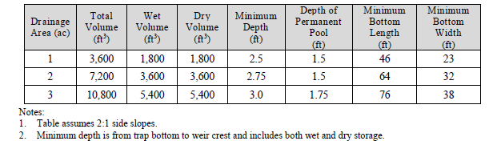
Embankments are located at the lowest point of the sediment trap and typically consist of mixed size rock or a stabilized earthen berm with a rock-armored overflow notch. The bottom of the embankment should be level with the wet storage portion of the trap. The design table below summarizes the recommended embankment top width (also referred to as weir length) for sediment traps as a function of contributing drainage area.
Recommended embankment widths for sediment traps (Source: Iowa Statewide Urban Design and Specification Design Manual, 2013 Revision)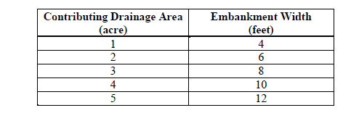
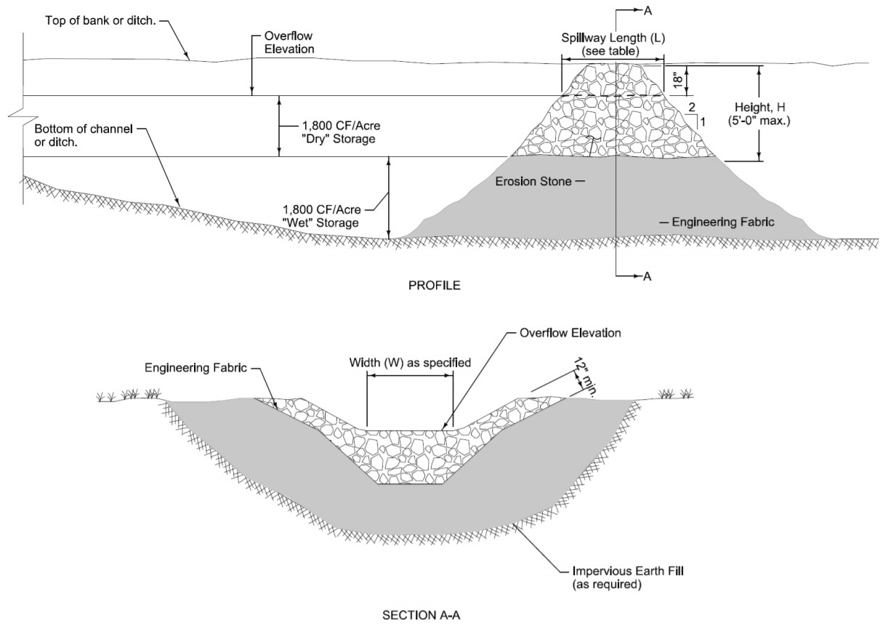
Typical sediment trap design (Source: Iowa SUDAS, 2014)
Sediment Basins
Per the MPCA Construction Stormwater General Permit (2018), sediment basins are required when ten (10) or more acres of disturbed land discharges to a common location. If the site is located within one miles of a special or impaired water, this requirement is more stringent at 5 or more acres. The maximum drainage area for a single sediment basin should not exceed 100 acres.
Sediment basins consist of a principal spillway, dewatering device, and an emergency (overflow) spillway. A principal spillway conveys the design volume of treated stormwater away from the site and discharges it. It consists of a vertical riser that controls basin water levels and an outlet pipe. A dewatering device releases the runoff over time, allowing the sediment to settle out. Dewatering devices can take many forms including modifications to risers and floating skimmers. The MPCA Construction Stormwater General Permit section 14. 6 (2018), requires emergency spillways to safely pass stormwater from storms exceeding the basin design storm without compromising the integrity of the basin.
Similar to sediment traps, the total storage volume provided by sediment basins should be a minimum of 3,600 ft³ per acre of contributing area. Contributing drainage area should include the entire drainage area, not only the disturbed area. The total storage volume should be divided equally between wet (retention) and dry (drawdown, or dewatered) storage. Storage volume is measured from the bottom of the basin to the elevation of the principal spillway crest.
The following design recommendations apply to sediment basins:
- The ratio of the surface area (ft²) at the designed high water elevation to the discharge rate from a 15-year, 24-hour storm (cfs) is greater than or equal to 0.0035.
- Basin length to width ratio should be 2:1 or greater, in order to maximize settling time.
- Use a wedge design with the inlet located at the narrow end of the basin.
- Locate inflows to the basin as far from the riser as possible to maximize travel time through the basin and increase effectiveness of treatment. Baffles may be installed to maximize detention time and increase sediment removal efficiency.
- For small temporary sediment traps, the embankment height should not exceed five feet. For temporary sediment basins, the embankment (dam) height should not exceed fifteen (15) feet.
- For embankments up to ten (10) feet in height, the embankment top width should be a minimum of eight (8) feet. For embankments between ten (10) and fifteen (15) feet in height, the minimum top width should be ten (10) feet.
- Soils used for embankments exceeding five feet must be selected and compacted in accordance with NRCS or MnDOT standards.
- For rock sediment trap berms, use mixed size rock to ensure slower drain-down times and maximum sediment settling.
- Inside embankment side slopes should be designed at a ratio of 2:1 or flatter, and outside embankment side slopes should be 3:1 or flatter. All slopes should be designed to be stable through the use of erosion controls such as seeding, mulching, and sodding.
- Protect inflows and outlets from erosion by armoring with riprap or other appropriate techniques.
- Increase detention time by using rock, filter fabric, rock bags, or similar measures to modify the inlet, and use berms or other approaches that slow down exiting flow to allow more sediment to settle out.
- Increase sediment removal via flocculation and faster settling through the use of polymers, available as powders, flocculant logs/bags, and other products. Follow manufacturer’s directions for applicability and use. See Dewatering practices: chemical treatment and sediment filtration.
- For superior sediment basin discharge water quality, consider use of a floating skimmer. These devices draw clarified water from the surface of the impounded stormwater, where sediment concentrations are the lowest. Several do-it-yourself and proprietary products are available to choose from; see https://www.dot.state.mn.us/research/TS/2014/201418.pdf for more information.
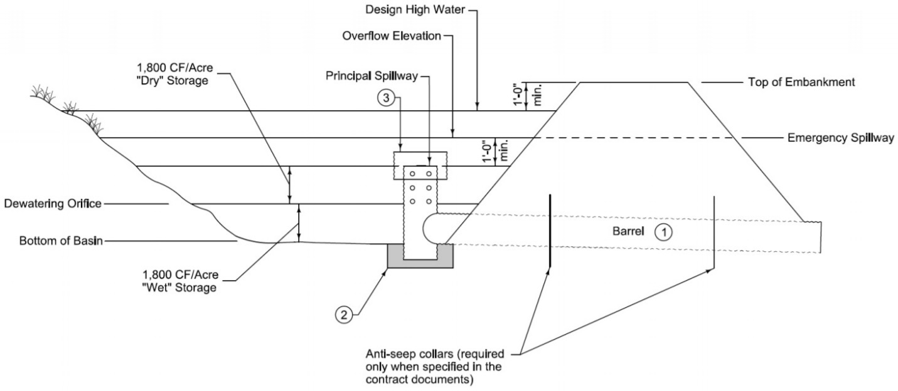
Typical design for a sediment basin with an emergency spillway (Source: Iowa SUDAS, 2014)

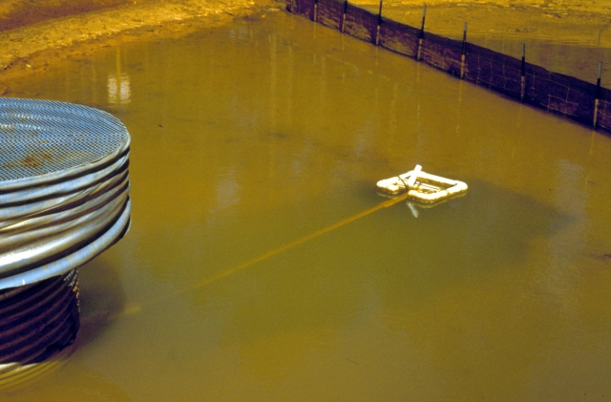
Floating skimmer installed in temporary sediment basin to draw and discharge cleaner water from the top of the impoundment. (Source: J. W. Faircloth & Son, Inc.)

Construction recommendations and specifications
While sediment traps differ from basins in terms of pollutant targeting design options, sizing, and (typically) permanence, there are some basic construction recommendations common to both BMPs:
- Install traps/basins as early as possible, prior to disturbing large portions of the upland construction site, so they are available for sediment removal during the active construction period.
- Assess drainage toward the trap/basin to ensure it conforms to site design. Use berms or ditches to capture flows that may bypass the trap/basin where necessary.
- Clear and grub the area under the embankment, removing any vegetation and the root mat.
- Ensure that earthen containment berms are constructed according to design. Soils used to construct the embankment must be free of roots, woody debris, large rock, organic material, and other non-soil material.
- Compact containment embankment fill soils by traversing with equipment in one-foot lifts during construction..
- Ensure that the berm is capable of handling the lateral stress from ponded water (i.e., apply MnDOT and NRCS soil and compaction specifications for embankments exceeding five feet in height.
- For rock sediment trap berms, use mixed size rock to ensure slower drain-down times and maximum sediment settling.
- Outlets (e.g., overflow, piped) must be stable and able to handle heavy incoming/outgoing flows.
- Ensure that there are no large bottom-elevation outlet structure holes, pipe openings, rock voids in the berm, or other features that may cause the trap/basin to drain down too quickly, less than12 – 24 hours, after a rain.
- Mixed size rock berms or filter fabric can be used, if necessary, to slow flows from permanent stormwater outlets during the construction period.
- Remove limbs, debris, trash, building materials, soil stockpiles, etc. immediately after constructing the trap/basin.
- Stabilize side slopes and berms of traps/basins with seed, erosion control blanket, stone, etc. as soon as they are built, to prevent filling the available volume with sediment from the trap/basin itself. The bottom can remain unstabilized until final sediment removal occurs.
- Ensure that stormwater discharges from the basin will exit onto an armored ant-scour pad or other erosion proof structure/area, and can move downstream via stabilized swales, ditches, channels, or as sheet flow.
- Remove any non-sediment upland materials that may wash into the trap/basin (e.g., limbs, debris, trash, building materials, etc.)
- Stabilize upland areas that may contribute significant amounts of eroded soil to the trap/basin as quickly as possible, to avoid frequent dredging and maintenance.
- Use silt fencing or other sediment controls where necessary to further reduce sediment inputs to the trap/basin – it’s easier to remove sediment from a silt fence than a trap/basin.
The MnDOT Standard Specifications for Construction (2018 Edition) includes several specifications relevant to sediment basins and traps.
MnDOT Specification 2573.3 Part A includes guidance for construction of temporary sediment basins and traps. Part A.4 (page 514) states: “Construct temporary sediment basins concurrently with the start of soil disturbing activities. Direct storm water runoff from drainage areas to the basins. Stabilize the exposed side slopes of the basins. Provide an outlet to the basin that discharges water from the surface, separates floatables, and provides scour protection or energy dissipation.” Part A.6 requires the use of a water treatment plan for these devices, stating: “Provide a water treatment plan for turbid or sediment laden water. Submit the water treatment plan to the Engineer before pumping. Do not begin work until the Engineer accepts the water treatment plan including any contractor required permits. Include in the water treatment plan the use of sediment traps, vegetative filter strips, flocculants, or other water treatments per 3875, ‘Water Treatments’.”
MnDOT Specification 2573.3 Part P includes guidance for the maintenance of sediment basins and traps. Part P.2 (page 518) states: “Drain the basin and remove the sediment when the depth of sediment collected in the basin reaches 50% of the storage volume determined by the outfall device. Complete drainage and removal within 72 hours or as soon as field conditions allow access. Remove sediment to the original designed or excavated grade or as necessary to restore the function of the device. Restore stabilized condition of side slopes and access road. Clean out and shape temporary sedimentation basins intended for use as permanent water quality management basins as shown on the plans.” Maintenance is discussed in greater detail below.
MnDOT Specification 2573.4 prescribes “method of measurement” related to temporary sediment traps and basins. Part E (Temporary Sediment Traps, page 519) states: “The Engineer will measure sediment trap excavation by volume. The Engineer will measure overflow devices separately.” Further, Part G (Sediment Removal) states: “The Engineer will measure sediment removal from temporary sediment traps and basins by backhoe hours or vac-truck hours. The spreading and hauling of sediment is incidental to the backhoe hour removal.”
MnDOT Specification 2573.5 prescribes “basis of payment” related to temporary sediment traps and basins. Part G (Sediment Traps, page 520) states: “The Department will pay for removal of sediment from sediment traps by backhoe or vac-truck hour. Sediment spreading and disposal are incidental.” Further, Part I (Pay Items, page 521) states that payment by the Department for sediment trap excavation (Item No. 2573.504) shall be calculated on the basis of cubic yards.
The relevant specifications noted above in 2573.4 (Method of Measurement) and 2573.5 (Basis of Payment) are important when considering cost implications of these practices, discussed further below.
MnDOT Specification 3875 (Water Treatment) outlines requirements for use of passive dewatering treatment methods for sediment traps and basins. Specification 3875.2 Part A (page 694) states: “Use passive dewatering treatment methods, using time and gravity to settle out sediments, if draining basins, traps, ditches, or sumps to prepare the construction site for the next storm event.” Part A.2 provides specifications regarding the design of the riser pipe, stating: “Provide a riser pipe in a pond, basin, or trap outlet structure meeting the following requirements or characteristics:
- Two-thirds the height of the outlet above the floor of the structure,
- Made of perforated PVC or metal pipe of the same diameter as the outlet structure, and
- Surrounded by clean rock from 1 in to 2 in, for the entire height of the riser pipe.
Install a trash guard on the top overflow.”

Inspection and maintenance
Sediment Traps
The MPCA Construction Stormwater General Permit (2018) does not include specific requirements for inspection and maintenance of temporary sediment traps. Temporary sediment traps, however, should be inspected at least weekly and after each significant (0.5-inch or greater) rainfall event and repaired immediately. Recommended maintenance includes:
- Ensure that trap sidewalls are vegetated or otherwise stabilized to prevent erosion of the structure and filling of the trap volume.
- Check spillway for accumulated debris, erosion, and displacement of rock.
- Immediately address erosion, bulging, or other conditions indicating weakness or potential failure of the containment berm.
- Remove sediment from the trap when sediment accumulates to the clean out level (50% of wet storage depth).
- Dispose of dredged sediment at fill areas, soil stockpiles, or other locations where it can be stabilized with vegetation or contained via sediment controls (e.g., silt fencing). Dredged sediment containing hazardous wastes (i.e., from demolition debris, waste sites, etc.) must be characterized and disposed of in accordance with MPCA requirements (https://www.pca.state.mn.us/waste/minnesota-rules-hazardous-waste-solid-waste-and-tanks).
- When performing sediment cleanout, inspect the trap for accumulated trash and other debris. Keep inflow, outflow, and interior of trap clear of any debris.
- Prevent erosion at inflow and outflow by installing and maintaining riprap or other appropriate measures.
- Stabilize or use silt fencing to address upslope areas that are contributing excessive volumes of sediment to the trap and increasing maintenance needs.
- Maintain original dimensions of trap (grade, depth, etc.) throughout life of practice.
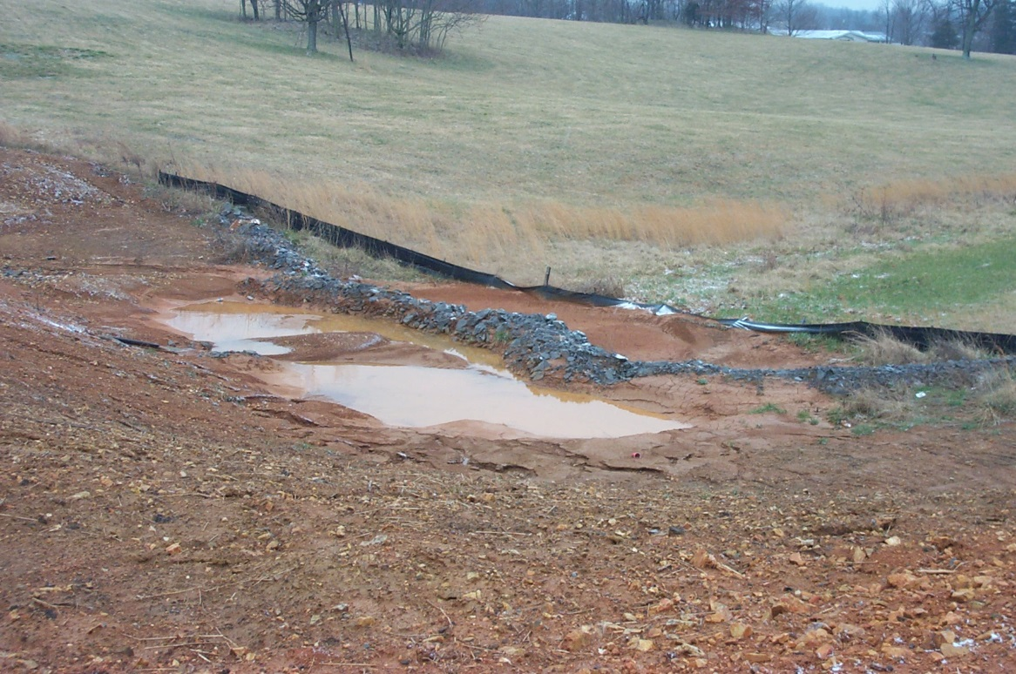
Temporary sediment trap in need of maintenance to remove accumulated sediment. The stone berm will need to be reinforced after accumulated sediment is removed, and areas draining to trap should be stabilized as soon as possible to prevent the trap from being overloaded. Note that the silt fence behind the sediment trap is also being overtopped due to neglected maintenance. (Source: Tetra Tech)
Sediment Basins
The recommended maintenance activities outlined above for sediment traps also apply to sediment basins. Maintenance of sediment basins is necessary when sediment levels reach half of the design volume of the basin. Once this threshold is reached, 72 hours are allotted for proper maintenance to occur. As noted above, MnDOT Specification 2573.3 Part P.2 (2018 edition) states: “Drain the basin and remove the sediment when the depth of sediment collected in the basin reaches 50% of the storage volume determined by the outfall device. Complete drainage and removal within 72 hours or as soon as field conditions allow access. Remove sediment to the original designed or excavated grade or as necessary to restore the function of the device. Restore stabilized condition of side slopes and access road. Clean out and shape temporary sedimentation basins intended for use as permanent water quality management basins as shown on the plans.”
Additionally, during inspections, the embankment should be evaluated for signs of seepage, settlement, or slumping, and any problems should be repaired immediately. All woody vegetation (e.g., trees, brush, etc.) should be cleared from the embankment and principal spillway. During sediment cleanout, trash and other debris should be removed from the basin, dewatering device, and riser structure.

Costs
The following table summarizes estimated BMP costs based on MnDOT data summarizing average bid prices for awarded projects in 2017.
Unit costs related to sediment traps and basins (Source: MnDOT 2017 Average Bid Prices)
Bid Item | Item Description | Units | Average Price
2573602/00010 | Temporary sediment trap | each | $605.00
2106501/00010 | Excavation – common | cubic yards | $5.60
2106607/00020 | Excavation – subgrade | cubic yards | $9.59
2106523/00060 | Common embankment (CV) | cubic yards | $2.18
2106521/00070 | Granular embankment (CV) | cubic yards | $8.51

Reference materials
Except where more stringent recommendations are presented in this guidance, BMPs shall comply with MnDOT and other state requirements. Primary design references include:
- 2018 Minnesota NPDES/SDS Construction Stormwater General Permit
https://www.pca.state.mn.us/water/construction-stormwater
- 2018 MnDOT Standard Specifications for Construction
http://www.dot.state.mn.us/pre-letting/spec/
- Minnesota Urban Small Sites Best Management Practice Manual (Chapter 3: Runoff Pollution Prevention – Temporary Sedimentation Basins/Traps)
https://metrocouncil.org/Wastewater-Water/Planning/Water-Resources-Management/Water-Quality-Management-Key-Roles.aspx
- MnDOT Erosion Control Handbook II
https://www.dot.state.mn.us/environment/erosion/pdf/2006mndotecfieldhandbook.pdf
The following is a list of additional resources that are not specific to Minnesota:
- Clean Water Services Erosion Prevention and Sediment Control Manual (2008) (4.3.9 Sediment Basin and 4.3.11 Sediment Trap)
https://www.cleanwaterservices.org/media/1464/erosion-prevention-and-sediment-control-manual.pdf
- Contractor’s Handbook for Erosion, Sediment, and Stormwater Management on Capital Project Construction Sites (Lexington-Fayette Urban County Government) (2018)
https://www.lexingtonky.gov/sites/default/files/2018-12/LFUCG%20Contractor%27s%20Handbook%20Final%20v29Nov2018.pdf
- District of Columbia Erosion and Sediment Control Manual (2017) (Chapter 6) https://doee.dc.gov/sites/default/files/dc/sites/ddoe/publication/attachments/2017%20DC%20ESC%20Manual_FINAL.pdf
- Iowa Statewide Urban Design and Specification (SUDAS) Design Manual (2016) (Chapters 7E-12 and 7E-13)
https://iowasudas.org/manuals/design-manual/
- Kentucky Erosion Prevention and Sediment Control Manual (Revised 2009). (Chapter 4.7) http://dep.ky.gov/formslibrary/Documents/09BMPManual_Final.pdf
- New York State Standards and Specifications for Erosion and Sediment Control (2016)
https://www.dec.ny.gov/docs/water_pdf/2016nysstanec.pdf

Stabilized Earth/Soil Berm
Berms are compacted or vegetated structures that are designed to 1) slow, pond, or filter runoff, and 2) divert runoff on a construction site to a sediment trap/basin, or ensure clean upland runoff does not move into disturbed areas. They may also be called filter berms, diversion berms, or earth berm barriers, depending on their composition and use. Berms can be constructed from soil, rock, wood chips, and compost, depending on the construction site characteristics (discussed below). They are typically used as a temporary perimeter control BMP to divert clean runoff away or around disturbed areas on a construction site as well as to collect sediment-laden flows from disturbed areas and direct them toward sediment traps or basins. Berms are often used where the installation of silt fence is not feasible or may be used in combination with a silt fence to minimize under-draining of the fence and increase sheet flow runoff filtering.
Stabilized berms are sited to divert stormwater away from the disturbed areas of construction sites
(Source: Created by Tetra Tech for US EPA and State of Kentucky)

Purpose and function
Berms prevent off-site sedimentation by diverting runoff to a sediment trapping device and can also be used to divert clean water from entering a disturbed area. They can also trap sediment by ponding and settling out sheet flow runoff, or by filtering sediment as runoff passes through permeable berms. Stabilized earth/soil berms are constructed from compacted soil, compost, mulch/wood chips, aggregate, or other filtering materials.
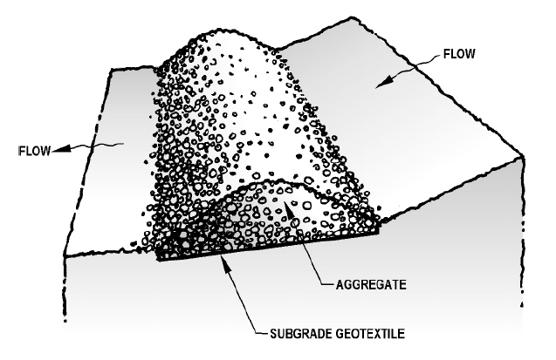
Schematic of a berm constructed from compacted aggregate (Source: Clean Water Services, 2008)

Applicability
The size, soil condition, and topography of the site must be considered before selecting, sizing, and installing a stabilized berm. They should be installed before upslope construction activities begin, particularly any activities causing soil disturbance. They should be maintained until the contributing area is fully stabilized and vegetation is established. Soil berms should be stabilized immediately with vegetation, erosion control blankets, or similar measures to prevent the berm from eroding and becoming a source of sediment in runoff.
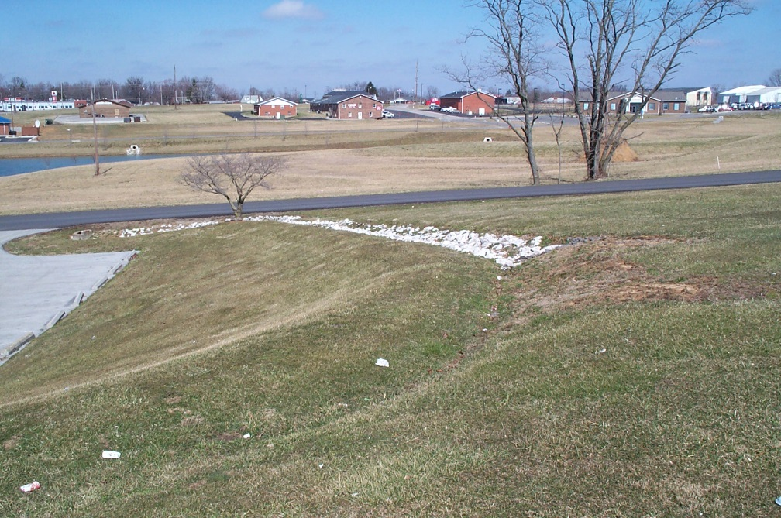
A berm has been used on this site to divert runoff from upland areas during site disturbance. This earthen berm has been stabilized with vegetation (sod). The steeper portion of drainage is lined with stone to reduce erosion from higher flow velocities. Stabilizing upslope areas reduces erosional stress on flow diversion berms. (Source: Tetra Tech)

Site applicability
Berms are effective for treating smaller, flatter drainage areas. Berms can be used on larger sites by installing multiple berms to partition the drainage area so that individual structures are not overwhelmed by incoming flow. Berm effectiveness is reduced when slopes exceed 10%. Soils used to construct berms should be free of roots, large rock, vegetation, organic matter, and other non-soil material. Soils with sand content exceeding 70 percent may not be effective for berms experiencing high velocity flows. Berms constructed of wood chips, compost, or mulch are recommended for flatter areas (i.e., < 6%) while berms constructed of earthen materials are more suitable for steeper slopes.
Berms are well suited for redirecting sheet flow to treatment areas such as temporary sediment traps and can be installed along a slope to intercept sheet flow. Earth/soil berms are generally not recommended for areas receiving concentrated flow unless they are armored with erosion control blankets or turf reinforcement matting. However, they can be appropriate for locations downgradient from areas of disturbed earth and across or at the bottom of a slope, provided that sufficient space is provided to disperse and handle the accumulated runoff and resultant flow. They can also be installed along roadways and other areas to facilitate diversion of runoff and at the tops of slopes as an erosion prevention measure.
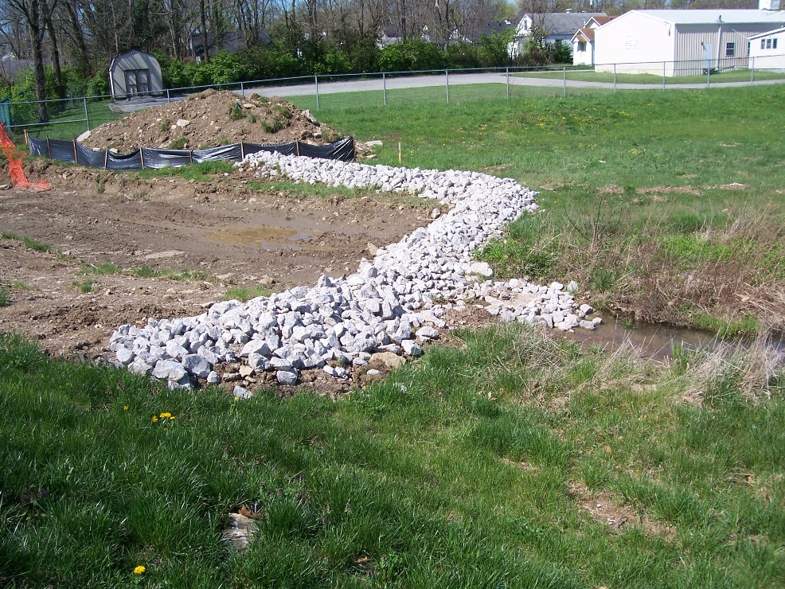
Rock berms make excellent sediment barriers and can also be used to direct runoff to temporary sediment traps. This newly constructed sediment trap with rock berm and stone scour pad is installed in a drainage swale. (Source: Tetra Tech)

Permit applicability
Stabilized earth and soil berms are cited for use for several construction activities in the MPCA Construction Stormwater General Permit (2018), specifically for practices that are susceptible to clogging from excess sediment:
- Section 16.4 states: “Permittees must not excavate infiltration systems to final grade, or within three (3) feet of final grade, until the contributing drainage area has been constructed and fully stabilized unless they provide rigorous erosion prevention and sediment controls (e.g., diversion berms) to keep sediment and runoff completely away from the infiltration area.”
- Similarly, Section 17.3 states: “Permittees must not install filter media until they construct and fully stabilize the contributing drainage area unless they provide rigorous erosion prevention and sediment controls (e.g., diversion berms) to keep sediment and runoff completely away from the filtration area.”

Effectiveness
Diversion berms are highly effective for moving sediment-laden flows to traps, basins, or other structures/areas where sediment can be removed via settling or filtration. When used as a sheet flow barrier, berms can be effective in sediment removal, but may need frequent maintenance as they are prone to clogging from mud and soil. They are somewhat effective for flow attenuation by slowing down flow, and for removing nutrients and metals associated with sediment. Berms are typically ineffective for managing floating or dissolved pollutants.
Expected performance for stabilized earth/soil berms
Water Quantity
Flow attenuation | Secondary design benefit
Runoff volume reduction | Little or no design benefit
Water Quality
Pollution prevention
Soil erosion | Primary design benefit
Sediment control | Primary design benefit
Nutrient loading | Secondary design benefit
Pollutant removal
Total suspended solids | Primary design benefit
Total phosphorus | Secondary design benefit
Heavy metals | Secondary design benefit
Floatables | Little or no design benefit
Oil and grease | Little or no design benefit

Planning considerations
Berms should be integrated into an erosion prevention and sediment control system that takes the entire site into consideration. Prior to any earth disturbing activities, berms should be installed where appropriate on downgradient limits-of-disturbance, and upgradient of buffer or disturbed zones (i.e., where used to divert clean upland runoff around areas to be graded). They should be integrated with other BMPs, such as minimization of disturbed areas, minimization of the length of exposure time, or adequate seeding and mulching. If downgradient berms become overloaded with sediment and runoff volumes, additional upgradient controls (e.g., silt fencing, temporary vegetative stabilization, sediment traps) may be necessary. Like other perimeter control BMPs, stabilized earth/soil berms must remain in place until the construction site is fully stabilized.
For best results, plan and schedule project activities to minimize maintenance needs, ideally through timely grading operations and stabilization of disturbed areas with seeding, mulching, or other ground covers. Timing of berm installation may be adjusted to accommodate short term activities, such as clearing and grubbing, and passage of vehicles. Such activities must be completed as quickly as possible and the stabilized berms reinstalled immediately after the activity is finished, or before the next precipitation event, whichever comes first.

Design
Berm design is dependent on their intended use, i.e., as a flow diversion device or as a flow interceptor and small sediment barrier/trap. Berms can be constructed from material stockpiles on site. For example, shredded wood mulch or wood chips can be derived from the clearing and grubbing phase of the project. Rock can be used to construct temporary berms, and site development work can be adapted to include contoured berms during mass grading. Topsoil is often stockpiled at the construction site until needed for final grading; this can be a valuable resource for constructing a stabilized berm until it is needed elsewhere. The following design recommendations apply to berms:
- Do not use soil berms in areas of concentrated flow. Properly spaced stone and/or fiber log check dams may be used to prevent ditch downcutting prior to stabilization.
- Berms should be designed to carry peak flows from a 2-year, 24-hour storm event.
- It is recommended that drainage areas for individual berm structures be small enough to ensure effectiveness as a sediment removal or flow diversion device.
- The maximum drainage area slope should be 10%. On steeper (greater than6%) and/or long slopes (greater than 50-75 ft), multiple berms installed perpendicular to the flow path may be placed at regular intervals down the slope.
- To the extent possible, berms should be placed away from the toe of a slope and on the flattest area available to allow sheet flow energy to dissipate and provide a greater storage area for sediment.
- Install berms on the contour perpendicular to sheet flow with the ends turned upslope to prevent runoff from bypassing the berm.
- Berms constructed from soil should be stabilized immediately using methods such as vegetation, erosion control blankets, or similar measures.
- Install energy dissipation such as riprap where flows diverted by berms may cause scour or erosion.
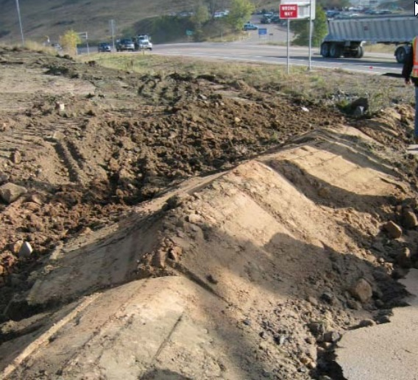
Example of a berm constructed from compacted soil. Compacted soil berms built from native soil are extremely useful for directing sheet runoff toward sediment traps/basins, reducing the need for long sections of high-maintenance silt fencing. (Source: Colorado DOT)
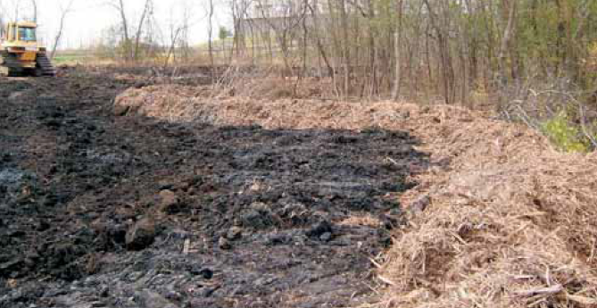
In this example, wood chips generated on site during the tree clearing and grubbing phase were repurposed for berm construction. (Source: MnDOT)
Recommended berm shape, base width, height, and side slopes depend on the berm material and are summarized in the table below.
Recommended dimensions for stabilized berms (Source: MnDOT 2018 Standard Specifications)
Berm Type/Material | Recommended shape | Recommended base width | Recommended height | Recommended side slopes
Type 1 – compost | Trapezoidal | 5 feet | 2 feet (minimum) | 2:1
Type 2 – slash mulch | Trapezoidal | 5 feet | 2 feet (minimum) | 2:1
Type 3 – rock weeper system | Trapezoidal | 8 feet | 2 feet (maximum) | 2:1
Type 4 – topsoil | Trapezoidal | 7 feet | 2 feet (minimum) | 2:1
Type 5 – rock | Trapezoidal | 5 feet | 2 feet (maximum) | 2:1

Permissible velocities for prevention of erosion of the berm are based on soil type and are summarized in the table below. These values reflect the maximum velocity of runoff that should be intercepted by a berm before erosion is likely to occur.
Maximum runoff velocity (feet per second) for a berm based on soil type (Source: Iowa Statewide Urban Design and Specification Design Manual, 2013 Revision) 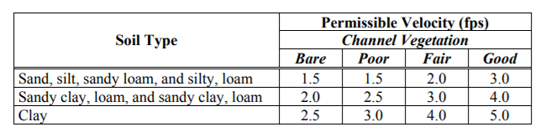

Construction recommendations and specifications
Berm material selection, design, siting, and installation is dependent on its use, i.e., as a flow diversion device or as a flow interceptor (e.g., flow attenuator, sediment removal BMP). General construction recommendations include:
- Ensure berm fabrication, construction, or installation is appropriate for the intended use in terms of location, slope, spacing, and endpoints.
- Berm shape is usually trapezoidal, and shape must be consistent through its length.
- Berms must be substantial enough to maintain their structural integrity while handling incoming flows.
- Fiber rolls and other lighter weight products used as berms must have full soil contact and be properly staked down or otherwise secured.
- Some materials used for berming (e.g., mulch, bark) may require netting to prevent washouts.
- Soil berms handling erosive flows require stabilization (e.g., erosion control blanket over seed).
- Flow diversion berms should discharge to a sediment control BMP (for muddy flows) or a scour-resistant dispersal area (for clean upland diversion flows).
The MnDOT Standard Specifications for Construction (2018 Edition) includes several specifications relevant to stabilized earth/soil berms.
MnDOT Specification 2573.3 Part E discusses installation of filter berms used as a perimeter control, with specific guidance provided based on construction material, as follows:
- Part E.1 covers Type 1 and Type 2 filter berms, which are constructed from compost or slash mulch. The specification states: “For slope breaks and perimeter control, install filter berms along the contour of the slope and perpendicular to sheet flow. Install the filter berms so the beginning and end of the installation points slightly up the slope to create a “J” shape at each end to contain runoff from above and prevent it from flowing around the ends of the berm. For slopes that receive runoff from above, place a filter berm at the top of the slope to control the velocity of the flow running onto the slope, and to spread the runoff into sheet flow… Upon formation, immediately seed compost filter berms.”
- Part E.2 pertains to Type 3 filter berms constructed from aggregate, stating: “Line the bottom of the rock weeper with a Type IV geotextile per 3733, “Geotextiles.” Provide a rock weeper that forms a trapezoidal-shaped berm. Install coarse filter aggregate per 3149, “Granular Material,” on the front half of the berm. Install Class I riprap per 3601, “Riprap Material,” on the back half of the berm.”
- Part E.3 covers Type 4 filter berms, which are constructed from soil. The specification states: “For perimeter control, construct a topsoil berm using topsoil salvaged from the project. Immediately following formation, stabilize the berm with seed and mulch or an equivalent approved by the Engineer.”
- Part E.4 pertains to Type 5 filter berms constructed from riprap, stating: “Install Class II riprap on top of a Type IV geotextile liner per 3733, “Geotextiles.” Configure riprap in a trapezoidal-shaped berm.”
Specification 2573.3 Part P.1 covers maintenance of filter berms, stating: “Expand, enlarge, or augment the filter berm with additional erosion and sediment control practices if concentrated flows bypass or breach the berm or to maintain the dimensions of the berm.” Inspection and maintenance of stabilized earth/soil berms is discussed below.
Specification 2573.5 Part A discusses basis of payment for filter berms. The specification states: “The contract pay item for Topsoil filter berm includes seed and mulch. The contract pay item for rock or rock weeper filter berm when converted from temporary to permanent conditions includes the cost to modify the berm dimensions.”
Specification 2573.5 Part B.1 covers temporary seeding as a stabilization measure for soil berms, stating: “Perform temporary seeding in addition to temporary mulching on graded areas with topsoil and unable to receive permanent seeding or slopes and topsoil berms left idle for longer than 21 days. Use cover crop and mid-term stabilization seed mixtures as shown in 3876, “Seed”, Table 3876-1 for temporary seeding. Prepare the soil in accordance with 2574.3.A and 2574.3.B, except for stockpile and berms where no soil preparation is needed.”
Specification 3874 is specifically dedicated to filter berms and outlines specific design requirements. The specification includes the following guidance:
- Specification 3874.1 (Scope) states: “Provide filter berms to slow, filter, and divert storm water runoff and other pollutant water.”
- Specification 3874.2 (Requirements) states: “Provide the following types of filter berms. Dimensions may vary by the contract:”
  - Part A (Type 1 – Compost): “Provide compost berms meeting the following requirements and characteristics:
    - (1) Grade 2 Compost per 3890,
    - (2) Trapezoidal shape with 5 ft. base width,
    - (3) Min. height 2 ft. in loose volume, and
    - (4) 2:1 (V:H) side slopes.
  - Part B (Type 2 – Slash Mulch): “Provide slash mulch berms meeting the following requirements and characteristics:
    - (1) Type 5 Mulch per 3882,
    - (2) Trapezoidal shape with 5 ft. base width,
    - (3) Min. height 2 ft. in loose volume, and
    - (4) 2:1 (V:H) side slopes.
  - Part C (Type 3 – Rock Weeper System): “Provide rock weeper systems meeting the following requirements and characteristics:
    - (1) Type IV Geotextile Fabric per 3733,
    - (2) Trapezoid shape with 8.0 ft. base width,
    - (3) Max height 2.0 ft.,
    - (4) 2:1 (V:H) side slopes
    - (5) Front half composed of Coarse Filter Aggregate per 3149.2.H, and
    - (6) Back half composed of Class I Riprap per 3601.
  - Part D (Type 4 – Topsoil): “Provide topsoil filter berm meeting the following requirements and characteristics:
    - (1) Topsoil Excavation material per 2105,
    - (2) Trapezoid shape with 7 ft. base width,
    - (3) Min. height 2 ft., and
    - (4) 2:1 (V:H) side slopes.
  - Part E (Type 5 – Rock): “Provide rock filter berm meeting the following requirements and characteristics:
    - (1) Type IV Geotextile fabric per 3733 as a liner,
    - (2) Class II Riprap per 3601,
    - (3) Trapezoid shape with 5 ft. base width,
    - (4) Max. Height 2.0 ft., and
    - (5) 2:1 (V:H) side slopes.
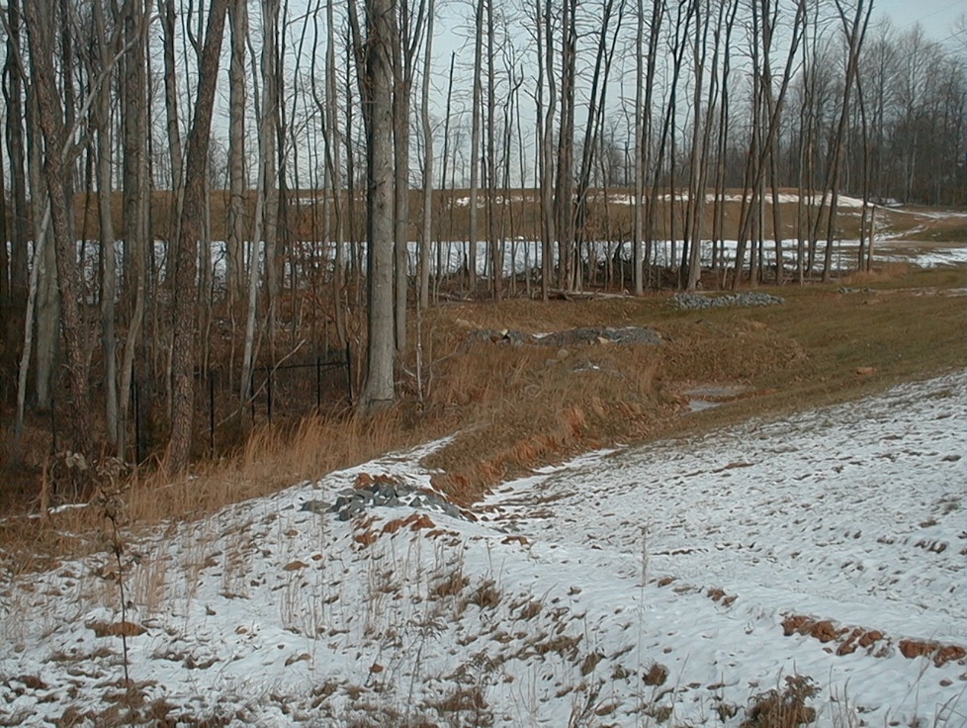
A stabilized berm left in place during winter. (Source: Horticultural Management of Ohio)

Inspection and maintenance
The control of runoff is a key element of sediment control on a construction site, and berms can be an effective measure for managing sediment from construction runoff if they are properly installed and maintained.
Frequent inspection and maintenance are essential to the proper performance of this BMP. As noted above, Specification 2573.3 Part P.2 discusses maintenance requirements for berms, stating: “Expand, enlarge, or augment the filter berm with additional erosion and sediment control practices if concentrated flows bypass or breach the berm or to maintain the dimensions of the berm.”
Inspect berms weekly, before rain events, and after rain events, particularly events of 0.5 inch or greater, to ensure they are functioning. If not, complete the following tasks as needed:
- Look for runoff bypassing ends of berms or undercutting berms and repair.
- Repair damaged areas of the berm (washed out, eroded, and flattened areas).
- Recompact soil around berm as necessary to prevent breakouts and/or piping.
- Perform repairs using a piece of equipment or hand tool capable of excavating, contouring, and compacting back to the berm’s original design.
- Remove accumulated sediment and debris once sediment depth reaches one-half of berm height and repair any damage to vegetative cover.
- Prevent damage to the berm by ensuring that equipment operators do not drive over the berm.
- Remove berm once the site reaches final stabilization. Fill, compact, and vegetate areas of ground disturbance to blend with adjacent ground.

Costs
The following table summarizes estimated BMP costs based on MnDOT data summarizing average bid prices for awarded projects in 2017.
Unit costs related to stabilized earth/soil berms (Source: MnDOT 2017 Average Bid Prices)
Bid Item | Item Description | Units | Average Price
2573515/00011 | Filter berm type 1 (compost) | linear feet | $28.00
2573515/00013 | Filter berm type 3 (rock weeper system) | linear feet | $26.97
2573515/00014 | Filter berm type 4 (topsoil) | linear feet | $2.30
2573515/00015 | Filter berm type 5 (rock) | linear feet | $48.02
2105604/00003 | Grade protection | square yard | $23.50
2574550/00012 | Compost grade 2 | cubic yard | $50.22
2575513/00050 | Mulch material type 5 (slash mulch) | cubic yard | $45.00
2105604/00034 | Geotextile fabric type IV | square yard | $2.31
2451511/00030 | Coarse filter aggregate (CV) | cubic yard | $52.78
2511501/00011 | Random riprap class I | cubic yard | $64.10
2511501/00012 | Random riprap class II | cubic yard | $74.82
2574525/00010 | Common topsoil borrow | cubic yard | $28.14

Reference materials
Except where more stringent recommendations are presented in this guidance, BMPs shall comply with MnDOT and other state requirements. Primary design references include:
- 2018 Minnesota NPDES/SDS Construction Stormwater General Permit
https://www.pca.state.mn.us/water/construction-stormwater
- 2018 MnDOT Standard Specifications for Construction
http://www.dot.state.mn.us/pre-letting/spec/
- MnDOT Erosion Control Handbook II
https://www.dot.state.mn.us/environment/erosion/pdf/2006mndotecfieldhandbook.pdf
The following is a list of additional resources that are not specific to Minnesota:
- Contractor’s Handbook for Erosion, Sediment, and Stormwater Management on Capital Project Construction Sites (Lexington-Fayette Urban County Government) (2018)
https://www.lexingtonky.gov/sites/default/files/2018-12/LFUCG%20Contractor%27s%20Handbook%20Final%20v29Nov2018.pdf
- Idaho Transportation Department Best Management Practices Manual (2014) (Chapter 2, SC-1)
https://itd.idaho.gov/env/?target=bmp-manual
- Iowa Statewide Urban Design and Specification (SUDAS) Design Manual (2013) (Chapters 7E-3 and 7E-8)
http://www.iowasudas.org/manuals/manual.cfm?manual=design
- Kentucky Erosion Prevention and Sediment Control Manual (Revised 2009) (Chapter 4.3.3) http://dep.ky.gov/formslibrary/Documents/09BMPManual_Final.pdf
- Montana Department of Transportation: Erosion and Sediment Control Best Management Practices Manual (2015)
https://www.mdt.mt.gov/publications/docs/manuals/env/bmp-manual-jan15.PDF
- New York State Standards and Specifications for Erosion and Sediment Control (2016)
https://www.dec.ny.gov/docs/water_pdf/2016nysstanec.pdf

