## Swale Main Channel

For a swale main channel BMP (no underdrain), stormwater can be retained through three separate methods. Stormwater can infiltrate into the soils as it travels through the main channel to the outflow, stormwater can pond behind a check dam and infiltrate into the underlying soils, or stormwater can be stored in the pore spaces of an engineered bioretention base and infiltrate into the underlying soils. If stormwater runoff to the main channel flows over a side slope through sheet flow, a swale side slope BMP should be used in combination with the swale main channel BMP. All pollutants in the infiltrated water are credited as being reduced. Pollutants in the stormwater that flows through the channel outflow are removed through filtration and sedimentation.

### MIDS calculator user inputs for swale main channel

For swale main channel systems, the user must input the following parameters to calculate the volume and pollutant load reductions associated with the BMP.

* **Watershed tab**
  + **BMP Name:** this cell is auto-filled but can be changed by the user.
  + **Routing/downstream BMP**: if this BMP is part of a treatment train and water is being routed from this BMP to another BMP, the user selects the name of the BMP from the dropdown box to which water is being routed. All water must be routed to a single downstream BMP. Note that the user must include the BMP receiving the routed water in the Schematic tab or the BMP will not appear in the dropdown box.
  + **BMP Watershed Area:** BMP watershed areas are the areas draining directly to the BMP. Values can be added for four soil types (Hydrologic Soil Groups (HSG) A, B, C, D) and for three Land Cover types (Forest/Open Space, Managed Turf and impervious). The surface area of the BMP should be included as a managed turf land cover under the hydrologic soils group of the native soils located under the BMP. Units are in acres.
  + If a swale side slope is routed to this BMP, do not include the side slope watershed areas for the swale main channel since this would be double counting the contributing area.
* **BMP Parameters tab**
* **Swale bottom width (W**B**):** This is the average bottom width of the swale main channel. Units are in feet. Based on design restrictions, the bottom width cannot be less than 2 feet.
* **Channel length (LC):** This is the length of the swale channel from the furthest upstream point to the furthest downstream point. Units are in feet.
* **Channel slope (S):** This is the slope of the channel. Units are in percent. The slope is calculated by taking the difference between vertical elevations at the upstream and downstream points of the swale and dividing by the horizontal distance between the two locations. The slope therefore represents an average slope over the length of the swale. If the slope varies over the length of a swale, the user should take an average slope over the entire length rather than break the swale into separate smaller lengths. Based on design restrictions, the channel slope cannot be less than 0.5 percent or greater than 4 percent.
* **Underlying soil - Hydrologic Soil Group**: The user selects the most restrictive soil (lowest hydraulic conductivity) within 3 feet of the soil surface or the soil/media interface (if a bioretention base is utilized) of the swale main channel. There are 14 soil options that fall into 4 different Hydrologic Soil Groups ([Hydrologic Soil Group](http://stormwater.pca.state.mn.us/index.php/Glossary#H) (HSG) A, B, C, or D) for the user. These correspond with soils and infiltration rates contained in [this Manual](http://stormwater.pca.state.mn.us/index.php/Design_infiltration_rates). Once a soil type is selected, the corresponding infiltration rate will populate the “Infiltration rate of underlying soils” field. The user may also select “User Defined.” This selection will activate the “User Defined Infiltration Rate” cell, allowing the user to enter a different value from the value in the predefined selection list. The maximum allowable infiltration rate is 1.63 inches per hour.
* **Manning’s *n* (Vegetation):** The user selects a type of vegetation cover on the swale main channel, which populates a corresponding Manning’s *n*. The vegetation types are mowed turf or native grasses. Mowed turf would be selected if the main channel is mowed on a consistent basis. Native grasses would be selected if the main channel is left to grow or is mowed infrequently. Once a vegetation cover is selected, the corresponding Manning’s *n* will populate in the “Manning’s n” field. The user may also select “User Defined.” This selection will activate the “User Defined Manning’s *n*” cell allowing the user to enter a value different from the values in the predefined selection list.
* **Does the swale have a check dam?:** This is a YES/NO question. The user selects YES if one or more check dams have been installed in the swale main channel. By selecting YES, the “Is check dam permeable?” input box will become active.
* **Is check dam permeable?:** This is a YES/NO questions. The user selects YES if the check dams are permeable, allowing stormwater to filter through the media and NO if they are impermeable, acting as a dam and providing extended detention in the swale main channel. If NO is selected, the design parameters associated with the check dam will become active. If YES is selected, the design parameters will remain inactive as no credit toward the performance goal is obtained for permeable check dams.
* **Top width at check dam (WT):** This is the width of the check dam at the overflow elevation (top of check dam) and is used to calculate the storage volume behind the check dam. Units are in feet.
* **Depth at check dam (DCD):** This parameter represents the elevation change between the overflow point of the check dam (top of check dam) and the soil surface of the swale. Units are in feet.
* **Number of check dams:** This parameter is the number of check dams built throughout the length of the swale main channel. If multiple check dams are constructed, enter the average value of all dams for top width and depth.
* **Required drawdown time**: This is the time in which the stormwater captured and ponded behind the check dam must drain into the underlying soil/media. The user may select from predefined values of 48 or 24 hours. The MPCA [Construction Stormwater General Permit](http://www.pca.state.mn.us/index.php/water/water-types-and-programs/stormwater/construction-stormwater/index.html) requires drawdown within 48 hours, but 24 hours is *Highly recommended* when discharges are to a trout stream. The calculator uses the underlying soil infiltration rate and the “depth at check dam” to check if the BMP is meeting the drawdown time requirement. The user will encounter an error and be required to enter a new “Depth at check dam” if the stormwater stored in the BMP cannot drawdown in the required time.
* **Does the swale have a bioretention base?:** This is a YES/NO question. Answer YES if the swale main channel has engineered soils similar to a bioretention basin. Answer NO if the swale main channel has native soils rather than engineered media. If YES is selected, then the design parameters associated with the bioretention base will be activated.
* **Media depth (DM):** This is the depth of the bioretention base media from the surface of the swale main channel down to the native soils. Units are in feet.
* **Media porosity minus filed capacity (*n* - FC)** - This is the ratio of media pore space to the total media volume between the underdrain invert and the bottom of the media (top of native soil). If multiple types of media are used in the BMP, this value should be an average of the media installed between the underdrain and the native soils. Values for porosity and field capacity based on soil type can be found [here](http://stormwater.pca.state.mn.us/index.php/Soil_water_storage_properties). The user inputs this value in cubic feet of pore space per cubic feet of media. The recommended range for this value is 0.15 to 0.35.
* **BMP Summary Tab:** *The BMP Summary tab* summarizes the volume and pollutant reductions provided by the specific BMP. It details the performance goal volume reductions and annual average volume, dissolved P, particulate P, and TSS load reductions. Included in the summary are the total volume and pollutant loads received by the BMP from its direct watershed, from upstream BMPs and a combined value of the two. Also included in the summary, are the volume and pollutant load reductions provided by the BMP, in addition to the volume and pollutant loads that exit the BMP through the outflow. This outflow load and volume is what is routed to the downstream BMP if one is defined in *the Watershed tab. Finally*, percent reductions are provided for the percent of the performance goal achieved, percent annual runoff volume retained, total percent annual particulate phosphorus reduction, total percent annual dissolved phosphorus reduction, total percent annual TP reduction, and total percent annual TSS reduction.

### Model input requirements and recommendations

The following are requirements for inputs into the MIDS calculator. If the following are not met, an error message will inform the user to change the input to meet the requirement.

* Swale bottom width cannot be less than 2 feet.
* Channel slope cannot be greater than 4 percent or less than 0.5 percent.
* Manning’s *n* cannot be greater than 1.
* The stormwater behind the check dam must meet the drawdown time requirement specified. The drawdown time requirement is checked by comparing the user defined drawdown time with the calculated drawdown time (DDTcalc) calculated using the following:

$${DDT}_{calc}=\frac{D_{CD}}{I_{R}/ 12}$$

Where

DCD is the depth of the check dams (ft); and

IR is the infiltration rate of the native soils (inches/hr).

If the DDTcalc is greater than the user defined required drawdown time then the user will be prompted to enter a new check dam depth or infiltration rate.

* Infiltration rates of the underlying soils are restricted to 1.63 inches/hour or less.

### Methodology

#### Required Treatment Volume

“Required treatment volume,” or the volume of stormwater runoff delivered to the BMP, equals the performance goal (1.1 inches or user-specified performance goal) times the impervious area draining to the BMP plus any water routed to the BMP from an upstream BMP. This stormwater is delivered to the BMP instantaneously following the [Kerplunk method](http://www.stormh2o.com/SW/Articles/Kerplunk_15253.aspx).

#### Volume Reduction

The volume reduction achieved by a BMP compares the capacity of the BMP to the required treatment volume. The “Volume reduction capacity of BMP [V]” is calculated using BMP inputs provided by the user. The swale main channel BMP can achieve volume reduction through three mechanisms. The first is from infiltration as the stormwater travels along the channel, the second is from infiltration of the stormwater stored behind the check dam, and the third is from infiltration of stormwater that is stored in the media of the bioretention base.

With no real storage capacity, the main method of stormwater volume reduction is via infiltration as the stormwater travels through the main channel. To obtain an instantaneous volume credit for a swale main channel, annual volume reductions were determined and converted to a volume reduction capacity credit that follows the [Kerplunk method](http://www.stormh2o.com/SW/Articles/Kerplunk_15253.aspx).

To determine the volume loss credit given for a swale main channel (VMC), the P8 water quality model was used. 55 years of hourly rainfall data were modeled for swale main channels with various configurations of channel length, swale bottom width, channel slope, soil infiltration rate, and Manning’s *n* parameters. The model results provided annual average volume reduction rates. The model results were used to create relationships between swale modeling parameters and annual volume reductions using multivariate regression. The developed relationship is used with the user provided inputs to calculate an annual percent stormwater volume reduction for the swale main channel in the calculator.

The next step is to convert the annual volume reduction to an instantaneous stormwater volume reduction that follows the [Kerplunk method](http://www.stormh2o.com/SW/Articles/Kerplunk_15253.aspx) used for other BMPs. This is accomplished through the use of performance curves (add link to addendum) developed from multiple modeling scenarios. The performance curves use the annual volume reduction percentage, the infiltration rate of the underlying soils, the contributing watershed percent impervious area, and the size of the contributing watershed to calculate the “Volume reduction capacity” of the BMP.

In addition to the volume reduction provided as stormwater travels through the main channel, the storage capacity of the swale main channel can be increased through the addition of check dams. If the check dams are impermeable, they provide areas of ponded water in the swale main channel that will infiltrate into the soils. The “volume reduction capacity” obtained through the addition of check dams in the system is equal to the storage volume provided behind a check dam multiplied by the number of check dams installed. The storage volume behind a check dam is represented by the following equation:

$$V_{CD}=\frac{{D_{CD}}^{2}}{S}\left(\frac{1}{2}W_{B}+\frac{1}{6}\left(W_{T}-W_{B}\right)\right)$$

Where

DCD is the depth of the check dam (ft);

S is the slope of the swale main channel in percent;

WB is the bottom width of the swale in feet; and

WT is the top width of the check dam in feet.

The volume reduction capacity of the check dams (VCD) is added to the volume reduction capacity achieved through infiltration along the swale main channel (VMC).

The third method of volume reduction provided in a swale main channel BMP is through the addition of a bioretention base. This is a layer of engineered soils above the native soils capable of storing water and allowing it to infiltrate into the underlying native soils. The “volume reduction capacity” associated with this BMP component is equal to the amount of water the can be instantaneously captured by the BMP in the media. The capture volume (VBB) is therefore equal the following:

$$V_{BB}=D_{M}*W_{B}{*L}_{C}*(n-FC)$$

Where

DM is the media depth of the bioretention base (ft);

WB is the main channel width (ft);

LC is the main channel length (ft); and

(n-FC) is the media porosity minus the field capacity.

If a bioretention base is selected, then the credit given for the infiltration into the soils of the main channel (VMC) is removed since all stormwater that would have infiltrated into the soils as it travels through the main channel is now instead collected in the pore space of the media. If check dams are installed the total stormwater volume reduction capacity of the swale main channel would be equal to the volume reduction provided by the bioretention base (VBB) plus the storage capacity of the check dams (VCD).

#### Pollutant Reduction

Pollutant load reductions are calculated on an annual basis. Therefore, the first step in calculating annual pollutant load reductions is converting the “Volume reduction capacity of BMP,” which is an instantaneous volume reduction, to an annual volume reduction percentage. This is accomplished through the use of performance curves (add link to addendum) developed from multiple modeling scenarios. The performance curves use the total “Volume reduction capacity [V]” of the BMP to calculate a percent annual volume reduction.

All pollutants in the infiltrated water are captured for a 100 percent removal. For water routed to the main channel but that does not infiltrate, pollutant removal occurs through filtration. Removal rates for this water are 68 percent for total suspended solids (TSS), 73 percent for particulate phosphorus, and 0 percent for dissolved phosphorus. A schematic of the removal rates can be seen in the sidebar.

NOTE: The user can modify event mean concentrations (EMCs) on the ***Site Information*** tab in the calculator. Default concentrations are 54.5 milligrams per liter for total suspended solids (TSS) and 0.3 milligrams per liter for total phosphorus (particulate plus dissolved). The calculator will notify the user if the default is changed. Changing the default EMC will result in changes to the total pounds of pollutant reduced.

### Routing

Overflow from a swale main channel can be routed to any other BMP, except for a green roof and a swale side slope or any BMP in a stormwater treatment sequence that would cause stormwater to be rerouted back to the swale main channel already in that sequence. All BMPs can be routed to the swale main channel.

### Assumptions for swale main channel

The following general assumption applies in calculating the credit for a swale main channel. If this assumption is not followed, the stormwater volume and pollutant reduction credits cannot be applied.

* The swale main channel has been properly [designed](http://stormwater.pca.state.mn.us/index.php/Design_criteria_for_filtration), [constructed](http://stormwater.pca.state.mn.us/index.php/Construction_specifications_for_filtration) and will be properly [maintained](http://stormwater.pca.state.mn.us/index.php/Operation_and_maintenance_of_filtration) according to specifications for filtration systems.

### Images



Symbol for Swale Main Channel in MIDS calculator

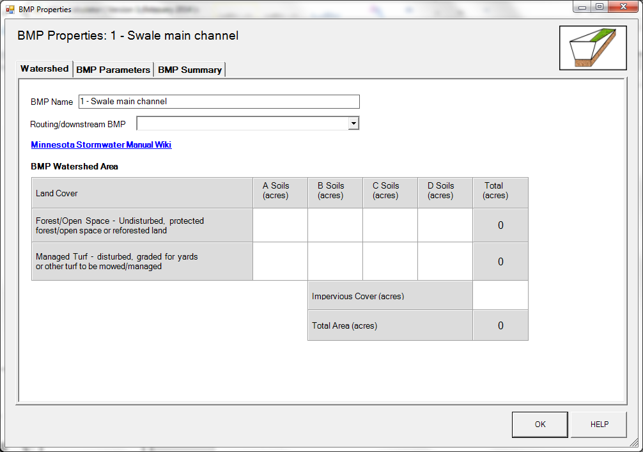

BMP watershed area parameters

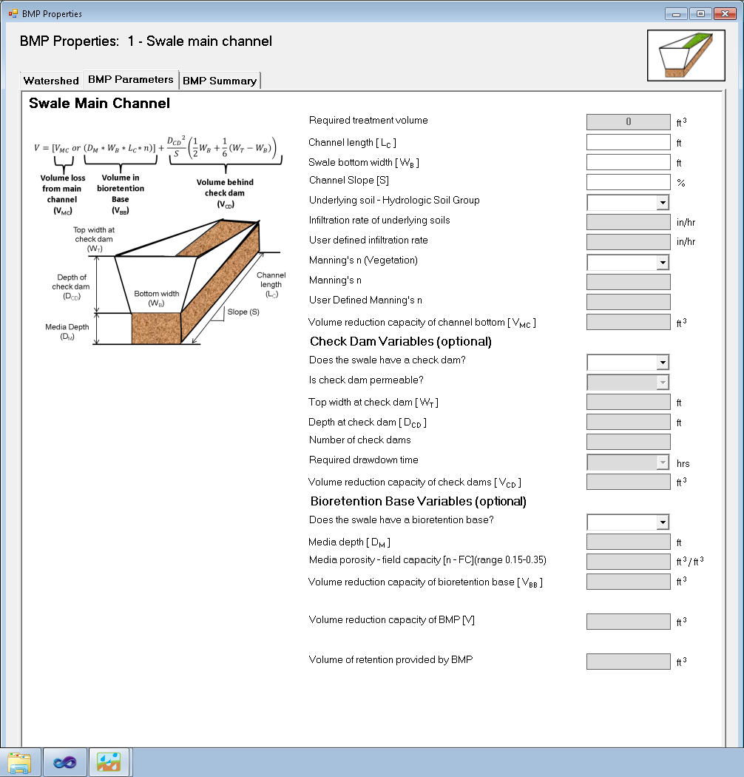

Screen shot from MIDS calculator showing user inputs needed for a Swale Main Channel BMP.

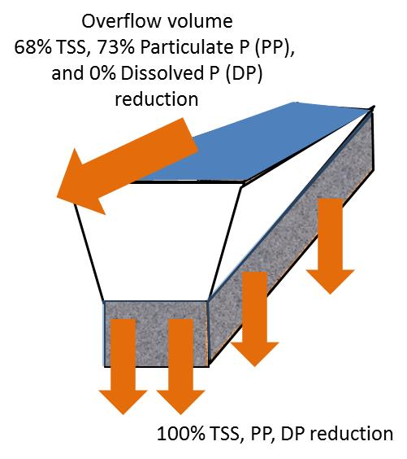

Schematic showing pollutant load reductions for infiltrated and overflow water