**REPORT FOR OBJ1.TASK 2: USE OF TREES AND URBAN FORESTS FOR STORMWATER MANAGEMENT**

To: MPCA

From: The Kestrel Design Group Team (The Kestrel Design Group Inc, with Dr. William Hunt, PE and Ryan Winston, PE - North Carolina State University)

Date: October 16, 2013

Re: Contract CR5332

**TASK 2 SCOPE**

**Obj1.Task 2: Use of Trees and Urban Forests for Stormwater management:**

Prepare a report, including graphics, summarizing the use of urban forestry and trees for stormwater management in urban land use settings.

* 1. Review existing literature on the use of urban forestry and trees for stormwater management in urban land use settings. The review shall include but not be limited to the following:
     1. General concepts of urban forestry and use of trees for stormwater management (e.g. what is urban forestry, how do trees function as stormwater BMPs, etc. See <http://www.fs.fed.us/ucf/> for examples of general information on urban forestry and use of trees as stormwater BMPs);
     2. Benefits of trees and urban forestry for stormwater management, including a range of volume reduction and pollutant removal (phosphorus and total suspended solids) for tree BMPs;
     3. Constraints on the use of trees, including maintenance considerations; seasonal effects, including effects of leaf letter; and the need for additional BMPs, such as street sweeping, to alleviate potential pollutant loading concerns;
     4. A discussion of the applicability of tree BMPs when site constraints exist; and
     5. Non-stormwater benefits associated with use of trees as BMPs, such as effects of trees on air quality, aesthetics, and carbon sequestration.

The review shall include a discussion of the following factors:

1. Different variations for tree BMPs, such as tree boxes and tree trenches;
2. Types of trees appropriate for different ecoregions in Minnesota, including native and non-native deciduous and coniferous species; and
3. Factors affecting tree stormwater performance, such as salt, high temperatures, vehicle exhaust, and drought tolerance.
   1. Prepare and submit a Technical memo summarizing the findings of the literature review.
   2. Prepare and submit a final report describing the use of trees and urban forestry for stormwater management. Include graphics, references to relevant recent literature, and links to relevant documents, organizations, and research.

**LIST of FIGURES**

Figure 2.1 Plant Hardiness Zone Map for Minnesota

Figure 2.2: Causes of Stress on Trees

**REPORT**

* + 1. **General concepts of urban forestry and use of trees for stormwater management (e.g. what is urban forestry, how do trees function as stormwater BMPs, etc. See** [**http://www.fs.fed.us/ucf/**](http://www.fs.fed.us/ucf/) **for examples of general information on urban forestry and use of trees as stormwater BMPs);**

“The term urban forest refers to all publicly and privately owned trees within an urban area— including individual trees along streets and in backyards, as well as stands of remnant forest (Nowak et al. 2001). Urban forests are an integral part of community ecosystems, whose numerous elements (such as people, animals, buildings, infrastructure, water, and air) interact to significantly affect the quality of urban life. (Nowak et al 2010 Sustaining America’s Urban Trees and Forests)

Trees are already part of virtually all development and can be integrated even into the densest urban areas. Many cities already have tree requirement ordinances. However, the potential of these trees to provide significant stormwater benefits is largely untapped to date.

See Task 13 report for stormwater benefits. See remainder of this report for general concepts and non-stormwater benefits of urban trees.

* + 1. **Benefits of trees and urban forestry for stormwater management, including a range of volume reduction and pollutant removal (phosphorus and total suspended solids) for tree BMPs;**

See “REPORT FOR OBJ1.TASKS 2 and 13: WATER QUALITY BENEFITS OF TREES AND URBAN FORESTS FOR STORMWATER MANAGEMENT” and REPORT FOR OBJ1. 13: STORMWATER VOLUME BENEFITS OF TREES”

* + 1. **Constraints on the use of trees, including maintenance considerations; seasonal effects, including effects of leaf litter; and the need for additional BMPs, such as street sweeping, to alleviate potential pollutant loading concerns;**

Potential constraints on the use of urban trees for stormwater management include:

* Above ground space limitations such as utilities, lighting, signs, structures.
* Below ground space limitations such as structures, pavement, existing trees, and utilities.
* Regulations regarding types and locations of trees planted along public streets and right of ways, such as, for example, minimum sight distances and setbacks from street corners.
* Need to locate trees outside of snow plow paths and snow storage areas.

While engineers often worry that tree roots will affect underdrains, inspections of underdrains in hundreds of bioretention practices by North Carolina State Engineers did not find roots clogging underdrains (Winston, 2013).

Additional information:

* See “Factors affecting tree stormwater performance, such as salt, high temperatures, vehicle exhaust, and drought tolerance” below for constraints that affect tree growth and health.
* See Task 10 for report on street sweeping, effects of leaf litter, and street sweeping
* See Task 7 for maintenance guidelines.
  + 1. **A discussion of the applicability of tree BMPs when site constraints exist;**
* See Task 10, Street sweeping
* See “Different variations for tree BMPs, such as tree boxes and tree trenches;” for techniques to extend rootable soil volume under pavement in areas dominated by impervious area, with limited open space.
* Where overhead utilities restrict tree growth, tailor species to available space.
  + 1. **Non-stormwater benefits associated with use of trees as BMPs, such as effects of trees on air quality, aesthetics, and carbon sequestration.**

Like most stormwater BMP’s, trees provide a host of other benefits, in addition to stormwater, including other environmental benefits, energy savings, social and health benefits, wildlife benefits, and economic benefits.

**Environmental Benefits**

***Cleaner air:***

• “Modest increases of 10% canopy cover in the New York City Area were shown to reduce peak

ozone levels by up to 4 parts per billion or by nearly 3% of the maximum and 37% of the amount

by which the area exceeded its air quality standard. Similar results were found in Los Angeles and along the East Coast from Baltimore to Boston (Luley and Nowak 2004 in USDA Forest Service 2004).”

• “Annual benefits provided by parking lot trees in Sacramento, California, (8.1% tree shade) were

valued at approximately $700,000 for improved air quality. By increasing shade to 50% in all

parking lots in Sacramento, the annual benefits will increase to $4 million” (McPherson 2001 in USDA Forest Service 2004).

***Reduction of the urban heat island effect***

***Cools cars in parking lots on hot days***

• “Trees in Davis, California, parking lots reduced asphalt temperatures by as much as 36 degrees Fahrenheit, and car interior temperatures by over 47 degrees Fahrenheit” (Scott et al 1999 in USDA Forest Service 2004).

***Carbon sequestration***

• “Philadelphia's 2.1 million trees currently store approximately 481,000 metric tons of carbon with an estimated value of $9.8 million” (Nowak et al 2003 in USDA Forest Service 2004).

***Reduced Pavement Maintenance Needs***

• Tree shade has been correlated with better pavement performance, which translates into reduced pavement maintenance costs, and increased pavement durability (McPherson and Muchnick 2005).

***Reduce noise pollution by absorbing sound***

• “Trees reduce noise pollution by absorbing sounds. A belt of trees 98 feet wide and 49 feet tall can reduce highway noise by 6 to 10 decibels” (New Jersey Forest Service, undated in USDA Forest Service 2004)

**Wildlife Habitat**

Trees are crucial to wildlife. The Oaks genus, for example, one of the most valuable for wildlife, supports 534 species of Lepidoptera (a large order of insects that includes moths and butterflies) (Talamy and Darke 2007 p. 147), as well as many bird species.

**Energy Benefits**

Strategically placed trees can reduce building cooling and heating energy use. For example:

• “The net cooling effect of a young, healthy tree is equivalent to 10 room-size air conditioners

operating 20 hours a day” (The National Arbor Day Foundation 2004 in USDA Forest Service 2004).

• “Trees properly placed around buildings as windbreaks can save up to 25% on winter heating costs” (Heisler 1986 in USDA Forest Service 2004).

• “As few as three trees properly positioned can save the average household between $100 and $250

annually in energy costs” (U.S. Department of Energy 2003 in USDA Forest Service 2004).

• “Fifty million shade trees planted in strategic, energy-saving locations could eliminate the need for

seven 100-megawatt power plants” (McPherson and Simpson 2003 in USDA Forest Service 2004).

• “Shade from two large trees on the west side of a house and one on the east side can save up to 30% of a typical residence’s annual air conditioning costs” (Simpson and McPherson 1996 in USDA Forest Service 2004).

• “Rows of trees reduce windspeed by up to about 85%, with maximum reductions increasing in

proportion to visual density. Because even a single row of dense conifers can cause large

reductions in windspeed, effective windbreaks can be planted on relatively small house lots.

Compared with an open area, a good windbreak that does not shade the house will save about

15% of the heat energy used in a typical home” (Heisler 1990 in USDA Forest Service 2004).

**Social Benefits**

• “Views of nature reduce the stress response of both body and mind when stressors of urban

conditions are present” (Parsons et al 1998 in USDA Forest Service 2004).

• “Trees in urban parks and recreation areas are estimated to improve outdoor leisure and recreation

experiences in the United States by $2 billion per year” (Dwyer et al 1989 in USDA Forest Service 2004).

• “Trees reduce crime. Apartment buildings with high levels of greenery had 52% fewer crimes than

those without any trees. Buildings with medium amounts of greenery had 42% fewer crimes” (Kuo and Sullivan 2001 in USDA Forest Service 2004).

• “Hospital patients recovering from surgery who had a view of a grove of trees through their

windows required fewer pain relievers, experienced fewer complications, and left the hospital

sooner than similar patients who had a view of a brick wall” (Ulrich 1984 and Ulrich 1985 in USDA Forest Service 2004).

• “Americans travel about 2.3 billion miles per day on urban freeways and highways. Studies show

drivers exposed to roadside nature scenes had a greater ability to cope with driving stresses” (Wolf 2000 in USDA Forest Service 2004).

• “Symptoms of Attention Deficit Hyperactivity Disorder (ADHD) in children are relieved after contact

with nature. Specifically, ADHD kids are better able to concentrate, complete tasks, and follow

directions after playing in natural settings. The greener the setting, the more relief” (Taylor et al 2001 in USDA Forest Service 2004).

• “Trees help girls succeed. On average, the greener a girl’s view from home, the better she

concentrates and the better her self-discipline, enabling her to make more thoughtful choices and

do better in school” (Taylor et al 2002 in USDA Forest Service 2004).

• “Trees and forests in urban areas convey serenity and beauty along a number of sensory

dimensions, often surrounding the individual with nature in an environment where natural things

are at a premium” (Dwyer et al 1991 in USDA Forest Service 2004).

• Streets with trees are safer because trees reduce traffic speeds and drivers seeing natural roadside views show lower levels of stress and frustration compared to those viewing all-built settings (Wolf 2010).

**Economic Benefits**

• “Shoppers in well-landscaped business districts are willing to pay more for parking and up to 12% more for goods and services” (Wolf 1999 in USDA Forest Service 2004).

• “Landscaping, especially with trees, can significantly increase property values” (Neely 1988 in USDA Forest Service 2004).

• “Desk workers with and without views of nature were surveyed. Those without views of nature, when asked about 11 different ailments, claimed 23% more incidence of illness in the prior 6 months” (Kaplan and Kaplan 1989 in USDA Forest Service 2004).

• “Amenity and comfort ratings were about 80% higher for a tree-lined sidewalk compared with those for a nonshaded street” (Wolf 1998 in USDA Forest Service 2004).

• “Quality of products ratings were 30% higher in districts having trees over those with barren sidewalks” (Wolf 1998 in USDA Forest Service 2004).

**Monetary Costs and Benefits of Street Trees in Minneapolis**

McPherson et al (2005) quantified lifecycle benefits and costs of urban trees in Minneapolis based on a sample size of 198,633 actively managed street trees, and found that the benefits of the ecosystems provided by trees significantly outweigh their costs:

* “Minneapolis’s municipal trees are a valuable asset, providing approximately $25 million ($125 per tree) in gross annual benefits.”
* “After costs are taken into account, Minneapolis’s municipal tree resource provides approximately $15.7 million SE $1.8 million), or $79 per tree in total net annual benefits to the community.”

**Resources about Tree Benefits**

Many publications have been written about the benefits of trees, and many of these have quantified tree benefits. Example publications about non-stormwater tree benefits, include, for example:

McPherson, E.G., J.R. Simpson, P.J. Peper, S.E. Maco, S.L. Gardner, S.K. Cozad, and Q. Xiao. 2005. City of Minneapolis, Minnesota Municipal Tree Resource Analysis. Center for Urban Forest Research. USDA Forest Service, Pacific Southwest Research Station.

McPherson, E. G.; Simpson, J. R.; Peper, P. J.; Maco, S. E.; Gardner, S. L.; Cozad, S. K.; Xiao, Q. (2006). Midwest Community Tree Guide: Benefits, Costs and Strategic Planting PSW-GTR-199. USDA Forest Service, Pacific Southwest Research Station, Albany, CA.

Dr. Kathleen Wolf ‘s publications of the value of trees available on 11/09/2012 at <http://www.naturewithin.info/>

USDA Forest Service NA-IN-02-04. 2004. Urban and Community Forestry Appreciation Tool Kit, downloaded 11/09/2012 from http://www.dvrpc.org/green/pdf/ValueofTreesStatsSheet.pdf

Tools available to quantify tree benefits include, for example:

i-tree calculators, available 11/09/2012 from <http://www.itreetools.org/>

**Discussion of the following factors:**

1. **Different variations for tree BMPs, such as tree boxes and tree trenches;**

Many different types of tree BMP’s exist. The most prevalent types are described below.

**Tree Preservation**

Where existing trees exist, tree preservation is highly recommended, as existing trees are typically bigger than newly planted trees, and bigger trees provide significantly more benefits than smaller trees (see Task 2, tree stormwater benefits).

**Incorporating Trees into Traditional Bioretention Practices**

Incorporating Trees into Traditional Bioretention Practices is also highly recommended (see Task 2 for tree stormwater and non-stormwater benefits).

Accordingly, North Carolina’s bioretention standards recommend incorporating trees in all bioretention practices except for grassed cells: “A minimum of one (1) tree, three (3) shrubs, and three (3) herbaceous species should be incorporated in the bioretention planting plan unless it is a grassed cell. A diverse plant community is necessary to avoid susceptibility to insects and disease.”

**Techniques for Providing Uncompacted Soil Volume for Tree Growth and Stormwater Management Under Paved Surfaces.**

Where there is not enough open space for traditional bioretention, several techniques exist to protect soil volume under pavement from traffic compaction so that this soil can be used both for bioretention and tree root growth. Examples of these techniques include:

1. Structural cells
2. Rock based structural soil
3. Sand based structural soil
4. Soil boxes

See Task 5 for more information on each of the above Techniques for Providing Uncompacted Soil Volume for Tree Growth and Stormwater Management Under Paved Surfaces.

1. **Types of trees appropriate for different ecoregions in Minnesota, including native and non-native deciduous and coniferous species; and**

* See Task 3 for a sampling of tree species appropriate for stormwater management in Minnesota.
* Many other tree species and cultivars, in addition to those listed in Task 3, are available for stormwater management. Consult with a local arborist, horticulturist or landscape architect for more guidance on species selection. Many books, websites also provide additional guidance regarding tree species and cultivars, including, for example:
* Minnesota Department of Transportation’s Plant Selector, available 08/2013 at <http://dotapp7.dot.state.mn.us/plant/>
* USDA Plant Selector, available 08/2013 at <http://plants.usda.gov/java/>
* Bassuk, Nina, Deanna F. Curtis, BZ Marranca, Barb Neal. 2006. RECOMMENDED URBAN TREES: Site Assessment and Tree Selection for Stress Tolerance. Urban Horticulture Institute Cornell University, Ithaca, New York. Available August 2013 from <http://www.hort.cornell.edu/uhi/outreach/recurbtree/pdfs/~recurbtrees.pdf>
* Cappiella, Karen, Tom Schueler, Jennifer Tomlinson, and Tiffany Wright. 2006. Urban Watershed Forestry Manual. Part 3. Urban Tree Planting Guide.Third in a Three-Part Manual Series on Using Trees to Protect and Restore Urban Watersheds. Prepared for and published by: United States Department of Agriculture Forest Service Northeastern Area State and Private Forestry. Available August 2013 from <http://www.na.fs.fed.us/pubs/uf/watershed3/urban_watershed_forestry_manual_part3.pdf>
* Shaw, D. and R. Schmidt. 2003. Plants for Stormwater Design: Species Selection for the Upper Midwest. Minnesota Pollution Control Agency (MPCA).
* Species lists developed specifically for Minnesota by the University of Minnesota Extension Service:
* Johnson, Gary R. University of Minnesota Extension Service, Urban and Community Forestry; and Katie M. Himanga, Heartwood Forestry. 2009. Technical Adviser: Gerald L. Jensen, Minnesota Department of Natural Resources, Division of Forestry. Reviewed and updated (2009): Gary R. Johnson, University of Minnesota Extension Service, Urban and Community Forestry. Recommended Trees for Southeast Minnesota: An Ecosystem Approach. Downloaded 08/2013 from http://www.extension.umn.edu/distribution/naturalresources/dd6574.html
* Johnson, Gary R., University of Minnesota Extension Service, Urban and Community Forestry; Katie M. Himanga, Heartwood Forestry.Technical Adviser: Gerald L. Jensen, Minnesota Department of Natural Resources, Division of Forestry. Reviewed and updated (2009): Liam McClannahan, University of Minnesota Extension Service, Forest Resources. Recommended Trees for Southwest Minnesota: An Ecosystem Approach. Downloaded 08/2013 from http://www.extension.umn.edu/distribution/naturalresources/DD6575.html
* Johnson, Gary R., University of Minnesota Extension Service, Urban and Community Forestry; Peter Bedker, Treescapes-Community Forestry Consultants. Technical Adviser: Gerald L. Jensen, Minnesota Department of Natural Resources, Division of Forestry. Reviewed and updated (2009): Adam Flett, University of Minnesota Extension Service, Forest Resources. Recommended Trees for Northern Tallgrass Prairie: An Ecosystem Approach. Downloaded 08/2013 from http://www1.extension.umn.edu/garden/yard-garden/trees-shrubs/recommended-trees-for-minnesota/northern-tallgrass-prairie/
* Johnson, Gary R., University of Minnesota Extension Service, Urban and Community Forestry; and Peter Bedker, Treescapes-Community Forestry Consultants. Technical Adviser: Gerald L. Jensen, Minnesota Department of Natural Resources, Division of Forestry Reviewed and updated (2009): Gary R. Johnson, University of Minnesota Extension Service, Urban and Community Forestry. Recommended Trees for Northwest and Central Minnesota: An Ecosystem Approach. Downloaded 08/2013 from http://www.extension.umn.edu/distribution/naturalresources/DD6945.html
* Choose species suited to site conditions and regulations, and project goals. Consider, for example:
* How often/how long the site will be dry
* Flooding depth and duration
* Soil salt and salt spray exposure
* Tolerance to atmospheric pollutants
* Tolerance of compacted soils
* Tolerance to stormwater pollutants expected at the site
* Temperature hardiness (see Figure 2.1 for USDA hardiness zones in Minnesota),
* Soil type and pH
* Ability to withstand wind and wind storms
* Growth rate
* Volume of rootable soil available
* Overhead spatial constraints
* Restrictions on views (eg storefronts)
* Desired sightlines
* Wind and sun exposure, including microclimatic conditions like, for example, wind tunnels and extreme sun exposure from reflection from large glass windows in urban areas.
* Available maintenance vs. tree maintenance needs and tree tolerance for pruning.

Native species are generally best adapted to local conditions, require low maintenance, and are most beneficial for local wildlife. However, especially in urban conditions, well-adapted, hardy non-native species may be desired if they are not invasive.

Maximizing species diversity is recommended to maximize resilience of the urban forest, and to minimize mortality from species specific insect or disease outbreaks such as, for example, Dutch Elm disease or Emerald Ash borer.

* See Task 13 for literature search on tree related factors that affect magnitude of interception and evapotranspiration.

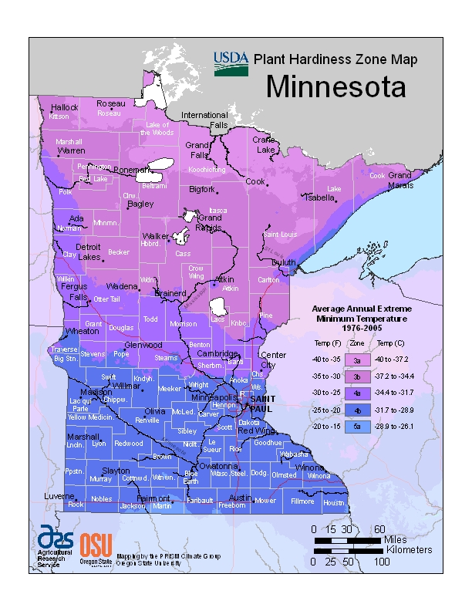

Figure 2.1 Plant Hardiness Zone Map for Minnesota ( from http://planthardiness.ars.usda.gov/PHZMWeb/Default.aspx#)

1. **Factors affecting tree stormwater performance, such as salt, high temperatures, vehicle exhaust, and drought tolerance.**

**Adequate Rootable Soil Volume**

According to Coder (2007), by far the most important factor to grow healthy trees is to provide an adequate volume of rootable (i.e. not compacted to a level that affects root growth, see Objective 2 Task 6 for root limiting compaction) soil, to allow for adequate air, water and drainage. He writes:

“There are many environmental constraints on tree survival and growth. All limitations for

trees have impacts on daily and seasonal growth which can be measured and prioritized. Many people become obsessed by small constraints on trees while major life-altering impacts are ignored. Soil compaction is one of those major problems causing significant tree stress and strain, and whose impacts are usually blamed on other things. Figure 1 [*2.2 in this report*] shows the individual items causing the greatest growth limitations for tree growth. The top three things (by far!) are soil water availability, soil aeration, and soil drainage -- all three greatly disrupted by site compaction. Drought and soil compaction head the list of major tree growth stress problems [italics added].”

Research has shown that trees need 2 cubic feet of rootable soil volume per square foot of tree canopy to thrive (e.g. Lindsey and Bassuk 1991). Most urban trees, confined to a 4’ x 4’ (i.e. 64 c.f. if assumed to be 4’ deep) tree pit hole, have less than 1/10th the rooting volume they need to thrive. To provide 2 c.f. of rootable soil to allow a tree with a 30’ canopy to thrive would require 1413 c.f. of rootable soil! Not surprisingly, studies have found that trees surrounded by pavement in urban downtown centers only live for an average of 13 years (Skiera and Moll, 1992), a very small fraction of their much longer lifespan under natural conditions.

See “Different variations for tree BMPs, such as tree boxes and tree trenches” for techniques to provide trees with adequate rootable soil volumes even in ultra urban areas.

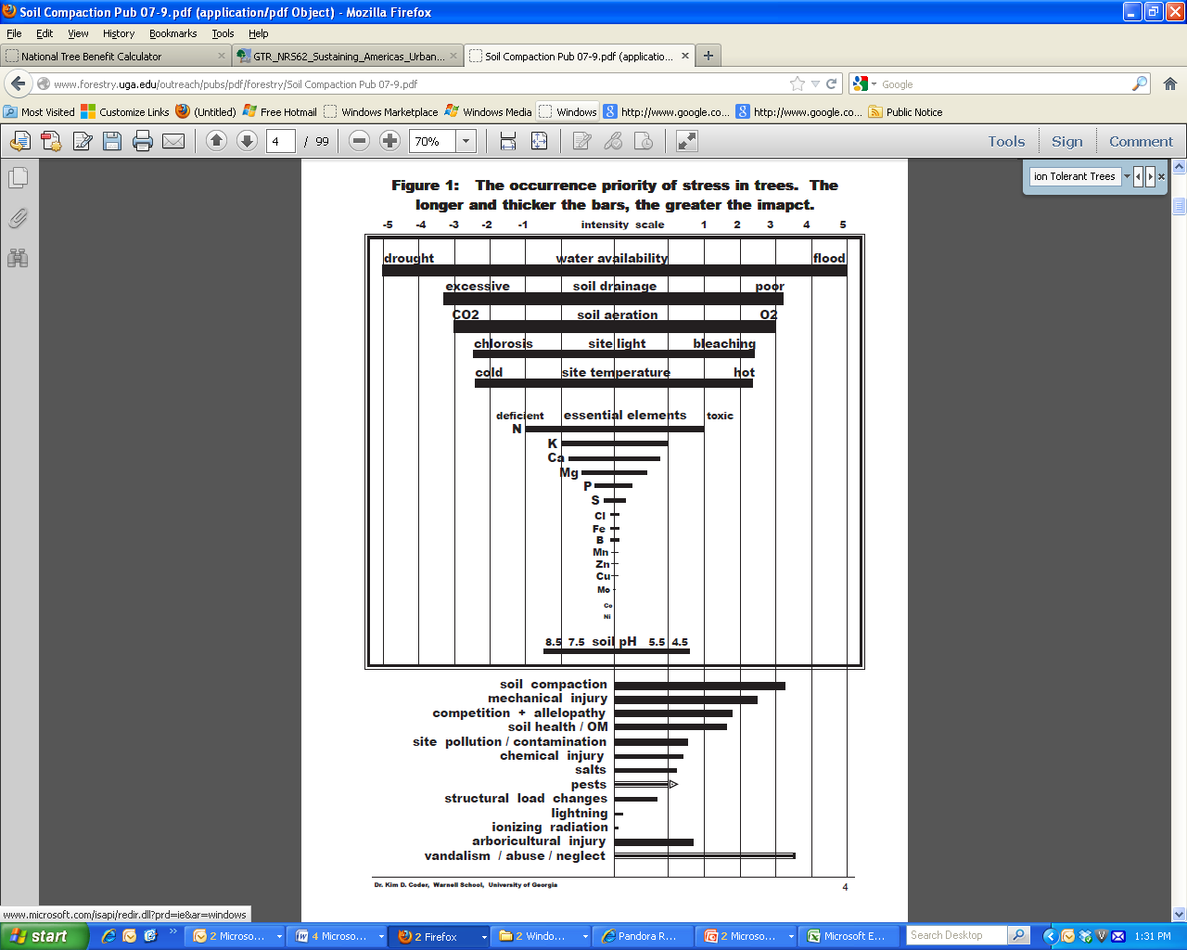

Figure 2.2: Causes of Stress on Trees - the longer and thicker the bar, the greater the stress (Source: Coder 2007)

Figure 2.2 shows various factors that affect tree health as well as their relative impact on tree growth.

**Other factors that affect tree health**

Other factors, besides providing adequate rootable soil volume, that can affect the health of trees used for stormwater management include:

* Exposure to frequent inundation
* Increased temperatures in urban areas, such as, for example, due to the urban heat island effect and re-reflected heat adjacent south-facing skyscraper windows.
* Atmospheric pollution
* Physical damage from vandalism, mowers, and other maintenance
* Soil salt and salt spray exposure
* Droughty conditions in between rain events, particularly if sandy soils are used.

If tree bioretention areas are used for snow storage, compaction from the snow as well as salt from the snow can also negatively affect tree growth.

**Tree Size**

Providing adequate growing conditions to grow large, healthy trees is crucial because stormwater volume benefits provided by large trees are orders of magnitude greater for large trees than for small trees (see Task 13).

**REFERENCES**

Coder, Kim. 2007. Soil Compaction Stress and Trees: Symptoms, Measures, and Treatments. Warnell School Outreach Monograph WSFNR07-9, available August 2013 from <http://www.warnell.uga.edu/outreach/pubs/pdf/forestry/Soil%20Compaction%20Pub%2007-9.pdf>

Dwyer, John F.; Schroeder, Herbert W.; Louviere, Jordan J.; Anderson, Donald H. 1989. Urbanities [sic] Willingness to Pay for Trees and Forests in Recreation Areas. Journal of Arboriculture 15(10).

Dwyer, J. F.; Schroeder, H.W.; Gobster, P. H. 1991. The Significance of Urban Trees and Forests: Toward a Deeper Understanding of Values. Journal of Arboriculture 17(10).

Heisler, G.M. 1986. Energy Savings With Trees. Journal of Arboriculture 12.

Heisler, Gordon M. 1990. Tree plantings that save energy. In: Rodbell, Philip D., ed. Proceedings of the Fourth Urban Forestry Conference; 1989 October 15-19; St. Louis, MO.Washington, DC: American Forestry Association.

Kaplan, R.; Kaplan, S. 1989. The Experience of Nature: A Psychological Perspective. Cambridge, MA: Cambridge University Press.

Kuo, F.; Sullivan,W. 2001. Environment and Crime in the Inner City: Does Vegetation Reduce Crime? Environment and Behavior 33(3).

Lindsey, P. and N. Bassuk. 1991. Specifying Soil Volumes to Meet the Water Needs of Mature Urban Street Trees and Trees in Containers. Journal of Arboriculture 17(6): 141-149.

Luley, Christopher J. and David J. Nowak. 2004. Help Clear the Smog with Your Urban Forest: What You and Your Urban Forest Can Do About Ozone. Brochure. Davey Research Group and USDA Forest Service, Northeastern Research Station.

Nowak, David J.; Stein, Susan M.; Randler, Paula B.; Greenfi eld, Eric J.; Comas, Sara J.; Carr, Mary A.;

Alig, Ralph J. 2010. Sustaining America’s urban trees and forests: a Forests on the Edge report.

Gen. Tech. Rep. NRS-62. Newtown Square, PA: U.S. Department of Agriculture, Forest Service,

Northern Research Station. 27 p. available August 2013 from http://www.fs.fed.us/openspace/fote/reports/nrs-62_sustaining_americas_urban.pdf

McPherson, E.G. 2001. Sacramento's Parking Lot Shading Ordinance: Environmental and Economic Costs of Compliance. Landscape and Urban Planning 57.

McPherson, E.G.; Simpson, J.R. 2003. Potential Energy Savings in Buildings by an Urban Tree Planting Program in California. Urban Greening 2(2003).

McPherson, E. G. and J. Muchnick. 2005. Effects of Street Tree Shade on Asphalt Concrete

Pavement Performance. Journal of Arboriculture 31, 6, 303-309

Neely, D., ed. 1988. Valuation of Landscape Trees, Shrubs, and Other Plants, 7th ed. Council of Tree and Landscape Appraisers, International Society of Arboriculture.

Nowak, D.; Crane, D.; Stevens, J. 2003. Draft Plan. Philadelphia’s Urban Forest, Urban Forest Effects Model (UFORE) Analysis. Newtown Square, PA: USDA Forest Service, Northeastern Research Station.

Parsons, R.; Tassinary, L.G.; Ulrich, R.S.; Hebl, M.R.; Grossman-Alexander, M. 1998. The View From the Road: Implications for Stress Recovery and Immunization. Journal of Environmental Psychology 18(2).

Scott, Klaus I.; Simpson, James R.; McPherson, E. Gregory. 1999. Effects of Tree Cover on Parking Lot Microclimate and Vehicle Emissions. Journal of Arboriculture 25(3).

Simpson, J.R.; McPherson, E.G. 1996. Potential of Tree Shade for Reducing Residential Energy use in California. Journal of Arboriculture 22(1).

Tallamy, Douglas W. and Rick Darke. 2007. Bringing Nature Home: How You Can Sustain Wildlife with Native Plants. Timber Press.

Taylor, A.F.; Kuo, F.; Sullivan,W. 2001. Coping with ADD: The Surprising Connection to Green Play Settings. Environment and Behavior 33(1).

Taylor, Andrea Faber; Kuo, Frances E.; Sullivan, William C. 2002. Views of Nature and Self-Discipline: Evidence from Inner City Children. Journal of Environmental Psychology 22(1-2).

The National Arbor Day Foundation. 2004. The value of trees to a community. www.arborday.org/trees/Benefits.cfm (January 12).

Ulrich, R. 1984. View through Window May Influence Recovery from Surgery. Science 224.

Ulrich, R.S. 1985. Human Responses to Vegetation and Landscapes. Landscape and Urban Planning 13.

USDA Forest Service. The Value of Trees. Urban and Community Forestry Appreciation Tool Kit

NA-IN-02-04. Available August 2013 from <http://www.dvrpc.org/green/pdf/ValueofTreesStatsSheet.pdf>

U.S. Department of Energy. 2003. Energy Savers, Tips on Saving Money and Energy at Home. Energy Efficiency and Renewable Energy Clearinghouse.

Winston, Ryan. 2013. Personal Communication.

Wolf, K.L. 2010. Safe Streets - A Literature Review. In: Green Cities: Good Health (www.greenhealth.washington.edu). College of the Environment, University of Washington.

Wolf, Kathy L. 2000. The Calming Effect of Green: Roadside Landscape and Driver Stress. Factsheet #8. Seattle: University of Washington, Center for Urban Horticulture.

Wolf, K. L. 1999. Nature and Commerce: Human Ecology in Business Districts. In: Kollins, C., ed. Building Cities of Green: Proceedings of the 9th National Urban Forest Conference.Washington, DC: American Forests.

Wolf, Kathy L. 1998. Trees in Business Districts: Positive Effects on Consumer Behavior! Fact Sheet #5. Seattle: University of Washington, College of Forest Resources, Center for Urban Horticulture.

**Please Note:**

The Kestrel Design Group (including its employees and agents) assumes no responsibility for consequences resulting from the use of the information herein, or from use of the information obtained at linked Internet addresses, or in any respect for the content of such information, including (but not limited to) errors or omissions, the accuracy or reasonableness of factual or scientific assumptions, studies or conclusions, the defamatory nature of statements, ownership of copyright or other intellectual property rights, and the violation of property, privacy, or personal rights of others. The Kestrel Design Group is not responsible for, and expressly disclaims all liability for, damages of any kind arising out of use, reference to, or reliance on such information. No guarantees or warranties, including (but not limited to) any express or implied warranties of merchantability or fitness for a particular use or purpose, are made by the Kestrel Design Group with respect to such information.

The Kestrel Design Group does not endorse, approve, certify, or control references and Internet links included herein and does not guarantee the availability, accuracy, completeness, efficacy, timeliness, or correct sequencing of information in these references and links. No one should rely on the accuracy, completeness, efficacy, and timeliness of such information. Reference therein to any specific commercial product, process, or service by trade name, trademark, service mark, manufacturer, or otherwise does not constitute or imply endorsement, recommendation, or favoring by the Kestrel Design Group.