- Opening (10 minutes) (Link to guidance )
  - Introductions (name, organization, how you will use the Estimator)
  - Prequisites
    - Downloaded the Estimator workbook
    - Know the basic structure of the Estimator
    - Know the basic functionality of the Estimator
- Problem 1 – drainage is to the lake (45 minutes (25-10-10))
  - Area 1: C and D soils
  - Area 2: A and B soils
  - Area 3: C soils up in watershed; A and B soils in lower watershed
  - Must reduce phosphorus loading by 40 percent
  - Report out
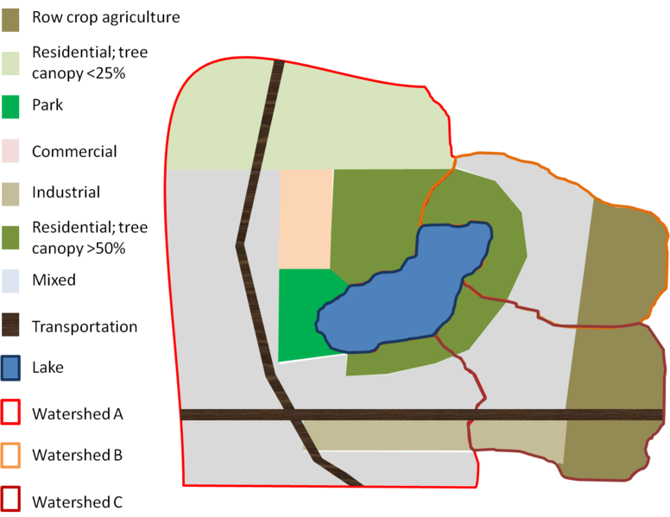
Land use | Acres
 | Area 1 (C/D soils) | Area 2 (A/B soils) | Area 3 (C/d up; B down)
Commercial | 75
Industrial | 80 |  | 110
Multi-use | 975 | 275 | 235
High canopy res | 200 | 200 | 80
Park | 70
Agriculture |  | 220 | 240
Transportation | 75 |  | 60
Low canopy res | 400
- Discussion questions (15 minutes)
  - What practices might result in a change in emc?
  - What practices might result in a change in runoff coefficient?
  - What conditions apply when removal efficiency changes?
  - What conditions apply when fraction treated changes?
  - What conditions apply when fraction infiltrated changes?
  - What practices could be accounted for in Section 2 (Adjusted loads)?
- Problem 2 (45 minutes (25-10-10))
  - Subwatershed A: 300 acres of residential land use on D soils
  - Subwatershed B: The entire area consists of mixed (multi-use) land use, but for calculation purposes we will use a separate worksheet in the Estimator for each of the following
    - 70 acres draining to biofiltration
    - 175 acres draining to underground infiltration
    - 275 acres draining to sand filters
    - 125 acres untreated runoff draining to Pond 1 plus drainage from the biofiltration and infiltration areas
    - 125 acres draining to Pond 2 plus drainage from the sand filter area
    - 175 acres draining to Pond 3 plus drainage from Pond 2
    - 70 acres of direct runoff (untreated)
  - Subwatershed C: 200 acres of ultra-urban land use on C soils (emc = 0.24 mg/L).
  - Must reduce phosphorus loading by 40 percent
  - Report out
