Biofiltration Basin with an underdrain at bottom example (Version 2)

An unlined biofiltration basin with an underdrain at the bottom is to be constructed in a watershed that contains a 1.4 acre parking lot surrounded by 0.8 acres of pervious area (turf area and the bioretention BMP area). All of the runoff from the watershed will be treated by the biofiltration basin. The soils across the area have a unified soils classification of SM (HSG type B soil). The surface overflow is located 1 ft above the media surface. The surface area of the biofiltration basin at the overflow point will be 6534 square feet. The area is 5600 square feet at the media surface. The area at the media-soil interface is 3320 square feet. The total media depth will be 3 feet. The media will be Media Mix C, which is mostly sand resulting in a difference between the media wilting point and field capacity of 0.11 cubic feet per cubic foot and the difference between the media porosity and field capacity is 0.26 cubic feet per cubic foot. The P content of the media is less than 30 mg/kg (milligrams per kilogram) and no soil amendments will be used to attenuate phosphorus. The following steps detail how this system would be set up in the MIDS calculator.

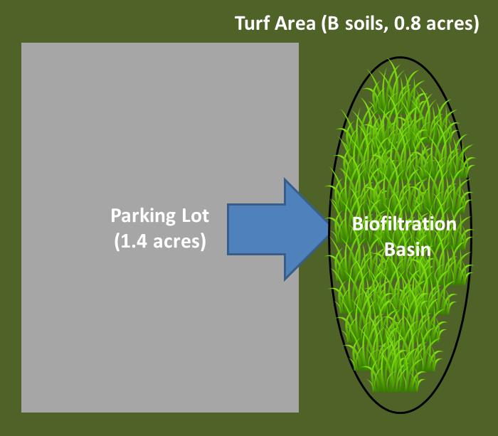
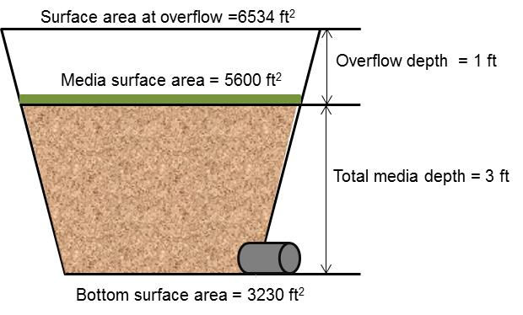
Step 1: Determine the watershed characteristics of your entire site. For this example we have a 2.2 acre site with 1.4 acres of impervious area and 0.8 acres of pervious area in type B soils. The pervious area includes the turf area and the area of the biofiltration basin.

Step 2: Fill in the site specific information into the “Site Information” tab. This includes entering a Zip Code (55414 for this example) and the watershed information from Step 1. The Managed turf area includes the turf area and the area of the bioretention basin. Zip code and impervious area must be filled in or an error message will be generated. Other fields on this screen are optional.
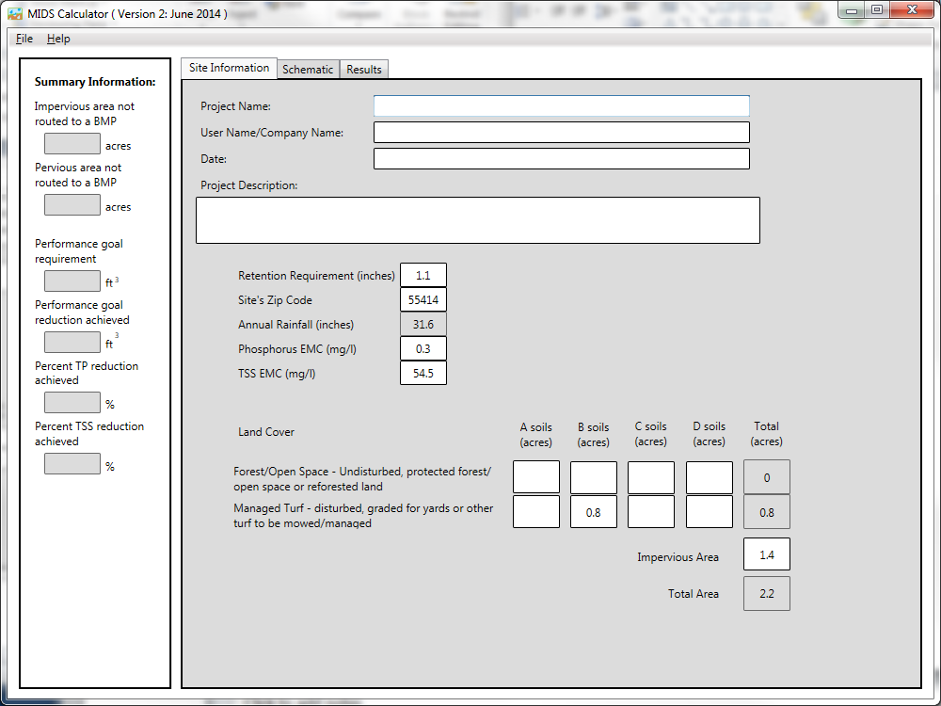

Step 3: Go to the Schematic tab and drag and drop the “Bioretention basin (with underdrain)” icon into the “Schematic Window”
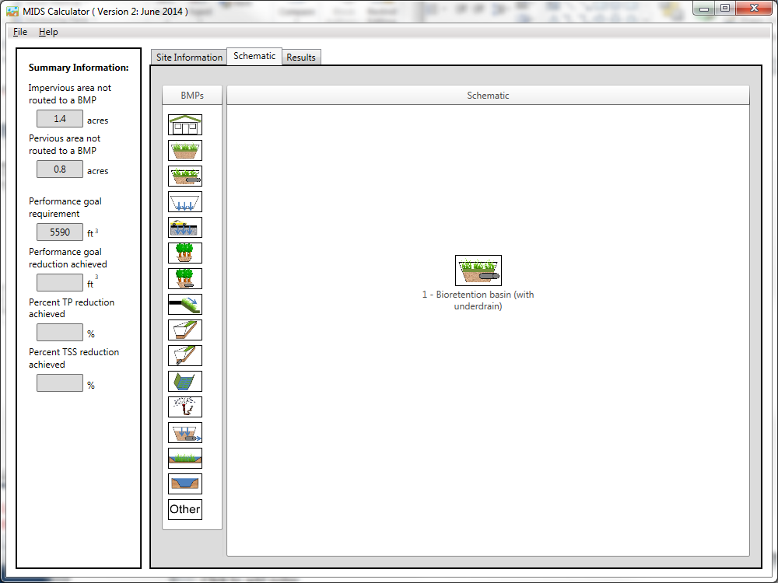
Step 4: Open the BMP properties for the bioretention basin by right clicking on the “Bioretention basin (with underdrain)” icon and selecting “Edit BMP properties”, or by double clicking on the “Bioretention basin (with underdrain)” icon.
Step 5: Click on the “Minnesota Stormwater Manual Wiki” link or the “Help” button to review input parameter specifications and calculation specific to the “Bioretention basin (with underdrain)” BMP.
Step 6: Determine the watershed characteristics for the Bioretention basin. For this example the entire site is draining to the bioretention basin. The watershed parameters therefore include a 2.2 acre site with 1.4 acres of impervious area and 0.8 acres of pervious turf area in type B soils. There is no routing for this BMP. Fill in the BMP specific watershed information (1.4 acres on impervious cover and 0.8 acres of Managed turf in B soils).
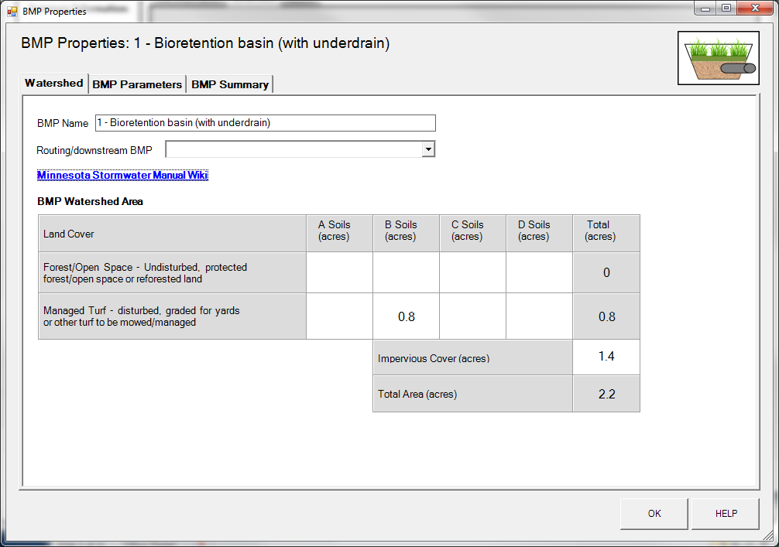

Step 7: Enter in the BMP design parameters into the “BMP parameters” tab. Bioretention basin with an underdrain requires the following entries.
- Is the underdrain elevated above native soils – No;
- Are the sides of the basin lined with an impermeable liner – No;
- Is the bottom of the basin lined with an impermeable liner – No;
- Surface area of overflow which is 6534 square feet;
- Surface area at media surface which is 5600 square feet;
- Bottom surface area (area at media-soil interface) which is 3230 square feet;
- Overflow depth which is 1 foot;
- Total media depth which is 3 feet;
- Media field capacity minus wilting point which is 0.11 cubic feet per cubic foot;
- Media porosity minus field capacity which is 0.26 cubic feet per cubic foot;
- Is a tree(s) planted in the BMP – No;
- Bioretention planting media mix which is Media Mix C;
- Is the P content of the media less than 30 mg/kg which autofills to “Yes” for Media Mix C;
- Is a soil amendment used – No;
- Underlying soil – Hydrologic Soil Group which is SM (HSG B; 0.45 in/hr) from the dropdown box; and
- Required drawdown time (hrs) which is 48 from the dropdown box.

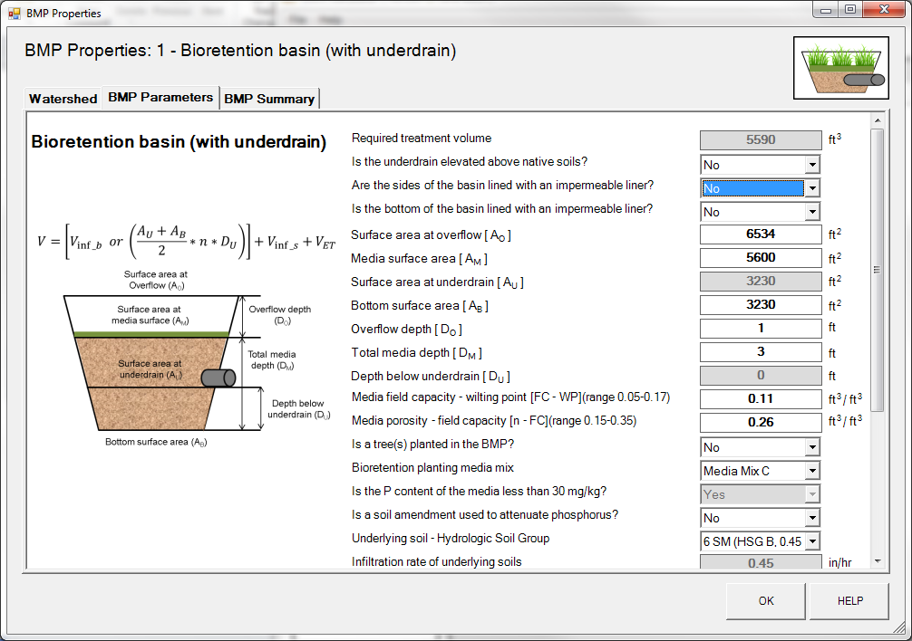
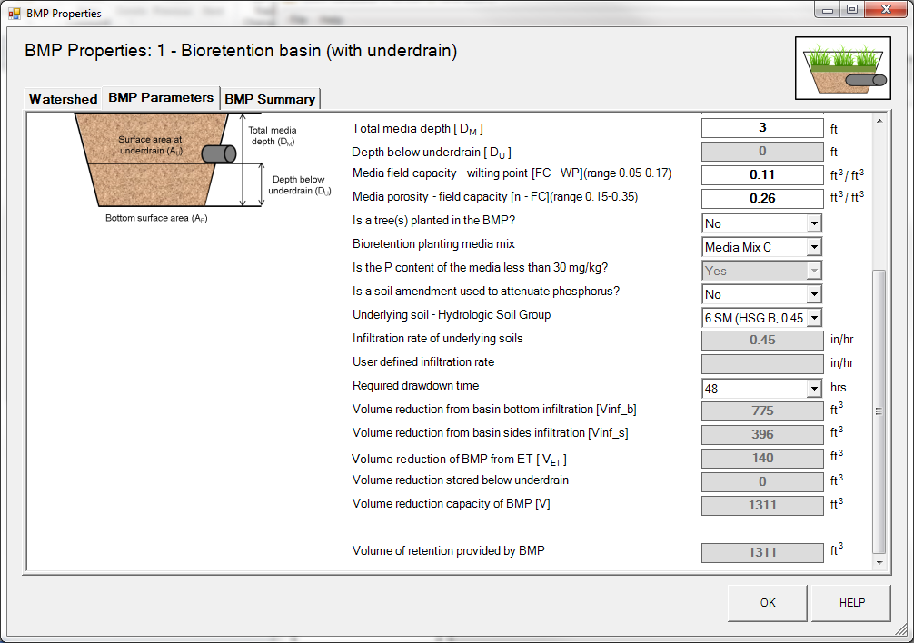
Step 8: Click on “BMP Summary” tab to view results for this BMP.
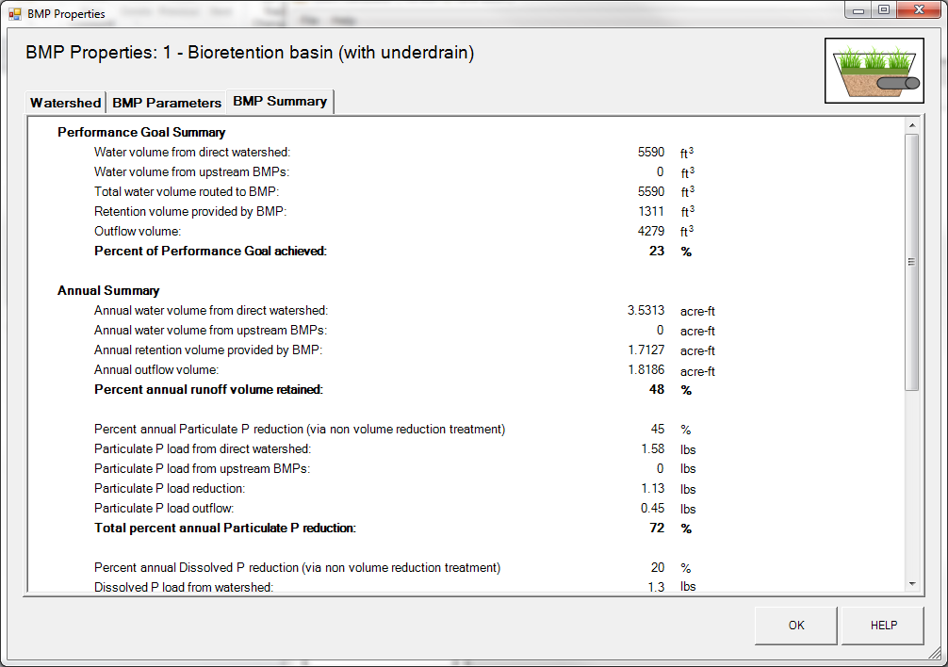
Step 9: Click on the “OK” button to exit the BMP properties screen.
Step 10: Click on “Results” tab to see overall results for the site.
