REPORT FOR OBJ1.TASK 11: FACT SHEET SUMMARY OF URBAN FORESTS MANAGING STORMWATER AS A BMP

To: MPCA
From: The Kestrel Design Group Team (The Kestrel Design Group Inc, with Dr. William Hunt, PE and Ryan Winston, PE - North Carolina State University)
Date: October 15, 2013
Re: Contract CR5332

TASK 11 SCOPE

The fact sheet will include the following sections:
- Overview of the BMP
- Summary of design criteria
- Benefits
- Limitations or constraints
- General description
- Management suitability
- Mechanisms
- Pollutant removal (phosphorus, and total suspended solids)
- Site factors
- Illustrations

LIST of FIGURES

Figure 11.1: Mechanisms Of Tree Stormwater Benefits

FACT SHEET CONTENT

    - Overview of the BMP

Urban tree and soil systems provide water quantity and water quality benefits through stormwater infiltration, filtration, interception, and evaporation, and uptake of pollutants by trees and associated microbes (see Figure 11.1). Trees are already part of virtually all development and can be integrated even into the densest urban areas. Many cities already have tree requirement ordinances. However, the potential of these trees to provide significant stormwater benefits is largely untapped to date. Integrating urban trees into stormwater management systems provides opportunity to provide significant stormwater benefits using elements (trees and soils) that are already part of most sites and developments.

    - Summary of design criteria

- Infiltration requires suitable in situ soils; if soils are not suitable for infiltration, filtration is still possible.
- To provide the maximum benefits and lifespan possible, trees need adequate rootable soil volume (2 cubic feet of soil for every square foot of tree canopy)
- Use impermeable liner as needed to separate tree BMP from road, parking lot, sidewalk or adjacent walls or building foundation.
- A large enough soil infiltration rate should be provided to allow for adequate filtration (and perhaps infiltration) of stormwater. Infiltration rate shall not be so high as to limit tree growth or water quality treatment, however. Soils shall have infiltration rates between 1 and 4 in/hr.
- A typical bioretention soil media may be used in tree filters (link to bioretention soil specification). If a non-standard soil mix is utilized, a maximum of 15% silt and clay and 10% organic matter by volume should be specified.

    - Benefits

See Task 2 ii and v, Task 13

    - Limitations or constraints

See Task 2 iii and 3, Task 13

    - General description

Many different types of urban tree stormwater BMP’s exist. Where existing trees exist, tree preservation is highly recommended, as existing trees are typically bigger than newly planted trees, and bigger trees provide significantly more benefits than smaller trees (see Task 13, credits). Incorporating trees into traditional bioretention practices is also highly recommended.

Street trees, trees in parking lots, trees in urban plazas, as well as any other trees also provide stormwater benefits.

While trees have tremendous potential to provide stormwater benefits, most urban trees do not provide nearly the magnitude of stormwater benefits they are capable of providing given adequate growing conditions. Large trees provide orders of magnitude greater stormwater benefits than small trees, but the average lifespan for urban trees is only 13 years (Skiera and Moll, 1992), so most urban trees do not survive nearly long enough to reach their mature size and provide the magnitude of stormwater benefits they are capable of at maturity.

By far the most important factor to grow healthy trees is to provide an adequate volume of rootable soil, to allow for adequate air, water and drainage (e.g. Coder 2007).

Research has shown that trees need 2 cubic feet of rootable soil volume per square foot of tree canopy area to thrive (e.g. Lindsey and Bassuk 1991). Most urban trees, confined to a 4’ x 4’ (i.e. 64 c.f. if assumed to be 4’ deep) tree pit hole, have less than 1/10th the rooting volume they need to thrive. To provide 2 c.f. of rootable soil to allow a tree with a 30’ canopy to thrive would require 1413 c.f. of rootable soil, 22 times more than the typical 64 c.f.!

Where there is not enough open space to grow large, healthy urban trees, several techniques exist to protect soil volume under pavement from traffic compaction so that this soil can be used both for bioretention and tree root growth. Examples of these techniques include:
- Structural cells
- Rock based structural soil
- Sand based structural soil
- Soil boxes

    - Management suitability

Same as bioretention, can range greatly in size, and can be sized to meet desired goals.

    - Mechanisms

- Infiltration (with appropriate in situ soils)
- Filtration
- Temperature Control
- Settling
- Evaporation
- Interception
- Transpiration
- Soil Adsorption
- Biological/ Micro. Uptake

    - Pollutant removal (phosphorus, and total suspended solids)

See “REPORT FOR OBJ1.TASKS 2 and 13: WATER QUALITY BENEFITS OF TREES AND URBAN FORESTS FOR STORMWATER MANAGEMENT”

    - Site factors

- Drainage Area – same as for bioretention. See Manufacturer’s recommendations for proprietary systems.
- Max. Slope – same as for bioretention. See Manufacturer’s recommendations for proprietary systems.
- Min. Depth to Bedrock and Seasonally High Water Table- same as for bioretention
- SCS Soil Type (can be used in C&D soil types with modifications (e.g. underdrains) – A, B
- Freeze/ Thaw Suitability - Good
- Potential Hotspot Runoff (requires impermeable liner) - Suitable

    - Illustrations

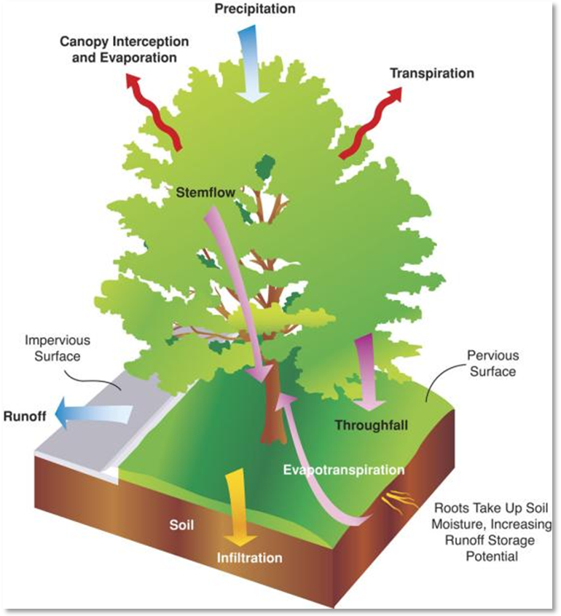

Figure 11.1: Mechanisms Of Tree Stormwater Benefits, created by Mike Thomas, ISA

See also many other illustrations in other tasks

REFERENCES

Coder, Kim. 2007. Soil Compaction Stress and Trees: Symptoms, Measures, and Treatments. Warnell School Outreach Monograph WSFNR07-9, available August 2013 from http://www.warnell.uga.edu/outreach/pubs/pdf/forestry/Soil%20Compaction%20Pub%2007-9.pdf

Lindsey, P; Bassuk, N. (1991). “Specifying Soil Volumes to Meet the Water Needs of Mature Urban Street Trees and Trees in Containers.” J. Arboriculture. 17(6), 141-149.

Skiera, B.; Moll, G. (1992). The Sad State of City Trees. Am. Forests. March/April, 61-64.
Please Note:

The Kestrel Design Group (including its employees and agents) assumes no responsibility for consequences resulting from the use of the information herein, or from use of the information obtained at linked Internet addresses, or in any respect for the content of such information, including (but not limited to) errors or omissions, the accuracy or reasonableness of factual or scientific assumptions, studies or conclusions, the defamatory nature of statements, ownership of copyright or other intellectual property rights, and the violation of property, privacy, or personal rights of others. The Kestrel Design Group is not responsible for, and expressly disclaims all liability for, damages of any kind arising out of use, reference to, or reliance on such information. No guarantees or warranties, including (but not limited to) any express or implied warranties of merchantability or fitness for a particular use or purpose, are made by the Kestrel Design Group with respect to such information.
The Kestrel Design Group does not endorse, approve, certify, or control references and Internet links included herein and does not guarantee the availability, accuracy, completeness, efficacy, timeliness, or correct sequencing of information in these references and links. No one should rely on the accuracy, completeness, efficacy, and timeliness of such information. Reference therein to any specific commercial product, process, or service by trade name, trademark, service mark, manufacturer, or otherwise does not constitute or imply endorsement, recommendation, or favoring by the Kestrel Design Group.

