Permeable Pavement Example (Version 2)

Half of an existing 1.4 acre parking lot is going to be converted to permeable pavement. The entire parking lot (1.4 acres) plus 0.4 acres of pervious area (Turf Area) surrounding the parking lot will drain into the permeable pavement. The soils across the area have a unified soils classification of SM (HSG type B soil). An underdrain will be installed under the permeable pavement 0.5 feet above the native soils. Following the MPCA Construction Stormwater General Permit requirement, the water below the underdrain needs to drawdown in a 48 hour time period. The media below the underdrain has a porosity of 0.4 cubic feet per cubic foot. The following steps detail how this system would be set up in the MIDS calculator.
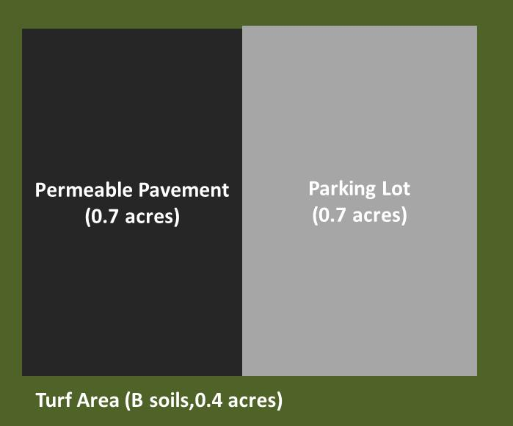
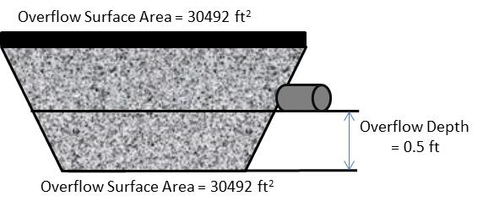
Step 1: Determine the watershed characteristics of your entire site. For this example we have a 1.8 acre site with 1.4 acres of impervious area and 0.4 acres of pervious turf area in type B soils. The impervious area includes the area of parking lot that has permeable pavement.
Step 2: Fill in the site specific information into the “Site Information” tab. This includes entering a Zip Code (55414 for this example) and the watershed information from Step 1. Zip code and impervious area must be filled in or an error message will be generated. Other fields on this screen are optional.
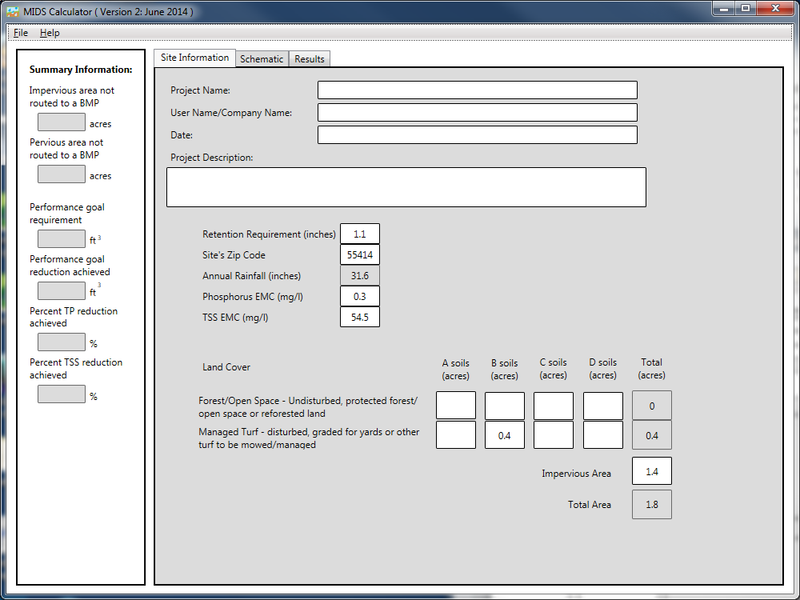
Step 3: Go to the Schematic tab and drag and drop the “Permeable Pavement” icon into the “Schematic Window”
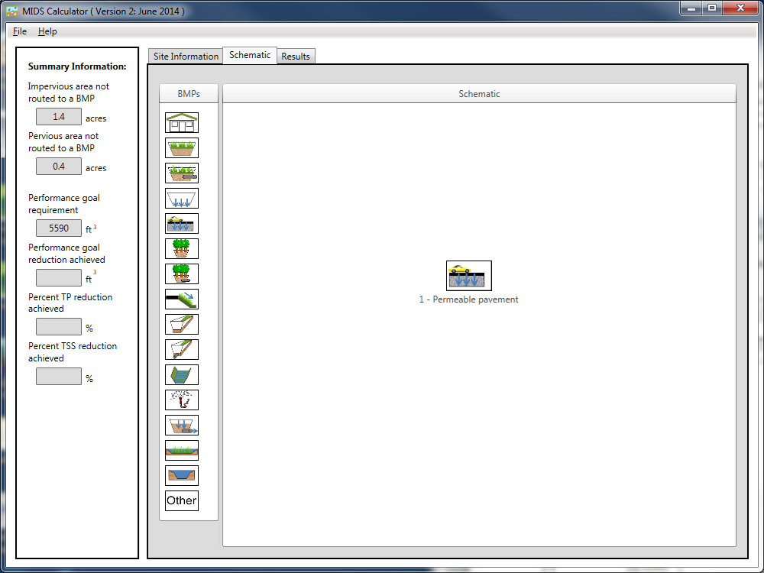

Step 4: Open the BMP properties for the permeable pavement by right clicking on the “Permeable pavement” icon and selecting “Edit BMP properties”, or by double clicking on the “Permeable pavement” icon. Click on the “Watershed” tab.
Step 5: Click on the “Minnesota Stormwater Manual Wiki” link or the “Help” button to review input parameter specifications and calculation specific to the “Permeable pavement” BMP.
Step 6: Determine the watershed characteristics for the permeable pavement. For this example the entire site is draining to the permeable pavement. The watershed parameters therefore include a 1.8 acre site with 1.4 acres of impervious area and 0.4 acres of pervious turf area in B soils. There is no routing for this BMP. Fill in the BMP specific watershed information (1.4 acres on impervious cover and 0.8 acres of Managed turf in B soils).
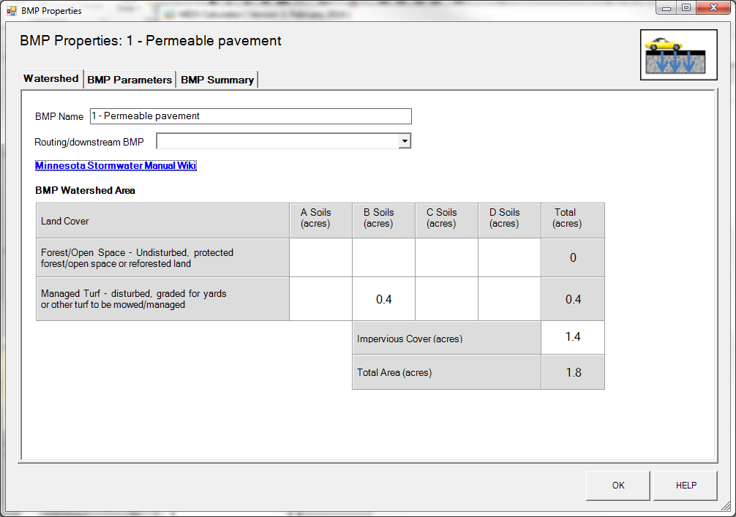

Step 7: Enter in the BMP design parameters into the “BMP parameters” tab. Permeable pavement requires the following entries:
- Surface area at underdrain. This is the area of the BMP, which is therefore the area of the permeable pavement. This area is 0.7 acre or 30492 square feet.
- Bottom surface area, which is the area at the interface between the bottom of the permeable pavement system and the top of the underlying native soils. This area is 30492 square feet.
- The depth below the underdrain is 0.5 feet.
- The media porosity is 0.4 cubic feet per cubic foot.
- Will the soil require compaction – No.
- Underlying soil – Hydrologic Soil Group, which is 6 SM (HSG B, 0.45 in/hr).
- Required drawdown time, which is 48 hours.
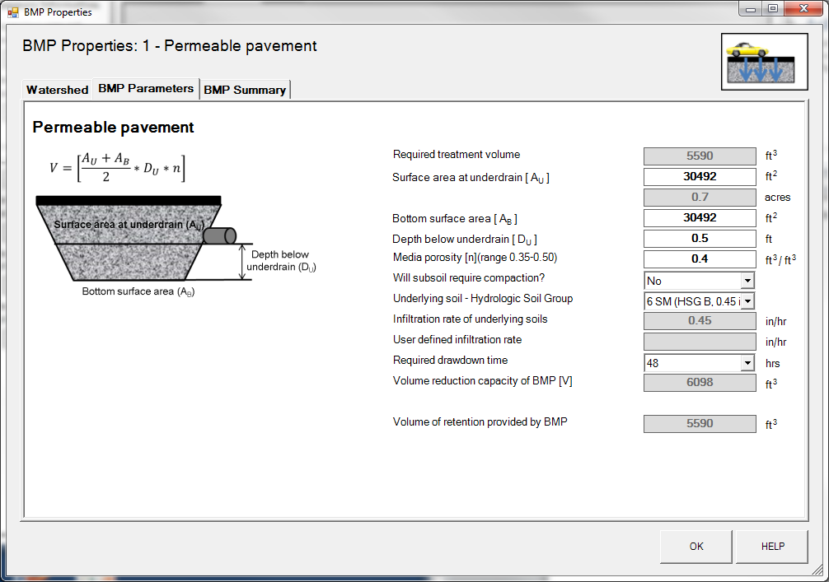

Step 8: Click on “BMP Summary” tab to view results for this BMP.
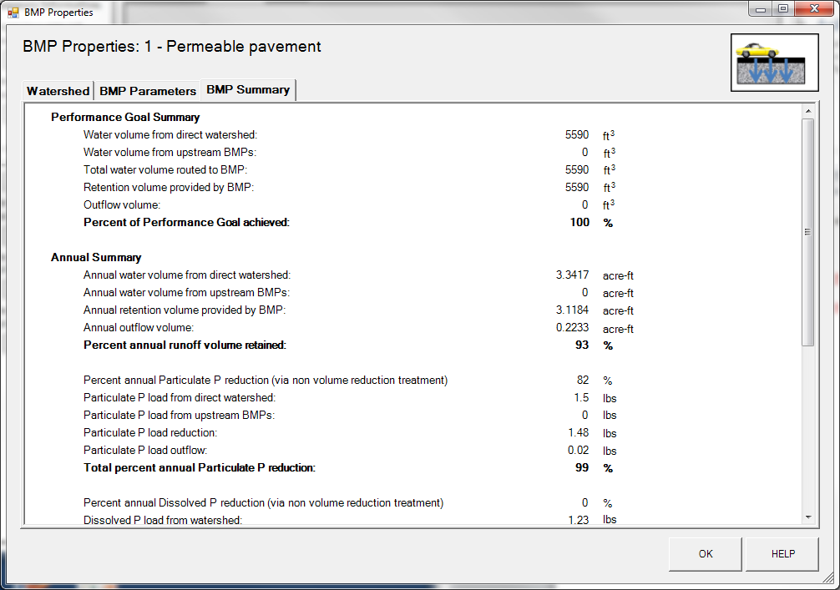
Step 8: Click on the “OK” button to exit the BMP properties screen.

Step 9: Click on “Results” tab to see overall results for the site.
