Memorandum

From: Jeremy Walgrave, PE  Derek Schlea | Date: December 11, 2017
To: Mike Trojan, MPCA | CC: Andy Erickson, HR Green, AES

Subject: Minnesota Stormwater Manual Updates – Stormwater Step Pools

- Stormwater Step Pool Overview Page
  - Brief definition
Stormwater step pools are defined by design features that address higher energy flows due to more dramatic slopes than dry or wet swales. Using a series of pools, riffle grade control, native vegetation and a sand seepage filter bed, flow velocities are reduced, treated, and, where applicable, infiltrated. The physical characteristics of the stormwater step pools are similar to Rosgen A or B stream classification types, where “bedform occurs as a step/pool, cascading channel which often stores large amounts of sediment in the pools associated with debris dams” (Rosgen, 1996). These structures feature surface/subsurface runoff storage seams and an energy dissipation design that is aimed at attenuating the flow to a desired level through energy and hydraulic power equivalency principles (Anne Arundel County, 2009). Stormwater step pools are designed with a wide variety of native plant species depending on the hydraulic conditions and expected post-flow soil moisture at any given point within the stormwater step pool.
  - Function within the treatment train
Stormwater step pools may be located at the end of the stormwater treatment train, the main form of conveyance between or out of BMPs, or designed as off-line configurations where the water quality volume is diverted to the stormwater step pool. In any case, the practice may be applied as part of a stormwater management system to achieve one or more of the following objectives:
- reduce stormwater pollutants
- increase groundwater recharge
- decrease runoff peak flow rates
- decrease the volume of stormwater runoff
- preserve base flow in streams
- reduce thermal impacts of runoff
  - MPCA permit applicability
One of the goals of this Manual is to facilitate understanding of and compliance with the MPCA Construction General Permit (CGP), which includes design and performance standards for permanent stormwater management systems. These standards must be applied in all projects in which at least 1 acre of new impervious area is being created, and the permit stipulates certain standards for various categories of stormwater management practices.
For regulatory purposes, stormwater step pools fall under the “Infiltration / Filtration" category described in Part III.D.1. of the MPCA CGP. If used in combination with other practices, credit for combined stormwater treatment can be given. Due to the statewide prevalence of the MPCA permit, design guidance in this section is presented with the assumption that the permit does apply. Also, although it is expected that in many cases the stormwater step pool will be used in combination with other practices, standards are described for the case in which it is a stand-alone practice.
The following terms are thus used in the text to distinguish various levels of stormwater step pool design guidance:
REQUIRED: Indicates design standards stipulated by the MPCA CGP (or other consistently applicable regulations).
HIGHLY RECOMMENDED: Indicates design guidance that is extremely beneficial or necessary for proper functioning of the stormwater step pool, but not specifically required by the MPCA CGP.
RECOMMENDED: Indicates design guidance that is helpful for stormwater step pool performance but not critical to the design.
Of course, there are situations, particularly retrofit projects, in which a stormwater step pool is constructed without being subject to the conditions of the MPCA permit. While compliance with the permit is not required in these cases, the standards it establishes can provide valuable design guidance to the user. It is also important to note that additional and potentially more stringent design requirements may apply for a particular stormwater step pool, depending on where it is situated both jurisdictionally and within the surrounding landscape.
  - Retrofit suitability
If adequate space exists, stormwater step pools are suitable for retrofit applications. However, space considerations often limit their use in ultra-urban and highway/road settings.
  - Special receiving waters suitability
The following table provides guidance regarding the use of stormwater step pools in areas upstream of special receiving waters. This table is an abbreviated version of a larger table in which other BMP groups are similarly evaluated. The corresponding information about other BMPs is presented in the respective sections of this Manual.
Summary of design restrictions for special waters.
Link to this table
BMP Group | Stormwater Management Category
 | A Lakes | B Trout Waters | C Drinking Water | D Wetlands | E Impaired Waters
Filtration | RECOMMENDED | RECOMMENDED | NOT RECOMMENDED if potential for stormwater pollution sources evident | RECOMMENDED | RECOMMENDED unless target TMDL pollutant is a soluble nutrient or chloride
Filtration | Some variations NOT RECOMMENDED due to poor phosphorus removal, combined with other treatments | RECOMMENDED | RECOMMENDED | ACCEPTABLE | RECOMMENDED for non-nutrient impairments
  - Cold climate suitability
Stormwater step pools should remain effective water quality improvement systems for many years, even during winter conditions, if designed and constructed properly and it has been shown that hydraulic efficiency and infiltration rates can remain at levels used for design sizing. However, in cold climates, some special considerations are HIGHLY RECOMMENDED for stormwater step pools to ensure sustained functionality and limit the damage freezing temperatures and snow and ice removal may cause.
One concern with stormwater step pools in cold weather is the ice that forms both over the top of the facility and within the soil interstices. To avoid these problems to the extent possible, it is HIGHLY RECOMMENDED that the facility be actively managed to keep it dry before it freezes in the late fall. This can be done by various methods, including limiting inflow, under-drainage, and surface disking.
Even if the infiltration properties of a stormwater step pool are marginal for snowmelt runoff during the period of deep frost in the winter, the storage available in the facility will provide water quality benefit if it is dry entering the melt season. Routing the first highly-soluble portions of snowmelt (first flush) to a stormwater step pool provides the opportunity for soil treatment (such as filtration, adsorption, microbial activity) of these soluble pollutants. Again, however, flow originating in an industrial area, a high traffic area where large amounts of salt are added, or another PSH should be diverted away from stormwater step pools if pretreatment features have not been properly designed to handle such an increase in loading.
For all BMPs it is HIGHLY RECOMMENDED that snow and ice removal plans including predetermined locations for stockpiling be determined prior to or during the design process. Stormwater step pools cannot be used for significant snow storage areas as debris build-up, plant damage, and lower infiltration rates are likely to occur. Some snow storage is unavoidable when BMPs are adjacent to areas where snow removal is required, but it is critical that the property owner and snow and ice removal contractor have identified other areas for large scale snow storage.
Excessive deicing agents have the potential to create a hot spot in some locations that could lead to reduced infiltration rates or concentrations that exceed surface water or groundwater standards. Locations such as busy intersections on slopes, parking garage ramps or on walkways near the entrances of commercial buildings are likely to be heavily treated with deicing agents to avoid slip and falls or vehicle collisions. This should be taken into consideration when siting any stormwater step pool.
Plant selection is critical to ensure that the damaging effects of snow and ice removal do not severely impact plantings or seedings. Even a small amount of snow storage can break and uproot plants requiring additional maintenance in the spring. Woody trees and shrubs should be selected that can tolerate some salt spray from plowing operations.
  - Water quantity treatment
Stormwater step pools can help reduce detention requirements for a site by providing elongated flow paths, longer times of concentration, and volumetric losses from infiltration and evapo-transpiration. Generally, however, to meet site water quantity or peak discharge criteria, it is HIGHLY RECOMMENDED that another structural control (e.g., detention) be used in conjunction with a stormwater step pool.
  - Water quality treatment
Stormwater step pools can remove a wide variety of stormwater pollutants through chemical and bacterial degradation, sorption, and filtering. Surface water load reductions are also realized by virtue of the reduction in runoff volume.
For properly designed, operated, and maintained infiltration systems, the water quality volume routed into them should be “removed” from stormwater flow, resulting in 100 percent efficiency relative to volume and pollutant reduction. This logic assumes that stormwater is the beneficiary of any infiltration system, but ignores the fact that pollution, if any remains after the internal workings of the infiltration BMP itself (see later discussion in this section), is being transferred into the shallow groundwater system.
Properly designed infiltration systems discussed later in this section will accommodate a design volume based on the required water quality volume. Excess water must be by-passed and diverted to another BMP so that the design infiltration occurs within 48 hours if under state regulation, or generally within 72 hours under certain local and watershed regulations. In no case should the by-passed volume be included in the pollutant removal calculation.
Design specifications in the following sections should prevent putting contaminated runoff and excess water beyond that which will infiltrate within the given time frame. Any runoff containing toxic material or excess volume that cannot infiltrate should be diverted away from the infiltration system and reported as inflow to another treatment device.
  - Limitations
The following general limitations should be recognized when considering installation of stormwater step pools:
- Limited monitoring data are available and field longevity is not well documented.
- Failure can occur due to improper siting, design, construction and maintenance.
- Systems are susceptible to clogging by sediment and organic debris
- There is a risk of groundwater contamination depending on subsurface conditions, land use and aquifer susceptibility.
- They are not ideal for stormwater runoff from land uses or activities with the potential for high sediment or pollutant loads.
  - Related Pages
Swales for stormwater management
Design criteria for stormwater step pools
Construction specifications for stormwater step pools
Operation and maintenance of stormwater step pools
References for stormwater step pools
- Stormwater Step Pool Design Criteria Page
  - Details and CADD images
Use this link to access .pdf diagrams of CADD drawings.
To see all filtration CADD images in a combined pdf, click here
- Links to .dwg files for swales
- Stormwater step pool layout: File:Swale Layout2 (1).pdf
- Typical grass channel cross-section without soil amendment: File:MIDS Dry Swale Sections-SHEET 2.pdf
  - Major design elements
    - Physical feasibility initial check
Before deciding to use a stormwater step pool practice for stormwater management, it is helpful to consider several items that bear on the feasibility of using such a device at a given location. This section describes considerations in making an initial judgment as to whether or not stormwater step pool practice is the appropriate BMP for the site. The following links provide additional information on specific constraints to infiltration.
- Karst
- Shallow soils and shallow depth to bedrock
- Shallow groundwater
- Soils with low infiltration capacity
- Separation distances
- Potential stormwater hotspots
- Wellhead protection
- Contaminated soils and groundwater
- Procedures for investigating sites with potential constraints
      - Contributing drainage area
The RECOMMENDED maximum drainage area is typically 5 acres.
      - Site topography
Unless slope stability calculations demonstrate otherwise, it is HIGHLY RECOMMENDED that stormwater step pools be located a minimum horizontal distance of 200 feet from down-gradient slopes greater than 20 percent, and that slopes in contributing drainage areas be limited to 15 percent
      - Site location/minimum setback
Warning: A minimum setback of 50 feet between an infiltration practice and a water supply well is REQUIRED by the Minnesota Department of Health Rule 4725.4350.
      - Depth to groundwater and bedrock
A separation distance of at least 3 feet is REQUIRED under the MPCA CGP between the bottom elevation of a stormwater step pool and the elevation of the seasonally high water table.
Shallow bedrock areas should be avoided for stormwater step pools with a minimum separation distance of 3 feet.
A field soil properties investigation is HIGHLY RECOMMENDED.
      - Karst topography
If stormwater step pools are used in karst areas, it is RECOMMENDED that maximum pool depths be 3 to 5 feet. Impermeable liners maybe needed. Geotechnical investigations are REQUIRED in karst areas.
      - Wellhead protection areas
See stormwater and wellhead protection for guidance and recommendations for determining the appropriateness of infiltrating stormwater in a Drinking Water Supply Management Area (DWSMA). For more information on source water protection see Minnesota Department of Health.
      - Soils hydrologic soil group mapping (link to “Design infiltration rates, in inches per hour, for A, B, C, and D soil groups” Table)
See NRCS Web Soil Survey for hydrologic soil descriptions for the stormwater step pool location. A and B soils are potentially suitable for an infiltration practice. The maximum allowed infiltration rate shall not exceed 1.63 in/hr.
    - Practice and site considerations
Several considerations are made in this section for the conceptual design. Further design guidance and specifications are in the following sections.
      - Conveyance
It is HIGHLY RECOMMENDED that the designer provides non-erosive flow velocities within the stormwater step pool and at the outlet point to reduce downstream erosion. During the 10-year or 25-year storm (depending on local drainage criteria), discharge velocity should be kept below 4 feet per second for established grassed channels. Erosion control matting or rock should be specified if higher velocities are expected.
      - Pretreatment
If there is space for pretreatment prior to the stormwater step pool it should be evaluated. See the pretreatment section for more information.
Although local drainage criteria may require a certain frequency event be used in the design, it is HIGHLY RECOMMENDED that larger events be considered depending on the adjacent property and associated risks.
      - Grading

Slope of stormwater step pool
The longitudinal slope of a stormwater step pool may vary from 2% up to 10% and greater slopes if necessary. It is HIGHLY RECOMMENDED that the design engineer consider the expected watershed flow to be conveyed by the stormwater step pool in making this preliminary determination of design alternate.

Stormwater step pool bottom
It is HIGHLY RECOMMENDED that the stormwater step pool bottom be no less than 4 feet wide and be sized with the relative stage-dependent flow driven cross-sectional area in mind.

Side slopes
It is RECOMMENDED that the maximum side slopes within a stormwater step pool do not exceed 3H:1V and be designed with the relative stage-dependent flow driven cross-sectional area in mind.

Stormwater step pool depth
Stormwater step pool depth will be estimated based on the relative stage-dependent flow driven cross-sectional area.

Infiltration and filtration considerations
The design engineer should review the results of the feasibility check to assist in the selection of stormwater step pool type. An additional consideration includes watershed soil transport to the site. Watersheds with unstable soils or lack of vegetative cover (e.g., construction, farmland and highly impervious surfaces) can generate and transport excessive sediments to the stormwater step pool that may affect both infiltration and filtration capacity. In these situations, pretreatment via sedimentation processes is HIGHLY RECOMMENDED. Another consideration is the level of compaction and structure of in-situ soils, when considering stormwater step pools. Construction of developments and roads, for example, significantly alter the parent state of native soils and therefore their hydrologic soil classification should be downgraded for feasibility study purposes.
      - Filter media
Filtration media is comprised of a combination of sand and organic material on top of a pea gravel bed that encases a perforated drain pipe. The media assists in the removal of fine particulate and dissolved pollutants, improving on the overall performance of stormwater step pools.
      - Underdrains
Underdrains are comprised of a perforated, level PVC pipe laid within filter media to convey runoff to either a stable day-lit area, a second form of treatment, or connected to the storm sewer. Solid-walled PVC section of piping area connected to the perforated drain pipe with a “tee” junction piece and extended to the stormwater step pool’s surface to serve as an inspection and cleanout access point. These observation/maintenance wells are spaced throughout the system.
      - Treatment
Stormwater treatment in stormwater step pools varies by design, relying on several functions. Organic and mineral sediments suspended in stormwater flows are deposited onto the stormwater step pool bottom, depending on their size and mass as well as water retention time in a process termed sedimentation. Though stormwater step pools generally do not detain or retain water for extended periods, this function can be enhanced through the use of check dams or weirs that hold back flows for a design period. The second function in pollutant removal is sorption of particulate matter via the stormwater step pool soils and vegetation as it passes through the system. For stormwater step pools with or without filter media, a portion of the stormwater flows percolate through soil where fine particulate and dissolved pollutants are treated. In fully infiltrating soils, 100% of that portion of pollutant is removed from the surface conveyance to downstream waterbodies, though some shallow ground water connections to nearby water bodies or aquifers should be considered. For stormwater step pools with filter media and underdrains, a significant portion of dissolved contaminants are removed before being conveyed via drain pipe to downstream stormwater treatment practices or a receiving body of water. The last form of treatment stormwater step pools provide is plant uptake of pollutants.
In most cases, stormwater step pools are not considered a volume reduction practice unless there is suitable in-situ soil for infiltration to occur, though some volume reduction can occur through evapotranspiration.
      - Vegetation
Vegetation plays a crucial role in stormwater step pool treatment capacity, flow attenuation and stabilization of the device (i.e., erosion control). It is HIGHLY RECEOMMENDED that preference is given to robust native, non-clump forming grasses as the predominant plant type within the stormwater step pool flow area. Care must also be taken to consider species selection in light of sun exposure duration/timing as well as soil moisture, ponding depth and ponding duration.
      - Landscaping
Stormwater step pools can be effectively integrated into the site planning process and aesthetically designed as attractive green spaces planted with native vegetation. Because vegetation is fundamental to the performance and function of the stormwater step pool, aesthetically chosen vegetation may only be possible on the surface tops of the stormwater step pools.
      - Snow considerations
Considering management of snow, the following are recommended
- Plan a plow path during design phase and tell snowplow operators where to push the snow. Plan trees around (not in) plow path, with a 16 foot minimum between trees.
- Plan for snow storage (both temporary during construction and permanent). Don’t plow into raingardens routinely. Raingardens should be a last resort for snow storage (i.e. only for very large snow events as “emergency overflow”.
- Snow storage could be, for example, a pretreatment moat around a raingarden, i.e. a forebay for snow melt.
For more information and example photos, see the section on snow and ice management.
      - Safety
Stormwater step pools do not pose any major safety hazards. Potential hazards could occur from the steep side slope and rock checks of the stormwater step pools if they are close to pedestrian traffic or roadways with no shoulders.
  - Materials specification
    - Erosion control
The use of temporary erosion control materials is REQUIRED in the design and construction of all swale types to allow for the establishment of firmly-rooted, dense vegetative cover. The stormwater step pool bottom and side slopes up to the 10-yr event should use robust erosion control matting that can resist the expected shear stresses associated with channelized flows. The matting should have a minimum life expectancy of three years. Upper banks of the stormwater step pool slope should be protected by either similar matting or a straw/coconut blend erosion control blanket. See MNDOT specifications for guidance on selection of erosion control products.
    - Filter media
Filter media used in stormwater step pool designs should follow guidance on material specifications within the Bioretention section of the MN Stormwater Manual.
    - Underdrains
The following are RECOMMENDED for filtration practices with underdrains.
- The minimum pipe diameter is 4 inches.
- Install 2 or more underdrains for each practice system in case one clogs. At a minimum provide one underdrain for every 1,000 square feet of surface area.
- Include at least 2 observation /cleanouts for each underdrain, one at the upstream end and one at the downstream end. Cleanouts should be at least 4 inches diameter vertical non-perforated schedule 40 PVC pipe, and extend to the surface. Cap cleanouts with a watertight removable cap.
- Construct underdrains with Schedule 40 or SDR 35 smooth wall PVC pipe.
- Install underdrains with a minimum slope of 0.5 percent, particularly in HSG D soils (Note: to utilize Manning’s equation the slope must be greater than 0).
- Include a utility trace wire for all buried piping.
- For underdrains that daylight on grade, include a marking stake and animal guard.
- For each underdrain have an accessible knife gate valve on its outlet to allow the option of operating system as either bioinfiltration, biofiltration system or both. The valve should enable the ability to make adjustments to the discharge flow so the sum of the infiltration rate plus the under-drain discharge rate equal a 48 hour draw-down time.
- Perforations should be 3/8 inches. Use solid sections of non-perforated PVC piping and watertight joints wherever the underdrain system passes below berms, down steep slopes, makes a connection to a drainage structure, or daylights on grade.
- Spacing of collection laterals should be less than 25 feet.
- Underdrain pipes should have a minimum of 3 inches of washed #57 stone above and on each side of the pipe (stone is not required below the pipe). Above the stone, two inches of choking stone is needed to protect the underdrain from blockage.
- Avoid filter fabric.
- Pipe socks may be needed for underdrains imbedded in sand. If pipe socks are used, then use circular knit fabric.
- The procedure to size underdrains is typically determined by the project engineer. An example for sizing underdrains is found in Section 5.7 of the North Carolina Department of Environment and Natural Resources Stormwater BMP Manual.
    - Rock (MNDOT – specs)
    - Weir (MNDOT – specs)
    - Plants (MNDOT specs)
Refer to the vegetation section of the manual for selection of Minnesota native plants to be used in stormwater step pools. Care must be taken to specify plants for their position in the system (stormwater step pool bottom, side slopes and buffer). Preference towards robust non-clump forming grasses or sedges should be given to the stormwater step pool bottom that can withstand flow forces as well as provide adequate filtration functions. It is also important to understand draw-down time not only within the channel itself, but in either in-situ soils or the filter media as plants have variable tolerance to the depth and duration of inundation as well as soil moisture period. Lastly, care should be taken to understand sun exposure requirements of various plants to ensure a robust, dense establishment of vegetative cover.

Open vegetated swale materials specifications. Table Link
Parameter | Specification | Size | Notes
Dry swale soil | USCS; ML, SM, SC | n/a | soil with a higher percent organic content is preferred
Dry Swale sand | ASTM C-33 fine aggregate concrete sand | 0.02” to 0.04”
Check Dam (pressure treated) | AWPA Standard C6 | 6” by 6” or 8” by 8” | do not coat with creosote; embed at least 3’ into side slopes
Check Dam (natural wood) | Black Locust, Red Mulberry, Cedars, Catalpa, White Oak, Chestnut Oak, Black Walnut | 6” to 12” diameter; notch as necessary | do not use the following, as these species have a predisposition towards rot: Ash, Beech, Birch, Elm, Hackberry, Hemlock, Hickories, Maples, Red and Black Oak, Pines, Poplar, Spruce, Sweetgum, Willow
Filter Strip sand/gravel pervious berm | sand: per dry swale sand  gravel; AASHTO M-43 | sand: 0.02” to 0.04” gravel: 1/2” to 1” | Mix with approximately 25% loam soil to support grass cover crop; see Bioretention planting soil notes for more detail
Pea gravel diaphragm and curtain drain | ASTM D 448 | varies (No. 6) or (1/8” to 3/8”) | use clean bank-run gravel
Under-drain gravel | per pre-cast manufacturer | 1.5” to 3.5”
Under-drain | ASTM D-1785 or AASHTO M-278 | 6” rigid Schedule 40 PVC | 3/8” perf. @ 6” o.c.; 4 holes per row
Rip rap | per local criteria | size per requirements based on 10- year design flow

  - Design procedure – design steps
    - Step 1. Make a preliminary judgment
It is important to acknowledge that each site has unique and defining features that require site-specific design and analysis. The guidance provided below is intended to provide the fundamentals for designing stormwater step pool systems to meet regulatory requirements but is not intended to substitute engineering judgment regarding the validity and feasibility associated with site-specific implementation. Designers need to be familiar with the hydrologic and hydraulic engineering principles that are the foundation of the design and enlist the expertise of qualified individuals in stormwater management and stream restoration plantings with respect to developing appropriate planting plans and habitat improvement features.
      - Consider basic issues for initial suitability screening
Make a preliminary judgment as to whether site conditions are appropriate for the use of a stormwater step pool, and identify its function in the overall treatment system.
A. Consider basic issues for initial suitability screening, including:
- Site drainage area
- Site topography and slopes
- Regional or local depth to ground water and bedrock
- Bottom of the channel and pools
- Site location/minimum setbacks
- Presence of active karst
B. Determine how the stormwater step pool will fit into the overall stormwater treatment system, including:
- Decide whether the stormwater step pool is the only BMP to be employed, or if there are other BMPs addressing some of the treatment requirements.
- Decide where on the site the stormwater step pool will most likely be located.
    - Step 2. Confirm design criteria and applicability
A. Determine whether a media filter must comply with the MPCA CGP. To determine if permit compliance is required, see Permit Coverage and Limitations.
B. Check with local officials, watershed organizations, and other agencies to determine if there are any additional restrictions and/or surface water or watershed requirements that may apply.
    - Step 3. Perform field verification of site suitability
Refer to “Design Guidelines for Step Pool Conveyance, Anne Arundel County Government, Department of Public Works, Bureau of Engineering”.
Stormwater step pools consist of an open channel conveyance with alternating riffles and pools. These systems are best suited for ditches, outfalls, ephemeral and intermittent channels with longitudinal profile slopes that are less than 10%. However, the design can be easily adapted for sites where the slope exceeds 10 percent. For these sites, the size and quantity of the cobbles and rows of boulders inherent in the design computations are increased to mitigate for the stability issues associated with steep slopes. It is noted that the utilization of two or more rows of boulders typically will result in a water cascade. In extreme slope situations (>50%), the designer may elect to use imbricated riprap (stones are usually two to three foot long boulders that overlap and stack on top of one another to provide structural integrity), gabion baskets, retaining walls, drop storm drain structures or other structural/geotechnical slope treatment methods to safely traverse the grade.
Connection of high-gradient, stormwater step pools to downstream water resources areas must identify and inventory problem areas such as erosion, buffer deficiencies, headcuts and infrastructure impacts that may affect stormwater step pool design and feasibility. For projects that drain to stream channels with active incisions, it is imperative that proper tie-in design be established between the stormwater step pool system and the connecting downstream channel. This could be accomplished by installing an in-stream weir at the proper elevation to promote upstream floodplain connection and prevent headcut erosion from unraveling the proposed stormwater step pool. An example design solution for tying the stormwater step pool with downstream incised perennial channel is presented in the Swale CAD section. It is noted that each case should be evaluated carefully and that design engineers propose appropriate solutions based on the individual circumstance surrounding each case. Additionally, the design engineer is responsible for notifying and obtaining all required approvals from the Local, State and Federal authorities.
Evaluation of in-situ soils for infiltration capacity:
Refer to the Infiltration page of the MN Stormwater Manual.
Confirm infiltration rate of in-situ soils. Link to step 3 in “Design Criteria for infiltration”
Link to “Recommended number of soil borings, etc.”
Perform groundwater mounding analysis:
- Stormwater infiltration and groundwater mounding
- When should a mounding analysis be conducted?
- How to predict the extent of a mound
- Example mound calculations
    - Step 4. Select design variant based on physical suitability evaluation
Once the physical suitability evaluation is complete, it is HIGHLY RECOMMENDED that the better site design principles be applied in sizing and locating the stormwater step pool on the development site. Given the drainage area and slope, select the appropriate practice for the first iteration of the design process.
Note: Information collected during the physical suitability evaluation (see Step 1) should be used to explore the potential for multiple BMPs versus relying on a single practice. Compute watershed runoff values.
    - Step 5. Compute runoff control volumes and other key design parameters
Refer to “Design Guidelines for Step Pool Conveyance, Anne Arundel County Government, Department of Public Works, Bureau of Engineering” for step-pool hydraulic design.
      - Map a preliminary vertical alignment for the project
- Measure the elevation difference “ΔE” between the top and the bottom of the proposed stormwater step pool. In the event that the proposed stormwater step pool connects to an incised downstream channel, the elevation of the floodplain terrace shall be used as the downstream elevation. An in-stream weir design with a top of weir elevation set at the floodplain terrace is necessary at the tie-in location.
- Compute the average outfall slope, S, by dividing ΔE by L_{design}.
- Stormwater step pool segments utilized for water quality shall not exceed 5% in longitudinal slope. If the overall slope exceeds 5%, estimate the length of boulder cascade to use for traversing the grade. Boulder cascades maybe placed at 2H:1V or 50% slope. A maximum 5 ft of vertical drop shall be permitted at any single cascade location. Multiple cascades maybe required along the length of the project to traverse steeper grades. The location of the cascade shall be selected to minimize site disturbances and environmental impacts.
- Assume that the length of the pools is equal to the length of the riffles at 10ft. The minimum length of pools and riffles shall not be less than 10 ft.
- Assume a fixed one foot drop along the length of the riffle.
- Assume a minimum 18 inch fixed pool depth.
- Assume no elevation drop along the length of the pool to allow for dead storage ponding and promote filtration/infiltration.
- Alternate pool and riffle channels using an even length distribution along the horizontal alignment. Three consecutive pools separated by cobble riffle grade control structures shall be used following a cascade.
- Using the assumptions above, ΔE-ΔEcascade in feet will equal the number of riffle channels and associated pools.
- Boulders shall be used in-stream to transition the in-stream weir with the downstream bed elevation. A maximum 5% longitudinal profile slope shall be used to establish the grade transition.
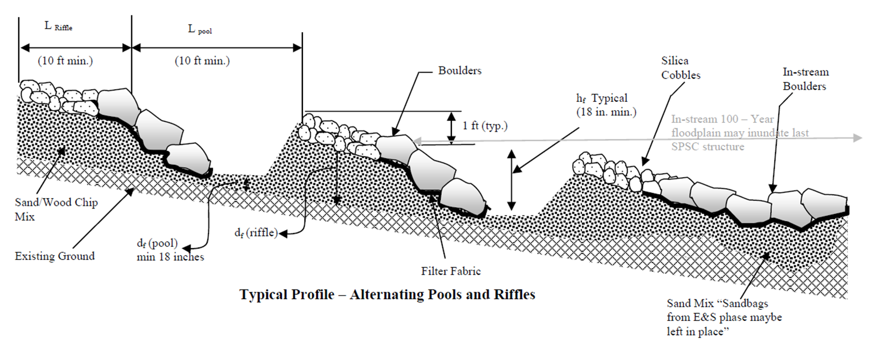
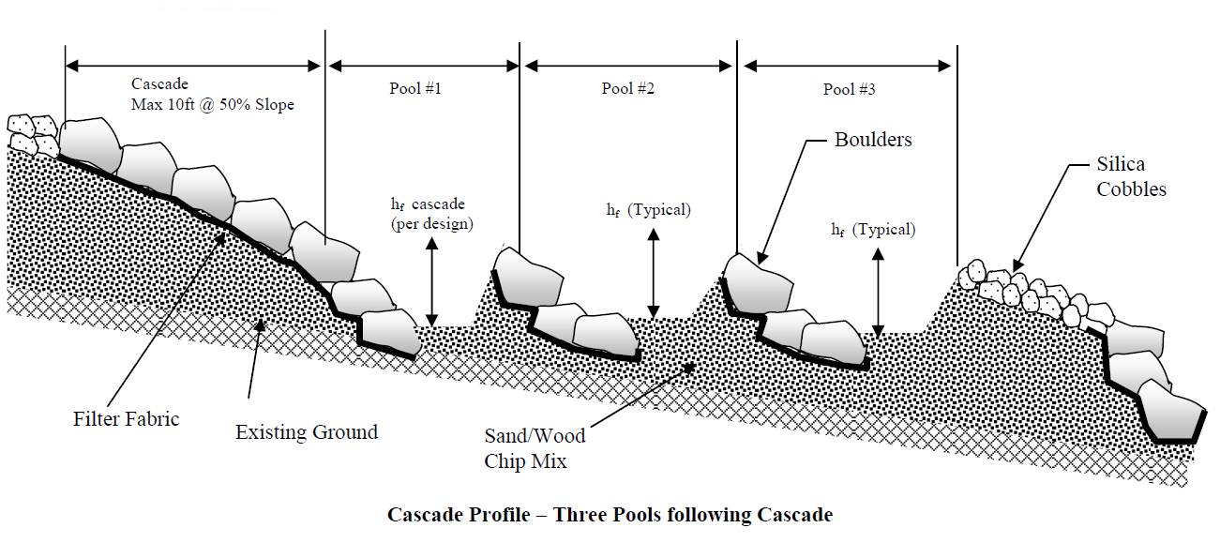

      - Design the typical cross-section for the riffle/cascade and pool channel segments
- The riffle/cascade and pool channels shall be parabolic in shape.
- Design the riffle/cascade and pool channels to carry the Q_{design} for the unmanaged 100-year storm flow in a parabolic shape. The area and hydraulic radius of a parabola are computed as follows:
Area = 2WD/3 Mathematical Solution
Hydraulic Radius = (2W²D)/(3W² + 8D²) Chow, 1959
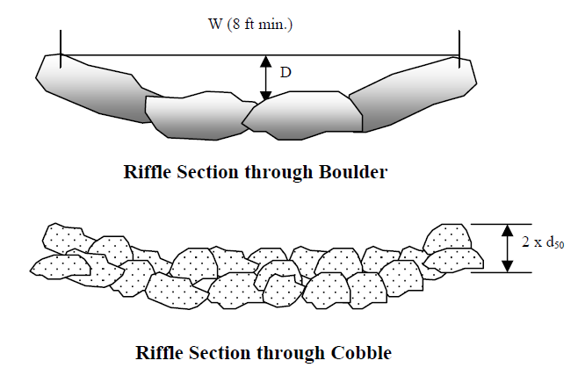
- The minimum freeboard for lined waterways or outlets shall be 0.25 ft above design high water in areas where erosion-resistant vegetation cannot be grown and maintained. No freeboard is required if vegetation can be grown and maintained. (USDA, 2006.)
- Select a trial constructed riffle channel width (W). The width is the dimension perpendicular to the flow.
- Select a trial constructed riffle channel depth (D). The Width/Depth ratio shall not be less than 2.
- The dead storage depth within the pool shall not be considered when checking for adequacy of conveyance.
- Design using a trial cobble with a d50 of 6 inches. The density of the stone shall be specified. The depth of the cobble material is equal to 2 x d50 (MDSHA, Highway Drainage Manual, 1981). Boulders shall be used to line cascade segments.
- Calculate the Manning’s n roughness coefficient based on the constructed depth, D, associated with the 100-year ultimate flow conditions and the cobble size:
n = D1/6/ (21.6 log (D/D₅₀)+14), (USDA, 2006).
Where:
n = Manning’s n, use 0.05 for cascades.
D = depth of water in the riffle channel associated with unmanaged
100-year Q design, ft
D₅₀ = cobble size, ft
- Use the Manning formula to calculate the flow and velocity associated with the trial parameters D, W, and d50. The design flow shall meet or exceed the 100-year ultimate flow conditions.

Q = (1.49/n) · A · Rh^{2/3} · S^{1/2}
Where:
Q = 100 year ultimate flow (cfs)
1.49 = conversion factor
n = Manning’s n, determined by USDA, 2006 equation
A = cross-section area of a riffle channel, which for a parabola = 2/3(W)(D), where W is top constructed width (ft) and D is the constructed depth (ft)
Rh = hydraulic radius (ft), calculated using Chow 1959 relationship for parabolas
S = average slope over entire length of project (ft/ft)
V = velocity in the riffle channel (ft/sec), V = Q/A
- Using small incremental depths (0.1 ft), develop a hydraulic rating curve/table for the channel to ensure that subcritical flow conditions prevail to the greatest extent possible. This is achieved by calculating the Froude Number, Fr. A Froude number exceeding 1 indicates that the flow is supercritical. A Froude number of less than 1 indicates that the flow is subcritical in nature. The Isbash coefficient for high turbulence should be used when sizing the cobble stones to accommodate supercritical conditions. Increasing the cobble size or the width depth ratio of the riffle channel can increase roughness and reduce velocity. This can further assist in meeting subcritical flow conditions. Refer to the design example at the end of this document for an example of a hydraulic rating curve table.
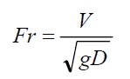

- The design velocity shall be checked to ensure that it is below the maximum allowable velocity estimated from the Isbash formula below (NRCS, 2007). A graphical solution of the Isbash formula is also shown. This will be an iterative design process. Spreadsheets can be used to streamline the calculations.
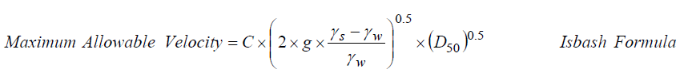
Where:
C = 0.86 for prevailing supercritical flow and 1.2 for prevailing subcritical flow
g = 32.2 ft/sec2
γ_{s} = stone density (lb/ft3)
γ_{w} = water density (lb/ft3)
D₅₀ = cobble stone diameter (ft)
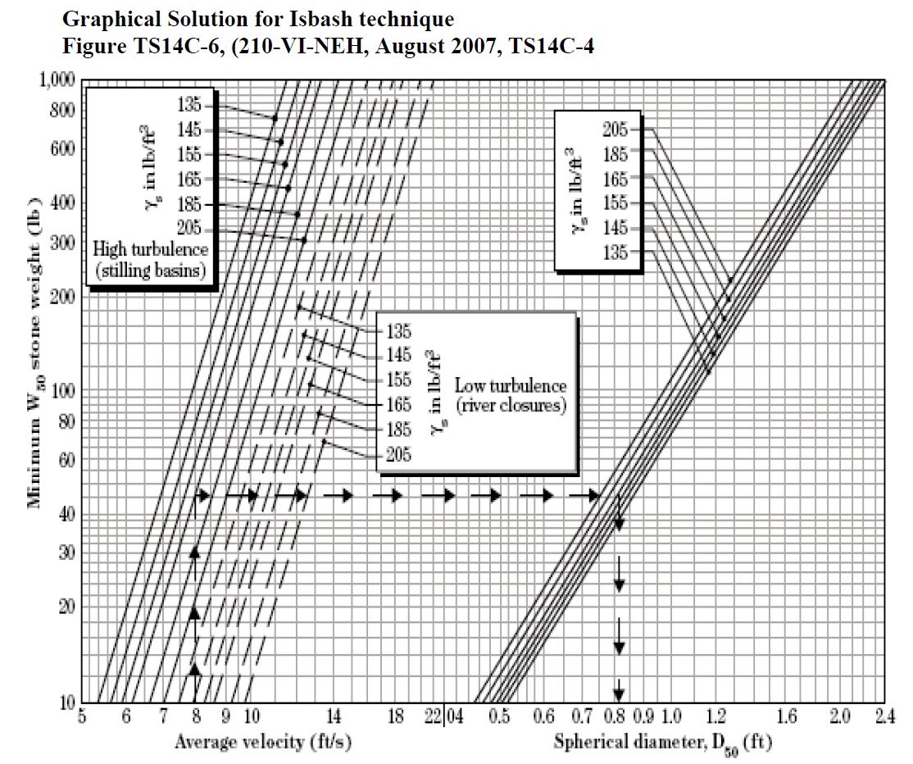
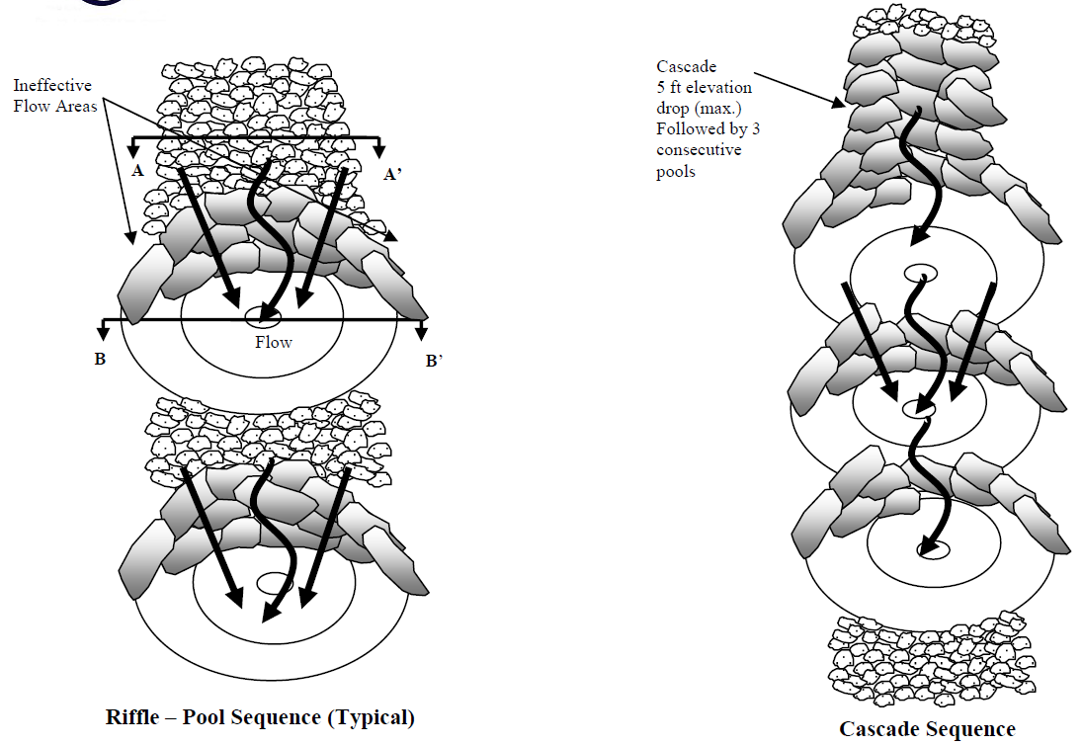
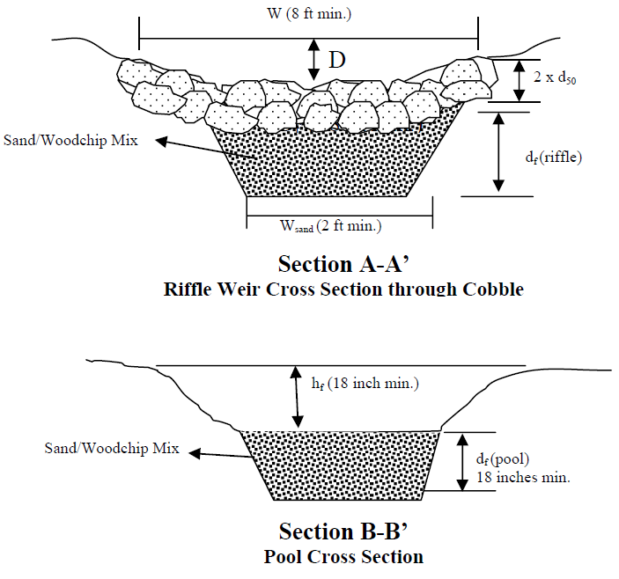
- The constructed depth of the typical pools (h_{f}) and the pool directly following a cascade (h_{f} cascade) shall not be less than 18 inches and shall not exceed 4 ft. This will result in a pool geometric design with less than 4 ft of embankment. The minimum design depth of the pools shall be estimated based on the use of the solved form of the Bernoulli conservation of energy equation shown below. The Bernoulli equation was solved to achieve a pool channel velocity of 4 ft/sec. D and V correspond to the riffle/cascade channel design depth and velocity respectively.
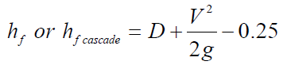
- To ensure stability, the pools shall be constructed with a minimum side slope of 3H:1V.
- The sand/wood chip filter media shall meet the MNDOT specifications for sand. Sand shall conform to MNDOT Specifications, Division III.3131.2 Coarse Sand. Sand substitutions such as Diabase and Graystone are not acceptable. No calcium carbonated or dolomitic sand substitutions are acceptable. No “rock dust” can be used for sand. The woodchips are added to the sand mix, approximately 20% by volume, to increase the organic content and promote plant growth and sustainability.
- The minimum depth of the sand/woodchip mix filter media, d_{f}, below the invert of the pools, shall be 18 inches.
- Filter fabric shall be placed under all boulders. Refer to design figures for placement location. To prevent undercutting, a continuous sheet of filter fabric shall be used along the cross-section.
- Boulders serve as the weir component of the riffle grade control structure. The boulders should be arranged in a curved manner as shown on the riffle pool sequence schematic and the weir elevation view. This arrangement is intended to encourage flow deflection to the center of the pool and the creation of ineffective flow areas near the channel banks. To achieve this, the boulders shall be arranged horizontally in the center of the channel and the arms on either side of the channel shall be extended parabolically/ approximately 20 degree angle longitudinally to the center of the pool. The sandstone boulders should be sized by the engineer to be at least 3 to 4 times heavier than the riffle channel cobble. Typically, the diameter of boulders shall not be less than 2 ft. in length. The typical boulder size shall be designed and specified on the plans by the engineer to best fit the channel shape. i.e., smaller cross-sections will require smaller boulders, while larger channel cross-sections may require larger boulders. The boulders should be tabular in shape to allow for maximum interlocking.
- The footer rocks provide added stability to the boulder in the event that excessive erosion is experienced in the energy dissipation pools. The footer rocks may not be necessary in the event that the utilized boulders size is adequately anchored (six inches below the lowest elevation point in the pool). The footer rocks shall be equivalent in size to the boulders and should be tabular in shape to allow for maximum interlocking. Footer rocks shall be anchored 6 inches below the lowest elevation point within the pool.
      - Design the in-stream weir tie-in structure (if applicable)
- The in-stream weir shall be set approximately 30 ft downstream of the tie-in location. The top elevation of the weir shall be set at the desired/historic floodplain elevation as determined appropriate by the engineer and approval authority. This is intended such as to impede headcut through the stormwater step pool and inundate the floodplain for all flows above the base-flow conditions, thus enhance the water quality conditions. To avoid the creation of a high hazard dam condition, the maximum height of the weir shall not exceed 3 ft. Multiple weirs, not to exceed 3 ft in height, may be required upstream to traverse the grade gradually and connect incised channels to the floodplain.
- The in-stream weir shall be connected longitudinally to the downstream existing grade through a maximum 5% slope boulder channel. This will ensure that flow velocities do not impede the fish passage (if applicable).
- Sand shall be used for filling the stream bed to the desired elevation. Sand bags utilized as part of the erosion and sediment control plan for creating instream diversion maybe left in place. Geotextile shall be used to separate the sand fill and the overlay boulders that line the channel. The boulders shall extend in cross-section to the 100-year floodplain elevation.
- The in-stream boulders shall be sized such as to remain in place under the 100-year velocity and shear stress, and shall be placed in a manner such as to create maximum hydraulic friction.
- The last one or two structures within the stormwater step pool may be inundated by the in-stream 100-year flood elevations.
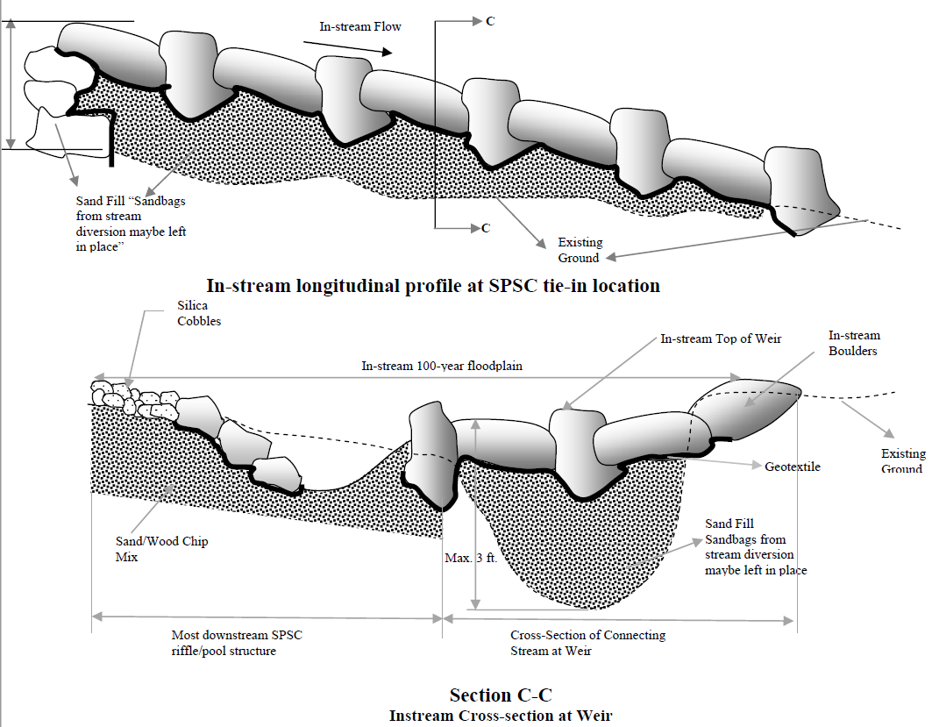
      - Check and adjust the design parameters based on project goals

    - Step 6. Check 2-year and 10-year velocity erosion potential and freeboard
Check for erosive velocities and modify design as appropriate based on local conveyance regulations. Provide 6 inches of freeboard.
    - Step 7. Design low flow control at downstream headwalls and checkdams
Design control to pass Vwq in 48 hours.
    - Step 8. Design inlets and sediment forebay(s)
Inlets to stormwater step pools must be provided with energy dissipaters such as riprap or geotextile reinforcement. Pre-treatment of runoff is typically provided by a sediment forebay located at the inlet. Enhanced swale systems that receive direct concentrated runoff may have a 6-inch drop to a pea gravel diaphragm flow spreader at the upstream end of the control. A pea gravel diaphragm and gentle side slopes should be provided along the top of channels to provide pre-treatment for lateral sheet flows.
    - Step 9. Check volume, peak discharge rates and drawdown time against state, local, and watershed organization requirements (NOTE: steps are iterative)
      - General considerations
Follow the design procedures identified in the Unified Sizing Criteria section of the Manual to determine the volume control and peak discharge requirements for water quality, recharge (not required), channel protection, overbank flood and extreme storm.
Model the proposed development scenario using a surface water model appropriate for the hydrologic and hydraulic design considerations specific to the site. This includes defining the parameters of the stormwater step pool practice defined above: ponding elevation and area (defines the ponding volume), filtration rate and method of application (effective filtration area), and outlet structure and/or flow diversion information. The results of this analysis can be used to determine whether or not the proposed design meets the applicable requirements. If not, the design will have to be re-evaluated.
Warning: The following items are specifically REQUIRED by the MPCA Permit:
A. Volume: Volume reduction may be achieved where in-situ soils, depth to bedrock and depth to groundwater are suitable (see “Design Criteria for infiltration”), though gradients dictating the use of stormwater step pools may limit actual infiltration potential as well as present bluff instability risks. Therefore, it is advisable that stormwater step pools be designed to filter the water quality volume of runoff as opposed to relying on infiltration. Stormwater step pool systems shall be sufficient to filter a water quality volume of 1 inch of runoff from the new impervious surfaces created by the project. If this criterion is not met, increase the storage volume of the filtration practice or treat excess water quality volume (Vwq) in an upstream or downstream BMP (see Step 5).
B. Drawdown: Filtration practices shall discharge through the soil or filter media in 48 hours or less. Additional flows that cannot be infiltrated or filtered in 48 hours should be routed to bypass the system through a stabilized discharge point.
Experience has demonstrated that, although the drawdown period is 48 hours, there is often some residual water pooled in the infiltration practice after 48 hours. This residual water may be associated with reduced head, water gathered in depressions within the practice, water trapped by vegetation, and so on. The drawdown period is therefore defined as the time from the high water level in the practice to 1 to 2 inches above the bottom of the facility. This criterion was established to provide the following: wet-dry cycling between rainfall events; unsuitable mosquito breeding habitat; suitable habitat for vegetation; aerobic conditions; and storage for back-to-back precipitation events. This time period has also been called the period of inundation.
      - Special considerations for stormwater step pools
- If the required WQv and Rev are not met by the proposed SPSC design, then increase the filtration capacity by adjusting the depth of pools, width of sand/woodchip mix filter, or length of the facility. If these adjustments are not feasible, utilize other BMP measures to provide the remaining water quality volume.
- In situations where the existing soil, underlying the proposed SPSC, is confirmed through “borings” to be highly infiltratable, the designer may utilize the water quality sizing criteria for an infiltration basin in lieu of filtration. This is prescribed so the designer engineer is not forced, under certain circumstances, to replace highly infiltratable native soil with non-native filter bed material.
- The proposed stormwater step pool will satisfy peak management flow requirements if two conditions are met:
    - First, adequate storage volume within the pools and sand/woodchip voids shall be provided to meet the required storage volume/quantity management for the project
    - Second, it must be demonstrated that the design renders the hydraulic power equivalent to the predevelopment/desired hydraulic power through the proposed energy dissipation pools.
  - To achieve the conditions above, the designer must compare the required peak management storage volume with the combined volume within the pools and the volume in the voids within the sand/woodchip mix. A 30% porosity shall be used for the sand/woodchip mix to calculate the volume within the voids. The selected design for the stormwater step pool must be checked using the conservation of energy principles to ensure that the hydraulic power is adequately reduced to design/predevelopment levels. This is achieved by equating the predevelopment or reference condition hydraulic power to the post development hydraulic power and solving for the equivalent added stream length/volume of storage needed to render this power to the desired condition. The conservation of energy principles are then utilized to convert the energy loss within this horizontal length to an equivalent vertical drop. The vertical drop is then converted to multiple drops that are distributed along the system in a manner that result in the least site disturbances. The provided quantity/volume of pools is then compared with the calculated quantity/volume of pools. If the provided pool storage is less than the computed/required pool storage, then additional stormwater step pool design measures or additional upland management strategies must be taken to reduce the inflow and in turn the hydraulic power. Refer to the figure below for a demonstration of the stormwater step pool provided volume of storage and input parameters for the conservation of energy computations. It should be noted that equating the geometric configuration of a multiple pool system to one pool with an area equal to the cumulative areas within the individual pools is a conservative measure and is used to simplify the hydraulic power routing computations. It is expected that cumulative roughness and headloss within the multiple pool configuration to be much higher than the individual pool configuration.
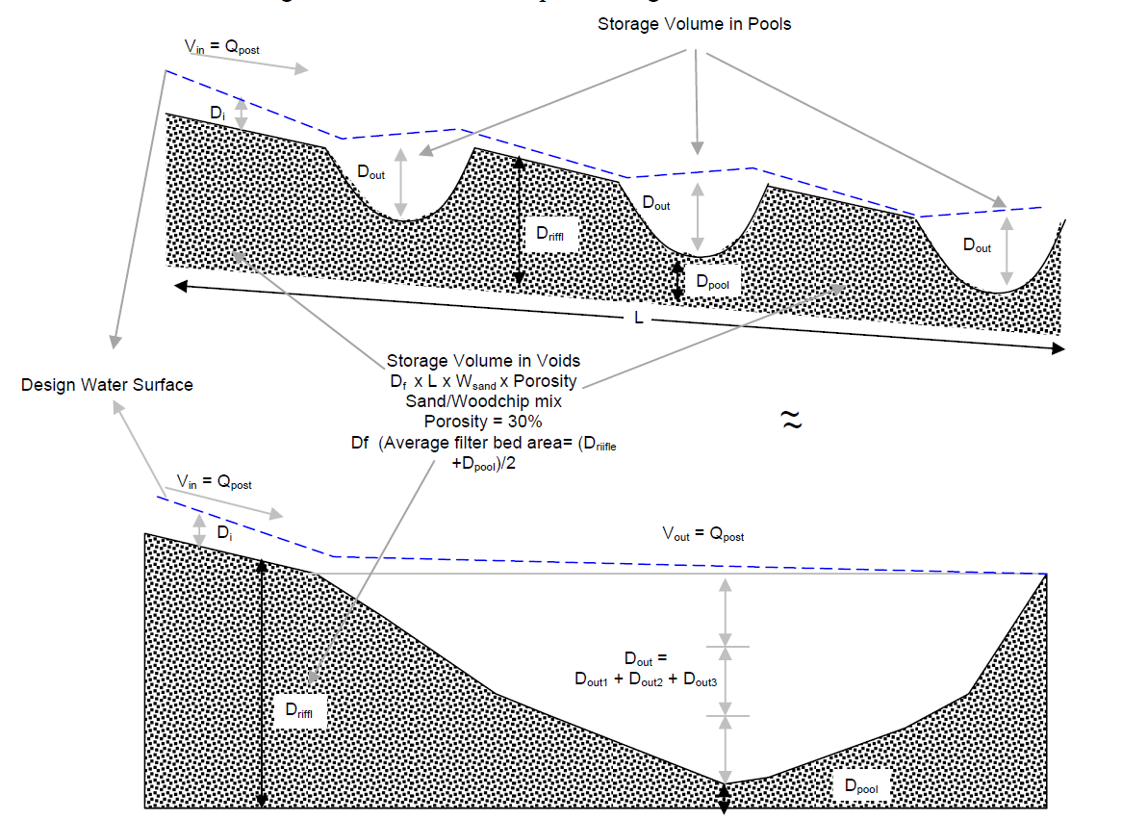

- The following steps should be followed in checking the before/after hydraulic power:
    - Compute the predevelopment/design and post development hydraulic powers by substituting the predevelopment and post development discharges in terms of Q in the hydraulic power equation. The hydraulic power is expressed in the units of lb/sec.
Hydraulic Power = γ x Q x S
Where,
γ = is the unit weight of water = 62.4 lb/ft3
Q = corresponds to the Atlas 14 event discharge
S = is the slope of the outfall channel in percent
    - Equate the predevelopment/design and post development hydraulic powers and solve for the needed added stream length.
γ x Q_{pre} x (ΔE/L_{pre})= γ x Q_{post} x (ΔE/L_{post})
  - The elevation difference between the top and bottom of the project and the unit weight of water will remain constant, therefore, the channel protection requirement could be expressed in terms of a required additional stream channel length L_{add}, needed to render the post development hydraulic power equivalent to the predevelopment hydraulic power.
L_{add} = L_{pre} x (Q_{Post}/Q_{Pre}) - L_{pre}
  - The required headloss due to friction through the stormwater step pool system can be calculated using the Darcy-Weisbach equation. By substituting L_{add} for L, this headloss becomes equivalent to the energy loss within an added stream channel of length L_{add}. The friction factor can be calculated using established relationships between Darcy-Weisbach friction factor and the Manning friction coefficient listed in Chow, 1959. The Darcy –Weisbach headloss equation is as follows:
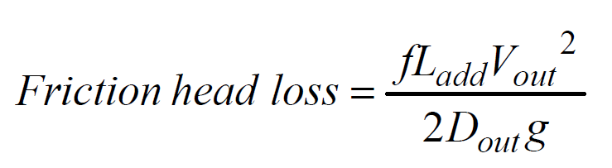

  - By substituting the required headloss term in the Bernoulli conservation of energy equation, the total combined design depth in ft of all proposed pools shall be at least equal to the “Dout” term embedded in the Bernoulli conservation of energy equation depicted below. If the total combined depth in ft of all proposed pools is less than the calculated “Dout” term, then additional pools are required or alternatively the pools could be made deeper. Solve for the “Dout” term using trial and error techniques or available commercial solver functions/calculators, (e.g., Microsoft Excel). The general and solved forms of the Bernoulli conservation of energy equation are shown below.
General Form of the Bernoulli Equation
(Potential + Kinetic + Static) Energies SPSC entrance = (Potential + Kinetic + Static) Energies stormwater step pool outlet + Head loss within stormwater step pool system
Solved form of the Bernoulli Equation
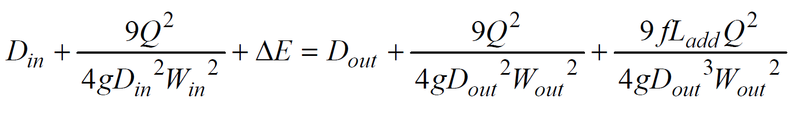
Where,
f = Darcy-Weisbach friction factor, the Chow 1959 equations below maybe used to relate the friction factor to a manning roughness:
f = 8gRh−1/ 3n2 Chow, 1959

L_{add} = additional channel length (ft) required to render the post development power to predevelopment conditions
V_{in} = Design velocity at entrance riffle = V
D_{in} = Design depth at entrance riffle = D
W_{in} = Design width of riffle = W
W_{out} = Width of the pool (ft)
V_{out} = typical velocity of flow (ft/sec) in the pool, this term is unknown in the Bernoulli equation. Using flow continuity principals, this term could be expressed in terms of the CPV design discharge, Dout, and Wout.
g = acceleration due to gravity = 32.174 ft/sec2
D_{out} = Solve for combined depth of flow in all pools (ft) and compare to the total provided pool depth
    - Step 10. Finalize the cross-section and profile design for the project

Grading plan
Develop a grading plan based on the preliminary profile and cross-section typical design.

Dimensions
Adjust the preliminary profile dimensions to accommodate site specific concerns/impacts. Minimum design parameters for hydraulic, water quality, and quantity management criteria should be rechecked based on adjustments to the riffle/pool channels to ensure that safe and adequate conveyance is still maintained.

Rock checks
Adjust the preliminary rock check dimensions to accommodate site specific concerns/impacts. Minimum design parameters for hydraulic, water quality criteria should be rechecked based on adjustments to the channels profile and bank and bed stability to ensure that safe and adequate conveyance is still maintained.

Filter bed
The sand/woodchip mix filter bed shall have a minimum depth of 18 inches under the riffle channel and a minimum width of 4 ft and shall be placed as the substrate drainage material along the entire project length. The actual dimensions of the sand/woodchip mix filter bed will be determined based on the required water quality volume. Typically, construction of the step-pool system shall begin at the downstream end and proceed upstream to the project outfall. The outlet pool is designed to be placed at the lowest point in the project reach. This is often in the receiving wetland or stream/ floodplain, but can also be located in upland settings where the stormwater step pool system discharges to another stormwater BMP or adequate storm conveyance system.

Footer boulders
Footer boulders shall be placed at the interface of the pools and riffles as shown below. Additional boulders shall be placed on top of the footer boulders at the weir elevation upstream of the footer boulders to form the riffle channel parabolic shape.
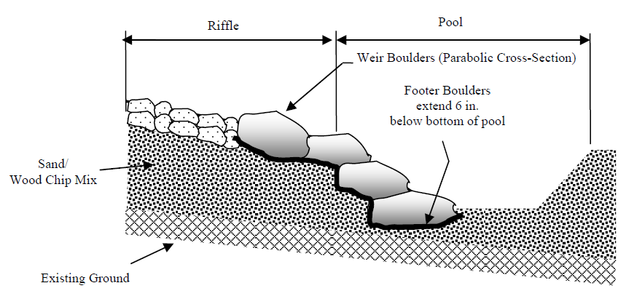

Entry pool
Continue the process of alternating pools and riffles up through the system to the entry pool. If the entry pool ties to an existing pipe outfall, additional armoring of the pool maybe needed to address the pipe exit velocities associated with supercritical hydraulic conditions. The designer may elect to use a larger size pool at the project entry to dissipate the outfall velocity and/or to address pretreatment concerns.

Upstream drainage
If the stormwater step pool is proposed downstream of a pipe system, it is desirable that the top invert of the weir associated with the entry pool is set at or above the invert of the discharge pipe or culvert. It is the responsibility of the design engineer to check the adequacy of the upstream drainage system

Site stabilization
Course woodchips and compost should be used throughout the limit of disturbance for site stabilization. All areas should be seeded and planted as well as blanketed/matted. Jute blanket should be used within the stormwater step pool bottom and side slopes. Erosion control blanket with biodegradable netting can be used above the side slopes within the floodplain.

Excess materials
It is advisable that excess materials, i.e., cobbles and boulders, be placed at the edge of the cross-section for use during the maintenance phase to correct any physical instability.
    - Step 11. Prepare vegetation and landscaping plan
A landscaping plan for a stormwater step pool should be prepared to indicate how the enhanced system will be stabilized and established with vegetation. Landscape design should specify proper species and based on specific site, soils, sun exposure and hydric conditions present along the channel. Further information on plant selection and use can be found in the Minnesota plant lists section.
    - Step 12. Prepare operation and maintenance plan
See Operation and Maintenance section for guidance on preparing an O&M plan.
    - Step 13. Prepare cost estimate
See Cost Considerations section for guidance on preparing a cost estimate that includes both construction and maintenance costs.
  - References
Anne Arundel County, 2009. Design Guidelines for Step Pool Storm Conveyance, Anne Arundel County Government, Department of Public Works, Bureau of Engineering
  - Related pages
https://stormwater.pca.state.mn.us/index.php?title=Design_criteria_for_infiltration
https://stormwater.pca.state.mn.us/index.php?title=Design_criteria_for_filtration
https://stormwater.pca.state.mn.us/index.php?title=Design_criteria_for_bioretention
- Stormwater Step Pool Construction Specifications Page
Green Infrastructure: Stormwater step pool practices can be an important tool for retention and detention of stormwater runoff and treatment of pollutants in stormwater runoff. Because stormwater step pools incorporate dense vegetation and infiltration/filtration, additional benefits may include cleaner air, carbon sequestration, improved biological habitat, and aesthetic value.
This page provides a discussion of construction specifications for stormwater step pools.
  - Access agreements
An easement is a legally binding agreement between two parties, and is defined as “a non-possessory right to use and/or enter onto the real property of another without possessing it. “An easement is required for one party to access, construct, or maintain any feature or infrastructure on the property of another. Easements can be temporary or permanent. For example, temporary easements can be used if limits needed for construction are larger than the permanent easement footprint of constructed features. Having an easement provides a mechanism for enforcement of maintenance agreements to help ensure infiltration practices are maintained and functioning. See an example access agreement.
  - Construction specifications for stormwater step pool practices
Construction of stormwater step pools incorporates techniques and steps that may be considered nonstandard. It is recommended that construction specifications include project pretreatment devices, construction sequencing, temporary and permanent erosion control measures, excavation and fill, grading, soil decompaction, material specifications, and final stabilization. All of these topics are addressed in further detail below.
Additional specifications for items applicable to stormwater step pool practices can be found in the Minnesota Department of Transportation’s (MnDOT) Specifications for Construction. The current version of this resource was completed in 2016. Below is a list of MnDOT sections that may be helpful when writing project specifications for stormwater step pool practices.
1717 Air, land and water pollution
2101 Clearing and grubbing
2105 Excavation and embankment
2511 Riprap
2571 Plant installation and establishment
2572 Protection and restoration of vegetation
2573 Storm water management
2574 Soil preparation
2575 Establishing turf and controlling erosion
3149 Granular material
3877 Topsoil material
3878 Sod
3882 Mulch material
3884 Hydraulic erosion control products
3885 Rolled erosion control products
3897 Sediment control log
    - Pre-construction meeting
A pre-construction meeting is recommended and should include a walkthrough of the site with the builder/contractor/subcontractor to identify important features of the work and to review and discuss the plans. This is the best time to identify potential issues related to construction methods and sequencing that will affect site protection, erosion and sediment control, and proper installation of the work.
    - Site protection
      - Pretreatment
Pretreatment is a REQUIRED part of infiltration and filtration practices. Pretreatment is needed to protect BMPs from the build-up of trash, gross solids, and particulate matter. When the velocity of stormwater decreases, sediment and solids drop out. If pretreatment is not provided, this process will occur in the BMP, resulting in long-term clogging and poor aesthetics.
Warning: The Construction Stormwater general permit states: To prevent clogging of the infiltration or filtration system, the Permittee(s) must use a pretreatment device such as a vegetated filter strip, small sedimentation basin, or water quality inlet (e.g., grit chamber) to settle particulates before the stormwater discharges into the infiltration or filtration system.
      - Temporary erosion and sediment control
During construction, it is critical to keep sediment out of the stormwater step pool as much as practicable. Utilizing sediment and erosion control measures will help to keep the stormwater step pool areas from clogging, especially for infiltration and filtration types. As soon as grading is complete, stabilize slopes to reduce erosion of native soils. Protect temporary soil stockpiles from run-on and run-off from adjacent areas and from erosion by wind. Sweep as often as required if sediment is on paved surfaces to prevent transport offsite by tracking and airborne dust. All sediment and erosion control measures must be properly installed and maintained. When sediment build up reaches 1/3 the height of the device, action is required, such as removing the accumulated sediment or installing additional sediment controls downgradient of the original device. Link here for more information.
Warning:
- It is REQUIRED that future stormwater step pool locations not be used as temporary sedimentation basins unless 3 feet of cover is left in place during construction.
- If a stormwater step pool area is excavated to final grade (or within 3 feet of) it is REQUIRED that rigorous erosion prevention and sediment controls (e.g., diversion berms) are used to keep sediment and runoff away from the stormwater step pool area.
      - Compaction prevention
Preventing and alleviating compaction are crucial during construction of stormwater step pool practices, as compaction can reduce infiltration rates by increasing bulk density of the soil. The stormwater step pool area should be marked with paint and/or stakes to keep construction traffic from traveling in the area.
    - Inspection and documentation
Inspections before, during, and after construction are needed to ensure stormwater step pools are built in accordance with the plans and specifications. It is recommended that onsite inspectors are familiar with project plans and specifications to ensure the contractor’s interpretation of the plans are consistent with the designer’s intent. The inspectors should take frequent photos and notes of construction activities and features as work progresses and at all critical points (such as immediately prior to backfilling). They should check dimensions and depths of all installed materials. All materials and products should be verified or tested for conformance with the specifications.

Construction checklists
- Infiltration basin
- Bioretention
- Rock check
- Plunge pool
  - Construction sequence
    - Step 1 – Site examination and preparation
It is the responsibility of the contractor to:
- Examine the areas for performing earthwork and determine that conditions are satisfactory to proceed, or to correct all unsatisfactory conditions prior to starting work.
- Arrange to locate, mark, and protect all existing utilities and underground facilities in the areas of work.
- Remove all existing features marked for removal and required earthwork
    - Step 2 – Excavation

For stormwater step pools with no infiltration or filter media
Cut the stormwater step pool area as shown on the plans. Where possible, excavation should be performed with a backhoe and work should be done from the sides and outside the footprint of the stormwater step pool area to avoid soil compaction. If it is necessary to work in the stormwater step pool bottom area, only low ground pressure tracked equipment should be allowed to complete the work. Rubber tire equipment should be strictly prohibited within the stormwater step pool bottom area, unless working from pavement outside of the basin or trench. The contractor should start the work at the far side of the trench or basin and work their way out.
Contractor is to ensure all laws and regulations are followed regarding stability of excavations. This may require shoring, bracing, sloping, or benching. Materials should not be stockpiled near the edge of the excavation. Drainage and control of water in the excavation must also be considered.
    - Step 3 – Decompaction
Soil decompaction is required in all stormwater step pool bottom areas. Decompact subsoil with a backhoe ripper attachment or other approved method to a depth of at least 18 inches below subgrade in all locations indicated on the drawings. Also known as soil loosening or soil ripping, this technique has been shown to increase infiltration and reduce compaction from construction activities. For more information on alleviating compaction, link here.
    - Step 4 – Installation of materials - filter media (if applicable)
Soil test results should be provided to the designer a minimum of two weeks prior to delivery of planting soil to the site. Submitted test results should include gradation and USDA soil texture classification or certification that the soil mix meets MnDOT specifications or other requirements. Samples of the mixed product should be also provided to the designer two weeks prior to delivery of media to the site. The designer should review the materials as soon as possible to avoid any potential delays in the procurement and review of another media source should the initial submittal not meet specifications.
All accumulated sediment and silt from the bottom of the stormwater step pool area should be removed prior to the placement of filtration media. The contractor should make every effort possible to place the filtration media in a way to minimize compaction of the subgrade and the filtration media itself. No construction vehicles are allowed in the filtration area after the media is placed unless approved by designer. Loose placement of filtration media shall be accomplished by dumping from the edges and spreading with the bucket of a backhoe, which is outside of the filtration area, or some other acceptable means determined by the designer. If spreading with a backhoe is not possible for the entire area of the filtration area, only tracked skid steers or other low ground pressure equipment should be permitted in the basin to spread the filtration media. This method should be minimized as much as possible. Travel over placed filtration media should be strictly prohibited. The contractor should overfill the filtration media areas approximately 20 percent to account for consolidation of the loose soil once wetting occurs. Any small irregularities at the designed finished grade should be worked out with hand tools. The contractor should contact the designer upon final placement of media for a final inspection prior to planting and mulching. At this inspection, the designer should check thickness and grades after soil wetting occurs and notify the contractor of areas that do not meet the tolerances specified. Tolerances in final grade are commonly vertically +/- 0.1 foot and horizontally +/- 0.5 foot.
If time goes by between the initial placement of infiltration media and planting, the contractor should be required to remove or mix in accumulated silt. This work is also a chance to perform any final subgrade grading adjustments required to obtain the finished grades as shown on the drawing.
    - Step 5 – Restoration and plantings
After final placement of grading and filtration media (if applicable) has been approved, planting or seeding should happen as soon as possible to avoid erosion, sedimentation, and the establishment of weeds. The contractor should notify the designer at least four days in advance of when planting or seeding will occur in advance of delivery of materials to the site to allow for scheduling of site inspections. At least two weeks prior to the planting or seeding dates, any existing weeds should be thoroughly eradicated mechanically or with herbicide within the project area.
Warning: It is REQUIRED that the planting or seeding contractor have proven successful experience installing and maintaining projects of similar scope and scale and provide a superintendent that will be onsite during the entire seeding or planting process.
All seed and plants should be shipped and stored with protection from weather or other conditions that would damage the product. All plants and seeds will be inspected by the designer and items that have become wet, moldy, or otherwise damaged in transit or in storage should be rejected. Plants and seed should arrive within 24 hours of delivery. Plants and seed needs to be protected against drying and damage prior to planting.
It is typical for the plant or seeding contractor to guarantee the work for some length of time. The common minimum for herbaceous plantings or sod is 60 days during the growing season. The growing season in central Minnesota is defined as May 1st through October 31st. A one-year guarantee on containerized plants can help to ensure good establishment and decrease weed infestations while maintaining infiltration rates over time through the growth of healthy root systems. Any watering required to keep the plants healthy should be covered under the cost of the warranty period. It is appropriate to require that the contractor provide some form of surety, such as a letter of credit or other security, to the permitting entity for 150 percent of the estimated costs and quantities of all herbaceous plants or seeding for the duration of the 1-year warranty period. Planting and seeding establishment should meet the requirements within MnDOT Section 2571 (page 478).
Warning: Seeding maintenance requires specialized knowledge and experience in plant and weed identification. Ensure a thorough maintenance plan is established prior to construction and that budget has been allocated for at least three full growing seasons and preferable longer. Native seedings can be more difficult than containerized plantings to establish.
    - Step 7 – Final stabilization and Closeout
As defined in the NPDES/SDS Construction Stormwater permit, final site stabilization is achieved when all soil disturbing activity is completed and the exposed soils have been stabilized with a vegetative cover with a uniform density of at least 70 percent over the entire site or by equivalent means to prevent soil failure. Simply seeding and mulching is not considered acceptable cover for final stabilization. Final stabilization must consist of an established permanent cover, such as a perennial vegetative cover, concrete, riprap, gravel, rooftops, asphalt, etc
- Stormwater step pool Operation and Maintenance Page
The most frequently cited maintenance concern for stormwater step pools is surface soil/media and underdrain clogging caused by organic matter, fine silts, hydrocarbons, and algal matter. Common operational problems include:
- standing water;
- clogged soil/media surface;
- clogged inlet, outlet or underdrains; and
- invasive plants out-compete native vegetation.
  - Design phase maintenance
Implicit in the design guidance is the fact that many design elements of filtering and infiltration systems can minimize the maintenance burden and maintain pollutant removal efficiency. Key examples include:
- limiting drainage area;
- providing easy site access (REQUIRED);
- providing pretreatment (REQUIRED); and
- utilizing native plantings (see Plants for Stormwater Design).
For more information on design information for stormwater step pools, link here.
  - Construction phase maintenance
Proper construction methods and sequencing play a significant role in reducing problems with operation and maintenance (O&M). In particular, with construction of filter and infiltration practices the most important action for preventing operation and maintenance difficulties is to ensure that the contributing drainage area has been fully stabilized prior to bringing the practice on line (this is a REQUIRED practice).
Warning: It is required that the contributing drainage area has been fully stabilized prior to bringing the practice on line
Inspections during construction are needed to ensure that the filter/infiltration practice is built in accordance with the approved design standards and specifications. Detailed inspection checklists should be used that include sign-offs by qualified individuals at critical stages of construction, to ensure that the contractor’s interpretation of the plan is acceptable to the professional designer. An example construction phase inspection checklist is provided below.
Stormwater step pool construction inspection checklist.
Link to this table
To access an Excel version of form (for field use), click here.
Project:
Location:
Site Status:
Date:
Time:
Inspector:
Construction Sequence | Satisfactory / Unsatisfactory | Comments
1. Pre-Construction
Pre-construction meeting
Runoff diverted (Note type of bypass)
Facility area cleared
Soil tested for permeability
Soil tested for phosphorus content (include test method)
Verify site was not overdug
Project benchmark near site
Facility location staked out
Temporary erosion and sediment protection properly installed
2. Excavation
Size and location per plans
Side slopes stable
Lateral slopes completely level
Longitudinal slopes within design range
Soils not compacted during excavation
Groundwater / bedrock verified
Stockpile location not adjacent to excavation area and stabilized with vegetation and/ or silt fence
Verify stockpile is not causing compaction and that it is not eroding
Was underlying soil ripped or loosened
3. Check Dams
Dimensions per plans
Spacing and grade installed per plans
Materials per specifications
4. Structural Components
Pretreatment devices (e.g., filter strip, rock diaphragm) installed per plans
Inlets installed per plans
Outlets installed per plans
Underdrain installed to grade
Underdrain installed per plans
Soil bed composition and texture conforms to specifications
5. Vegetation
For native stormwater step pools, plants and materials ordered 6 months prior to construction
For native stormwater step pools, construction planned to allow for adequate planting and establishment of plant community
Complies with planting specs
Topsoil complies with specs in composition and placement
Soil properly stabilized for permanent erosion control
6. Final Inspection
Dimensions per plans
Pre-treatment operational
Inlet/outlet operational
Check dams operational
Soil/media/ filter bed permeability verified
Effective stand of vegetation stabilized
Construction generated sediments removed
Contributing drainage area stabilized before flow is diverted to the practice
Comments:
Actions to be taken:
  - Post-construction operation and maintenance
Proper maintenance is critical to the successful operation of a filtration/infiltration practice. Without regular maintenance, filtration/infiltration system soil/media can become clogged, losing its ability to conduct and infiltrate water at the designed rate. This can lead to stagnant water, mosquito breeding habitat, and reduction or elimination of pollutant removal capacity.
Warning: A maintenance plan clarifying maintenance responsibility is REQUIRED. Effective long-term operation of filtration/infiltration practices necessitates a dedicated and routine maintenance schedule with clear guidelines and schedules. Proper maintenance will not only increase the expected lifespan of the facility but will improve aesthetics and property value.
    - Inspection and maintenance planning
A maintenance plan clarifying maintenance responsibilities is REQUIRED. Effective long-term operation of filtration/infiltration practices necessitates a dedicated and routine maintenance schedule with clear guidelines and schedules. Proper maintenance will not only increase the expected lifespan of the facility but will improve aesthetics and property value.
Some important post-construction considerations are provided below along with RECOMMENDED maintenance standards.
- A site-specific O&M plan that includes the following considerations should be prepared by the designer prior to putting the stormwater practice into operation:
  - Inspection and routine maintenance checklist (see below)
  - Operating instructions for any outlet components
  - Vegetation maintenance schedule
Stormwater step pool operation & maintenance checklist.
Link to this table
To access an Excel version of form (for field use), click here.
Project:
Location:
Site Status:
Date:
Time:
Inspector:
Maintenance Item | Satisfactory / Unsatisfactory | Comments
1. Debris Cleanout (Monthly)
Contributing areas clean of litter and vegetative debris
Filtration/infiltration facility clean
Inlets and outlets clear
2. Check Dams or Energy Dissipators (Annual and After Major Storms)
No evidence of flow going around structures
No evidence of erosion at downstream toe
3. Vegetation (Monthly)
Vegetation maintenance complies with O&M plan
Vegetation meets performance standards (including control of specified invasive species)
Minimum mowing depth not exceeded
No evidence of erosion
4. Dewatering (Monthly)
Dewaters between storms within 48 hours
5. Sediment Deposition (Annual)
Area clean of sediment
Winter accumulation of sand removed each spring
Contributing drainage area stabilized and free of erosion
6. Outlet/Overflow Spillway (Annual)
No evidence of structural deterioration
No evidence of erosion
No evidence of blockage
Good condition, no need for repairs
7. Other (Monthly)
Encroachment on easement area (if applicable)
Complaints from residents (if applicable)
Any public hazards (specify)
Comments:
Actions to be taken:
- A legally binding and enforceable maintenance agreement should be executed between the practice owner and the local review authority to ensure the following:
  - Sediment should be cleaned out of any sedimentation chamber when it accumulates to a depth equal to ½ the total depth to the outlet, or when greater than 1.5 feet, whichever is less. The sediment chamber outlet devices should be cleaned/repaired when drawdown times exceed 36 hours. Trash and debris should be removed as necessary; and
  - Silt/sediment should be removed from the step pool and connecting swale bottoms when the accumulation exceeds one inch. When the soil/media’s infiltration capacity diminishes substantially (i.e., when water ponds in pools for more than 48 hours), the top few inches of discolored material should be removed, core aeration or cultivation should be conducted as warranted, removed soil should be replaced with fresh soil/media, and appropriate vegetation should be installed (e.g., seed) and secured (e.g., erosion control blanket). Removed sediments should be disposed in an acceptable manner (e.g., landfill).
- Turf grass swales (connecting step pools) should be mowed as needed during the growing season to maintain maximum grass heights less than 12 inches.
- Adequate access must be provided for inspection, maintenance and landscaping upkeep, including appropriate equipment and vehicles.
- Maintenance activities should be careful not to cause compaction. No vehicles will be allowed within the footprint of the filtration or infiltration area. Foot traffic and stockpiling should be kept to a minimum.
- Stormwater step pools generally should not be used as dedicated snow storage areas, but can be with the following considerations.
  - Snow storage should not occur in areas designated as potential stormwater hotspots for road salt.
  - Areas designed for infiltration should be protected from excessive snow storage where sand and salt is applied.
  - Specific snow storage areas should be assigned that will provide some filtration before the stormwater reaches the BMP areas. NOTE: Chloride will not be attenuated in filtration/infiltration BMPs such as stormwater step pools.
  - When used for snow storage, or if used to treat parking lot runoff, the BMP area should be planted with salt tolerant and non-woody plant species.
  - Practices should always be inspected for sand build-up on the surface following the spring melt event.
- General maintenance activities and schedule are provided below.
    - Summary of typical maintenance regime
The list below highlights the assumed maintenance regime for a stormwater step pool.
- First year after planting
  - Adequate water is crucial to plant survival and temporary irrigation may be needed unless rainfall is adequate until plants mature
- As needed
  - Prune and weed to maintain appearance
  - Remove trash and debris
  - Mow filter strip/grass channel (if present)
  - Replace vegetation whenever percent cover of acceptable vegetation falls below 90 percent or project specific performance requirements are not met. If vegetation suffers for no apparent reason, consult with horticulturist and/or test soil as needed
- Semi-annually
  - Inspect inflow and pretreatment systems for clogging (off-line systems) and remove any sediment
  - Inspect filter strip/grass channel for erosion or gullying. Sod as necessary
  - Herbaceous vegetation, trees and shrubs should be inspected to evaluate their health and replanted as appropriate to meet project goals
  - Remove any dead or severely diseased vegetation
- Annually in fall
  - Inspect and remove any sediment and debris build-up in pretreatment areas
  - Inspect inflow points and infiltration surface for buildup of road sand associated with spring melt period, remove as necessary, and replant areas that have been impacted by sand/salt build up
- Annually in spring
  - Cut back and remove previous year’s plant material and remove accumulated leaves if needed (or conduct controlled burn where appropriate)
  - Estimated hours to perform maintenance activities
All estimated hours listed below would be to perform maintenance on a stormwater step pool system approximately 1,000 square feet in size that has adequate pretreatment and where seed and/or live plants have been installed appropriately.
- Plant Establishment Period (First two years)
  - Monthly weeding – 12 visits (6 per year) at 1 hour per visit
  - Vegetation replacement – 1 overseeding or replanting effort, 2 hours (assuming 10 percent warrants replacement)
  - Spring cleanup (cut back of previous years vegetation) – 2 cleanups (1 per year) at 2 hours each
  - Erosion, sediment, and pretreatment cleanout – 2 cleanouts (1 per year) at 1 hour each (assuming vacuum truck clean-out of any sump catch basins)
- Regular Maintenance (After first two years)
  - Bi-monthly (every other month) weeding – 3 visits per year at 1 hour per visit
  - Vegetation replacement – 1 overseeding or replanting effort per year on average, 1 hour (assuming 5 percent warrants replacement)
  - Spring cleanup (cut back of previous years vegetation) – 1 per year at 2 hours
  - Erosion, sediment, and pretreatment cleanout – 2 hours per year on average (assuming vacuum truck clean-out of any sump catch basins once per year, and at least one bi-yearly (every other year) sediment removal from the bottom of the stormwater step pool)
  - Erosion protection and sediment monitoring, removal, and disposal
Regular inspection of not only the BMP but also the immediate surrounding catchment area is necessary to ensure a long lifespan of the water quality improvement feature. Erosion should be identified as soon as possible to avoid the contribution of significant sediment to the BMP.
Pretreatment devices need to be maintained for long-term functionality of the entire BMP. Accumulated sediment in filter strips, rock diaphragms, water quality sump catch basins, or any pretreatment features will need to be inspected yearly. Timing of cleaning of these features is dependent on their design and sediment storage capabilities. In watersheds with erosion or high sediment loadings, the frequency of clean out will likely be increased. A vacuum truck is typically used for sediment removal. It is possible that any sediment removed from pretreatment devices or from the bottom of a step pool system may contain high levels of pollutants. All sediments, similar to those retrieved from a stormwater pond during dredging, may be subjected to the MPCA’s guidance for reuse and disposal.
If a grassed filter strip is used as pretreatment, they should be mowed as frequently as a typical lawn. Native vegetated filter strips can be maintained less frequently, such as once per year (e.g., mow and remove cut material or prescribed burn). Depending on the contributing watershed, grassed BMPs may also need to be swept before mowing. All grassed BMPs should be swept annually with a stiff bristle broom or equal to remove thatch and winter sand. The University of Minnesota’s Sustainable Urban Landscape Series website provides guidance for turf maintenance, including mowing heights.
Sediment loading can potentially lead to a drop in infiltration or filtration rates. It is recommended that infiltration performance evaluations follow the four level assessment systems in Stormwater Treatment: Assessment and Maintenance (Gulliver et al., 2010).
  - Seeding, planting, and landscaping maintenance
Plant selection during the design process is essential to limit the amount of maintenance required. It is also critical to identify who will be maintaining the BMP in perpetuity and to design the plantings or seedings accordingly. The decision to install containerized plants or to seed will dictate the appearance of the BMP for years to come. If the BMP is designed to be seeded with an appropriate native plant based seed mix, it is essential the owner have trained staff or the ability to hire specialized management professionals. Seedings can provide plant diversity and dense coverage that helps maintain drawdown rates, but landscape management professionals that have not been trained to identify and appropriately manage weeds within the seeding may inadvertently allow the BMP to become infested and the designed plant diversity be lost. The following are minimum requirements for seed establishment and plant coverage.
- At least 50 percent of specified vegetation cover at end of the first growing season, not including REQUIRED cover crop
- At least 90 percent of specified vegetation cover at end of the third growing season, not including REQUIRED cover crop
- Supplement seeding/plantings to meet project specifications if cover requirements are not met
- Tailor percent coverage requirements to project goals and vegetation. For example, percent cover required for turf after one growing season would likely be 100 percent, whereas it would be lower for other vegetation types.
For information on plant selection, link here.
For proper nutrient control, stormwater step pools must not be fertilized unless a soil test from a certified lab indicates nutrient deficiency. If this is the case, apply the minimum rate of appropriate nutrients to provide a suitable environment for vegetation establishment while also minimizing the mobilization (and loss) of nutrients to downstream receiving waters. Irrigation may be needed during establishment, depending on soils, precipitation, and if stormwater flows are kept off-line during establishment.
Weeding is especially important during the plant establishment period, when vegetation cover is not 100 percent yet. Some weeding will always be needed. It is also important to budget for some plant replacement (at least 5 to 10 percent of the original plantings or seedings) during the first few years in case some of the plants or seed that were originally installed don’t become vigorous. It is highly recommended that the install contractor be responsible for a plant warranty period. Typically, plant warranty periods can be 60 days or up to one year from preliminary acceptance through final inspections. If budget allows, installing larger plants (#1 container vs. 4” pot) during construction can decrease replacement rates if properly cared for during the establishment period.
Weeding in years after initial establishment should be targeted and thorough. Total eradication of aggressive weeds at each maintenance visit will ultimately reduce the overall effort required to keep the BMP weed free. Mulch is generally not recommended for use in stormwater step pools since flowing water typically washes it downstream; however, mulch may be appropriate in planting beds or around individual trees on upper sideslopes and adjacent areas.
Rubbish and trash removal will likely be needed more frequently than in the adjacent landscape. Trash removal is important for prevention of mosquitoes and for the overall appearance of the BMP.
  - Sustainable service life
The service life of stormwater step pools depends upon the pollutant of concern.
    - Infiltration rate service life before clogging
Infiltration rates in stormwater step pools have not been studied as closely as many other BMPs (e.g., infiltration basins and bioretention systems). However, it is known that plant roots are essential in macropore formation, which helps to maintain the infiltration rate. If proper pretreatment is present, service life for infiltration should be unlimited. However, if construction site runoff (or another source of fines) is not kept from entering the stormwater step pool, clogging will occur, limiting or eliminating the infiltration function of the system, thus requiring restorative maintenance or repair (Brown and Hunt, 2012).
    - Nitrogen reduction
Nitrogen removal is not a primary function of stormwater step pools.
    - Phosphorus reduction
Phosphorus removal in stormwater step pools is achieved primarily through infiltration and sorption of phosphorus to trapped sediments. Sediment bound phosphorus is removed through sedimentation, while removal of soluble phosphorus depends on the type of soil/media used. If the soil/media is already saturated with P (i.e., its P binding sites are full), it will not be able to retain additional dissolved P and the P in stormwater will tend to leach from the soil/media as it passes through the biofilter (Hunt et al., 2006). It is highly recommended that the P-index of the media at installation be below 30, which equates to less than 36 milligrams per kilogram P, to ensure P removal capacity. Laboratory research has suggested an oxalate extractable P concentration of 20 to 40 milligrams per liter will provide consistent removal of P (O’Neill and Davis, 2012).
    - Heavy metals retention
Metals are typically retained in infiltration systems (including stormwater step pools) through sedimentation and adsorption processes. Since there are a finite amount of sorption sites for metals in a particular soil/media, there will be a finite service life for the removal of dissolved metals. Morgan et al. (2011) investigated cadmium, copper, and zinc removal and retention with batch and column experiments. Using synthetic stormwater at typical stormwater concentrations, they found that 6 inches of filter media composed of 30 percent compost and 70 percent sand will last 95 years until breakthrough (i.e., when the effluent concentration is 10 percent of the influent concentration). They also found that increasing compost from 0 percent to 10 percent more than doubles the expected lifespan for 10 percent breakthrough in 6 inches of filter media for retainage of cadmium and zinc. Using accelerated dosing laboratory experiments, Hatt et al. (2011) found that breakthrough of Zn was observed after 2000 pore volumes, but did not observe breakthrough for Cd, Cu, and Pb after 15 years of synthetic stormwater passed through the media. However, concentrations of Cd, Cu, and Pb on soil/media particles exceeded human and/or ecological health levels, which could have an impact on disposal if the media needed replacement. Since the majority of metals retainage occurs in the upper 2 to 4 inches of the soil/media (Li and Davis, 2008), long-term metals capture may only require rejuvenation of the upper portion of the media.
    - Polycyclic aromatic hydrocarbons (PAHs) reduction
Accumulation of polycyclic aromatic hydrocarbons (PAHs) in sediments has been found to be so high in some stormwater retention ponds that disposal costs for the dredging spoils were prohibitively high. Research has shown that rain gardens, on the other hand, are “a viable solution for sustainable petroleum hydrocarbon removal from stormwater, and that vegetation can enhance overall performance and stimulate biodegradation.” (Lefevre et al., 2012). Stormwater step pools provide some of the same functions as rain gardens, and therefore would be expected to provide some PAH management. However, stormwater step pools performance in PAH management has not been the focus of any identified studies.
  - Typical maintenance problems and activities
The following table summarizes common maintenance concerns, suggested actions, and recommended maintenance schedule.
Typical maintenance problems and activities for stormwater step pools.
Link to this table
To access an Excel version of form (for field use), click here.
Inspection Focus | Common Maintenance Problems | Maintenance Activity | Recommended Maintenance Schedule
Drainage Area and Drawdown Time | Clogging, sediment deposition | Ensure that contributing catchment areas to practice and inlets are clear of debris. | Monthly
Drainage Area and Drawdown Time | Erosion of catchment area contributing significant amount of sediment | In case of severely reduced drawdown time, scrape bottom of basin and remove sediment. Disc or otherwise aerate/scarify basin bottom. De-thatch if basin bottom is turf grass. Restore original design cross section or revise section to increase infiltration rate and restore with vegetation as necessary. | Upon identification of drawdown times longer than 48 hours or upon complete failure
Pretreatment | Pretreatment screens or sumps reach capacity | Remove sediment and oil/grease from pretreatment devices/structures. | Minimum yearly or as per manufacturer's recommendations
Pretreatment | Vegetative filter strip failure | Reduce height of vegetative filter strip that may be limiting in‐flow. Re‐establish vegetation to prevent erosion. Leave practice off‐line until full reestablishment. | Mow grass filter strips monthly. Restore as necessary
Site Erosion | Scouring at inlets | Correct earthwork to promote non‐erosive flows that are evenly distributed. | As necessary
Site Erosion | Unexpected flow paths into practice | Correct earthwork to eliminate unexpected drainage or created additional stable inlets as necessary. | As necessary
Vegetation | Reduced drawdown time damaging plants | Correct drainage issues as described above. | Replace with appropriate plants after correction of drainage issues
Vegetation | Severe weed establishment | Limit the ability for noxious weed establishment by properly mowing, mulching (if appropriate), or timely herbicide or hand weeding. Refer to the MDA Noxious Weed List. | Bi‐monthly April through October
Vegetation | Vegetative cover | Add seed/plants to maintain ≥95% vegetative cover. | Bi‐monthly April through October
  - Maintenance agreements
A Maintenance Agreement is a legally binding agreement between two parties, and is defined as ”a nonpossessory right to use and/or enter onto the real property of another without possessing it.“ Maintenance Agreements are often required for the issuance of a permit for construction of a stormwater management feature and are written and approved by legal counsel. Maintenance Agreements are often similar to Construction Easements. A Maintenance Agreement is required for one party to define and enforce maintenance by another party. The Agreement also defines site access and maintenance of any features or infrastructure if the property owner fails to perform the required maintenance.
Maintenance Agreements are commonly established for a defined period such as five years for a residential site or 10 to 20 years for a commercial/governmental site after construction of the infiltration/filtration practice. Maintenance agreements often define the types of inspection and maintenance that would be required for that infiltration/filtration practice and what the timing and duration of the inspections and maintenance may be. Essential inspection and maintenance activities include but are not limited to drawdown time, sediment removal, erosion monitoring and correction, and vegetative maintenance and weeding. If maintenance is required to be performed due to failure of the site owner to properly maintain the infiltration/filtration practices, payment or reimbursement terms of the maintenance work are defined in the Agreement. Below is an example list of maintenance standards from an actual Maintenance Agreement.
- Live plantings and seeding areas shall be watered as necessary to achieve performance standards.
- Weeding and vegetation management (e.g., mowing, spot spraying) shall be conducted as necessary to achieve performance standards.
- Dead plant material, garbage, and other debris shall be removed from the stormwater step pool at least annually.
- Silt/sediment should be removed from the step pool and connecting stormwater step pool bottoms when the accumulation exceeds one inch.
- Side slopes must be inspected for erosion and the formation of rills or gullies at least annually, and erosion problems must be corrected immediately.
- If properly planned, designed, constructed, and maintained (including protected from sediment and compaction and incorporating sufficient pretreatment), a stormwater step pool is likely to retain its effectiveness for well over 20 years. After that time, inspection will reveal whether sedimentation warrants scraping out the step pool and swale bottoms and replanting them.
In some project areas, a drainage easement may be required. Having an easement provides a mechanism for enforcement of maintenance agreements to help ensure stormwater step pools are maintained and functioning. Drainage easements also require that the land use not be altered in the future. Drainage easements exist in perpetuity and are required property deed amendment to be passed down to all future property owners.
As defined by the Maintenance Agreement, the landowner should agree to provide notification immediately upon any change of the legal status or ownership of the property. Copies of all duly executed property transfer documents should be submitted as soon as a property transfer is made final.
- Example Maintenance Agreement 1
- Example Maintenance Agreement 2
- Example Maintenance Agreement 3
  - Maintenance inspection reports
- Maintenance inspection report for stormwater step pool (also referred to as dry swale with check dams)
  - upload MS Word version File:Maintenance inspection report for dry swale with check dams.docx
Link to Chesapeake Stormwater visual indicators form.

  - References
- Anne Arundel County, 2009. Design Guidelines for Step Pool Storm Conveyance, Anne Arundel County Government, Department of Public Works, Bureau of Engineering
- Brown, R.A. and Hunt, W.F. 2010. Impacts of construction activity on bioretention performance. Journal of Hydrologic Engineering. 15(6), 386-394.
- Gulliver, J.S., A.J. Erickson, and P.T. Weiss (editors). 2010. Stormwater Treatment: Assessment and Maintenance. University of Minnesota, St. Anthony Falls Laboratory. Minneapolis, MN.
- Hatt, B.E., Steinel, A., Deletic, A., and Fletcher, T.D. 2011. Retention of heavy metals by stormwater filtration systems: Breakthrough analysis. Water, Science, and Technology. 64(9), 1913-1919.
- Hunt, W.F., Jarrett, A.R., Smith, J.T., and Sharkey, L.J. 2006. Evaluating bioretention hydrology and nutrient removal at three field sites in North Carolina. Journal of Irrigation and Drainage Engineering. 132(6), 600-608.
- Lefevre, G.H., P.J. Novak, R.M. Hozalski. 2012. Fate of naphthalene in laboratory-scale bioretention cells: implications for sustainable stormwater management. Environmental Science and Technology 46(2):995-1002.
- Li, H. and Davis, A.P. 2008. Heavy metal capture and accumulation in bioretention media. Environmental Science & Technology. 42, 5247-5253.
- Morgan, J.G., K.A. Paus, R.M. Hozalski and J.S. Gulliver. (2011). Sorption and Release of Dissolved Pollutants Via Bioretention Media. SAFL Project Report No. 559, September 2011.
- North Carolina Department of Environment and Natural Resources. 2009. NCDENR Stormwater BMP Manual – Section 14, Grassed Swale. https://ncdenr.s3.amazonaws.com/s3fs-public/Water%20Quality/Surface%20Water%20Protection/SPU/SPU%20-%20BMP%20Manual%20Documents/BMPMan-Ch14-GrassSwale-20090608-DWQ-SPU.pdf
- O’Neill, S.W. and Davis, A.P. (2012). Water treatment residual as a bioretention amendment for phosphorus. I: Evaluation studies. Journal of Environmental Engineering. 138(3), 318-327.
- Rosgen, D., 1996, Applied River Morphology, Wildland Hydrology.
- Virginia Department of Conservation and Recreation (VA DCR). 2011. Virginia DCR Stormwater Design Specification No. 3 – Grass Channels, Version 1.8, March 1, 2011. Division of Soil and Water Conservation. Richmond, VA. http://www.vwrrc.vt.edu/swc/april_22_2010_update/DCR_BMP_Spec_No_3_GRASS_CHANNELS_Final_Draft_v1-8_04132010.htm
- Virginia Department of Conservation and Recreation (VA DCR). 2011. Virginia DCR Stormwater Design Specification No. 10 – Dry Swales, Version 1.9, March 1, 2011. Division of Soil and Water Conservation. Richmond, VA. http://chesapeakestormwater.net/wp-content/uploads/downloads/2012/02/DCR-BMP-Spec-No-10_DRY-SWALE_Final-Draft_v1-9_03012011.pdf
- West Virginia stormwater management and design guidance manual
- Anne Arundel website also has a design calculator – see http://www.aacounty.org/departments/public-works/wprp/watershed-assessment-and-planning/step-pool-conveyance-systems/

  - Related pages
Add links

