Example 1
A bioinfiltration practice is proposed at a site where a groundwater contaminant plume exists. Determine the minimum allowable distance to the plume (X in the schematic) from the edge of the infiltration practice closest to the plume. Site characteristics include the following.
- The bioinfiltration practice is designed to infiltrate 1 inch of runoff from a 1 acre impervious surface. The practice will be 1.2 feet deep and have square dimensions. Thus, the practice is 55 feet wide by 55 feet long.
- Soils are Hydrologic Soil Group B, SM, which is assumed to have an infiltration rate of 0.45 inches per hour or 0.9 feet per day. Thus R = 0.9 feet per day.
- Since the ponded depth is 1.2 feet and the recharge rate is 0.9 feet per day, the time over which recharge occurs is 1.33 days (1.2 divided by 0.9).
- The aquifer material is the same as the soil (HSG B-SM) and is classified as a silty gravelly sand. The table of aquifer hydraulic properties in the Manual gives a saturated hydraulic conductivity of 5 X 10⁻⁶ meters per second and a specific yield of 0.21 for fine sand, and a conductivity of 1 X 10⁻⁷ and specific yield of 0.18 for silt. We select the more conservative values associated with sand for this calculation (the values that would cause the greatest lateral migration of the plume).
- The aquifer is determined to be 7 feet thick based on measurements within the plume.
Entering these values into the USGS calculator indicates the distance from the center of the bioinfiltration practice to a point where the mound height is 0.25 feet (considered the safe mound height) is 40.5 feet. Subtracting half the length of the bioinfiltration practice (since the mound calculation is from the center of the practice) gives a distance of 40.5 minus 27.5 feet or 13 feet. Introducing a safety factor of 2 gives the minimum allowable distance, X, as 26 feet. The bioinfiltration practice should be located so that the closest point of the practice is 26 feet or more from the plume.

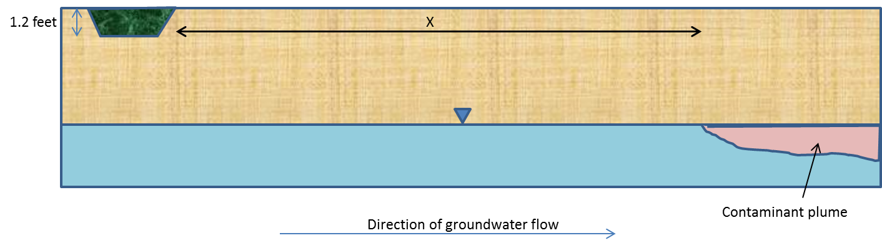

Example 2
An infiltration basin is being constructed on a site with a known contaminant plume. The basin is designed to treat 1.5 acres of runoff from an impervious surface. The distance from the property boundary to the plume is 90 feet. What is the maximum length that the infiltration basin can be (Z in the schematic) and what will the width of the basin be if the maximum length is utilized? Site characteristics include the following.
- Soil tests indicate the soil is very coarse sand with an infiltration rate of 6 inches per hour. The maximum recommended depth of an infiltration practice is 4 feet. Thus, the entire design volume can be infiltrated in 8 hours [(6 in/hr)(1ft/12in)(24 hr/day)]. The recharge rate is 12 feet per day and the time is 0.33 day.
- The hydraulic conductivity is 12 feet per day. The specific yield for a coarse sand is 0.26 (see link).
- The aquifer is determined to be 15 feet thick based on measurements within the plume.
If the basin was designed as a square, the length would be 36.9 feet and the length of the mound from the center of the basin to a point where the mound height was 0.25 feet would be 71.5 feet. This means the length from the edge of the basin to this mound height is 71.5 minus 18.5 (half the basin length) or 53 feet. Using a safety factor of 2, the acceptable length would thus be 106 feet. This does not include the basin length and exceeds the 90 foot distance we have to work with. If the basin length was 20 feet and the width was 136.1 feet, the length of the mound from the center of the basin to a point where the mound height was 0.25 feet would be 44.5 feet. Subtracting off half of the basin length gives an acceptable plume length of 34.5. Using a safety factor of 2 yields a length of 69 feet from the edge of the basin to a point where the mound height is 0.25 feet. Adding the length of the basin so that it fits on the property, 20 feet, gives a total length of 89 feet, which is within the property boundary and achieves an acceptable plume length. The infiltration basin can therefore be 20 feet by 136.1 feet (Z = 20 feet in the schematic). A smaller length could also be used.

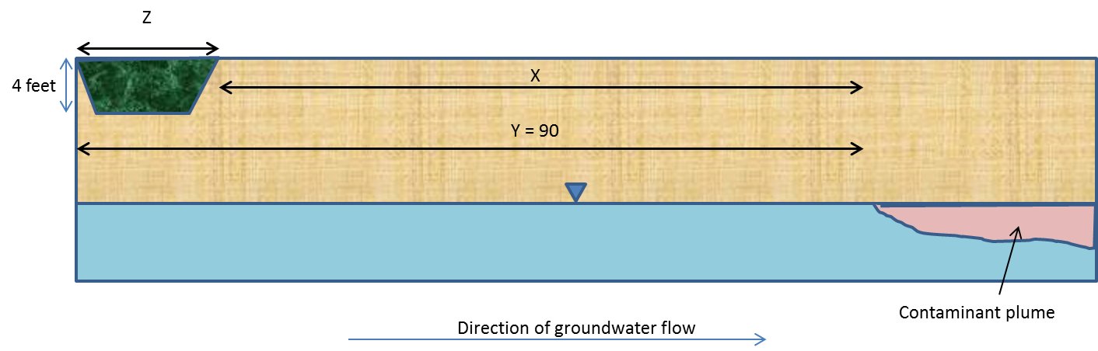

Example 3
An infiltration basin is being constructed on a site with known soil contamination that is 2 feet about the water table. The basin is designed to treat 1.5 acres of runoff from an impervious surface. The basin is square and therefore 36.9 feet on each side. What is the minimum distance from the edge of the basin to a point where the soil contamination will not be intersected?
- Soil tests indicate the soil is very coarse sand with an infiltration rate of 6 inches per hour. The maximum recommended depth of an infiltration practice is 4 feet. Thus, the entire design volume can be infiltrated in 8 hours [(6 in/hr)(1ft/12in)(24 hr/day)]. The recharge rate is 12 feet per day and the time is 0.33 day.
- The hydraulic conductivity is 12 feet per day. The specific yield for a coarse sand is 0.26 (see link).
- The aquifer is determined to be 15 feet thick based on measurements within the plume.
To solve this problem, we introduce a safety factor of 2 and are therefore looking for a scenario where the mound height is 1 foot or less (2 feet of separation from the contaminant to the water table divided by the safety factor in this case). Using the USGS calculator indicates the distance from the center of the basin to a point where the mound height is 1 foot is 38 feet. Subtracting half the basin length yields a distance of 38 minus 18.5 or 19.5 feet. The edge of the infiltration basin closest to the contamination should therefore be a minimum distance of 19.5 from the contamination.

