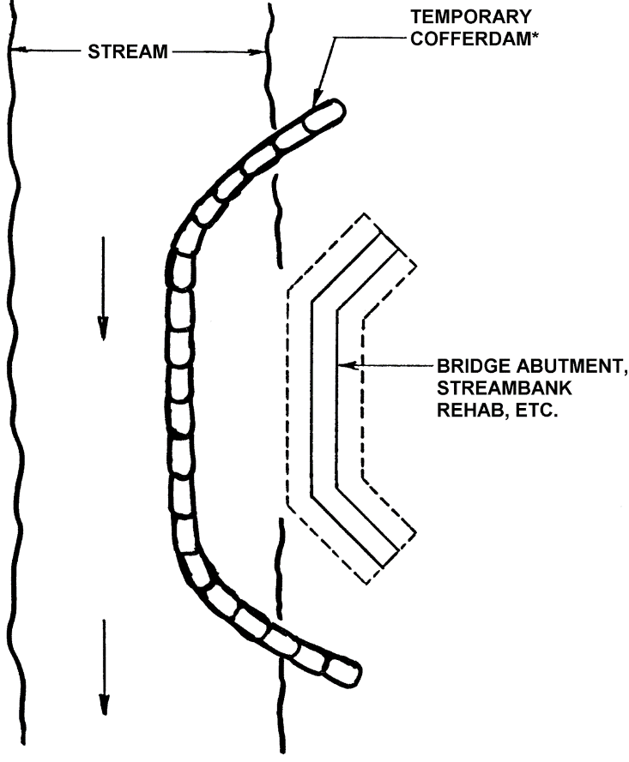
Diversion Barrier Controls (Temporary)
Figure 1-1. Example of temporary barrier application
Source: Pennsylvania DEP

Definition
Cofferdams and small dikes are temporary barriers or dams used to stop or redirect the flow of water from a construction site work area, such as a support column foundation, a shoreline retaining wall location, a trench crossing at a stream or river, or other area adjacent to or within a body of water.

Purpose and Function
Temporary diversion barrier controls (e.g. cofferdams) allow for “working in the dry” when construction projects are adjacent to – or within – surface waters. They prevent water from entering work zones on or near waterbodies, such as where excavation, concrete pouring, drilling, or other tasks are being conducted. They function by holding back water and creating a relatively dry area for construction activities requiring such conditions. These activities can include water exclusion enclosures adjacent to banks, within a river or lake, or water exclusion areas along stream reaches that have been dewatered by damming the upstream channel and creating a bypass ditch or pipe to deliver the diverted flow downstream beyond the work area (e.g., pipe trench location). Diversion barrier controls also prevent work zone sediment from entering the waterbody.

Applicability
Diversion barrier controls are appropriate for work zones that require dewatering and water exclusion during the construction period. Cofferdams and temporary dikes are almost always removed after work is completed. Floating sediment curtains may be used during the installation or use of diversion barrier controls to minimize turbid conditions in the waterbody.

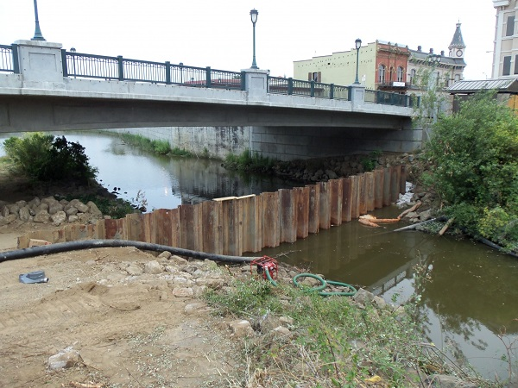
Figure 1-2. Example sheet pile cofferdam installation
Source: provenmanagement.com

Site Applicability
Temporary diversion barrier controls such as cofferdams and smaller dikes or barriers are very site specific. The type and configuration of the barrier is driven by the height and resulting pressure of water to be excluded, underwater conditions (i.e., soil, rock, etc.), the length of the barrier, the length of time and season of use, and other criteria. They provide a means to complete work required for underwater locations where temporary dewatering and water exclusion can be accomplished. Sheet pile cofferdams are often used for larger projects, such as bridge piers. Smaller, easily constructed barriers made of wood, earthen berms, Jersey wall sections, water-filled tubes, sandbags, and other materials can be used for smaller projects. Portable fabric dams can also be used to exclude water while preventing downstream siltation from eroding earthen dams.

Permit Applicability
Section IV.C.1 of the 2013 MPCA Construction Stormwater General Permit states that “(t)he Permittee(s) must employ sediment control practices as necessary to minimize sediment from entering surface waters.” Diversion barrier controls keep water out of the work zone, and sediment out of the waterbody. Where diversions are used at work zones below the waterline, Section IV.C.2 of the permit states that “a floating silt curtain can be used as a perimeter control practice if the floating silt curtain is installed as close to shore as possible.” Floating silt curtains should be kept as close to the work zone as possible, to prevent turbid conditions at locations away from the work zone.

Effectiveness
Properly designed and installed cofferdams and other barriers are effective at keeping sediment out of the adjacent waterbody (Table 1-1). Where cofferdams and temporary drainage ditches/channels are used to dewater or divert a stream, river, lake, or other area, special attention is required to ensure that bare soil along the bypass ditch or channel is stabilized. Methods can include lining a small temporary stream bypass channel with plastic, where necessary, or using geotextile to cover exposed bare areas. Careful installation and removal of the barrier and restoration of the work area is required to ensure effectiveness.

Table 1-1. Expected performance for temporary diversion barrier controls
Water Quantity
Flow attenuation
Runoff volume reduction
Water Quality
Pollution prevention
Soil erosion
Sediment control
Nutrient loading
Pollutant removal
Total suspended solids
Total phosphorus
Heavy metals
Floatables
Oil and grease
Primary design benefit
Secondary design benefit
Little or no design benefit

Planning Considerations
Temporary diversion barrier control location is typically driven by engineering and operational staging considerations for the overall project (e.g., location of bridge support piers, lakeside armoring, sewer line route, etc.). Whenever possible, install and use temporary barriers during periods of low flow and warmer weather for greater efficiency and effectiveness. Winter and early spring may pose a greater risk of damage to diversions due to ice pressure and ice breakup. Components and materials are selected based on water height/hydraulic pressure, site conditions, longevity requirements, and other relevant factors. Temporary diversion barrier controls should be sited, constructed, and operated so as to cause minimal disruption to the aquatic environment, especially during fish spawning. Note that these projects usually need state, federal, or local permits. For example, placement of cofferdams in regulated waterbodies requires permit coverage from the US Army Corps of Engineers under Section 404 of the Clean Water Act, and a Water Quality Certification from MPCA.

Design and Construction
Small barriers (i.e., less than 2-3 feet high) can be installed by field personnel based on standard designs and industry practice. Larger barriers require site specific engineering analysis. Design parameters for cofferdams and other water exclusion barriers incorporate the planning considerations noted above, along with safety concerns regarding stability, the power of flowing water at stream and river locations, and other water related safety issues. Other design considerations include the following:
- Mobilization areas for temporary diversion barrier placement or construction should be kept as small as possible to facilitate erosion and sediment control, and protected with downgradient sediment barriers.
- Placement activities should minimize vegetation removal and disturbance of adjacent areas to the maximum extent practicable.
- Where possible, use barrier controls constructed without earth fill – such as sand bags, sand totes, Jersey wall sections, collapsible fabric membrane dams, Aqua-Barrier®, Portadam, water filled bags/tubes, sheet piling, plastic wrapped hay bales/soil/aggregate/riprap, plastic sealed plywood, plastic sealed trench box lids, or other suitable materials.
- Earth fill barriers require stabilization to prevent erosion as bare soils come into contact with flowing water. Stabilization can often be achieved by covering bare areas with well-secured plastic sheeting.
- Sheet pile or collapsible fabric dams should be considered in sensitive areas, such as spawning areas.
- Ensure that barriers structures are of sufficient height to prevent waves or overflows from flooding the enclosed work area.
- For dewatering a stream reach, install barriers at upstream and downstream locations. If used, stabilize the bypass trench/channel with plastic sheeting, rock, or other liner material to prevent turbidity downstream.
- Dewatering of the enclosure typically requires sediment removal to ensure that turbid water is not discharged into nearby waterbodies. Prior to discharge to a water of the State, sediment-laden water is required to be treated with an appropriate BMP such as:
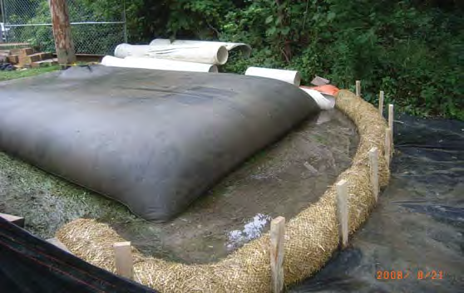
  - Sand filters
  - Flocculants
  - Portable treatment unit
  - Sediment pond or bags
- If stored onsite, material excavated from the mobilization site, the enclosure, or removed from the discharge water should be placed in stockpiles protected with erosion and sediment control measures, such as plastic sheeting or tarpaulin covers, downgradient sediment barriers, temporary mulch and seed, or other measures.
Figure 1-3. Sediment bag
Source: MnDOT
- Upon completion of work in the barrier area, demobilization and backfilling should occur with minimal additional soil disturbance and in a manner that minimizes turbidity in the nearby waterbody. Backfilling with hydraulic dredge or via slurry application should be avoided if possible.
- Suggested materials for temporary barriers in shallow water (up to 3 feet) include:
  - Sandbags
  - Plywood barriers
  - Median barriers
  - Jersey wall sections
  - Water-filled bags or tubes (aqua tubes)
  - Collapsible portable fabric membrane
- For temporary barriers in medium depth water (3 to 6 feet), suggested materials include:
  - Large sand totes
  - Collapsible portable fabric membrane
  - Porta-dam
  - Riprap with weighted silt curtain or plastic barrier
- For temporary barriers in deep water (more than 6 feet), suggested materials include:
  - Sheet piling
  - Other structural steel or concrete materials

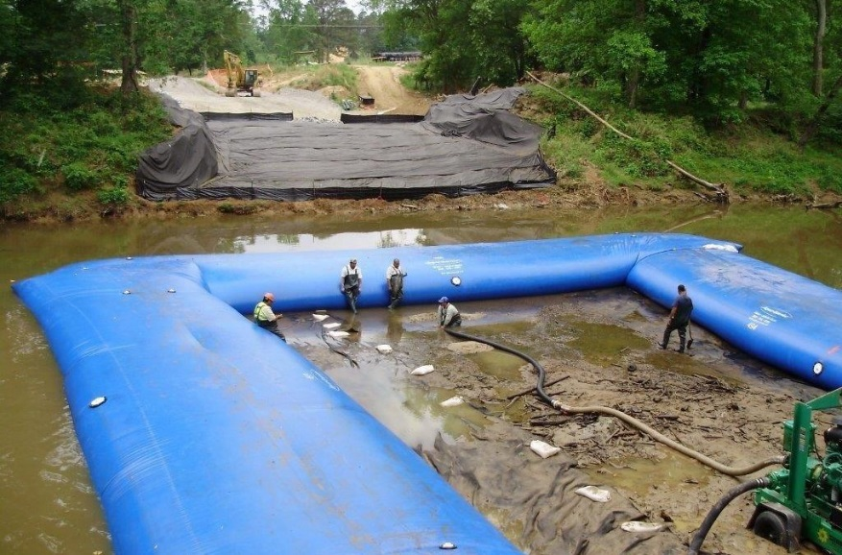
Source: hydrologicalsolutions.com
Figure 1-4. Example cofferdam installation

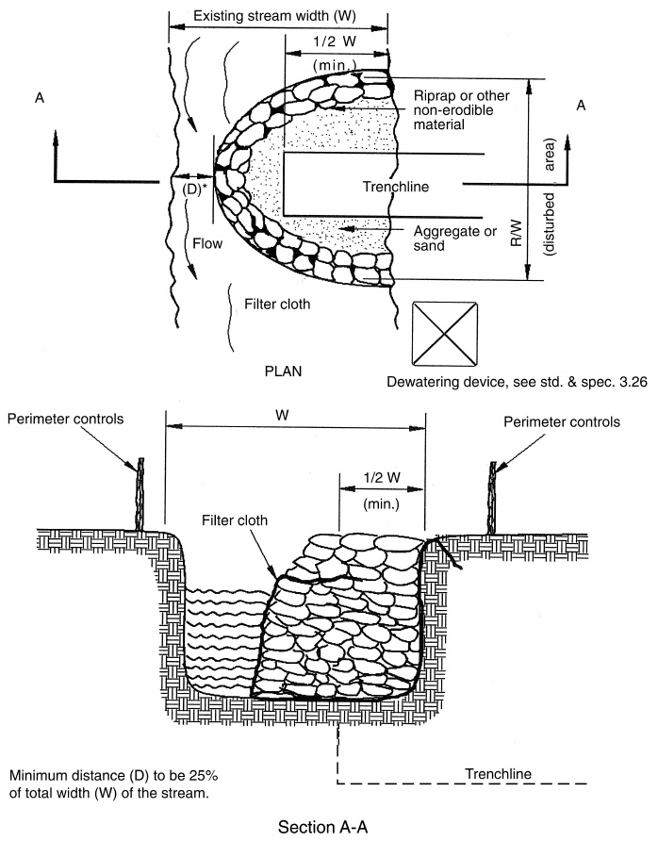
Source: MPCA
Figure 1-5. Example cofferdam cross section

Standards and Specifications

Detailed guidance on planning and executing projects within and adjacent to waterbodies can be found in Chapter 3 of the Minnesota DNR’s Best Practices Manual: Best Practices for Meeting DNR General Public Waters Work Permit GP 2004-0001 – Methods for In-Water Construction (http://files.dnr.state.mn.us/waters/watermgmt_section/pwpermits/gp_2004_0001_chapter3.pdf)

In addition, MnDOT Specification 2451.3.A.3.a (Cofferdams; page 282) provides guidance for cofferdam placement and removal. The 2016 edition of MnDOT Standard Specifications for Construction can be found on page 282 of the following guidance document:
http://www.dot.state.mn.us/pre-letting/spec/ (See http://www.dot.state.mn.us/pre-letting/spec/2016/2016specbook.pdf)

Inspection and Maintenance
Due to the proximity to regulated waters, temporary diversion barriers require continuous observation and inspection throughout mobilization, installation, and deconstruction to ensure minimal impacts on nearby waterbodies. Key inspection guidance includes the following:
- Ensure that disturbed areas where mobilization and barrier installation occurs are protected with erosion prevention and sediment control measures. Inspect them weekly to ensure performance.
- Waters adjacent to the barrier structures should be inspected for turbidity on a continuous basis. Excessive turbidity should be addressed and eliminated to the extent possible. If the source of turbidity cannot be eliminated or mitigated, the use of floating turbidity curtains or other barrier is recommended.
- Dewatering intakes, transmission pipes/hoses, discharge areas, and treatment facilities for the discharge also require continuous monitoring and inspection to ensure that intake filters (if used) are serviced, pipes/hoses do not leak and discharge turbid water, and treatment facilities (e.g., filter bag, sediment trap/basin, etc.) are functioning properly.

Maintenance for temporary diversion barriers includes responding to the inspection and monitoring findings listed in the preceding subsection. Particular concerns include turbidity in the adjacent waterbody, erosion and sediment runoff from staging/mobilization areas, and performance of the BMP(s) responsible for sediment removal at the dewatering discharge location. In general, find and eliminate sources of turbidity, or use floating silt curtains to prevent turbid waters from migrating away from the immediate construction area. Clear sediment and debris from dewatering pump intake screens and filters as needed. Clean discharge area filters (e.g., filter fabric, silt fencing, etc.) and remove accumulated sediment before it restricts or consumes half of the effective treatment volume or storage capacity. Replace or clean filter bags as needed.

The following provides an example inspection and maintenance checklist (Source: Toronto and Region Conservation Authority)
- Ensure that the cofferdam or barrier is effectively isolating the work area.
- Ensure that an impermeable liner has been used in the construction of the barrier.
- Check for any leaks, particularly at the bottom and sides (streambanks) of the dam.
- Construction practices should prevent tearing of sand bags and release of material into the stream.
- Leaks should be addressed by constructing a second barrier to contain the leak.

Costs
The following table summarizes estimated BMP costs based on MnDOT data summarizing average bid prices for awarded projects in 2014.

Table 1-2. Average Bid Prices (Based on Awarded Projects) for Spec Year 2014. Average price varies from year to year. Data for other years can be found on MnDOT’s website. (Source: MnDOT)
Bid Item | Item Description | Units | Average Price
2105.601/00045 | Temporary Stream Diversion System | LS | $26,292.50
2452.601/00011 | Steel Sheet Piling (Temporary) | LS | $107,614.29
2452.618/00011 | Steel Sheet Piling (Temporary) | SF | $16.75
2573.504/00010 | Sandbag Barrier | SF | $10.55
2105.601/00010 | Dewatering | LS | $65,587.94

Reference Materials
Except where more stringent requirements are presented in this guidance, cofferdams (temporary dikes) shall comply with MnDOT and other state requirements. Primary design references include:
- MnDOT Erosion Control Handbook II
http://www.dot.state.mn.us/environment/erosion/pdf/2006mndotecfieldhandbook.pdf
- 2013 Minnesota NPDES/SDS Construction Stormwater General Permit
http://www.pca.state.mn.us/index.php/water/water-types-and-programs/stormwater/construction-stormwater/index.html
- MnDOT Standard Specifications for Construction (2016 Edition)
http://www.dot.state.mn.us/pre-letting/spec/
- MnDNR Best Practices Manual: Best Practices for Meeting DNR General Public Waters Work Permit GP 2004-0001 Methods for In-Water Construction, Chapter 3 http://files.dnr.state.mn.us/waters/watermgmt_section/pwpermits/gp_2004_0001_chapter3.pdf

The following is a list of additional resources that are not specific to Minnesota:
- Delaware Erosion & Sediment Control Handbook (Cofferdam Stream Diversion)
http://www.dnrec.delaware.gov/swc/pages/sedimentstormwater.aspx
- Illinois Urban Manual Practice Standard: Cofferdam (Code 803)
http://www.aiswcd.org/illinois-urban-manual/practice-standards/
- Idaho Transportation Department (ITD) Temporary and Construction Site Best Management Practices (EC-3 Coffer Dam)
http://itd.idaho.gov/enviro/stormwater/BMP/default.htm
- Washington State Department of Transportation (WSDOT) Road Maintenance Guidelines, Part 2: Best Management Practices (Cofferdam)
http://www.wsdot.wa.gov/NR/rdonlyres/F70E7937-F4DD-4ECC-9909-0C108C97C37A/0/Part2.pdf

Storm Drain Inlet Protection

Definition
Inlet protection includes a wide variety of approaches for trapping sediment through physical filtration and settling processes before it enters a storm drain. There are many options and variations available. Inlet protection is part of a system of erosion prevention and sediment control, and works best when upslope sources of sediment are reduced – primarily by stabilizing bare areas and maintaining perimeter controls.

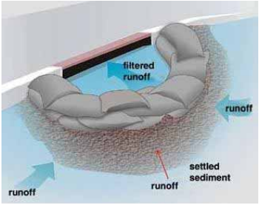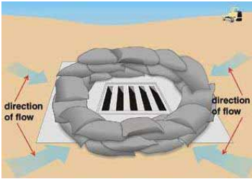
Source: MPCA
Figure 2-1. Examples of inlet protection BMPs utilized with a catch basin (top) and drop inlet (bottom)

Purpose and Function
Inlet protection devices intercept, and/or filter sediment before it can be transported from a site into the storm drain system and discharged into a lake, river, stream, wetland, or other waterbody. These devices also keep sediment from filling or clogging storm drain pipes, ditches, and downgradient sediment traps or ponds. Inlet protection may also include placement of a barrier to create a bypass of an inlet transferring flow downstream to a sediment trap, basin, or other inlet discharging to a non-critical area.

Applicability
Inlet protection devices may be applied to any curb inlet, drop inlet, manhole, catch basin, or other entry point to the stormwater drainage system that might receive inflows with high sediment levels. Inlet protection is critical because it often is the last treatment measure before stormwater enters receiving waters.

Site Applicability
Construction sites often drain toward the inlets, pipes, and ditches that comprise the stormwater drainage system. Inlet protection devices can help protect these surface and subsurface systems from high levels of sediment in runoff. Inlet protection in areas with surface drainage ditches are usually only protected by stabilization practices, perimeter controls, and sediment traps. Consider the following when evaluating the use of inlet protection for a site:
- Most inlet protection devices are suitable for a drainage area of one acre or less. Runoff from larger disturbed areas should be routed to more suitable BMPs such as a temporary sediment trap or temporary sediment basin.
- Inlet protection devices may result in ponding of water around the inlet. This may result in a traffic hazard depending on site location.
- Inlet protection should be located in areas where potential ponding will not have adverse impacts.
- Under high flow conditions, sediment removal may be ineffective.
- Inlet protection is intended for low flows having relatively low sediment loading.
- Inlet protection that is not properly installed, maintained, or removed may result in short-circuiting of flow and introduction of sediment into the storm drain system.
- Stabilizing bare soil areas draining to the inlet and maintaining perimeter controls (e.g., silt fence, fiber logs) can help to prevent sediment overloads at inlet locations.

Permit Applicability
Section IV.C.1 of the 2013 MPCA Construction Stormwater General Permit states that the permittee(s) “must employ Sediment control practices as necessary to minimize sediment from entering surface waters, including curb and gutter systems and storm sewer inlets.” In addition, Section IV.C.4 stipulates that “(a)ll storm drain inlets must be protected by appropriate BMPs during construction until all sources with potential for discharging to the inlet have been stabilized. Inlet protection may be removed for a particular inlet if a specific safety concern (street flooding/freezing) has been identified by the Permittee(s) or the jurisdictional authority (e.g., city/county/township/MnDOT engineer). The Permittee(s) must document the need for removal in the SWPPP.”

Where permanent stormwater controls include filtration systems, Section III.D.1.d of the 2013 MPCA Construction Stormwater General Permit specifies that “(t)o prevent clogging of the infiltration or filtration system, the Permittee(s) must use a pretreatment device such as a vegetated filter strip, small sedimentation basin, or water quality inlet (e.g., grit chamber) to settle particulates before the stormwater discharges into the infiltration or filtration system.”

Effectiveness
Properly selected, installed, and maintained inlet protection devices can remove 25-35 percent of total solids and up to 15-25 percent of nutrients from incoming flows (Florida DOT 2010). They work very well in keeping sandy and some silty soils out of storm drains, but have somewhat limited effectiveness with fine clay soils passing through the barrier. Supplementing downgradient inlet protection devices with upgradient soil stabilization and perimeter controls increases in importance as site soils become finer (e.g., clays). Filter fabric can be added to inlet protection devices using coarse stone or aggregate to enhance sediment removal. However, the possibility of increased ponding should be considered. The following table summarizes expected performance for an array of typical water quantity and quality target constituents for storm drain inlet protection BMPs that are properly designed, installed, and maintained.

Table 2-1. Expected performance for storm drain inlet protection
Water Quantity
Flow attenuation
Runoff volume reduction
Water Quality
Pollution prevention
Soil erosion
Sediment control
Nutrient loading
Pollutant removal
Total suspended solids
Total phosphorus
Heavy metals
Floatables
Oil and grease
Primary design benefit
Secondary design benefit
Little or no design benefit

Planning Considerations
Install inlet protection devices before upslope soil disturbance occurs. In newly developed areas, inlet protection should be placed immediately after the storm sewer inlets are installed. It is critical that the storm sewer inlet not be completely blocked by inlet protection when public safety is a concern. Inlet protection should only be used in locations where sediment can be removed and temporary ponding will not create a public safety hazard or cause property damage. Blocking an inlet can cause streets to flood and sediment to build up. Select inlet protection devices that do not pond water where adjacent areas are open to traffic. Examples of these include low-profile filter berms and filters suspended in the inlet structure. Because inlet protection devices are high-maintenance BMPs, ensure that up-gradient soil stabilization, perimeter protection, and other erosion control practices are in place to minimize the amount of sediment in stormwater flowing to inlets. Note that straw bales are not approved as inlet BMPs.

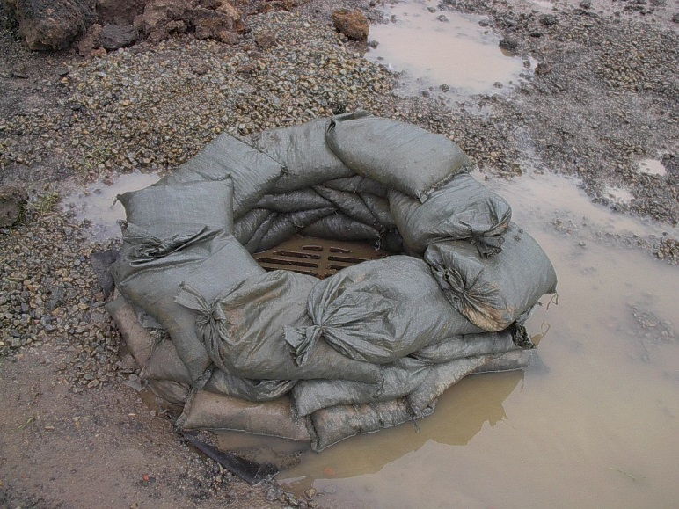
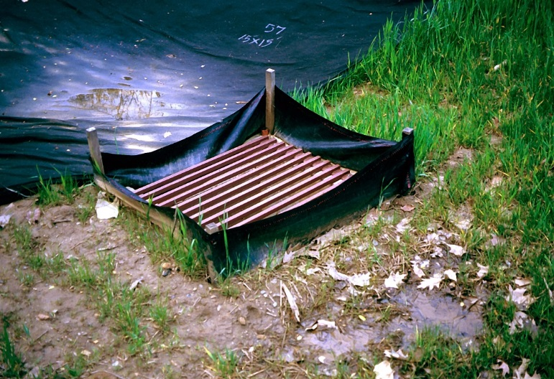
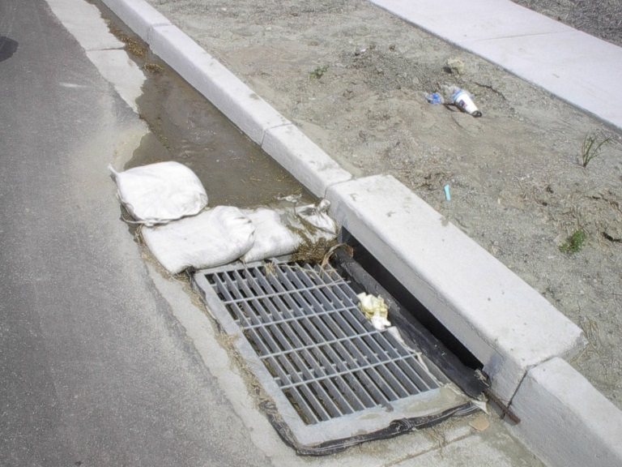
Design
Figure 2-2. Drop inlet with gravel bag protection
Source: Tetra Tech
Figure 2-3. Inlet protection for a drop inlet using silt fence
Source: Tetra Tech
Figure 2-4. Inlet protection for curb inlet using gravel bags and filter suspended in the inlet. Additional bags can be placed at intervals against the curb upstream to increase sediment trapping potential in ultra-urban situations.
Source: Tetra Tech

Performance of all types of inlet protection depends on proper installation and use of materials. Materials should be checked for conformance with applicable MnDOT specifications. Inlet protection devices can be fabricated from clean aggregate, filter fabric, or other materials, or an appropriate device can be selected from the many commercial products available for construction site stormwater management. As noted above, devices that are bulky (e.g., concrete block) or that result in deeply ponded water and sediment deposits (e.g., rock and other berms) may not be appropriate for inlets on or immediately adjacent to public roadways.

Inlet protection can include:

- Rock berms, bags, tubes, and logs
- Compost and fiber logs
- Sediment dikes
- Inlet frame filters
- Silt fence enclosures
- Silt fence ring and rock filter (berm or log) combination
- Pop-up head risers
- Geotextile wraps
- Filter bag inserts
- Other manufactured products such as drop inlet baskets

MnDOT classifies protection devices for field inlets, curb inlets, curb inlets without a curb head, and culvert inlets. When using manufactured inlet protection products, the MnDOT approved/qualified products list should be consulted to determine the acceptable materials and products to protect each type of inlet. The current list of approved/qualified products for inlet protection can be found on the MnDOT website: http://www.dot.state.mn.us/products/erosioncontrolandlandscaping/inletprotection.html

Regardless of the type of inlet protection BMP selected, there are a few key design guidelines:
- For best results, reduce demands on inlet BMPs through prompt stabilization of upslope areas and maintenance of appropriate perimeter controls downslope of disturbed areas.
- Filtration devices generally offer better performance than ponding devices, but they involve higher attention to maintenance – removing and cleaning them regularly.
- Inlet protection devices must intercept all incoming flows before they can enter storm drains.
- Select and install BMPs that cannot be floated or otherwise pushed away by heavy inflows.
- While overflow allowances are necessary to facilitate ponding and settling, no bypasses around the sides of the inlet protection device or below the device should occur unless the inlet is being intentionally bypassed (i.e., to prevent flows to a critical area by routing them to a sediment trap, basin, or non-critical area).
- Inlet protection BMPs should be left in place until the drainage area is stabilized with established vegetation or pavement.

Standards and Specifications
MnDOT Standard Plan 5-297.405 provides standard detail for storm drain inlet protection (effective date: 8/6/2014). Specific BMP types covered include “Filter Bag Insert”, “Rock Log/Compost Log”, “Pop-Up Head”, “Sediment Control Inlet Hat”, and “Silt Fence Ring and Rock Filter Berm”:
http://standardplans.dot.state.mn.us/StdPlan.aspx (See page 30, Standard Plan 5-297.405, 4 of 7.)

MnDOT Specification 2573.3.M (Storm Drain Inlet Protection) provides general guidance for implementation and maintenance of inlet protection BMPs. Specifications 3137 (Coarse Aggregate) and 3886 (Silt Fence) may also be applicable depending on the selected design. The 2016 edition of the MnDOT Standard Specifications for Construction can be found here:
http://www.dot.state.mn.us/pre-letting/spec/ (See http://www.dot.state.mn.us/pre-letting/spec/2016/2016specbook.pdf, page 494.)

Inspection and Maintenance
Storm drain inlet protection is only as effective as the filter or barrier used around the inlet. Properly maintaining inlet protection is difficult and often inlets become clogged, causing erosion elsewhere.
- Inspect inlet protection immediately before and after rain events and snowmelt.
- Note where no inlet protection is present, and determine need for inlet protection.
- Look for and document sediment deposits on the pavement and sediment on inlet filters.
- During cold weather, note if ice and snow are affecting performance.
- Note any actual or potential bypasses around the sides or underneath inlet protection.
- Ensure that there are no large holes or gaps in the inlet protection.
- Assess whether or not the BMP will be dislodged in the event of high incoming flows.
- Note where overflows occur during heavy rain, to ensure public safety and erosion control
- Observe and document any safety concerns regarding sediment deposits and the BMP, such as mud in the roadway (especially high-speed roads), BMP components in traffic lanes, etc.

The following is an example inspection checklist for inlet protection BMPs (source: Ohio EPA):

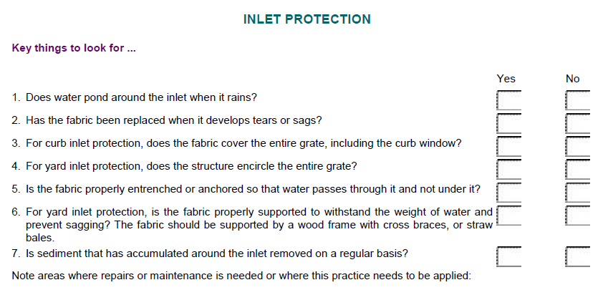

Inlet protection devices are high-maintenance BMPs, and typically require maintenance after nearly every precipitation event.
- Maintain inlet BMPs until all upslope areas are stabilized, and incoming flows are clean.
- Remove sediment deposits on the pavement before they reach halfway up to the overflow point.
- Remove sediment deposits immediately if they might affect traffic safety.
- Remove sediment from filtration areas, and clean filter surfaces to ensure future performance.
- Geotextiles, rock, and perforated pipe can easily become plugged with sediment. These should be routinely cleaned and/or replaced.
- Any excavated sediment should be placed where it will not create an erosion problem.
- Remove snow and ice affecting performance – use hand tools or heat; do not use salt.
- Repair or otherwise address bypasses over, underneath, or around the sides of the BMP.
- Ensure that heavy rains overtopping the BMP do not cause safety or erosion concerns.
- Repair any holes or gaps in the inlet protection device.
- If flows are dislodging the BMP, use sand/rock bags or other item to hold the BMP securely in place, or replace the failing BMP with another device that can handle incoming flows.
- Where inlet BMPs might impact traffic safety, select a low-profile alternative or use filter inserts.
- If inlet protection devices cannot be used due to traffic safety concerns, the sediment levels in incoming flows must be reduced through immediate stabilization of upslope bare areas and enhanced perimeter controls. If the unprotected inlet discharges to a suitable area, a sediment trap may be installed to address the untreated flow.

MnDOT’s workmanship and rework schedule in Table 2-2 (2016; version under development at the time of manual update) identifies common deficiencies for various types of temporary sediment control BMPs, including storm drain inlet protection, and corrective actions for these deficiencies. Once complete, the full, final version of this table will replace Table 2573-1 in MnDOT Standard Specifications for Construction (2016 edition).

Table 2-2. Excerpt from Table 2573-1, Temporary Sediment Control: Corrective Actions
Item | Corrective Action Required if | Corrective Action
Storm drain inlet protection | Inlet opening unprotected  Emergency overflow not provided where required  Device not cleaned out  Improper inlet protection for scope of work  Flooding occurring in public use drive lanes | Immediately install inlet control device appropriate to the work  Immediately correct missing overflow condition  Immediately restore function of inlet control device  Immediately correct inlet device for scope of work  Immediately correct flooding condition by changing device or flow constriction

Costs
The following table summarizes estimated BMP costs based on MnDOT data summarizing average bid prices for awarded projects in 2014.

Table 2-3. Average Bid Prices (Based on Awarded Projects) for Spec Year 2014. Average price varies from year to year. Data for other years can be found on MnDOT’s website. (Source: MnDOT)
Bid Item | Item Description | Units | Average Price
2573.530/0010 | Storm Drain Inlet Protection | EACH | $175.21
2573.531/0010 | Storm Drain Inlet Protection | LS | $500.00

Reference Materials
Except where more stringent requirements are presented in this guidance, BMPs shall comply with MnDOT and other state requirements. Primary design references include:
- MnDOT Erosion Control Handbook II
http://www.dot.state.mn.us/environment/erosion/pdf/2006mndotecfieldhandbook.pdf
- Minnesota Urban Small Sites Best Management Practice Manual (Inlet Protection)
http://www.metrocouncil.org/Wastewater-Water/Planning/Water-Resources-Management/Water-Quality-Management-Key-Roles.aspx
- 2013 Minnesota NPDES/SDS Construction Stormwater General Permit
http://www.pca.state.mn.us/index.php/water/water-types-and-programs/stormwater/construction-stormwater/index.html
- MnDOT Standard Specifications for Construction (2016 Edition)
http://www.dot.state.mn.us/pre-letting/spec/
- MnDOT Standard Drawings for use in Construction Plans http://standardplans.dot.state.mn.us/StdPlan.aspx

The following is a list of additional resources that are not specific to Minnesota:
- Clark County Washington Stormwater Manual (BMP C220: Storm Drain Inlet Protection)
https://www.clark.wa.gov/environmental-services/stormwater-code-and-manual
- Clean Water Services Erosion Prevention and Sediment Control Manual (4.3.5 Inlet Protection)
https://www.cleanwaterservices.org/media/1464/erosion-prevention-and-sediment-control-manual.pdf
- Florida DOT 2010 study on Inlet Protection Devices and their Effectiveness, conducted by the University of Central Florida’s Civil, Environmental, and Construction Engineering Department http://www.dot.state.fl.us/research-center/Completed_Proj/Summary_RD/FDOT_BDK78_977-03_rpt.pdf
- Ohio Environmental Protection Agency (Ohio EPA) Construction Site Inspection Checklist for OHC000004 http://www.epa.ohio.gov/portals/35/storm/CGP_Ins1.pdf.
- North Carolina Erosion and Sediment Control Planning and Design Manual (6.50-6.55 Inlet Protection)
https://deq.nc.gov/about/divisions/energy-mineral-land-resources/energy-mineral-land-permit-guidance/erosion-sediment-control-planning-design-manual
- Tennessee Department of Environment and Conservation (TDEC) Erosion and Sediment Control Handbook (7.35 Inlet Protection) http://tnepsc.org/handbook.asp
- Virginia Erosion and Sediment Control Handbook (3.07 Storm Drain Inlet Protection) http://www.deq.virginia.gov/Programs/Water/StormwaterManagement/Publications/ESCHandbook.aspx

Outlet Energy Dissipation (Scour Protection)

Definition
Permanent or temporary energy dissipators prevent erosion, turbulence, and turbidity where stormwater pipes or ditches discharge to unprotected areas, such as channel banks, slopes, or upslope outfall locations. Their main purpose is to reduce the speed of concentrated flows to prevent scour at conveyance outlets. This practice is also called Scour Protection or Outlet Protection. Common types of outlet protection devices include concrete aprons, riprap-lined basins, and settling (stilling) basins.

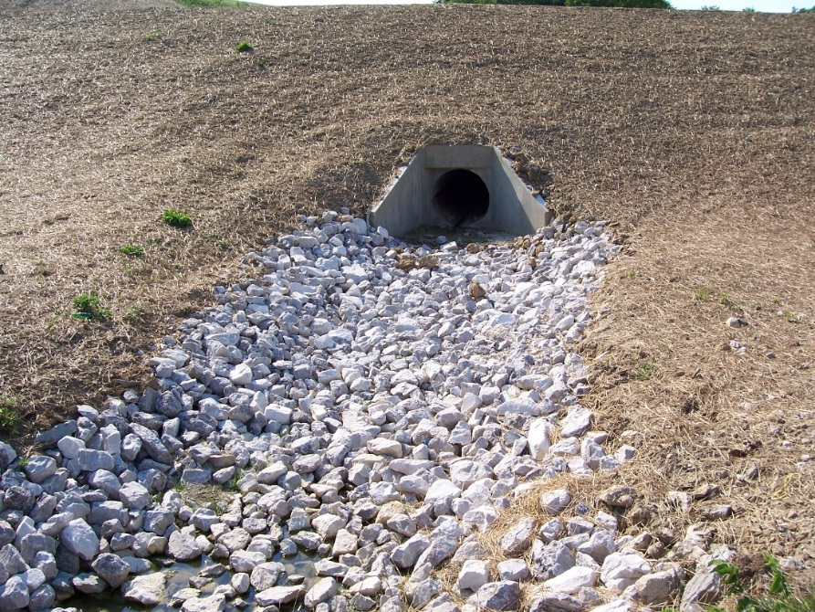
Figure 3-1. Example of riprap outlet protection
Source: Tetra Tech

Purpose and Function
Energy dissipators intercept incoming flows from pipes and ditches and deflect, scatter, or otherwise neutralize the erosive force of concentrated, moving stormwater. These structures are intended to protect soil from turbulence and high velocities, which can otherwise cause scour erosion. They typically consist of a structural apron lining fabricated from riprap, concrete, turf reinforcement mats, or other structural materials. Certain types of basins (e.g., settling/stilling/impact basins) can also function as energy dissipators. Many of these techniques are effective and relatively inexpensive and easy to install. Energy dissipators require careful design based on the hydraulic forces of concentrated flows exiting pipes and ditches.

Applicability
Energy dissipators at pipe and ditch outlets are appropriate for any unpaved or otherwise non-armored location where concentrated flows are discharged to areas subject to erosion.

Site Applicability
Energy dissipators are used where concentrated flows are discharged against channel banks, on poorly stabilized slopes, or onto upslope areas that are not protected against erosive flows. They are appropriate at the outlets of ponds, pipe slope drains, culverts, ditches, or other conveyances, and where runoff is conveyed to a natural or manmade drainage feature such as a stream, wetland, lake, or ditch. The most common applications include riprap aprons at culvert outlets, ditches lined with turf reinforcement matting, and stilling or impact basins designed to accept and dissipate high energy stormwater flows. Some important considerations when selecting energy dissipators for a site include:
- It may be difficult to remove sediment trapped by the dissipator without removing and replacing the structure.
- Rock/riprap outlets with high velocity flows require frequent maintenance.
- These BMPs may not be aesthetically pleasing.

Permit Applicability
Section III.C.3 of the 2013 MPCA Construction Stormwater General Permit requires energy dissipation at the outlet of temporary and wet sedimentation basins. Section IV.B.3 of the permit states that the permittee(s) “must use erosion controls and velocity dissipation devices such as check dams, sediment traps, riprap, or grouted riprap at outlets within and along the length of any constructed stormwater conveyance channel, and at any outlet, to provide a non‐erosive flow velocity, to minimize erosion of channels and their embankments, outlets, adjacent stream banks, slopes, and downstream waters during discharge conditions.”

Section IV.B.5 stipulates that “(p)ipe outlets must be provided with temporary or permanent energy dissipation within 24 hours after connection to a surface water,” and Section IV.B.6 requires permittee(s) to use “velocity dissipation devices if necessary to prevent erosion when directing stormwater to vegetated areas.” Discharge points from the dewatering of sediment basins must be “adequately protected from erosion and scour,” and “(t)he discharge must be dispersed over natural rock riprap, sand bags, plastic sheeting, or other accepted energy dissipation measures” (Section IV.D.1).

Effectiveness
Properly installed temporary and permanent energy dissipators are effective in preventing channel bank scour, slope gullying, and plunge pool erosion where concentrated flows discharge into unarmored, poorly stabilized areas.

Table 3-1. Expected performance for outlet energy dissipators
Water Quantity
Flow attenuation
Runoff volume reduction
Water Quality
Pollution prevention
Soil erosion
Sediment control
Nutrient loading
Pollutant removal
Total suspended solids
Total phosphorus
Heavy metals
Floatables
Oil and grease
Primary design benefit
Secondary design benefit
Little or no design benefit

Planning Considerations
A review, analysis, and evaluation of both the location and magnitude of concentrated flows associated with culvert, ditches, and channel discharges can help identify where scour and other erosion are likely to occur. Culvert outlets are common places where energy dissipators are needed, as are locations where ditches discharge to terraces or slopes that are not armored against erosive, concentrated flows. In cases where flow velocities are too high for the economical use of an apron, a stilling basin or impact basin may be more appropriate. These structures dissipate energy from high-velocity flows to an acceptable level before discharging to an outlet channel.

Energy dissipator design and installation instructions can usually be included in the construction/installation plans for pipes, ditches, and channels. For example, culverts can be outfitted with outlet riprap aprons during installation, and ditches discharging into larger channels can be designed to include appropriate turf reinforcement matting and/or other structural elements where small, high-velocity ditches discharge against poorly armored banks of larger channels.

Key planning considerations for large projects – especially those involving mass clearing and grading – include 1) minimizing the number and magnitude of concentrated flows during initial clearing and grading, to the extent possible; and 2) installing permanent drainage features (e.g., stabilized ditches, channels, energy dissipators, vegetated channel buffers, etc.) as early as possible, especially since installing, stabilizing, and maintaining temporary drainage infrastructure is expensive and time-consuming. Following these two recommendations can reduce construction costs and increase the overall efficiency of sediment and erosion control on a site.

Due to their proximity to surface water locations, many energy dissipation practices are installed in areas subject to state, federal, or local permits. For example, where energy dissipation materials are installed within waters of the U.S., permit coverage from the U.S. Army Corps of Engineers under Section 404 of the Clean Water Act and water quality certification from MPCA under Section 401 of the Clean Water Act is required.

Design and Construction
Temporary energy dissipators at construction sites, which often include riprap aprons, are designed for short-term (e.g., less than one year) erosion control during the construction period. Design of permanent dissipators will be driven by erosive force estimates and the final aesthetics desired at the dissipator location. For example, highway and industrial areas may be suitable sites for the use of riprap aprons or concrete structures at culvert outlets, while the softer look of vegetation growing through underlying turf reinforcement mats may be more appropriate for some commercial and residential areas. Temporary devices should be completely removed as soon as the surrounding drainage area has been stabilized.

In general, dissipator design focuses on a few key variables: flow velocity, flow depth, and culvert or ditch characteristics (e.g., type, size, shape, roughness), as well as approaches for spreading out the outlet flow, deflecting it via armored surfaces, absorbing its energy in a stilling or impact basin, or roughening flow paths to reduce erosive forces. A properly designed riprap apron employs several of these approaches including spreading the flow and deflecting and roughening its movement through the use of adequately sized rock. The subsections below provide summary design information and references for designing a variety of energy dissipators. Alternative methods for energy dissipation can be found in the Federal Highway Administration’s HEC-14 (see Reference Materials).

Riprap Aprons
Most outlet protection applications consist of a structural apron lining. Apron linings can be made of riprap, concrete, grouted riprap or other structural materials. Riprap aprons are best suited for temporary use during construction, while grouted or wire tied rock riprap can decrease maintenance requirements. As indicated above, in some cases flow velocities may be too high for economical use of an apron.

Outlet energy dissipators may or may not require a detailed design, depending upon the scope and complexity of the job. For outlets with very high velocities or very low tailwater conditions, outlet protection should be designed only by a qualified engineer. The following criteria are recommended for the design of structurally lined aprons below pipe outlets:
- The tailwater depth must be determined immediately downstream of the outlet pipe, and the maximum capacity of the pipe should be used when computing tailwater. If the tailwater elevation is less than the elevation halfway up on the pipe outlet, the outlet is classified as a minimum-tailwater-condition outlet. If the tailwater exceeds this level, the outlet is classified as a maximum-tailwater-condition outlet. Pipes that discharge onto broad, flat areas without a defined channel can usually be classified as a minimum-tailwater-condition outlets. Refer to Figure 3-4 for minimum tailwater conditions and Figure 3-5 for maximum tailwater conditions.
- The most desirable configuration for the outlet is a straight section. This is the only alignment that should be used for the ground design charts included below. If a curve is necessary before the end of the apron, the curve should be located in the upper section of the apron, and a special design should be used. The dimensions of the apron should be determined from the appropriate table. Apron-length requirements are computed from Figure 3-4 or Figure 3-5 as applicable. The apron should be constructed level and at the elevation of the outlet pipe invert.
- The apron can be constructed of riprap, cable-tied concrete or other suitable material. If riprap is used, the median rock size (D₅₀) can be determined from the example information in Table 3-2; detailed design criteria can be derived from Figure 3-4 or Figure 3-5. A nonwoven geotextile blanket should be used under the apron if riprap is used.
- Outlets on slopes steeper than 10 percent should have additional protection, such as an engineered energy dissipator (e.g., chute blocks, paved or riprapped stilling basin, etc.).

Table 3-2. Example sizing information for riprap energy dissipators at culvert outlets

Culvert size | Avg. rock diameter | Apron  width* | Apron  length** | Apron  length***
8" | 3" | 2–3 ft. | 3–5 ft. | 5–7 ft.
12" | 5" | 3–4 ft. | 4–6 ft. | 8–12 ft.
18" | 8" | 4–6 ft. | 6–8 ft. | 12–18 ft.
24" | 10" | 6–8 ft. | 8–12 ft. | 18–22 ft.
30" | 12" | 8–10 ft. | 12–14 ft. | 22–28 ft.
36" | 14" | 10–12 ft. | 14–16 ft. | 28–32 ft.
42" | 16" | 12–14 ft. | 16–18 ft. | 32–38 ft.
48" | 20" | 14–16 ft. | 18–25 ft. | 38–44 ft.

* Apron width at the narrow end (pipe or channel outlet) ** Apron length for slow-flow (no pressure head) culverts *** Apron length for high flow (pressure head) culverts
Source: Kentucky Division of Water

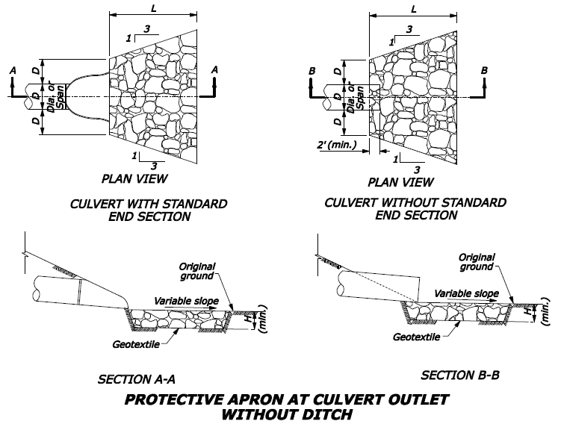
Source: Federal Highway Administration (HEC 14)
Figure 3-3. Riprap apron example schematic

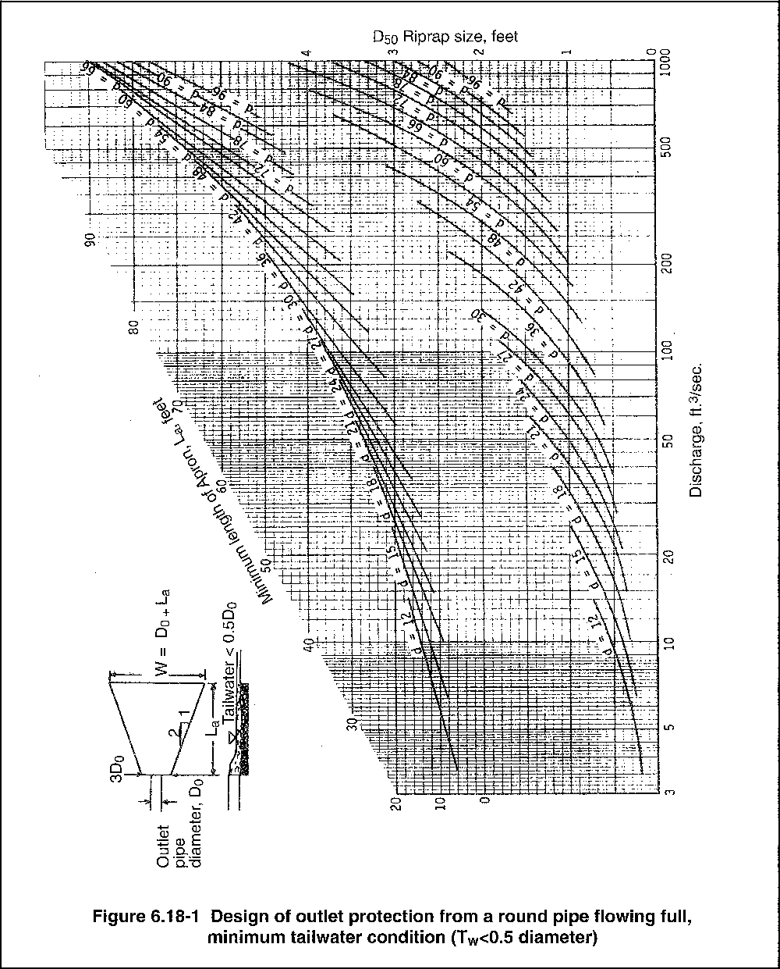
Source: MPCA
Figure 3-4. Design of outlet protection for a round pipe, flowing full, with minimum tailwater condition

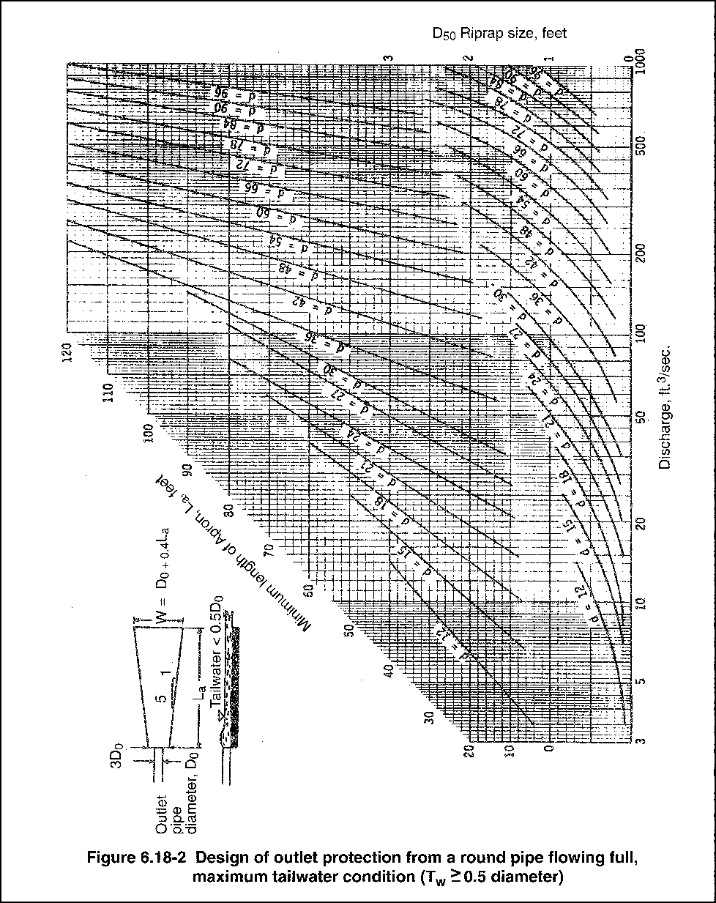
Source: MPCA
Figure 3-5. Design of outlet protection for a round pipe, flowing full, with maximum tailwater condition

Stilling Basin/Impact Basin
A stilling basin is an excavated pool of water that is lined with riprap and used to dissipate energy from high-velocity flow. An impact basin is a reinforced concrete structure that slows water velocities to an acceptable level before discharging water to an outlet channel. Riprap stilling basins and plunge pools reduce flow velocity rapidly. They should be considered as an alternative to riprap aprons where pipe outlets are cantilevered, or where high flows would require an excessive apron length. Where conditions warrant, other energy dissipators such as concrete impact basins may be considered.

Stilling basins are used to convert flows from supercritical to subcritical flow regimes by allowing a hydraulic jump to occur within the structure over a wide range of flow conditions and depths. A professional engineer must design energy dissipators and stilling basins using hydraulic computations. A primary operation and maintenance concern for both energy dissipators and stilling basins is the accumulation of sediment and trash.

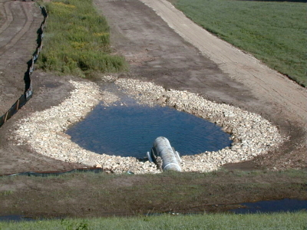
Source: Vernon County, Wisconsin
Figure 3-6. Example riprap stilling basin/plunge pool installation

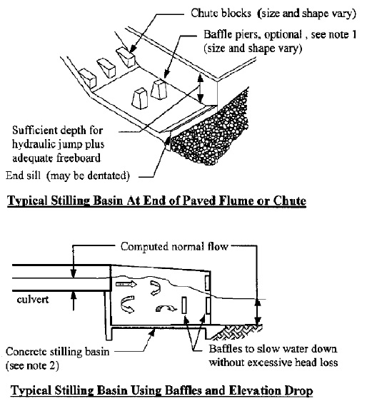
Source: Tennessee Department of Environment and Conservation
Figure 3-7. Typical stilling basin designs

Standards and Specifications
MnDOT Standard Plates 3133D and 3134D provide standard detail for “Riprap at RCP Outlets” and “Riprap at CSP Outlets”, respectively (effective date: 8/6/2014):
http://standardplates.dot.state.mn.us/stdplate.aspx

The MnDOT Standard Specifications for Construction (2016 edition) Specification 2573.3.L (Culvert End Controls) states that culvert outlet ends must be protected with “energy dissipation devices, transition devices, or both to reduce erosion and sediment loss while reducing the velocity of water existing culvert.” Specifications 2501 (Pipe Culverts) and 2503 (Pipe Sewers) may also be applicable depending on the BMP/device chosen. Additional materials specifications that may be applicable include Specifications 2511 and 3601 (Riprap), and 3733 (Geotextile). The 2016 edition of the MnDOT Standard Specifications for Construction can be found here: http://www.dot.state.mn.us/pre-letting/spec/ (See http://www.dot.state.mn.us/pre-letting/spec/2016/2016specbook.pdf, page 493.)

Inspection and Maintenance
Inspect energy dissipators before periods of flow to ensure they are prepared to function. Inspect after flow periods (including stormwater runoff and runoff from snowmelt) to observe and document deficiencies. Inspection guidelines include:
- Confirm that the length, width, shape, and composition of the energy dissipator matches design criteria after construction and before/after flow events.
- After periods of flow, look for signs that dissipator components have been dislodged or moved.
  - Inspect apron(s) for displacement of riprap and damage to underlying fabric.
- Observe and document any scour or other erosion in the vicinity of the energy dissipator.
- Note any accumulations of woody or other debris at the outlet or within the dissipator structure.
- Inspect culvert or ditch inlet and flow areas for accumulations of woody or other debris.

Energy dissipation devices should be inspected periodically to check for scour, and any needed repairs should be completed promptly to prevent further damage.
- Restore dissipator to its original specifications if it is found to diverge from design criteria.
- Replace rock or other components that have been dislodged by heavy flows.
  - If rock continues to wash away, consider using larger material.
- Repair and damage to underlying fabric.
- Where erosion/scour is occurring outside dissipator area, increase dissipator size in the eroded area.
- Frequently remove sediment and other debris accumulations from inlets, flow pipes/ditches, and the dissipator area.

Costs
The following table summarizes estimated BMP costs based on MnDOT data summarizing average bid prices for awarded projects in 2014.

Table 3-3. Average Bid Prices (Based on Awarded Projects) for Spec Year 2014. Average price varies from year to year. Data for other years can be found on MnDOT’s website. (Source: MnDOT)
Bid Item | Item Description | Units | Average Price
2573.530/0010 | Culvert End Controls | EACH | $194.30

Reference Materials
Except where more stringent requirements are presented in this guidance, BMPs shall comply with MnDOT and other state requirements. Primary design references include:
- MnDOT Erosion Control Handbook II
http://www.dot.state.mn.us/environment/erosion/pdf/2006mndotecfieldhandbook.pdf
- 2013 Minnesota NPDES/SDS Construction Stormwater General Permit
http://www.pca.state.mn.us/index.php/water/water-types-and-programs/stormwater/construction-stormwater/index.html
- MnDOT Standard Specifications for Construction (2016 Edition)
http://www.dot.state.mn.us/pre-letting/spec/
- MnDOT Standard Plates (Approved Standard Drawings) http://standardplates.dot.state.mn.us/#

The following is a list of additional resources that are not specific to Minnesota:
- California Stormwater BMP Handbook (BMP EC-10: Velocity Dissipation Devices) https://www.escondido.org/Data/Sites/1/media/pdfs/Utilities/BMPVelocityDissipationDevices.pdf
- Clark County Washington Stormwater Manual (BMP C209: Outlet Protection)
https://www.clark.wa.gov/environmental-services/stormwater-code-and-manual
- Clean Water Services Erosion Prevention and Sediment Control Manual (4.2.4 Outlet Protection)
https://www.cleanwaterservices.org/media/1464/erosion-prevention-and-sediment-control-manual.pdf
- Federal Highway Administration, Hydraulic Engineering Circular No. 14 (“HEC 14”), Third Edition – Hydraulic Design of Energy Dissipators for Culverts and Channels
https://www.fhwa.dot.gov/engineering/hydraulics/pubs/06086/hec14.pdf
- Kentucky Division of Water Best Management Practices (BMPs) for Controlling Erosion, Sediment, and Pollutant Runoff from Construction Sites – Planning and Technical Specifications Manual, http://transportation.ky.gov/Stormwater/Pages/Construction-Development-Community-ResourcesGuidance.aspx
- North Carolina Erosion and Sediment Control Planning and Design Manual (6.41 Outlet Stabilization Structure)
https://deq.nc.gov/about/divisions/energy-mineral-land-resources/energy-mineral-land-permit-guidance/erosion-sediment-control-planning-design-manual
- Tennessee Department of Environment and Conservation (TDEC) Erosion and Sediment Control Handbook (7.23 Outlet protection) http://tnepsc.org/handbook.asp
- Virginia Erosion and Sediment Control Handbook (3.18 Outlet Protection) http://www.deq.virginia.gov/Programs/Water/StormwaterManagement/Publications/ESCHandbook.aspx

