Swale Side Slope and Wet Swale Example
The runoff from a 1.4 acre parking lot surrounded by 0.359 acre of pervious turf area flows through sheet flow over one of the side slopes of a swale and into the main channel of the swale, which consists of a wet swale. The soils across the area have a unified soils classification of SW (HSG type A soil). A second side slope associated with the wet swale does not receive runoff from impervious surfaces. Each of the swale side slopes are 800 feet long by 10 feet wide with a side slope of 5H:1V. The maintenance on the swale side slopes call for mowing once a year. The following steps detail how this system would be set up in the MIDS calculator.
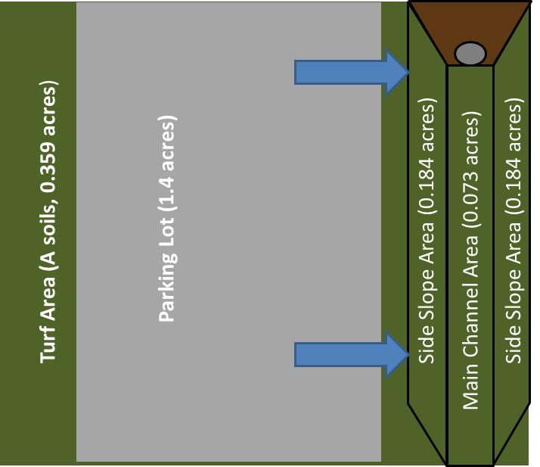
Wet Swale (0.073 acres)

Step 1: Determine the watershed characteristics of your entire site. For this example we have a 2.2 acre site with 1.4 acres of impervious area (parking lot) and 0.8 acre of pervious area in type A soils. The pervious area includes the turf area and the area of the swale side slopes and main channel (wet swale).

Step 2: Fill in the site specific information into the “Site Information” tab. This includes entering a Zip Code (55414 for this example) and the watershed information from Step 1. The Managed Turf area includes the turf area, the area of the side slopes and the area of the main channel. Zip code and impervious area must be filled in or an error message will be generated. Other fields on this screen are optional.

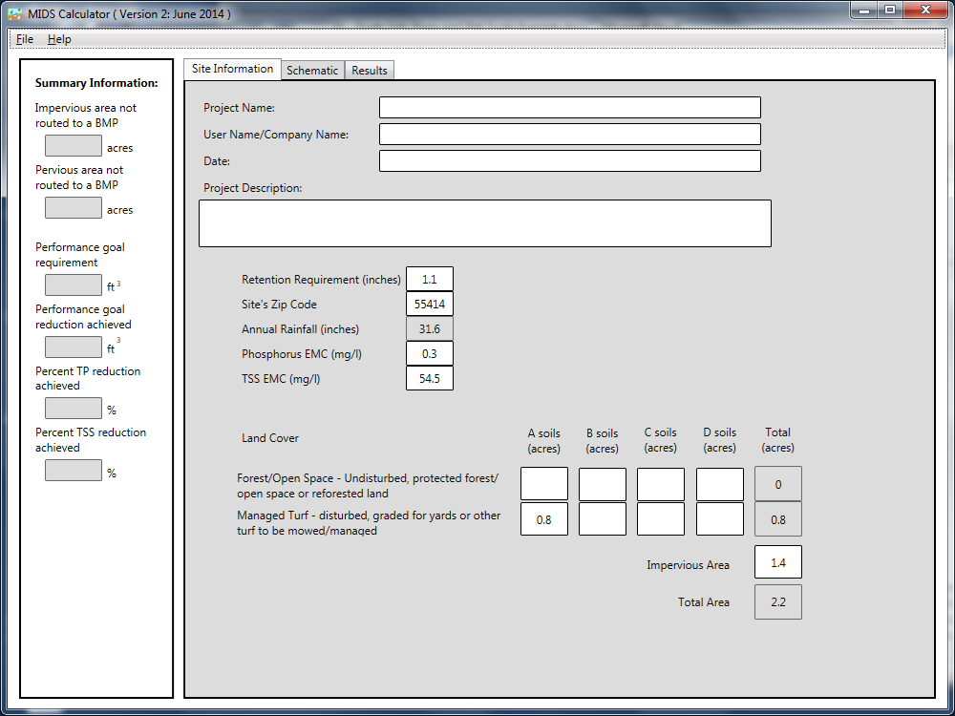
Step 3: Go to the Schematic tab and drag and drop a “Swale Side Slope” and a “Wet Swale” icon into the “Schematic Window”
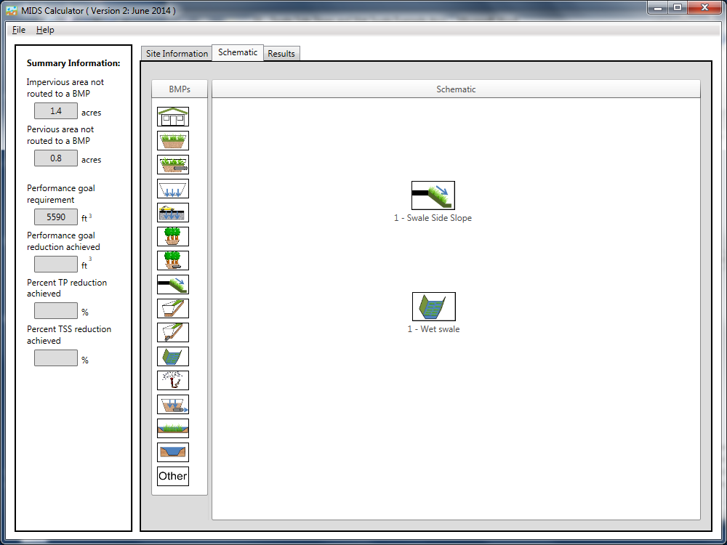
Step 4: Determine the watershed characteristic for each of the BMP components. For this example the swale side slope watershed includes 1.4 acres of impervious area and 0.543 acre of pervious area (0.359 acre of turf area plus 0.184 acre of swale side slope. The watershed of the wet swale includes the pervious area of the wet swale (0.073 acre) and the pervious area of the other swale side slope (0.184) for a total pervious area of 0.257 acre. Since no impervious area is being routed to the second side slope, the area can be included in the direct watershed area of the wet swale. However, the second swale side slope could be also placed in the calculator as a separate BMP.

Step 5: Open the BMP properties for the swale side slope by right clicking on the “Swale Side Slope” icon and selecting “Edit BMP properties”, or by double clicking on the “Swale Side Slope” icon.
Step 6: Click on the “Minnesota Stormwater Manual Wiki” link or the “Help” button to review input parameter specifications and calculation specific to the “Swale Side Slope” BMP.
Step 7: Fill in the specific BMP watershed information (1.4 acres of impervious and 0.543 acre of Managed Turf on A Soils. Route the side slope BMP to the wet swale BMP.
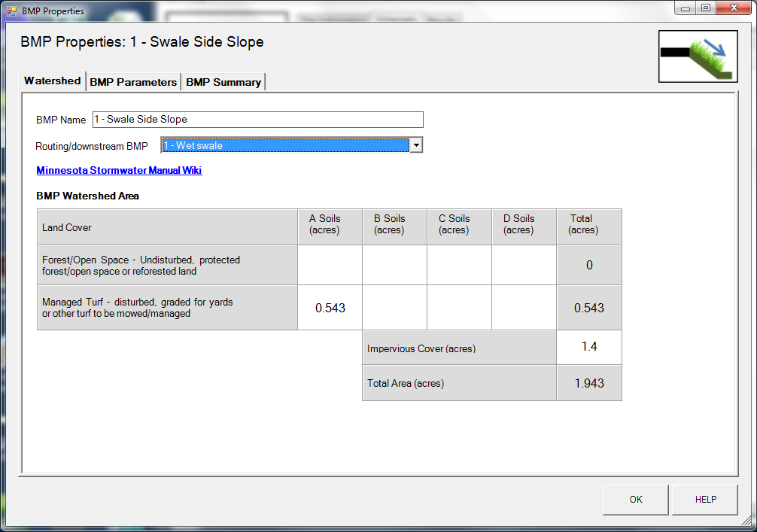

Step 8: Enter in the BMP design parameters into the “BMP parameters” tab. Swale Side Slope requires the following entries.
- Side slope [H:V] which is 5:1
- Flow path length which is 10 feet
- Channel length, which is 800 feet
- Underlying soil – Hydrologic Soil Group, which is 4 SW (HSG A, 1.63 in/hr)
- Manning’s n (vegetation), which is Native grass

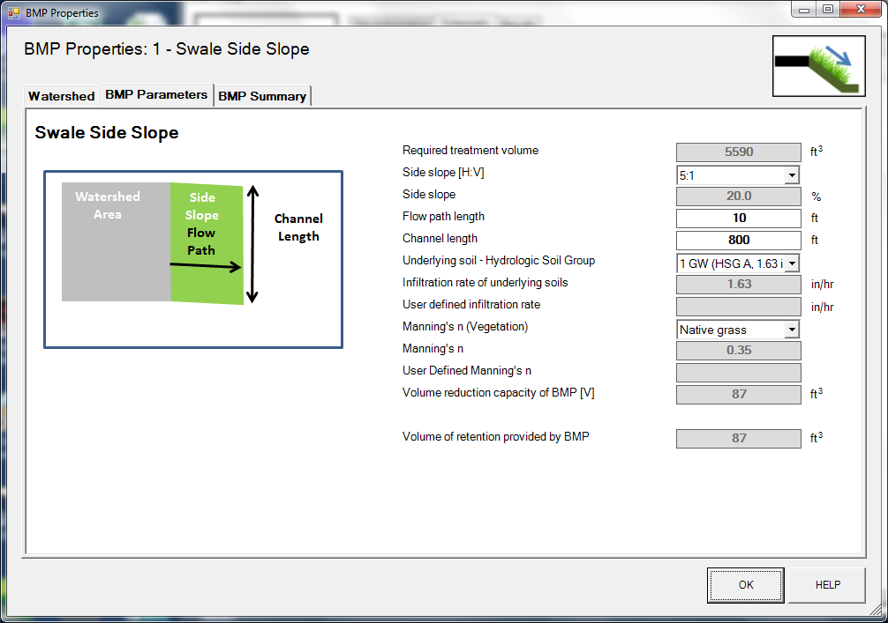

Step 9: Click on “BMP Summary” tab to view results for this BMP.
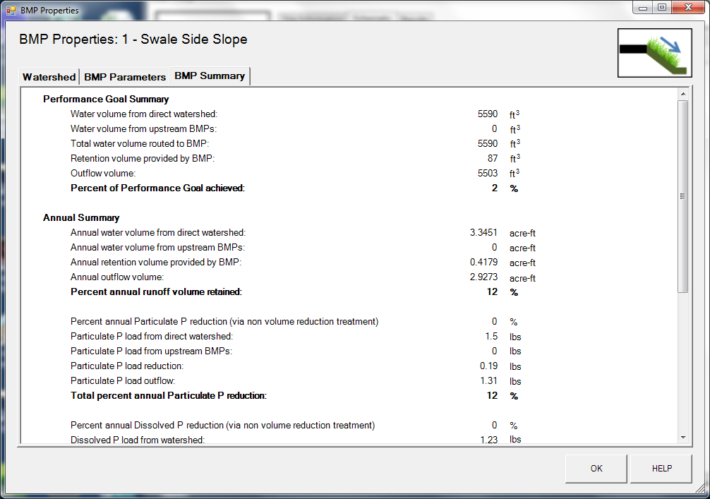

Step 10: Click on the “OK” button to exit the BMP properties screen. An arrow will appear showing that the swale side slope has been routed to the wet swale.
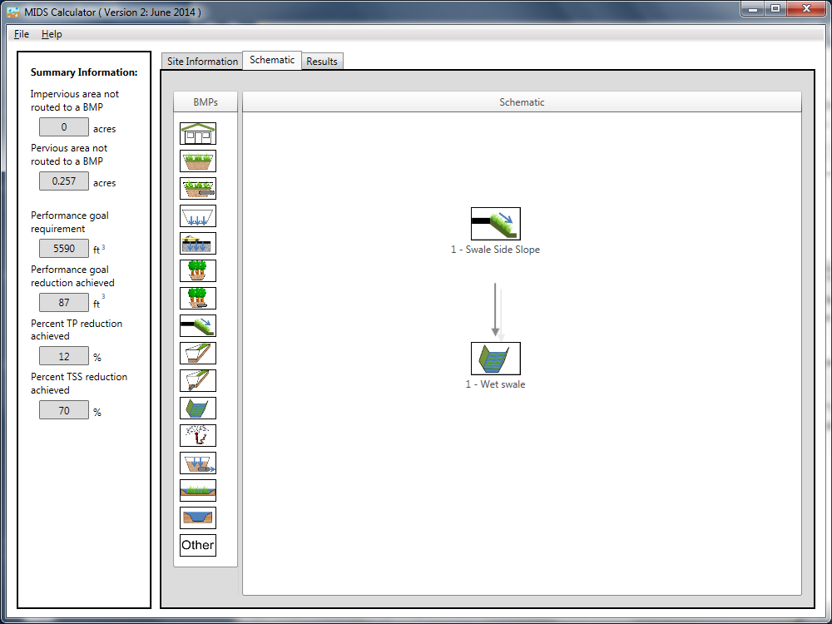
Step 11: Open the BMP properties window for the swale main channel by right clicking on the “Wet Swale” icon and selecting “Edit BMP properties”, or by double clicking on the “Wet Swale” icon.
Step 12: Click on the “Minnesota Stormwater Manual Wiki” link or the “Help” button to review input parameter specifications and calculation specific to the “Wet Swale.”
Step 13: Enter in the watershed information for the swale main channel in the “Watershed” tab (0.257 acre for Pervious Turf on A Soil which includes the area of the main channel and the other side slope).
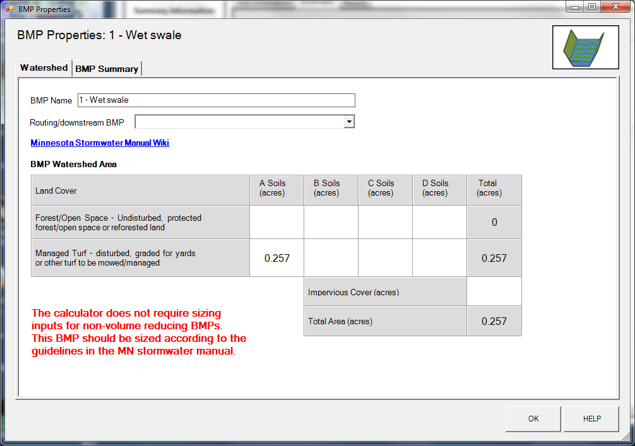

Step 14: Design parameters are not required for the wet swale BMP. Click on “BMP Summary” tab to view results for this BMP.
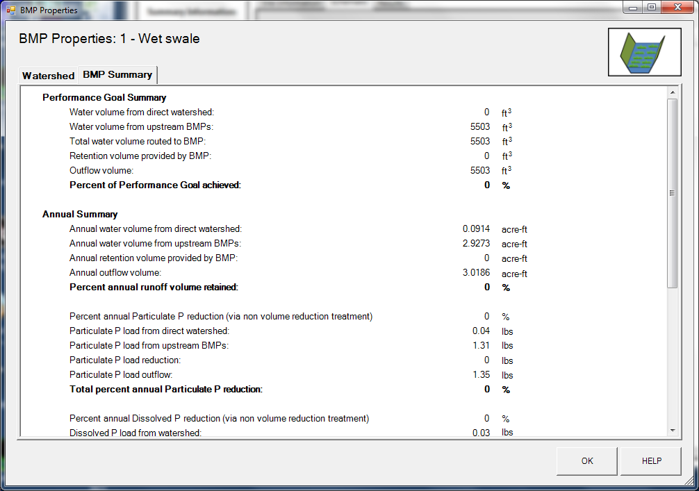
Step 15: Click on the “OK” button to exit the BMP properties screen.
Step 16: Click on “Results” tab to see overall results for the site.
