Tree trench system without an underdrain example (Version 2)

A tree trench system is to be constructed in a watershed that contains a 1.4 acre parking lot surrounded by 0.8 acres of pervious area (turf area and the tree trench BMP area). All of the runoff from the watershed will be treated by the tree trench system. The soils across the area have a unified soils classification of SM (HSG type B soil). The surface area of the tree trench basin is 5600 square feet at the media surface. The area at the media-soil interface is 3320 square feet. The total media depth will be 4 feet. Following the MPCA Construction Stormwater General Permit requirement, the water in the media of the tree trench needs to drawdown in a 48 hour time period. The media will be Media Mix D, which is a Loamy sand composition resulting in a difference between the media wilting point and field capacity of 0.05 cubic feet per cubic foot and the difference between the media porosity and field capacity is 0.35 cubic feet per cubic foot. The tree trench will be planted with 10 medium sized deciduous trees. The following steps detail how this system would be set up in the MIDS calculator.
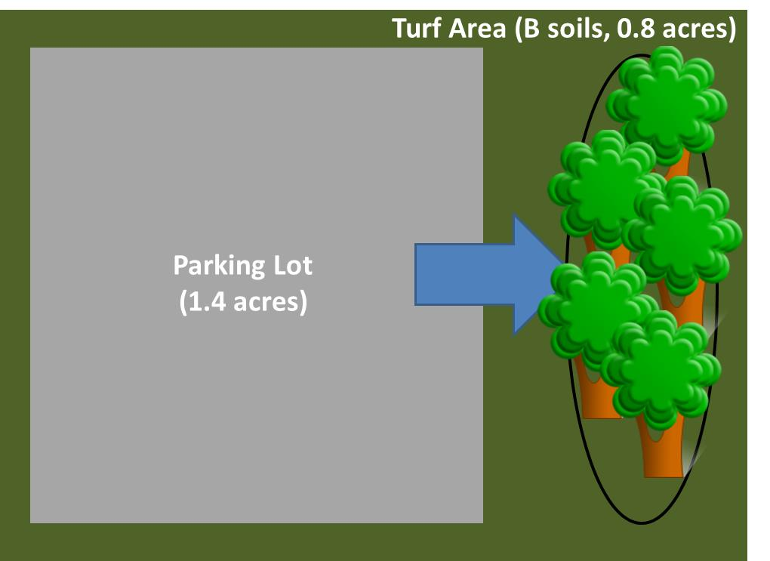
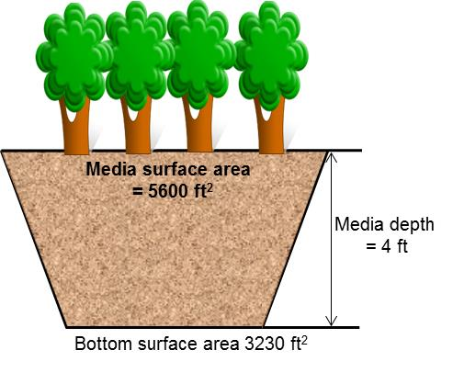
Step 1: Determine the watershed characteristics of your entire site. For this example we have a 2.2 acre site with 1.4 acres of impervious area and 0.8 acres of pervious area in type B soils. The pervious area includes the turf area and the area of the tree trench basin.
Step 2: Fill in the site specific information into the “Site Information” tab. This includes entering a Zip Code (55414 for this example) and the watershed information from Step 1. The Managed turf area includes the turf area and the area of the tree trench basin. Zip code and impervious area must be filled in or an error message will be generated. Other fields on this screen are optional.
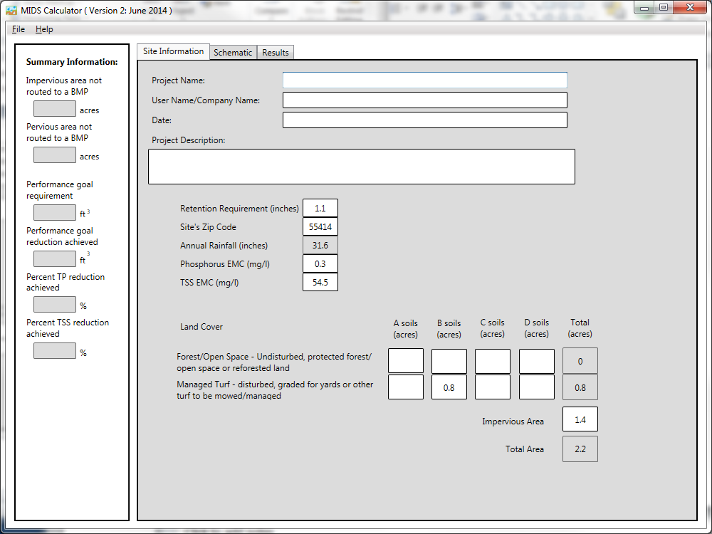

Step 3: Go to the Schematic tab and drag and drop the “Tree trench system/Box (w/o underdrain)” icon into the “Schematic Window”
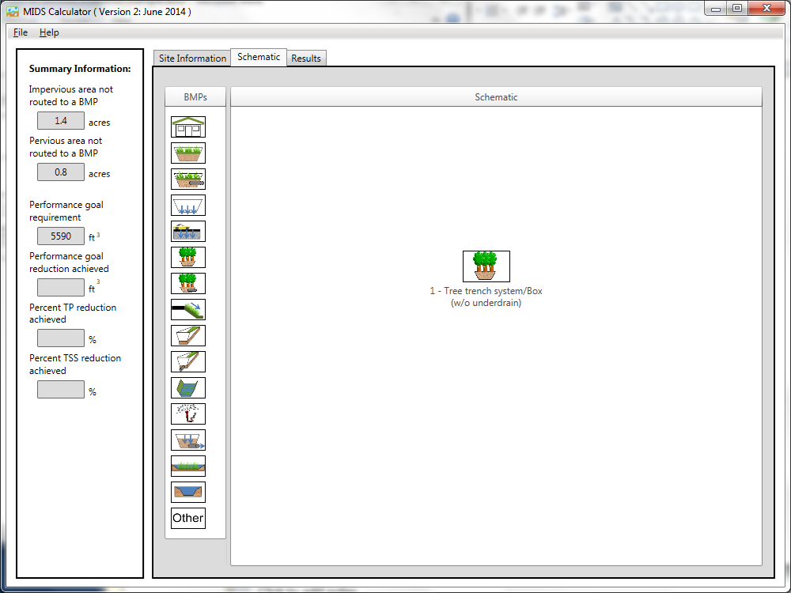
Step 4: Open the BMP properties for the tree trench by right clicking on the “Tree trench system/Box (w/o underdrain)” icon and selecting “Edit BMP properties”, or by double clicking on the “Tree trench system/Box (w/o underdrain)” icon.
Step 5: Click on the “Minnesota Stormwater Manual Wiki” link or the “Help” button to review input parameter specifications and calculation specific to the “Tree trench system/Box (w/o underdrain)” BMP.
Step 6: Determine the watershed characteristics for the tree trench. For this example the entire site is draining to the tree trench. The watershed parameters therefore include a 2.2 acre site with 1.4 acres of impervious area and 0.8 acres of pervious turf area in type B soils. There is no routing for this BMP. Fill in the BMP specific watershed information (1.4 acres on impervious cover and 0.8 acres of Managed turf in B soils).

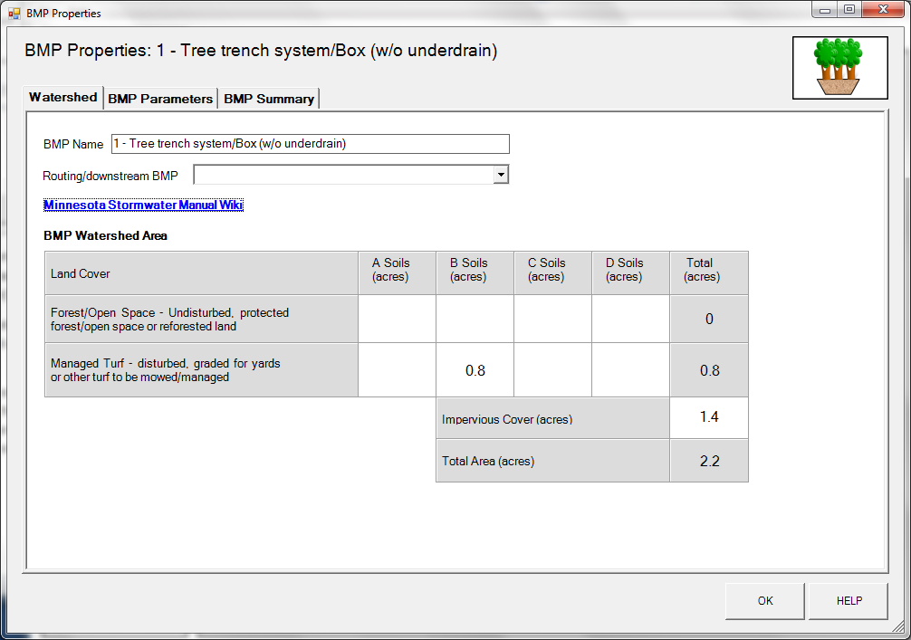

Step 7: Enter in the BMP design parameters into the “BMP parameters” tab. Tree trench systems requires the following entries.
- Surface area at media surface which is 5600 square feet;
- Bottom surface area (area at media-soil interface) which is 3230 square feet;
- Media depth which is 4 feet;
- Media field capacity minus wilting point which is 0.05 cubic feet per cubic foot;
- Media porosity minus field capacity which is 0.35 cubic feet per cubic foot;
- Tree type is Deciduous;
- Tree Size is Medium;
- Number of Trees is 10;
- Underlying soil – Hydrologic Soil Group which is SM (HSG B; 0.45 in/hr) from the dropdown box; and
- Required drawdown time (hrs) which is 48 from the dropdown box.
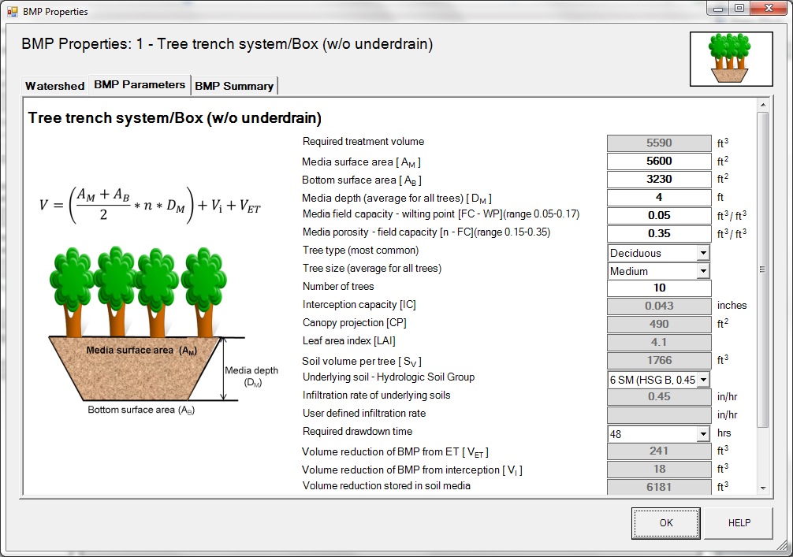
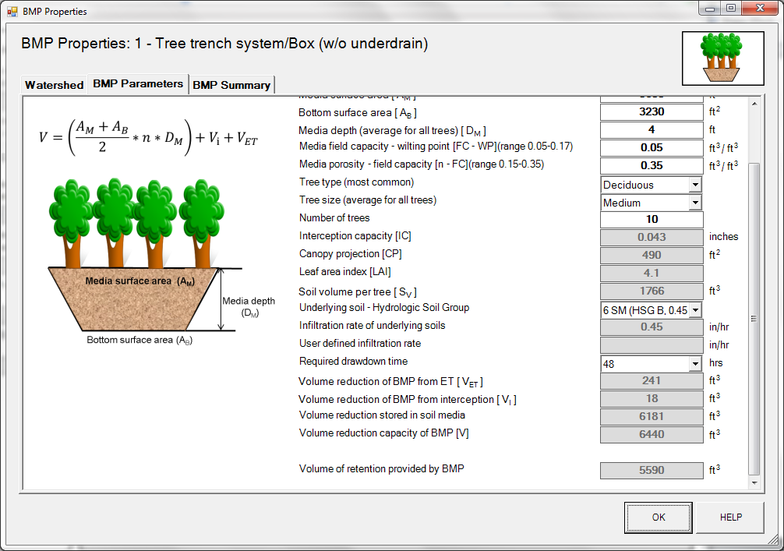
Step 8: Click on “BMP Summary” tab to view results for this BMP.
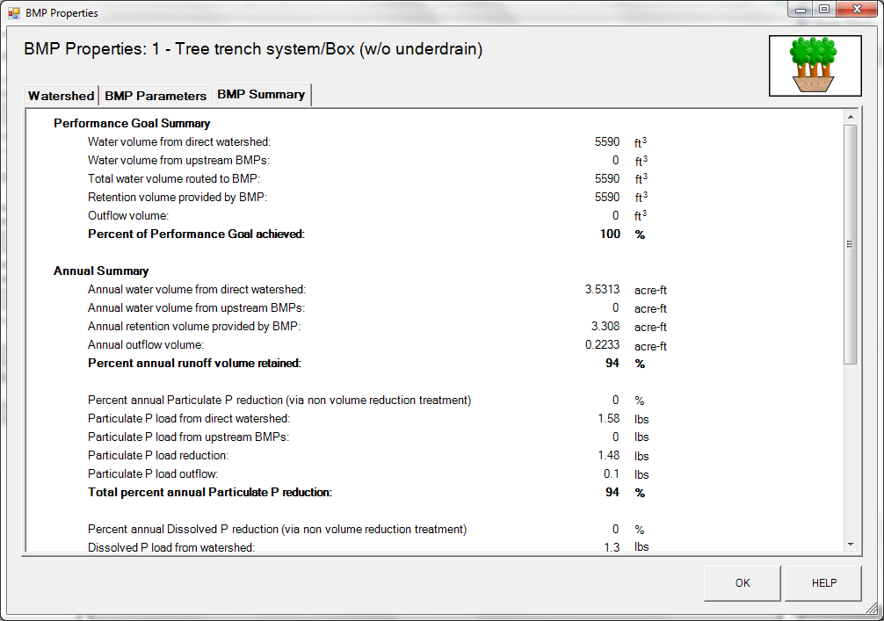

Step 9: Click on the “OK” button to exit the BMP properties screen.
Step 10: Click on “Results” tab to see overall results for the site.
