Simple Estimator Training Session - Level 1
- Opening (10 minutes) (https://stormwater.pca.state.mn.us/index.php?title=Guidance_and_examples_for_using_the_MPCA_Estimator)
  - Introductions (name, organization, how you will use the Estimator)
  - Prequisites
    - Downloaded the Estimator workbook
    - Know the basic structure of the Estimator
    - Know the basic functionality of the Estimator
- Problem 1 (10 minutes)
  - Area 1:
    - One acre each of residential, commercial, industrial, mixed, park, and transportation
    - In each land use implement 0.5 acres of biofiltration
  - Area 2:
    - One acre each of residential, commercial, industrial, mixed, park, and transportation
    - In each land use implement 0.5 acres of infiltration
  - Review the summary sheet
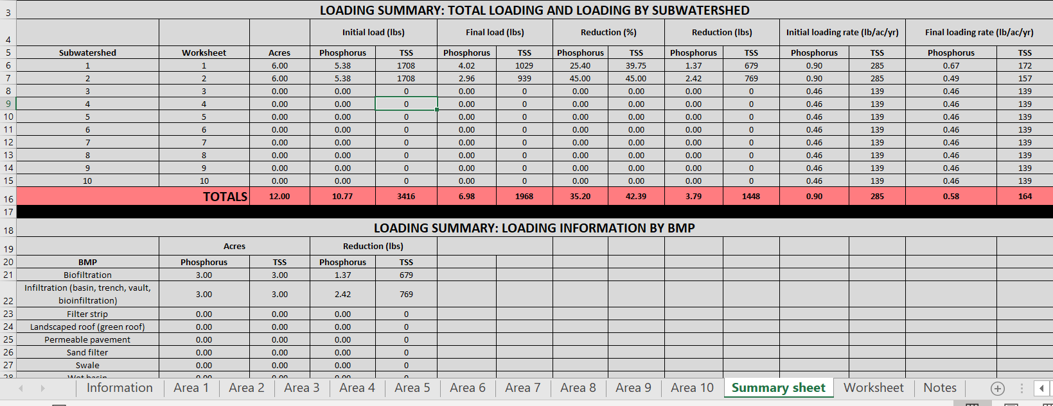
- Problem 2 (10 minutes)
  - Areas 1 and 2 the same but assume street sweeping on transportation land use reduces sediment load by 50%. How is this accounted for?
  - Area 3
    - One acre of agricultural land
    - Convert agricultural land to residential in Section 2 of worksheet
    - Implement infiltration across entire one acre
  - Review the summary sheet
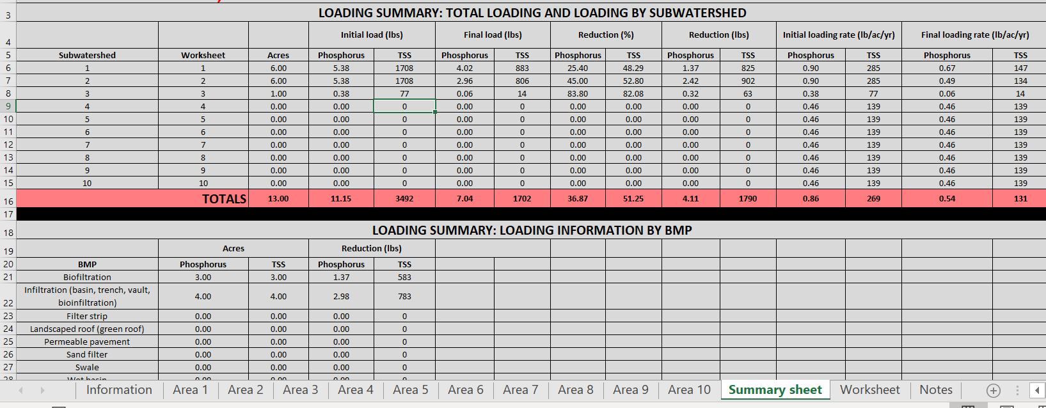
- Problem 3 (20 minutes)
  - Use the same areas and acreages as Problem 2
  - Keep the one acre transition to residential in Area 3
  - Delete the BMPs in Area 1 and Area 2
  - Section 2: adjust emcs and/or runoff coefficients and note the results
  - Sections 3 and 4: implement BMPs and note the results
  - Report out
- Open exercise (10 minutes)
    - Keep the inputs the same as when you reported out but change BMP removal efficiency
    - Keep the inputs the same as when you reported out but change annual fraction treated
    - Keep the inputs the same as when you reported out but change the amount infiltrated
- Discussion questions (15 minutes)
  - What practices might result in a change in emc?
  - What practices might result in a change in runoff coefficient?
  - What conditions apply when removal efficiency changes?
  - What conditions apply when fraction treated changes?
  - What conditions apply when fraction infiltrated changes?
- Problem 4 – drainage is to the lake (45 minutes (25-10-10)
  - Area 1: C and D soils
  - Area 2: A and B soils
  - Area 3: C soils up in watershed; A and B soils in lower watershed
  - Must reduce phosphorus loading by 30 percent
  - Report out
  - Wrap up
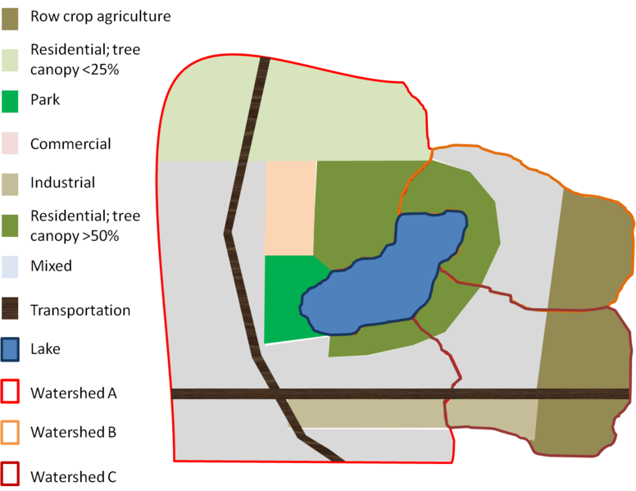
Land use | Acres
 | Area 1 | Area 2 | Area 3
Commercial | 75
Industrial | 80 |  | 110
Multi-use | 975 | 275 | 235
High canopy res | 200 | 200 | 80
Park | 70
Agriculture |  | 220 | 240
Transportation | 75 |  | 60
Low canopy res | 400

