Bioretention Basin (w/o underdrain) Example (Calculator Version 2)

A bioretention basin without an underdrain is to be constructed in a watershed that contains a 1.4 acre parking lot surrounded by 0.8 acres of pervious area (turf area and the bioretention BMP). All of the runoff from the watershed will be treated by the bioretention basin. The soils across the entire area have a unified soils classification of SM (HSG type B soil). The bioretention basin is designed to have 1 foot of ponding depth below the overflow. The surface area of the bioretention basin at the overflow point will be 6534 square feet. If the outflow point is a pipe, the area is taken at the invert of the overflow pipe. The bottom surface area (the area at the media surface) is 5600 square feet. Following the MPCA Construction Stormwater General Permit requirement, ponded water in the bioretention basin needs to drawdown in a 48 hour time period. The following steps detail how this system would be set up in the MIDS calculator.
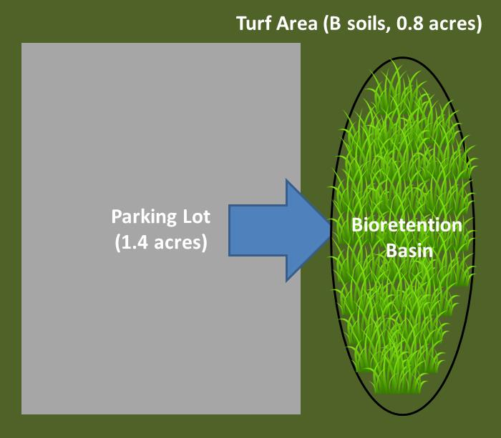
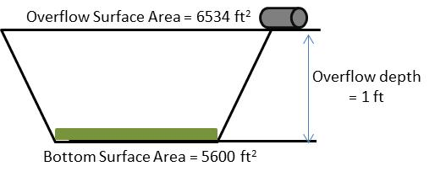

Step 1: Determine the watershed characteristics of your entire site. For this example we have a 2.2 acre site with 1.4 acres of impervious area and 0.8 acres of pervious area in type B soils. The pervious area includes the turf area and the area of the bioretention basin. The entire site drains into the bioretention basin.
Step 2: Fill in the site specific information into the “Site Information” tab. This includes entering a Zip Code (55414 for this example) and the watershed information from Step 1. The Managed turf area includes the turf area and the area of the bioretention basin. Zip code and impervious area must be filled in or an error message will be generated. Other fields on this screen are optional.
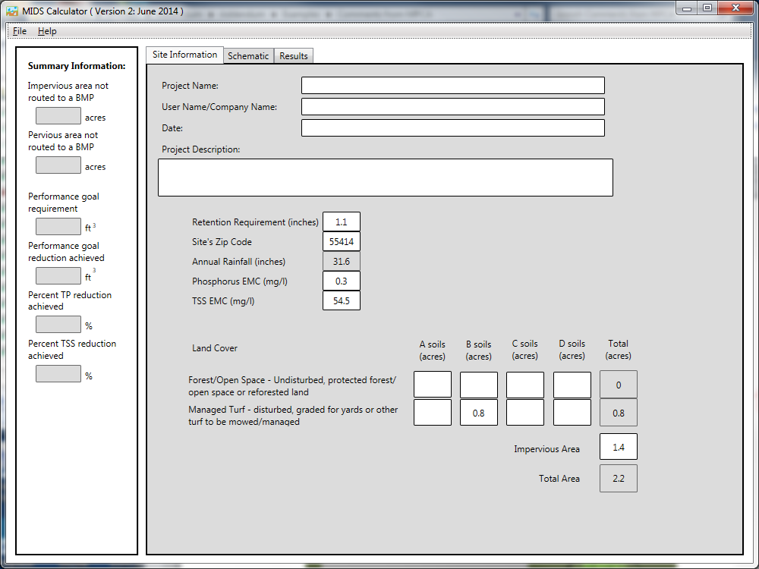

Step 3: Go to the Schematic tab and drag and drop the “Bioretention basin (w/o underdrain)” icon into the “Schematic Window”
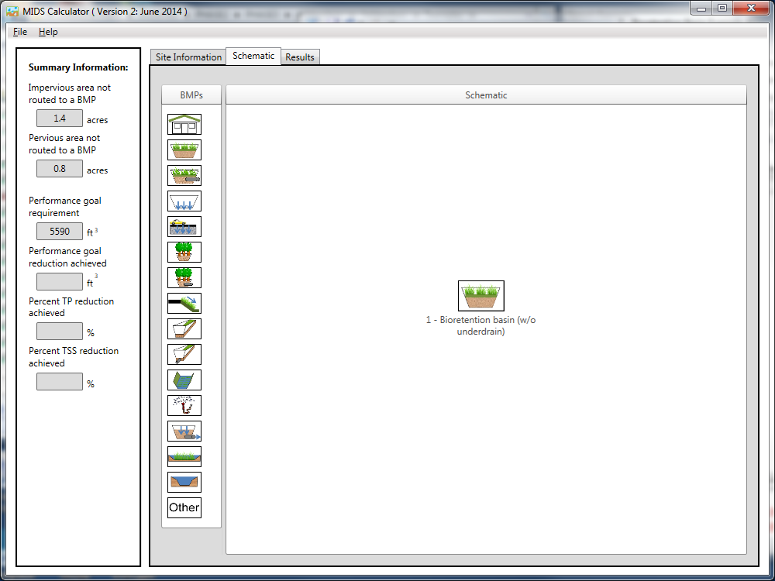

Step 4: Open the BMP properties for the bioretention basin by right clicking on the “Bioretention basin (w/o underdrain)” icon and selecting “Edit BMP properties”, or by double clicking on the “Bioretention basin (w/o underdrain)” icon.
Step 5: Click on the “Minnesota Stormwater Manual Wiki” link or the “Help” button to review input parameter specifications and calculation specific to the “Bioretention basin (w/o underdrain)” BMP.
Step 6: Determine the watershed characteristics for the Bioretention basin. For this example the entire site is draining to the bioretention basin. The watershed parameters therefore include a 2.2 acre site with 1.4 acres of impervious area and 0.8 acres of pervious turf area in type B soils. There is no routing for this BMP. Fill in the BMP specific watershed information (1.4 acres on impervious cover and 0.8 acres of Managed turf in B soils).
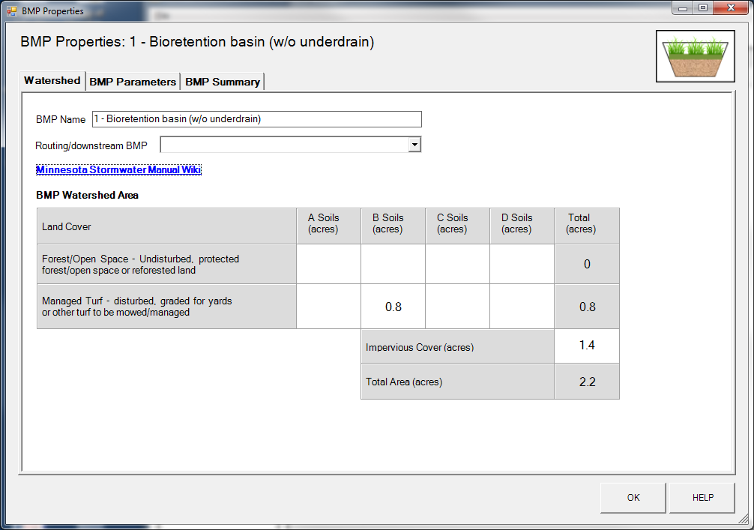

Step 7: Click on the “BMP Parameters” tab and enter the BMP design parameters. Bioretention basin with no underdrain requires the following entries.
- Overflow surface area which is 6534 square feet;
- Bottom surface area which is 5600 square feet;
- Overflow depth which is 1 foot;
- Underlying soil – Hydrologic Soil Group which is SM (HSG B; 0.45 in/hr) from the dropdown box; and
- Required drawdown time (hrs) which is 48 from the dropdown box.
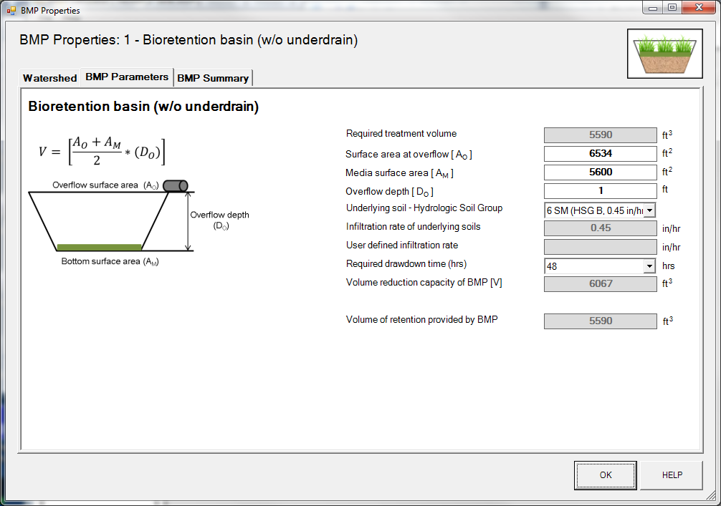

Step 8: Click on “BMP Summary” tab to view results for this BMP.
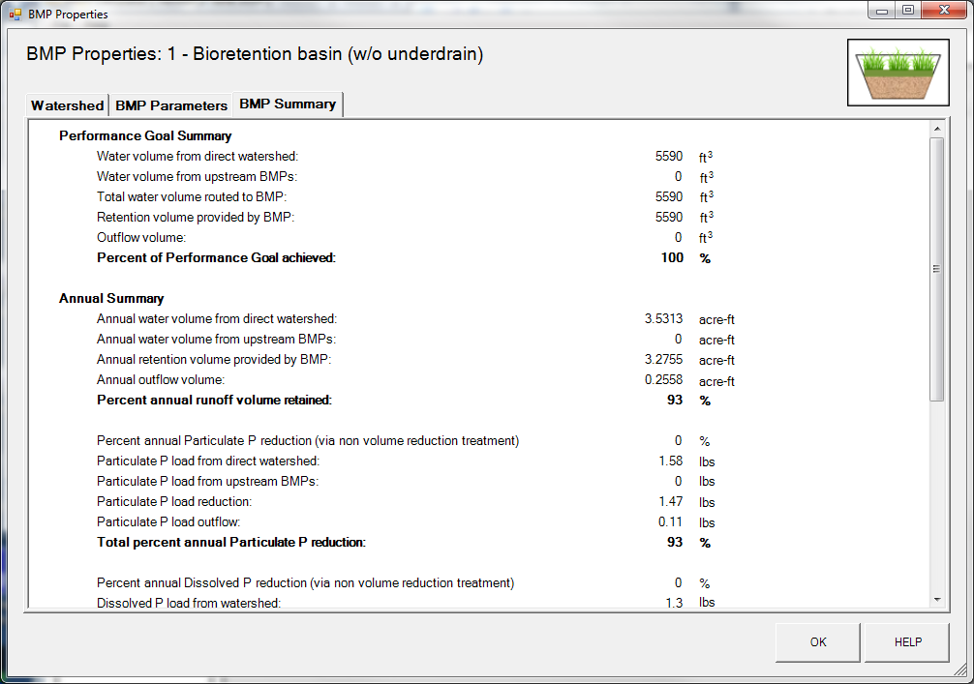

Step 9: Click on the “OK” button to exit the BMP properties screen.
Step 10: Click on “Results” tab to see overall results for the site.
