**Memorandum**

|  |  |
| --- | --- |
| **From:** B. Crary, A. Savineau, A. Aufdenkampe | **Date:** 05/14/2020 |
| **Project:** MPCA-GI |
| **To:** C. Kjeldahl, M. Trojan | **CC:** |

**SUBJECT: Tree Interception Capacity: Analyses and Recommendations**

Summary

LimnoTech was tasked to review the tree rainfall interception values shown in the MPCA stormwater manual and used in the MIDS calculator and, if needed, make recommendations for modifying these values. The tree rainfall interception values are expressed as both an event-based “credit” that represents the rainfall interception depth capacity of a tree, and an annual percent performance that represents the annual rainfall interception and runoff reduction capacity of a tree.

LimnoTech performed a literature review of the most recent science describing the interception capacity of trees. The literature typically reported interception capacity as either an event-based interception depth expressed as inches of rain intercepted, or as an annual interception performance expressed as a percent of annual precipitation intercepted. Comparisons between studies that look at interception depths were difficult due to important differences in study designs (i.e. uniqueness of the individual trees, sizes of studied rainfall events, and selection of reported statistical values). These study-to-study differences would require normalization to a common set of factors to be comparable, because interception depth has been shown to be positively correlated with storm size and intensity (up to storms of at least 2 inches or 50 mm in size) and related the morphology of individual trees as captured by metrics such as leaf area index.

In contrast, studies that reported on the long-term rainfall interception performance (i.e. percentage of total rainfall intercepted over a weeks to months) were easier to compare. The longer study periods subjected the test trees to wider ranges of rainfall event size that were more comparable among studies and helped temper the variability due to the uniqueness of rainfall events.

LimnoTech conducted a meta-analysis of the annual rainfall interception performance, and observed that **deciduous and coniferous trees intercept approximately 30% and 57% of annual precipitation.** These values are based on the average of the performances documented in all reviewed studies for trees and climates that are applicable to Minnesota.

LimnoTech then constructed a simple model to estimate the rainfall interception depth capacity of urban trees based off the annual rainfall percent interception. The models showed that **deciduous and coniferous trees with interception capacities of 0.14 inches and 0.40 inches, respectively, would intercept approximately 30% and 57% of annual rainfall over the canopy area**.

LimnoTech also **developed a proposed methodology to incorporate the annual performance values in the MIDS calculator.** The current version of the MIDS calculator aggregates interception and infiltration mechanisms, which results in an overall underestimation of annual performance. The proposed methodology breaks out the interception and infiltration mechanisms, which results in a more accurate reflection of the annual performance obtained from the literature.

Literature Review

LimnoTech reviewed 26 published articles, documents, and presentations to review interception capacity and annual tree performance (see reference section). Although the literature were similar in nature, the details and methods of each study varied. For example, some studies reported an average interception depth over a range of small rainfall events, while some focused exclusively on winter performance. While each study provided insight into the mechanism and effectiveness of interception, metadata from these studies was recorded so that a meta analysis could be conducted.

Information Recorded

“Performance” was not always characterized by the same metric across studies. All performance values were considered essential information during this review, and the following metrics were commonly recorded:

* Minimum observed interception
* Maximum observed interception
* Average and median interception
* Interception as a percent (%) of annual or long-term precipitation

The tree characteristics in the literature varied widely. Some studies were performed on mature trees while others focused on young trees. Similarly, some studies observed performance of isolated urban trees while others considered the full canopy of forest stands. This variability was often captured in the following characteristics, but not all studies recorded sufficient information to normalize for these factors:

* Genus, Species, and Common Name
* Tree Type (Deciduous, Coniferous, Broadleaf Evergreen, and Mixed)
* Canopy Area and Canopy Diameter
* Leaf Area and Leaf Area Index, which is related to leaf area density and canopy height.
* Age of tree(s)

Each study also had its own experimental and climatic characteristics. Some studies were performed in lab settings or with artificial rainfall, while others were in an open environment. The following metrics were generally recorded to capture this variability:

* Study Time Frame
* Study Region
* Study Type (artificial rainfall or field study)
* Rainfall event size or precipitation rate time series

Findings

Rainfall interception – the capture of precipitation on the foliage of trees before it hits the ground and contributes to runoff – is fairly simple in concept but quite difficult to predict for a given event. Tree specific characteristics, notably leaf area index[1], influence a tree’s ability to capture precipitation for any rainfall event. There are a several well-cited models to predict interception based on tree characteristics. Some predict interception based on single factors, like the Gomez model that empirically relates performance to LAI with moderate success (R2 = 0.76; Gomez et al., 2001). Others, such as Xiao model that incorporates a suite of canopy architecture metrics, such as crown diameter, stem diameter at breast height, stem projection area, seasonal vegetation development, and other tree measurements (Xiao, 2000), are increasingly complex.

Storm specific characteristics also greatly influence interception during single events. Wind speed, time since last rainfall, and size of rainfall droplets are each noted in the literature as contributing factors. Gross precipitation is often a good predictor of total interception, although this is variable. Net interception increases with increasing gross precipitation while the proportion of interception decrease. Climates that have higher frequencies of extreme events tend to have less interception on annual basis (Smets et al. 2019).

Meta-Analysis

The literature review included 26 studies, which are shown in the Reference Section of the memorandum. The literature typically reported interception capacity as either an event-based interception depth expressed as inches of rain intercepted, or as an annual interception performance expressed as a percent of annual precipitation intercepted.

Event-Based Rainfall Interception Depth

LimnoTech conducted a meta-analysis of reported interception depths for individual rainfall events, and calculated values are shown in Table 1. The total range of reported interception depths was 0.02 inches to 0.46 inches, however this included storage measured for very small rainfall events that functionally served as an upper limit to interception depth for that event.

The meta-analysis of the reported values deviated from the conclusions made by individual studies. For example, the average reported interception values for deciduous trees are larger in some cases than the equivalent average values for coniferous trees, which is likely due to differences in studied storm sizes among studies. This is in conflict with the findings from individual studies that showed coniferous trees had larger interception capacities. Similarly, the mean reported values of some studies appeared to be higher than the maximums reported in others, also likely due to the size of rainfall events that were considered. Therefore, it was concluded that interception depths are difficult to compare globally across studies.

**Table 1: Meta-analysis of reported literature values**

|  |  |  |  |  |
| --- | --- | --- | --- | --- |
| Set | Metric | Interception (inches) | | Comment |
| **Deciduous** | **Coniferous** |
| Average of All data | Interception Minimum1 | 0.015 | 0.017 | Individual studies show that coniferous trees have higher storage capacities than deciduous trees, but the average of the data taken from the literature do not reflect this observation. The reported means from several studies were higher than the reported maximums from others, which is why the average maximum (0.109”) is less than the average of reported mean interception (0.138”). |
| Average of All data | Interception Maximum1 | 0.109 | 0.081 |
| Average of All data | Interception Mean1 | 0.138 | 0.077 |
| Average of Locally-relevant data | Interception Minimum1 | 0.015 | 0.017 | The means interception values from some studies are higher than the maximums from others. This is possible due to the range of event sizes that were observed in the respective studies. |
| Average of Locally-relevant data | Interception Maximum1 | 0.109 | 0.081 |
| Average of Locally-relevant data | Interception Mean1 | 0.086 | 0.120 |

1Average of values recorded from literature review.

Annual Rainfall Interception Performance

LimnoTech conducted a meta-analysis of reported annual or long-term rainfall interception performance. A total of 14 annual percent interception values that represented mature trees from similar climates were reported out of the 26 studies. The annual performance ranged from 14% to 75% of total rainfall intercepted. Seven of the 14 values described coniferous species while seven described deciduous species. The average annual performance was 57% and 30% interception for coniferous and deciduous trees, respectively (Table 2).

Although interception performance for specific events is negatively correlated to rainfall event size (Figure 1), integrating long-term performance over many events dampens variability and the time period increases. Therefore, the annual percent rainfall intercepted metric is much more comparable across studies since performance is normalized to a long period of random rainfall events. This average annual metric, when summarized across studies, relates to the conclusions made in individual studies, namely that coniferous trees have a higher storage capacity than deciduous trees.

**Table 2: Reported Annual Interception**

|  |  |  |  |  |  |
| --- | --- | --- | --- | --- | --- |
| Coniferous | | | Deciduous | | |
| Tree Name | **Percent Interception** | **Reference** | **Tree Name** | **Percent Interception** | **Reference** |
| Red Cedar | 75% | 7 | **Willow Peppermint** | 44% | 12 |
| Douglas Fir | 69% | 7 | **Ginkgo** | 38% | 21 |
| Red Cedar | 61% | 1 | **Red Maple** | 29% | 6 |
| Douglas Fir | 49% | 1 | **Willow Oak** | 29% | 6 |
| Black Pine | 47% | 26 | **Blue Gum** | 29% | 12 |
| White Pine | 43% | 6 | **Silver Birch** | 24% | 26 |
|  |  |  | **Sweetgum** | 14% | 21 |
| Average | **57%** |  | **Average** | **30%** |  |

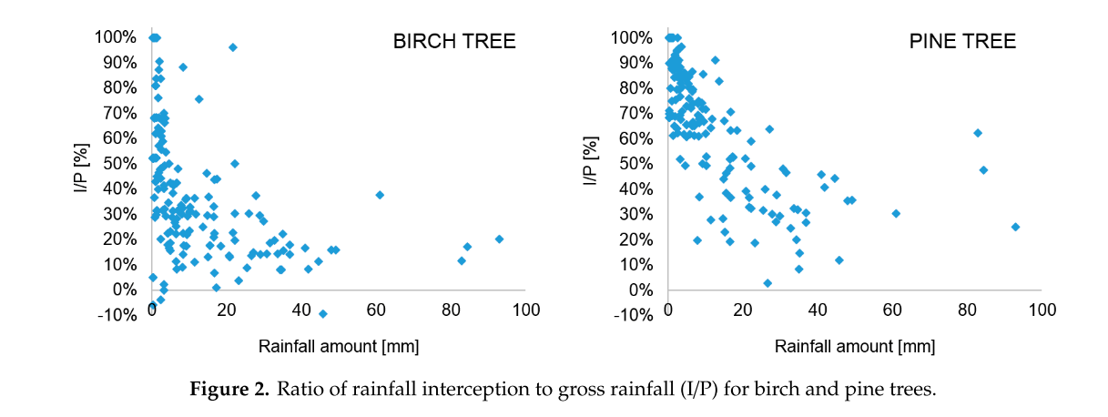

**Figure 1: Interception as a function of gross precipitation (Zabret et al. 2019)**

Modeling Analysis

Annual performance was the most reliable summary taken from the literature, but the “credit” for tree interception used by MPCA is based on the maximum storage capacity of the canopy, in inches. Therefore, two models were considered to relate the maximum storage capacity to annual performance (Table 3). In both of these models, instantaneous canopy interception and storage is calculated hourly for a 20-year Minnesota precipitation time series, with maximum interception depth as a variable input and annual performance as an output. Maximum interception depth was iteratively altered within the models until the annual average performance was achieved (30% for deciduous and 57% for coniferous).

**Table 3: Modeling Approaches**

|  |  |  |  |
| --- | --- | --- | --- |
| Model | Approach | Inputs | Output |
| Storm Discrete | Identify individual precipitation events and assume complete interception up to the capacity. | Precipitation, interception depth, length of dry time between storms | Annual Performance = (sum of volume intercepted)/(total precipitation) |
| Storage Balance | Perform water balance using hourly rainfall and evaporation rates. Assume all rainfall is intercepted unless capacity of canopy has been reached. Canopy will “fill” with rainfall at each interval and “empty” through evaporation. | Precipitation, interception depth, evaporation rates | Annual Performance = (sum of volume intercepted)/(total precipitation) |

Model Inputs

Rainfall

A twenty year hourly rainfall time series (1/1/2000-12/31/2019) for the Minneapolis area was used in both models. The rainfall data was accessed from the North American Land Data Assimilation System gridded forcing dataset using a Data Rod query[2]. These data are not direct observations but forcing data based on climate models.

For the storm discrete model, a 6 hour dry interval between events was chosen.

Evaporation

Monthly evaporation rates for Minneapolis were converted into hourly rates for use in the storage balance model. Evaporation rates were accessed through NOAA[3].

Model Results

The models produced results that are relatively similar (Table 4). The percent difference between the two models was 10% for coniferous trees and 24% for deciduous trees.

**Table 4: Model Results**

|  |  |  |  |
| --- | --- | --- | --- |
| Model | Tree Type | Target Annual Performance | Interception Depth to Achieve Target (in) |
| Storm Discrete | Deciduous | 30% | 0.14 |
| Coniferous | 57% | 0.40 |
| Storage Balance | Deciduous | 30% | 0.11 |
| Coniferous | 57% | 0.45 |

The model-predicted interception capacities were higher in most cases than the reported literature values (Table 1), however, these reported values may not be directly comparable to the model results. For example, only a few of these studies considered larger events (e.g. 0.5” and larger) and therefore the reported values may not be true capacities.

Rather than compare these model results to the results of the meta-analysis, the results were compared to several studies that looked at interception as a function of gross precipitation (Figures 2 through 4). For these studies, the approximate median interception values for gross precipitation events of about 1.1 inches, or 27.94 millimeters (the current regulatory event) were compared to the model results. In all cases, the modeled interception depths fall within the reported range of the studies (Table 5).

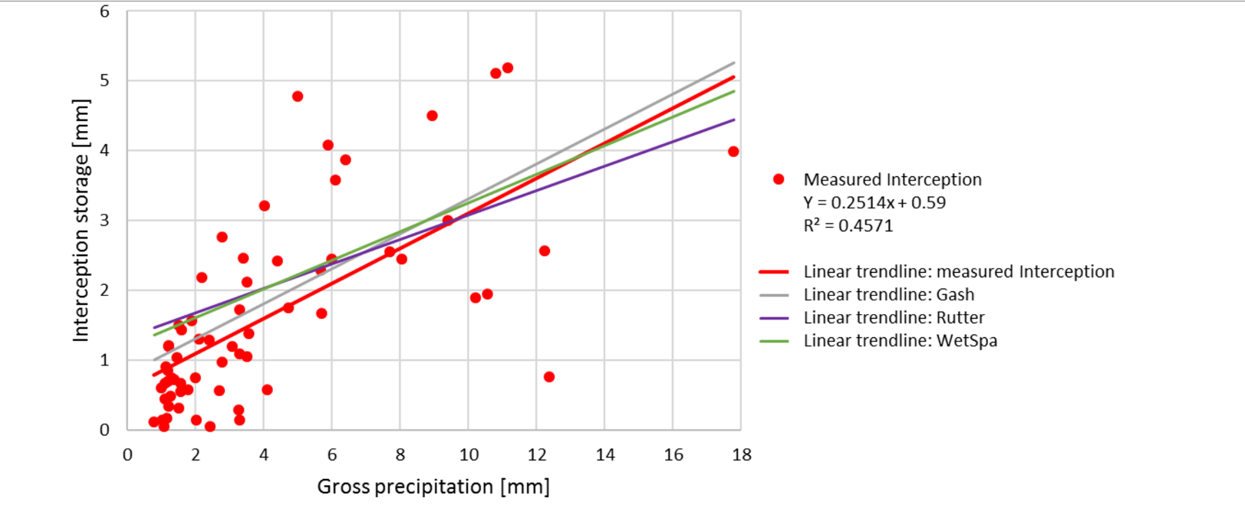

**Figure 2: Interception as a function of gross precipitation (Smets et al. 2019)**



**Figure 3: Interception as a function of gross precipitation (Zabret et al. 2019)**

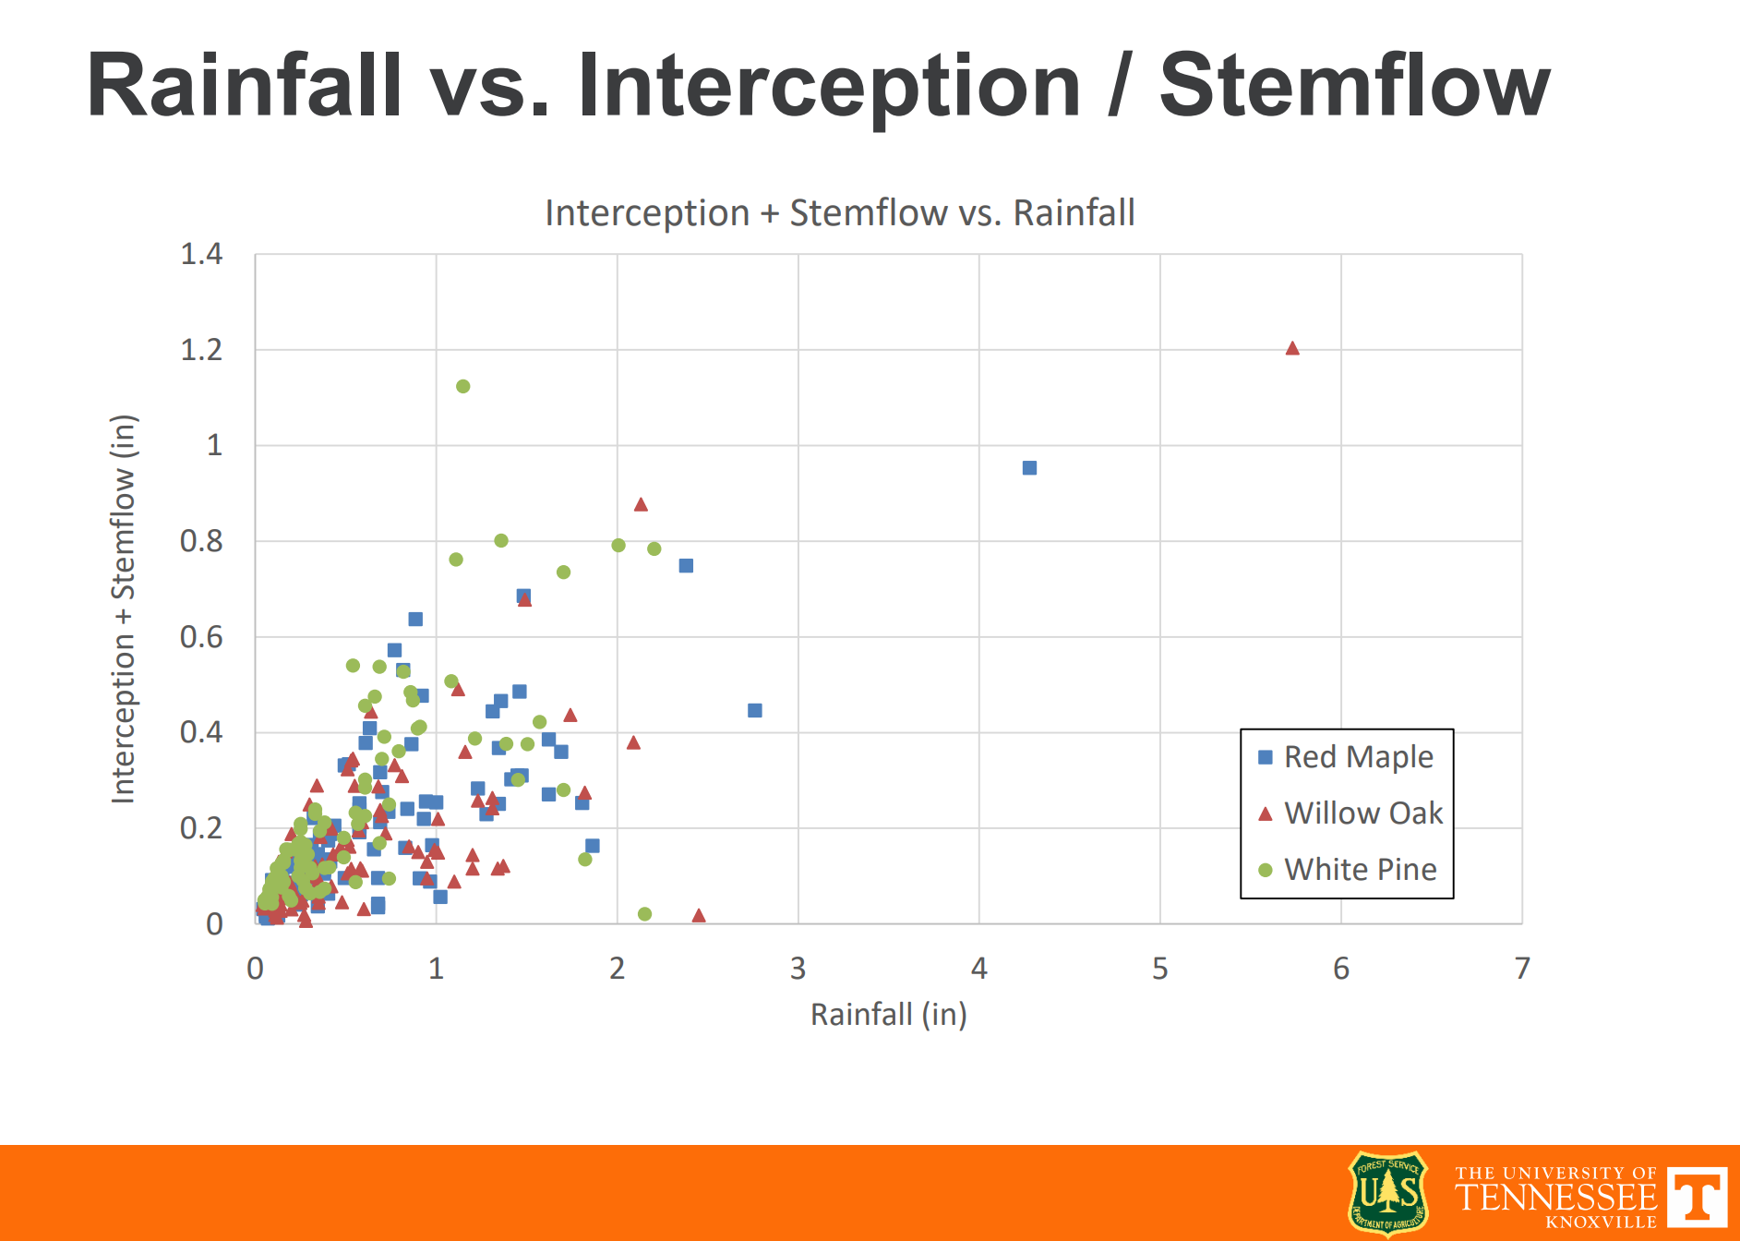

**Figure 4: Interception as a function of gross precipitation (Hathaway, 2019)**

**Table 5: Model-Study Comparison of Interception Depths for a 1.1 Inch Event**

|  |  |  |
| --- | --- | --- |
| Study | Median Interception (inch) for 1.1 inch event and observed ranges1 | |
| **Deciduous** | **Coniferous** |
| Hathaway, 2019 | 0.2 (0.05-0.65)  0.3 (0.10-0.65) | 0.35 (0.15-0.8) |
| Smets, et. al., 2019 | 0.30 | - |
| Zabret, et. al., 20192 | 0.17 (0.06-0.33) | 0.33 (0.08-0.50) |
| Modeling Analysis | 0.11-0.14 | 0.40-0.45 |

*1 Approximation of results based on visual inspection of graphic. The estimates for the range of interception for a 1.1” event shown in parentheses are also based on visual inspection.*

*2 A representative I/P [%] for 27.94 mm of rainfall was selected off the graphic and multiplied by 27.94 mm to estimate interception in mm. I/P*Rainfall = Interception.*

The results from Smets et al. (2019), Zabret, et al. (2019), and Hathaway (2019) studies demonstrate that interception varies considerably at any given rainfall depth, but they show that the model results are within the typical ranges and therefore validate the model.

Model Recommendations

Both models perform well, but the storm-discrete has two advantages.

1. the predicted interception depths match the Smets, Zabret, and Hathaway findings slightly better and
2. the storm discrete model mimics how the credit is evaluated.

Given these advantages, **LimnoTech recommends that the interception credit for deciduous trees be updated to 0.14” and the interception credit for coniferous trees be updated to 0.40”.**

Proposed Draft Update to MIDS

The current version of MIDS uses performance curves based on the instantaneous retention volume of a BMP, which includes the interception capacity, to determine the annual performance. The specific performance curve that is employed by MIDS is dependent on the drainage area characteristics and infiltration characteristics of the underlying soil. While this approach is appropriate for the volume of runoff that is *retained* in a BMP, the volume that is *intercepted* should be factored into performance separately.

LimnoTech drafted an update to MIDS that breaks out the performance calculations: the established performance curves are used for throughfall precipitation and runoff that is routed to a trench or tree box, while intercepted rainfall is factored separately into runoff reduction performance. LimnoTech set the annual performance for interception to the average annual performances calculated in the meta-analysis (57% for coniferous, 30% for deciduous).

A comparison of the current and draft MIDS is shown in Table 6 for a scenario with 10 large deciduous trees in a trench with an underdrain on a site with one impervious acre and one turf acre draining to the trench, where only interception storage capacity is credited.

**Table 6: MIDS methodological comparison**



In the current MIDS, interception credit is factored into the infiltration performance. For this 10 tree scenario, the annual performance of the tree trench is 1.09% (Table 6, Option A). However, if the annual interception performance from the literature of 30% is factored into the total runoff on the site, the overall site performance is increased from 1.09% to 1.7% (Table 7). The current MIDS version only estimates an interception performance of 19% for this specific case, although this number would vary for different scenarios as MIDS currently and incorrectly derives long-term interception performance from infiltration based performance metrics.

**Table 7: Site wide Performance**

|  |  |  |
| --- | --- | --- |
|  | **Current MIDS** | **Proposed MIDS** |
| **Baseline Runoff** | 121934 | 121934 |
| **Runoff Remaining** | 120605 | 119856 |
| **% Reduction** | 1.09% | 1.70% |

**Table 8: Canopy-based Performance**

|  |  |  |
| --- | --- | --- |
|  | **A** | **B** |
| **Baseline Runoff** | 6927 | 6927 |
| **Runoff Remaining** | 5598 | 4849 |
| **% Reduction** | 19.19% | 30.00% |

Recommendations

Based on the information gained from the literature review and modeling analysis, LimnoTech recommends the following:

* Setting the annual rainfall interception performance of deciduous and coniferous trees at 30% and 57%, respectively. These values are based on the average of the performances documented in all reviewed studies for trees and climates that are applicable to Minnesota.
* Setting the rainfall interception depth capacity of deciduous and coniferous trees at 0.14 inches and 0.40 inches, respectively. This interception depth translates into an annual rainfall interception performance of 30% and 57% respectively, thereby aligning both tree metrics.
* Revising the MIDS calculator with the proposed methodology that breaks out the interception and infiltration mechanisms that incorporates the recommended annual rainfall interception performance values in the MIDS calculator.

References

1. Asadian, Y. & Weiler, M. A new approach in measuring rainfall interception by urban trees in coastal British Columbia. Water Qual. Res. J. Canada 44, 16–25 (2009).
2. Asadian, Y. Rainfall Interception in an urban environment. Thesis (2010). doi:10.1558/jsrnc.v4il.24
3. Broxton, P. D. et al. Quantifying the effects of vegetation structure on snow accumulation and ablation in mixed-conifer forests. Ecohydrology 8, 1073–1094 (2015).
4. Cappiella, K. et al. Recommendations of the Expert Panel to Define BMP Effectiveness for Urban Tree Canopy Expansion. (2016).
5. Coenders-Gerrits, M. & Sellers, B. Rainfall interception and redistribution by a common North American understory and pasture forb, Eupatorium capillifolium (Lam. dogfennel). Hydrol. Earth Syst. Sci. Discuss. 1–22 (2019). doi:10.5194/hess-2019-579
6. Hathaway, J. Quantifying rainfall interception in the urban canopy. (2019).
7. Huang, J. Y., Black, T. A., Jassal, R. S. & Lavkulich, L. M. L. Modelling rainfall interception by urban trees. Can. Water Resour. J. 42, 336–348 (2017).
8. Kermavnar, J. & Vilhar, U. Canopy precipitation interception in urban forests in relation to stand structure. Urban Ecosyst. 20, 1373–1387 (2017).
9. Klamerus-Iwan, A. Different views on tree interception process and its determinants. For. Res. Pap. 75, 291–300 (2014).
10. Li, X. et al. A study on crown interception with four dominant tree species: A direct measurement. in Hydrology Research 47, 857–868 (Nordic Association for Hydrology, 2016).
11. Li, X. et al. Rainfall interception by tree crown and leaf litter: An interactive process. Hydrol. Process. 31, 3533–3542 (2017).
12. Livesley, S. J., Baudinette, B. & Glover, D. Rainfall interception and stem flow by eucalypt street trees – The impacts of canopy density and bark type. Urban For. Urban Green. 13, (2013).
13. Nytch, C. J., Meléndez-Ackerman, E. J., Pérez, M. E. & Ortiz-Zayas, J. R. Rainfall interception by six urban trees in San Juan, Puerto Rico. Urban Ecosyst. 22, 103–115 (2019).
14. Perry, S., Garbon, J. & Lee, B. Urban Stormwater Runoff Phosphorus Loading and BMP Treatment Capabilities. Imbrium Syst. (2009).
15. Smets, V. et al. The importance of city trees for reducing net rainfall: Comparing measurements and simulations. Hydrol. Earth Syst. Sci. 23, 3865–3884 (2019).
16. Šraj, M. Rainfall interception by deciduous and coniferous trees in an urban area. (2015).
17. Staelens, J., De Schrijver, A., Verheyen, K. & Verhoest, N. E. C. Rainfall partitioning into throughfall, stemflow, and interception within a single beech (Fagus sylvatica L.) canopy: influence of foliation, rain event characteristics, and meteorology. Hydrol. Process. 22, 33–45 (2008).
18. Storck, P., Lettenmaier, D. P. & Bolton, S. M. Measurement of snow interception and canopy effects on snow accumulation and melt in a mountainous maritime climate, Oregon, United States. Water Resour. Res. 38, 5-1-5–16 (2002).
19. Xiao, Q. & McPherson, E. G. Rainfall interception by Santa Monica’s municipal urban forest. Urban Ecosyst. 6, 291–302 (2002).
20. Xiao, Q. & McPherson, E. G. Surface Water Storage Capacity of Twenty Tree Species in Davis, California. J. Environ. Qual. 45, 188–198 (2016).
21. Xiao, Q. & McPherson, G. G. Rainfall interception of three trees in Oakland, California. Urban Ecosyst. 14, 755–769 (2011).
22. Xiao, Q. A new approach to modeling tree rainfall interception. J. Geophys. Res. Atmos. 105, 29173–29188 (2000).
23. Xiao, Q., McPherson, E. G., Ustin, S. L., Grismer, M. E. & Simpson, J. R. Winter rainfall interception by two mature open-grown trees in Davis, California. Hydrol. Process. 14, 763–784 (2000).
24. Yang, B., Lee, D. K., Heo, H. K. & Biging, G. The effects of tree characteristics on rainfall interception in urban areas. Landsc. Ecol. Eng. 15, 289–296 (2019).
25. Yang, Y., Endreny, T. A. & Nowak, D. J. iTree-Hydro: Snow hydrology update for the urban forest hydrology model. J. Am. Water Resour. Assoc. 47, 1211–1218 (2011).
26. Zabret, K. & Šraj, M. Evaluating the influence of rain event characteristics on rainfall interception by urban trees using multiple correspondence analysis. Water (Switzerland) 11, (2019).

Attachment: Meta Analysis

1. The leaf area index is the leaf area divided by the tree’s crown projection area (LAI = LA/CPA)
2. <https://ldas.gsfc.nasa.gov/nldas/v2/forcing>
3. <http://www.nws.noaa.gov/oh/hdsc/PMP_related_studies/TR34.pdf>