

**Occurrence and Mechanisms of   
Constructed Stormwater Ponds that   
Do Not Effectively Retain Phosphorus**

A Technical Report to

Minnesota Pollution Control Agency

Prepared by LimnoTech

DRAFT: June 19, 2019

TABLE OF CONTENTS

Project Overview 1

Contributors and Acknowledgments 1

Task A: Literature Review of Ponds That Do Not Effectively Retain Phosphorus 2

Description of Task A 2

Literature Review 2

LimnoTech Review 3

BMP Database Review 4

Summary 5

Task B: Mechanisms For Phosphorus Release 5

Description of Task B 5

Introduction 5

Background 5

A Conceptual Model of Pond Phosphorus Retention and Release 7

Processes and Mechanisms Influencing Phosphorus Fluxes 8

1. Input, or External Phosphorus Load 8

2. Sedimentation by (2a) Adsorption & Particle Settling and (2b) Incorporation into Benthos 9

3. Mixing 11

4. Sediment Resuspension 11

5. Dissolution and Diffusion, or Internal Phosphorus Load 12

6. Biological Uptake & Decay 13

7. Groundwater Exchange 14

8. Export 14

Temporal Dynamics of Drivers 15

Summary 15

Task C: List of Ponds with Phosphorus Data 16

Description of Task C 16

Introduction 16

Data Structure 16

Pond Identity Information 16

Design and Maintenance Information 17

Pond Geometry 18

Upstream Drainage Area 18

Pond Performance Information 19

Wetland Classification Information 20

Summary of Data 20

Task D: Assessing Indicators of Phosphorus Release 25

Description of Task D 25

Introduction 25

Continuous Variable Assessment 26

Categorical Variable Assessment 29

Land use 29

Nationwide Urban Runoff Program (NURP) 30

Pond Type 31

Methodological Limitations 33

Assessment Summary 33

Project Conclusions 34

References 35

Appendix A 38

# Project Overview

Stormwater ponds are an important feature in the management of urban runoff in order to mitigate the downstream impacts of water quantity and water quality (Minnesota Stormwater Manual, 2019). The US Environmental Protection Agency (EPA) Nationwide Urban Runoff Program (NURP) research project intensively studied the performance of 28 stormwater ponds from 1979-1983 to determine the characteristics of ponds that were most effective at retaining stormwater contaminants. The analysis of the NURP data formed a foundational set of criteria -- based on maximizing sedimentation and minimizing scour -- that have been used to design and maintain constructed stormwater ponds since the mid-1980s to the present day (EPA 1983; Driscoll 1983; Walker 1987).

A number of recent studies have found that many constructed stormwater ponds are not as effective at removing phosphorus as expected and that some ponds may be at times releasing phosphorus (Mccomas & Stuckert 2011; LSRCA 2011; Song et al. 2015; Taguchi et al. 2019 in review). These and other studies suggest that biological and geochemical processes, such as hypoxia, may be important to releasing phosphorus from pond sediments.

The goal of this project is to determine the likely extent or occurrence of constructed stormwater ponds that do not effectively retain phosphorus and identify conditions that likely lead to sediment phosphorus release. Our work and this report are organized into four related tasks.

* Task A: Estimate the extent and occurrence of constructed stormwater ponds that do not effectively retain phosphorus.
* Task B: Identify conditions likely to contribute to phosphorus export from constructed stormwater ponds.
* Task C: Compile information for constructed stormwater ponds identified as potentially exporting phosphorus into a spreadsheet or database.
* Task D: Conduct a high level assessment of characteristics, trends, and patterns

The purpose of this work is to inform the development of qualitative recommendations for pond design, construction, maintenance, and/or monitoring to maximize phosphorus retention.

## Contributors and Acknowledgments

This project was supported by the Minnesota Pollution Control Agency (MPCA), with oversight and review by Mike Trojan.

LimnoTech contributors included Anthony Aufdenkampe, Dendy Lofton, Ben Crary, Hans Holmberg, and Jeremy Walgrave.

Other contributors included Drs. John S. Gulliver and Ben L. Janke.

We thank Kerry Holmberg and Bruce Wilson, from the University of Minnesota, for sharing their lists of stormwater ponds in Minnesota with phosphorus data.

# Task A: Literature Review of Ponds That Do Not Effectively Retain Phosphorus

## Description of Task A

**Task A: Estimate the extent and occurrence of constructed stormwater ponds that do not effectively retain phosphorus.**

* Review existing literature and contact individuals who can provide information on which to estimate the occurrence of constructed stormwater ponds that do not effectively retain phosphorus. The information to be used in the evaluation will be limited to areas with similar climate characteristics and will include Minnesota, Iowa, Michigan, Wisconsin, and Ontario, Canada.

## Literature Review

While the topic of stormwater ponds is common in the literature, the evaluation of phosphorus release mechanisms in engineered systems is not broadly studied. Several studies have performed broad spatial evaluations over a few points in time (e.g. Riley Purgatory Bluff Creek Watershed District, Lake Simcoe Region Conservation Authority), while other studies have taken an intense look at a few ponds over time (e.g. Song et al. 2015, 2017).

Riley Purgatory Bluff Creek Watershed District’s (RPBCWD) 2014 Stormwater Pond Project was perhaps the broadest study identified (RPBCWD 2014). RPBCWD surveyed total phosphorus and dissolved phosphorus concentrations in 98 lakes within the District’s boundaries. The survey took place between 2010 and 2013, and the dataset is based on an intensive, seasonally-representative sampling program over three years (average of 6 samples per pond). In this study, surface samples were collected in the downstream third of the flow-path, near the outlet and at the edge of the pond, in dry-weather conditions.

RPBCWD found that in 2013 (the year with the broadest sampling effort), 71% of the ponds surveyed had annual average TP concentrations that were higher than the MPCA’s threshold for effluent water (0.25 mg/L), and suggested that these ponds may not be retaining phosphorus. LimnoTech’s own review of this data found that 44 percent of the ponds had an average TP concentration greater than 0.38 mg/L over the 2010-2013 period, which is the upper 95th percentile confidence limit of Twin Cities stormwater runoff measurements (n=19 sites; Janke et al. 2017). If it is assumed that the Janke, et al’s work represents typical P concentrations in stormwater runoff, then this data can be used to infer if a pond might be exporting more phosphorus than it is receiving through runoff inflow. While paired influent concentrations were not taken in this survey, these data show that a large proportion of these ponds have high internal concentrations of phosphorus relative to typical inflow concentrations during dry weather conditions.

The Lake Simcoe Region Conservation Authority (LSRCA) conducted a similar study in 2010, with a specific focus on anoxic conditions (LSRCA 2010). The ponds surveyed were limited to Ontario, Canada and were generally found to have considerably lower surface concentrations of TP than the ponds in RPBCWD study (median concentrations of 0.03 mg/L and 0.34 mg/L, respectively). Despite the relatively low concentrations, LSRCA estimated that the collective removal efficiency from these ponds is 25% less than the designed efficiency. Efficiency estimates are based on volume-based equations from the Canadian Ministry of Environment’s 2003 stormwater guidance, and do not reflect a monitored mass balance.

Notably, low DO concentrations were documented during the daytime in 42 of the 98 ponds that had been surveyed. It was not reported whether these ponds were anoxic throughout the water column, but LSRCA noted that anoxia has been reported ponds as shallow as 2 meters. Measurements indicate that these ponds were releasing phosphorus at times of low DO, but LSRCA notes that more targeted study would be necessary to state conclusively that the sediments are releasing phosphorus into the pond’s effluent under certain conditions. LSRCA suggests that “a release of sediment bound P during specific weather conditions is occurring in many ponds.”

This conclusion is supported by other recent research in Ontario, Canada. Song, et al. (2017) studied phosphorus dynamics in a small set of ponds under a variety of environmental conditions and found that phosphorus conditions within a single ecosystem can change greatly throughout the year. Particulate phosphorus was the dominant form found in the water column and was found to increase from inflow to outflow locations. Organic phosphorus was the dominant fraction measured in the sediments in June and September, but the authors found that biological mineralization significantly decreased the organic phosphorus fraction by September (by as much as 37% near the outlet). Notably, this mineralization in the sediments corresponded to an increase of TP in the water column in late summer. Organic phosphorus remained the dominant fraction despite the decrease in concentration.

Earlier work by Song, et al. highlighted the importance of measuring fractions of phosphorus while trying to understand the internal phosphorus processing in stormwater ponds (Song et al. 2015). Particulate phosphorus concentrations were found to be consistently higher in effluent concentrations than in influent stormwater. Other spatial fractionation patterns were observed (phosphomonoester are highest near influent locations and decrease within ponds) and ultimately correlated to precipitation and hydrologic conditions. For example, high concentrations of phosphomonoesters were associated with high influent flow. On the other hand, the average concentration of phosphodiesters, indicators of biological activity, was not found to be heavily influenced by flow regime, but were found to increase internally during dry periods. Additional fraction-specific patterns are described in detail by the authors (Song et al. 2015).

Poor performing ponds have been identified for decades. Walker, et al. 1987 found a range of 0-79 percent phosphorus removal efficiencies for NURP detention basins and 0-62 percent removal for wetlands, several of which were in Saint Paul, Minnesota. The authors believed the NURP designs were “reasonably robust” in the Saint Paul area, but the ponds were performing below efficiency predictions from an empirical model based on physical and watershed characteristics.

## LimnoTech Review

In conjunction with Task C, LimnoTech compiled pond data from literature and other available resources. Of the over 500 ponds in this initial compilation, we narrowed the dataset to include 240 ponds in the Upper Midwest or Canada that had at least one surface TP measurement (see Task C and Appendix A). Measurements from these data show that 24 percent of ponds had an average concentration greater than the upper 95th percentile confidence limit of Twin Cities stormwater measurements (Janke et al. 2017). The sampling patterns of these ponds do not necessarily capture the full extent of climatic and biogeochemical conditions nor do they specifically capture effluent volumes, thus, the 24% exceedance of the local stormwater average event mean concentration (EMC) should not be considered a proxy for mass-based efficiency. Rather, these values simply indicate that a strong proportion of ponds have internal concentrations larger than stormwater EMCs during the sampled time points.

## BMP Database Review

Paired influent and effluent TP measurements, collected at approximately the same time, from retention ponds were queried from the International Stormwater Database (<http://www.bmpdatabase.org/>). There were 66 retention ponds with paired TP measurements, eight of which were in Minnesota, Wisconsin, or Michigan (Table 1). There is a fairly large number of paired samples for each pond, albeit the measurements for the upper-Midwest samples range from 1979-2008. In many cases, the sample sets span throughout a given year.

**Table 1: Paired TP Summary for Retention Ponds (*source: International Stormwater BMP Database*)**

|  |  |  |
| --- | --- | --- |
| **Nation-wide** | Number of Ponds | **66** |
| Median Number of Samples | **8** |
| Median % paired *[Effluent TP] > [Influent TP]* | **13%**  **(0% - 100%)** |
| Ponds with at least one paired *[Effluent TP] > [Influent TP]* | **46** |
| **Upper Midwest** | Number of Ponds | **8** |
| Median Number of Samples | **21** |
| Median fraction of pairedsamples, within a pond, where *[Effluent TP] > [Influent TP]* | **13%**  **(0% - 28%)** |
| Ponds with at least one paired *[Effluent TP] > [Influent TP]* | **6** |

In total, 17% of the effluent measurements exceeded the paired influent measurement, and six of the eight ponds in the upper-Midwest had at least one effluent exceeding the influent (Table 2). The median effluent exceedance is 13% for both the national and upper-Midwest dataset, suggesting that the national dataset may be an appropriate comparison in some circumstances.

Higher effluent concentrations do not occur in all paired samples within a pond, highlighting the variable nature of TP export. For the upper-Midwest dataset, these exceedances occurred throughout the year suggesting multiple possible drivers of TP export. Further, concentration data do not indicate the overall load retained (i.e. difference between influent and effluent loads). Pond performance may vary based on season or volume storage capacity (for example), and an overall mass balance (such as the sum of daily loads in and out of the pond) would be needed to assess the overall retention over the course of an average annual seasonal cycle.

## Summary

Overall the literature has not come to a conclusion on the extent of phosphorus release from stormwater ponds, but recent efforts have begun to shed light on the processes. RPBCWD has revealed a large proportion of ponds (44%) have surface concentrations that are higher than estimated stormwater influent, and LSRCA identified that many are not operating as efficiently as designed (overall loss of 25% efficiency). LSRCA speculated that anoxic conditions (which were documented in nearly half of their 98-pond survey) may be contributing to internal phosphorus loading. This speculation has been supported by recent literature highlighting the conditional influences on internal phosphorus dynamics.

LimnoTech’s independent review of data shows a range of results, but is limited by data availability and type. Paired influent and effluent data from the International Stormwater Database shows approximately 13% of paired samples within ponds have a higher effluent concentration than. Similarly, 24% of all compiled data have a concentration higher than stormwater concentrations. Yet, these summaries are just snapshots in time and do not reflect mass-based efficiency.

# Task B: Mechanisms For Phosphorus Release

## Description of Task B

**Task B: Identify conditions likely to contribute to phosphorus export from constructed stormwater ponds.**

* Document major biogeochemical and geochemical mechanisms driving phosphorus release from the sediments and retention by the sediments in constructed stormwater ponds.
* Develop a conceptual model of the major mechanisms.

## Introduction

### Background

For over three decades, constructed stormwater ponds have been designed and maintained to maximize sedimentation and minimize scour during storm periods. The US Environmental Protection Agency (EPA) Nationwide Urban Runoff Program (NURP) research project found that a permanent pool was a valuable feature of stormwater ponds because it (1) increases sedimentation efficiency and reduces bottom scouring potential by dissipating runoff energy, and (2) provides habitat for algae and aquatic plans to assist in the removal of soluble pollutants, which in turn provides treatment to occur during intervals between storms (EPA 1983; Walker 1987). Analysis of NURP results also found that the average removal efficiency of total suspended solids (TSS) increased with increasing ratios of pond surface area to its catchment area (Apond/Acatchment), average surface overflow rate during storms (Q/Apond), and permanent pool volume to average storm volume (Vpond/Vstorm) (EPA 1983; Driscoll 1983; Walker 1987). Walker (1987) extended this work by modeling the measured storm-period phosphorus removal for ponds studied by NURP. Walker modeled sedimentation of phosphorus with an empirical second-order rate function (i.e. proportional to the square of the phosphorus concentration) to explain 89% of the variability. He found that hydraulic residence time greater than 2 days was a key factor for overall phosphorus removal efficiency, along with related scaling parameterizations, such as the ratio of pond surface area to the watershed’s impervious area (Figures 1, 2, from Walker 1987).

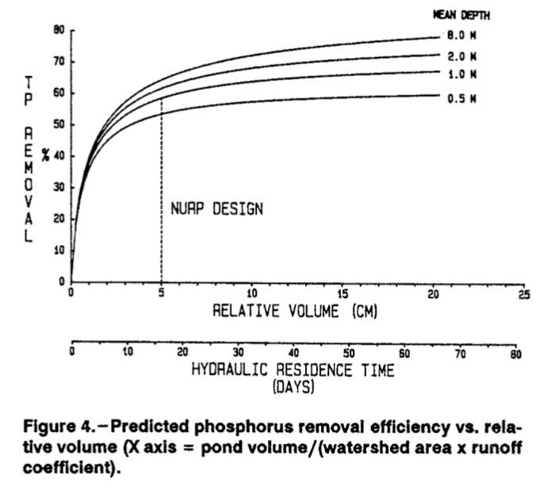

Figure 1: Predicted phosphorus removal efficiency vs. relative volume (X axis = pond volume/(watershed area x runoff coefficient). Adapted from Figure 4 in Walker 1987.

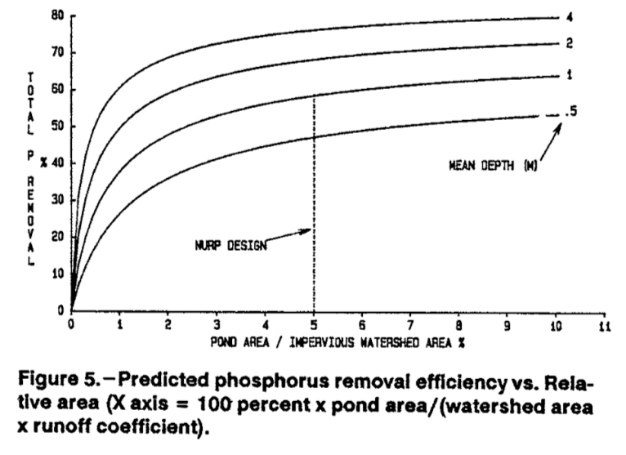

Figure 2: Predicted phosphorus removal efficiency vs. relative area (X axis = 100 percent x pond area/(watershed area x runoff coefficient). Adapted from Figure 5 in Walker 1987.

As a result of these and other studies, in the decades since, the design of stormwater ponds for water quality has focused nearly entirely on the goal of maximizing sedimentation of phosphorus bound to particles and minimizing scouring of these particles by subsequent storms. Other physical, geochemical, and biological processes have not adequately been considered.

### A Conceptual Model of Pond Phosphorus Retention and Release

In order to identify conditions likely to contribute to phosphorus export from constructed stormwater ponds, we first document all the physical, geochemical, and biological processes and mechanisms driving phosphorus retention and release from ponds.

We organize our description and discussion of these processes via conceptual “box” model of the major mechanisms. Box models are simplified versions of complex systems, reducing them into conceptual boxes (reservoirs of material) that are connected by fluxes of that material in and out of each box. Box models can thus be used as the basis for developing mass balance equations for either steady state or dynamic systems.

For this report, we conceptualize a stormwater pond composed of three boxes:

* Upper Water Column, or Epilimnion
* Lower Water Column, or Hypolimnion
* Benthic Sediment

We then define eight major fluxes of phosphorus that connect these three boxes to each other, to the catchments upstream and downstream of the pond, and to groundwater (Figure 3). These major fluxes of phosphorus are:

1. Input, or External Phosphorus Load
2. Sedimentation by (2a) Adsorption & Particle Settling and (2b) Incorporation into Benthos
3. Mixing
4. Sediment Resuspension
5. Dissolution & Diffusion
6. Biological Uptake & Decay
7. Groundwater Exchange
8. Export

We organize our discussion of processes around these fluxes, describing mechanisms for each flux, the environmental drivers that act as forcing to those fluxes, and the factors that affect the magnitude of those fluxes.

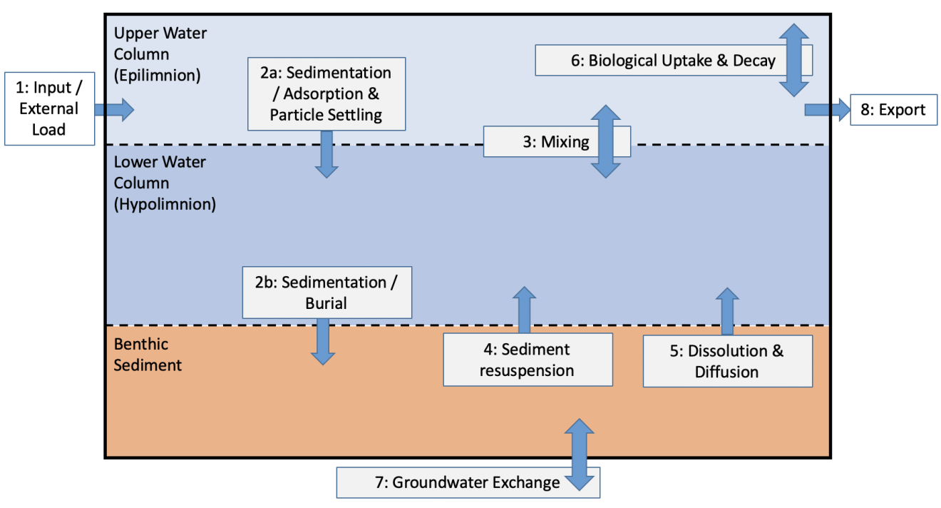

Figure 3: A conceptual box model of a stormwater pond composed of three reservoirs of phosphorus (shown as boxes) and seven major fluxes of phosphorus (arrows).

## Processes and Mechanisms Influencing Phosphorus Fluxes

### 1. Input, or External Phosphorus Load

External phosphorus loads to stormwater ponds are delivered through two physical pathways, which are (1) runoff from the upstream catchment via surface water inlets, and (2) and atmospheric deposition directly to the pond surface. Atmospheric deposition of phosphorus directly to the surface of stormwater ponds can be considered a negligible source in stormwater due to the smaller surface area and longer hydraulic residence time compared to larger bodies of surface water. Therefore, the processes and drivers of direct runoff are given more discussion in this report.

Rainfall and snowmelt are the primary **drivers** of phosphorus entering stormwater ponds through direct runoff.

Several interrelated **factors** together determine the magnitude of the runoff phosphorus load, or the total mass of P entering the pond with stormwater as calculated from water flux multiplied by P concentration.

* **Storm size** (i.e. total event depth and precipitation intensity). Increasing storm size not only increases the water flux, but it also increases the total P concentrations through increased movement of solids on connected impervious surfaces, through connecting an increasing proportion of the landscape to the surface water (when the precipitation exceeds the infiltration capacity of the given land cover), and through increasing soil, bank, and channel erosion and resuspension.
* **Catchment size**. Increasing upstream catchment size, as reflected by the scale independent ratio of catchment area to pond area, increases the total captured volume of water that must either be infiltrated into the soil or runoff to the pond.
* **Catchment land cover**. Decreasing the infiltration capacity of land cover will increase the fraction of precipitation that runs off to surface waters. The percent of a catchment that is impervious has long been recognized as a primary factor. Turf grass can also have both a low infiltration capacity and can also result in high concentrations of P in runoff due to P fertilizer applications. Deciduous tree cover and lawn management near impervious surfaces can lead to higher P loads from fallen leaves, seeds and flowers and grass clippings.
* **Antecedent Conditions**. Phosphorus can build up on catchment surfaces during the dry periods between storms. Atmospheric dry deposition and animal waste (i.e. dogs & geese) build up on impervious surfaces and also on turf and lawns. The longer the interval between storms, the more P accumulates to be carried by runoff from the next storm to surface waters. Construction activities can also impact P runoff loads. Many of these factors exhibit seasonality, such as leaf fall in the autumn, and dust from nearby agricultural lands during periods when fields are plowed or disturbed.

### 2. Sedimentation by (2a) Adsorption & Particle Settling and (2b) Incorporation into Benthos

Dissolved inorganic phosphorus (DIP) species -- including the bio-available ortho-phosphate ion and also condensed phosphates (i.e. pyrophosphate, metaphosphate, and polyphosphate) -- have a strong affinity for binding to inorganic and organic particles through a variety of adsorption and/or surface complexation reactions. These sorption processes can occur relatively rapidly and explain the observation that typically more than half of aquatic total phosphorus (TP) is found in the particulate form, and that proportion typically increases as water travels downstream from runoff sites, to streams, ponds and lakes, likely as a result of increasing contact with mineral particles (Pitt et al. 2003; Kayhanian et al. 2007; Yi et al. 2019). As a result, sedimentation is an effective means to remove total phosphorus from stormwater (Walker 1987).

Sedimentation of particulate phosphorus (PP) in ponds can be viewed as a two-step process. First, terrestrial-derived particles (organic and inorganic), aquatic macrophyte detritus, and algal detritus settle through the upper and lower water column at a rate that is a function of the particle size and particle density. Second, settled particles become incorporated over time and eventually buried into the benthic sediment layers, where they can be considered to be removed from surface waters.

The primary **driver** of sedimentation is the delivery of particulate phosphorus by stormwater inflow.

The **factors** that determine the magnitude of the phosphorus sedimentation include:

* **Mineral surfaces for adsorption**. Particulate phosphorus is typically in the form of inorganic phosphorus species adsorbed to the surfaces of minerals such as alumino-silicates, aluminum oxides, and iron oxides via anion exchange, ligand exchange, and cation bridging mechanisms. The phosphorus content (in weight percent) of total suspended solids/sediments (TSS) is thus largely determined by the concentration of reactive surface binding sites in the TSS, which is turn a function of the mineralogy of the TSS and its mineral surface area. Smaller particle size is loosely correlated with reactive mineral surface area, but for the same mineral size the mineral surface area can vary by one to two orders of magnitude. Generally, the highest reactive surface areas are found on the various aluminum oxide and hydroxide minerals -- such as gibbsite (Al(OH)3 , either naturally formed or from precipitating soluble alum (Al2(SO4)3·nH2O), boehmite (γ-AlO(OH)), and diaspore (α-AlO(OH), alumina (Al2O3)) -- and various iron(III) oxide and hydroxide minerals -- such as goethite (α-FeOOH), akaganéite (β-FeOOH), lepidocrocite (γ-FeOOH), ferrihydrite (FeOOH•1.8H2O), Magnetite (Fe3O4, or Fe2+Fe3+2O4). Even these aluminum and iron oxides exhibit a wide range of variability that depends both on the specific mineralogy and also the formation conditions of that specific mineral.
* **Organic Phosphorus**. Stormwater ponds contain substantial amounts of organic phosphorus, primarily delivered as organic particles that come from detrital leaves, grass clippings, seeds, flowers, etc. that are carried by runoff. The size of particulate organic phosphorus (POP) varies from sub-millimeter to the size of a leaf, depending upon the degree of degradation that has occurred. Dissolved organic phosphorus (DOP) molecules can be released into the water as organic detritus leaches and decomposes.
* **Particle size and density**. Increasing particle size and/or density increases the settling velocity, which, in turn, increases the rate at which particles settle out of the water column. Inorganic particles derived from soil minerals have a much higher density relative to water than organic particles derived from the detritus of terrestrial vegetation, aquatic macrophytes and algae. The particle size/density distribution delivered to a pond depends on storm size and intensity, where bigger and more intense storms can deliver larger and more dense particles. Small particles can aggregate into larger particles under non-turbulent conditions.
* **Hydraulic residence time.** Results from NURP and related studies (Figure 1, from Walker 1987) recommended that stormwater ponds be designed to have a mean hydraulic residence time (mean pond volume / mean outflow rate) of 2 to 10 days or longer in order to allow for enough time for the particles containing phosphorus to settle.
* **Settling time**. A particle requires a certain amount of time to settle the distance from the water surface to the benthic sediment, and this time is determined by the particle’s settling velocity (which is a function of its size and density) multiplied by the water column depth. Increasing the settling time between storms or other turbulent events increases the sedimentation of the smaller and/or low-density particles.
* **Pond geometry**. The pond area, depth, volume, and shape influence sedimentation in numerous ways. Increasing pond volume relative to average storm volume (Vpond/Vstorm) or relative to catchment area proportionally increases average hydraulic residence time and settling times (Walker 1987). Although depth is positively related to volume and therefore hydraulic residence time, increasing depth also increases the amount of time required to fully settle and incorporate particles into the benthic sediments. Increasing the distance from inlet to outlet, while holding volume constant and therefore decreasing depth, can increase the effective settling time. Adding a forebay, increasing sinuosity of the water travel pathway from inlet to outlet, and/or increasing aquatic macrophytes or flooded vegetation can all decrease turbulent mixing in the later portions of the water flow path, thereby increasing sedimentation efficiency for smaller/lower-density particles.
* **Algal/macrophyte production**. Greater in-pond primary production rates of algae and/or aquatic macrophytes will increase the flux of organic particles and organic coagulants to the water column, increasing the delivery and sedimentation of particulate phosphorus to the benthic sediment.
* **Burial**. As benthic sediments accumulate, layers can get buried over time by increasing mass and depth of overlying sediment, which in turn compresses the lower sediment layers, reducing their porosity. Increasing the depth of a layer within the benthic sediment and decreasing its porosity both serve to decrease diffusive exchange with the lower water column (see flux 5, below).

### 3. Mixing

The process of turbulent mixing between the upper and lower water column results in bidirectional exchanges of water, solutes and particles. Mixing is caused by turbulence, or shear-stresses within water column.

The two main **drivers** of turbulent mixing are stormwater inflows, in which the momentum of high-velocity flows entering the pond are dissipated through turbulent eddies, and wind, which creates a shear on the pond surface that is partially transferred throughout the water column.

The factors that determine the magnitude of turbulent mixing include:

* **Storm size**. Increasing precipitation and runoff, increases the mass and velocity of inflowing water, which increases water momentum and turbulence.
* **Wind speed and duration**. Increasing wind speed at the air-to-water interface increases the turbulent energy transferred into the water column for mixing.
* **Pond geometry and landscape position**. Increasing the length of a pond can increase wind fetch (i.e. the maximum uninterrupted distance that wind can travel over open water with sustained velocity), which can increase the wind-driven turbulent energy input. Increasing wind-sheltering from buildings, trees, or other vegetation decreases wind-driven mixing by increasing the wind separation zone where the near surface wind is light and in the opposite direction from the prevailing wind. The wind separation zone distance is 8-12 times the height of sheltering, and lower wind velocity prevails for approximately 50 times the height of wind sheltering. Increasing pond depth decreases the ability for turbulent energy to reach the bottom of the pond.
* **Water density stratification**. Increasing density stratification in the water column through solar heating or through road salt inputs (i.e. chloride) increases density stratification, reducing mixing. Road salts in particular can increase water density of the lower water column to a point where mixing requires a high input of turbulent energy.

### 4. Sediment Resuspension

The resuspension and scouring of particulate phosphorus from the benthic sediment to the lower water column is a physical process that was examined in the EPA NURP study and associated research (EPA 1983, Driscoll et al. 1983, Walker 1987). The mechanism for resuspension is high turbulence at the sediment-water interface,which releases particulate phosphorus and potentially porewater dissolved phosphorus into the overlying water.

The major **drivers** of high turbulence include stormwater inflows, wind forces, and bioturbation (e.g. carp or other benthic-disturbing organisms). Bioturbation can be a particularly important driver because the turbulent energy is directly applied to the sediment-water interface, which means it can occur even if there is significant water column stratification that limits the reach of turbulence that is applied to the top of the water column.

Primarily, physical **factors** of the pond design control the extent to which turbulent forces lead to sediment resuspension.

* **All factors that promote water column mixing** can also promote particle resuspension, although the turbulent energy for resuspension of sediment is much greater than for water column mixing. If the turbulent energy is applied to the top of the water column, as with wind and most stormwater inflows, then the entire water column must first become mixed before turbulent resuspension will occur.
* **Presence of carp or other benthic-disturbing organisms** is the primary factor controlling bioturbation.

### 5. Dissolution and Diffusion, or Internal Phosphorus Load

The diffusive flux of soluble phosphorus from the benthic sediments to the lower water column is often described as internal phosphorus load of a lake or pond. The mechanisms for internal P loading follow a **two-step process** in which (1) phosphorus is transformed from particulate forms (PP) to dissolved forms (DP), followed by (2) dissolved phosphorus species diffusing from sediment porewater into the lower water column based on concentration gradients.

**Step 1: Dissolution**. Phosphorus exists in many forms in sediments, which include particulate and dissolved phases of both inorganic and organic forms. The transformation of phosphorus species within sediments is driven by interacting biogeochemical and geochemical processes. From a biogeochemical standpoint, two processes drive the availability of dissolved phosphorus that can diffuse from the sediments:

1. **Desorption** or dissolution of inorganic phosphorus species bound to surfaces of solid minerals such as alumino-silicates, aluminum oxides, and iron oxides via a number of mechanisms including the reversible anion exchange, ligand exchange, and cation bridging reactions. Although phosphate can be incorporated into the mineral structure of some minerals, such as vivianite (Fe2+ Fe2+2(PO4)2·8H2O) and apatite Ca10(PO4)6(OH,F,Cl)2, these minerals are rare and only form under specific conditions that are not typically common in ponds.
2. **Mineralization** of phosphorus-containing natural organic matter, typically through microbially-mediated oxidation reactions such as respiration, releases dissolved organic phosphorus (DOP) and dissolved inorganic phosphorus (DIP).

An important **driver** for desorption is anoxia, or the absence of dissolved oxygen, which leads to the reductive dissolution of ferric iron (Fe3+) oxide minerals. Under oxic water conditions, iron is most stable in its most oxidized iron(III) state in insoluble minerals. Under anoxic conditions, ferric iron (Fe3+) is reduced to ferrous iron (Fe2+), which is soluble. Thus, the iron oxide minerals to which phosphate ion (PO43+) is bound can dissolve “out from under” the phosphate ion, which in turn returns to the dissolved phase.

An important consequence of mineralization is the consumption of dissolved oxygen by the mineralization reactions. This in turn serves as an important feedback that promotes reductive dissolution of ferric oxide minerals along with desorption and dissolution of phosphorus.

A number of **factors** influence the rates of phosphorus dissolution and the concentrations of dissolved phosphorus in benthic sediment porewaters.

* **Quantity and quality of organic matter**. Increasing inputs of particulate and dissolved organic matter to the pond will increase the biological oxygen demand (BOD) rate. In addition, natural organic matter is a complex mixture with different components exhibiting an extremely wide range of bioavailability, with biologically mediated reaction times commonly ranging from hours to thousands of years. Just as particle size distributions can vary widely, organic matter reaction times also have a wide distribution.
* **Gas exchange and mixing**. The gas exchange fluxes of oxygen from the atmosphere to the upper water column, and the mixing of dissolved oxygen to the lower water column both occur at a rate that is proportional to turbulence in the water column. Increasing turbulence increases the flux of oxygen into the upper and lower water column, which decreases the occurrence and duration of bottom water anoxia.
* **Mineralogical composition of sediment**. As described in the section above for flux 2a (Adsorption & Settling), the mineralogical composition and its reactive surface area determine how much phosphorus is bound to sediment particles and how tightly it is bound. Of the minerals in typical pond sediments, only ferric iron (Fe3+) oxide minerals will release phosphorus under anoxic conditions. Increasing the proportion of sedimentary phosphorus that is bound to iron oxides will increase the susceptibility and amount of phosphorus that has the potential to be released under anoxic conditions.
* **Other chemical factors**. The aqueous pH and the concentrations of other solutes can have an important effect on phosphate adsorption and desorption (Shang et al. 1992; Manning & Goldberg 1996; Ruttenberg et al. 2001; Spiteri et al. 2008; Yang et al. 2018). For example, pH affects the net charge on mineral surfaces, which affects anion exchange mechanisms. The protonation of phosphate itself is pH dependent, which affects ligand exchange. Cation bridging mechanisms require high concentrations of polyvalent cations, such as calcium and magnesium. Other dissolved ions, such as sulfate or arsenate, can compete with phosphate for available binding sites on mineral surfaces.

**Step 2: Diffusion**. Once phosphorus is dissolved, it is available to diffuse from benthic sediment layers into the lower water column. Molecular aqueous diffusion is a slow process, diffusive fluxes from a sediment layer will decrease with distance to the lower water column through overlying sediments. Decreasing sediment porosity will also decrease diffusive fluxes.

Bioturbation -- including “ventilation” from burrows and also sediment disruption by bottom feeding fish -- is a very effective mechanism for increasing the “diffusive” fluxes from sediments to water column because it effectively decreases the molecular diffusion distance over which pore water dissolved phosphorus needs to travel.

If phosphorus and ferrous iron (Fe2+) are dissolved under anoxic conditions, shortly after these solutes diffuse or mix into oxygenated waters, the iron will oxidize to ferric iron (Fe3+) that will then rapidly precipitate in the water column into very small particles of insoluble, high-surface-area iron oxide mineral forms. These re-precipitated iron oxide particles can be nearly coloidal in size and can co-precipitate with phosphate (and many other surface reactive species) at very high mass ratios of phosphate to iron oxide (i.e. weight-percent concentrations). These initially colloidal particles typically coagulate into larger particles. This process explains how anoxia-driven dissolution and diffusion of phosphorus from benthic sediments can result in the export of particulate phosphorus from ponds.

### 6. Biological Uptake & Decay

Once in the system, phosphorus recycles among biotic and abiotic components. There is a generalized sequence of processes that includes nutrient uptake by algae and plants, transfer of energy and nutrients through the aquatic food chain (if higher organisms are present in the stormwater pond), decay and subsequent release of nutrients through organic matter decomposition and mineralization, and re-assimilation of available nutrients by aquatic organisms.

Phosphorus is typically the limiting nutrient for algae growth in freshwater systems. Fresh inputs of dissolved phosphorus to pond readily leads to algal uptake under sufficient temperature and light conditions. Algae growth and decay can occur in short timescales (days to weeks), and consequently, nutrients can be recycled in the water column multiple times throughout the year. While the dissolved forms of phosphorus are readily taken up by algae, particulate phosphorus and organic matter may settle through the water column (#2a) and accumulate in benthic sediments (#2b) for further decomposition and mineralization.

In stormwater ponds, aquatic plants serve two important functions: sediment stabilization and nutrient uptake from the sediments. Decay of aquatic plant matter is similar to algal decay in that dissolved phosphorus is released into the water column and particulate phosphorus and organic matter settles through the water column and may accumulate in the sediments. The rates of decomposition and mineralization of organic matter (algae or plants) in the water column and sediments are driven by temperature, availability of oxygen and the presence of other electron acceptors as well (e.g. nitrate)

Aerobic decomposition of organic matter (e.g. algae and aquatic plants) in the water column and on the sediment surface consumes oxygen, which can enhance diffusive flux of dissolved phosphorus from the sediments under anoxic conditions (#5). Consequently, high organic matter in the system depletes oxygen which can lead to diffusive flux of phosphorus from the sediments.

### 7. Groundwater Exchange

In many discussion of stormwater pond efficiency, comparisons of inflow and outflow concentrations presume that there are no net fluxes with groundwater. However, stormwater ponds that are constructed above the water table may infiltrate water to the groundwater table, and stormwater ponds converted from wetlands or built near the water table may receive water inputs from groundwater sources. A full accounting of phosphorus retention by stormwater ponds needs to consider these possibilities.

Groundwater phosphorus concentrations are typically low, because of the high affinity of all forms of dissolved phosphorus to sorb to the mineral surfaces that are present in the ground. Therefore, the effect of net water inflows from groundwater could either dilute in-pond phosphorus water column concentrations and/or possibly increase the diffusive flux of phosphorus from benthic sediment into the water column. The effect of net water infiltration to the groundwater might be to effectively increase phosphorus retention in benthic sediment, both by increasing the flux of dissolved phosphorus to reactive mineral surfaces and/or decreasing diffusion out of sediment.

Stormwater pond efficiency studies should thus consider the potential for groundwater exchange in the interpretation of water column phosphorus concentrations as an indicator of net fluxes and loads.

### 8. Export

Surface water outflow is the obvious primary means to export phosphorus from a stormwater pond, but a number of processes might be considered in quantifying average annual export and managed to minimize export.

The **drivers** of phosphorus export are stormwater inflows and baseflow, from perennial inflowing streams and/or groundwater inflows. However, all of the processes and factors above can substantially affect how much phosphorus is retained by the pond as the water passes through it. In addition, the configuration of the pond outlet can also affect export.

A number of **factors** related to the pond outlet structure (i.e. weir, overflow pipe) can influence the magnitude of export fluxes.

* **Export from surface water vs. bottom water**. Although most pond outlets skim from surface waters, some outlet structures are designed to draw water from below the surface and even potentially from the lower water column. If a pond has a stratified water column, it is likely that dissolved phosphorus has a higher concentration in the lower water column than the upper water column. Also, concentrations of suspended particles are typically higher deeper in the water column, especially within a few days of a storm.
* **Debris exclusion**. Although many ponds in allow large vegetative debris to pass downstream, some pond outlets structures are designed to retain macrophyte detritus and other vegetative debris.
* **Controlled release**. There is increased interest in using passive and active controlled release structures and systems that are designed to temporarily hold water, increasing pond volume and effective settling time, before slowly draining pond waters several days later after the stormwater peak discharged has passed and after fine particles have settled.

## Temporal Dynamics of Drivers

Stormwater ponds are inherently dynamic systems with ever changing drivers that force sequences of processes that depend on numerous static and dynamic factors. The dominant processes controlling phosphorus concentrations during and immediately after a storm differ from the dominant processes much later in the interval between storms. Also, the downstream ecological impact is different between phosphorus export during a storm versus during near-baseflow conditions.

It is important to consider different scenarios of temporal sequencers in drivers and factors in order to evaluate the importance of some processes over others. Such an analysis could be of substantial value to the development of future recommendations to stormwater pond design, construction, maintenance, and monitoring.

## Summary

The design of stormwater ponds over the last three decades has focused nearly entirely on the goal of maximizing water quality via sedimentation of phosphorus bound to particles and minimizing scouring of these particles by subsequent storms. The result has been constructed ponds with deep, permanent pools with large average water volumes that provide mean hydraulic residence times of 2 to 10 days.

Previous stormwater pond designs have not adequately considered other physical, geochemical, and biological processes that strongly affect phosphorus concentrations that remain in the water column during inter-storm intervals, which in turn can be readily exported downstream via baseflow and with the next storm.

We describe here an overview and conceptual model all major physical, geochemical, and biological processes that we can identify, based on a review of the literature, our own experiences and research, and conversations with professionals throughout the upper midwest. We believe that our conceptual model can be used to inform the development of future recommendations to stormwater pond design, construction, maintenance, and monitoring.

# Task C: List of Ponds with Phosphorus Data

## Description of Task C

Task C: Compile information for constructed stormwater ponds identified as potentially exporting phosphorus into a spreadsheet or database.

Compile the following information, if available, for constructed stormwater ponds identified as potentially exporting phosphorus into a spreadsheet or database

* Pond name
* Pond location
* Year constructed
* Maintenance record
* Design information
* As built information (if available)
* Monitoring data (if available)
* Chemistry (i.e. TP, SRP, iron, DO) data in the pond (if available)
* Chemistry in any inflows or outflows (if available)
* The occurrence of stratification of temperature, conductivity, and DO in the pond (if available)
* Soil/sediment chemistry information (if available)
* Contact information

## Introduction

We have compiled a list of over 500 stormwater ponds in the upper Midwest in order to identify characteristics that may be indicative of phosphorus release in this general region. This list includes ~400 ponds in Minnesota and 98 that are located in Ontario, Canada. We narrowed the dataset to include 240 ponds that had at least one surface TP measurement (see Task A and Appendix A). The list was compiled through requests via personal communication and transcription from published studies. While the list covers large swaths of the Twin Cities metro area, it was beyond project scope to exhaustively survey all watershed managers and municipalities across the state or even across the metro area, and therefore some known ponds are certainly not included in this set. Further, the availability of data associated with each pond in the set varies widely. However, the size of the data set was deemed large enough to be representative of Minnesota and upper Midwest urban areas.

## Data Structure

The data was delivered in a spreadsheet with a single tab (Appendix A). There is a single row associated with an individual pond. The following information fields are populated for each, when available.

### Pond Identity Information

**Table C1: Identity Information**

|  |  |
| --- | --- |
| **Field Name** | **Description** |
| Pond Key | Unique human-readable key given to each pond for the purposes of this report |
| Pond Name | Source provided name |
| Watershed District |  |
| City |  |
| Location | Location information provided by source (e.g. address, intersection, metropolitan area) |
| Region | State or Province |
| Latitude |  |
| Longitude |  |
| Record Source | From where the data were derived or acquired |
| Data Source | Who owns or collected the data, references and/or contacts |

### Design and Maintenance Information

**Table C2: Design and Maintenance Information**

|  |  |
| --- | --- |
| **Field Name** | **Description** |
| Designed to NURP Standards | Yes/no |
| Construction or Conversion Year | Year pond was constructed or converted into stormwater pond |
| Construction of Conversion Year Note | Comment regarding construction year as collected from Record Source |
| Historical Wetland or Slough | Yes/no |
| Major Modification/Dredge Date | Date of major maintenance or retrofit |
| Major Modification/Dredge Actions | Description of any major maintenance or retrofit |

### Pond Geometry

**Table C3: Geometry**

|  |  |
| --- | --- |
| **Field Name** | **Description** |
| Pond Surface Area | Documented surface area in acres |
| Original Pond Volume | Designed volume in acre-feet |
| Current Pond Volume | Current volume in acre-feet |
| Number of Inlets | Number of hydrologic inlets |
| Tributary Infrastructure | Description of inlet infrastructure type |
| Number of Outlets | Number of hydrologic outlets |
| Downstream Infrastructure | Description of outlet infrastructure type |
| Average Depth | Average pond depth in feet |
| Maximum Depth | Maximum pond depth in feet |
| Unspecified Depth | Depth of unknown type in feet |

### Upstream Drainage Area

**Table C4: Drainage Area**

|  |  |
| --- | --- |
| **Field Name** | **Description** |
| Original Tributary Area | Drainage area during design and construction |
| Current Tributary Area | Area currently draining to pond |
| % Impervious | Existing percentage of area draining to pond that is impervious |
| Tributary Land Use | General land use in drainage area |
| Number of upstream ponds/wetlands | Number of ponds or wetlands discharging into pond |

### Pond Performance Information

**Table C5: Pond Performance**

|  |  |
| --- | --- |
| **Field Name** | **Description** |
| Average Surface TDP | Average concentration of total dissolved phosphorus in surface samples from all available data (mg/L) |
| Average Surface TP | Average concentration of total phosphorus in surface samples from all available data (mg/L) |
| Average Bottom TP | Average concentration of total phosphorus in near-sediment samples from all available data (mg/L) |
| Sediment Loose P 9 | (ug/g) |
| Sediment BD P | (ug/g) |
| Sediment NaOH P | Sediment bound P, base-extracted (ug/g) |
| Sediment HCl P | Sediment bound P, acid-extracted (ug/g) |
| Sediment Residual P | (ug/g) |
| Current Estimated Efficiency | TP removal efficiency estimated by source or publication.1 |
| Design Estimated Efficiency | TP removal efficiency estimated by record or publication.1 |

1This value was not estimated as part of this report.

### Wetland Classification Information

**Table C6: Wetland Classification**

|  |  |
| --- | --- |
| **Field Name** | **Description** |
| HGM Code | Wetland Classification (MN DNR) Hydrogeomorphic Code (Tiner 2003) |
| HGM Description | Wetland Classification (MN DNR) Hydrogeomorphic Description |
| SPCC Description | Wetland Classification (MN DNR) Simplified Plant Comm Class (Eggers and Reed 2011) |
| COW Class | Wetland Classification (MN DNR) Simplified Cowardin Class |
| HGM LL Description | Wetland Classification (MN DNR) Landscape Position |
| MMCD Wetland Type | Based on USFWS Circular 39, plus Metro Mosquito Control District’s characterization of vegetation, depth, and hydrology |

## Summary of Data

The compiled dataset includes over 500 stormwater ponds, most of which are in the Twin Cities (Table C7), and which represent a small subset of the total number of stormwater ponds the upper midwest, but which can nevertheless provide useful information toward the goal of this project. About half (240) of the compiled ponds had at least one surface TP measurement available. The remaining ponds with no surface TP data had other design or observational data of interest and thus were kept in the dataset.

**Table C7: Compile Pond Locations**

|  |  |  |  |  |  |
| --- | --- | --- | --- | --- | --- |
| **City** | **Count** | **N with Surface TP\*** | **City** | **Count** | **N with Surface TP\*** |
| Blaine | 1 | 0 | North St. Paul | 2 | 0 |
| Bloomington | 21 | 20 | Ontario | 98 | 24 |
| Chanhassen | 33 | 29 | Orono | 2 | 0 |
| Eagan | 18 | 5 | Plymouth | 3 | 0 |
| Eden Prairie | 29 | 29 | Richfield | 2 | 2 |
| Edina | 7 | 6 | Robbinsdale | 1 | 0 |
| Falcon Heights | 6 | 5 | Roseville | 38 | 34 |
| Fridley | 1 | 0 | Shoreview | 1 | 1 |
| Golden Valley | 1 | 1 | Shorewood | 9 | 9 |
| Lakeville | 4 | 0 | South St. Paul | 1 | 0 |
| Maplewood | 9 | 7 | St. Cloud | 9 | 3 |
| Minneapolis | 10 | 9 | St. Louis Park | 1 | 1 |
| Minnetonka | 11 | 11 | St. Paul | 38 | 34 |
| Mounds View | 1 | 0 | Vadnais Heights | 1 | 0 |
| New Brighton | 3 | 1 | Woodbury | 37 | 8 |
|  |  |  | Unknown | 21 | 1 |

*at least 1 measurement

The median average surface TP concentration was 0.2 mg/L, but the concentrations in the Ontario study were much lower that what was observed in the Minnesota dataset (Figure C1).

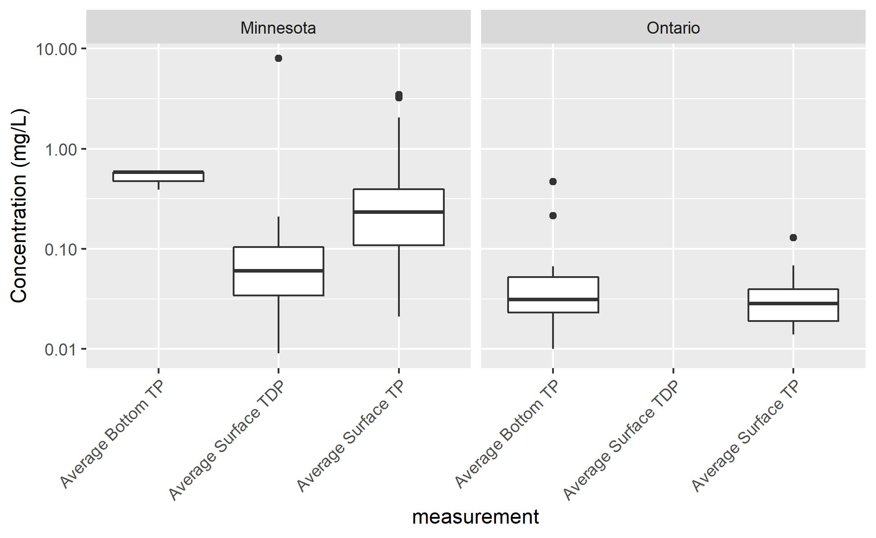

**Figure C1: Phosphorus concentrations, compared by region.**

Pond sizes varied widely, as some ponds such as Lake Lucy, might be considered more of a lake than a typical retention pond. Surface areas ranged from 0.03 acres to 106 acres (median = 0.7 acres) and volume ranged from 0.08 acre-feet to 300 acre-feet (median 2.4 acre-feet). Pond depths were often reported in either maximum or average depths, but not all recorded depths were specified as average or maximum. When pond volumes and surface areas were provided, average depths were back-calculated for this dataset. Depth values are summarized in Figure C2.

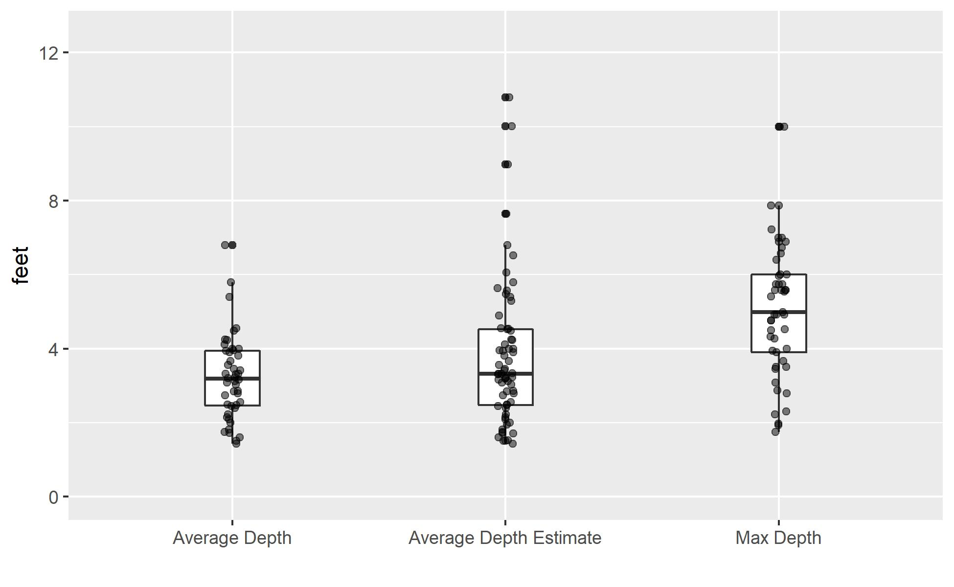

**Figure C2: Design depths range for ponds in dataset. “Average depth estimate” values are based on pond volumes and surface areas when average depth were not explicitly provided.**

The ratio of volume to drainage area, which is a proxy for runoff capacity, also varied widely in this dataset (Figure C3). Pond BC-P1.10B, in Chanhassen, had the smallest volume to drainage area ratio at 0.014 feet. LU-P1.11A (Lucy Lake), also in Chanhassen, had the largest volume to drainage area ratio of 10.2 feet.

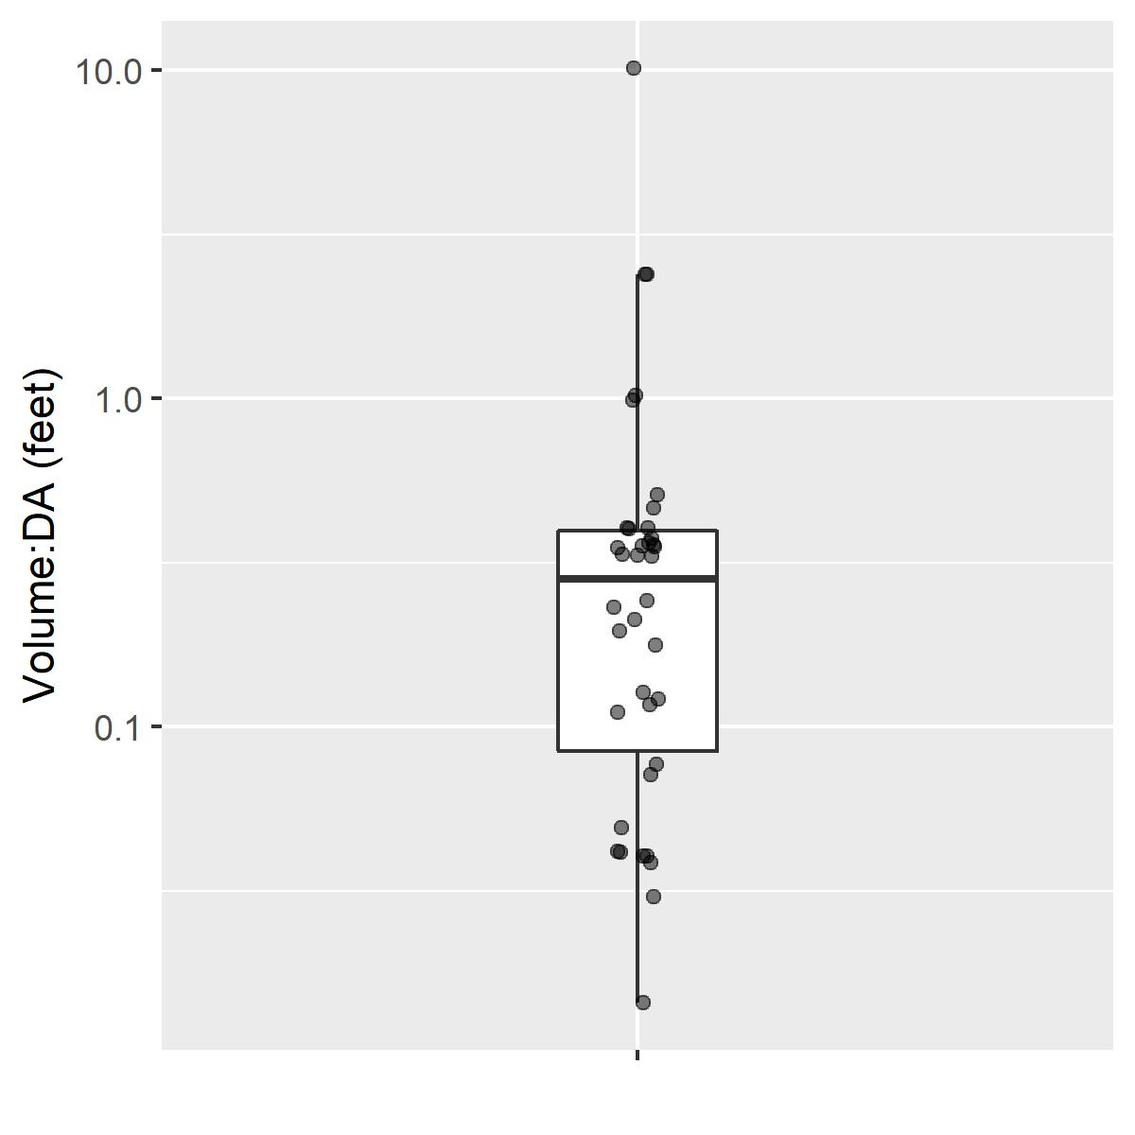

**Figure C3: Ratio of pond volume per drainage area**

Upstream land use details were difficult to curate. Convention and nomenclature varied within and between sources, and none of the sources appeared to do a quantitative assessment using geospatial information systems (GIS). Rather, land use appeared to be qualitative assessments of the source authors, and often included the listing of multiple land use types without an indication of the dominant type. Since drainage area delineations are not available for this dataset, best professional judgment was used to curate the list of land uses into one or two major land use types for each pond. This still left 25 unique land use groups, however (Table C8). Percent impervious drainage was also only found for five ponds.

**Table C8: Land Use Descriptions**

|  |  |  |  |
| --- | --- | --- | --- |
| **Land Use Description** | **Count** | **Land Use Description** | **Count** |
| Commercial | 14 | Residential | 91 |
| Commercial / Industrial | 3 | Residential with open water | 1 |
| Urban | 3 | Residential, park/institutional | 1 |
| Impervious | 2 | Residential/Commercial | 2 |
| Developed | 2 | Residential/Commercial | 6 |
| Undeveloped | 1 | Residential/Golf | 3 |
| Forest | 5 | Residential/Park | 8 |
| Wetland | 5 | Residential/Undeveloped | 3 |
| Grass | 6 | Residential/Wetland | 1 |
| Prairie | 3 | Medium density residential | 1 |
| Industrial | 9 | Residential/Forest | 0 |
| Park | 19 | School | 1 |
| Golf | 1 | Mixed | 3 |
|  |  | Unknown | 226 |

# Task D: Assessing Indicators of Phosphorus Release

## Description of Task D

Task D: Conduct a high level assessment of characteristics, trends, and patterns.

* Based on the data obtained in Goal 2, Objective 2, Task C, the contractor will assess if there are indicators in the data that could be correlated to a pond either retaining or releasing phosphorus.

## Introduction

We reviewed all compiled data to evaluate whether there was statistical support for the use of any pond-level metric as an indicator of phosphorus release or inefficient retention. This assessment was broken into two separate pieces. First, phosphorus conditions were compared against continuous, or numeric, variables in the dataset (e.g. max depth and age). Second, phosphorus concentrations were compared against the categorical variables that had been compiled (e.g. land use and pond type).

This assessment was kept at a high level because of the variability in the data collection. The mechanisms described in Task B occur at various temporal scales and only under certain environmental conditions (e.g. dry weather anoxia in late summer, scouring during large wet weather events). For statistical correlations to emerge from sporadic datasets with unknown sampling regimes, a given metric must influence phosphorus dynamics uniformly across all environmental conditions. Given what is understood about internal phosphorus dynamics, this is not an outcome that is expected. Further methodological limitations are described at the end of this section.

## Continuous Variable Assessment

A Pearson’s correlation matrix was created to compare all continuous variables against the phosphorus concentrations in the curated data. Pearson’s correlation is a linear comparison of two variables, where the coefficient ranges from -1 (strong inverse correlation) to +1 (strong positive correlation).

Pearson’s correlation coefficients were calculated and tested for significance for all possible combinations of continuous variables (Figure D1). All ponds were included in this analysis, but statistical comparisons were only made when a sufficient number of total measurements or observations existed. Coefficients were not calculated when the number of paired measurements or observations was less than 3 (degrees of freedom less than 1) for any combination of variables.

In addition to the curated variables, several derived variables were introduced for this analysis:

* ***Drainage area estimate:*** *current tributary area, or if not available, original tributary area*
* ***Volume estimate:*** *current volume, or if not available, original volume*
* ***Average depth estimate:*** *average depth, or if not available, pond volume estimate/surface area*
* ***Vol per DA:*** *volume per drainage area (based on ‘volume estimate’ and ‘drainage area estimate’)*
* ***SA per DA:*** *surface area per drainage area (based on ‘drainage area estimate’)*
* ***D per DA:*** *depth per drainage area (based on ‘average depth estimate’ and ‘drainage area estimate’)*

*Drainage area estimate*, *volume estimate,* and *average depth estimate* were each created to consolidate several fields of data into a single value, using the most current description when available. *Vol per DA, SA per DA,* and *D per DA,* were each created to provide a proxy value for runoff capacity within each pond.

Test results were interpreted with best professional judgement. Curated variables were taken from a number of sources, and like measurements and observations were assumed to be compatible. For example, “average total phosphorus” from one source would be considered comparable to “mean total phosphorus” and grouped into a single variable. Caution should also be given when interpreting individual variables. For example, current and design estimated efficiencies are largely comprised of LSRCA estimated P removal efficiency (LSRCA, 2010). These particular efficiency estimates were derived from volume measurements and local guidance, and they do not reflect a monitored mass balance. These estimates were still considered valid efficiency estimates for the purposes of this analysis, since the LSRCA utilized them as such.

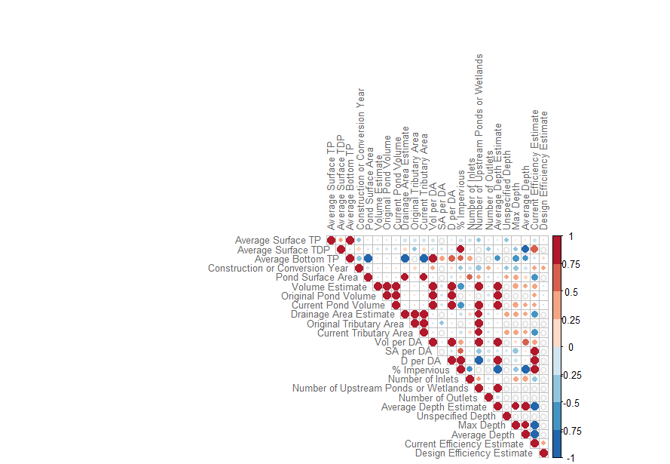

**Figure D1: Pearson’s correlation coefficient matrix. The size of each point is scaled by the absolute strength of the correlation, while the color is scaled by the strength and direction. Grey ‘o’ symbols are placed where there was either no data or fewer than 3 samples to compare.**

There were a total of 52 significant correlations within the correlation matrix, however, only 14 of those correlations involved a measure of phosphorus or P removal efficiency (most of these characterized by LSRCA) with another variable (not phosphorus or efficiency). Further, only 8 of those remaining significant correlations had a sample size larger than 3 (Table D1).

**Table D1: Significant Correlations**

|  |  |  |  |  |
| --- | --- | --- | --- | --- |
| **Variable 1** | **Variable 2** | **Pearson's Correlation Coefficient** | **p value** | **degrees of freedom** |
| Average Surface TP | Construction or Conversion Year | -0.31814 | 1.0E-04 | 143 |
| Average Surface TP | Current Tributary Area Acres | -0.17244 | 0.04 | 146 |
| Design Efficiency Estimate | Construction or Conversion Year | 0.325831 | 0.001 | 91 |
| Current Efficiency Estimate | Construction or Conversion Year | 0.305217 | 0.002 | 94 |
| Current Efficiency Estimate | Current Pond Volume | 0.341836 | 0.001 | 92 |
| Current Efficiency Estimate | Original Pond Volume | 0.347228 | 0.001 | 82 |
| Current Efficiency Estimate | Volume Estimate | 0.348053 | 0.001 | 94 |

Current efficiency estimates and design efficiency estimates both had a positive correlation with construction year, while correlations showed that surface TP had increased with pond age. These findings suggests that more recent ponds perform better than older ponds. However, it is unknown if the lower efficiency in older ponds is a function of design difference, physical condition, or sediment characteristics. Pond volume correlated to better efficiency and larger drainage area correlated negatively to surface TP concentrations, both suggesting that storm capacity may play a role in phosphorus retention. It should be noted, ultimately, that efficiency estimates are from LSRCA and are based, in part, on existing and design pond volumes.

The positive correlation with volume, in these cases, may represent more efficient settling conditions, thereby limiting phosphorus export mechanism. Nevertheless, this connection must not overlook the effect increased volume may have on other phosphorus dynamics at a given site (e.g. deeper ponds promoting anoxia). It is unclear from the sampling protocols what time of year and under what environmental conditions the surface samples were taken, so the data do not allow for the assessment of inter- or intra-annual variability.

While Table D-1 lists how pond performance relates to other factors, there were also notable relationships among the efficiency and phosphorus comparisons. In particular, P removal efficiency correlated to average surface TDP. This is counter-intuitive, simply because we often anticipate a negative correlation between any phosphorus measurement and P removal efficiency. In this case, surface TDP (in the absence of redox information and bottom TDP concentrations) may be indicative of diffusive flux of sediment P under anoxic conditions. Based on the findings from Song, et al. (2017), this correlation probably indicates complex internal cycling of phosphorus into different fractions at different times of the year. Further, it’s possible that higher influent TP or TDP contribute to higher surface TP concentrations despite effective removal.

## Categorical Variable Assessment

Categorical assessments (evaluations with non-numeric variables) were performed by comparing summary statistics among relatable categories. More rigorous statistical assessment (i.e. logistic regression) were deemed unsuitable for this dataset since the sampling regimes are not well understood.

### Land use

Land use is a common predictor for runoff volumes and pollutant loading. Generally speaking, more developed or impervious drainage areas have higher pollutant loading. This is because increases in impervious areas increase runoff from a landscape and also because more point source and nonpoint pollutant loading typically occurs in developed areas.

Drainage area descriptions for the ponds compiled in Task C often included multiple land use types. Since drainage area delineations are not available for this dataset, best professional judgment was used to curate the list of land uses into one or two major land use types for each pond. This yielded 25 different land use categorizations (Figure D2). The number of phosphorus measurements within each group was often small, and thus limited the opportunity for statistical testing across groups. Consolidation of groups would not have addressed this issue, since groups like ‘industrial’ and ‘urban’ would still be limited by size.

A few visual patterns did emerge from viewing the range of average surface TP concentrations, however. Ponds draining residential and park landscapes had comparable medians (0.29 mg/L and 0.31 mg/L, respectively), but there were a handful of residential ponds exceeding the maximum surface concentrations observed in ponds draining parklands. Though sample sizes were small, ponds in drainage areas dominated by grass and prairies had low surface TP concentrations within a tight range. Interestingly, the pond with the highest average surface TP has a forest dominated drainage area (StP-29, average surface TP = 3.5 mg/L).

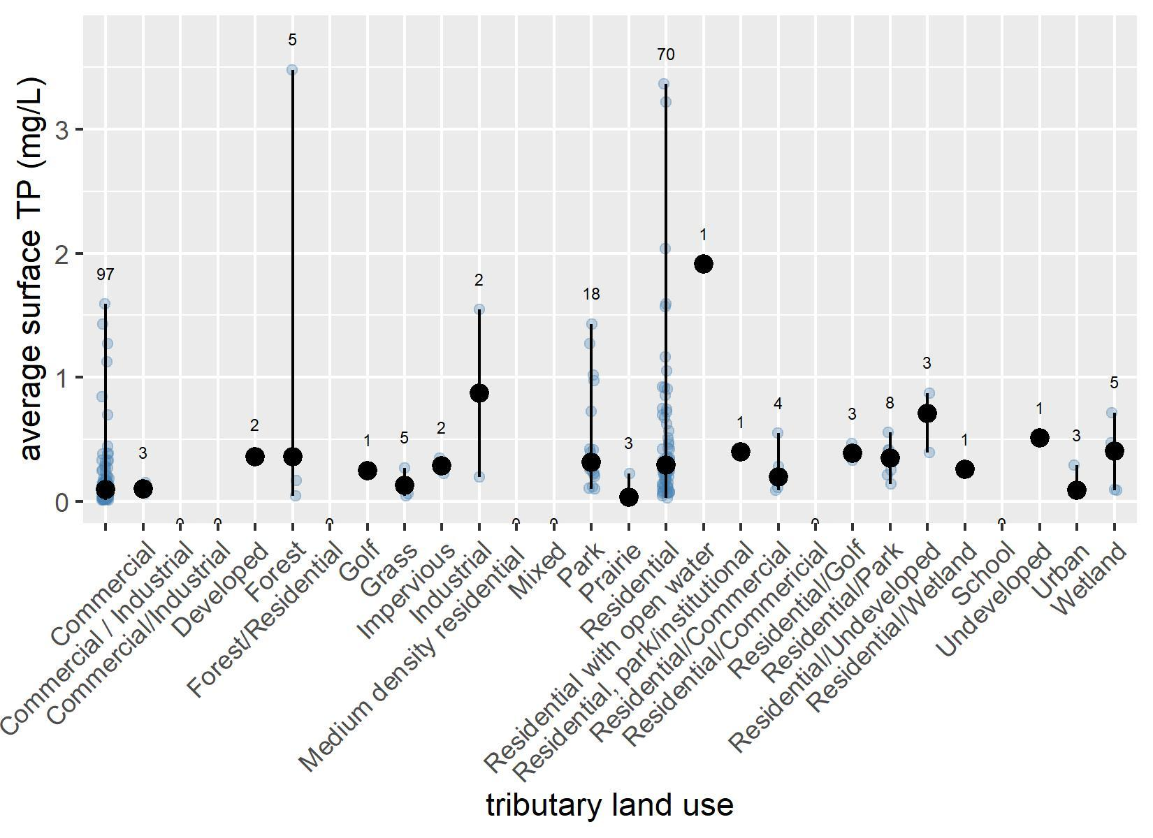

**Figure D2: Range of surface TP concentrations in ponds, grouped by drainage area land use. Solid black line drawn from min to max measurement. Black circles drawn at median value. Light blue points drawn for each measurement to show distribution. Number of samples for each group shown on top of range.**

### Nationwide Urban Runoff Program (NURP)

The Nationwide Urban Runoff Program (NURP) introduced a loose set of reinforced design standards based on their study of ponds that were effectively retaining TSS and total phosphorus across the USA.

Within Minnesota, 50 ponds from the compiled pond list had been listed as designed to NURP standards, while 40 were listed as not adhering to these standards. Respectively, 49 and 38 of these ponds had average surface TP conditions available.

The range of surface TP conditions was approximately the same for ponds designed or not designed to the NURP standards. Counterintuitively, however, the median concentration in ponds designed to NURP standards (0.41 mg/L) was higher than the ponds not designed to the standards (0.32 mg/L). This finding does not appear to be due to pond age, as the median construction year for NURP ponds is 1994 compared to 1978 for non-NURP ponds.

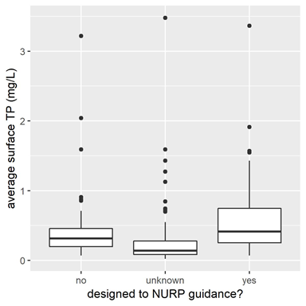

**Figure D3: Comparison of surface TP concentrations based on design standards.**

### Pond Type

Stormwater pond construction can be a very site-specific process. Ponds are often constructed in low-lying locations where a drainage network can easily be connected. In some situations, stormwater ponds are created by connecting a storm sewer network to an existing wetland or waterbody and engineering the system to meet a retention or detention need.

The information compiled in Task C included some information about the origin of each pond. Ponds were classified as wetlands, converted wetlands, natural, constructed, or unknown (Table D2). There are a large portion of ponds for which this information is unknown, but also large sample sizes for constructed and converted wetlands. Given the low sample size for natural and wetlands, these two groups were dropped from further analysis.

**Table D2: Surface TP concentrations by pond type**

|  |  |  |  |  |  |
| --- | --- | --- | --- | --- | --- |
| Type | n with average surface TP | mean of average surface TP (mg/L) | median of average surface TP (mg/L) | min of average surface TP (mg/L) | max of average surface TP (mg/L) |
| constructed | 81 | .26 | .15 | .01 | 1.6 |
| converted wetland | 62 | .57 | .36 | 0.07 | 3.4 |
| natural | 3 | .13 | .14 | 0.07 | 0.2 |
| unknown | 88 | .28 | .13 | 0.02 | 3.5 |
| wetland | 4 | .41 | .29 | 0.2 | 0.8 |

The available comparison with these groups was the surface TP concentrations of constructed ponds versus those that were converted wetlands. The median average surface concentrations were significantly higher (Mann Whitney U, p<0.05, W = 1215.5) in converted wetlands than in constructed ponds (Figure D4). While not tested with data as part of this investigation, it is plausible that converted wetlands have larger internal sediment TP that is recycled into the water column. Higher sediment TP concentrations could be a legacy artifact of a functional wetland, and high concentrations would remain if the wetland was not excavated during conversion. Newly constructed ponds would not have this artifact, though as the ponds age, sediment TP accumulation would occur.

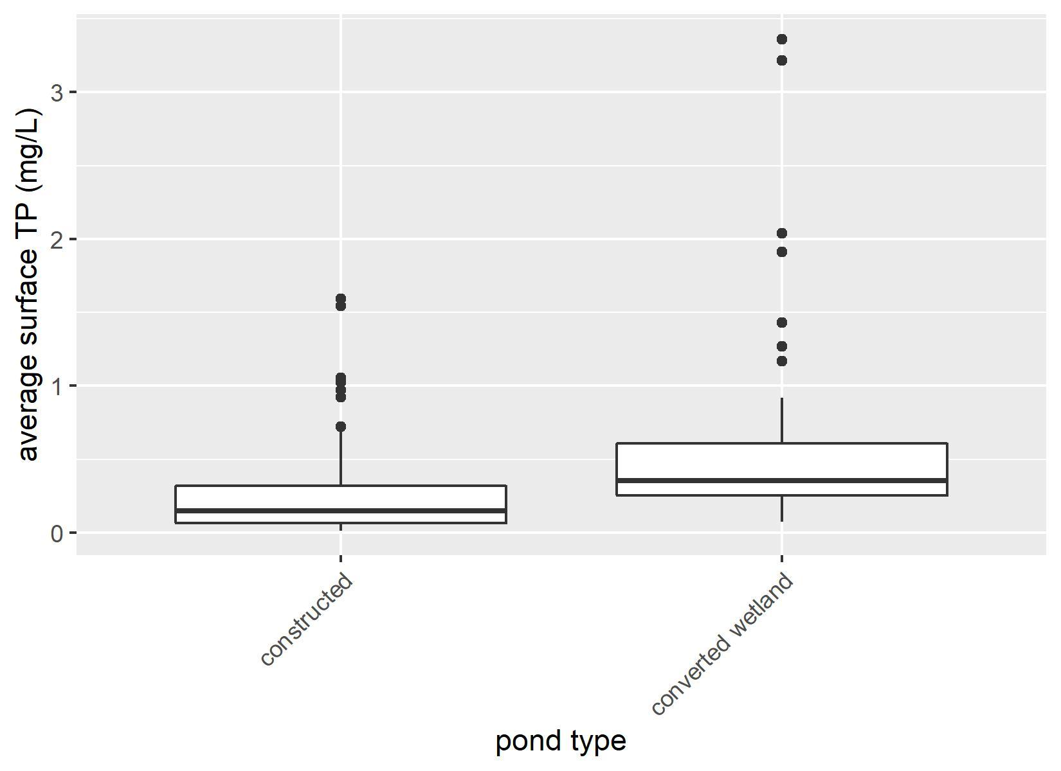

**Figure D4: Surface TP concentrations compared by pond type. Wetlands and Natural ponds were omitted from this comparison because of small sample sizes. Ponds of unknown type were also excluded.**

## Methodological Limitations

* Sample Sizes - Large number of ponds, sparse overlapping data for statistics
* Sampling Regimes - Some are understood, others are unknown. We were unable to identify if periodic grab samples adequately capture inter-annual mechanistic variability.
* Measurement Types - TP and TDP do not tell whole internal P dynamic story

## Assessment Summary

Overall, this assessment revealed some anticipated and some unanticipated findings, but it is clear that these data are not sufficiently detailed to tell the story of internal phosphorus cycling. Linear correlations suggest that ponds built more recently perform more effectively, but positive correlations between estimated P removal efficiency and surface TDP highlight that there is more to be gleaned learned about the internal mechanisms beyond estimated efficiency.

Categorical analysis raised questions about previously held notions. Minnesota ponds designed to NURP guidance have higher surface TP concentrations than non-NURP ponds. While data was limited, ponds in residential and forested drainage areas were among the ponds with highest surface TP concentrations.

The stormwater ponds surveys that we analyzed for this report largely focused on measurements of water column phosphorus concentrations, which demonstrated that many ponds have high phosphorus concentrations relative to water quality standards and regional average event mean concentrations (EMC). However, presentations of average phosphorus concentrations for a pond -- without consideration for the timing of each collected sample relative to the stormwater hydrograph, or the difference between the concentration in the inlet versus the outlet -- provide insufficient information to assess the efficiency of a pond to retain phosphorus during a storm let alone on an average annual basis. Therefore, although we have found limited or weak correlations between pond and catchment characteristics versus pond phosphorus, similar to previous studies (RPBCWD 2014; Taguchi et al. 2018), we believe that this is primarily due to the insufficient data and metadata in our survey of ponds. For many of these ponds in our listing, sufficiently granular data may exist, but it would be a large effort to wrangle such data together for enough ponds for statistical analyses of pond characteristics versus performance.

Task D: Conduct a high level assessment of characteristics, trends, and patterns. (MAR-APR, 2019)

* Based on the data obtained in Goal 2, Objective 2, Task C, the contractor will assess if there are indicators in the data that could be correlated to a pond either retaining or releasing phosphorus.

# Project Conclusions

Stormwater ponds are an important feature in the management of urban runoff in order to mitigate the downstream impacts of water quantity and water quality. States, regional authorities and local governments are under considerable pressure to measurably improve water quality. As such, there is interest to maximize pollutant removal efficiencies for existing and new stormwater ponds.

To that end, this project has the goal to determine the likely extent or occurrence of constructed stormwater ponds that do not effectively retain phosphorus and identify conditions that likely lead to sediment phosphorus release. The purpose of this work is to inform the development of qualitative recommendations for pond design, construction, maintenance, and/or monitoring to maximize phosphorus retention.

We found and conclude:

* Previously published studies demonstrate that for many stormwater ponds (1) water column phosphorus concentrations are higher than water quality standards or regionally calculated event mean concentrations, and that (2) many ponds appear to operate at removal efficiencies that are lower than targeted during pond design (Task A).
* Previously published studies typically do not present sufficiently detailed data to independently assess phosphorus removal performance, as most only present average phosphorus concentrations in the pond water column and sometimes in the influent waters to the pond (Task A). Calculations of the difference of these averages between influent and presumed effluent concentrations, especially when sample numbers are not equal and collections known to be paired, can not provide robust estimates of removal due to differing hydrological conditions.
* The design of stormwater ponds over the last three decades has focused nearly entirely on the goal of maximizing water quality via sedimentation of phosphorus bound to particles and minimizing scouring of these particles by subsequent storms (Task B).
* The full suite of physical, geochemical, and biological processes, mechanisms, drivers and factors that control phosphorus cycling and fluxes within stormwater ponds, and their temporal dynamics, should be considered when evaluating and managing phosphorus retention by ponds (Task B).
* Useful information can be gleaned from the compilation (Task C) and reanalysis (Task D) of existing metadata on pond characteristics and summary data on pond phosphorus concentrations and previously estimated removal efficiency. However, these summary datasets are insufficiently detailed to support robust statistical analyses that might best highlight the characteristics of ponds that are best and worst at retaining phosphorus during storms or over an annual cycle.

We conclude that the literature and compiled data suggest that stormwater ponds could be further optimized to retain phosphorus, and that the physical, geochemical, and biological processes, mechanisms, drivers and factors that control phosphorus cycling and fluxes within a stormwater pond (Task B) are sufficiently understood to:

* Explore the optimization of stormwater pond designs at retaining phosphorus over a range of pond characteristics and temporal scenarios of drivers, via analytical and numerical extension of our conceptual box model; and
* Guide the development of targeted monitoring studies to support newer guidelines for the design, construction, maintenance, and/or monitoring of stormwater ponds to maximize phosphorus retention.

# References

Chen, L., Delatolla, R., D’Aoust, P. M., Wang, R., Pick, F., Poulain, A., & Rennie, C. D. (2019). Hypoxic conditions in stormwater retention ponds: potential for hydrogen sulfide emission. *Environmental Technology (United Kingdom)*, *40*(5), 642–653. <https://doi.org/10.1080/09593330.2017.1400112>

Chiandet, A. S., & Xenopoulos, M. A. (2016). Landscape and morphometric controls on water quality in stormwater management ponds. *Urban Ecosystems*, *19*(4), 1645–1663. <https://doi.org/10.1007/s11252-016-0559-8>

Driscoll, E. D. (1983, July). Performance of detention basins for control of urban runoff quality. In *International Symposium on Urban Hydrology, Hydraulics, and Sediment Control*, University of Kentucky.

Erickson, A. J., Taguchi, V. J., & Gulliver, J. S. (2018). The challenge of maintaining stormwater control measures: A synthesis of recent research and practitioner experience. *Sustainability (Switzerland)*, *10*(10), 1–15. <https://doi.org/10.3390/su10103666>

Gulliver, J. S., & Ph, D. (n.d.). When Retention Ponds are a Source of Phosphorus ( P ).

Hupfer, M., & Lewandowski, J. (2008). Oxygen controls the phosphorus release from lake sediments - A long-lasting paradigm in limnology. *International Review of Hydrobiology*. <https://doi.org/10.1002/iroh.200711054>

Janke, B. D., Finlay, J. C., & Hobbie, S. E. (2017). Trees and Streets as Drivers of Urban Stormwater Nutrient Pollution. *Environmental Science and Technology*, *51*(17), 9569–9579. <https://doi.org/10.1021/acs.est.7b02225>

Kayhanian, M., Suverkropp, C., Ruby, A., & Tsay, K. (2007). Characterization and prediction of highway runoff constituent event mean concentration. *Journal of Environmental Management*, *85*(2), 279–295. <https://doi.org/10.1016/j.jenvman.2006.09.024>

Kynkäänniemi, P. (2014). *Small Wetlands Designed for Phosphorus Retention in Swedish Agricultural Areas*. Swedish University of Agricultural Sciences.

Lawrence, I., & Breen, P. F. (1998). Design Guidelines : Stormwater Pollution Control Ponds and Wetlands, 68.

LSRCA. (2011). *Stormwater Pond Maintenance and Anoxic Conditions Investigation*.

MacKenzie, S., Stratford, C., Palmer-Felgate, E. J., Bowes, M. J., & Neal, C. (2011). Phosphorus release from sediments in a treatment wetland: Contrast between DET and EPC0 methodologies. *Ecological Engineering*, *37*(6), 826–832. <https://doi.org/10.1016/j.ecoleng.2010.12.024>

Manning, B. A., & Goldberg, S. (1996). Modeling Competitive Adsorption of Arsenate with Phosphate and Molybdate on Oxide Minerals. *Soil Science Society of America Journal*, *60*(1), 121. <https://doi.org/10.2136/sssaj1996.03615995006000010020x>

McComas, S., & Stuckert, J. (2011). *Fish Surveys of Ten Stormwater Ponds in Bloomington , Minnesota in 2010*.

McEnroe, N. A., Buttle, J. M., Marsalek, J., Pick, F. R., Xenopoulos, M. A., & Frost, P. C. (2013). Thermal and chemical stratification of urban ponds: Are they “completely mixed reactors”? *Urban Ecosystems*, *16*(2), 327–339. <https://doi.org/10.1007/s11252-012-0258-z>

Minnesota Pollution Control Agency. Permit No: MN R100001 (2013).

Minnesota Stormwater Manual contributors, 'Stormwater ponds', Minnesota Stormwater Manual, 18 September 2017, 20:23 UTC, <<https://stormwater.pca.state.mn.us/index.php?title=Stormwater_ponds&oldid=33410>> [accessed 17 June 2019]

Mitchell, J. (2016). Stormwater Pond Phosphorus Evaluation.

Nurnberg, G. K. (2009). Assessing internal phosphorus load - Problems to be solved. *Lake and Reservoir Management*, *25*(4), 419–432. <https://doi.org/10.1080/00357520903458848>

Olsen, T. (2017). *Phosphorus Dynamics in Stormwater Ponds*. University of Minnesota.

Orihel, D. M., Baulch, H. M., Casson, N. J., North, R. L., Parsons, C. T., Seckar, D. C. M., & Venkiteswaran, J. J. (2017). Internal phosphorus loading in Canadian fresh waters: a critical review and data analysis. *Canadian Journal of Fisheries and Aquatic Sciences*, *74*(12), 2005–2029. <https://doi.org/10.1139/cjfas-2016-0500>

Osgood, R. A., Osgood, R. A., Llc, O. C., & Lane, G. (2017). Lake and Reservoir Management Controlling Wolffia using alum in a pond Controlling Wolffia using alum in a pond, *2381*(October). <https://doi.org/10.1080/07438141.2011.642932>

Palmer-Felgate, E. J., Mortimer, R. J. G., Krom, M. D., Jarvie, H. P., Williams, R. J., Spraggs, R. E., & Stratford, C. J. (2011). Internal loading of phosphorus in a sedimentation pond of a treatment wetland: Effect of a phytoplankton crash. *Science of the Total Environment*, *409*(11), 2222–2232. <https://doi.org/10.1016/j.scitotenv.2011.02.034>

Performance, S., & Report, M. (2013). 2013 Showcasing Water Innovation : Stormwater Performance.

Perry, S., Garbon, J., & Lee, B. (2009). Urban Stormwater Runoff Phosphorus Loading and BMP Treatment Capabilities. *Imbrium Systems*. Retrieved from http://www.imbriumsystems.com/Portals/0/documents/sm/technical_docs/Urban Stormwater Runoff Phosphorus Loading and BMP Treatment Capabilities.pdf

Pitt, R., Maestre, A., Morquecho, R., Brown, T., Swann, C., Cappiella, K., & Schueler, T. (2003). Evaluation of Npdes Phase 1 Municipal Stormwater Monitoring Data. In *National Conference on Urban Stormwater: Enhancing the Programs at the Local Level. EPA/625/R-03/003.* (pp. 306–327).

RPBCWD. (2014). *Stormwater Pond Project*.

Selbig, W. R., Fienen, M. N., Horwatich, J. A., & Bannerman, R. T. (2016). The effect of particle size distribution on the design of urban stormwater control measures. *Water (Switzerland)*, *8*(1), 1–17. <https://doi.org/10.3390/w8010017>

Song, K., & Burgin, A. J. (2017). Perpetual Phosphorus Cycling: Eutrophication Amplifies Biological Control on Internal Phosphorus Loading in Agricultural Reservoirs. *Ecosystems*, *20*(8), 1483–1493. <https://doi.org/10.1007/s10021-017-0126-z>

Song, K., Winters, C., Xenopoulos, M. A., Marsalek, J., & Frost, P. C. (2017). Phosphorus cycling in urban aquatic ecosystems: connecting biological processes and water chemistry to sediment P fractions in urban stormwater management ponds. *Biogeochemistry*, *132*(1–2), 203–212. <https://doi.org/10.1007/s10533-017-0293-1>

Song, K., Xenopoulos, M. A., Marsalek, J., & Frost, P. C. (2015). The fingerprints of urban nutrients: dynamics of phosphorus speciation in water flowing through developed landscapes. *Biogeochemistry*, *125*(1), 1–10. <https://doi.org/10.1007/s10533-015-0114-3>

Taguchi, V. J., Olsen, T. A., Natarajan, P., Janke, B. D., Gulliver, J. S., Finlay, J. C., & Stefan, H. G. (2019). Internal Loading in Stormwater Ponds as a Phosphorus Source to Downstream Waters. *Submitted*.

Taguchi, V. J., Olsen, T.A., Natarajan, P., Janke, B.D., Finlay, J.C., Stefan, H.G., Gulliver, J.S. and Bleser, C.S. (2018). Urban Stormwater Ponds can be a Source of Phosphorus, Stormwater Updates,<http://stormwater.safl.umn.edu/updates-newsletters/updates-april-2018>.

U.S. Environmental Protection Agency. 1983. "Results of the Nationwide Urban Runoff Program: Volume 1 – Final Report." WH-554. Water Planning Division. Washington, DC. Alternately cited as: Athayde, D. N., Shelly, P. E., Driscoll, E. D., Gaboury, D., & Boyd, G. (1983). Results of the nationwide urban runoff program—volume 1—final report: US Environmental Protection Agency. WH-554. <https://www3.epa.gov/npdes/pubs/sw_nurp_vol_1_finalreport.pdf>

U.S. EPA. 1983. "Results of the Nationwide Urban Runoff Program: Executive Summary." , WH-554. Water Planning Division. U.S. Environmental Protection Agency, Washington, DC.

Walker, W. W. (1987). Phosphorus removal by urban runoff detention basins. *Lake and Reservoir Management*, *3*(1), 314–326. <https://doi.org/10.1080/07438148709354787>

Yi, R., Song, P., Liu, X., Maruo, M., & Ban, S. (2019). Differences in dissolved phosphate in shallow-lake waters as determined by spectrophotometry and ion chromatography. *Limnology*, (0123456789). <https://doi.org/10.1007/s10201-019-00574-2>

# Appendix A

See attached “PondData_LimnoTech_20190628_toMPCA+formatted.xlsx” spreadsheet.