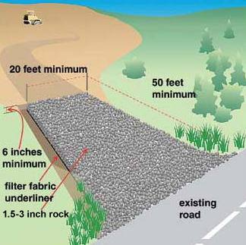
Vehicle Tracking BMPs
Figure 1. Vehicle tracking rock pad at site entrance/exit rock. Pad length should be five times the circumference of the largest tire exiting the site, or a minimum of 50 ft. whichever is longer.
Source: Created by Tetra Tech for US EPA and State of Kentucky

Definition
A vehicle tracking BMP is a rock (stone, gravel) pad, shaker rack, wheel washer, or other BMP designed to prevent the transport of soil, mud, and rock from vehicles to offsite areas, such as public roadways and public or private parking lots.

Purpose and Function
Vehicles leaving construction sites can track sediment and other items onto adjoining roadways that can create safety hazards and contribute significantly to sediment pollution in waterways. The purpose of a vehicle tracking BMP is to prevent the export of soil, mud, and rock on work vehicles from being carried offsite and deposited on public roads, parking lots, and other areas. Pollutant removal, including nutrients and heavy metals that are associated with sediment (see section on Effectiveness), is primarily accomplished through the removal of soil and mud from construction equipment. Temporary site entrances/exits, which are installed during the construction period until permanent stabilization of access roads, provide interaction of vehicle tires with a non-adhesive, irregular surface such as coarse rock beds that help remove sediment prior to the time when roadways, parking lots, and other areas are either paved or stabilized.

Applicability
Vehicle tracking BMPs are installed at all construction sites where vehicles leave any disturbed part of the site as part of planned construction activity.

Site Applicability
Vehicle tracking BMPs are appropriate during the construction period for all sites with vehicles passing through disturbed areas prior to entering public roadways or other offsite areas.

Permit Applicability
Section IV.C.6 of the 2013 MPCA Construction Stormwater General Permit states that “(w)here vehicle traffic leaves any part of the site (or onto paved roads within the site): (a)The Permittee(s) must install a vehicle tracking BMP to minimize the track out of sediment from the construction site. Examples of vehicle tracking BMPs include (but are not limited to) rock pads, mud mats, slash mulch, concrete or steel wash racks, or equivalent systems” and “(b) The Permittee(s) must use street sweeping if such vehicle tracking BMPs are not adequate to prevent sediment from being tracked onto the street”.

Section IV.E.5.d of the 2013 MPCA Construction Stormwater General Permit states that “(c)onstruction site vehicle exit locations must be inspected for evidence of off‐site sediment tracking onto paved surfaces. Tracked sediment must be removed from all paved surfaces both on and off site within 24 hours of discovery, or if applicable, within a shorter time.”

Note that Section IV.F.3 of the permit states “If the Permittee(s) wash the exterior of vehicles or equipment on the project site, washing must be limited to a defined area of the site. Runoff from the washing area must be contained in a sediment basin or other similarly effective controls and waste from the washing activity must be properly disposed of. The Permittee(s) must properly use and store soaps, detergents, or solvents. No engine degreasing is allowed on site.”

Effectiveness
When properly installed and maintained, vehicle tracking BMPs are effective at removing mud and soil from vehicles leaving the site. The overall effectiveness can range from low (less than 30 percent soil removal) to moderate (30 to 60 percent removal) for rock pads and shaker racks, depending on the design, installation, frequency of use, and maintenance. For example, effectiveness of rock pads will decrease as rock voids become clogged with soil and mud. To prevent this, the rock must be periodically top-dressed with additional rock, replaced, or the length of the pad increased. Properly installed and operated wheel washer units are effective at removing more than 75 percent of sediment in nearly all applications. Table 1 summarizes expected performance for an array of typical water quantity and quality target constituents for temporary vehicle tracking BMPs.

Table 1. Expected performance for temporary vehicle tracking BMPs
Water Quantity
Flow attenuation
Runoff volume reduction
Water Quality
Erosion prevention
Sediment control
Nutrient loading
Pollutant removal
Total suspended solids
Total phosphorus
Heavy metals
Floatables
Oil and grease

Primary design benefit
Secondary design benefit
Little or no design benefit

Planning Considerations
Where possible, configure the site so that few exiting vehicles pass through muddy disturbed areas (i.e., by restricting vehicle traffic to stabilized roadways, graveled parking areas for workers, etc.). When planning a vehicle tracking BMP, the following guidelines should be followed:
- Install the vehicle tracking BMP prior to any land disturbing activity.
- All construction traffic should be limited to exiting the site through these designated locations.
- Locate vehicle tracking BMPs on well drained areas if possible, such as on hilltops or upper slopes.
- Keep exit pads away from streams and wetlands if possible.
- Ensure traffic safety at exit points in addition to siting exits in well drained locations.
- Avoid siting exits at dips, low spots, and areas that stay wet or remain wet after precipitation.
- Exit pads can be set back off the roadway if there is no risk of tracking mud or debris after vehicles traverse the pad. For example, an exit pad could lead to a gravel access road connecting the site to a paved roadway, rather than immediately adjacent to the roadway.
- For most sites with a low risk of sediment tracking, a rock exit pad will suffice if it is located, installed and maintained properly.
- Sites with moderate and high-risk of sediment tracking may require a shaker rack or a wheel washer.
- Where wheel washers are used, a source of wash water is required. Muddy wash water should pass through a sediment control BMP prior to offsite discharge.
- The use of a wheel washer also requires a turnout or doublewide exit to avoid entering vehicles having to drive through the wash area.
- Sediment that collects on or adjacent to the exit pad will need to be managed by a trap or other BMP, to keep it from moving off-site.
- When planning the most effective entrance/exit, the following should be taken into account:
  - Underlying soils on site – silty and clayey soils cling more readily to tires, and require longer or otherwise more effective exit pads.
  - Frequency of use – heavier traffic will wear out small, thin rock pads quickly.
  - Length and width of the entrance/exit –longer, wider pads can accommodate heavier traffic and more challenging soils (e.g., clays, silts).
  - Depth of rock – Thin rock layers do not scrape mud off tires as effectively as thicker rock pads.
  - Size and type of vehicles – tractor trailers and heavy delivery trucks require a thicker, longer exit pad than exits serving pickup trucks and automobiles.
  - Frequency of maintenance – exit pads sited in wet conditions, with clay or silt soils, and used frequently by heavy vehicles will require more frequent cleaning and maintenance than those located in well drained, sandy areas and used by light vehicles less frequently.

Design and Construction
In this section, design and construction guidance is provided for three designs:
- Rock/stone pad (vehicle tracking pad)
- Shaker rack
- Wheel washer/wash rack

Vehicle tracking BMPs can also be developed using wood chips or mats or constructing access pads.
All designs shall be planned and sited according to the information discussed above, along with considerations for managing sediment that accumulates at the vehicle tracking BMP. For most applications, the vehicle tracking BMP area can be graded to facilitate drainage toward a stabilized swale or ditch that discharges into a treatment area. This treatment area can include a sediment trap, a curved section of silt fence (i.e., with the ends turned uphill to prevent bypasses), a sediment pond, or other approved sediment removal device. Additionally, onsite runoff that flows directly to the BMP should be diverted via a pipe, culvert, or water bar to prevent surface water and sediment loads from directly discharging at the construction entrance and onto paved roadways.

6.1. Rock/Stone Pad (Vehicle Tracking Pad)
Rock/stone pads remove material from vehicle tires through physical scraping action. Additionally, vehicle tracking pads can be installed to provide a barrier and keep the truck wheels from coming in contact with wet, adhesive underlying soils. The amount of construction traffic and frequency of use should be considered when designing a vehicle tracking pad. Specific design requirements include the following:
- Exit pads constructed of rock should be of sufficient width to treat the widest vehicles.
- Pad width should be a minimum 20 feet; the length should be five times the circumference of the largest tire exiting the site. For sites that cannot accommodate this minimum length, shaker racks or wheel washer/wash racks should be used (see below).
- The pad can be laid at grade on the exit road – excavation is not required.
- Rock used for the pad should be coarse aggregate of sufficient size to remove mud from vehicles (e.g., approximately 2 to 6 inches, depending on site conditions). Generally, the larger the aggregate, the better.
- Pad thickness should be sufficient to remove material from tires – i.e., 6 to 12 inches.
- The rock pad should be underlain with nonwoven geotextile fabric to prevent subsidence and migration of mud from underlying soil.
- A turning radius of 20 feet should be included on each edge where the pad intersects the road.
- Design so that drainage from the pad area leads to a sediment trap, silt fence, or other appropriate BMP for settling.

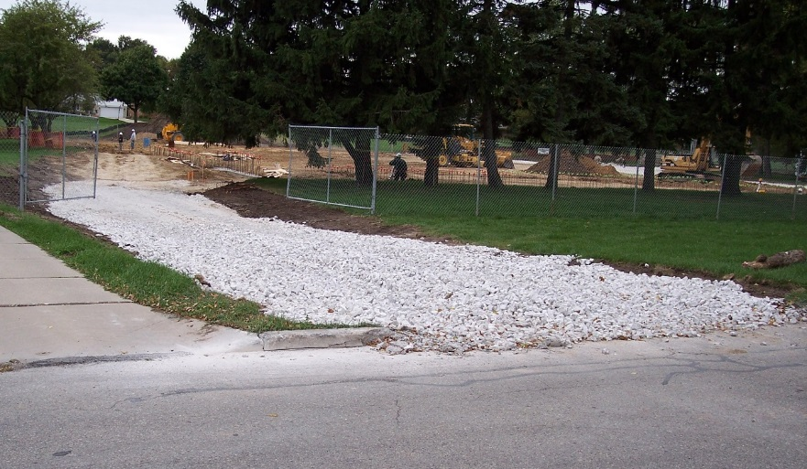
Source: City of Milwaukee
Figure 2. Example vehicle tracking pad

6.2. Shaker Rack
Shaker racks – also known as exit grids, rumble strips, rumble racks, rumble plates, etc. – remove material from vehicle tires through bouncing and shaking action. These are appropriate when the rock pad alone is not sufficient to remove sediment from tires.. Where used, shaker racks must both be long enough and able to create enough vibration to dislodge mud, soil, and rock. Racks can be fabricated from either concrete or metal (i.e., similar to cattle guards), or acquired from sediment and erosion control product vendors. Specific design requirements include the following:
- Shaker rack exit pads should be of sufficient width to handle the widest vehicles.
- Pads should be long enough to remove mud, soil, and rock from tires. Wheel washers (see below) may be necessary if rock pads and shaker racks are ineffective.
- Racks with less than 4 inches of soil storage space below the top of the rack should be installed over a 6 inch pad of coarse aggregate.
- Design so that drainage from the pad area leads to a sediment trap, silt fence, or other appropriate BMP for settling.

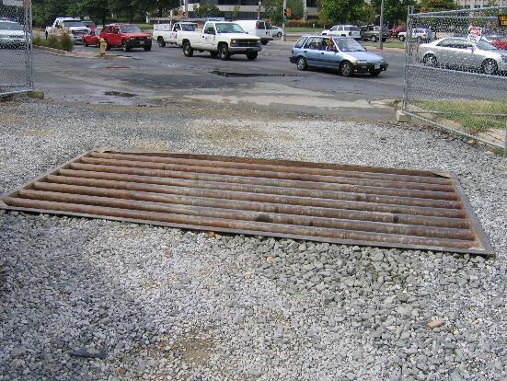
Source: Tetra Tech
Figure 3. Example shaker rack installation

6.3. Wheel Washer/Wash Rack
In many cases, the action of tires moving over a rock pad or shaker rack may not adequately remove sediment, and a wash rack may be required. Wheel washer systems – also called wash racks – use pressure-sprayed water to remove mud, soil, and rock from vehicles exiting the site. They can be fabricated from piping, hoses, driveway racks (e.g., concrete and metal cattle guards), and other materials, or acquired from construction site stormwater compliance vendors. Designs range from pipe units that can be hung from Jersey wall sections to wash stations that include elevated driveways above sediment trapping basins. Specific design requirements include:
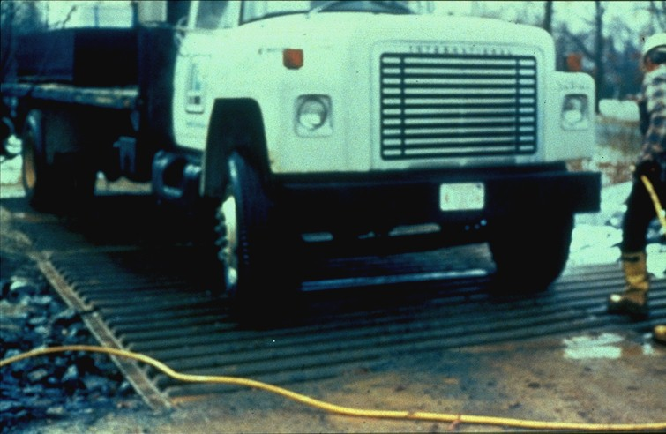
- Washer spray must be directed to remove material on the inside as well as outside of wheels.
- Design so that drainage from the wheel wash area leads to a sediment trap, silt fence, or other BMP for settling. Wash water migrating off the site will need to be treated to remove sediment (e.g., via a sediment trap, rock berm, silt fence, or sediment pond) or recycled.
- Consider ice buildup on roadways as dripping vehicles leave the site during cold weather.

A wash rack installed on the rock pad may make washing more convenient and effective. The wash rack would consist of a heavy grating over a lowered area that allows for water and sediment to collect and drain away. The grating may be a prefabricated rack, such as a cattle guard, or it may be constructed on site of structural steel. The wash rack must be strong enough to support the vehicles that will cross it. Figure 4 and Figure 4 show examples of typical wash rack installations.

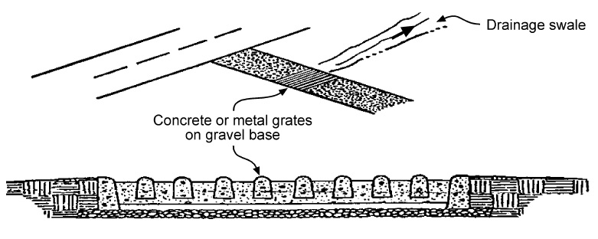
Source: MPCA Protecting Water Quality in Urban Areas Manual (Fig. 6.04-1)
Figure 4. Example wash rack installation

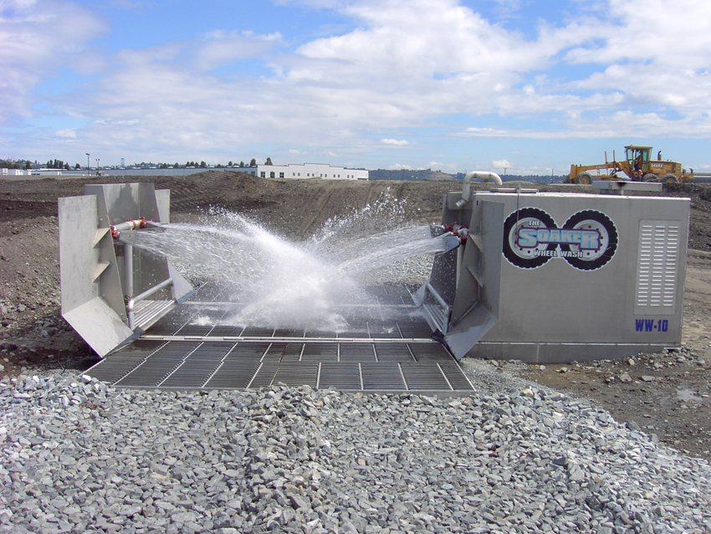
Source: Meeds Environmental, LLC
Figure 5. Example commercial wheel wash system

Standards and Specifications
MnDOT Standard Plan 5-297.405 provides a standard detail for “Construction Exits” (effective date: 8/6/2014). BMPs covered include “Slash Mulch, Crushed Rock, or Sheet Pad Construction Exit” and “Rumble Pad Construction Exit”: http://standardplans.dot.state.mn.us/StdPlan.aspx http://dotapp7.dot.state.mn.us/edms/download?docId=1482903
(See page 31, Standard Plan 5-297.405, 5 of 7)

MnDOT Specification 2573.3.K (Construction Exit Controls) provides guidance for exit type selection and use, and ranks exit controls from lowest to highest protection. Specification 3882 (Mulch Material) may also be applicable, depending on the exit type selected. The 2016 edition of the MnDOT Standard Specifications for Construction can be found here: http://www.dot.state.mn.us/pre-letting/spec/
(See http://www.dot.state.mn.us/pre-letting/spec/2016/2016specbook.pdf, page 507)

Inspection
Vehicle tracking BMPs require continuous monitoring, especially during and after rain events and during snowmelt when safety risks from mud, soil, and other debris on roadways, especially high speed urban and rural highways, are greatest. Specific inspection requirements include the following.
- Check continuously for mud and soil deposits on offsite roads and other areas.
- Inspect sediment deposition area for accumulations that affect exit pad performance.
- Ensure that exit pad area has positive drainage toward treatment BMP device/area.
- Inspect exit pad drainage ditch or swale to ensure proper vegetation or other stabilization.
- Inspect downgradient sediment treatment BMP to ensure ongoing effectiveness.
- During cold weather, monitor any drip-induced ice buildup on offsite paved surfaces.

MnDOT’s workmanship and rework schedule (2016; version under development at the time of manual update) identifies common deficiencies and corrective actions for various types of temporary sediment control BMPs, including vehicle tracking controls (Table 2). Once complete, the full, final version of this table will replace Table 2573-1 in MnDOT Standard Specifications for Construction (2016 edition).
Table 2. Excerpt from Table 2573-1, Temporary Sediment Control: Corrective Actions
Item | Corrective Action Required if | Corrective Action
Exit controls | Not installed  Not installed with geotextile liner  Not appropriate for time of year  Not appropriate for equipment  Not proper length for tire rotations  Not maintained for function | Install exit to detail shown in plans  Remove exit surface and install geotextile  Amend exit type for time of year  Amend exit type for load bearing and vehicle volume  Ensure length is 5 times the circumference of the largest tire  Remove sediment buildup by removal and add new surface; if inadequate, replace or amend exit to include shaker rack, wheel wash/r/wash rack
Wheel washoff | Not installed during weather and seasonal events dictated by conditions | Cease using exit until washoff system is operational

Maintenance
If site inspection(s) reveal concerns, maintenance will be necessary. Maintenance of vehicle tracking BMPs includes the following:
- Immediately remove mud, soil, and other debris from offsite areas – particularly roadways.
- Remove sediment that accumulates in the pad area, ditch/swale, or nearby stormwater facilities if performance is affected.
- Revegetate or otherwise stabilize eroding ditches, swales, or traps/basins treating exit pad runoff.
- Adjust the vehicle tracking BMPs to ensure proper functioning if performance is poor, including the following:
  - Clean or add rock – including larger rock, or extend the length of rock pads.
  - Regrade rock as needed to ensure positive drainage.
  - Extend the length of shaker racks; ensure drivers use enough speed to dislodge debris.

Maintenance of wheel washers/wash racks includes the following:
- Ensure wash water drainage, collection, and treatment systems are functioning.
- The wash water collection area should be regularly cleaned out to ensure sediment is contained properly.
- Remove/discharge wash water as needed.
- Maintain a clean run-out pad.
- Adjust wheel washer nozzle direction and spray pressure, and add nozzles as needed.

Cold weather considerations include the following:
- As with summer months, additional rock/aggregate should be readily available for top dressing and maintenance of the pad throughout winter.
- Construction sites should maintain functioning vehicle tracking BMPs during the winter even if no construction activities are taking place.
- Use salt or sand if ice accumulates on roadways due to dripping caused by wheel washer.
- Plowing and street sweeping may be needed to ensure mud does not remain on roadways.
- Promptly remove sediment and sediment laden snow and ice on roadways prior to spring melt.

Costs
The following table summarizes estimated BMP costs based on MnDOT data summarizing average bid prices for awarded projects in 2014.

Table 3. Average Bid Prices (Based on Awarded Projects) for Spec Year 2014. Average price varies from year to year. Data for other years can be found on MnDOT’s website. (Source: MnDOT)
Bid Item | Item Description | Units | Average Price
2573.535/00010 | Stabilized Construction Exit | LS | $5,763.08

Reference Materials
Except where more stringent requirements are presented in this guidance, vehicle tracking BMPs shall comply with MnDOT and other state requirements. Primary design references include:
- MnDOT Erosion Control Handbook II http://www.dot.state.mn.us/environment/erosion/pdf/2006mndotecfieldhandbook.pdf
- Minnesota Urban Small Sites Best Management Practice Manual (Vehicle Tracking Pad) http://www.metrocouncil.org/Wastewater-Water/Planning/Water-Resources-Management/Minnesota-Urban-Small-Sites-BMP-Manual.aspx
- 2013 Minnesota NPDES/SDS Construction Stormwater General Permithttp://www.pca.state.mn.us/index.php/water/water-types-and-programs/stormwater/construction-stormwater/index.html
- MnDOT Standard Specifications for Construction (2016 Edition) http://www.dot.state.mn.us/pre-letting/spec/
- MnDOT Standard Drawings for use in Construction Plans http://standardplans.dot.state.mn.us/StdPlan.aspx

The following is a list of additional resources that are not specific to Minnesota:
- Clean Water Services Erosion Prevention and Sediment Control Manual (4.2.2 Construction Entrance, 4.2.13 Tire Wash Facility) https://www.cleanwaterservices.org/Content/Documents/Permit/Erosion%20Prevention%20And%20Sediment%20Control%20Manual.pdf
- North Carolina Erosion and Sediment Control Planning and Design Manual (6.06 Temporary Gravel Construction Entrance/Exit) http://deq.nc.gov/about/divisions/energy-mineral-land-resources/energy-mineral-land-permit-guidance/demlr-publications
- Tennessee Department of Environment and Conservation (TDEC) Erosion and Sediment Control Handbook (7.28 Construction Exit, 7.29 Tire washing facility) http://tnepsc.org/handbook.asp
- Virginia Erosion and Sediment Control Handbook (3.02 Temporary Stone Construction Entrance) http://www.deq.virginia.gov/Programs/Water/StormwaterManagement/Publications/ESCHandbook.aspx
- Clark County Washington Stormwater Manual (BMP C105: Stabilized Construction Entrance/Exit, BMP C106: Wheel Wash) https://www.clark.wa.gov/environmental-services/stormwater-code-and-manual
- Best Management Practices (BMPs) for Controlling Erosion, Sediment, and Pollutant Runoff from Construction Sites. University of Kentucky, 2009. http://dep.ky.gov/formslibrary/Documents/09BMPManual_Final.pdf
- Delaware Erosion and Sediment Control Handbook. 2003. http://www.dnrec.state.de.us/DNREC2000/Divisions/Soil/Stormwater/New/Delaware%20ESC%20Handbook_06-05.pdf

Perimeter Controls for Disturbed Areas

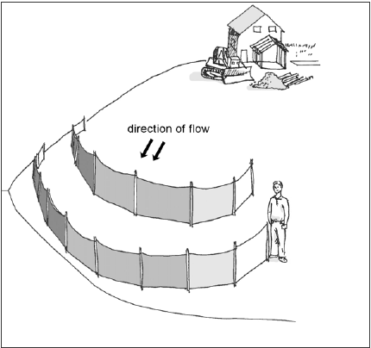
Definition
Figure 6. Schematic of silt fencing, one of the most commonly used methods of perimeter control
Source: Clark County Washington
Perimeter controls for disturbed areas are temporary sediment barriers that intercept and remove soil and debris from sheet flow runoff on construction sites. Removal mechanisms include ponding the runoff to allow for settling, and physically filtering sediment as it passes through a sediment barrier (e.g., silt fence, rock/soil berm, gravel bags, fiber log, etc.). Some designs (e.g., berms, ditches) use perimeter controls to collect and convey sheet flow to larger treatment areas, such as sediment traps, where sediment removal can occur through multiple processes.

Purpose and Function
Perimeter controls intercept sheet flow from slopes and remove sediment and other contaminants through ponding, settling, and physical filtration, effectively preventing contaminants from leaving the site and entering surface waters. Concentrated flows within the site typically require treatment via source controls, sediment traps, settling ponds, or other methods prior to reaching the site perimeter. Ditch check dams are also used for small concentrated flows.

Although silt fences are one of the most commonly used methods of perimeter control, other perimeter control BMPs are available that can be equally or more effective depending on site conditions. Typical perimeter control methods include:
- Silt fence (super duty, machine sliced, hand installed, preassembled)
- Ditch checks (fiber rolls/biorolls, filter/rock/compost log, etc.)
- Sediment traps or berms (rock, soil, compost, etc.)
- Perimeter control ditches
- Other (sand bags, rock logs, snow berm, etc.)

In most applications, treatment occurs at or along the perimeter control device, e.g., silt fence, rock berm, and fiber log. Other applications may involve the use of perimeter control berms or ditches to direct sheet flows to a treatment area, such as a sediment trap, sediment basin, or other BMP. Perimeter controls are generally recognized as the last line of defense in a system of erosion prevention and sediment control, and are usually placed near the downgradient borders of disturbed areas and soil stockpiles. They are also used to separate work zones from adjacent waterbodies.

Applicability
Perimeter controls are universally used to ensure that sediment and other contaminants are contained on the construction site. The wide variety of perimeter control materials, configurations, and uses make them a standard practice on nearly all construction sites where clearing, grading, excavation, or fill activities occur. The location and type of perimeter control BMPs, along with other sediment control BMPs required by the Permit, must be identified in the site’s Stormwater Pollution Prevention Plan.

Site Applicability
Perimeter controls are useful on nearly every site as part of a system of BMPs designed to prevent erosion and control sediment transport to offsite areas. The selection, installation, operation, and maintenance of a particular perimeter control or group of controls is based on site considerations: slopes, soils, site size, proximity of waterbodies, and other factors. In general, super duty silt fence and rock berms provide the most protection, and are typically indicated below steeper, longer slopes under construction during the wet season. Shorter, flatter slopes under construction during dry or frozen periods can be protected with lighter duty controls (e.g., fiber rolls). The use of silt fences as a sediment barrier is not recommended in areas of concentrated flow, such as ditches. In these cases, soil berms, silt dikes, straw wattles, excelsior logs, rock check dams, or other BMPs suitable for concentrated flow should be used.

Permit Applicability
Section IV.C.2 of the 2013 MPCA Construction Stormwater General Permit states that “sediment control practices must be established on all downgradient perimeters and be located upgradient of any buffer zones” (for information on buffer zones required for temporary BMPs during construction, see Part IV.C.9; for buffer zones required as permanent BMPs, see Appendix A, Part C.3). “The perimeter sediment control practice must be in place before any upgradient land‐disturbing activities begin. These practices shall remain in place until Final Stabilization has been established”.

In addition, the permit notes that “(a) floating silt curtain placed in the water is not a sediment control BMP to satisfy perimeter control requirements in (Part IV.C.2) except when working on a shoreline and below the waterline. In those cases, a floating silt curtain can be used as a perimeter control practice if the floating silt curtain is installed as close to shore as possible. Immediately after the short term construction activity (e.g., installation of rip rap along the shoreline) in that area is complete, an upland perimeter control practice must be installed if exposed soils still drain to the surface water.”

Section IV.C.3 is also applicable to perimeter control BMPs, and states: Permittee(s) “shall re-install all sediment control practices that have been adjusted or removed to accommodate short‐term activities such as clearing or grubbing, or passage of vehicles, immediately after the short‐term activity has been completed. The Permittee(s) shall complete any short‐term activity that requires removal of sediment control practices as quickly as possible. The Permittee(s) must re‐install sediment control practices before the next precipitation event even if the short‐term activity is not complete.”

Effectiveness
Perimeter control BMPs are effective at preventing offsite sediment discharges in sheet flow when used with an appropriate upgradient system of erosion prevention and sediment control BMPs (e.g., upslope diversions, timely seeding and mulching) that minimize both the area and time of exposed soil. In some cases, full stabilization and management of disturbed upgradient areas can remove the need for extensive perimeter controls. In general, perimeter controls are high-maintenance BMPs, particularly after rain events. Table 4 summarizes expected performance for an array of typical water quantity and quality target constituents for properly selected, installed, and maintained perimeter controls.

Table 4. Expected performance for perimeter control
Water Quantity
Flow attenuation
Runoff volume reduction
Water Quality
Erosion prevention
Sediment control
Nutrient loading
Pollutant removal
Total suspended solids
Total phosphorus
Heavy metals
Floatables
Oil and grease

Primary design benefit
Secondary design benefit
Little or no design benefit

Planning Considerations
Perimeter controls should be integrated into an erosion prevention and sediment control system, taking the entire site into consideration. Prior to clearing, grubbing, grading, and other earth disturbing activities, perimeter controls should be installed on all down gradient limits-of-disturbance, and upgradient of buffer zones. Integrate perimeter controls with other BMPs, such as upslope diversions of runoff around disturbed areas, minimization of disturbed areas, minimization of the length of exposure time, adequate seeding and mulching, etc. If downgradient perimeter controls become overloaded with sediment and runoff volumes, additional upgradient controls may be necessary. Perimeter controls must remain in place until final stabilization has been established.

As noted above, perimeter controls typically require a high degree of maintenance. For best results, plan and schedule project activities to minimize maintenance requirements, ideally through timely grading operations and stabilization of disturbed areas with seeding, mulching, or other ground covers. Timing of perimeter control installation may be adjusted to accommodate short term activities, such as clearing and grubbing, and passage of vehicles. Such activities must be completed as quickly as possible and the perimeter control BMPs reinstalled immediately after the activity is finished, or before the next precipitation event, whichever comes first.

Design and Construction
Perimeter control design is driven by the size of the site and drainage area, slope steepness, soil type(s), proximity of waterbodies, and other factors. The design of a site’s perimeter control system should anticipate ponding that will occur upslope of the controls, and provide sufficient storage and deposition areas. Stabilized outlets are also required to prevent flows from overtopping the controls at undesired locations. The subsections below contain specific design information for the various types of materials that may be used to construct perimeter control BMPs. For all of the subsections below, the following design considerations apply:
- Specify that perimeter controls be installed downslope from disturbed areas and soil stockpiles, so that they intercept all sediment-laden flows.
- Perimeter controls are not needed upslope of disturbed areas, except when used to divert flows away from disturbed areas (i.e., diversion berms and ditches – not silt fencing).
- Where possible, leave room between the perimeter control BMP and the disturbed area for any equipment that will be used to remove sediment from or otherwise service the BMP.
- Install initial perimeter control BMPs before clearing, grubbing, grading, and other earth-disturbing activities occur.
- Keep perimeter controls in place until all upslope areas are fully stabilized.
- For larger sites and/or those with steeper slopes (> 2% slopes, > ½ acre), perimeter controls are placed on the topographic contour, with the ends turned up to prevent bypasses.
- Where the perimeter control approach includes directing sheet flow to a separate BMP for treatment, design must include stabilization of concentrated flow areas (e.g., ditches, berms) to prevent erosion caused by moving water. Where installed adjacent to waterbodies, this approach typically involves pumping the redirected flow to an upslope location for treatment.
- Additional perimeter controls may need to be added, or controls moved to different locations on a site as conditions change.

6.1. Silt Fence
Silt fencing is the perimeter control BMP used on most construction sites, and is moderately to very effective if sited, installed, and maintained properly. Silt fencing is intended to slow velocities and temporarily detain incoming runoff so that sediment is removed by settling and filtration – i.e., as muddy water passes through the fabric. Design and installation considerations for silt fencing includes the information below.
- The most common types of silt fence installations include:
  - Super duty (consisting of a concrete or water filled jersey barrier with geotextile)
  - Heavy duty (used where extra strength is required, such as near water bodies, on steep slopes, and in areas with unstable or highly erodible soils; typically has metal posts and is machine sliced)
  - Preassembled (light-duty; posts are pre-attached to geotextile)
- Do not use in areas of concentrated flow – silt fencing is for sheet flow only.
- For predominantly sandy soils, fabrics with Standard Sieve opening sizes of 10 to 30 are acceptable. For mostly silty soils, use fabric with 30 to 60 Standard Sieve openings. For clayey soils, specify silt fence fabric with Standard Sieve size openings of 60 to 100 or higher. Use the higher range values (i.e., smaller openings), for silt fences along surface waters and buffer areas.
- Silt fences should be installed on the contour (as opposed to up and down a hill).
- Since silt fence is not designed to withstand high water levels, locate them so that only shallow pools can form – i.e., no more than half the height of the silt fence.
- Spacing of wood or metal posts should not exceed 6 feet and should be installed on the downhill side of the fabric.
- Silt fence serves no function along ridges or near drainage divides where there is little movement of water. Confining or diverting runoff unnecessarily with a sediment fence may create erosion and sedimentation problems that would not otherwise occur.

The following describes the components and installation of the silt fence:
- Anchoring of the silt fence is critical. The bottom 6 to 12 inches of the fabric must be buried and compacted to prevent bypasses.
- Burial of the bottom of the fabric can be via trench and backfill, or via the slicing method.
- Posts can be 2x2 inch hardwood, metal T-posts, or round metal posts. Steel posts are used typically for heavy duty applications, while standard applications may use wooden posts.
- Posts should be driven at least 1.5 to 2 feet into the ground, to support runoff and sediment loads.
- Use J-hooks to intercept and trap flows that may run along silt fence sections.
- Low fence line corners and dips should be reinforced with rock or other berms/checks.
- Silt fence ends should be turned upslope to capture runoff and prevent bypasses.
- Lightly pull fabric taut during installation – avoid excessive sagging between posts.
- Fabric can be attached to posts with staples, plastic ties, wire, or clips.

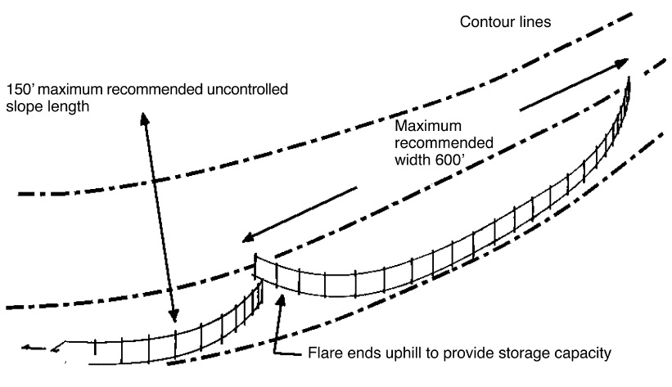
Source: MPCA
Figure 7. Typical silt fence layout

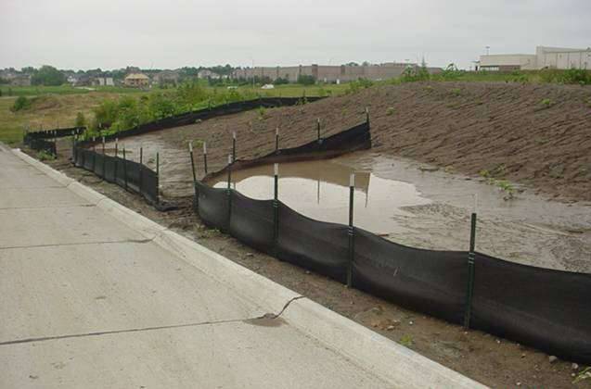
Source: Nebraska H2O
Figure 8. Example of properly functioning silt fence

6.2. Fiber Logs/Rolls
Fiber logs, fiber rolls, biorolls, or wattles fabricated from a variety of materials (e.g., straw, wood fiber, compost, coconut, etc.) can perform effectively as perimeter control BMPs for relatively flatter sites or smaller drainage areas. They are also effective when used with mulch or erosion control blankets on steeper slopes to break up slope lengths, intercept and spread out downslope flows, promote vegetative growth, and generally prevent slope erosion.

Design guidelines for using fiber logs as perimeter controls include:
- Do not use for perimeter control below slopes longer than 30 feet and steeper than 15 percent.
- When used for perimeter control, use 20 inch diameter logs where slopes are 10 to 15 percent, 10 inch diameter logs for slopes 5 to 10 percent, and 8 inch diameter logs for flatter slopes.
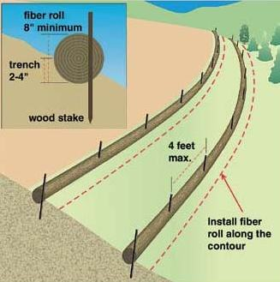
- On slopes, install on the contour, with ends turned upslope slightly to deter bypasses.
Figure 9. Schematic showing fiber rolls installed along contour of slope
- If installing on bare soil, prepare a smooth, rounded trench with a depth of ¼ the log diameter.
- Must be staked down. When staking down, ensure good soil contact for the full length of the fiber log.
- Where used on slopes, space 10 feet apart for 1H:1V slopes, 20 feet apart for 2H:1V slopes, 30 feet apart for 3H:1V slopes, and 40 feet apart for 4H:1V or flatter slopes.
- Use stakes that are 16 inches longer than the diameter of the fiber log for soft soils, and 10 inches longer than the fiber log diameter in hard or rocky soils. Space stakes no more than 3 to 4 feet apart; shorten stake spacing on steeper slopes

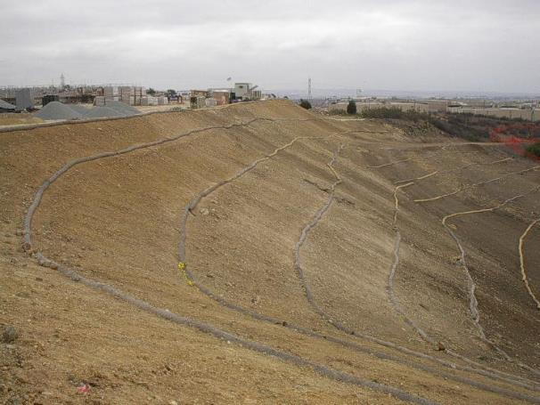
Source: Tetra Tech
Figure 10. Fiber rolls along slope

6.3. Rock and Other Berms
Perimeter control berms consisting of stabilized soil, rock, rock bags, mulch, compost, grubbed roots and brush, and other material can also serve to reduce sediment discharges offsite, through ponding, filtration, or redirection of runoff to a sediment trap or other treatment unit. These systems are a very efficient method for sediment removal, but may require frequent maintenance as they are prone to clogging from mud and soil. In addition, installation may be labor intensive, they are easily damaged by equipment, and removal can be difficult. Design considerations include the general guidelines listed at the beginning of this section, as well as those listed below:
- As with other perimeter controls, rock and other berms are typically installed on the contour, with the ends turned upslope to prevent bypasses.
- Soil berms (i.e., linear stockpiles) used to redirect sheet flows to treatment areas (e.g., sediment traps, rock berm or check) should be stabilized immediately with vegetation, erosion control blankets, or other means to prevent the berm from eroding and becoming a source of sediment runoff. Temporary flow checks and an outlet flow dissipater may be needed, depending on the slope.
- Rock or gravel bags can be used as a sheet flow diversion berm or as a ponding/filtration perimeter control. Bags should not be filled more than two-thirds, so that they create a solid berm without large spaces or gaps between the bags.
- Compost berms and shredded wood mulch berms may be used in flatter areas where other perimeter controls are not feasible. Compost berms must meet MnDOT Specification 3890 Grade 2. Compost and shredded wood mulch berms should be at least 2.5 feet wide and 1 foot tall.

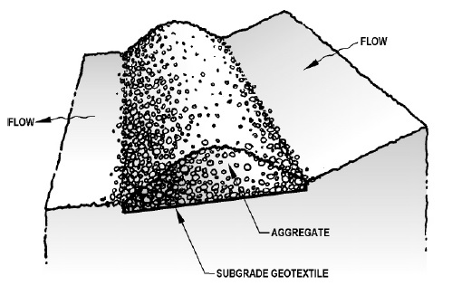
Source: Clean Water Services
Figure 11. Example perimeter control berm

6.4. Perimeter Control Ditches
Perimeter control ditches function like soil berms – they redirect downslope sheet flow from the disturbed area perimeter to a sediment trap, settling pond, rock berm, or other treatment unit designed to settle or filter soil from site runoff. Design considerations include:
- All ditches must be stabilized immediately after construction. Seeding rates and the use of mulch or rolled erosion control products will be determined by the ditch slope and other site-specific factors.
- Long, steep ditches may need temporary ditch checks to prevent erosion and down-cutting.
- Where using a ditch or berm to redirect site runoff from the perimeter to a separate treatment unit (e.g., sediment trap or pond) and the disturbed area perimeter is within or adjacent to the protective buffer of a surface water body, consider siting the treatment unit at an upslope location.

6.5. Cold Weather Considerations
Permit requirements specify that all construction sites must remain in compliance throughout winter, even if no construction is occurring. Properly functioning sediment controls must remain in place during minor thaws and during the large spring snowmelt to prevent transport of sediment to surface waters. The best way to ensure proper functioning of perimeter controls throughout winter is to have all sediment controls installed prior to the first freeze. For winter construction, materials such as compost berms, logs and rolls, fiber rolls, rock bags, and rock filters can be installed over snow cover to provide new sediment control. Snow berms may also be used for projects that will be complete before snowmelt. All BMPs must be inspected and maintained immediately following intermittent snow melt or rainfall that occurs in winter months.

Standards and Specifications
MnDOT Standard Plan 5-297.405 provides standard detail for perimeter control BMPs utilized for temporary sediment control (effective date: 8/6/2014). BMPs covered include “Flotation Silt Curtain”, “Sediment Control Logs”, “Filter Berms”, “Bale Barriers”, and several “Silt Fence” plans (including Types TB, HI, MS, and PA).

The MnDOT Standard Specifications for Construction (2016 edition) outline specific requirements for various types of perimeter control BMPs, including selection and materials specifications. Applicable specifications include 2573 (Storm Water Management), 3149 (Granular Material), 3874 (Filter Berm), 3882 (Mulch Material), 3886 (Silt Fence), 3887 (Flotation Silt Curtain), 3890 (Compost), 3893 (Sandbags), and 3897 (Sediment Control Log), see http://www.dot.state.mn.us/pre-letting/spec/

Inspection
For all perimeter control BMPs, initial inspections should ensure that controls are intercepting all upslope runoff from disturbed areas. Check upslope areas to determine if there are opportunities to reduce the volume of runoff being handled by perimeter controls, reduce the amount of sediment in the runoff (i.e., by installing diversions above the disturbed area), or immediately stabilize idle bare areas and/or portions of the site that are at final grade. Where perimeter controls redirect flows to sediment traps, ponds, or other treatment BMPs, ensure that berms/ditches are stable, flow paths are unobscured, and that the treatment BMP is able to handle inflows appropriately and are functioning properly. If it is determined through inspection that the selected perimeter control BMPs are ineffective, they must be upgraded to a method that is effective at keeping sediment on the site.

MnDOT’s workmanship and rework schedule (2016; version under development at the time of manual update) identifies common deficiencies for various types of perimeter control BMPs and corrective actions for these deficiencies. Once complete, the full, final version of this table will replace Table 2573-1 in MnDOT Standard Specifications for Construction (2016 edition).

Table 5. Excerpt from Table 2573-1, Temporary Sediment Control: Corrective Actions
Item | Corrective Action Required if | Corrective Action
Silt fence | Wrong type installed  Installed in wrong location  Improper geotextile used  Insufficient geotextile embedment or weighting units  Insufficient compaction of soil  Soil turned over, loosened, or both due to inadequate equipment for sliced type  Inadequate fastenings  Incorrect post spacing  Inadequate intra-fence end-joint connections  Improperly wrapped under J-barrier  Silt fence left in place when no longer needed  Turbidity barrier missing top interconnect cable  Silt fence type not maintained for function or performance | Remove and install as shown in plan  Remove silt fence  Replace with correct geotextile  Reinstall silt fence or apply sandbags or aggregate toe mass  Compact soil with tire or plate compactor  Compact soil with tire or plate compactor  Install more zip-ties  Install more posts  Wrap geotextiles around post to provide seal; else fill gap  Reinstall J-barrier  Immediately remove silt fence  Install interconnect cable  Immediately fix the problem
Bale barriers | Not notched in  Not properly staked into the ground  Not properly overlain with RECP | Remove bales and subcut a notch  Add stakes of sufficient length  Install blanket and anchors
Filter berms | Damaged or compacted by equipment  Berm breached or bypassed  Improper depth to width ratio  Rock weeper missing filter aggregate face | Restore filtration function by soil loosening  Add fill, embed rock buttress, reconfigure drainage  Add more fill to conform to berm detail  Add coarse filter aggregate front side of flow
Floating silt curtain | Curtain not end anchored on land or adjacent perimeter control  Curtain not weighted sufficiently in water or for field conditions  Improper depth(s)  Improper in-water anchoring/tethering  Curtain left in water beyond temporary in-water work phase  Curtain too far from land edge  Navigation buoys not installed with flowing water type | Bring end of curtain onto land or close the gap  Install correct curtain, add anchors and cables  Install correct curtain depth for in-water ground contact  Remove and install with proper depths  Immediately remove and install new controls on land  Recover and reinstall following detail of 6 ft maximum  Install navigation buoys as necessary
Perimeter controls | Incorrect BMP for location  Not properly J-hooked at termination points  Not placed along contours when feasible  Wrong type installed for intended application  Not maintained for function  No redundant practice above water resource | Remove and install proper perimeter control  Remove section, install J-hook section and connect upgradient  Reconfigure control to match slope contour  Remove and install proper control  Immediately apply maintenance to restore function  Add control redundancy
Sediment control logs | Not staked properly resulting in undermining or movement of logs  Log ends not overlapped when more than one is needed in a line | Install additional stakes  Reconfigure logs for overlap
Sandbag barrier | Sandbags not butt end jointed to provide seal  Sandbags not sufficiently high  Sandbags not installed on contour  Sandbags not working as a diversion  Middle of sandbag dike higher than ends | Re-install sand bags  Add more sand bags in interlocked pyramid style configuration  Re-configure barrier to conform to contour  Re-install with a plastic cover wrap  Reconfigure placement to lower middle or extend upper ends

The subsections below provide additional inspection guidelines for each of the BMPs addressed in the section above.

8.1. Silt Fence
- During installation, make sure support posts are on the downhill side of the fabric.
- Inspect silt fences at least once a week and after each rainfall, as required by permits, and make required repairs immediately.
- Verify posts are correctly spaced.
- After installation, tug on the top of the fabric between posts to ensure that it is embedded tightly.
- Make sure fabric is securely attached to the posts, without excessive sagging.
- Ensure geotextile overlap is used on heavy duty type fence.
- Ensure soil is compacted (not turned over/loosened) for machine-sliced fence.
- After a rain, check silt fences for bypasses below or around the ends of each silt fence section.
- Note and record blowouts, sections where the fence is down, etc.
- Note the condition of support posts along each section of silt fence.
- Observe and record the amount of sediment deposited on the upslope side of the silt fence.

8.2. Fiber Logs
- After a rain, check for bypasses under the fiber logs and at the ends of each row.
- Note the physical integrity of the logs, and document any significant deterioration found.
- Check the stakes to make sure they are still holding the logs securely in place.

8.3. Rock and Other Berms
- Make sure berms retain their initial configuration and ponding/filtration/flow function.
- Look for scouring downslope of berms where ponded overflows occur.
- Check berms and note areas where runoff has blown out or bypassed bermed areas.
- Look for washouts, undercutting (e.g., animal burrows), and end bypasses along berms.

8.4. Perimeter Control Ditches
- Observe the flow perimeter of ditches and note any vertical or horizontal scour erosion.
- Look for scour and offsite sediment discharges where ditches overflow during heavy rains.

Maintenance
The maintenance guidelines below respond directly to the inspection findings that result from observing field conditions listed in the previous section. For best results, complete maintenance tasks immediately, before conditions worsen and consume more time and resources to resolve. Below are some key requirements from the 2013 MPCA Construction Stormwater General Permit:
- “If the down gradient sediment controls are overloaded (based on frequent failure or excessive maintenance requirement), the Permittee(s) must install additional upgradient sediment control practices or redundant BMPs to eliminate the overloading, and the SWPPP must be amended to identify these additional practices.”
- The permittee is required to “re‐install all sediment control practices that have been adjusted or removed to accommodate short‐term activities such as clearing or grubbing, or passage of vehicles, immediately after the short‐term activity has been completed.” Permittees must “complete any short‐term activity that requires removal of sediment control practices as quickly as possible,” and “must re‐install sediment control practices before the next precipitation event even if the short‐term activity is not complete.”
- “All perimeter control devices must be repaired, replaced, or supplemented when they become nonfunctional or the sediment reaches one‐half (1/2) of the height of the device. These repairs must be made by the end of the next business day after discovery, or thereafter as soon as field conditions allow access.”
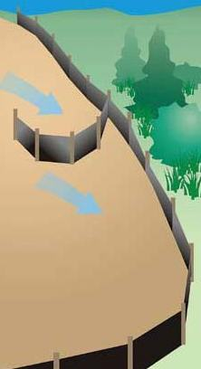
Other maintenance guidelines include:
Source: Created by Tetra Tech for US EPA and State of Kentucky
- Use J-hooks along silt fences, berms, and other structures to break up long flow paths, reduce flow velocities, and trap sediment before it reaches downgradient locations.
- Add more/longer stakes where fiber rolls become dislodged by runoff.
- Repair or replace perimeter controls found to be non-functional, due to severe weather conditions, age, extended use, damage, or other causes.
- Use rock berms along dips and in low corners of silt fences, fiber logs, and other BMPs if blowouts and bypasses occur frequently in these locations.
- Where repeated failures occur, install additional upgradient erosion prevention and/or sediment control practices or redundant BMPs to eliminate the problem (see above).
- Repair or replace ineffective fabric and fiber rolls due to collapse, tearing, decomposition, etc. within 24 hours of discovery.
- When all areas above the perimeter control BMP(s) have been stabilized, the temporary BMP(s) (e.g., silt fences, temporary berms, etc.) must be removed. (Note: Fiber logs are typically left in place on slopes.)
- After removing temporary BMPs, collect and dispose of the accumulated sediment, and fill and compact holes, trenches, depressions, or any other ground disturbance to blend with the surrounding landscape. Stabilize the area with seed, mulch, sod, or other BMP.

Costs
The following table summarizes estimated BMP costs based on MnDOT data summarizing average bid prices for awarded projects in 2014.

Table 6. Average Bid Prices (Based on Awarded Projects) for Spec Year 2014. Average price varies from year to year. Data for other years can be found on MnDOT’s website. (Source: MnDOT)
Bid Item | Item Description | Units | Average Price
2573.501/00010 | Bale Barrier | LF | $4.97
2573.502/00010 | Silt Fence, Type HI | LF | $2.58
2573.502/00020 | Silt Fence, Type PA | LF | $7.00
2573.502/00030 | Silt Fence, Type SD | LF | $19.87
2573.502/00040 | Silt Fence, Type MS | LF | $1.99
2573.502/00050 | Silt Fence, Type TB | LF | $10.24
2573.504/00010 | Sandbag Barrier | SF | $10.55
2573.505/00010 | Flotation Silt Curtain Type Still Water | LF | $14.99
2573.505/00020 | Flotation Silt Curtain Type Moving Water | LF | $39.57
2573.515/00013 | Filter Berm Type 3 | LF | $54.49
2573.515/00015 | Filter Berm Type 5 | LF | $22.95
2573.533/00011 | Sediment Control Log Type Straw | LF | $2.90
2573.533/00012 | Sediment Control Log Type Wood Fiber | LF | $4.29
2573.533/00013 | Sediment Control Log Type Coir | LF | $13.25
2573.533/00015 | Sediment Control Log Type Compost | LF | $2.58
2573.533/00016 | Sediment Control Log Type Rock | LF | $5.00
2573.533/00017 | Sediment Control Log Type Blanket System | LF | $2.52

Reference Materials

Except where more stringent requirements are presented in this guidance, perimeter controls shall comply with MnDOT and other state requirements. Primary design references include:
- MnDOT Erosion Control Handbook II http://www.dot.state.mn.us/environment/erosion/pdf/2006mndotecfieldhandbook.pdf
- Minnesota Urban Small Sites Best Management Practice Manual (Silt Fences) http://www.metrocouncil.org/Wastewater-Water/Planning/Water-Resources-Management/Minnesota-Urban-Small-Sites-BMP-Manual.aspx
- 2013 Minnesota NPDES/SDS Construction Stormwater General Permit http://www.pca.state.mn.us/index.php/water/water-types-and-programs/stormwater/construction-stormwater/index.html
- MnDOT Standard Specifications for Construction (2016 Edition) http://www.dot.state.mn.us/pre-letting/spec/
- MnDOT Standard Drawings for use in Construction Plans http://standardplans.dot.state.mn.us/StdPlan.aspx

The following is a list of additional resources that are not specific to Minnesota:
- Clean Water Services Erosion Prevention and Sediment Control Manual (4.3.4 Filter Berm, 4.3.10 Sediment Fence) https://www.cleanwaterservices.org/Content/Documents/Permit/Erosion%20Prevention%20And%20Sediment%20Control%20Manual.pdf
- North Carolina Erosion and Sediment Control Planning and Design Manual (6.62 Sediment Fence (Silt Fence), 6.66 Compost Sock) http://deq.nc.gov/about/divisions/energy-mineral-land-resources/energy-mineral-land-permit-guidance/demlr-publications
- Tennessee Department of Environment and Conservation (TDEC) Erosion and Sediment Control Handbook (7.34 Silt fence) http://tnepsc.org/handbook.asp
- Virginia Erosion and Sediment Control Handbook (3.05 Silt Fence, 3.06 Brush Barrier) http://www.deq.virginia.gov/Programs/Water/StormwaterManagement/Publications/ESCHandbook.aspx
- Clark County Washington Stormwater Manual (BMP C232: Gravel Filter Berm, BMP C233: Silt Fence) https://www.clark.wa.gov/environmental-services/stormwater-code-and-manual
- Best Management Practices (BMPs) for Controlling Erosion, Sediment, and Pollutant Runoff from Construction Sites. University of Kentucky, 2009. http://dep.ky.gov/formslibrary/Documents/09BMPManual_Final.pdf
- Delaware Erosion and Sediment Control Handbook. 2003. http://www.dnrec.state.de.us/DNREC2000/Divisions/Soil/Stormwater/New/Delaware%20ESC%20Handbook_06-05.pdf
Check Dams (Ditch Checks, Ditch Dikes)

Definition
Check dams, also called ditch checks, dikes, wattles, etc., are temporary or permanent linear structures placed perpendicular to concentrated flows such as in drainage ditches, channels, and swales to reduce flow velocities and prevent channel down-cutting. Some sediment trapping may occur during low flows. Check dam materials may include rock, fiber logs (e.g., wattles), triangular sediment dikes, sand bags, and other materials or prefabricated systems. Straw/hay bales and silt fences should not be used for check dam applications, as they are not intended for concentrated flow areas.

Purpose and Function
Check dams are not intended as a replacement for proper ditch/channel stabilization (e.g., erosion blanket or turf mat over seed, use of rip-rap, etc.). Check dams help reduce ditch and channel velocities, prevent erosion, and trap small amounts of sediment by intercepting flow along a ditch or channel. The disruption in flow direction and speed creates low velocity areas on the upgradient side of the check dam, causing deposition of heavier sediment particles and resulting in reduced scour potential (i.e., lateral and vertical erosion). Under low-flow conditions, water ponds behind the structure and then slowly drains through, infiltrates, or evaporates. Under high-flow conditions, water flows over and/or through the structure. The main function of a check dam is to decrease velocity, not to collect sediment, although sediment capture and increased infiltration is an added benefit. Check dams are not a suitable substitute for major perimeter sediment trapping measures, and can be easily washed away by high ditch/channel flows if they are not designed or installed properly.

Applicability
Check dams may be used in ditches or channels to reduce erosion and trap sediment. Check dams are relatively inexpensive and easy to install. They are not approved for use in regulated waterbodies (i.e., Waters-of-the-State) without permit coverage from the U.S. Army Corps of Engineers under Section 404 of the Clean Water Act. MPCA water quality certification requirements also apply.

Site Applicability
Check dams are used to regulate flow velocities, reduce scour erosion, and trap small quantities of sediment along higher-risk ditches and channels that have slopes greater than 10 percent and soil types conducive to erosion (i.e., sandy/silty soils). They are appropriate for both temporary and permanent ditches and swales. While most flatter and shorter channels (i.e., slope < 3%, length < 200 feet) generally do not need check dams if they are stabilized immediately after construction (i.e., with sod, or seed and the appropriate rolled erosion control product), longer and steeper ditches can benefit from check dam installations. When evaluating the use of check dams for a particular site, consider the following:
- When carefully located and constructed, check dams may function as permanent installations.
- Rock from a temporary check dam can be spread into a ditch and used as a channel lining when the check dam is no longer necessary.
- Removal may be costly for some types of check dams.
- Check dams are suitable only for a limited drainage area (generally 10 acres or less).
- Check dams are intended for use in small open channels, not streams or rivers.
- Hydraulic capacity of the channel can be reduced when check dams are in place.
- Check dams may create turbulence downstream, causing erosion of the channel banks.
- Ponded water may kill grass in grass-lined channels.
- Check dams may be an obstruction to construction equipment.

Permit Applicability
Check dams are part of the overall stabilization system for a ditch or channel, and their use is driven by site conditions – specifically, channel slope, length, soil type, and flow velocities. Section IV.B.4 of the 2013 MPCA Construction Stormwater General Permit states that the permittee(s) “must stabilize the normal wetted perimeter of any temporary or permanent drainage ditch or swale that drains water from any portion of the construction site, or diverts water around the site, within 200 lineal feet from the property edge, or from the point of discharge into any surface water. Stabilization of the last 200 lineal feet must be completed within 24 hours after connecting to a surface water or property edge.”

In addition, the permittee(s) must “complete stabilization of the remaining portions of any temporary or permanent ditches or swales within 14 calendar days after connecting to a surface water or property edge and construction in that portion of the ditch has temporarily or permanently ceased.” Check dams should be used in conjunction with seed, mulch, blankets, mats, and/or other stabilization measures to help meet these requirements.

Effectiveness
Check dams are moderately effective in trapping sediment, and highly effective in preventing downcutting in a ditch or channel when used with appropriate rolled erosion control products installed over seed. They generally provide relatively fair-to-good removal of coarse and medium-sized sediment from runoff; however, most fine silt and clay particles will pass through the voids on these structures. Their primary benefit lies in preventing erosion prior to seed germination and growth in vegetated ditches and channels. Table 7 summarizes expected performance for an array of typical water quantity and quality target constituents for check dams.

Table 7. Expected performance for check dams
Water Quantity
Flow attenuation
Runoff volume reduction
Water Quality
Pollution prevention
Erosion prevention (i.e., for channel banks)
Sediment control
Nutrient loading
Pollutant removal
Total suspended solids
Total phosphorus
Heavy metals
Floatables
Oil and grease

Primary design benefit
Secondary design benefit
Little or no design benefit

Planning Considerations
Check dams are rarely effective in steep channels (i.e., more than 10% slope), and are easily dislodged by high ditch/channel flow velocities if they are not designed, sized, and installed properly. Common causes of failure include:
- Failure to account for high intensity rain storms
- Use of rock that is too small for flow velocities/volumes present
- Failure to secure temporary dike products against heavy flows
- Use of fiber log stakes that are too short – or that are spaced too far apart
- Presence of woody or other debris in storm flows, causing structural damage to check dams

Planning guidelines and material selection for check dams are driven by site considerations (e.g., ditch/channel slope, length, flow velocities, soils) and the longevity desired. In general, ditch/channel slope should not exceed 10 percent (otherwise, a drop structure should be considered), the drainage area should not exceed 10 acres, and flow velocities should not exceed 12 feet per second for a 10-year, 24-hour storm frequency.

When installing drainage ditches or channels, plan to stabilize them immediately after construction, as required. Un-vegetated/unarmored ditches and channels erode quickly on contact with flowing water – especially when they are long and steep. Include check dams as part of the ditch erosion prevention and sediment control system when ditches are longer than 200 feet and steeper than 3 percent. Wide, flat swales (i.e., < 1% slope, > 4 foot width) can also benefit from check dam installations when used as temporary linear sediment traps during the construction phase.

Design and Construction
Check dam types vary by composition and installation approach. Fiber logs, filled bags, and other check dams can include items made of straw, wood fiber, compost, wood slash, soil, sand, aggregate, riprap, and specialty products. These specific material compositions of various check dams largely determine its longevity once installed in the field. Spacing of the check dams within the ditch or channel will vary in accordance with slope and soil type (see Table 8 for example spacing).Some check dam types, like decomposable fiber logs, typically do not require removal since they can be left in the ditch or channel to deteriorate and add organic matter to further support vegetation establishment. Where appropriate, rock check dams can be spread out along ditch bottoms after the channel is vegetated as long as disturbance from equipment to do is minimized or stabilized o immediately afterwards. Manufactured sediment dikes and rock bag check dams must be removed after stabilization, prior to closing out the project permit.

General installation guidelines for all check dams include the following:

- Select a check dam type to meet longevity and other design objectives.
- Complete final grading of the ditch and rock/debris removal prior to check dam installation.
- Channel protection and stabilization (i.e., with turf reinforcement mats, Type 3 or 4 erosion control blankets, seed, etc.) should be achieved prior to installation of check dams.
- Install check dams immediately after ditch/channel stabilization (i.e., seeding and mulching or installation of rolled erosion control products).
- Install check dams all the way across the ditch or channel, perpendicular to the flow.
- Configure check dams so the sides extend up the bank slopes, with the overflow in the middle.
- The ends of each dam should be installed up bank slopes so that the bottom of the dam is 6 inches higher than the top of the center; this practice prevents water from running around the ends and causing additional erosion.
- Overflow dips in the middle of the check dam should be 8-12 inches lower than the sides.
- Ensure culvert entrances below check dams are not subject to damage or blockage from displaced stones.
- Protect the channel downstream of the lowest check dam from erosion, since water will flow over and around the dam.
- Ensure that the channel is stable above the most upstream check dam.
- If check dams are to be removed, vegetate and stabilize the footprint area immediately after removal. Seeding, mulching, or matting are appropriate stabilization practices.
- The maximum height of check dams varies by material (see Table 8 for examples).
- The spacing between ditch checks should be such that the bottom of the upstream check should be at the same elevation as the top of the downstream check.
- General check dam spacing can be calculated by dividing the height of the structure by the slope percentage (i.e., represented in the decimal form, for example, 5% = 0.05, etc.).

Table 8. Example check dam types, spacing, slope applications, and longevity
Check Dam Type | Spacing for Various Ditch Slopes (feet)* |  |  |  | Slope Applications | Longevity
 | Up to 2% | 3-5% | 6-9% | 10-15%
Mixed size rock (2 ft height) | 100 | 67-40 | 33-22 | 20-13 | Up to 15% | > 2 years
Rock bags (16 inch height) | 75 | 50-30 | 25-17 | 15-10 | Up to 15% | Up to 1 year
Rock bags (10 inch height) | 42 | 28-17 | 14-9 | 8-6 | Up to 15% | Up to 1 year
Triangular sediment dike (10 inch height) | 42 | 28-17 | 14-9 | 8-6 | Up to 15% | 1 to 2 years
Fiber log – wood / mulch (10 inch) | 42 | 28-17 | 14-9 | 8-6 | Up to 15% | 1 to 2 years
Fiber log – straw (10 inch) | 42 | 28-17 | 14-9 | NA | Up to 10% | Up to 6 months
* Note: reduce spacing intervals for highly erodible soils.

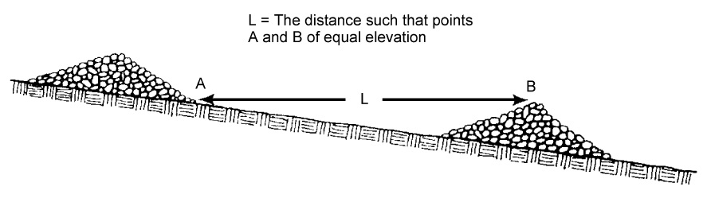
Source: MPCA
Figure 12. Space check dams in a channel so the crest of the downstream dam is at the elevation of the toe of the upstream dam

6.1 Rock Check Dams
- Rock check dams should consist of well-graded stone consisting of a mixture of rock sizes.
- For best results, use mixed sizes of aggregate and riprap that are collectively sized to withstand expected ditch channel flows (typically 1.5 inch to 12 inches). For example, a check dam specification may require Class IV riprap with percent less than the specified rock diameter:
100% < 24 inches
75% < 15 inches
50% < 9 inches
10% < 4 inches
- Check dams may be constructed of riprap, with a coarse aggregate facing on the uphill side.
- Other options include 1.5-inch clean gravel and river rock.
- Place a strip of nonwoven geotextile below check dam to provide a stable foundation and for easier removal.
- Construct check dams 4 to 5 feet wide at the bottom, and 1.5 to 2 feet wide at the top.
- Construct check dams 1.5 to 2 feet high, with side slopes no steeper that 2H:1V.
- To increase the effectiveness of rock check dams, a shallow pool upstream of the check is recommended, which allows additional sediment storage.
- For spacing and other details, see Table 8.

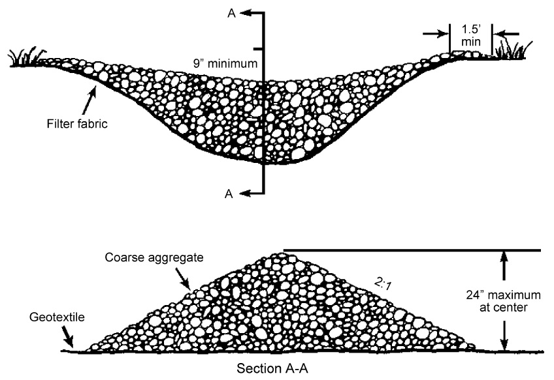
Source: MPCA
Figure 13. Stone should be placed over the channel banks to keep water from cutting around the dam

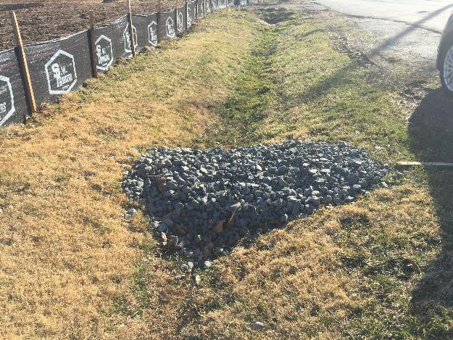
Source: Tetra Tech
Figure 14. Example rock check dam installation

6.2 Rock/Sand Bag Check Dams
Rock/sand bags are manufactured from durable, weather resistant tightly woven geotextile fabric material sufficient to prevent leakage of the filler material. They are relatively low cost and easy to install, move, replace, and reuse (if not damaged). Rock/sand bag check dams are a good short-term solution where concentrated flows are causing erosion, and can also be used to divert and slow the velocity of small flows. Biofilter bags may also be used when firmly staked to the ground. Additional rock/sand bag considerations include:
- Use fabric or net bags, with one-inch stone.
- Fill bags only three-fourths full of rock, to reduce gaps in the check dam.
- Construct check dams 1.5 to 2 feet high, with side slopes no steeper that 2H:1V.
- Rock/sand bags are not appropriate on steep slope applications or where water velocities or volumes are high.
- They can easily be damaged by construction equipment and are generally only effective for a few months.
- The ends of the bags should be tightly abutted and overlapped to direct flow away from bag joints.

For example spacing and other details, refer to Table 8 above.

6.3 Triangular Sediment/Silt Dike
Triangular sediment/silt dikes are pre-fabricated triangular shaped blocks typically made of foam or other flexible, lightweight material and covered with geotextile fabric. The geotextile extends from the bottom of the dike to provide aprons on the upslope and downslope sides, and the dike is anchored by trenching and stapling the aprons. They will form a check dam when laid in the channel. Material, section length, and weights vary among manufacturers, but they are all designed to be lightweight and relatively easy to install and maintain. Consider the following when using triangular dikes:
- Follow manufacturer’s instructions regarding product applications, limitations, and installation.
- Make sure product is trenched in and stapled down correctly, to reduce bypasses.
- Use longer stakes, and reduce stake spacing, where higher velocity flows are expected.
- These systems are not intended for use in steep slope applications or where water velocities or volumes are high.
- Because they are lightweight, they can easily be damaged by construction equipment.
- Products that are not damaged or deteriorated may be reused.

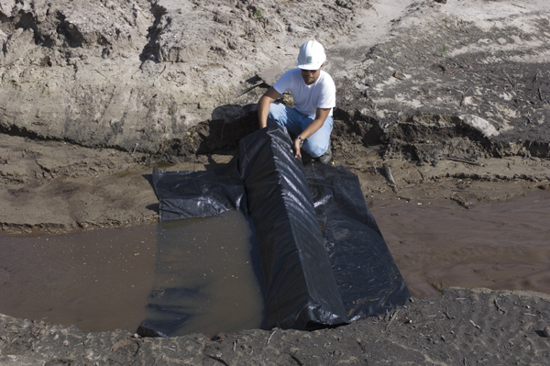
Source: spillcontainment.com
Figure 15. Installation of triangular silt dike in channel

6.4 Fiber Log Check Dams
Fiber logs (straw wattles, excelsior logs) are straw and wood-fiber cores wrapped with synthetic netting. They can be partially buried in a channel to create mini dams.

- Fiber logs are available in many diameters to meet site requirements.
- These can be helpful in establishing permanent vegetation in a channel.
- Follow manufacturer’s instructions regarding product applications, limitations, and installation.
- When staking down, ensure good soil contact for the full length of the fiber log.
- Use stakes that are 16 inches longer than the diameter of the fiber log for soft soils, and 10 inches longer than the fiber log diameter in hard or rocky soils. Space stakes 1 to 2 feet apart.
- For example spacing and other details, see Table 8.

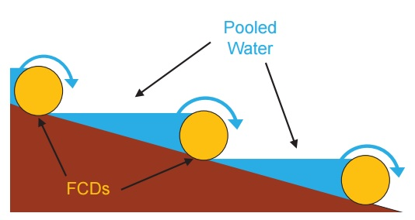
Source: North Carolina State University
Figure 16. Ditch cross-section illustrating fiber check dam (FCD) spacing to create series of pools

6.5 Erosion Control Blanket Pillow Checks

Erosion control blankets installed in ditches can be folded over to create “pillow checks” across the bottom of the channel. To install, fold a 12 to 16 inch section of the blanket over itself during blanket installation in the ditch bottom, and stake down securely with long staples or wooden stakes spaced every 12 inches. An alternate approach is to install the erosion blanket or turf reinforcement mat after seeding the ditch/channel, then install folded-over sections of blanket at regular intervals on top, similar to installation of other ditch checks. Spacing can range from 50 to 60 feet for flat ditches/channels, to 15 to 20 feet for steeper sections. Pillow checks can be left in the ditch or channel to decompose naturally.

6.6 Curb Gutter Checks

In developed residential and urban environments, a series of gutter checks can be installed in the runoff flow path along the curb to slow down flows and trap sediment. Sand bags and rock bags are used most often for this purpose. To install, lay the end of the bag against the curb, with the other end angled slightly upgradient. Make sure the end of the bag against the curb butts up tightly, to prevent bypasses between the curb and the bag. Install other bags similarly along the curb, so that sediment laden water flowing the curb must go around the small check dams. Spacing of the bags should be from five to ten feet apart. Installation can occur from the downgradient curb or other inlet and on up the slope, to the full extent of the area delivering sediment to the curb line. Bags should not need anchoring, due to the weight of the sand or rock.

Standards and Specifications
MnDOT Standard Plan 5-297.405 provides standard detail for ditch checks utilized for temporary sediment control (effective date: 8/6/2014). BMP types covered include “Rock Ditch Checks (Filter Berms) Type 3 (Rock Weeper) or Type 5 (Rock)”, “Sediment Control Log (Blanket System)”, and “Sediment Control Log (Wood Fiber or Compost)”.

The MnDOT Standard Specifications for Construction (2016 edition) provide brief guidance pertaining to the use of filter berms and sediment control logs as ditch checks (Specification 2573.3.E and F). This guidance mainly specifies that ditch checks be installed perpendicular to the ditch gradient. Materials specifications that may be applicable, depending on selected design, include Specification 3601 (Riprap Material), 3733 (Geotextiles), 3885 (Rolled Erosion Control Products), and 3886 (Silt Fence).

Inspection
Check dams should be inspected regularly, especially after rainfall exceeding 0.5 inch. Section
IV.E.5.c of the 2013 MPCA Construction Stormwater General Permit states that “drainage ditches and conveyance systems...must be inspected for evidence of erosion and sediment deposition during each inspection. The Permittee(s) must remove all deltas and sediment deposited in surface waters, including drainage ways, catch basins, and other drainage systems, and re-stabilize the areas where sediment removal results in exposed soil. The removal and stabilization must take place within seven (7) days of discovery unless precluded by legal, regulatory, or physical access constraints.” Specific inspection guidelines for check dams include the following:

- Inspect check dams and channels for damage after each runoff event (including runoff from snowmelt), and correct all damage immediately.
- Regular inspections should be made to ensure that the center of the dam is lower than the edges.
- Check the structural integrity of the check dams – shape, anchoring, and overall condition.
- Look for scour underneath the check dam and bypasses on the sides.
- Note the amount of sediment deposited upslope of the check dams.
- Observe erosion of ditch segments between check dams – downcutting and side scour.

MnDOT’s workmanship and rework schedule (2016; version under development at the time of manual update) identifies common deficiencies for various types of temporary sediment control BMPs – including ditch checks – and corrective actions for these deficiencies (Table 9). Once complete, the full, final version of this table will replace Table 2573-1 in MnDOT Standard Specifications for Construction (2016 edition).

Table 9. Excerpt from Table 2573-1, Temporary Sediment Control: Corrective Actions
Item | Corrective Action Required if | Corrective Action
Ditch checks (see also sediment control logs) | Sediment control logs not properly trenched, staked, or both  Not stapled properly for blanket and sediment control log system  Water flows around the end rather than over the middle  Incorrect spacing of checks  No geotextile liner used for rock weeper system or rock checks  Wrong one installed for intended or plan application | Remove sediment control logs and provide trench, and angle stake as per detail  Add more staples as per detail  Extend length of log where end is higher than middle  Add more checks following spacing detail  Remove rock and add geotextile  Remove improper check and install as per plan or amendment
Sediment control logs | Not staked properly resulting in undermining or movement of logs  Log ends not overlapped when more than one is needed in a line | Install additional stakes  Reconfigure logs for overlap

Maintenance
- Remove sediment adjacent to and accumulated behind check dams before it reaches halfway to the top of the dam.
- Restore dislodged or washed out check dams to their original configuration.
- Fill in or otherwise repair areas where check dam undercutting or bypasses have occurred.
- Add stones to dams as needed to maintain design height and cross section. Use larger stone, if necessary, to counter higher-than-expected flow velocities.
- Repair ditch/channel areas where excessive downcutting or side scour have occurred.
- Where fiber logs become dislodged by high ditch/channel velocities, use longer stakes and reduce the spacing between stakes.
- If the selected configuration is not preventing channel erosion, consider other materials or closer spacing in areas experiencing the most problems.
- If significant erosion occurs between dams, install a protective turf reinforcement mat or section of riprap liner in that portion of the channel.
- Rock weirs should be replaced when filtering capacity is reduced by one half.

The following provides an example summary of inspection and maintenance activities for check dams (Source: Prince George’s County Maryland):

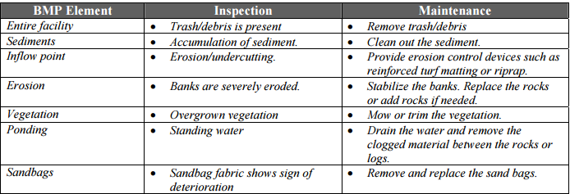

Costs
The following table summarizes estimated BMP costs based on MnDOT data summarizing average bid prices for awarded projects in 2014.

Table 10. Average Bid Prices (Based on Awarded Projects) for Spec Year 2014. Average price varies from year to year. Data for other years can be found on MnDOT’s website. (Source: MnDOT)
Bid Item | Item Description | Units | Average Price
2573.602/00015 | Rock Ditch Check | EACH | $1,305.98
2573.533/00011 | Sediment Control Log Type Straw | LF | $2.90
2573.533/00012 | Sediment Control Log Type Wood Fiber | LF | $4.29
2573.533/00013 | Sediment Control Log Type Coir | LF | $13.25
2573.533/00015 | Sediment Control Log Type Compost | LF | $2.58
2573.533/00016 | Sediment Control Log Type Rock | LF | $5.00
2573.533/00017 | Sediment Control Log Type Blanket System | LF | $2.52

Reference Materials
Except where more stringent requirements are presented in this guidance, check dams (temporary dikes) shall comply with MnDOT and other state requirements. Primary design references include:
- MnDOT Erosion Control Handbook II http://www.dot.state.mn.us/environment/erosion/pdf/2006mndotecfieldhandbook.pdf
- Minnesota Urban Small Sites Best Management Practice Manual (Check Dams) http://www.metrocouncil.org/Wastewater-Water/Planning/Water-Resources-Management/Minnesota-Urban-Small-Sites-BMP-Manual.aspx
- 2013 Minnesota NPDES/SDS Construction Stormwater General Permit http://www.pca.state.mn.us/index.php/water/water-types-and-programs/stormwater/construction-stormwater/index.html
- MnDOT Standard Specifications for Construction (2016 Edition) http://www.dot.state.mn.us/pre-letting/spec/
- MnDOT Standard Drawings for use in Construction Plans http://standardplans.dot.state.mn.us/StdPlan.aspx

The following is a list of additional resources that are not specific to Minnesota:
- Clean Water Services Erosion Prevention and Sediment Control Manual (4.2.1 Check Dam, 4.3.7 Pre-Fabricated Barrier System, 4.3.14 Wattles) https://www.cleanwaterservices.org/Content/Documents/Permit/Erosion%20Prevention%20And%20Sediment%20Control%20Manual.pdf
- North Carolina Erosion and Sediment Control Planning and Design Manual (6.63 Rock Dam) http://deq.nc.gov/about/divisions/energy-mineral-land-resources/energy-mineral-land-permit-guidance/demlr-publications
- Tennessee Department of Environment and Conservation (TDEC) Erosion and Sediment Control Handbook (7.20 Check dam, 7.25 Tubes and wattles) http://tnepsc.org/handbook.asp
- Virginia Erosion and Sediment Control Handbook (3.20 Rock Check Dams) http://www.deq.virginia.gov/Programs/Water/StormwaterManagement/Publications/ESCHandbook.aspx
- Clark County Washington Stormwater Manual (BMP C207: Check Dams, BMP C208: Triangular Silt Dike) https://www.clark.wa.gov/environmental-services/stormwater-code-and-manual
- Best Management Practices (BMPs) for Controlling Erosion, Sediment, and Pollutant Runoff from Construction Sites. University of Kentucky, 2009. http://dep.ky.gov/formslibrary/Documents/09BMPManual_Final.pdf
- Delaware Erosion and Sediment Control Handbook. 2003. http://www.dnrec.state.de.us/DNREC2000/Divisions/Soil/Stormwater/New/Delaware%20ESC%20Handbook_06-05.pdf

