Tree trench system/box (with underdrain)
For a tree trench/box BMP with an underdrain at the bottom, most of the stormwater captured by the BMP is lost to the underdrain. However, some stormwater infiltrates through the basin bottom and sidewalls if these do not have an impermeable liner. Evapotranspiration (ET) and interception also occur from the trees planted in the system. For a tree trench/box system with an elevated underdrain, in addition to volume losses through the sidewalls and through evapotranspiration and interception, a portion of the water stored in the media between the underdrain and the native soils is infiltrated. In a tree trench/box BMP with an underdrain, all pollutants in infiltrated water are removed, while pollutants are removed through filtration for the water that flows through an underdrain. All pollutants in water lost to ET and interception are removed.
The user should be aware of the difference between a tree trench system and a tree box.
- Tree trench system is a BMP that includes multiple trees. This BMP is commonly used in areas where pavement overlies the trench system. Runoff from the impermeable surface or through a permeable pavement surface is delivered underground to the underlying media in which the trees are planted. This Manual includes case studies and a discussion of types of tree BMPs.
- Tree box (also called soil box) typically includes a single tree. They are typically proprietary products or are included in bioretention BMPs. If a tree is included in a bioretention BMP, we recommend using the bioretention BMP in the MIDS calculator instead of this BMP.

MIDS calculator user inputs for Tree trench system/box with underdrain
For Tree trench system/box with underdrain BMPs, the user must input the following parameters to calculate the volume and pollutant load reductions associated with the BMP.
- Watershed tab
  - BMP Name: this cell is auto-filled but can be changed by the user.
  - Routing/downstream BMP: if this BMP is part of a treatment train and water is being routed from this BMP to another BMP, the user selects the name of the BMP from the dropdown box to which water is being routed. All water must be routed to a single downstream BMP. Note that the user must include the BMP receiving the routed water in the Schematic or the BMP will not appear in the dropdown box.
  - BMP Watershed Area: BMP watershed areas are the areas draining directly to the BMP. Values can be added for four soil types (Hydrologic Soil Groups (HSG) A, B, C, D) and for three Land Cover types (Forest/Open Space, Managed Turf and impervious). The surface area of the BMP should be included as a managed turf land cover under the hydrologic soils group of the native soils located under the BMP. Units are in acres.
- BMP Parameters tab
  - Is the underdrain elevated above native soils?: This is a YES/NO question. Answering YES means the underdrain is elevated within the media. This creates storage capacity between the underdrain and the native soils. Answering NO means that the underdrain is not elevated within the media and is directly above the native soils with no storage capacity below the underdrain.
  - Are the sides of the basin lined with an impermeable liner?: This is a YES/NO question. Answering YES means the sides of the basin are lined, preventing water from infiltrating into the native soils. Answering NO means the sides are not lined and infiltration is allowed through the side of the basin into the native soils.
  - Is the bottom of the basin lined with an impermeable liner?: This is a YES/NO question. Answering YES means the bottom of the basin is lined, preventing water from infiltrating into the native soils. Answering NO means the bottom is not lined and infiltration is allowed through the bottom of the basin into the native soils.
  - Media surface area (A_{M}): This is the area at the surface of the engineered media. The user inputs this value in square feet.
  - Surface area at underdrain (A_{U}): This is the surface area of the BMP at the invert elevation of the underdrain. If the response to “Is the underdrain elevated above native soils?” is set to “No” then this cell will become inactive and populated with the “Bottom surface area” value. The user inputs this value in square feet.
  - Bottom surface area (A_{B}): This is the surface area at the bottom of the engineered media. It represents the area where the engineered media changes to native soils. The user inputs this value in square feet.
  - Total media depth (D_{M}): This is the depth between the media surface and the native soils (i.e. the thickness of the engineered media). The user inputs this value in feet.
  - Depth below underdrain (D_{U}): This is the depth of the media between the underdrain invert and the native soils. If the response to “Is the underdrain elevated above native soils?” is set to NO, then this cell will become inactive and populated with a 0. The user inputs this value in feet.
  - Media field capacity minus wilting point (FC - WP): This is the amount of water between field capacity and the permanent wilting point stored in the media . This is water often considered to be available for uptake by plants. If multiple types of media are used in the BMP, this value should be an average of the media installed above the underdrain. Values for field capacity and wilting point based on soil type can be found here. The user inputs this value in cubic feet of water per cubic feet of media.
  - Media porosity minus filed capacity (n - FC): This is the ratio of media pore space to the total media volume between the underdrain invert and the bottom of the media (top of native soil). If multiple types of media are used in the BMP, this value should be an average of the media installed between the underdrain and the native soils. Values for porosity based on soil type can be found here. The user inputs this value in cubic feet of pore space per cubic feet of media.
  - Tree Type: The user selects the type of tree planted in the tree trench/box from a drop down menu. The user can select a tree type of deciduous or coniferous. If both deciduous and coniferous trees are planted at the site, they should be treated as separate Tree trench system/box BMPs.
  - Tree Size (average for all trees): The user selects the size of tree planted in the tree trench/box system. The user can select small, medium or large. Tree size for different tree types are listed in the tree species list. If multiple tree sizes are planted at the site, they should be treated as separate Tree trench system/box BMPs.
  - Number of trees: The user enters the total number of trees planted in the tree trench/box system.
  - Planting media mix: The user selects the type of media mix installed for planting from a predefined list of Media mixes: Media mix A (water quality blend), Media mix B (enhanced filtration blend), Media mix C (North Carolina State University water quality blend), Media mix D (tree mix), or Other. This value is used to determine the annual phosphorus load reduction credit.
  - Is the P content of the media less than 30 mg/kg?: This is a YES/NO question. The P content of the planting media should be tested using the Mehlich 3 test or an acceptable alternative method. Select YES if the P content of the planting media is less than 30 milligrams per kilogram and NO if it is greater. P content testing is not needed for planting media C or D; therefore, this item will automatically populate to YES if one of those two media types are selected. This value is used to determine the annual phosphorus load reduction credit.
  - Is a soil amendment used to attenuate phosphorus?: This is a YES/NO question. Answer YES if the filter media contains soils amendments to enhance phosphorus sorption and NO if amendments are not used. This value is used to determine the annual phosphorus load reduction credit.
  - Underlying soil - Hydrologic Soil Group: The user selects the most restrictive soil (lowest hydraulic conductivity) within 3 feet of the soil/media interface in the tree trench/box. There are 14 soil options that fall into 4 different Hydrologic Soil Groups (Hydrologic Soil Group (HSG) A, B, C, or D) for the user. These correspond with soils and infiltration rates contained in this Manual. Once a soil type is selected, the corresponding infiltration rate will populate in the “Infiltration rate of underlying soils” field. The user may also select “User Defined.” This selection will activate the “User Defined Infiltration Rate” cell allowing the user to enter a different value from the values in the predefined selection list. The maximum allowable infiltration rate is 1.63 inches per hour.
  - Required drawdown time: This is the time in which the stormwater captured by the BMP must drain into the underlying soil/media. The user may select from predefined values of 48 or 24 hours. The MPCA Construction Stormwater General Permit requires drawdown within 48 hours, but 24 hours is Highly Recommended when discharges are to a trout stream. The calculator uses the underlying soil infiltration rate and the “Depth below underdrain” to check if the BMP is meeting the drawdown time requirement. The user will encounter an error and be required to enter a new “Depth below underdrain” if the stormwater stored in the BMP cannot drawdown in the required time.
- BMP Summary Tab: The BMP Summary tab summarizes the volume and pollutant reductions provided by the specific BMP. It details the performance goal volume reductions and annual average volume, dissolved P, particulate P, and TSS load reductions. Included in the summary are the total volume and pollutant loads received by the BMP from its direct watershed, from upstream BMPs and a combined value of the two. Also included in the summary, are the volume and pollutant load reductions provided by the BMP, in addition to the volume and pollutant loads that exit the BMP through the outflow. This outflow load and volume is what is routed to the downstream BMP if one is defined in the Watershed tab. Finally, percent reductions are provided for the percent of the performance goal achieved, percent annual runoff volume retained, total percent annual particulate phosphorus reduction, total percent annual dissolved phosphorus reduction, total percent annual TP reduction, and total percent annual TSS reduction.

Model input requirements and recommendations
The following are requirements or recommendations for inputs into the MIDS calculator. If the following are not met, an error message will inform the user to change the input to meet the requirement.
- The water underneath the underdrain must meet the drawdown time requirement specified. The drawdown time requirement is checked by comparing the user defined drawdown time with the calculated drawdown time(DDT_{calc}) calculated using the following:

$${DDT}_{calc}=\frac{D_{U}}{I_{R}/ 12}$$
Where
D_{U} is the depth below the underdrain (ft); and
I_{R} is the infiltration rate of the native soils (inches/hr).

If the DDT_{calc} is greater than the user defined required drawdown time then the user will be prompted to enter a new depth below the underdrain or infiltration rate of the native soils.
- Infiltration rates of the underlying soils are restricted to a maximum of 1.63 inches/hour.
- Surface areas must be equal to or less than all surface areas at higher elevations.
- The “Depth below the underdrain” cannot be greater than the “Total media depth.”
- The number of trees must be 1 or more.

Methodology

Required Treatment Volume
“Required treatment volume,” or the volume of stormwater runoff delivered to the BMP, equals the performance goal (1.1 inches or user-specified performance goal) times the impervious area draining to the BMP plus any water routed to the BMP from an upstream BMP. This stormwater is delivered to the BMP instantaneously following the Kerplunk method.

Volume Reduction
The volume reduction achieved by a BMP compares the volume capacity of the BMP to the required treatment volume. The “Volume reduction capacity of BMP [V]” is calculated using BMP inputs provided by the user. For this BMP, the volume reduction credit methodology is determined by the location of the underdrain.
Underdrain located at BMP bottom: If the underdrain is located at the bottom of the BMP, then the “Volume reduction capacity of BMP [V]” is determined based on infiltration into the bottom of the BMP (V_{inf_b}), infiltration into the side slopes of the BMP (V_{inf_s}), evapotranspiration in the planting media above the underdrain (V_{ET}), and interception from the tree canopy (V_{I}).
Even with an underdrain present, under saturated media conditions some water will infiltrate through the native soils as water in the basin draws down. The volume of water lost through the bottom (V_{inf_b}) of the BMP equals the following:
$$V_{Inf_B}=I_{R}*\left(DDT\right)*A_{B}/(\frac{12in}{ft})$$
where
I_{R} is an infiltration rate into the native soils of 0.06 inches per hour;
A_{B} is the surface area at the bottom of the BMP in ft²; and
DDT is the drawdown time in hours.
The default infiltration rate is set at 0.06 inches per hour to represent a D soil. This rate was selected because it is assumed most of the stormwater will pass through the underdrain before it can infiltrate through the bottom of the BMP. This may be a conservative assumption if underdrains are small, spaced far apart, and the underlying soil has an infiltration rate greater than 0.06 inches per hour. Conversely, more closely spaced or larger underdrains may allow the basin to drain in less than the required drawdown time, resulting in a slight overestimation of infiltration loss through the basin bottom. If the user specifies that an impermeable liner is present at the bottom of the BMP, then no credit is given for infiltration into the bottom soils.
Under saturated conditions within the filter media, water will infiltrate through the sides of the basin as the stormwater draws down through the underdrain. Stormwater lost from a sloped sidewall (V_{inf_s}) is considered to infiltrate vertically into the surrounding soil. The volume of water infiltrated through the sidewalls equals the following:
$$V_{In{f_}_{S }}=I_{R}*\left(\frac{DDT}{2}\right)*\left(A_{M}-A_{U}\right)/(\frac{12in}{ft})$$
where
A_{M} is the surface area at the media surface in ft²; and
A_{U} is the surface area at the underdrain in ft².
The drawdown time is reduced by a factor of 2 to account for the drop in water level within the BMP over the drawdown period. The drop in water level is therefore considered to be linear over the drawdown time. A conservative default infiltration rate of 0.06 inches per hour is used because it is assumed that most of the stormwater will pass through the underdrain before it can infiltrate through the side walls of the BMP. If the user specifies that an impermeable liner is present on the sides of the BMP, then no credit is given for infiltration into the side soils.
The third mechanism contributing to the “Volume reduction capacity of BMP” is interception. Water intercepted by a tree canopy may evaporate or be slowly released such that it does not contribute to stormwater runoff. An interception credit is given by a simplified value of the interception capacity (I_{c}), as presented by Breuer et al. (2003) for deciduous and coniferous tree species. The volume of water lost through interception (V_{I}) in ft³ is given by
$$V_{I}=\frac{I_{C}}{12}*CP*N$$
where
I_{C} is the interception capacity for an individual tree in inches;
CP is the canopy projection area for an individual tree in ft²; and
N is the total number of trees planted in the tree trench.
The interception capacity (I_{C}) is determined based on data presented by Breuer et al. (2003) for deciduous and coniferous tree species (IC = 0.087 inches for coniferous trees and 0.043 inches for deciduous trees).
The canopy projection area (CP) is the perceived tree canopy diameter at maturity and varies by tree species. Canopy projection is determined based on the size of the tree (CP = 315 ft² for a small tree, 490 ft² for a medium sized tree, and 707 ft² for a large tree).
The final mechanism contributing to the “Volume reduction capacity of BMP” is evapotranspiration (ET). The water stored in the media between field capacity and wilting point is available for evapotranspiration. The volume of water lost through evapotranspiration (V_{ET}) is assumed to be the smaller of two calculated values of potential ET and measured ET.
- Potential ET (ET_{pot}) is equal to the amount of water stored in the media between field capacity and the wilting point. ET_{pot} is given by
$${ET}_{pot}=\left(D_{M}*\frac{A_{M}+A_{B}}{2}*\left(FC-WP\right)\right)$$
where
D_{M} is the total media depth;
A_{M} is the surface area of the media; and
(FC – WP) is the difference between field capacity and wilting point.
- Measured ET (ET_{mea}) is the amount of water lost to ET as measured using available data. Measured ET is calculated by:
$${ET}_{mea}=N*CP*LAI*E_{rate}*E_{ratio}*3 days*(adjustment)$$
Where
N is the number of trees in the BMP
CP is the canopy project area
LAI is the leaf area index. The LAI is stratified by tree type and tree size. For coniferous trees the LAI = 5.47. For deciduous trees LAI = 3.5 for small trees, 4.1 for medium sized trees, and 4.7 for large trees. These values are based on collected research for global leaf area from 1932-2000 (Scurlock, Asner and Gower, 2002).
E_{rate} is the evaporation rate. The evaporation rate (E_{rate}) is equal to the pan evaporation rate for a given area. This value is set to 0.02 ft/day which is based on evaporation data collected at the Southwest Research and Outreach Center in Lamberton, Minnesota.
E_{ratio} is the evaporation ratio. The evaporation ratio (E_{ratio}) accounts for the efficiency of the leaves to transpire the available soil water or, alternately, the stomatal resistance of the canopy to transpiration and water movement, relative to evaporation from a pan surface. This is set at 0.20, or 20 percent based on research by Lindsey and Bassuk (1991). This means that a 1 square centimeter leaf transpires only about 1/5 as much as 1 square centimeter of pan surface.
Three days is a typical time period between precipitation events in Minnesota based on analysis of rainfall data.
The adjustment accounts for soil volume that is less than the recommended volume. Since the recommended soil volume equals 2 times the canopy project area (CP), the adjustment term is given by Adjustment=(S_{v})/(2*CP) , where S_{v} is the actual soil volume available for each individual tree in cubic feet. S_{V} is given by (((A_{m}+A_{b})/2 * D_{m})/N) where N is the number of trees planted in the tree trench/box.
Measured ET and potential ET are compared and the volume lost to ET is the smaller of the two values.
Elevated Underdrain: If the underdrain is elevated above the bottom of the BMP, then the volume reduction credit is determined based on the storage capacity in the media between the underdrain and the native soils, infiltration through the sides of the BMP above the underdrain (V_{inf_s}), evapotranspiration in the planting media (V_{ET}), and interception of rainfall from the tree canopy (V_{I}).
When the underdrain is elevated, storage capacity becomes available in the media between the underdrain and the native soils. The storage capacity credit replaces the credit given for infiltration into the bottom of the BMP below the underdrain ($V_{Inf_B}$). The volume of water captured below the underdrain equals the following:
$$V= \left[\frac{A_{U}+A_{B}}{2}*(n-FC)*D_{U}\right]$$
where
A_{U} is the surface area at the underdrain in ft²;
A_{B} is the surface area at the bottom of the basin in ft²;
(n - FC) is the media porosity – field capacity of the soils; and
D_{U} is the depth of the media below the underdrain in ft.
The stored water must drain within the specified drawdown time. The underlying soil controls the infiltration rate. The user must input the soil with the most restrictive hydraulic conductivity in the 3 feet directly below the basin.
In addition to the credit given for the storage capacity below the underdrain, a tree trench system with an elevated underdrain also receives volume reduction credit for infiltration into the sloped sidewall as well as evapotranspiration and interception. Credit is given following the same methods described when the underdrain is located at the bottom of the BMP (see discussion above).
The “Volume of retention provided by BMP” is the amount of volume credit the BMP provides toward the performance goal. This value is equal to the “Volume reduction capacity of BMP [V]”, calculated using the above method, as long as the volume reduction capacity is less than or equal to the “Required treatment volume.” If “Volume reduction capacity of BMP [V]” is greater than “Required treatment volume”, then the BMP volume credit is equal to “Required treatment volume.” This check makes sure the BMP is not getting more credit than the amount of water it receives. For example, if the BMP is oversized the user will only receive credit for “Required treatment volume” routed to the BMP.

Pollutant Reduction
Pollutant load reductions are calculated on an annual basis. Therefore, the first step in calculating annual pollutant load reductions is converting “Volume reduction capacity of BMP,” which is an instantaneous volume reduction, to an annual volume reduction percentage. This is accomplished through the use of performance curves (add link to addendum) developed from multiple modeling scenarios. The performance curves use “Volume reduction capacity of BMP [V]”, the infiltration rate of the underlying soils, the contributing watershed percent impervious area, and the size of the contributing watershed to calculate a percent annual volume reduction. While oversizing a BMP above “Required treatment volume” will not provide additional credit towards the performance goal volume, it may provide additional pollutant reduction.
A 100 percent removal is credited for all pollutants associated with the reduced volume of stormwater. Stormwater captured by the tree trench/box system but not infiltrated or consumed through ET/interception is assumed to flow through the filter media and out the underdrain. A constant 68 percent removal rate is applied to the filtered stormwater for TSS reduction. The removal rates of the filtered stormwater for annual particulate phosphorus and dissolved phosphorus depend on the answers given to the three user inputs: “Planting media mix”, “Is the P content of the media less than 30 mg/kg?” and “Is a soil amendment used to attenuate phosphorus?”
Particulate Phosphorus: The particulate phosphorus credit given is either 0 percent or 45 percent depending on the media mix used and the P content of the media.
- If Media Mix C or D is used, the annual particulate phosphorus reduction credit is 45 percent of the filtered water volume.
- If a media mix other than C or D is used and the soil phosphorus as measured using the Mehlich 3 test or a suitable alternative test is 30 milligrams per kilogram or less, the annual particulate phosphorus reduction credit is 45 percent of the filtered water volume.
- If a media mix other than C or D is used and the soil phosphorus as measured using the Mehlich 3 test or a suitable alternative test is greater than 30 milligrams per kilogram, the annual pollutant phosphorus reduction credit is 0 percent of the filtered water volume.
- If a media mix other than C or D is used and the soil phosphorus has not been determined, the annual particulate phosphorus credit is 0 percent of the filtered water volume.
Dissolved Phosphorus: The dissolved phosphorus credit given is between 0 percent and 60 percent depending on the media mix, the media P content, and if the media was amended to attenuate phosphorus.
- If Media Mix C or D is used, or if a media mix other than C or D is used and soil phosphorus as measured using the Mehlich 3 test or a suitable alternative test is 30 milligrams per kilogram or less, the annual dissolved phosphorus credit applied to the filtered water volume is calculated by
$$credit=20\%*\frac{(D_{M}- D_{U})}{2 ft}$$
where (D_{M} - D_{U}) represents the media depth above the underdrain. The credit is calculated as a percent reduction with a maximum value of 20 percent for media depths above the underdrain greater than 2 feet. If the media depth above the underdrain is less than 2 feet the credit is reduced equivalently.
- If a media mix other than C or D is used and the soil phosphorus as measured using the Mehlich 3 test or a suitable alternative test is greater than 30 milligrams per kilogram, the annual dissolved phosphorus credit is 0 percent of the filtered water volume.
- If a media mix other than C or D is used and the soil phosphorus has not been determined, the annual dissolved phosphorus credit is 0 percent of the filtered water volume.
- An additional annual dissolved phosphorus credit of 40 percent of the filtered water volume may be received if phosphorus-sorbing amendments are used. Acceptable amendments include the following:
  - 5 percent by volume elemental iron filings above the internal water storage (IWS) layer or elevated underdrain;
  - minimum 5 percent by volume sorptive media above IWS layer or elevated underdrain; and
  - minimum 5 percent by weight water treatment residuals (WTR) to a depth of at least 3.9 inches (10 centimeters).
- An additional annual dissolved phosphorus credit commensurate with the research results can be applied if other phosphorus-sorptive amendments are proposed that have supporting third party research results showing dissolved phosphorus reduction for at least a 20-year lifespan.
The removal rates of the filtered stormwater for annual particulate phosphorus and dissolved phosphorus is summarized in the following table.
NOTE: The user can modify event mean concentrations (EMCs) on the Site Information tab in the calculator. Default concentrations are 54.5 milligrams per liter for total suspended solids (TSS) and 0.3 milligrams per liter for total phosphorus (particulate plus dissolved). The calculator will notify the user if the default is changed. Changing the default EMC will result in changes to the total pounds of pollutant reduced.

Routing
A tree trench/tree box BMP can be routed to any other BMP, except for a green roof and a swale side slope or any BMP that would cause water to be rerouted back to the tree trench/tree box BMP. All BMPs can be routed to a tree trench/tree box BMP except for a swale side slope BMP.

Assumptions for tree trench system/box (with underdrain)
The following general assumptions apply in calculating the credit for a tree trench/box. If these assumptions are not followed the volume and pollutant reduction credits cannot be applied.
- The tree trench system has been properly designed, constructed and will be properly maintained.
- Stormwater runoff entering the tree trench/box has undergone pretreatment.
- Stormwater captured by the BMP enters the BMP media instantaneously. This will slightly underestimate actual infiltration since some water will infiltrate through the basin bottom and sidewalls during a rain event, thus creating more volume for storage in the BMP.
- Evapotranspiration is independent of plant type, plant density and weather conditions.

Images

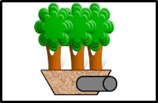
Symbol for tree trench system/Box (with underdrain)in MIDS calculator

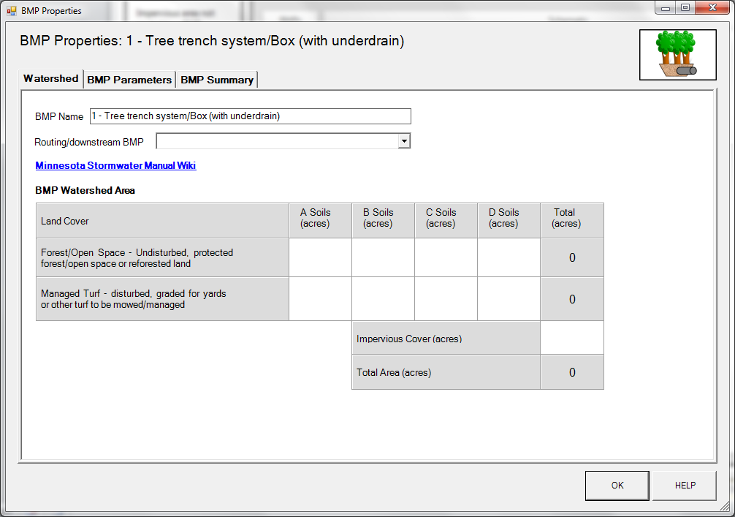
BMP watershed area parameters

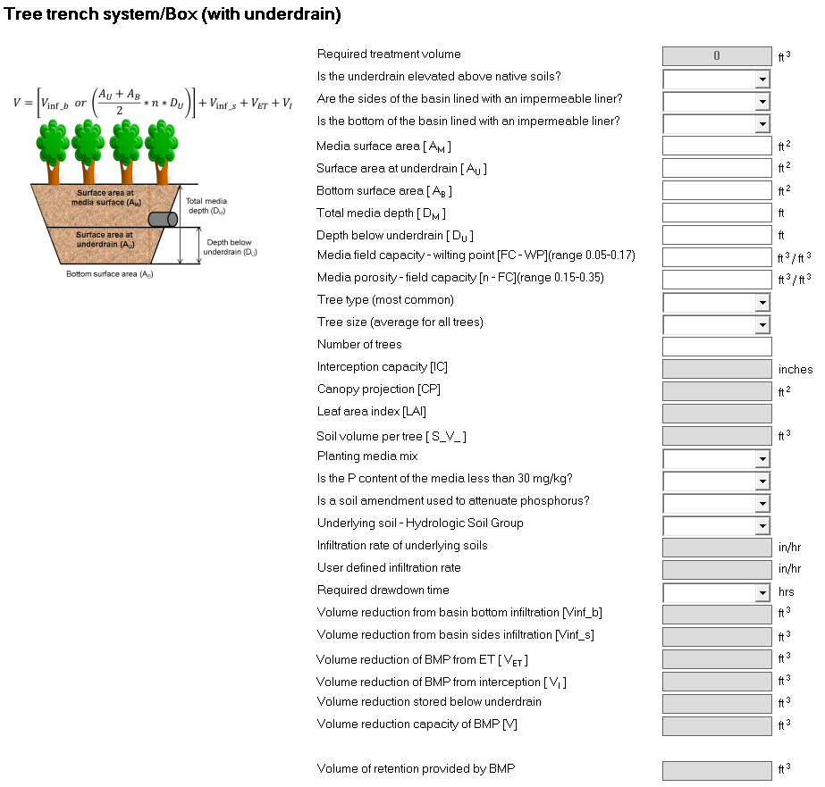
Screen shot from MIDS calculator showing user inputs needed for a tree trench with an underdrain.
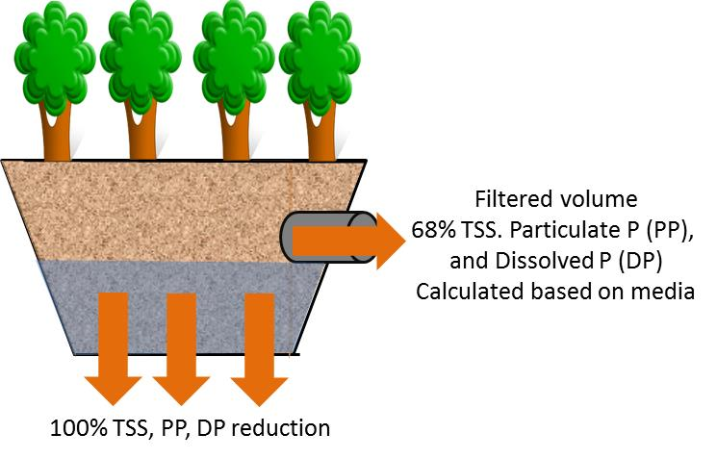
Schematic showing pollutant load reductions for infiltrated and filtration

