Duluth GSI Planning Case Study: Strategic Green Infrastructure Siting Tool
Brief Overview of Duluth’s Unique GSI Challenges
The City of Duluth (the “City”) faces unique challenges to green stormwater infrastructure (GSI) implementation. Group D soils dominate the landscape of Duluth and provide little infiltration of rain or storm water into the ground – a large obstacle to infiltration-based GI practices. The groundwater table can also be fairly high in Duluth, and bedrock is often shallow or exposed which creates further challenges to implementing successful GSI projects in this area. Despite these challenges, Duluth is committed to implementing GSI where feasible. To that end, the City developed a GSI siting tool to help identify potentially suitable locations for GSI implementation. This tool takes into consideration the challenging landscape and identifies locations suitable for GSI implementation and has helped the City’s GSI planning efforts by increasing the number of potentially suitable GSI locations that otherwise would not have been identified as such. This tool is a catalyst for other GSI planning efforts.
City of Duluth GSI Mission Statement
The City of Duluth is motivated in implementing large scale stormwater treatment structures, with a focus on green stormwater infrastructure due to its recognized positive impacts, as we are faced with a changing climate and increased urban development. Green stormwater infrastructure provides our community with enhanced green spaces while providing robust water quality treatment in some of our most underserved communities and capturing pollutants from some of our most aged stormwater conveyances. Through the use of these installations, we aim to reduce the impact of our urban areas and enhance our water resources to provide betterment and usefulness for Duluth communities.
Overview of Duluth’s GSI Siting Tool
The City of Duluth developed a tool that identifies potential suitable locations for the implementation of GSI projects. This GIS-based tool first identifies parcels that are city-owned, tax forfeited, or unbuilt road rights-of-way, then retains the portions of those parcels that are located within 75 feet of existing stormwater (e.g., storm sewers, catch basins, manholes, etc.), and finally removes area with infrastructure conflicts (e.g., flowing streams, natural gas lines, etc.). After the GIS analysis, the locations that are identified by the tool undergo a desktop review. The review includes a manual assessment of other environmental, economic, or social information such as size of the selected site, social and environmental equity metrics (including MPCA’s environmental justice dataset), local slopes and topography, depth to infrastructure, potential impact on trout streams, known water impairments, etc. The GIS analysis and desktop review ultimately produces a shortlist of potentially suitable locations for GSI implementation, as illustrated in Figure 1 below. Sites that pass the desktop review process are then further inspected during a site visit.
While this tool was created specifically for Duluth, the approach and tool are replicable and applicable to other communities wishing to identify suitable GSI implementation locations. For reference, the City of Duluth spent approximately two to three weeks gathering the necessary GIS data, establishing the GIS methodology (including the queries used by the tool), and applying the tool. The desktop review process took approximately three to five additional weeks. This timeline can vary based on the availability and number of GIS data sets used in the analysis, the number of locations identified within GIS, and the parameters of interest considered in the desktop review.
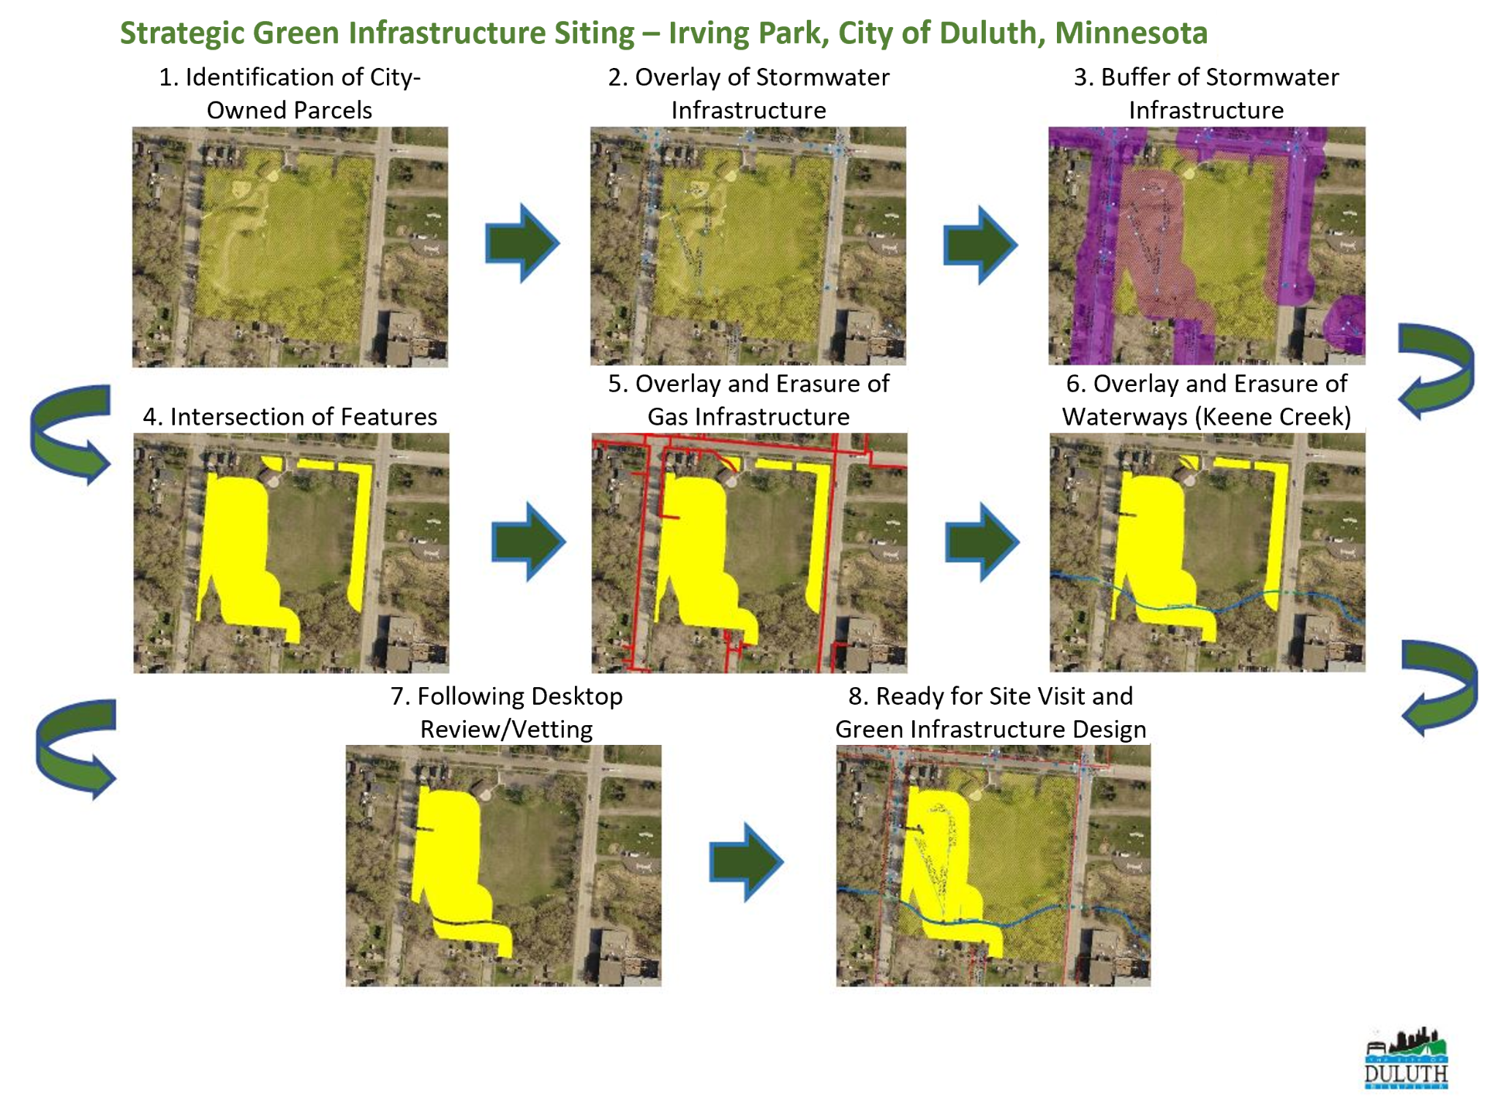
Figure 1: Process used by the GSI siting tool and desktop review to identify locations potentially suitable for GSI implementation. Image adapted from the City of Duluth Sustainability Page

How the GSI Siting Tool Informs Duluth’s GSI Planning Efforts
Using the GSI siting tool, the City has identified 203 feasible project areas across Duluth. This number fluctuates as stormwater infrastructure is updated or as understanding of the site-specific conditions develops. The City included these projects in their watershed management plans to identify the potential pollutant load reduction that could be achieved by these projects. Because the watershed management plans include a clear understanding of the watershed issues as well as an inventory of suitable GSI location, the City can use these in grant applications to obtain funding for GSI implementation. Because of the GSI siting tool, the City has been able to more competitively pursue Infrastructure and Investment Jobs Act and Bipartisan Infrastructure Law appropriations.
In addition to its primary use by the City for GSI siting on a large scale, the GSI siting tool also serves as a planning resource for collaboration and partnership with the City’s roads and other infrastructure projects. For example, city engineers planning a road design project can consult the GSI siting tool to identify if and where GSI can be incorporated into the project. This is particularly beneficial for smaller GSI projects that may not have been considered for construction as stand-alone projects but that make sense to include as part of a larger road reconstruction project.
References and Contact Information
A similar tool was developed by Murray County to identify suitable locations for solar development sites that would also contribute co-benefits such as agricultural preservation.
For more information on the City of Duluth’s GSI siting tool, contact Ryan Granlund, Utility Programs Coordinator at the City of Duluth via phone at 218-730-4088 or via email at rgranlund@duluthmn.gov.

