Constructed Stormwater Pond (Version 2)

A stormwater pond is to be constructed in a watershed that contains a 1.4 acre parking lot surrounded by 0.8 acres of pervious area. All of the runoff from the watershed will be treated by the stormwater pond. The soils in the area have a unified soils classification of SM (HSG type B soil). The stormwater pond will be designed to meet the specification of Design Level 2 for pollutant removal. The following steps detail how this system would be set up in the MIDS calculator.

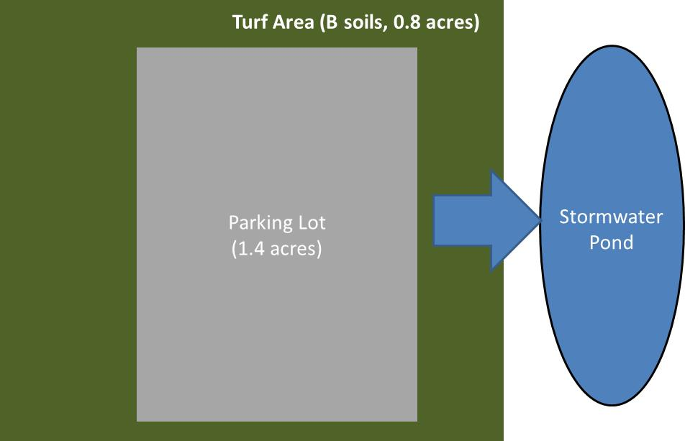
Step 1: Determine the watershed characteristics of your entire site. For this example we have a 2.2 acre site with 1.4 acres of impervious area and 0.8 acres of pervious turf area in type B soils. The pervious area does not include the pond area.

Step 2: Fill in the site specific information into the “Site Information” tab. This includes entering a Zip Code (55414 for this example) and the watershed information in Step 1.
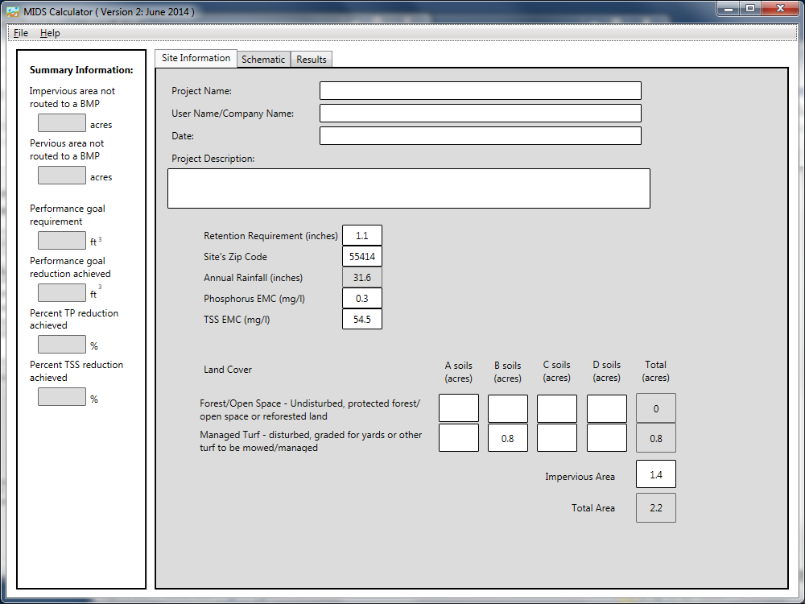

Step 3: Goto the Schematic tab and drag and drop the “Stormwater Pond” icon into the “Schematic Window”
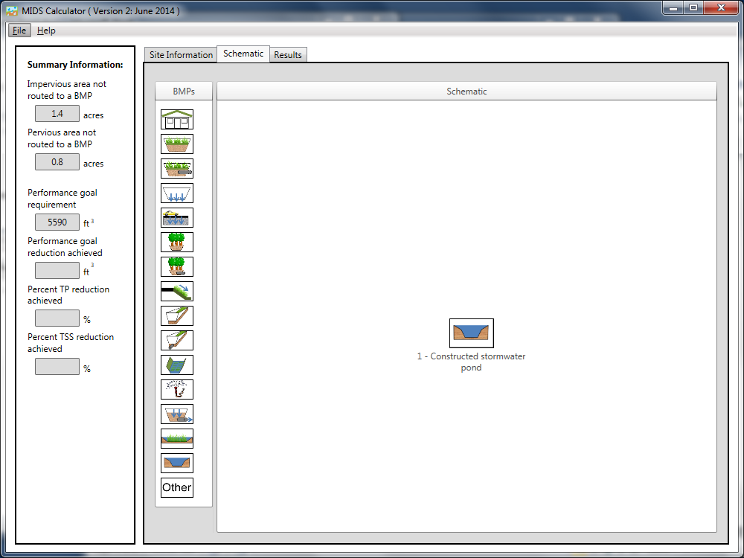
Step 4: Open the BMP properties for the stormwater pond by right clicking on the “Constructed stormwater Pond” icon and selecting “Edit BMP properties”, or by double clicking on the “Constructed stormwater pond” icon.
Step 5: Click on the “Minnesota Stormwater Manual Wiki” link or the “Help” button to review input parameter specifications and calculation specific to the “Constructed stormwater pond” BMP.
Step 6: Determine the watershed characteristics for the stormwater pond. For this example the entire site is draining to the wetland. The watershed parameters therefore include a 2.2 acre site with 1.4 acres of impervious area and 0.8 acres of pervious turf area in type B soils. There is no routing for this BMP. Fill in the BMP specific watershed information (1.4 acres on impervious cover and 0.8 acres of Managed Turf in B soils).

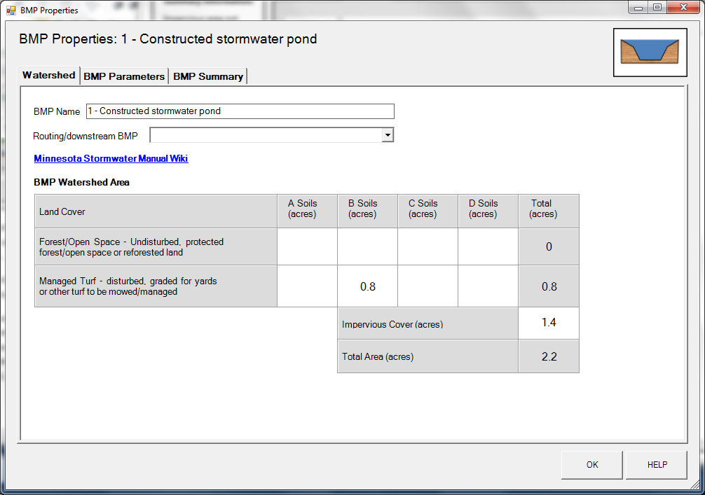
Step 7: Enter the BMP design parameters for the constructed stormwater pond into the “BMP parameters” tab. For this BMP all that is required is to specify the Design Level that the stormwater pond meets. This pond will be constructed to meet Design Level 2. Press the help button to review design specification required for each design level. Pollutant reduction rates are associated with each design level. A constructed stormwater pond does not provide volume reduction towards the performance goal or on an annual basis.
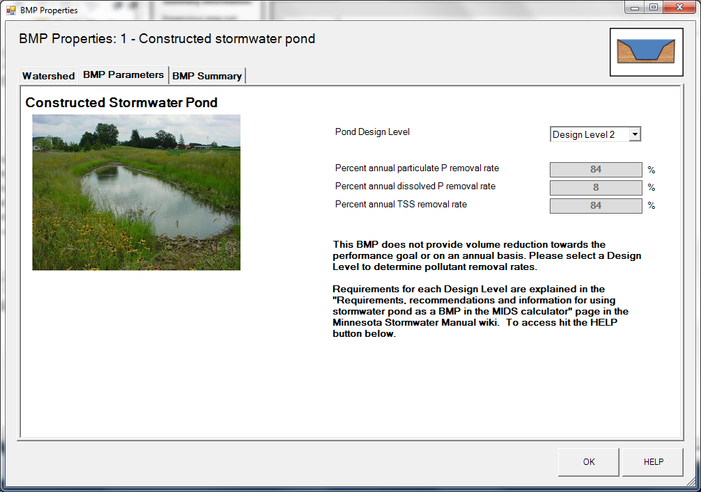
Step 8: Click on “BMP Summary” tab to view results for this BMP.
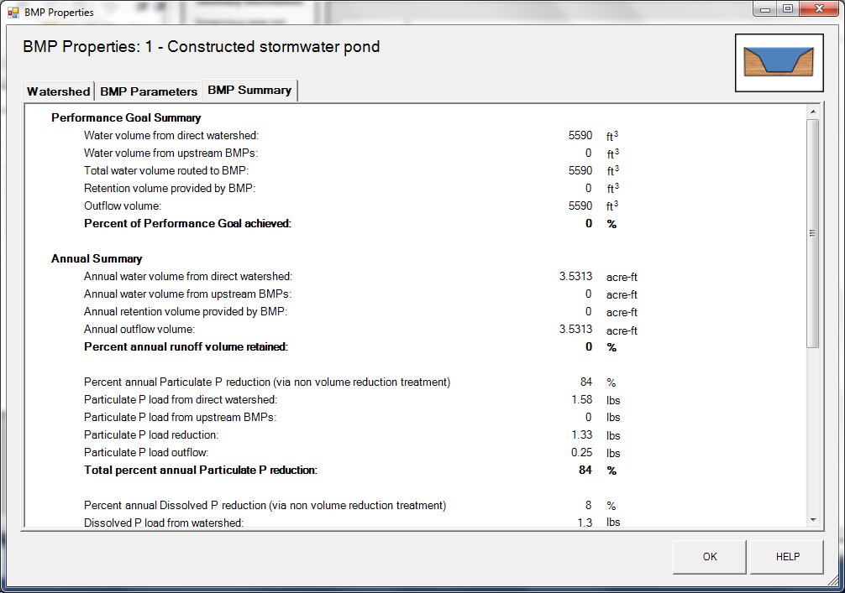
Step 9: Click on the “OK” button to exit the BMP properties screen.
Step 10: Click on “Results” tab to see overall results for the site.
