Swale Side Slope and Main Channel Example (Version 2)

The runoff from a 1.4 acre parking lot surrounded by 0.359 acres of pervious turf area flows through sheet flow over one of the side slopes of a swale and into a swale main channel. The soils across the area have a unified soils classification of SW (HSG type A soil). A second side slope associated with the main channel does not receive runoff from impervious surfaces. Each of the swale side slopes are 800 feet long by 10 feet wide with a side slope of 5H:1V. The main channel of the swale is 800 feet long by 4 feet wide with a 2 percent slope. The swale main channel does not have an underdrain, bioretention base or check dams. The maintenance on the swale calls for mowing once a year. The following steps detail how this system would be set up in the MIDS calculator.
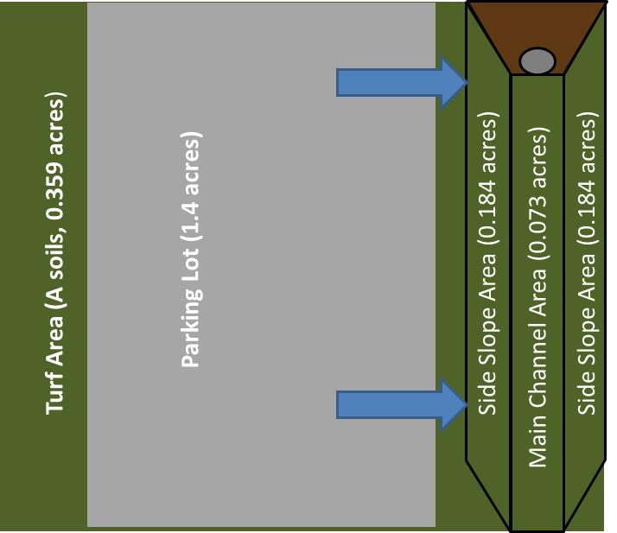

Step 1: Determine the watershed characteristics of your entire site. For this example we have a 2.2 acre site with 1.4 acres of impervious area (parking lot) and 0.8 acres of pervious area in type A soils. The pervious area includes the turf area and the area of the swale side slopes and main channel.
Step 2: Fill in the site specific information into the “Site Information” tab. This includes entering a Zip Code (55414 for this example) and the watershed information from Step 1. The Managed Turf area includes the turf area, the area of the side slopes and the area of the main channel. Zip code and impervious area must be filled in or an error message will be generated. Other fields on this screen are optional.
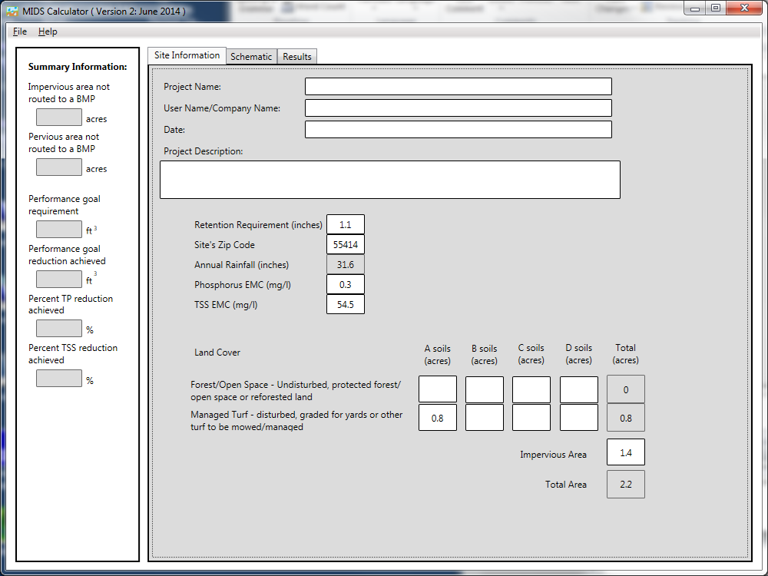

Step 3: Go to the Schematic tab and drag and drop a “Swale Side Slope” and a “Swale Main Channel” icon into the “Schematic Window”
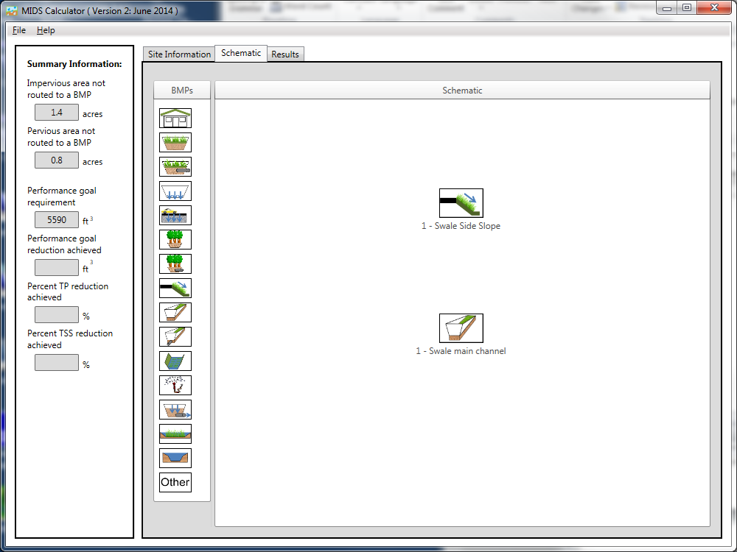
Step 4: Determine the watershed characteristic for each of the BMP components. For this example the swale side slope watershed includes 1.4 acres of impervious area and 0.543 acre of pervious area (0.359 acre of turf area plus 0.184 acre of swale side slope). The watershed of the swale main channel includes the pervious area of the main channel (0.073 acre) and the pervious area of the other swale side slope (0.184 acre) for a total pervious area of 0.257 acre. Since no impervious area is being routed to the second swale side slope, the area can be included in the direct watershed area of the main channel. However, the second swale side slope could be placed in the calculator as an additional BMP. Including it as a separate BMP provides a slightly greater annual volume reduction and more closely represents the true system.

Step 5: Open the BMP properties for the swale side slope by right clicking on the “Swale Side Slope” icon and selecting “Edit BMP properties”, or by double clicking on the “Swale Side Slope” icon.
Step 6: Click on the “Minnesota Stormwater Manual Wiki” link or the “Help” button to review input parameter specifications and calculation specific to the “Swale Side Slope” BMP.
Step 7: Fill in the specific BMP watershed information (1.4 acres of impervious and 0.543 acre of Managed Turf on A Soils. Route the side slope BMP to the main channel BMP.
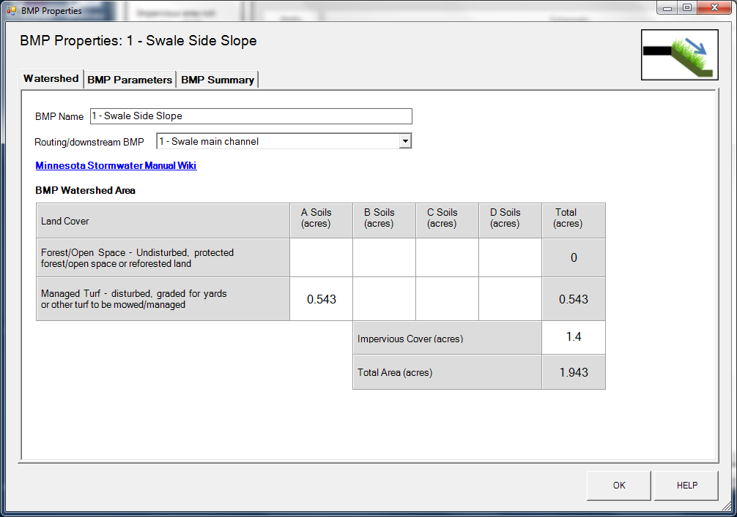

Step 8: Enter in the BMP design parameters into the “BMP parameters” tab. Swale Side Slope requires the following entries.
- Side slope [H:V] which is 5:1
- Flow path length which is 10 feet
- Channel length, which is 800 feet
- Underlying soil – Hydrologic Soil Group, which is 4 SW (HSG A, 1.63 in/hr)
- Manning’s n (vegetation), which is Native grass
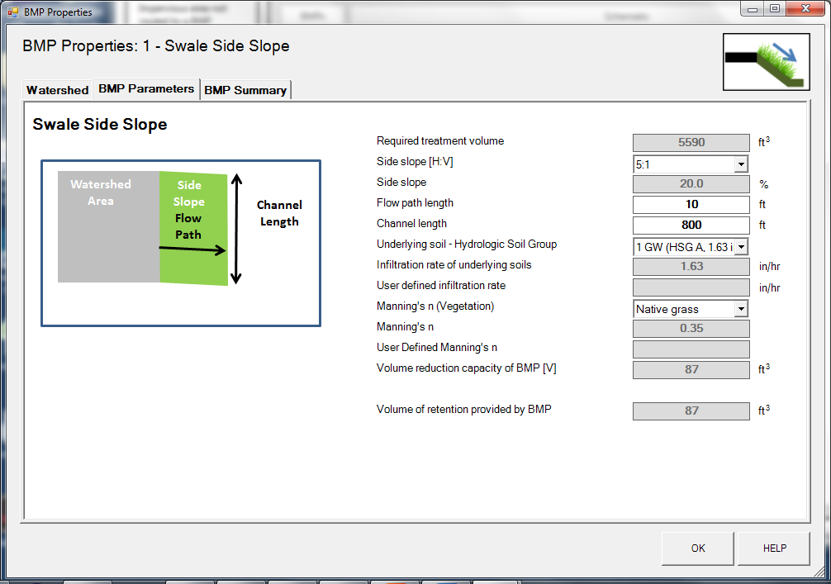

Step 9: Click on “BMP Summary” tab to view results for this BMP.
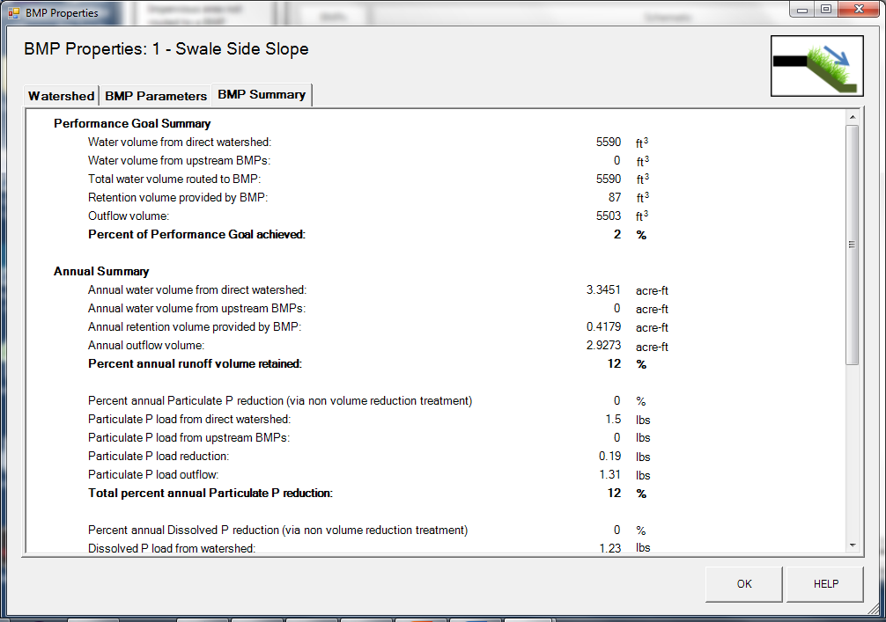

Step 10: Click on the “OK” button to exit the BMP properties screen. An arrow will appear showing that the swale side slope has been routed to the swale main channel.
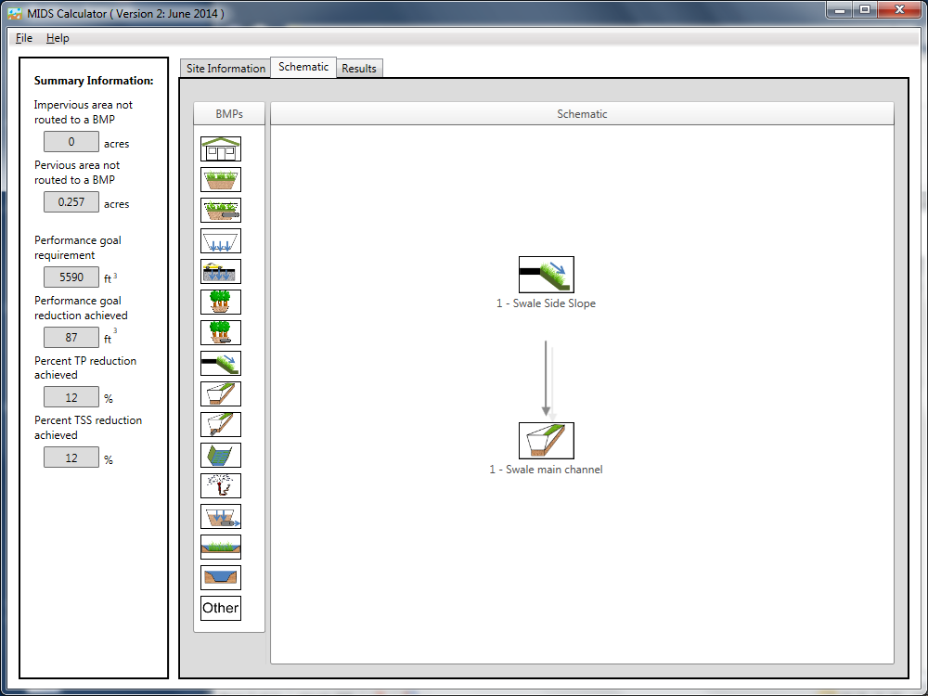
Step 11: Open the BMP properties window for the swale main channel by right clicking on the “Swale main channel” icon and selecting “Edit BMP properties”, or by double clicking on the “Swale main channel” icon.
Step 12: Click on the “Minnesota Stormwater Manual Wiki” link or the “Help” button to review input parameter specifications and calculation specific to the “Swale main channel” BMP.
Step 13: Enter in the watershed information for the swale main channel in the “Watershed” tab (0.257 acre for Pervious Turf on A Soil which includes the area of the main channel and the other side slope).
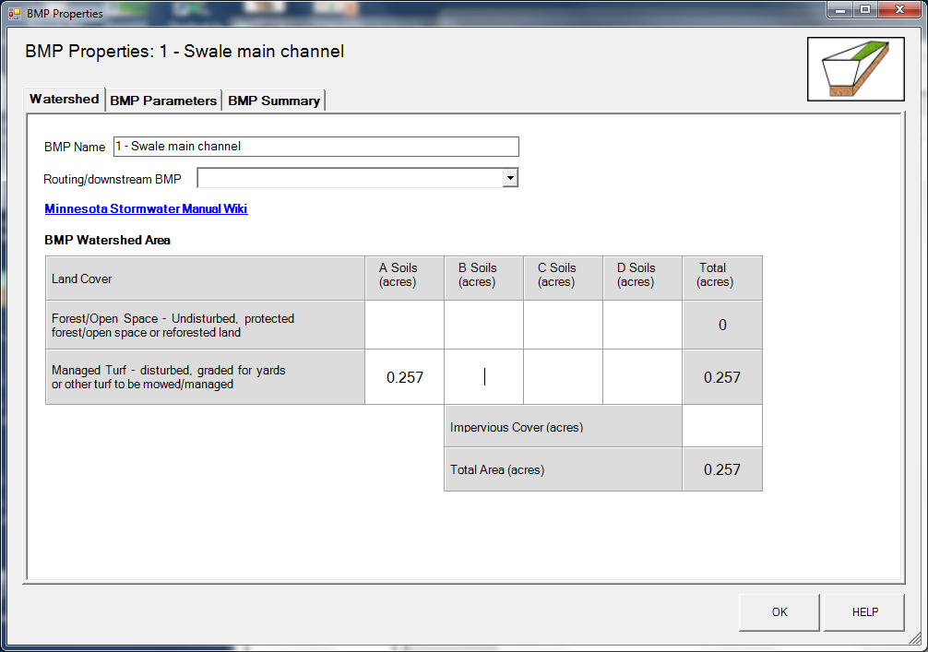

Step 14: Enter in the BMP design parameters into the “BMP parameters” tab. Swale main channel requires the following entries.
- Channel length, which is 800 feet
- Swale bottom width, which is 4 feet
- Channel slope, which is 2 percent (%)
- Underlying soil – Hydrologic Soil Group, which is 4 SW (HSG A, 1.63 in/hr)
- Manning’s n (vegetation), which is native grass
- Does the swale have a check dam, which is no
- Does the swale have a bioretention base, which is no
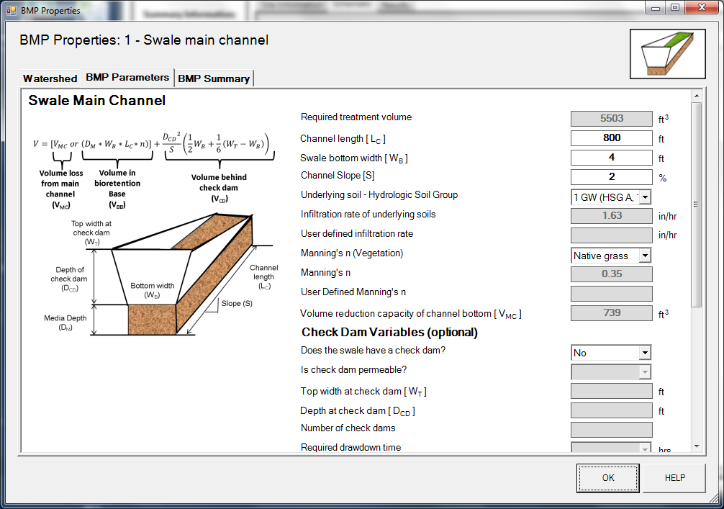
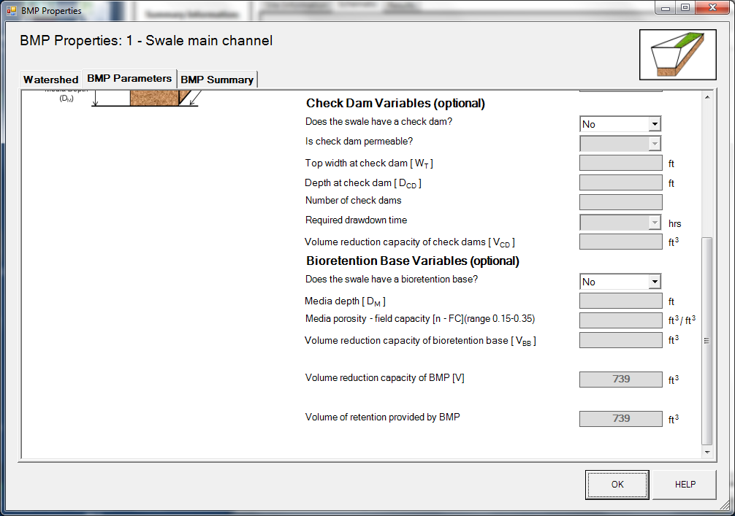
Step 15: Click on “BMP Summary” tab to view results for this BMP.
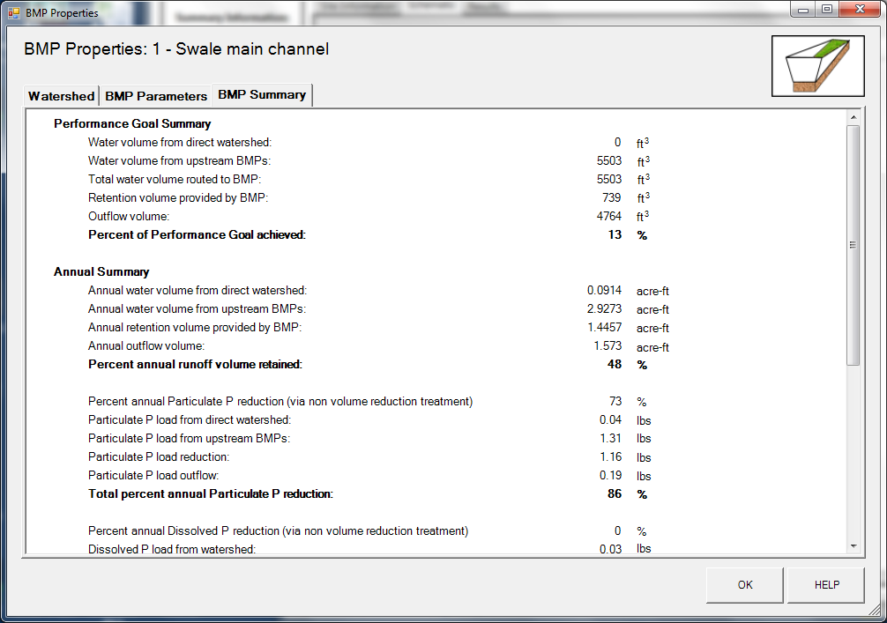
Step 16: Click on the “OK” button to exit the BMP properties screen.

Step 17: Click on “Results” tab to see overall results for the site.
