Agenda
- Intros
- Kickoff example
- How the calculator works
- Exercise 1
- Some info about the calculator
- Exercise 2

Kickoff Example
- Open calculator
- Site information tab
  - Need to enter yes/no to CSW permit question, a zip code (for rainfall data), and impervious area
  - Example: 5 acre site, 3 acres impervious, 2 acres pervious (turf) on B soil, zip=55155, no to permit
- Schematic tab
  - Accounting toolbar for the site is on left
  - Click and drag BMPs onto screen, then double click or right click on a BMP to enter info for that BMP
  - Example
    - Bioretention with underdrain at bottom, 2 acre pervious turf B soil, 1 acre impervious, not lined, 3000 ft² for each area, overflow depth=1.5 feet, 2 foot media depth, 0.11 FC-WPt, 0.25 MP-FC, no tree, Mix A, no to P test, no amendment, B soil (0.45 in/hr), 48 hr drawdown, route to bioretention with no underdrain
    - Bioretention no underdrain, 1 acre impervious , 3000 ft² areas, 1.35 feet depth, B soil, 48 hour drawdown
    - Infiltration basin, 1 acre impervious, 4000 ft² areas, 1.8 foot overflow depth, B soils, 48 hour drawdown
- Results tab – for entire site

How the calculator works
- Calculations
  - Volume performance goal is impervious area times performance goal plus water routed from other BMPs
  - Annual volume and pollutant calculations are based on long-term P8 and XP-SWMM modeling
    - For the bioretention with underdrain from the previous example, look at BMP Summary, Annual water volume. Now change pervious acres to D soil on main site page and in bioretention/underdrain page and look at Annual water volume. Why does the annual volume increase? What is annual volume if our zip is 56258 (Marshall, MN)?
  - Pollutant removal is based on assumed removal percentages for each BMP

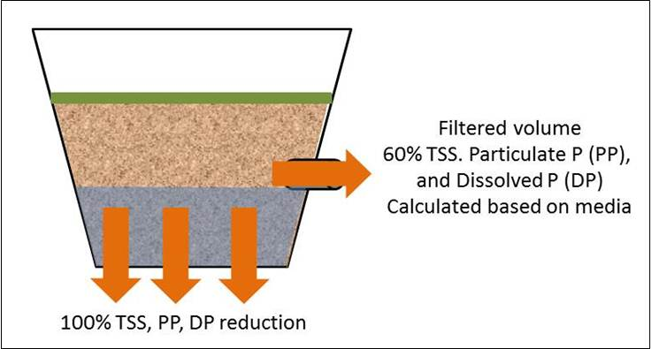

- Calculator can be used for volume or pollutant calculations, but also for BMP selection and sizing. It is not a substitute for more detailed modeling
- We’ll look at the Excel spreadsheet
- Errors and warnings
  - Warnings: Defaults for performance goal, TSS, and TP can be changed – get a warning
  - Restrictions
    - 48 hour drawdown requirement
    - Green roof: count as impervious surface, at least ½ of impermeable surface must be green roof, can only route another roof to a green roof
    - Bioretention: 1.5 foot depth max
    - Permeable pavement: Count permeable pavement as impervious, max 5:1 impervious:pervious ratio
    - Swale side slope: can only route to a swale; cannot route to a swale side slope
    - Disconnection: cannot be used to meet the CSW permit, cannot route another BMP to disconnection; cannot route more impervious or pervious than is in watershed tab for this BMP
    - Wet swale, sand filter, constructed pond, constructed wetland: no volume reduction
- Linking to the manual for help and guidance

Exercise 1. Pick one of the following. This example is for a site where the performance goal is relatively easy to achieve. Use the MIDS performance goal for each example.
- A 60-acre residential development on B soils (0.45 in/hr). The development includes 50 homes, each on 1-acre lots, and 10 acres of green space. The green space includes 5 acres of wooded trails and a 5-acre recreation area (e.g. ballfields). Total impervious is 25%.
- A 5-mile public transportation corridor serving light rail and low speed traffic. The corridor is on A soils (0.8 in/hr) and is 0.1 mile in width. The corridor is 100 percent impervious except for pervious areas associated with BMPs.
- A 12-acre (3 block) private development in downtown. Site is on B soils (0.45 in/hr). Buildings are being demolished and replaced by a new corporate complex that will include several new buildings and a 1-acre plaza. Roads constitute 5% of the total area. The area is 100% impervious, except for the plaza, which could be up to 25% pervious.
- Review and comment on a proposal for a development site. To access the file, go to Test page 2 in the Manual (https://stormwater.pca.state.mn.us/index.php?title=Minnesota_Stormwater_Manual_test_page_2) and save the Excel file for example 1 to your computer, then open the file in the MIDS calculator. Description: 75-acre development consisting of 50 acres of residential, 15 acres of commercial, and 10 acres of green space. Residential is 20% impervious; Commercial is 67% impervious. B soils except under the underground infiltration, which is an A soil. Below is a description of the site, including the table below.
  - Residential
    - Assume that all patio areas consist of porous pavement
    - Assume roof runoff not routed to pervious pavement, driveways, roads, and garage roof runoff all goes to bioretention BMPs
    - Assume 15 bioretention BMPs, each 1000 ft² in area and 1.5 feet deep
  - Commercial
    - One building has a 0.5 acre green roof
    - Served by a 0.2-mile long, 25-foot wide road (0.61 acres)
    - Buildings comprise 4 acres of roof
    - Remaining impervious acres (4.89) are parking and sidewalks
    - Pervious acres are turf and gardens
  - Residential and commercial is routed to reuse system, which irrigates the green space. Pond, 1 acre in size, is used to store water for irrigation.
  - Underground system at end of treatment train. System consists of 5 pipes, 10 ft diameter, 100 ft long, with overflow depth of 4 ft

Item | Average size | Number | Total acres | Notes
Roofs | 1742.4 | 10 | 0.400
Roads | 50000 | 1 | 1.148 | 25 ft road; each house has 200 ft curb length
Driveways | 1000 | 10 | 0.230 | 10 ft wide-100 ft long per driveway
Garages | 650 | 10 | 0.149
Patios | 325 | 10 | 0.075
 |  |  | 2.00

Some info about the calculator
- Calculation errors
- Using the underground infiltration BMP
- Phosphorus
- ET credits
- Harvest and use
- The Other BMP
- Lumping BMPs
- Some common issues and things to look for
  - If you aren’t getting the removal you expected, check the Summary Information on the Schematic tab and make sure there aren’t unaccounted for acreages
  - If the phosphorus removal seems low, check the balance on particulate and dissolved phosphorus. If there is little or no dissolved phosphorus removal, check your BMPs and/or media mix.
  - Volume removal for swales is low. Increase length of swale or add check dams/bioretention base.
  - If you are interested in annual removal you need to get the pervious acreages correct

Exercise 2. Pick one of the following or use your own work example. This example is for a site where the volume performance goal is difficult or impossible to meet practically. Use the MIDS performance goal for each example.
- A 40 acre development site on B soils (0.30 in/hr). A significant portion of the site is underlain by bedrock within 3 feet of the land surface (see Figure 1). The site includes 30 acres of residential land use (30% impervious), 5 acres of commercial land use (60% impervious), and 5 acres of green space.
- A 40 acre development site. Half the site (20 acres) is on C soils (0.20 in/hr) and half is on D soils (0.06 in/hr). The site includes 30 acres of residential land use (30% impervious), 5 acres of commercial land use (60% impervious), and 5 acres of green space.
- A 5-mile public transportation corridor serving light rail and low speed traffic. The corridor is on C soils (0.2 in/hr) and is 0.1 mile in width. The corridor is 100 percent impervious except for pervious areas associated with BMPs.
- A 12-acre (3 block) private development in downtown. Site is on C soils (0.2 in/hr). Buildings are being demolished and replaced by a new corporate complex that will include several new buildings and a 1-acre plaza. Roads constitute 5% of the total area. The area is 100% impervious, except for the plaza, which could be up to 25% pervious.
- You represent a regulated MS4 city that has a wasteload allocation for a TMDL. You must reduce phosphorus loading from your MS4 by 25%. Your city is 16 square miles in area. The following information may be useful.
  - 10 square miles of residential, 30% impervious, phosphorus EMC = 0.35 mg/L
  - 2 square miles of commercial, 70% impervious, phosphorus EMC = 0.25 mg/L
  - 1 square mile industrial, 80% impervious, phosphorus EMC = 0.20 mg/L
  - 1 square mile green space and open space, phosphorus EMC = 0.12 mg/L
  - 2 square miles row crop agriculture, annual phosphorus export = 0.5 lb/acre
  - Soils are predominantly loams and sandy clay loams

Use the calculator to determine total phosphorus (TP) loads for each land use setting. Assume ½ the pervious area in each land use is B soil (0.3 in/hr) and ½ is C soil (0.2 in/hr). Below are annual TP loads for each land use. TP consists of 55 percent particulate P (PP) and 45 percent dissolved P (DP).
*Residential – 2240 acres on B soils, 2240 acres on C soils, and 1920 acres of impervious, with a TP load of 4512.153 pounds and an annual export of 451 lb/mi2
*Commercial – 192 acres on B soils, 192 acres on C soils, and 896 acres of impervious, with a TP load of 1520.763 pounds and an annual export of 760 lb/mi2
*Industrial – 64 acres on B soils, 64 acres on C soils, and 512 acres of impervious, with a TP load of 670.138 pounds and an annual export of 670 lb/mi2
*Green and open space – 320 acres on B soils and 320 acres on C soils, with a TP load of 175.473 pounds and an annual export of 175 lb/mi2
*Agriculture – TP load of 640 pounds and an annual export of 640 lb/mi2

Note the annual export on a per area basis is greatest for commercial and industrial land uses. Also note that annual export is lower for residential than for agriculture. The TP load for the entire area is 7518 pounds per year. The required reduction is 1880 pounds per year.

There are many ways to decrease phosphorus loads.

- Review a proposal for a retail site (e.g. Costco, WalMart, etc.)(see Figure 2). To access the file, go to XXX and save the Excel file to your computer, then open the file in the MIDS calculator. Description
  - 25-acre commercial site
  - C soils
  - Building footprint = 3.5 acres
  - Parking area = 14.5 acres
  - Overflow parking = 4 acres
  - Preserved wooded area = 1 acre
  - Solar farm on turf = 1 acre
  - Walkways consist of permeable pavement
  - Large tree trench system underlies much of the parking lot
  - Green roof routed to harvest system that uses water to irrigate wooded area and supply indoor water for flushing
  - Runoff from a portion of the site is diverted to pervious areas and then to a swale system that ends in a bioretention system

Figure 1: schematic for site underlain by shallow bedrock.
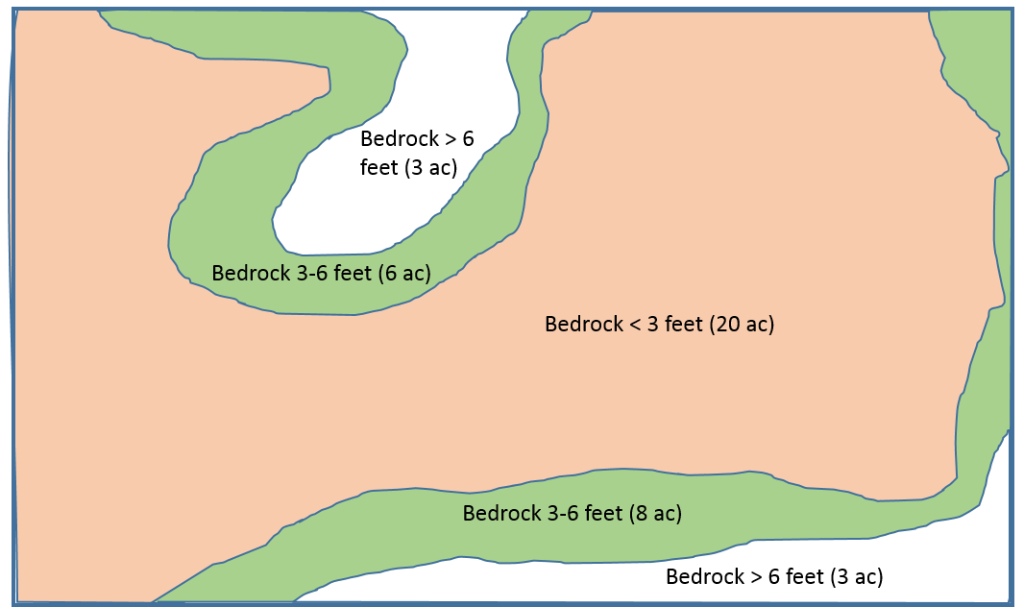

Figure 2: Schematic for Exercise 2, problem 5.
