Individual vs. Clumping of BMPs Example (Version 2)

Four bioretention basins are to be constructed to treat runoff in a residential area. The overflow from bioretention basin A flows into bioretention B; the overflow from bioretention B flows into bioretention C; the overflow from bioretention C flows into bioretention D; and finally the overflow from bioretention D flows into a stormwater pond labeled as BMP E. In this example two scenarios are considered. In the first scenario the bioretention basins are entered into the calculator as four individual BMPs. In the second scenario the bioretention basins are entered into the calculator as a single BMP even though the BMPs are constructed as individual basins. The purpose of this exercise is to compare calculator results when BMPs are treated as individual BMPs versus clumped as a single BMP.
The figures below shows BMP placement, routing, watershed areas and soil type locations of the site.
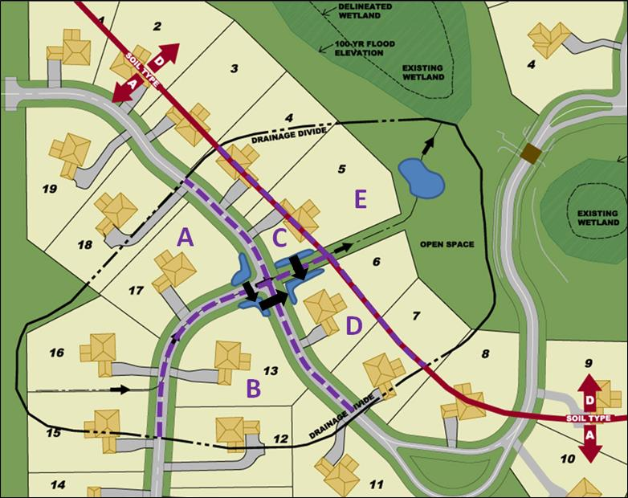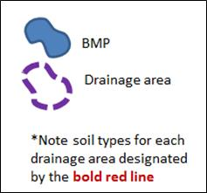
Zip code: 55042

The following tables display watershed information and BMP specific parameters for each of the scenarios: Individual and clumping. The watershed area for drainage areas A, B, C and D include the BMP surface as Turf. The watershed area for drainage area E excludes the permanent pool water surface area of the pond.

Individual Scenario

Drainage Area | Land Cover (acres)
 | Turf |  | Forest/Open Space |  | Impervious | Total
 | A soils | D Soils | A Soils | D Soils
A | 1.08 | 0 | 0 | 0 | 0.22 | 1.3
B | 0.72 | 0 | 0 | 0 | 0.18 | 0.9
C | 0.22 | 0 | 0 | 0 | 0.08 | 0.3
D | 0.39 | 0 | 0 | 0 | 0.16 | 0.55
E | 0 | 0.76 | 0 | 0.8 | 0.04 | 1.6
Total: | 2.41 | 0.76 | 0 | 0.8 | 0.68 | 4.65

Drainage Area | BMP Description | BMP Information
 |  | Surface area at overflow  (ft²) | Media surface area  (ft²) | Overflow depth  (ft) | Underlying soil type | Required drawdown time  (hrs)
A | Bioretention basin (w/o underdrain) | 650 | 600 | 1.4 | SP (HSG A) | 48
B | Bioretention basin (w/o underdrain) | 500 | 450 | 1.4 | SP (HSG A) | 48
C | Bioretention basin (w/o underdrain) | 750 | 500 | 1.4 | SP (HSG A) | 48
D | Bioretention basin (w/o underdrain) | 500 | 300 | 1.4 | SP (HSG A) | 48
E | Constructed stormwater pond | Meets Design Level 2 requirements

Clumped Scenario

Drainage Area | Land Cover (acres)
 | Turf |  | Forest/Open Space |  | Impervious | Total
 | A soils | D Soils | A Soils | D Soils
A + B + C + D | 2.41 | 0 | 0 | 0 | 0.64 | 3.05
E | 0 | 0.76 | 0 | 0.8 | 0.04 | 1.6
Total: | 2.41 | 0.76 | 0 | 0.8 | 0.68 | 4.65

Drainage Area | BMP Description | BMP Information
 |  | Surface area at overflow  (ft²) | Media surface area  (ft²) | Overflow depth  (ft) | Underlying soil type | Required drawdown time  (hrs)
A + B + C + D | Bioretention basin (w/o underdrain) | 2400 | 1850 | 1.4 | SP (HSG A) | 48
E | Constructed stormwater pond | Meets Design Level 2 requirements

Step 1: Open a new calculator file for the individual scenario.
Step 2: Determine the watershed characteristics for the entire site. For this example we have a 4.65 acre site with 0.68 acres of impervious area, 2.41 acres of Managed turf cover in A soils, 0.76 acres of Managed turf cover in D soils, and 0.80 acres of Forest/open space cover in D soils. The pervious areas include the Managed turf areas, the Forest/Open Space area, and the areas of the bioretention basins.
Step 3: Fill in the site specific information into the “Site Information” tab. This includes entering a Zip Code (55042 for this example) and the watershed information from Step 2. The Managed Turf area includes the turf area and the areas of the bioretention basin. Zip code and impervious area must be filled in or an error message will be generated. Other fields on this screen are optional.
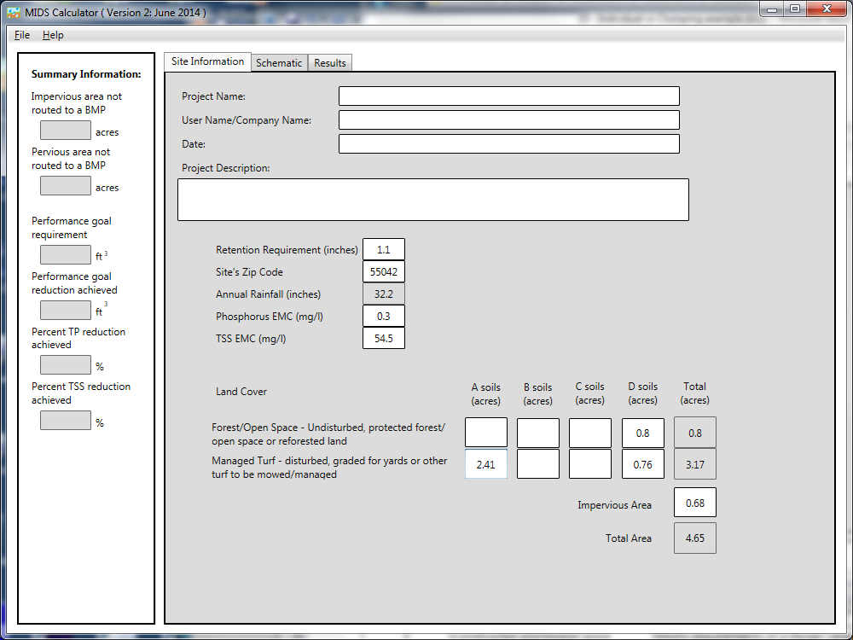

Step 4: Go to the Schematic tab and drag and drop four “Bioretention basin (w/o underdrain)” icons and one “Constructed stormwater pond” icon into the “Schematic Window”.
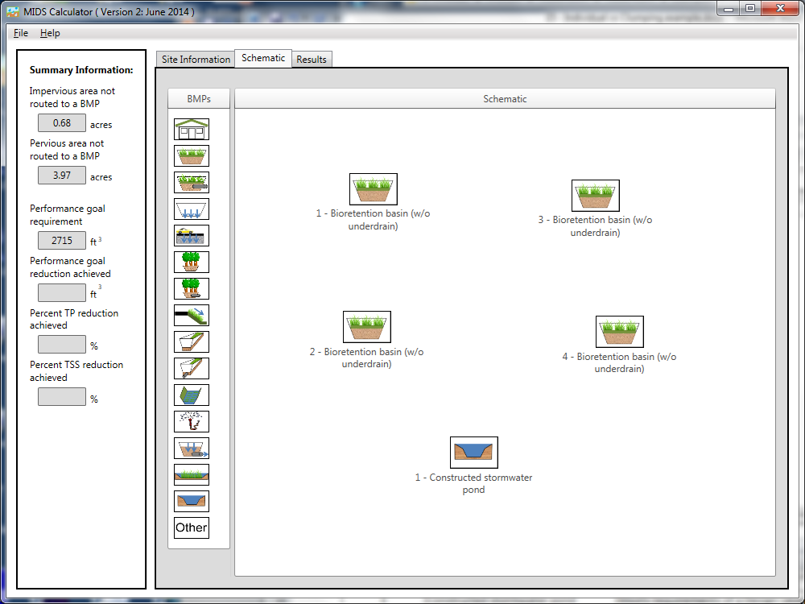

Step 5: Open the BMP properties for Basin A by right clicking on one of the “Bioretention basin (w/o underdrain)” icons and selecting “Edit BMP properties”, or by double clicking on one of the “Bioretention basin (w/o underdrain)” icons.
Step 6: Click on the “Minnesota Stormwater Manual Wiki” link or the “Help” button to review input parameter specifications and calculation specific to the “Bioretention basin (w/o underdrain)” BMP.
Step 7: Determine the watershed characteristics for bioretention basin A. The watershed parameters for bioretention basin A include a 1.3 acre site with 0.22 acres of impervious area and 1.08 acres of Managed turf area in A soils. The Managed turf area includes the 0.015 acre bioretention basin. Change the name of the BMP to represent bioretention basin A, route the BMP to bioretention basin B (if you have not renamed all the BMPs, route basin A to one of the available bioretention basins), and fill in the BMP specific watershed information.
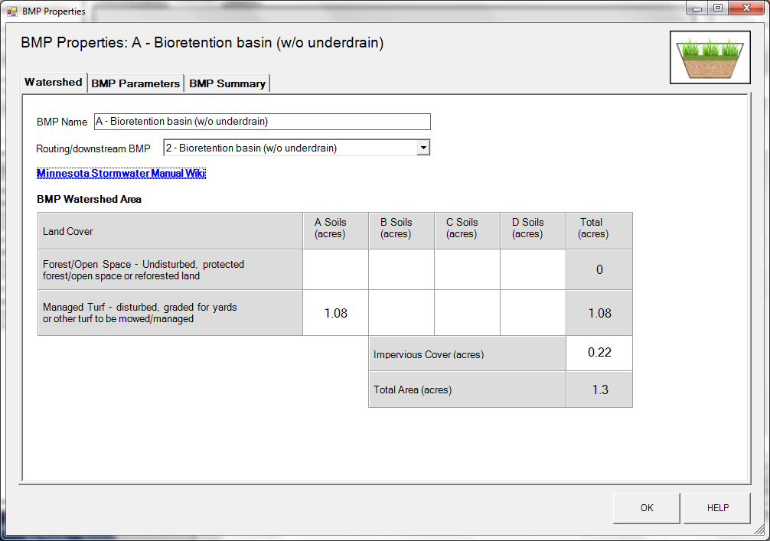

Step 8: Enter the BMP design parameters for bioretention basin A into the “BMP parameters” tab. The following inputs are required for this BMP.
- Overflow surface area, which is 650 square feet
- Bottom surface area, which is 600 square feet
- Overflow depth, which is 1.4 feet
- Underlying soil – Hydrologic Soil Group, which is 5 SP (HSG A, 0.8 in/hr)
- Required drawdown time, which is 48 hours
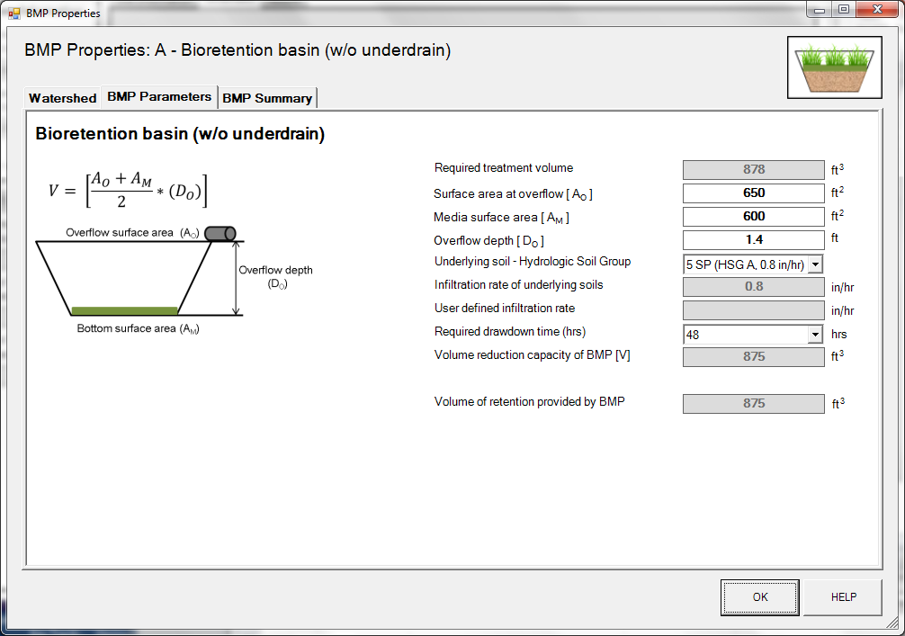

Step 9: Click on “BMP Summary” tab to view results for this BMP.
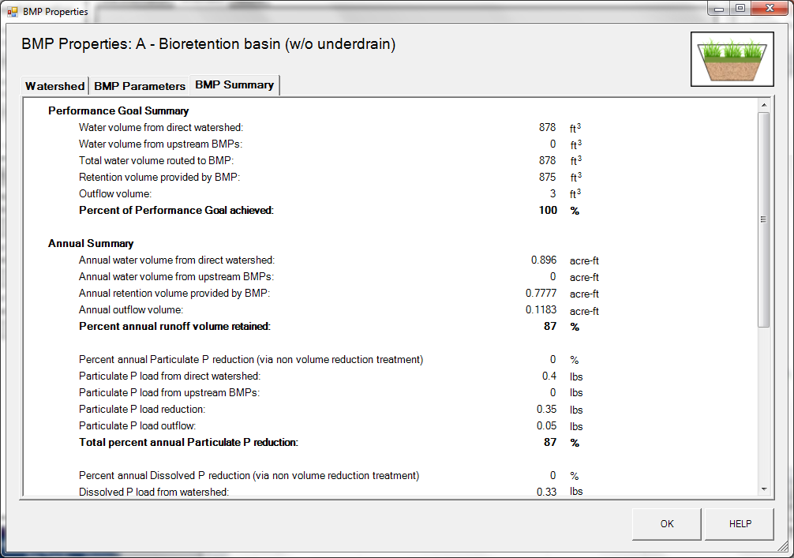
Step 10: Click on the “OK” button to exit the BMP properties screen.
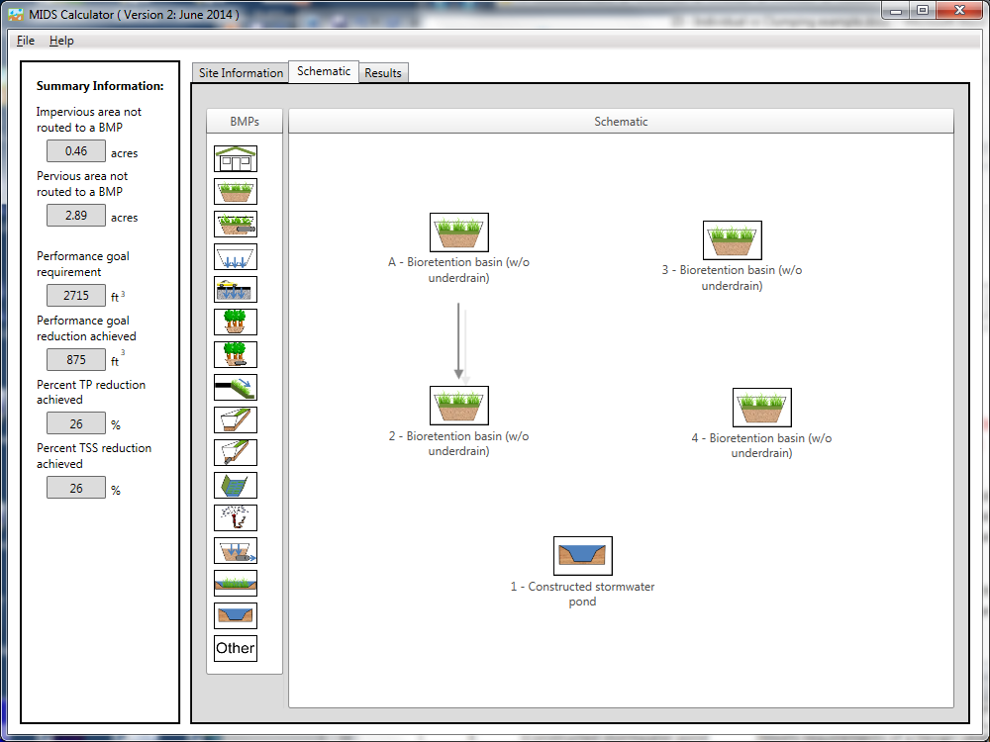
Step 11: Open the BMP properties for Basin B by right clicking on the “Bioretention basin (w/o underdrain)” icon that Bioretention basin A is routed to and selecting “Edit BMP properties”, or by double clicking on one of the “Bioretention basin (w/o underdrain)” icons.
Step 12: Determine the watershed characteristics for bioretention basin B. The watershed parameters for bioretention basin B include a 0.9 acre site with 0.18 acres of impervious area and 0.72 acres of Managed turf area in A soils. The Managed turf area includes the 0.012 acre bioretention basin. Change the name of the BMP to represent bioretention basin B, route the BMP to bioretention basin D (if you have not renamed all the BMPs, route to one of the remaining two available bioretention basins), and fill in the BMP specific watershed information.

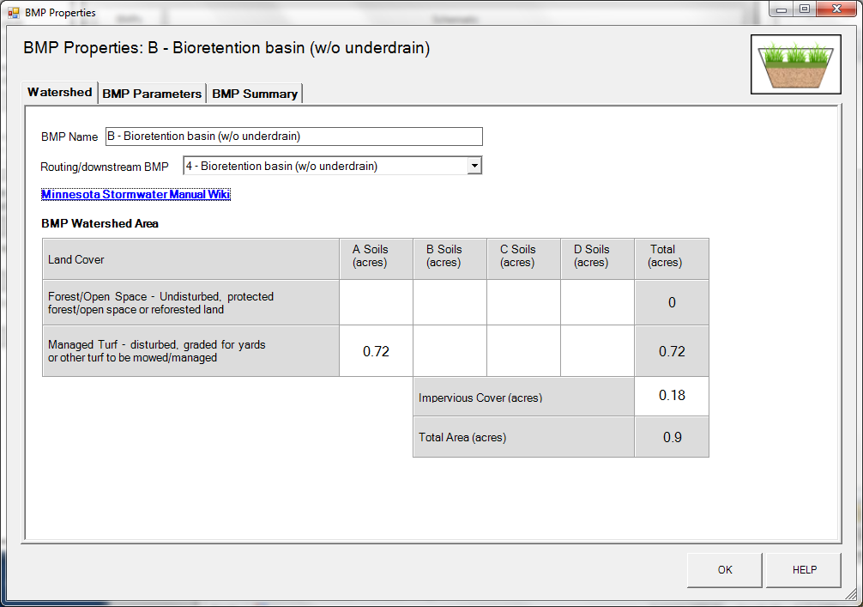

Step 13: Enter the BMP design parameters for bioretention basin B into the “BMP parameters” tab. The following inputs are required for this BMP.
- Overflow surface area, which is 500 square feet
- Bottom surface area, which is 450 square feet
- Overflow depth, which is 1.4 feet
- Underlying soil – Hydrologic Soil Group, which is 5 SP (HSG A, 0.8 in/hr)
- Required drawdown time, which is 48 hours

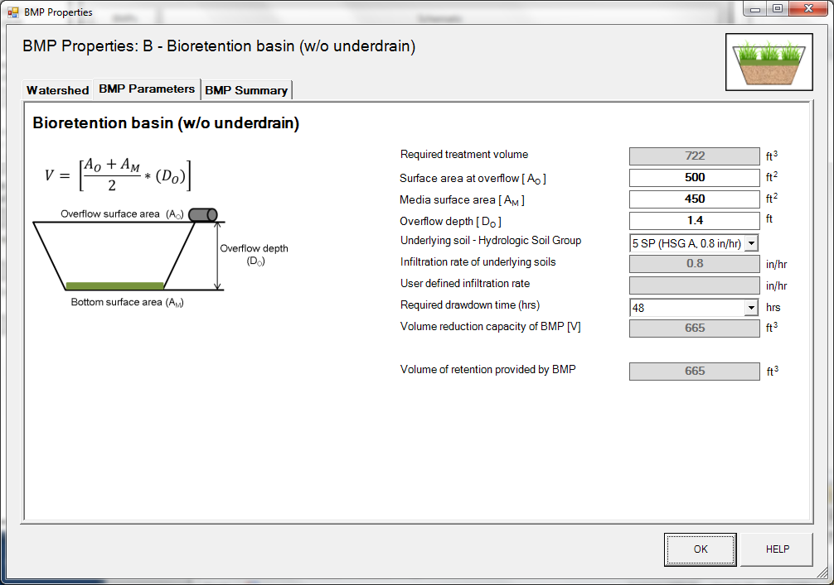

Step 14: Click on “BMP Summary” tab to view results for this BMP.
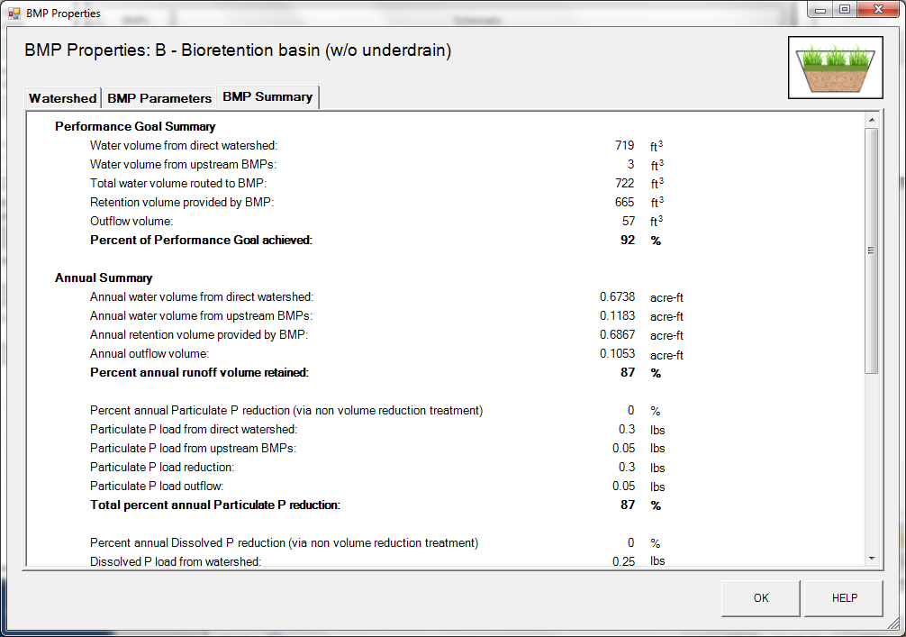
Step 15: Click on the “OK” button to exit the BMP properties screen.
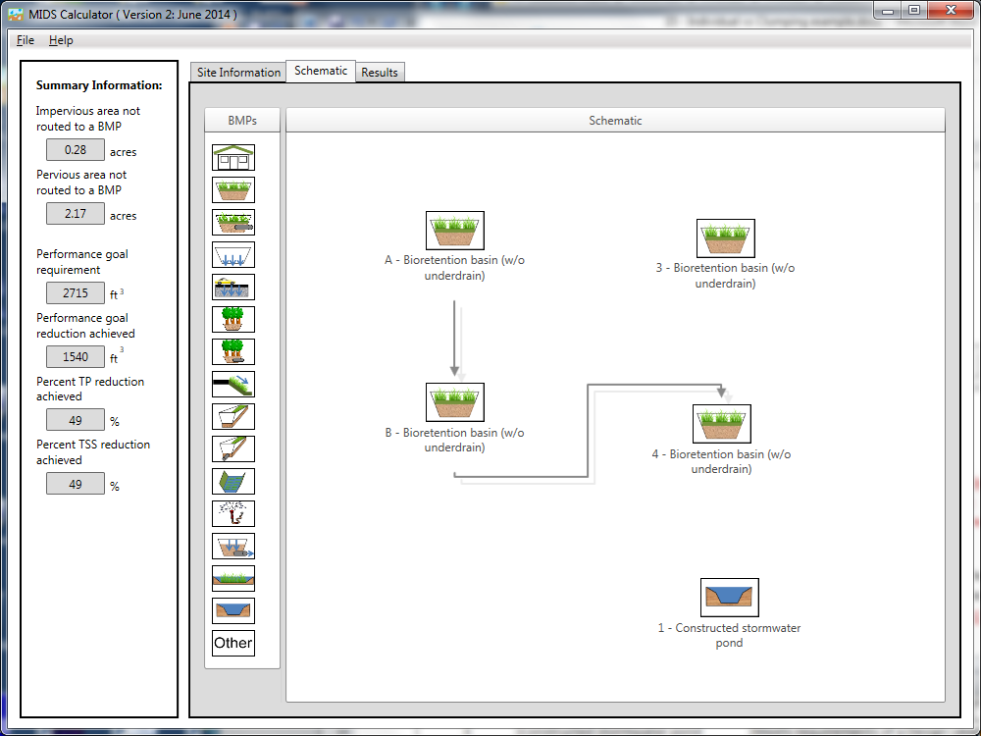
Step 16: Open the BMP properties for Basin C by right clicking on one of the “Bioretention basin (w/o underdrain)” icons and selecting “Edit BMP properties”, or by double clicking on one of the “Bioretention basin (w/o underdrain)” icons.
Step 17: Determine the watershed characteristics for bioretention basin C. The watershed parameters for bioretention basin C include a 0.3 acre site with 0.08 acres of impervious area and 0.22 acres of Managed turf area in A soils. The Managed turf area includes the 0.017 bioretention basin. Change the name of the BMP to represent bioretention basin C, route the BMP to bioretention basin D and fill in the BMP specific watershed information.

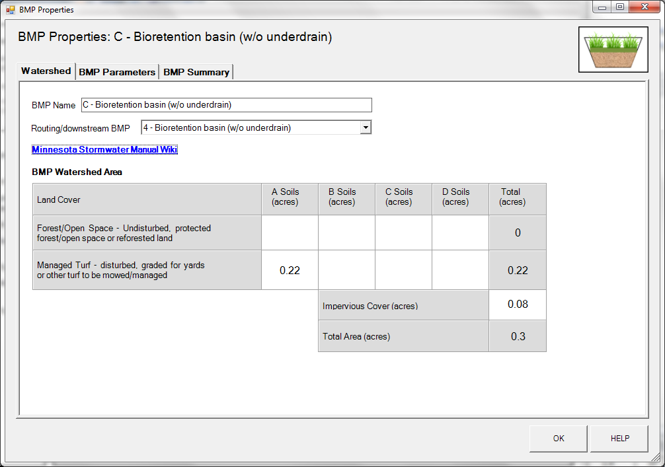

Step 18: Enter the BMP design parameters for bioretention basin C into the “BMP parameters” tab. The following inputs are required for this BMP.
- Overflow surface area, which is 750 square feet
- Bottom surface area, which is 500 square feet
- Overflow depth, which is 1.4 feet
- Underlying soil – Hydrologic Soil Group, which is 5 SP (HSG A, 0.8 in/hr)
- Required drawdown time, which is 48 hours

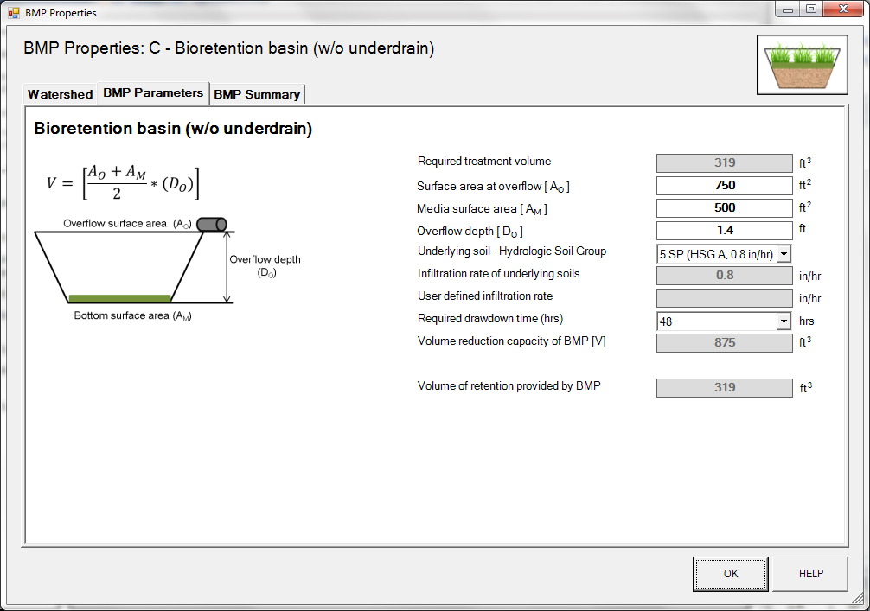
Step 19: Click on “BMP Summary” tab to view results for this BMP.
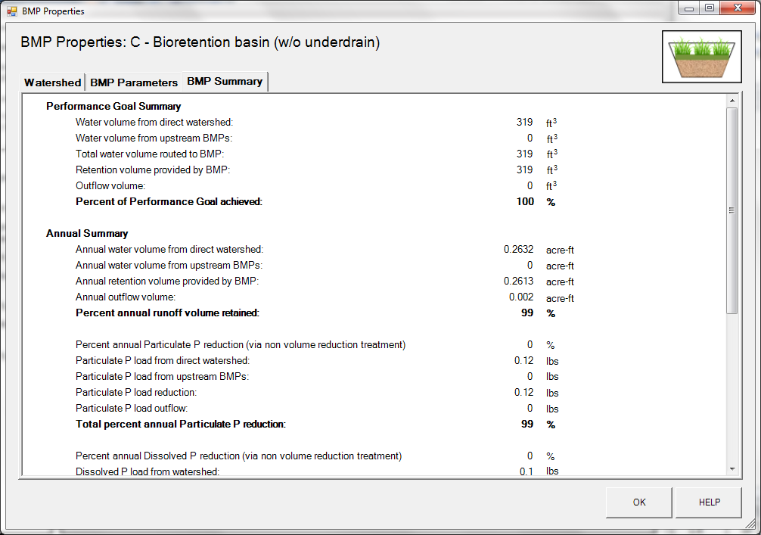
Step 20: Click on the “OK” button to exit the BMP properties screen.
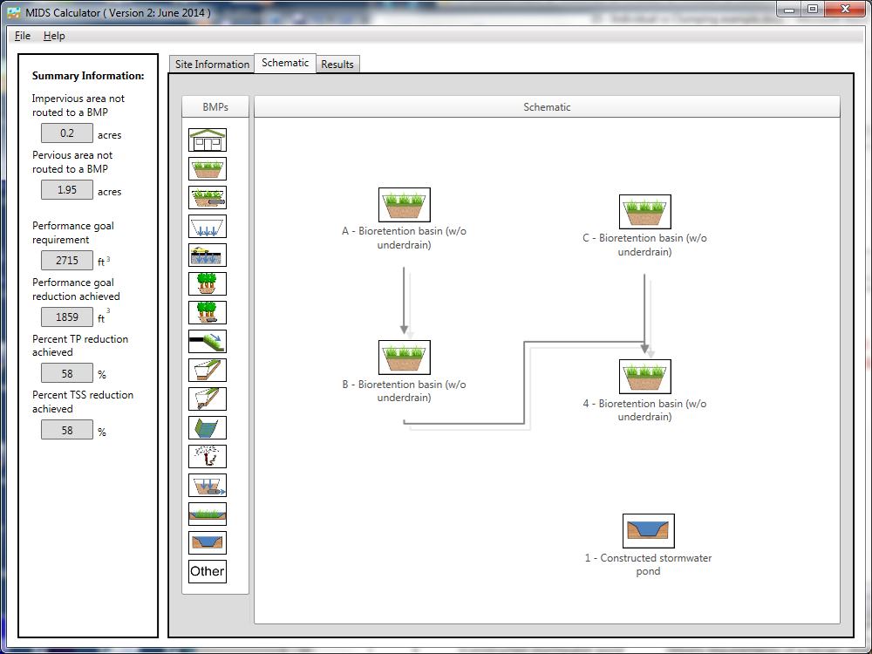
Step 21: Open the BMP properties for Basin D by right clicking on the “Bioretention basin (w/o underdrain)” icon and selecting “Edit BMP properties”, or by double clicking on the “Bioretention basin (w/o underdrain)” icon.
Step 22: Determine the watershed characteristic for bioretention basin D. The watershed parameters for bioretention basin D include a 0.55 acre site with 0.16 acres of impervious area and 0.39 acres of Managed turf area in A soils. The Managed turf area includes the 0.011 acre bioretention basin. Change the name of the BMP to represent bioretention basin D, route the BMP to the stormwater pond and fill in the BMP specific watershed information.

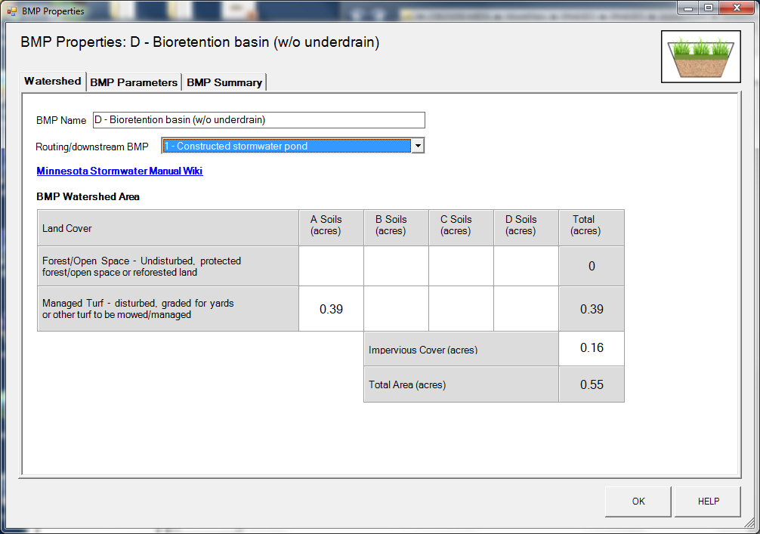

Step 23: Enter the BMP design parameters for bioretention basin D into the “BMP parameters” tab. The following inputs are required for this BMP.
- Overflow surface area, which is 500 square feet
- Bottom surface area, which is 300 square feet
- Overflow depth, which is 1.4 feet
- Underlying soil – Hydrologic Soil Group, which is 5 SP (HSG A, 0.8 in/hr)
- Required drawdown time, which is 48 hours

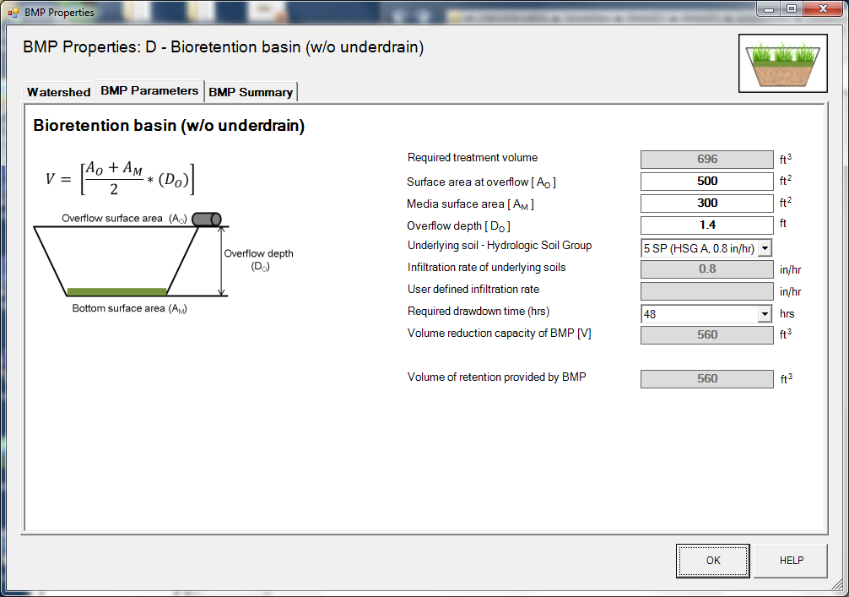

Step 24: Click on “BMP Summary” tab to view results for this BMP.
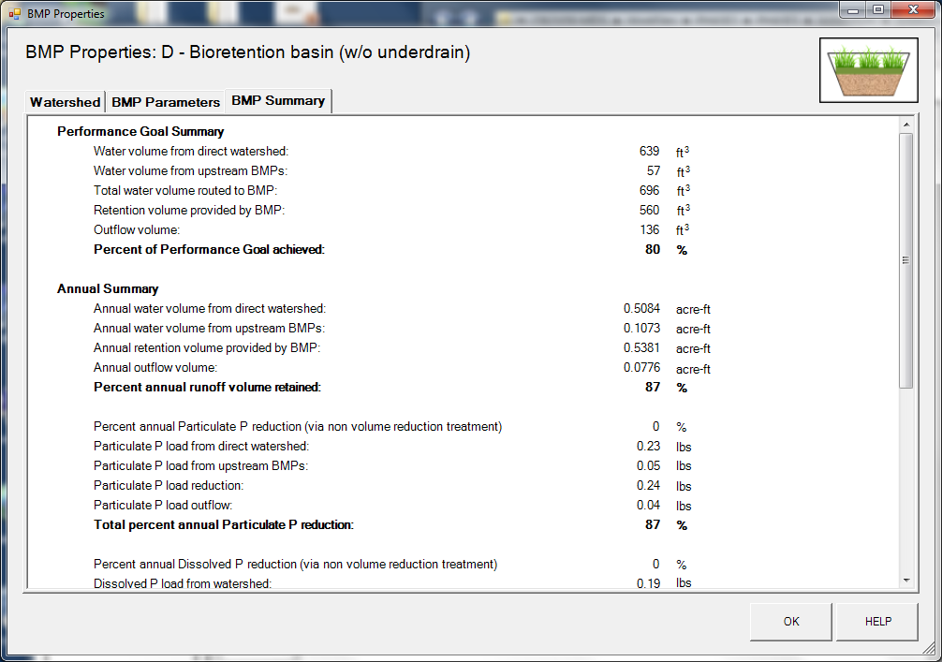
Step 25: Click on the “OK” button to exit the BMP properties screen.
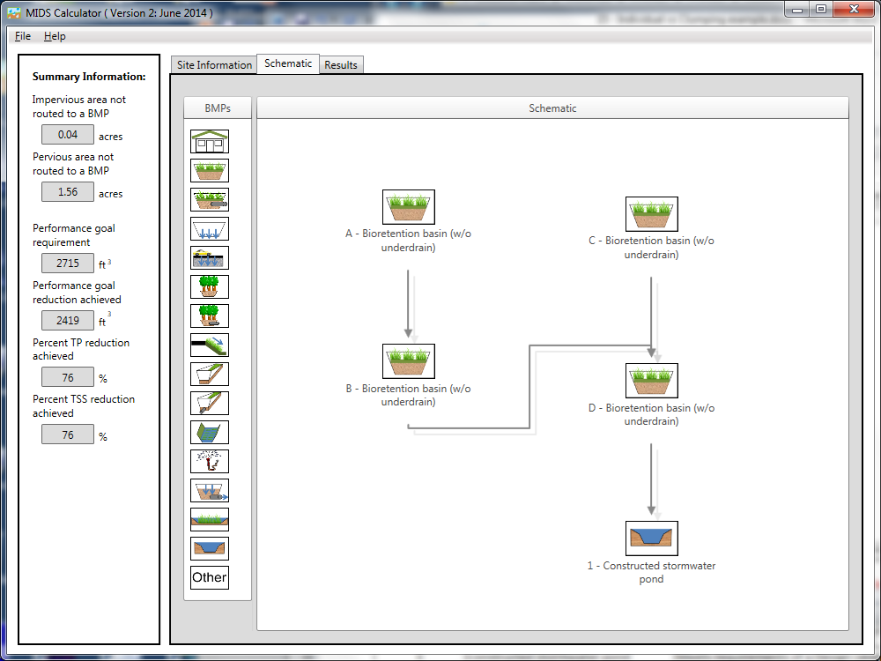
Step 26: Open the BMP properties for the constructed stormwater pond by right clicking on the “Constructed stormwater pond” icon and selecting “Edit BMP properties”, or by double clicking on the “Constructed stormwater pond” icon.
Step 27: Click on the “Minnesota Stormwater Manual Wiki” link or the “Help” button to review input parameter specifications and calculations specific to the “Construction stormwater pond” BMP.
Slide 28: Determine the watershed characteristics for the stormwater pond. The watershed parameters for the stormwater pond include a 1.6 acre site with 0.04 acres of impervious area, 0.76 acres of pervious turf area in D soils, and 0.80 acres of forested/open space in D soils. These acreages exclude the water surface area of the stormwater pond. Fill in the BMP specific watershed information.

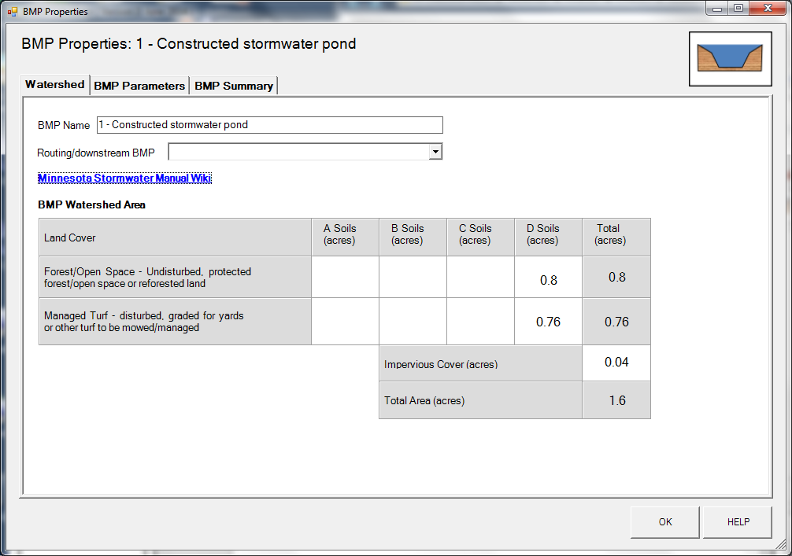

Step 29: Enter the BMP design parameters for the constructed stormwater pond into the “BMP parameters” tab. For this BMP all that is required is to specify the Design Level that the stormwater pond meets. This pond will be constructed to meet Design Level 2. Press the help button to review design specification required for each design level. Pollutant reduction rates are associated with each design level. A constructed stormwater pond does not provide volume reduction towards the performance goal or on an annual basis.
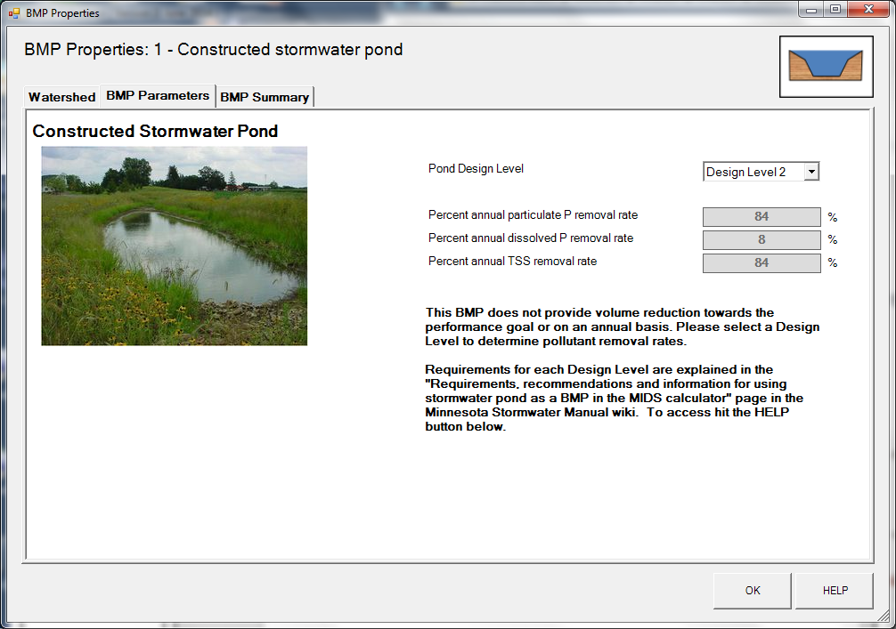
Step 30: Click on “BMP Summary” tab to view results for this BMP.
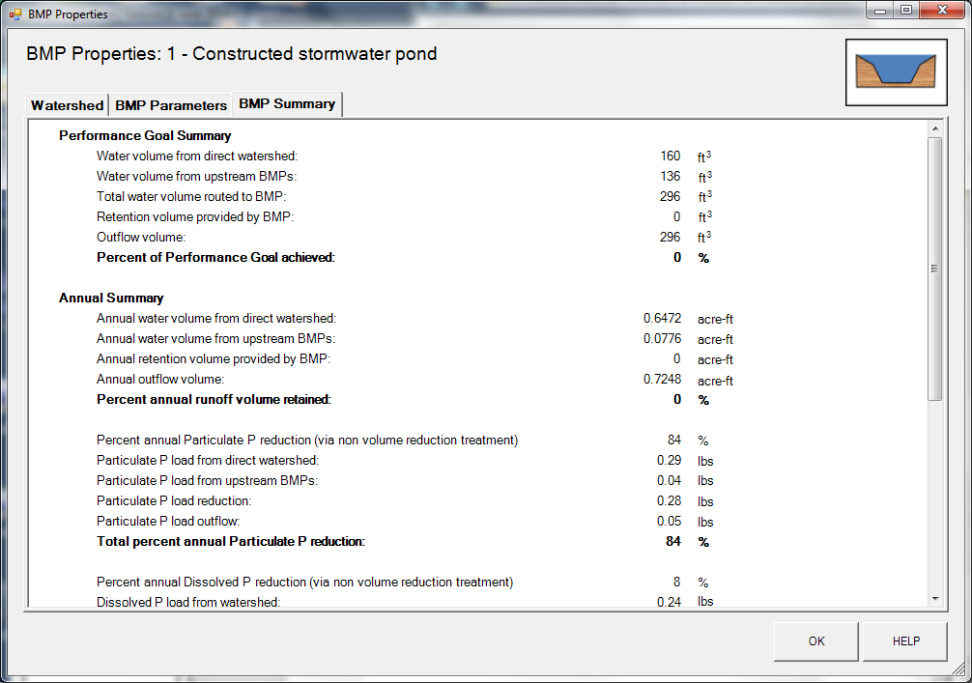
Step 31: Click on the “OK” button to exit the BMP properties screen.
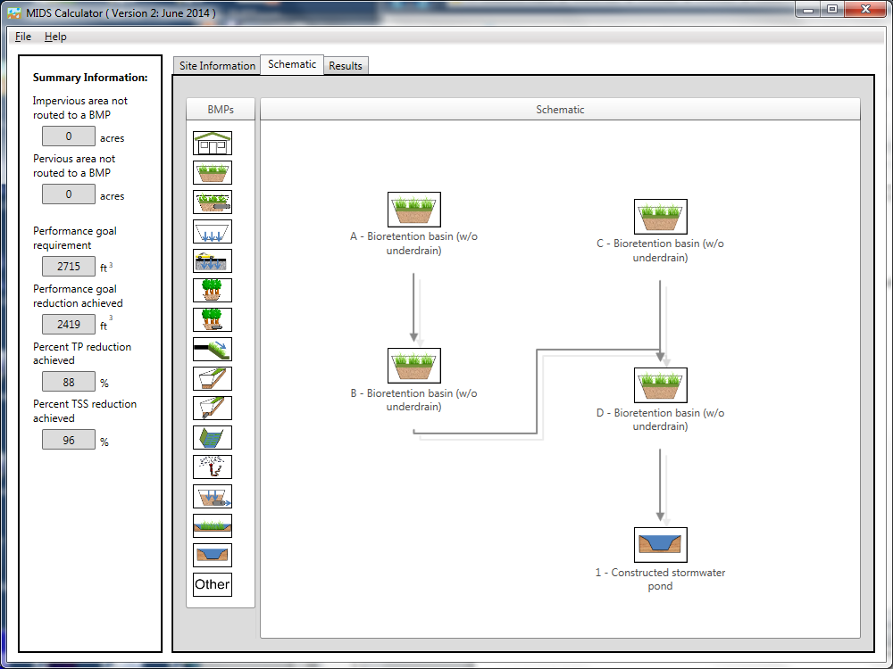
Step 32: Check the routing by looking at the “Schematic tab” to make sure all of the BMPs are routed correctly.

Step 33: Go to the “Results tab” and review the results for the entire site.
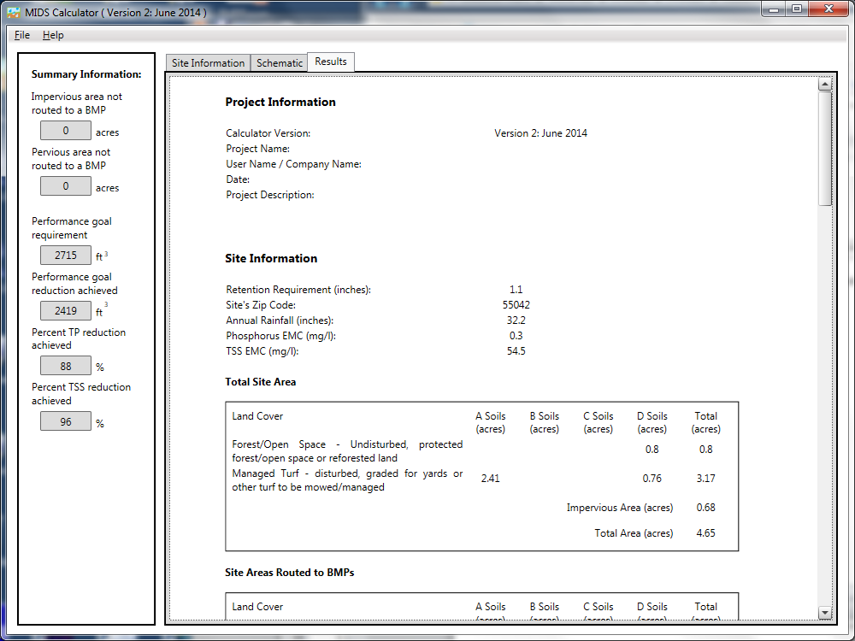
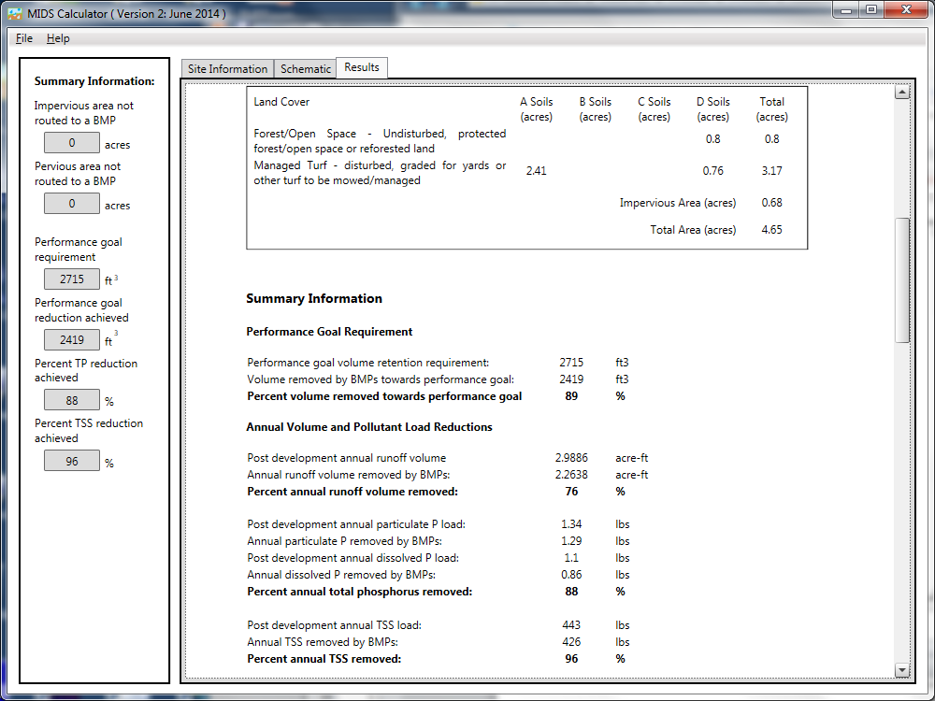
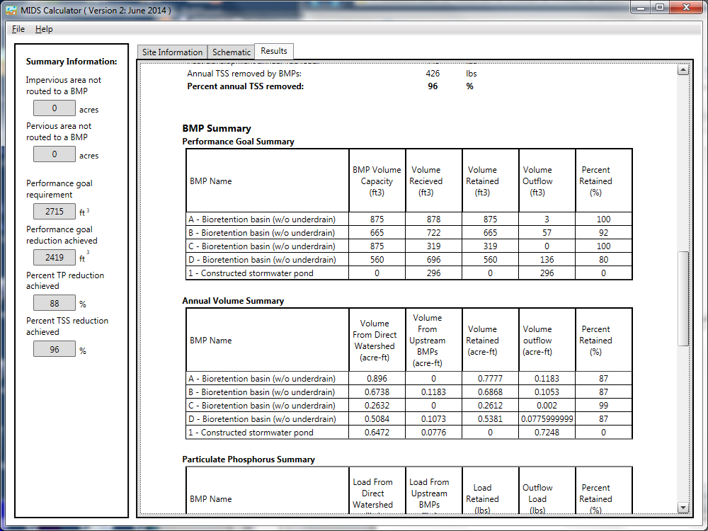
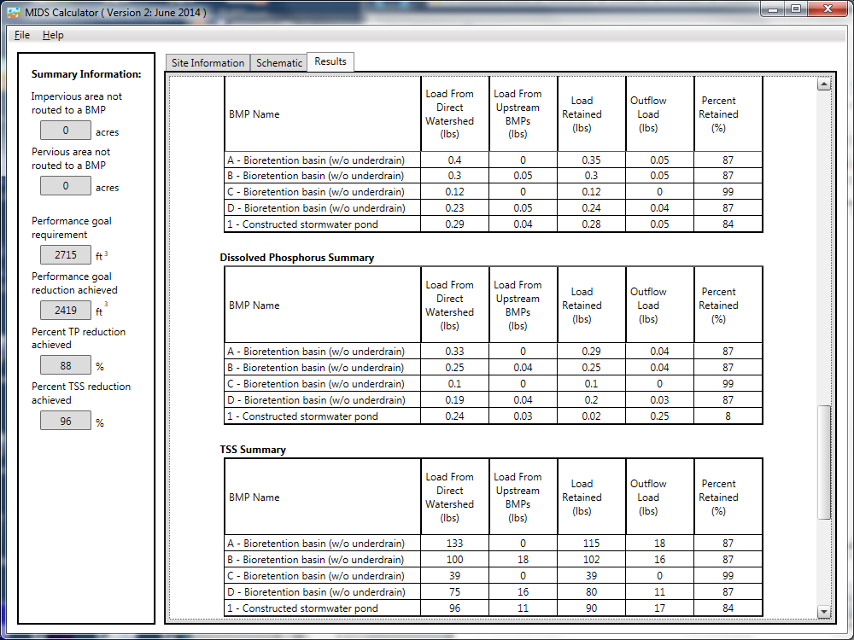

Step 34: Save the file for the individual calculator scenario. Open a new calculator file for the clumped scenario. In this scenario all four of the bioretention basins are clumped together as a single BMP for the calculator even though the four individual BMPs are constructed on the actual landscape.
Step 35: Determine the watershed characteristics for the entire site. For this example the watershed characteristics of the site are the same as the individual scenario. We have a 4.65 acre site with 0.68 acres of impervious area, 2.41 acres of Managed turf cover in A soils, 0.76 acres of Managed turf cover in D soils, and 0.80 acres of Forest/open space cover in D soils. The pervious areas include the Managed turf areas, the Forest/Open Space area, and the areas of the bioretention basin.
Step 36: Fill in the site specific information into the “Site Information” tab. This includes entering a Zip Code (55042 for this example) and the watershed information. The Managed Turf area includes the turf area and the areas of the bioretention basin. Zip code and impervious area must be filled in or an error message will be generated. Other fields on this screen are optional.
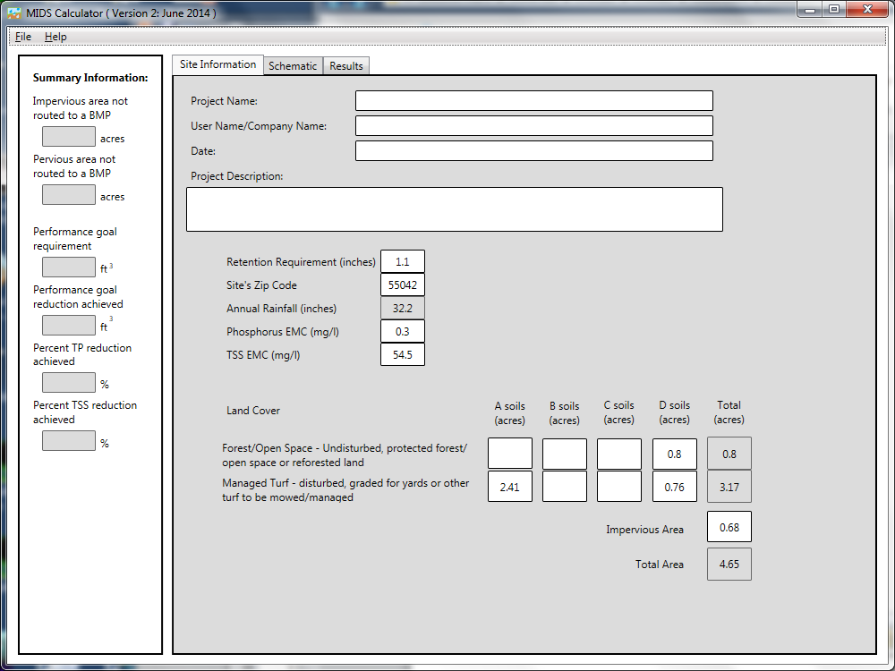

Step 37: Go to the Schematic tab and drag and drop a “Bioretention basin (w/o underdrain)” icon and a “Constructed stormwater pond” icon into the “Schematic Window”.

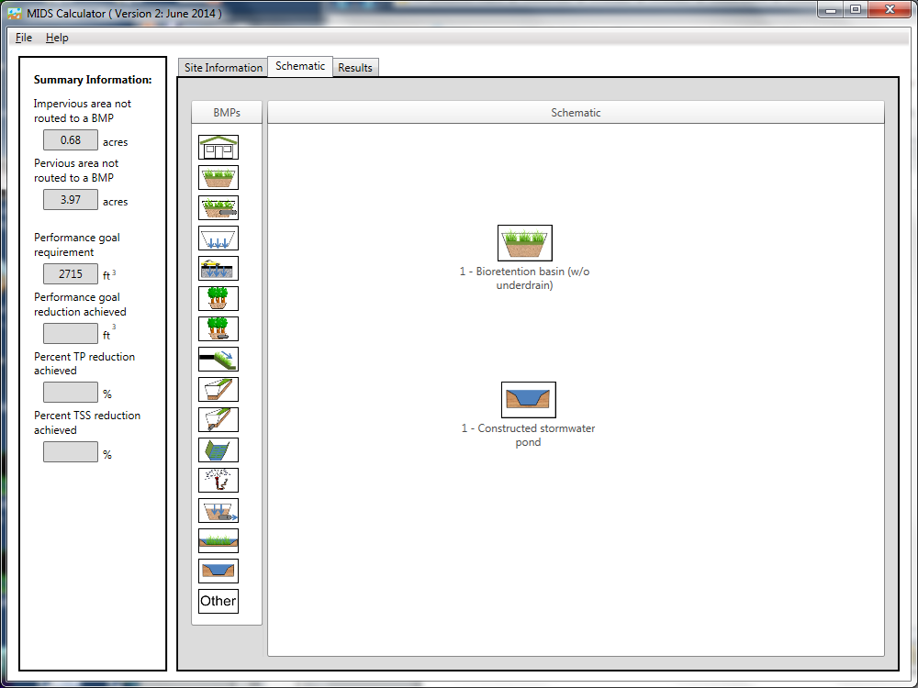
Step 38: Open the BMP properties for the bioretention basin by right clicking on the “Bioretention basin (w/o underdrain)” icon and selecting “Edit BMP properties”, or by double clicking on the “Bioretention basin (w/o underdrain)” icon.

Step 39: Determine the watershed characteristic for the bioretention basin. The watershed parameters for the bioretention basin in the clumping scenario include the entire watershed areas for all four bioretention basins from the individual scenario. The watershed information comprises a 3.05 acre site with 0.64 acres of impervious area and 2.41 acres of Managed turf area in A soils. The Managed turf area includes a 0.055 acre bioretention basin (the sum of the four areas for the basins used in the first scenario). Route the BMP to the constructed stormwater pond and fill in the BMP specific watershed information.
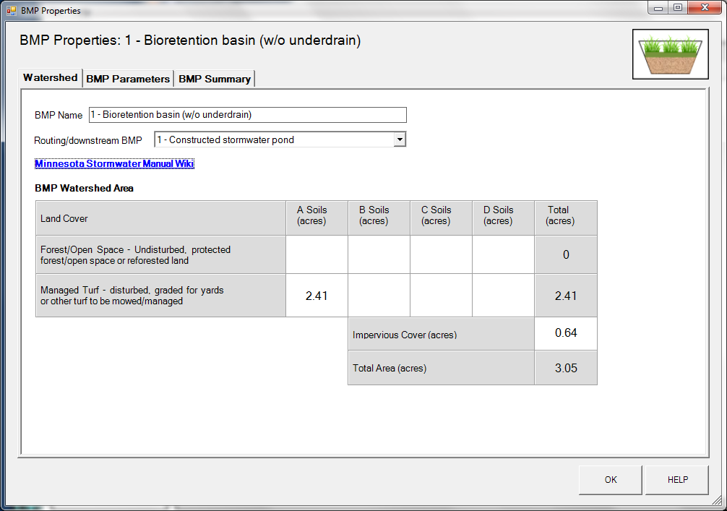

Step 40: Enter in the BMP design parameters for the bioretention basin into the “BMP parameters” tab. The following inputs are required for this BMP.
- Overflow surface area, which is 2400 square feet
- Bottom surface area, which is 1850 square feet
- Overflow depth, which is 1.4 feet
- Underlying soil – Hydrologic Soil Group, which is 5 SP (HSG A, 0.8 in/hr)
- Required drawdown time, which is 48 hours

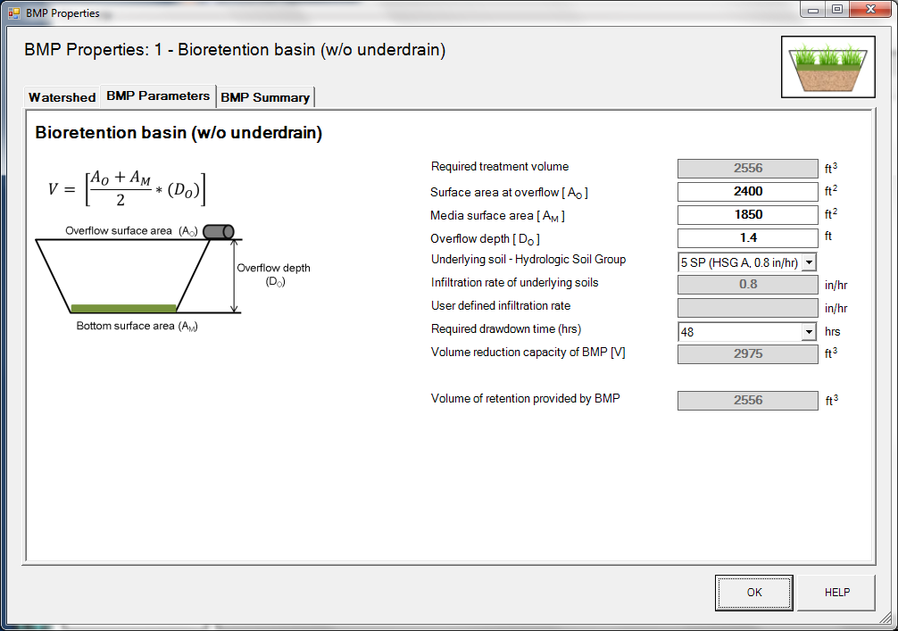

Step 41: Click on “BMP Summary” tab to view results for this BMP.
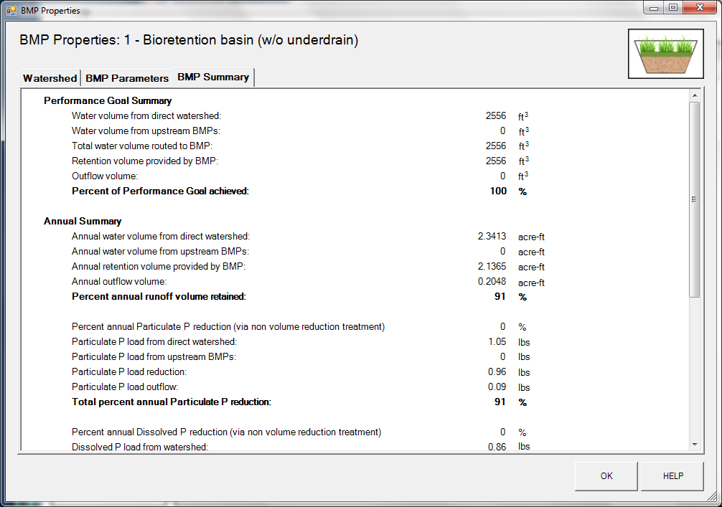
Step 42: Click on the “OK” button to exit the BMP properties screen.
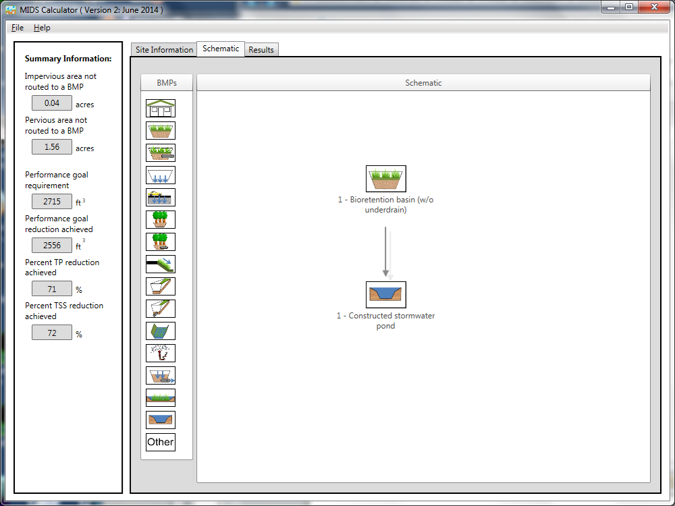
Step 43: Open the BMP properties for the constructed stormwater pond by right clicking on the “Constrcuted stormwater pond” icon and selecting “Edit BMP properties”, or by double clicking on the “Stormwater pond” icon.
Slide 44: Determine the watershed characteristics for the stormwater pond. The watershed parameters for the stormwater pond include a 1.6 acre site with 0.04 acres of impervious area, 0.76 acres of pervious turf area in D soils, and 0.80 acres of forested/open space in D soils. These acreages exclude the water surface area of the stormwater pond. Fill in the BMP specific watershed information.

Step 45: Enter the BMP design parameters for the constructed stormwater pond into the “BMP parameters” tab. For this BMP all that is required is to specify the Design Level that the stormwater pond meets. This pond will be constructed to meet Design Level 2. Press the help button to review design specification required for each design level. Pollutant reduction rates are associated with each design level. A constructed stormwater pond does not provide volume reduction towards the performance goal or on an annual basis.
Step 46: Click on “BMP Summary” tab to view results for this BMP.
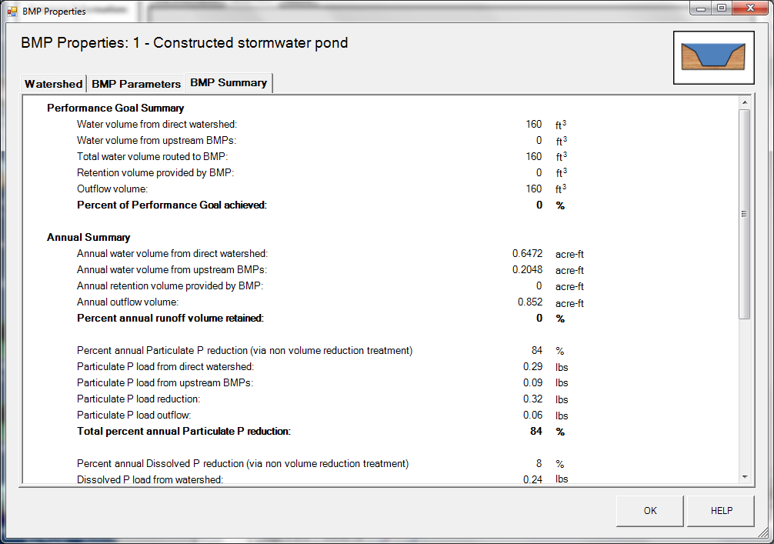
Step 47: Click the “OK” Button to close then “BMP properties” window.
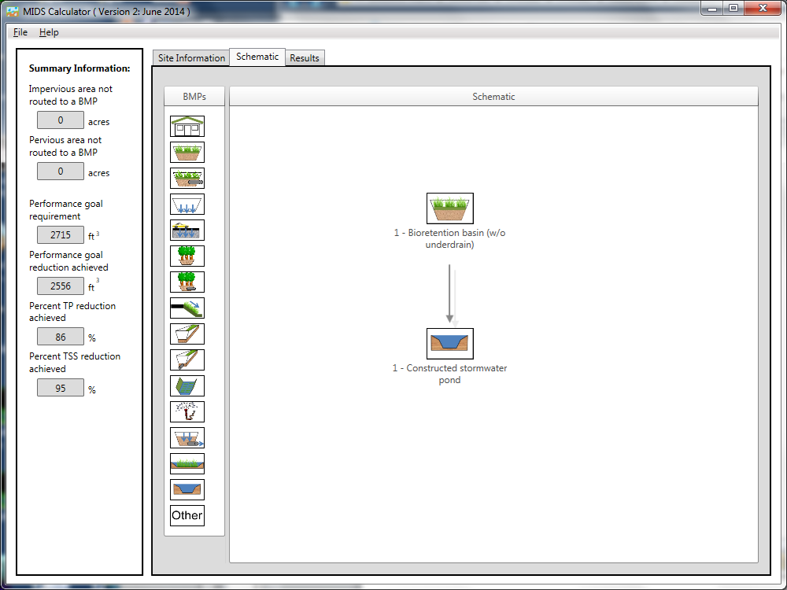

Step 48: Go to the “Results tab” and review the results for the entire site.
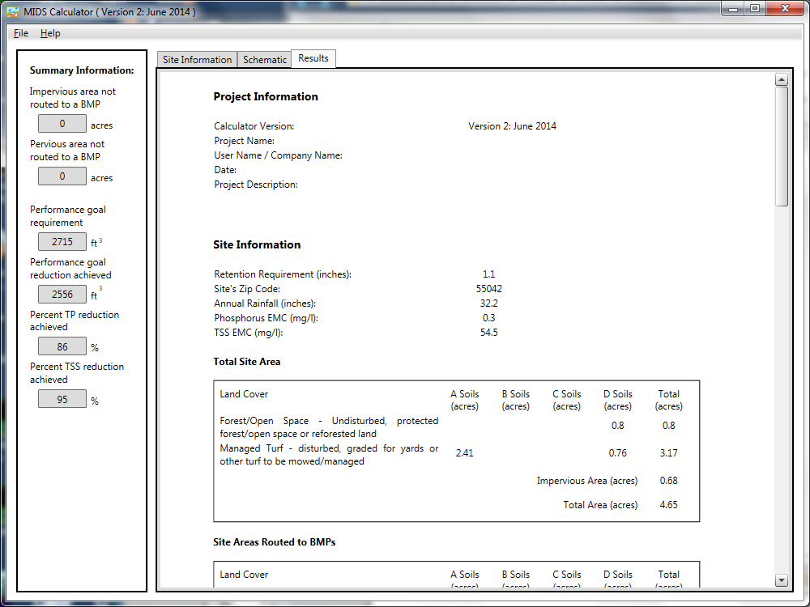
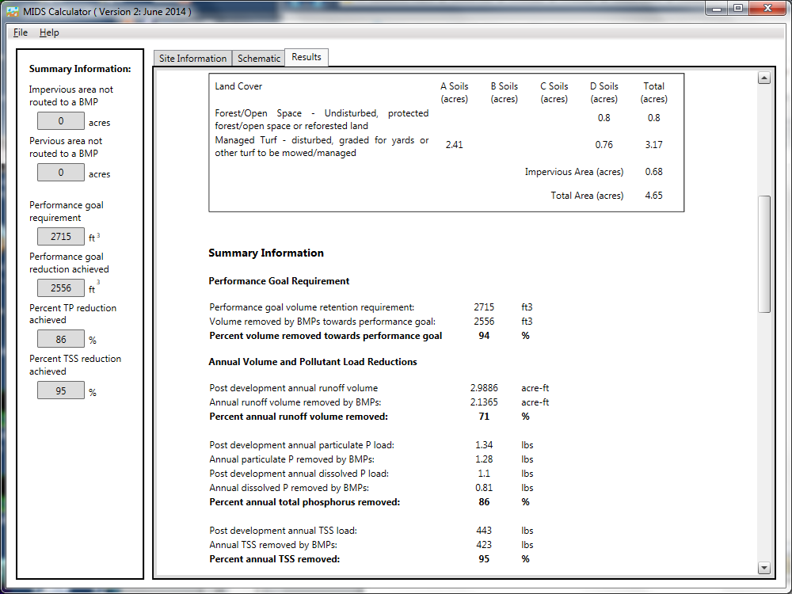
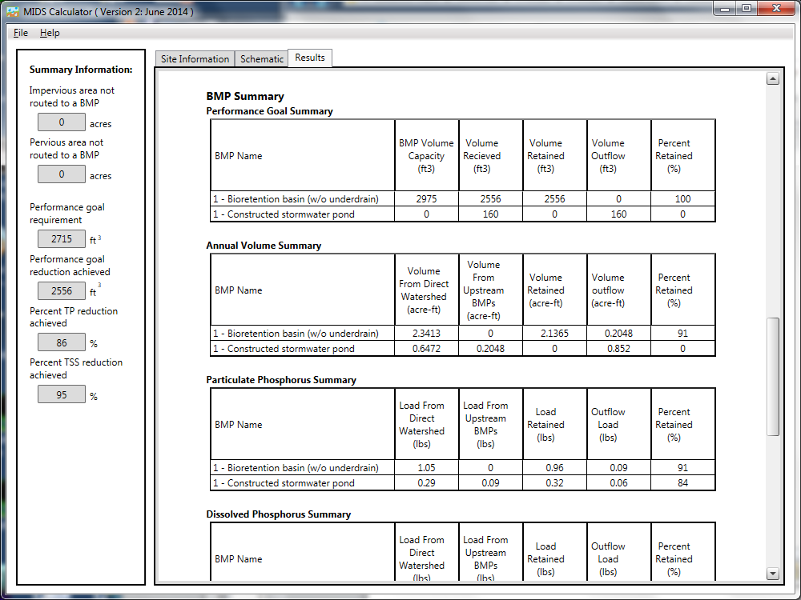
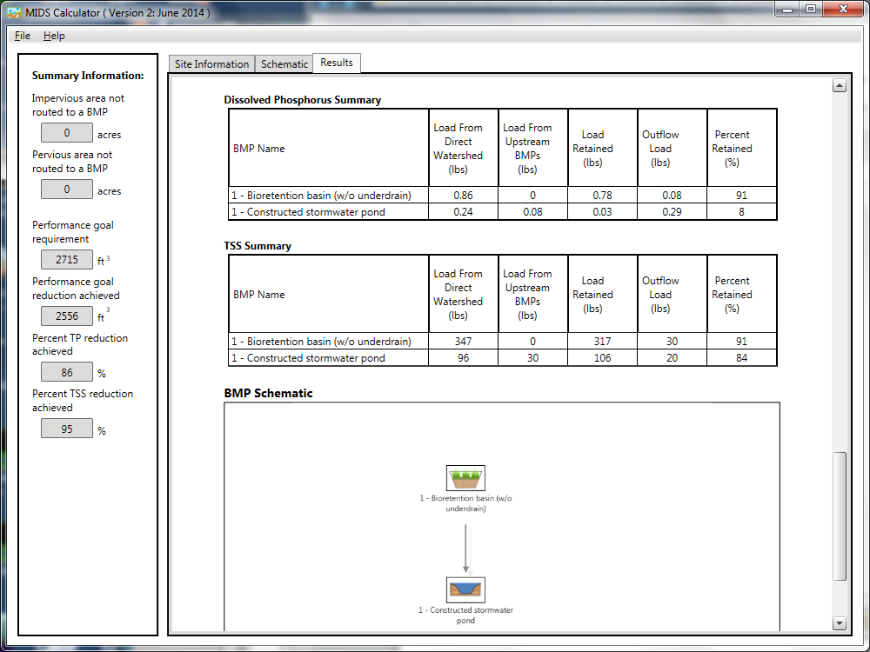
Step 49: Compare the results between the two scenarios and hypothesize as to why they are different.
The following table summarizes results for the two sites. Note the increased volume removed with the clumped scenario. Looking at the required treatment volumes and the treatment volume capacities for each basin in the individual scenario, Basins A and C are significantly oversized, while Basins B and D are slightly undersized. Clumping all the basins into a single BMP smoothes out these differences and provides an inaccurate depiction of how the BMPs will perform.
An advantage of clumping is it allows for several BMPs to be treated as a single BMP. In very complex systems with many BMPs, it would be simpler to clump BMPs. One way to minimize potential errors associated with clumping is to use the MIDS calculator to size individual BMPs, then clump the BMPs for the final site representation.
Scenario | Volume and load reduction
 | Volume  (ft³) | Particulate P  (lbs) | Dissolved P  (lbs) | TSS  (lbs)
Single | 2419 | 1.28 | 0.81 | 423
Clumped | 2556 | 1.29 | 0.86 | 426

