Harvest and re-use/Cistern Example (Version 2)

A cistern is going to be constructed to collect runoff from a 0.5 acre roof. The cistern will be constructed to hold 1995 cubic feet of water and will irrigate a 0.5 acre lawn area at an average irrigation rate of 1 inch/week. Irrigation will occur from May through September after which the cistern will drain completely and not collect runoff during the off season. The following steps detail how this system would be set up in the MIDS calculator.
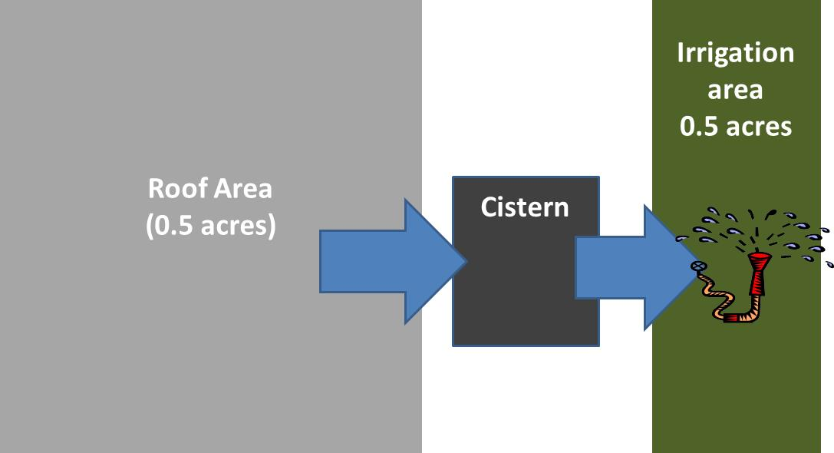
Step 1: Determine the watershed characteristics of your entire site. For this example we have a 0.5 acre site with all 0.5 acres being impervious. The entire roof area is draining to a cistern. The cistern area and irrigation area are not included in the watershed because runoffs from these two areas do not drain into the cistern BMP.

Step 2: Fill in the site specific information into the “Site Information” tab. This includes entering a Zip Code (55414 for this example) and the watershed information from Step 1. Zip code and impervious area must be filled in or an error message will be generated. Other fields on this screen are optional.
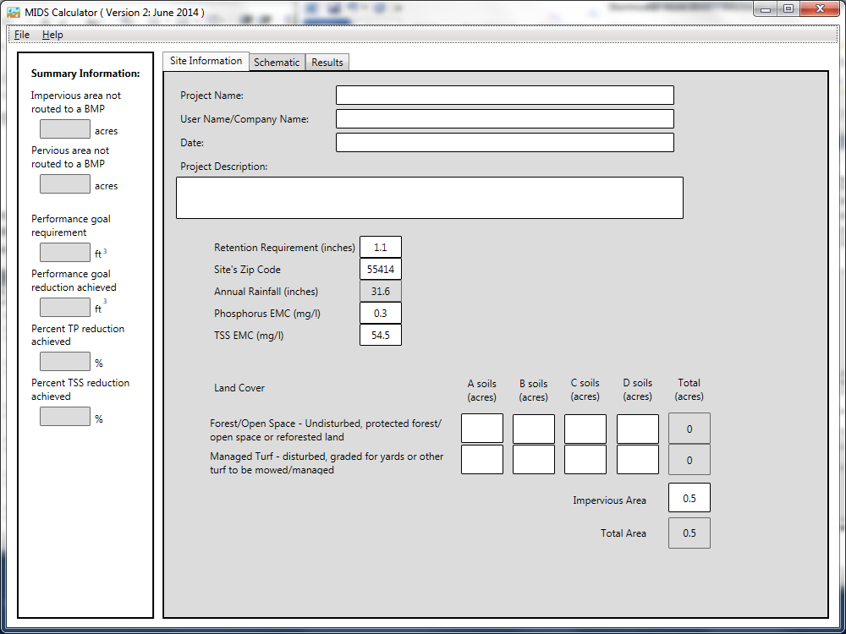

Step 3: Go to the Schematic tab and drag and drop the “Harvest and re-use/Cister” icon into the “Schematic Window”.

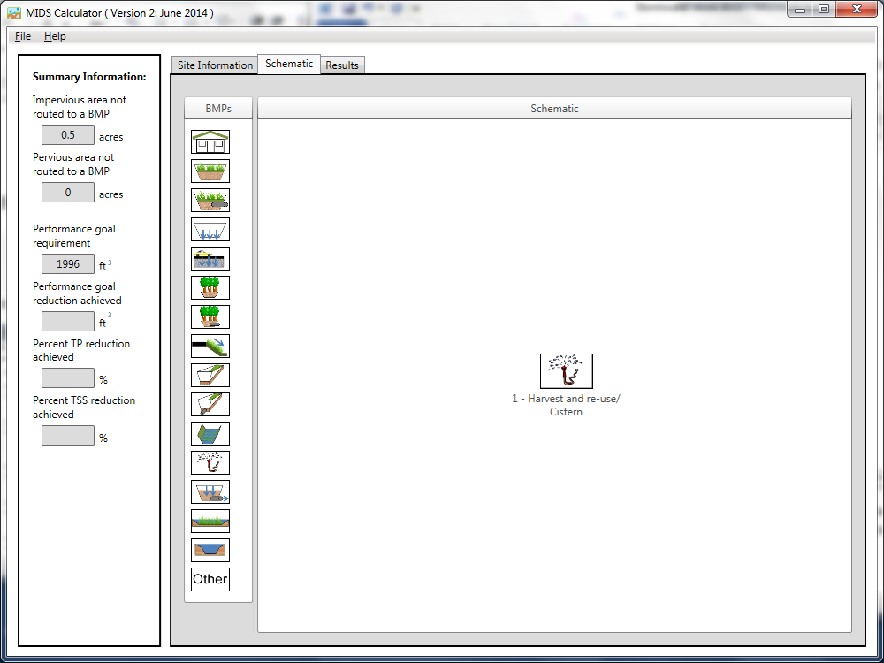
Step 4: Open the BMP properties for the Cistern by right clicking on the “Harvest and re-use/Cistern” icon and selecting “Edit BMP properties”, or by double clicking on the “Harvest and re-use/Cistern” icon.
Step 5: Click on the “Minnesota Stormwater Manual Wiki” link or the “Help” button to review input parameter specifications and calculation specific to the “Harvest and re-use/Cistern” BMP.
Step 6: Determine the watershed characteristic for the cistern. For this example the impervious area is draining to the cistern. The watershed parameters therefore include a 0.5 acre site all of it impervious. Fill in the BMP specific watershed information (0.5 acres on impervious cover).

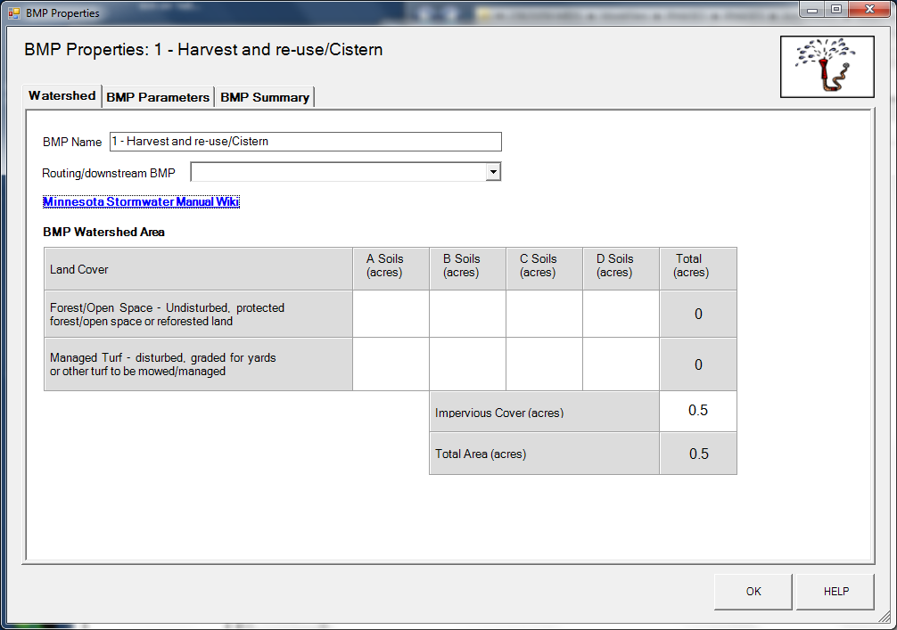
Step 7: Enter in the BMP design parameters into the “BMP parameters” tab. Harvest and re-use/Cistern requires the following entries:
- Reuse storage volume equal to the cistern volume of 1995.
- Irrigation application area equal to 0.5 acres.
- Irrigation application rate of 1 inch/week.
- Irrigation start month equal to May.
- Irrigation end month equal to September.
- Does the system go offline during off season – Yes
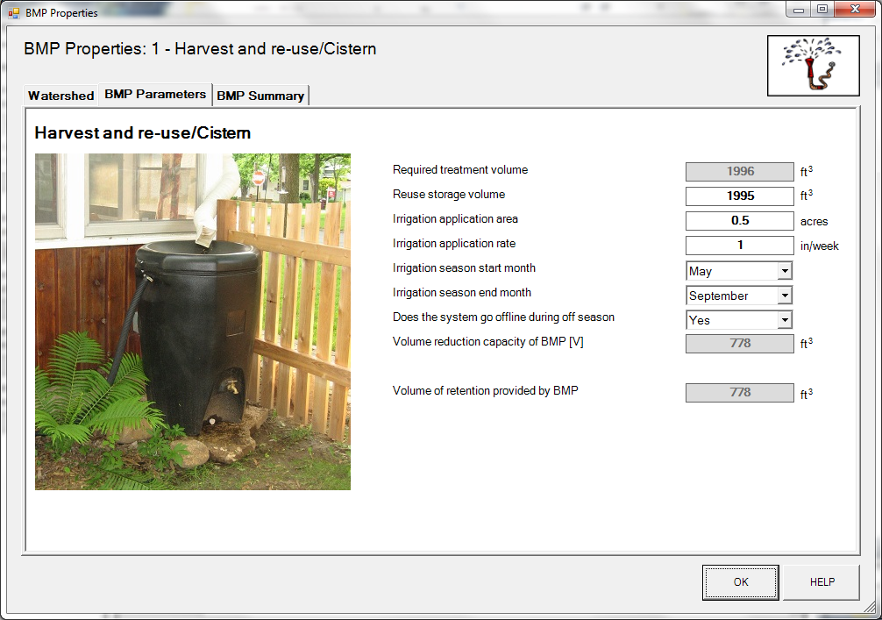
Step 8: Click on “BMP Summary” tab to view results for this BMP.
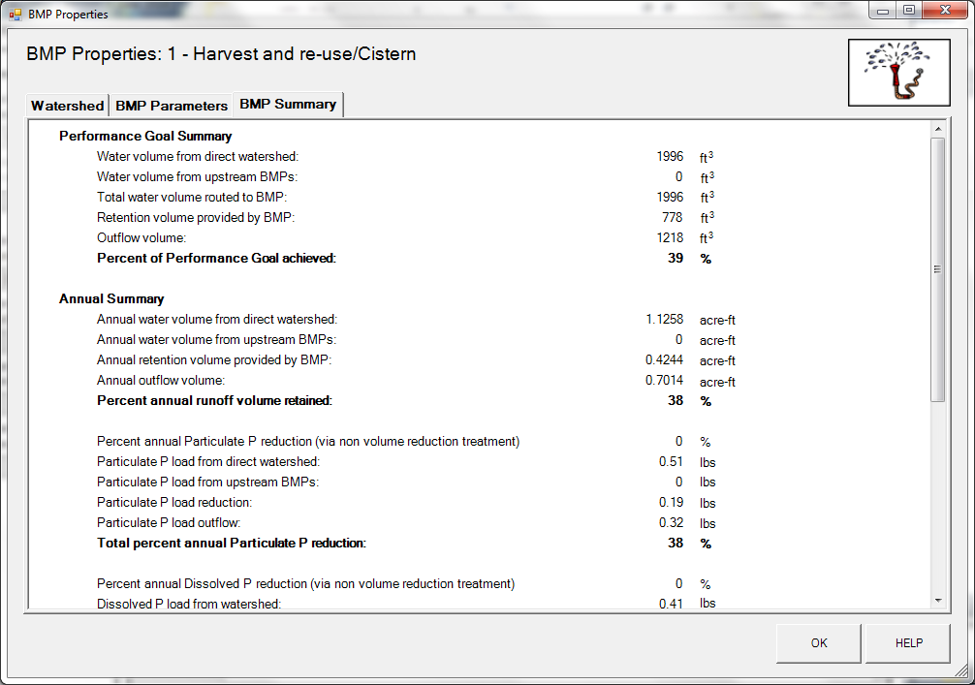
Step 8: Click on the “OK” button to exit the BMP properties screen.
Step 9: Click on “Results” tab to see overall results for the site.

