**REPORT for OBJ2.TASK 6: SOIL RIPPING FOR INFILTRATION**

To: MPCA

From: The Kestrel Design Group Team (The Kestrel Design Group Inc, with Dr. William Hunt, PE, Ryan Winston, PE, Dwayne Stenlund – Minnesota Department of Transportation, Dr. John Gulliver, PE – University of Minnesota

Date: July 31, 2013

Re: Contract CR5332 Objective 2 Task 6

**SCOPE**

Develop guidance and recommendations on the use of soil ripping to increase infiltration capacity of infiltration and bioretention BMPs.

1. Review literature information on soil ripping. Identify case studies and associated changes in soil infiltration rates resulting from use of soil ripping. Include a review of long-term effects of soil ripping on infiltration.
2. Prepare and submit a Technical memo summarizing the principles of soil ripping and conditions under which soil ripping is or is not recommended. Include a discussion of the effect of different soil types (e.g. clay, silt, sand) including amendments that may be needed for certain soil types. Include a discussion of effects from soil ripping over time (e.g. initial impact on soil infiltration rate and changes in infiltration rate over time following soil ripping). Cost information shall be included. Include appropriate graphics. As part of the memo, Kestrel shall provide recommendations regarding the feasibility of developing specifications for conducting soil ripping.
3. Prepare and submit a report summarizing information contained in the Technical memo, including life cycle properties, long-term benefits, and maintenance needs for bioretention and infiltration BMPs in which soil ripping has occurred. If development of specifications were recommended in the Technical memo associated with Task 6.b, the report shall include specifications for soil ripping, including CAD drawings and other graphics.

**Report Table of Contents:**

1. List of Figures
2. List of Tables
3. Effects of Development on Soil Properties Relevant to Stormwater Management
4. Ripping to Alleviate Soil Compaction Caused by Development
5. Effect of Ripping on Soil Compaction
6. Principles of Soil Ripping
7. Suitable conditions for Ripping
8. Where Ripping is Not Feasible
9. Summaries of Selected Studies on the Effects of Ripping
10. Effect of Ripping AND Amending Soils with Compost on Soil Compaction
11. How Compost Reduces Soil Compaction
12. Where Not to Use Compost to Alleviate Soil Compaction
13. Summaries of Selected Studies on the Effects of Ripping PLUS Compost on Soil Compaction
14. Precedent Specification
15. Precedent Stormwater Credits for Soil Restoration
16. Cost Estimates
17. Recommendations
18. References
19. **List of Figures**

Figure 6.1: Examples of various agricultural shank designs

Figure 6.2: A winged tip and a conventional tip subsoiler

Figure 6.3: Comparison of soil disturbance from a winged tip vs. a conventional tip: winged tips can typically be spaced farther apart because they fracture more of the soil than conventional tips

Figure 6.4: Impacts of having subsoiler shanks spaced correctly (top left) vs. spaced too widely apart (bottom left) and having shanks at correct depth (top right) vs. too deep (bottom right)

1. **List of Tables**

Table 6.1: Increase in Soil Bulk Density by Land Use or Activity

Table 6.2: A comparison of bulk densities for undisturbed soils and common urban conditions

Table 6.3: A Comparison of Root Limiting Bulk Density for Different Soil

Table 6.4: Reported Activities that Restore or Decrease Soil Bulk Density

1. **Effects of Development on Soil Properties Relevant to Stormwater Management**

A literature review by Schueler (2000) found that construction increases the bulk density of surface soils on the order of 0.35 gm/cc over the predevelopment land use. The compaction can extend up to two feet down into the soil profile. Urban lawn and turf areas are just as compacted as sites that have been subjected to construction traffic or that have been mass graded. Athletic fields appear even more compacted. Schueler (2000) summarized his literature review on increases in soil bulk density from various land uses (Table 1).

|  |  |  |
| --- | --- | --- |
| **Land Use or Activity** | **Increase in Bulk Density (gm/cc)** | **Source:** |
| Grazing | 0.12 to 0.20 | Smith, 1999 |
| Crops | 0.25 to 0.35 | Smith, 1999 |
| Construction, mass grading | 0.34 | Randrup, 1998 |
| Construction, mass grading | 0.35 | Lichter and Lindsey, 1994 |
| Construction, no grading | 0.2 | Lichter and Lindsey, 1994 |
| Construction traffic | 0.17 | Lichter and Lindsey, 1994 |
| Construction traffic | 0.25 to 0.40 | Smith, 1999; Friedman 1998 |
| Athletic fields | 0.38 to 0.54 | Smith, 1999 |
| Urban lawn and turf | 0.30 to 0.40 | Various Sources |

Table 6.1: Increase in Soil Bulk Density by Land Use or Activity (Schueler 2000)

The compaction that results from development acutely impacts stormwater management, as it increases runoff and severely decreases infiltration rates as well as the ability for plants to grow. While infiltration rates of soils of all textures are significantly reduced when compacted, Pitt et al (2008) found that:

* Sandy soils can still provide substantial infiltration capacity even when greatly compacted.
* Clay soils are less able to withstand low levels of compaction compared to sandy soils.
* Dry, uncompacted clay soils can have relatively high infiltration rates
* Saturated clay soils and compacted clay soils have very low infiltration rates.

To put in perspective the typical magnitude of the impacts of compaction from development, Tables 6.2 and 6.3 show a comparison of bulk density for undisturbed soils and common urban conditions, and root limiting soil bulk densities. Note even some urban lawns are compacted beyond root limiting bulk densities.

According to the 2006 Pennsylvania Stormwater Best Management Practices Manual’s chapter on soil amendment and restoration, axle loads >10 tons can compact up to 1’ deep, while axle loads > 20 tons can compact up to 2’ deep. These large loads are commonly applied during construction in “large areas compacted to increase strength for paving and foundation with overlap to “lawn” areas.”

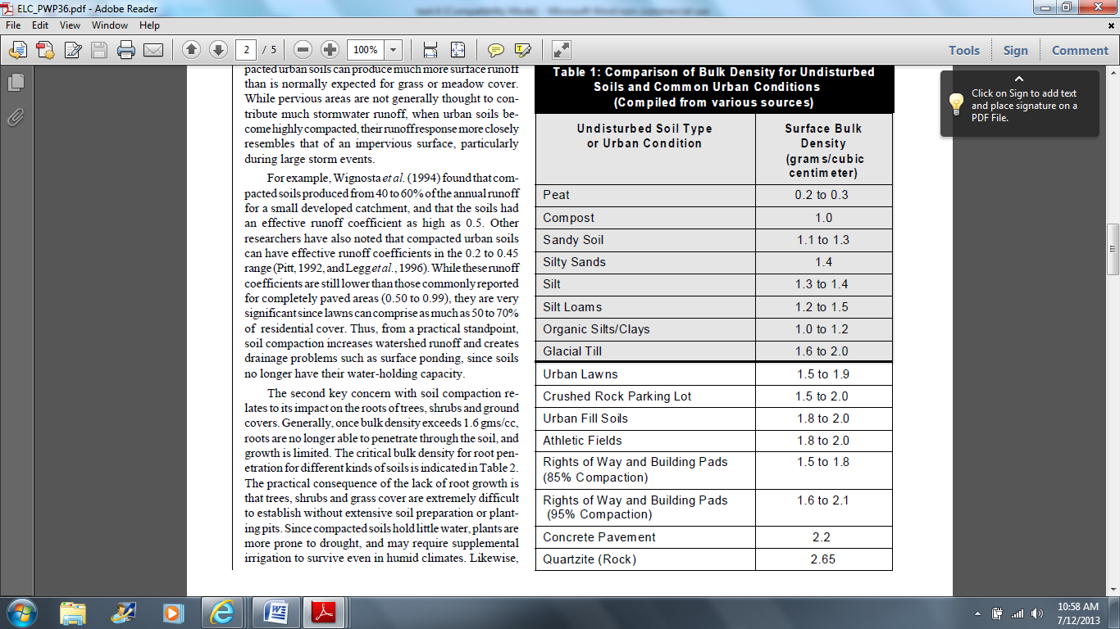

Table 6.2: a comparison of bulk densities for undisturbed soils and common urban conditions (Schueler 2000)

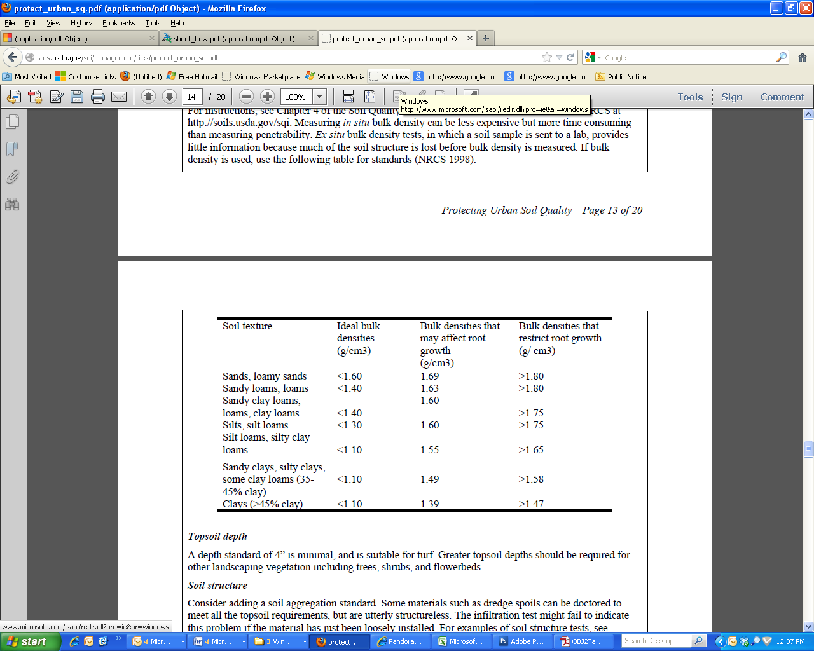

Table 6.3: A Comparison of Root Limiting Bulk Density for Different Soil Types (NRCS 1998 in Dallas and Lewandowski, 2003)

1. **Alleviating Soil Compaction Caused by Development**

Alleviation of compaction of disturbed soil is clearly crucial to the installation of successful vegetated stormwater infiltration practices.

While natural processes can alleviate soil compaction, additional techniques to alleviate soil compaction are often desirable because:

1. It can take many years for natural processes to loosen up soil
2. Natural processes operate primarily within the first foot or so of soil, and compaction from development can extend to two feet deep
3. Once soil compaction becomes so severe that plants and soil microbes can no longer thrive, they are no longer able to reduce soil compaction

Schueler (Technical Note 108) summarizes natural processes that can alleviate soil compaction as follows: “Once soil is compacted, is there anything that can be done to reverse the process? Many natural processes act to loosen up soil, such as freezing/thawing, particle sorting, earth worm activity, root penetration and the gradual buildup of organic matter. Often, however, these processes take decades to work, and operate primarily within the first foot or so of soil. In addition, many of these natural processes are effectively turned off when soil compaction becomes severe because water, plant roots and soil fauna simply cannot penetrate the dense soil matrix and get to work.”

One example of how easily soil becomes compacted and how long it can take to recover is the Oregon trail. Ruts are still visible today on the Oregon Trail from large wheeled covered wagon traffic between 1840 and 1869!

In a literature review of techniques to alleviate soil compaction, Schueler (Technical Note 108) concludes that “Based on current research, it appears that the best construction techniques are only capable of preventing about a third of the expected increase in bulk density during construction.”

From his literature review, summarized in Table 6.4, it appears that compost amendment and reforestation are the most effective techniques to reduce soil bulk density. Tilling (ripping) of soil alone did not appear to significantly reduce bulk density according to Schueler’s literature review.

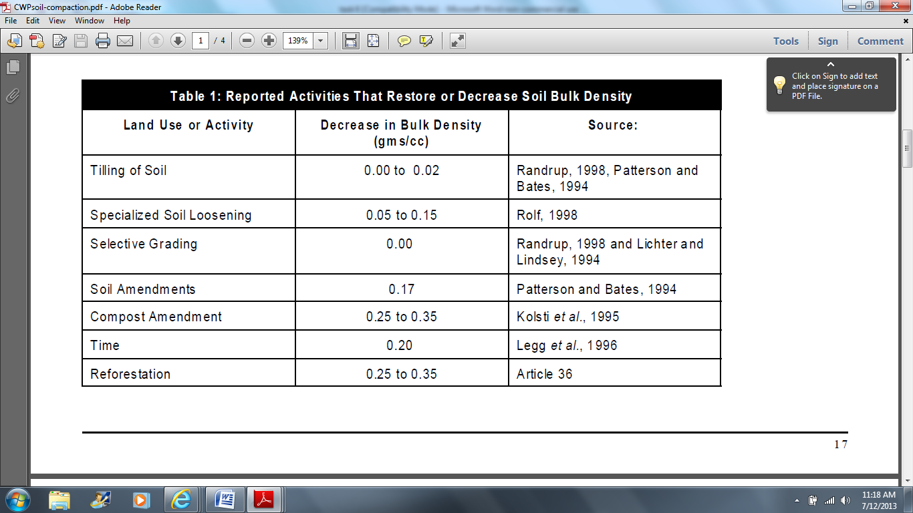

Table 6.4: Reported Activities that Restore or Decrease Soil Bulk Density (Schueler, Technical Note 108)

A more detailed review of literature on the effects of ripping and compost amendment on soil infiltration rates follows below.

1. **Effect of Ripping on Soil Compaction**
2. **Principles of Soil Ripping (subsoiling)**

The goal of subsoiling is to fracture compacted soil “without adversely disturbing plant life, topsoil, and surface residue. Fracturing compacted soil promotes root penetration by reducing soil density and strength, improving moisture infiltration and retention, and increasing air spaces in the soil” (Kees 2008).

According to Kees (2008), “compacted layers typically develop 12-22 inches below the surface when heavy equipment is used. Conventional cultivators cannot reach deep enough to break up this compaction. Subsoilers (rippers) can break up the compacted layer without destroying soil aggregate structure, surface vegetation, or mixing soil layers.

How effectively compacted layers are fractured depends on the soil's moisture, structure, texture, type, composition, porosity, density, and clay content. Success depends on the type of equipment selected, its configuration, and the speed with which it is pulled through the ground. No one piece of equipment or configuration works best for all situations and soil conditions, making it difficult to define exact specifications for subsoiling equipment and operation.”

Based on their previous research, Spoor (2003) similarly defines the goal of soil compaction reduction where a strong pan layer is present as follows:

“*to improve conditions with minimal loss of soil support, leaving the natural and biological processes to complete the remediation and stabilise the resulting soil condition. Subsoiling operations to alleviate soil compaction are frequently associated with* ***considerable loosening****, soil rearrangement and loss of bearing capacity. Such a type of disturbance is* ***most inappropriate for future subsoil protection from loading stresses****. The* ***prime aim*** *in compaction alleviation operations must, therefore, be the* ***creation of fissures or cracks through the damaged zone to restore rooting and drainage****, but* ***with minimum disturbance to the remaining bulk of the soil profile****. This disturbance is in effect, “fissuring without loosening”, allowing the bearing capacity of the soil to be maintained. Such an aim can best be achieved by generating a tensile soil failure within the damaged area, where fissures are generated, leaving the soil mass between the fissures largely intact, unbroken and strong.*

*Tensile failure can be generated by lifting the soil mass with a subsurface blade and allowing it to flow*

*over the blade so that soil bending occurs, the bending action placing the soil in tension and creating*

*fissures (Fig. 2). Appropriate cultivation tools for inducing this type of failure (Fig. 3) are winged subsoilers, subsurface sweeps and Paraplow type angled leg subsoilers (Spoor and Godwin, 1978)”*- bold added.

Urban (2008) concurs that the best soil compaction reduction methods leave soil peds intact, and if “soil is broken into overly fine particles, it will re-compact as gravity and water settle the soil…” He also adds that “adding organic or mineral amendments to the soil can help reduce this re-compaction…High-lignin compost or ESCS products are most commonly used”.

Subsoilers are available with a wide variety of shank designs (Figure 6.1). Shank design affects subsoiler performance, shank strength, surface and residue disturbance, effectiveness in fracturing soil, and the   
horsepower required to pull the subsoiler. According to Kees (2008), “Parabolic shanks require the least amount of horsepower to pull. In some forest applications, parabolic shanks may lift too many stumps and rocks, disturb surface materials, or expose excess subsoil. Swept shanks tend to push materials into the soil and sever them. They may help keep the subsoiler from plugging up, especially in brush, stumps, and slash. Straight or "L" shaped shanks have characteristics that fall somewhere between those of the parabolic and swept shanks.”

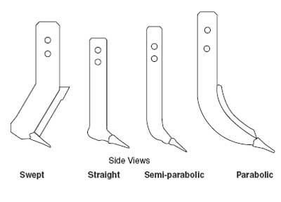

Figure 6.1: Examples of various agricultural shank designs (Kees 2008)

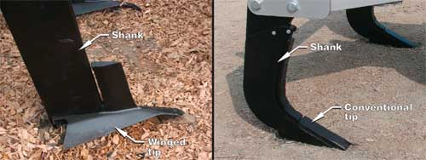

Figure 6.2: A winged tip and a conventional tip subsoiler (Kees 2008)

Shanks are available with winged tips and conventional tips (Figure 6.2). Winged tips cost more than conventional tips and require more horsepower, but can often be spaced farther apart (Figure 6.3). Increasing wing width also increases critical depth – the depth below which little soil loosening occurs (Owen 1987, Spoor 1978). Using shallow leading tines ahead of deeper tines also increases required shank spacing (Spoor 1978).

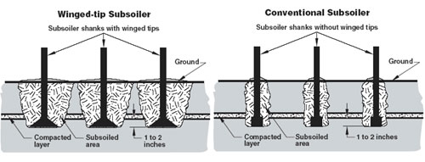

Figure 6.3: Comparison of soil disturbance from a winged tip vs. a conventional tip: winged tips can typically be spaced farther apart because they fracture more of the soil than conventional tips (Kees 2008)

Several researchers have found that there is a “critical depth”, and according to Spoor and Godwin (1978) this “critical depth is dependent upon the width, inclination and lift height of the tine foot and on the moisture and density status of the soil.” Spoor and Godwin (1978) explain that tine depth is crucial because “At shallow working depths the soil is displaced forwards, side-ways and upwards (crescent failure), failing along well defined rupture planes which radiate from just above the tine tip to the surface at angles of approximately 45” to the horizontal. Crescent failure continues with increasing working depth until, at a certain depth, the critical depth, the soil at the tine base begins to flow forwards and sideways only (lateral failure) creating compaction at depth.” They found that below the critical depth “compaction occurs rather than effective soil loosening.” They also found that “The wetter and more plastic a soil is, the shallower is the critical depth.”

Spoor 2006 explains as follows why it is so crucial to tailor shank depth to site conditions: “When soil is loaded by cultivation implements, it can deform and move in three distinct ways, often referred to as brittle, compressive (ductile) and tensile disturbances (Hettiaratchi, 1987)…Brittle and tensile types of disturbance are the only two modes of disturbance capable of alleviating compaction. Cracks and fissures are generated through the compacted area in both cases, with little disturbance between the cracks. Both brittle and tensile disturbances require an upward component of soil movement to allow the soil to dilate. In a field situation this upward movement is resisted by the overburden load and strength of the soil above implement working depth. If this resistance, usually termed the confining resistance, becomes too great, it becomes easier for the soil to move laterally rather than upwards and a compressive rather than brittle or tensile disturbance occurs. The confining resistance increases with increasing working depth and it is also dependent on moisture content and density.”

According to Kees (2008), the shank’s tip should run to a depth of 1-2 inches below the compacted layer (see Figure 6.4).

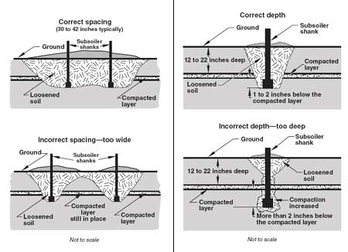

Figure 6.4: Impacts of having subsoiler shanks spaced correctly (top left) vs. spaced too widely apart (bottom left) and having shanks at correct depth (top right) vs. too deep (bottom right) (Image from Kees 2008). Note: compaction on a construction site can be much more severe than just the plow layer shown in the above agricultural or forestry images.

Ideal shank spacing will depend on soil moisture, soil type, degree of compaction, and the depth of the compacted layer. Spacing should be adjustable so the worked area can be fractured most efficiently (see figure 6.4).

Because ideal shank configuration will vary with varying soil textures and moisture, shank spacing and height should be adjustable in the field (Kees 2008).

Travel speed of the subsoiler also affects subsoiling disturbance. “Travel speed that is too high can cause excessive surface disturbance, bring subsoil materials to the surface, create furrows, and bury surface residues. Travel speed that is too slow may not lift and fracture the soil adequately” (Kees 2008).

Kees (2008) also recommends making sure that the shanks on the subsoiler are spaced so that they run in the tracks of the tow vehicle, because the equipment used to pull subsoilers is heavy enough to create compaction itself.

*Direction of travel and number of passes*

Multiple passes are generally required to alleviate compaction on severely compacted sites.

According to Spoor (2006), on “sites where compaction is frequently excessive and deep (densities up to 1.9–2.0 t /m3 [tons per cubic meters]), to depths of >0.8 m), it is virtually impossible, even with very large power units, to achieve the desired degree of soil break-up to the required working depth within a single or double pass. Using toolframes fitted with both shallow leading and deeper following tines can assist, with further improvements by fitting tines at three working depths. With these tine configurations the soil is disturbed progressively from the surface downward, thus reducing the size of soil unit produced. It is imperative to achieve the desired sized soil unit on the first pass, as subsequent passes at the same depth only stir the loosened medium, with little further soil unit break-up. An approach developed by Silsoe College, Cranfield University, in collaboration with Transco UK, for use on pipeline sites, was to work progressively deeper with repeated passes, up to 5 or 6 under extreme conditions, with the tractor operating on the same tramline/traffic lane on each pass (Spoor & Foot, 1998).” Much more detail on this approach is provided in their paper.

Kees (2008) recommends following ground contours whenever possible when subsoiling to “increase water capture, protect water quality, and reduce soil erosion.” He also states that “in some cases, two passes at an angle to each other may be required to completely fracture compacted soil.”

Spoor and Godwin (1978) also found that “Relatively closely spaced tines, staggered to prevent blockage, are more efficient at producing complete loosening than repeated passes with tines at wider spacings.”

*Need to field adjust*

According to Spoor and Godwin (1978) “The number of variables involved and soil variation make the accurate prediction of the critical depth for field conditions impractical. Simple field modifications are available, however, such as increasing tine foot width and lift height or loosening the surface layers, to allow rapid implement adjustment to satisfy a range of field conditions.”

If subsoiling was effective, “The ground should be lifted slightly and remain relatively even behind the subsoiler, without major disruption of surface residues and plants. No more than a little subsoil and a few rocks should be pulled to the surface. If large furrows form behind the subsoiler, the shanks may not be deep enough, the angle on winged tips may be too aggressive, or the travel speed may be too high” (Kees 2008).

1. **Where Ripping is Not Feasible**

Always know where utilities are buried prior to subsoiling. Avoid subsoiling in area that have buried utilities, wires, pipes, culverts, or diversion channels (Kees 2008, Urban 2008).

1. **Suitable conditions for Ripping**

According to Kees, 2008, “Soils should be mostly dry and friable. If the soil is too wet, subsoiler shanks will slide through the ground without breaking up the soil. The shank can actually glaze the soil and compact it even more. If the soil is extremely dry, getting the subsoiler into the ground can be difficult, requiring larger, more powerful tractors to pull the shanks through compacted areas. Soils, especially those with more clay content, can actually break into large clods or slabs if conditions are too dry.

For most areas, ideal subsoiling conditions are during summer months before the soils are completely dry. Soils should crumble without sticking together, yet not be so dry and hard that they can't be broken up easily.”

Urban (2008) describes ideal conditions for compaction reduction as follows: “soil moisture must be between field capacity and wilt point during compaction reduction for maximum effectiveness. This soil is considered friable, meaning it has adequate moisture to break into clods when lifted and turned with a shovel. Friable soil will make the hand dirty but not muddy when squeezed. If the soil is so wet that it makes a mud stain on the hand, compaction reduction efforts may be ineffective or even make things worse. If the soil is so dry that it does not break easily into clods, compaction reduction will also be limited. In most soil, “too wet” is defined as within several days after enough rain has fallen to saturate the soil profile. If the soil is heavily compacted or in an area of poor drainage, this may take much longer. If the soil is dry, it will take several inches of water to hydrate the soil. One rainy day may not provide enough water.”

1. **Summaries of Selected Studies and Publications on the Effects of Ripping on Soil Compaction**

While some studies did not find ripping to significantly alleviate soil compaction (e.g. Randrup 1998 and Patterson and Bates 1994 in Schueler Technical Note #108, Chaplin et al 2008 – clay soil site, Meek et al 1992 in Olson 2010, Olson 2010), others found very significant increases in infiltration rates after ripping (e.g. Tyner 2010, Chaplin et al 2008 – sandy soil site, Meek et al 1992 in Olson 2010).

Ripping is sometimes not effective to increase infiltration rates if:

* Equipment is not adequately tailored to meet project conditions
* Soil still had good structure and ripping destroyed remaining soil structure

In general, it appears as if ripping is effective for alleviating compaction where soils are severely compacted and ripping equipment is tailored to meet project goals and conditions.

According to Kees (2008), “Under ideal conditions, subsoiling should be 75 to 80 percent successful in breaking up compacted layers. In some cases, two passes at an angle to each other may be required to completely fracture compacted soil (Kees 2008).” Other studies have found in some conditions, 5 to 6 passes may be needed to alleviate compaction (Spoor 2006).

**Olson 2010**

A local study of the effects of ripping and amending soils with compost on soil compaction and infiltration rates was conducted by Olson (2010) at three sites in the Twin Cities Metropolitan area. At each site, he compared soil saturated hydraulic conductivity, bulk density, and soil strength of 3 treatments:

1. Ripped
2. Ripped and amended with compost
3. Control

“Deep tillage was effective at reducing the level of soil strength. Soil strength was approximately half that of the control plot in the first six inches of soil. However, tilling did not significantly improve the bulk density of the soil. At two of the sites, tilling was ineffective at improving that infiltration capacity of the soil. Tilling may have damaged natural pathways in the soils, thus reducing the permeability. Tilling was effective at remediating the soil at one site, which was not as well-established at the previous two sites. The geometric mean of Ksat was 2.1 to 2.3 times that of the control plot.”

See section on ripping with compost amendment for results from those plots.

**Tyner:**

* Studied effect of various de-compaction techniques on pervious concrete installed on compacted clay soils: 1) control – no treatment; 2) trenched – soil trenched and backfilled with stone aggregate; 3) ripped – soil ripped with a subsoiler; and 4) boreholes – placement of shallow boreholes backfilled with sand.
* Initial infiltration rate was VERY low:

*“Initially, the site was covered by poorly manicured grass…A 16.6 metric ton track loader removed the surface grass and root structure and graded the site: removing approximately 90 cm of soil from the northern end of the site and approximately 30 cm from the southern end. Although not in a purposeful manner, the cut surface was compacted and smeared by the track loader during grading. Also, several heavy rain showers fell on the bare clayey subsoil, which further sealed the surface. Shallow puddles of water from rain showers took more than 24 h to infiltrate suggesting that the infiltration capacity of the subgrade had deteriorated. Instead of a percolation test, which would bypass the compacted sealed surface, a double ring infiltrometer at 30 cm of head was used to measure the infiltration rate of the graded pad (ASTM D3385, 2003). After a 24 h wetting period, the infiltration rate was less than 0.3 cm d_1.”*

* Found that ripping subsoil to a depth of 17.7 inches significantly increased pervious pavement infiltration rates compared to control: average 4 inches/day for ripped vs. only 0.32 inches/day for control: more than a 10 fold increase!
* Clean coarse sand was poured across the ripped soil surface and allowed to penetrate into the fissures and cracks to help keep the fissures open and free flowing.
* Trenching resulted in even greater infiltration rates than ripping (110.2 inches/day for trenching vs 4 inches/day for ripped subsoils). Trenching is, however, significantly more costly than ripping.
* Measured infiltration rates 3 times over the course of 1 year, infiltration rates did not significantly change over the course of the year.

**Chaplin 2008:**

* Compared effects of subsoiling with several types of equipment on several soils at various slopes.
* Soil types tested included:

• Clay Loam (Janesville and Belle Plaine)

• Sandy Loam (Brainerd)

• Silty Loam (MnROAD)

* The tillage treatments applied in this study consisted of:

• DMI Ecolotill 5 tines 30” spacing 12” operational depth (DMI)

• Kongskilde Paraplow 4 tines 36” spacing 18” operational depth (KSK)

• Caterpillar Subsoiler 2 tines 36” spacing 24” operational depth (RIP)

• Control no tillage

* Data was collected from each site during the two summers that followed the application of the tillage treatment.
* Found subsoiling to significantly increase infiltration rate in sandy soil after a single pass, but not in clayey soil. However, from other references, it appears that multiple passes can be effective on sites where just one pass was not effective (e.g. Spoor 2006, Kees 2008)
* No significant differences were detected between the three tilling methods.
* “The post-tillage aesthetic appeal when using a non-inverting plow (Kongskilde Paraplow) was apparent in this study. The vegetation was largely undisturbed following tillage, and this would be beneficial in preventing erosion on slopes. The ripper and the DMI inverted more soil, and therefore the tillage operation was less appealing to motorists.”
* “… one third of the tilled ROW area (sandy loam) would have the capacity to infiltrate the same volume of water for a given rainfall event when compared to the same situation with untilled soil.”

**Spoor and Godwin 1978**

* Includes detailed description of effects of a range of rigid deep loosening tines at different working depths on soil compaction. Variations include, for example, implement shape (chisel tine, conventional subsoiler, mole plow, slant subsoiler), varying tine depths, angles, widths, and spacing, the effects of using shallow tines to loosen surface layers ahead of the deep tine, as well as the effects of using multiple passes vs. just a single pass.
* Includes many figures that visually illustrate the effects of varying tine geometry.

**Owen 1987**

The experiment was performed in both a Fundy clay soil and a Fredericton Research Station sandy loam. The results confirm the existence of a critical depth, below which little soil loosening occurs, in both soil

types and a difference in the critical depths in the two soils.

The study examined the soil disturbance and loosening that resulted from deep subsoiling in compacted soils with and without wings at 0.32, 0.52 and 0.72 m (2.6, 20.5, and 28.4 inches) deep in both a clay and sandy loam soil.

They concluded:

1. “There is a critical depth of operation for subsoiling in compact soils and this critical depth is greater in the clay soil tested than in the sandy loam.
2. In terms of the area disturbed, the major benefit achieved by using an increased wing width is through an increase in the critical depth, and hence in disturbed area and soil density reduction. When operating above the critical depth, the wings provided no benefit.
3. A greater volume of soil is disturbed when operating in the clay soil tested than in the sandy loam.
4. The wide wings improve the subsoiler's ability to reduce the dry bulk density in the clay soil.”

**Brown and Hunt 2010**

* This study did not look at the effects of ripping soil, but investigated a lower cost, less intensive method of reducing compaction on bioretention sites. They investigated the effect of using a backhoe bucket with teeth (as opposed to smearing the soil with the bottom of the bucket) to excavate the last 12 inches of a bioretention practice in wet vs dry and clayey vs sandy soils.
* The authors concluded:
* “Based on the data collected, it was determined that excavating the final 30 cm (12 in.) using the teeth on the bucket to rake the surface, instead of using the bucket to scoop and make the surface smooth, improved the soil properties that govern infiltration.”
* “Prior to backfilling the cell with gravel and sand, the impact of using the rake method for excavation in dry loamy sand and in wet clay can allow for the infiltration rate to be two and four times greater, respectively, than when the scoop method is used.”
* “The rake method scarified the bottom layer in the bioretention cell and created more pore spaces which is evidenced by a lower bulk density. This helped promote the underlying soil’s ability to exfiltrate water from bioretention cells to the underlying soils.”
* “The potential for exfiltration was reduced when using the scoop method because it compacted the soils to a greater extent, as evidenced by higher bulk densities.”
* “In particular, when excavating in wet conditions, the hydraulic conductivity and infiltration rate associated with the scoop method were significantly less than that of the rake method (p-values=0.005 and 0.034, respectively).”
* “Under dry conditions, there was no statistical significance associated with excavation technique, but the trend showed improved infiltration and hydraulic conductivity when using the rake method.”
* “The hydraulic conductivity associated with the scoop method of excavation were significantly less at the sandy soil sites, and the infiltration rate associated with the scoop method of excavation was significantly less at the clay soil sites. Based on the results of this study and because there is no extra cost associated with the rake method, it is recommended to use the rake excavation technique in preference to the “conventional” scoop method for future bioretention or other infiltration BMP projects to decrease outflow volume and pollutant loads. The same recommendation of scarifying the soil surface with the teeth of the bucket can also be applied to the side walls of the excavated pit to promote exfiltration from the sides of bioretention cells.”
* “For pure sand environments, because of extremely high infiltration rates and hydraulic conductivities, excavation may take place under wet or dry soil conditions.”
* “For clay to loamy sand, however, excavation during a dry soil condition is recommended. The infiltration rates were less impacted in dry soil compared to wet soil.”
* “In general, excavation should be avoided during or immediately following a rainfall event, or if a rainfall event will occur before the cell’s media can be replaced.”

1. **Effect of Ripping PLUS Compost Amendment on Soil Compaction**
2. **How Compost Reduces Soil Compaction**

“Compost works by aggregating soil particles (sand, silt, and clay) into larger particles (Cogger, 2005). Organic mineral complexes in the compost create water-soluble cement that binds the soil particles together (Craul, 1994). Aggregation of soil particles creates additional porosity, which reduces the bulk density of the soil (Cogger, 2005). Compost can also reduce the bulk density of a soil by dilution of the mineral matter in the soil (Cogger, 2005). When the porosity of the soil increases and the particle surface area increases, water holding capacity is also increased (Cogger, 2005). Increases in macropore continuity have been found as well (Harrison et al., 1998)… Studies have cited numerous beneficial abilities of compost: increased water drainage, increased water holding capacity, increased plant production, increased root penetrability, reduction of soil diseases, reduction of heavy metals, and the ability to treat many chemical pollutants (EPA, 1997; Harrison et al., 1998; WDOE Stormwater Management Manual, 2007).” (Olson 2010).

1. **Summaries of Selected Studies on the Effects of Ripping PLUS Compost Amendment on Soil Compaction**

Similar to the studies reviewed in Schueler’s literature review (Technical Note # 108), many other studies have also found that tilling in compost is an effective technique to alleviate soil compaction (e.g. Harrison et al 1998 in Olson 2010; Olson 2010, Virginia Tech Rehabilitation study). A sampling of those studies is described in more detail below.

**Olson 2010**

A local study of the effects of ripping and compost amendment on soil compaction and infiltration rates was conducted by Olson (2010) at three sites in the Twin Cities Metropolitan area. At each site, they compared soil saturated hydraulic conductivity, bulk density, and soil strength of 3 treatments:

1. Ripped
2. Ripped and amended with compost
3. Control

Each of the sites had sandy clay loam soil. Tilling and compost addition occurred during Fall 2008, and measurements were made in Spring 2009, and Spring and Summer of 2010. Compost addition was the most effective soil remediation technique. More specifically, on the plots that were ripped AND amended with compost:

* Soil strength was reduced
* Soil bulk densities on the compost plots were 18-37% lower than the control plot.
* The geometric mean of Ksat on the compost plots was 2.7 to 5.7 times that of the control plot.

According to the authors of this study “the effects of compost addition are…expected to outlast tillage alone”.

**Virginia Tech Soil Rehabilitation Study**

A study at Virginia Tech’s Soil Rehabilitation Experiment Site (SRES) found subsoiling and compost amendment to reduce soil bulk density. The study compared soil characteristics and tree growth in the following 4 soil treatments:

**1) Undisturbed (UN)** - was not graded or compacted. Existing vegetation was sprayed with herbicide.

In treatments 2-4, the plots were compacted to match standard urban post-construction soil conditions: topsoil was removed and subsoil was compacted to 2 g/cm3 bulk density.

**2) Minimum Effort (ME)** - 4 inches of soil added to the top of graded, compacted soil. It represents a low effort level of rehabilitation of compacted and low organic soils. This is a common practice among many contractors and landscapers.

**3) Enhanced Topsoil (ET)** - 4 inches of topsoil tilled to an 8 inch depth. Represents a moderate level of soil rehabilitation. Topsoil is rototilled to scarify the interface between the topsoil and existing compacted soil.

**4) Profile Rebuilding (PR)** - 4 inches of compost incorporated into the soil at a depth of 2 feet and 4 inches of topsoil tilled to an 8 inch depth. This treatment involves the highest degree of rehabilitation and is intended to address both the low organic matter of the compacted soil as well as the high bulk density.

Two years into the experiment, the PR soil has decreased bulk density in the subsoil and is accelerating the process of soil formation and long-term carbon storage. Trees growing in the PR treatment are not only growing faster (tree height, canopy, and trunk diameter are measured) than those in the compacted treatments without compost, they are even growing faster than those in the undisturbed treatment (Virginia Tech Rehabilitation study website, accessed July 10, 2013, from http://urbanforestry.frec.vt.edu/sres/index.html).

Based on the results of this research, Susan Day et al have created a “Soil Profile Rebuilding” specification (available from the Virginia Tech Rehabilitation study website, accessed July 10 from <http://urbanforestry.frec.vt.edu/sres/index.html>).

1. **Where Not to Use Compost to Alleviate Soil Compaction**

While it is effective in reducing compaction, tilling in compost amendment may not be desirable on sites with steep slopes, a high water table, wet saturated soils, or downhill slope toward a house foundation (Schueler Technical Note #108) or where there are tree roots or utilities, or where nutrients leaching from compost would pose a problem.

1. **Precedent Specifications**

Since soil restoration techniques will need to be tailored to site conditions, a prescriptive soil restoration specification is not recommended.

The 2006 Pennsylvania Stormwater Best Management Practices Manual’s chapter on soil amendment and restoration provides a sample specification for soil restoration. Their specification is not prescriptive, but does provide guiding principles, compost material specifications, and performance requirements. They require sub-soiling to loosen soil to less than 1400 kPa (200 psi) to a depth of 20” below final topsoil grade to reduce soil compaction in all areas where plant establishment is planned in areas where subsoil has become compacted by equipment operation, or has become dried out and crusted, or where necessary to obliterate erosion hills.

The Virginia Tech Rehabilitation study website also provides a “[Soil Profile Rebuilding Specification](http://urbanforestry.frec.vt.edu/sres/specification.html)” based on their research. The basic steps in their specification are:

* Spread mature, stable compost to a 4 inch depth over compacted subsoil.
* Subsoil to a depth of 24”
* Replace topsoil to 4” (6-8 if severely disturbed)
* Rototill topsoil to a depth of 6-8”
* Plant with woody plants

Washington State’s Department of Ecology’s “Stormwater Management for Western Washington”, Volume V: Runoff Treatment BMPs, Chapter 5, pages 5-7 to 5-10 also includes a very detailed soil restoration specification at:

<http://www.ecy.wa.gov/programs/wq/stormwater/manual.html>

The basic outline for their specification is:

“1. A topsoil layer with a minimum organic matter content of 10% dry weight in planting beds, and 5% organic matter content in turf areas, and a pH from 6.0 to 8.0 or matching the pH of the undisturbed soil. The topsoil layer shall have a minimum depth of eight inches except where tree roots limit the depth of incorporation of amendments needed to meet the criteria. Subsoils below the topsoil layer should be scarified at least 4 inches with some incorporation of the upper material to avoid stratified layers, where feasible.

2. Mulch planting beds with 2 inches of organic material.

3. Use compost and other materials that meet these organic content requirements:

a. The organic content for “pre-approved” amendment rates can be met only using compost that meets the definition of “composted materials” in WAC 173-350-100. This code is available online at: http://apps.leg.wa.gov/wac/default.aspx?cite=173-350

The compost must also have an organic matter content of 40% to 65%, and a carbon to nitrogen ratio below 25:1.

The carbon to nitrogen ratio may be as high as 35:1 for plantings composed entirely of plants native to the Puget Sound Lowlands region.

1. Calculated amendment rates may be met through use of composted materials meeting (a.) above; or other organic materials amended to meet the carbon to nitrogen ratio requirements, and meeting the contaminant standards of Grade A Compost.

The resulting soil should be conducive to the type of vegetation to be established.

• Implementation Options: The soil quality design guidelines listed above can be met by using one of the methods listed below:

1. Leave undisturbed native vegetation and soil, and protect from compaction during construction.

2. Amend existing site topsoil or subsoil either at default “pre-approved” rates, or at custom calculated rates based on tests of the soil and amendment.

3. Stockpile existing topsoil during grading, and replace it prior to planting. Stockpiled topsoil must also be amended if needed to meet the organic matter or depth requirements, either at a default “pre-approved” rate or at a custom calculated rate.

4. Import topsoil mix of sufficient organic content and depth to meet the requirements.

More than one method may be used on different portions of the same site. Soil that already meets the depth and organic matter quality standards, and is not compacted, does not need to be amended.”

1. **Precedent Stormwater Credits for Soil Restoration**

The 2006 Pennsylvania Stormwater Best Management Practices Manual’s chapter on soil amendment and restoration gives volume credits for soil restoration as follows:

For soils that have either been compost amended according to the recommendations of their BMP manual, or subject to restoration such that the field measured bulk densities meet the ideal bulk densities, the following volume reduction may be applied:

Amended Area (ft2) x 0.50 in x 1/12 = Volume (cf)

Ideal Bulk Densities (same as table 6.3):

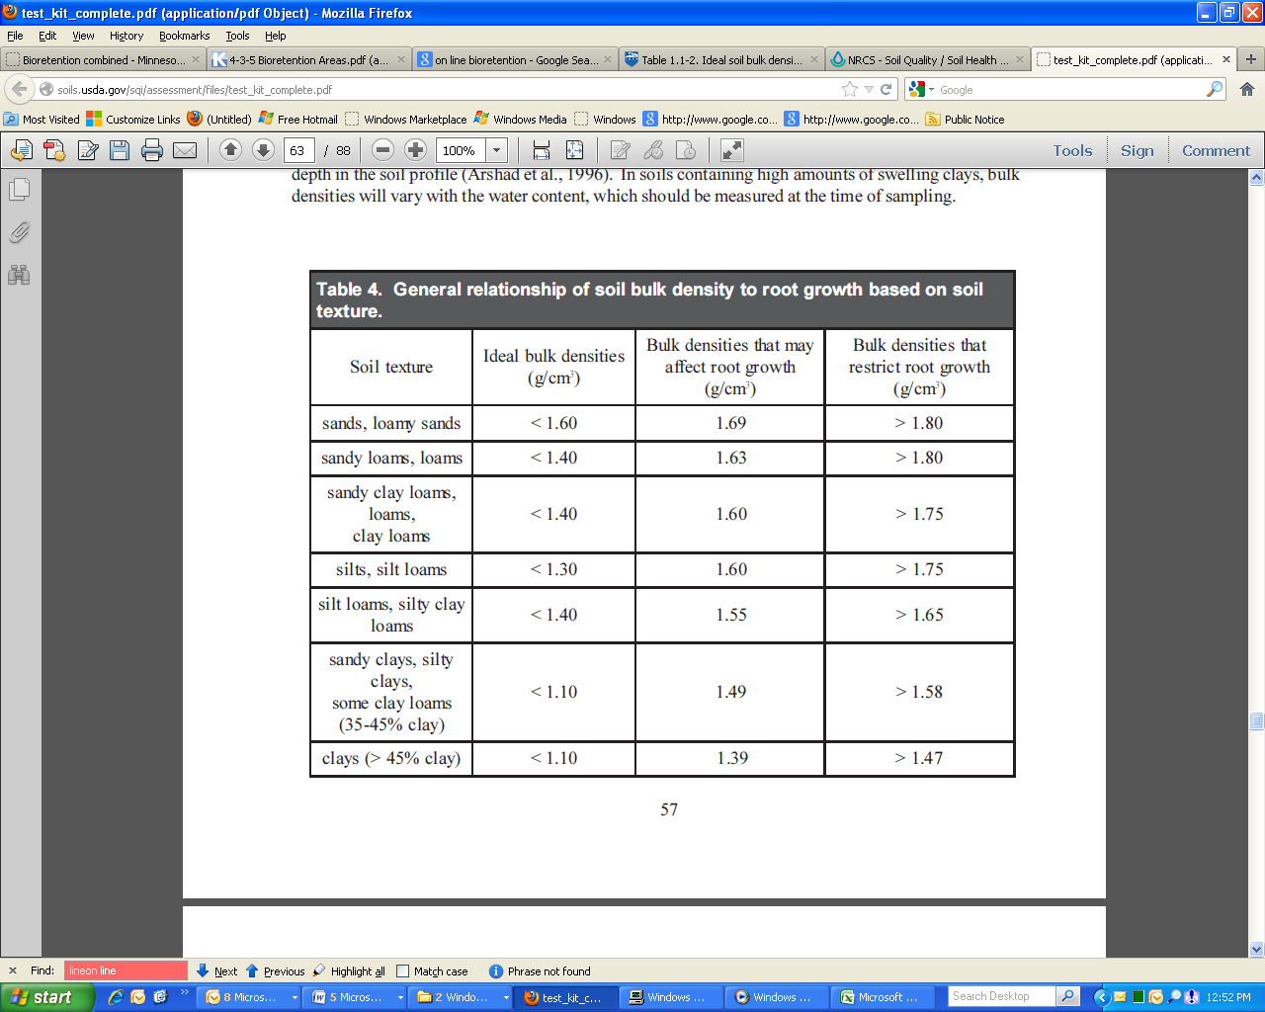

1. **Cost Estimates**

Cost for subsoiling varies significantly from project to project. Table 6.5, for example, shows average costs for subsoiling for MnDOT projects from 2002-2012 (source: Stenlund, 2013):

|  |  |  |  |  |
| --- | --- | --- | --- | --- |
| Year | Spec No. | Acres | Ave Bid Price | No. Projects |
| 2002 | 2105.55 | 200 | $                  61.26 | 3 |
| 2003 |  | 14 | $                646.87 | 3 |
| 2004 |  | 501 | $                  62.72 | 5 |
| 2005 |  | 73 | $                153.48 | 7 |
| 2006 |  | 1 | $            2,500.00 | 1 |
| 2007 |  | 231 | $                  90.87 | 4 |
| 2008 |  | 69 | $                245.65 | 2 |
| 2009 |  | 70 | $                450.09 | 9 |
| 2010 |  | 117 | $                344.09 | 7 |
| 2011 |  | 73 | $                329.23 | 2 |
| 2012 |  | 34 | $                420.99 | 4 |

Table 6.5: Average costs for subsoiling for MnDOT projects from 2002-2012 (source: Stenlund, 2013)

The 2006 Pennsylvania Stormwater Best Management Practices Manual’s chapter on soil amendment and restoration provides the following cost estimates:

“Tilling costs, including scarifying sub-soils, range from $800/ac to $1,000/ac

Compost amending of soil ranges in cost from $860 to $1,000/ac”

1. **Recommendations**

**Infiltration Basins:**

If compaction is above the bulk density that may affect root growth per Table xxx, soil must be remediated as follows:

* Spread 4” compost in accordance with MNDOT Grade 2 Compost or sand over ripped subsoil.
* Rip to a depth of 18” where feasible (see II.A.3 “Where Ripping is Not Feasible”)
* If compaction is still above the bulk density that may affect root growth per Table xxx, rip again at a 90 degree angle to first pass.
* If compaction is still above the bulk density that may affect root growth per Table xxx, rip again until compaction is below the bulk density that may affect root growth per Table xxx.

Note: Maintain a 2’ minimum separation distance between bottom of infiltration practice and the elevation of the seasonally high water table and bedrock. If there is only a 3’ separation distance between the bottom of the infiltration practice and the elevation of the seasonally high water table or bedrock, limit ripping depth to 12”.

**Bioretention Basins:**

For basins larger than 1000 s.f., if compaction is above ideal bulk density per Table x, soil must be remediated as follows:

* Rip to a depth of 18” where feasible (see II.A.3 “Where Ripping is Not Feasible”)
* For clay subsoil, incorporate 2” of sand. For bioretention without an underdrain, MnDOT Type 2 compost may be incorporated instead of sand.

Note: Maintain a 2’ minimum separation distance between bottom of bioretention practice and the elevation of the seasonally high water table and bedrock. If there is only a 3’ separation distance between the bottom of the bioretention practice and the elevation of the seasonally high water table or bedrock, limit ripping depth to 12”.

1. **References**

Brown, R.A. and Hunt, W.F. (2010). “Impacts of construction activity on bioretention performance.” *Journal of Hydrologic Engineering*. 15(6), 386-394.

Chaplin, Jonathan, Min Min, and Reid Pulley. 2008. “Compaction Remediation for Construction Sites.” Final Report. Department of Bioproducts and Biosystems Engineering, University of Minnesota, St. Paul, Minnesota.

Cogger, C. "Potential Compost Benefits for Restoration of Soils Disturbed by Urban Development." Compost Science & Utilization 13.4 (2005): 243-251.

Dallas, H. and A. Lewandowski, 2003. Protecting Urban Soil Quality: Examples for Landscape Codes and Specifications. USDA Natural Resources Conservation Services.

[Kees](http://www.fs.fed.us/t-d/pubs/htmlpubs/htm08342828/page08.htm#Gary), Gary. 2008. Using Subsoiling To Reduce Soil Compaction. U.S. Forest Service Technology & Development Publication [3400 Forest Health Protection](http://www.fs.fed.us/t-d/php/tdc_search.php?category=Program&srchword=10) 0834-2828-MTDC. Downloaded from [http://www.fs.fed.us/t-d/pubs/htmlpubs/htm08342828/index.htm July 15](http://www.fs.fed.us/t-d/pubs/htmlpubs/htm08342828/index.htm%20July%2015), 2013

NRCS. 1998. Soil Quality Test Kit Guide.

Olson, Nicholas Charles. 2010. Quantifying the Effectiveness of Soil Remediation Techniques in Compact Urban Soils. University Of Minnesota Master Of Science Thesis.

Owen, Gordon T*.* 1987. “Soil disturbance associated with deep subsoiling in compact soils.” Canadian Agricultural Engineering: 33-37.

Pennsylvania Stormwater Best Management Practices Manual. BMP 6.7.3: Soil Amendment & Restoration. 2006. Downloaded July 5 from http://www.elibrary.dep.state.pa.us/dsweb/Get/Version-69220/

Pitt, R., Chen, S., Clark, S.E., Swenson, J., and Ong, C.K. 2008. “Compaction’s impact on urban storm-water infiltration.” *Journal of Irrigation and Drainage Engineering*. 134(5), 652-658.

Schueler, T. 2000. The Compaction of Urban Soil: The Practice of Watershed Protection. Center for Watershed Protection, Ellicott City, MD. Pages 210-214 downloaded from <http://www.cwp.org/online-watershed-library/cat_view/63-research/75-monitoring>

Schueler, T. R. Can Urban Soil Compaction Be Reversed? Technical Note #108 from Watershed

Protection Techniques. 1(4): 666-669.

Selbig, W.R., and N. Balster. 2010. Evaluation of turf-grass and prairie-vegetated rain gardens in a clay and sand soil: Madison, Wisconsin, water years 2004–08: U.S. Geological Survey, Scientific Investigations Report 2010–5077, 75 p.

Spoor, G. & Godwin, R.J. 1978. An experimental investigation into the deep loosening of soil by rigid tines. Journal of Agricultural Engineering Research, 23, 243–258.

Spoor, G., Tijink, F.G.J. & Weisskopf, P. 2003. Subsoil compaction: risk, avoidance, identification and alleviation. Soil and Tillage Research, 73, 175–182.

Spoor, G. "Alleviation of Soil Compaction: Requirements, Equipment and Techniques." Soil Use and Management 22 (2006):113-122.

Stenlund, Dwayne. Minnesota Department of Transportation. 2013. Personal Communication.

Tyner, J.S., Wright, W.C., and Dobbs, P.A. (2009). “Increasing exfiltration from pervious concrete and temperature monitoring.” *Journal of Environmental Management*. 90, 2636-2641.

Urban, James. 2008. Up by Roots. International Society of Arboriculture: Champaign, IL.

Virginia Tech Rehabilitation study website, accessed July 10 from <http://urbanforestry.frec.vt.edu/sres/index.html>