Constructed Wetland Example (Version 2)

A wetland is to be constructed in a watershed that contains a 1.4 acre parking lot surrounded by 0.8 acres of pervious turf area. All of the runoff from the watershed will be treated by the wetland. The soils across the area have a unified soils classification of SM (HSG type B soil). The following steps detail how this system would be set up in the MIDS calculator.

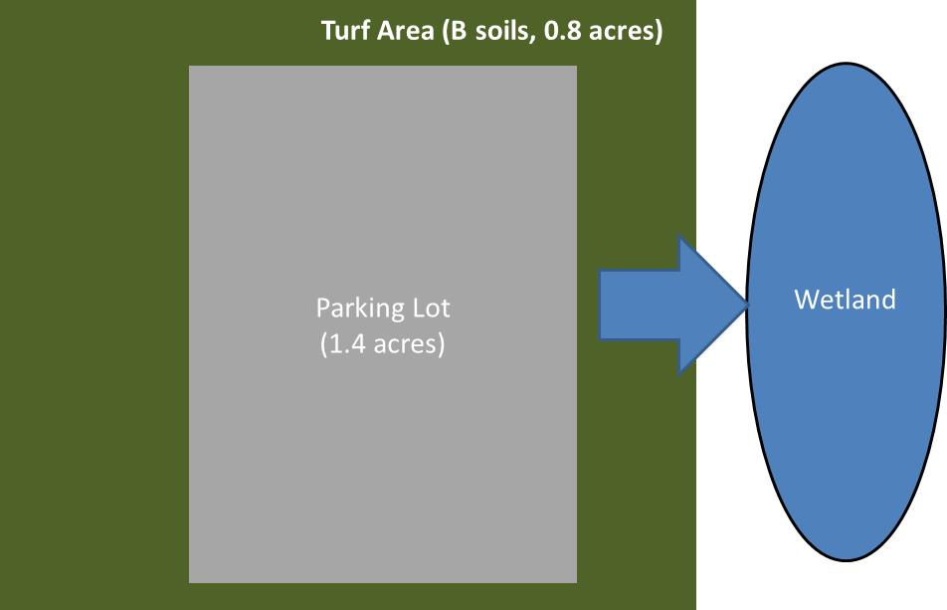
Step 1: Determine the watershed characteristics of your entire site. For this example we have a 2.2 acre site with 1.4 acres of impervious area and 0.8 acre of pervious turf area in type B soils. The pervious area or impervious area does not include the wetland area.

Step 2: Fill in the site specific information into the “Site Information” tab. This includes entering a Zip Code (55414 for this example) and the watershed information from Step 1. Zip code and Impervious area must be filled in or an error message will be generated. Other fields on this screen are optional.
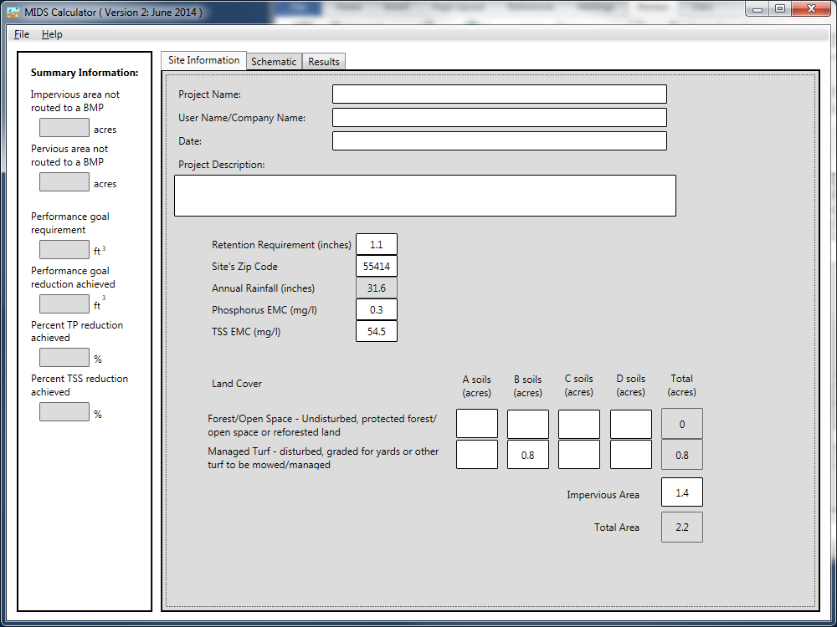

Step 3: Go to the Schematic tab and drag and drop the “Wetland” icon into the “Schematic Window”
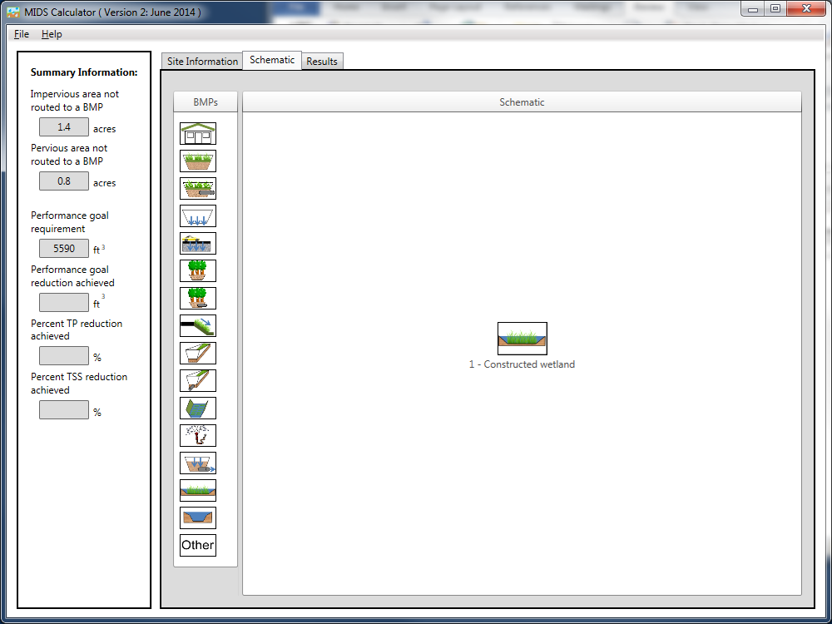
Step 4: Open the BMP properties for the wetland by right clicking on the “Constructed wetland” icon and selecting “Edit BMP properties”, or by double clicking on the “Constructed wetland” icon.
Step 5: Click on the “Minnesota Stormwater Manual Wiki” link or the “Help” button to review input parameter specifications and calculation specific to the “Constructed Wetland” BMP.
Step 6: Determine the watershed characteristics for the wetland. For this example the entire site is draining to the wetland. The watershed parameters therefore include a 2.2 acre site with 1.4 acres of impervious area and 0.8 acres of pervious turf area in type B soils. There is no routing for this BMP. Fill in the BMP specific watershed information (1.4 acres on impervious cover and 0.8 acres of Managed Turf in B soils).

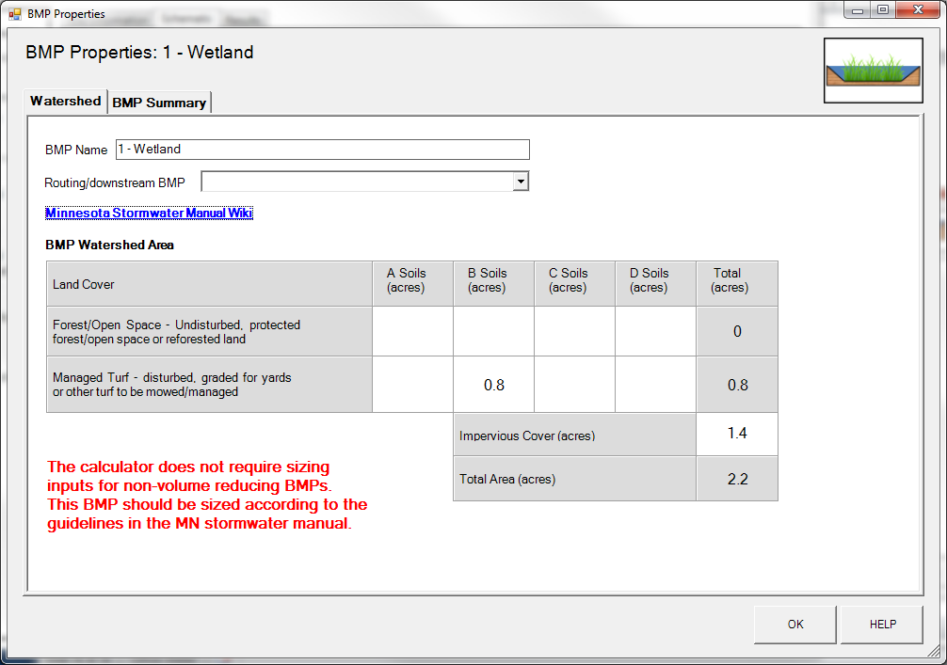

Step 6: Design parameters are not required for the wetland BMP. Click on “BMP Summary” tab to view results for this BMP.
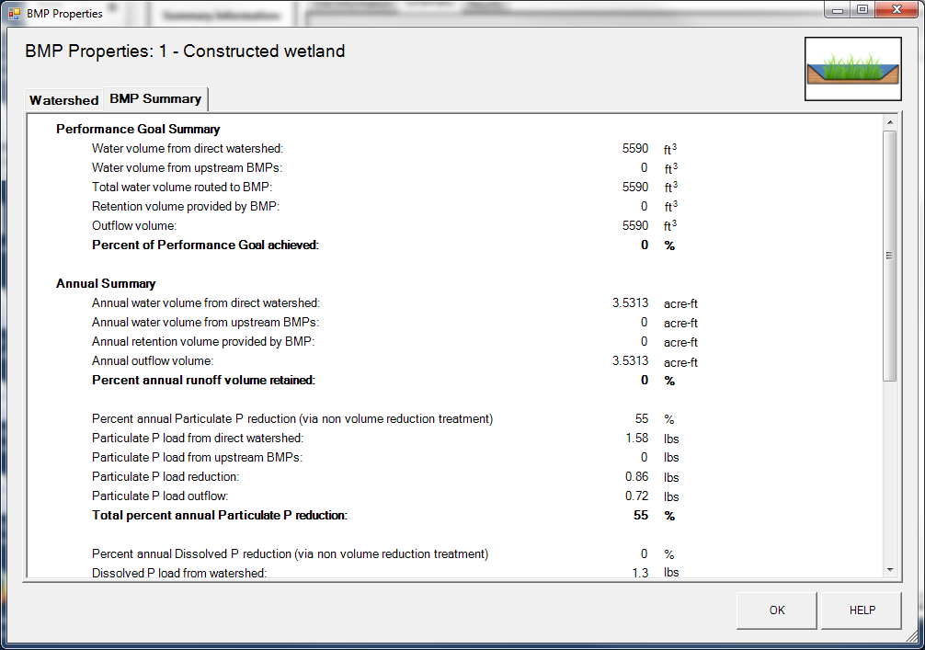

Step 7: Click on the “OK” button to exit the BMP properties screen.
Step 8: Click on “Results” tab to see overall results for the site.

