Storm Drain Stenciling Instructions

GENERAL INSTRUCTIONS

1. Work in groups of at least four, if possible. Two or three people can stencil and one or two can distribute the door hangers to houses nearby.

2. Because they are working in traffic, the people painting the stencils must wear orange safety vests (provided).

3. Three orange safety cones will be provided for each group. Before beginning to prepare the area for the stencil, place the cones approximately where the triangles are located in the diagram below.

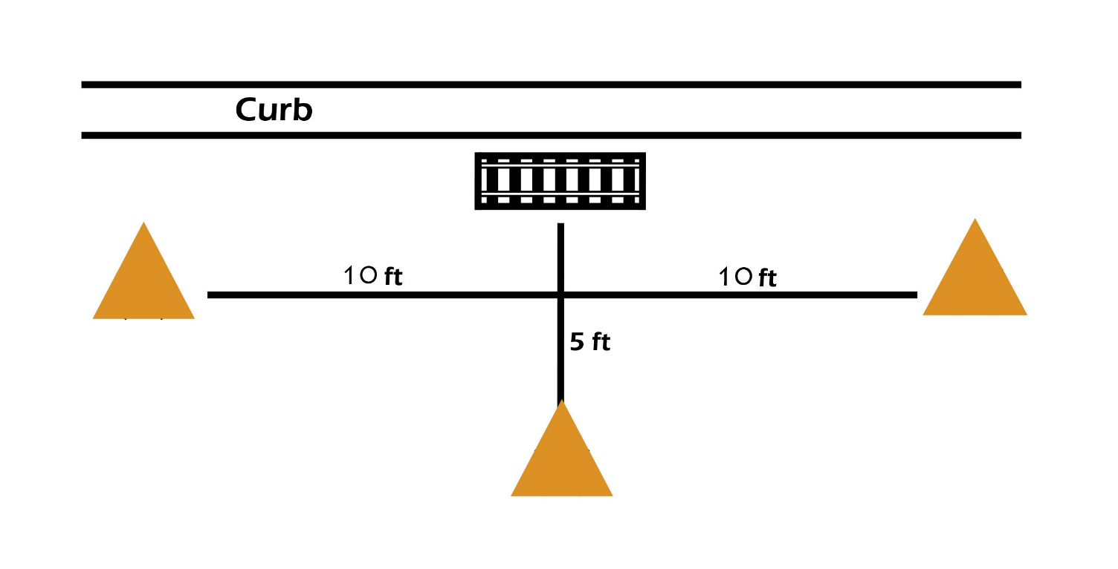
4. Have one person watch for traffic while the other paints the stencil

5. Do not attempt to paint stencils onto pavement that is wet with water from rain, lawn sprinkling, etc. The paint will not stick.

STENCILING INSTRUCTIONS

1. Set up the safety cones

2. You will be putting a stencil on each side of the catch basin and painting stencils so they can be read from the street. The stencils should be positioned as in the photo below.

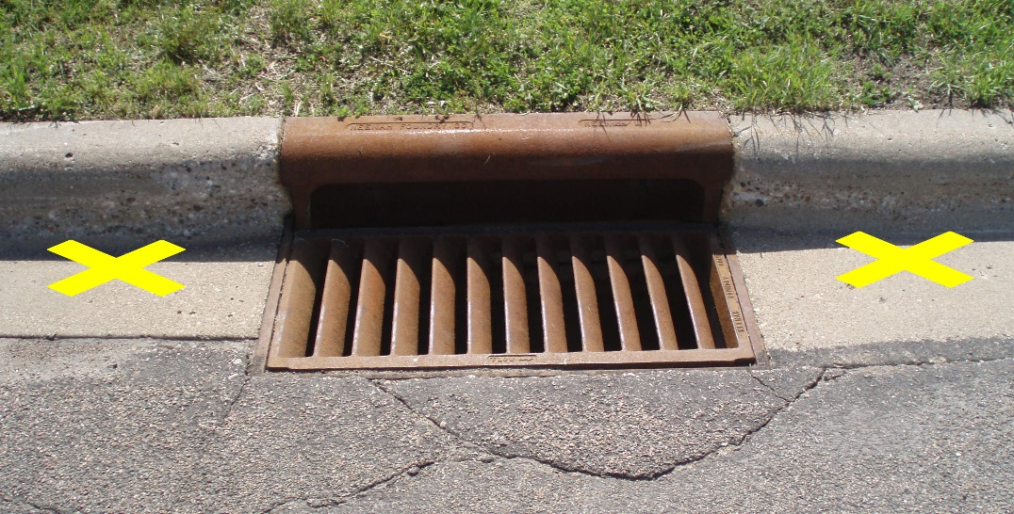

3. With the brushes provided, thoroughly clean the concrete gutter area on each side of the catch basin.

4. Lay the stencil down straight on the cleaned area. It may help to place weights on the sides of the stencil to keep it from curling while you are painting. Paint one word at a time on the stencil. If you are patient, your stencil will last longer and you will waste less paint. A few quick passes over each word should be enough. The less paint, the better.

5. Distribute the door hangers to homes nearby.

6. Keep a count of the number of catch basins your group stencils and mark them on the map provided. Fill out the provided volunteer group summary report when you are finished.

7. After you’ve finished your stenciling project, dry the stencils and use the putty knife provided to gently scrape away some of the excess paint on the stencil, especially around the letters.

8. Congratulate yourselves for helping keep your ponds and lakes, and rivers clean.

