REPORT FOR OBJ1.TASK 8: TREE MONITORING, INVENTORY, PROTOCOLS
To: MPCA
From: The Kestrel Design Group Team
Date: October 18, 2013
Re: Contract CR5332

SCOPE

Obj1.Task 8: Tree Monitoring, Inventory, Protocols:
Develop and submit monitoring guidelines for tree BMPs. Monitoring means tree assessments or inventories and does not refer to water quality monitoring.
  - Review scientific literature to identify existing guidelines for monitoring tree BMPs. In conducting this review, Kestrel will identify information that will be included in a tree inventory or assessment. This includes, but is not limited to number, age, and condition of trees; canopy coverage; and special considerations, such as cold climate and soil type. Sources of information will include the United States Department of Agriculture’s i-Tree tool (see http://www.itreetools.org/) and case studies of tree inventories or assessments, such as the inventory conducted in the city of Vancouver, B.C. (see http://www.cityofvancouver.us/News.asp?submenuID=16578&Id=88287). Identify methods for conducting assessments and inventories, such as remote sensing and volunteer programs.
  - Prepare and submit a Technical memo summarizing monitoring guidelines for tree BMPs.
  - Prepare and submit a report that provides monitoring guidelines.

LIST OF TABLES

Table 8.1 - Tree Indicators (Eichhorn-Roskams 2013)
Table 8.2 - Apical Shoot Scoring System (Eichhorn-Roskams 2013)
Table 8.3 - Fructification Scoring System (Eichhorn-Roskams 2013)
Table 8.4 - Signs and Symptoms Scoring (Eichhorn-Roskams 2013)
Table 8.5 – (4 pages total: 8.5.1-8.5.4) Signs and Symptoms Specification (Eichhorn-Roskams 2013)
Table 8.6 - Crown Distance Scoring (Eichhorn-Roskams 2013)
Table 8.7 - Summary of features of four types of urban forest analyses (USDA USFS NRS 2013)

REPORT

INTRODUCTION
The health of the urban, suburban, rural, and natural forest is rarely limited to individual species alone. Rather, the assessment of the forest health should be both related to the individual and the larger collection of and interaction between individuals. Although assessment of the individual is a discrete process and set of data, the assessment of the larger canopy and forest should not be neglected due to difficulty in assessing and quantifying the larger, landscape-scale health and functioning.
Many metrics and methods have been developed for assessment of individual tree health. The concept of “resilience” at the individual and canopy levels is the core of the assessment tools; the majority of these evaluative methods and metrics focus on the response of the individual or evaluative unit to a disturbance regime to quantify the “resilience.” The type and capacity of response to the given disturbance and the time it takes to return to the initial qualitative equilibrium state indicate the overall resilience to the disturbance or pressure. (Eichhorn and Roskams 2013) Eichorn and Roskams (2013) cite various sources indicating that this return to “equilibrium” is not always return to the initial state, stating that, “open systems will reorganize at critical points of instability.” Determining the critical thresholds for certain pressures, disturbances, and changes the system or individual can tolerate before it cannot recover can provide proxy for tree and forest health. (Eichhorn and Roskams 2013)
The resilience of the tree individuals and canopy is often difficult to quantify directly for many pressures. Rather, indirect measures are often employed for inventory and monitoring of tree health. Measurements and metrics can also be taken both directly (e.g. assessing growth rings from a core) and indirectly (e.g. remote sensing of canopy leaf area). Direct and indirect methodologies are discussed and compared hereafter.
It is suggested that the base of monitoring, evaluation, and correlation of forest health be that of overall forest resilience, rather than individual tree health; the foundation of the assessment focuses on the health of the individual as a component of the collection of individuals in the forest canopy. Eichhorn and Roskams (2013) suggest using two levels of monitoring and implementation:

- Level 1 – a large-scale systemic network of the trees within the defined forest area or region; and,
- Level 2 – an individual- or stand-based approach using intensive monitoring plots
These levels are not distinct in their interactions and the informants gained at each level can inform the interactions and informants at the other. Interactions at each of these levels may also be correlated with and inform forest health and interactions at the national or global scale. We suggest future strategies and policy efforts to standardize, create, and implement a larger national, and possibly global, forest assessment tool for monitoring, assessing, and evaluating the health of our forest.
Per the International Co-operative Programme on Assessment and Monitoring of Air Pollution Effects on Forests (per Eichhorn and Roskams 2013), implementation within the MPCA tree monitoring focuses on the following objectives of Minnesota tree condition monitoring, as a subset of the national and global forest system:
- to contribute to a [Minnesota-wide] early warning system and to a better understanding of tree vitality, including relationships to stress factors and ecosystem disturbances;
- to provide a periodic information on the spatial and temporal variation of tree condition in relation to stress factors;
- to currently document and evaluate the major environmental challenges in [Minnesota] such as the impact of climate change on forest ecosystem stability;
- to gain information about the impact of biotic and abiotic stressors on crown and tree condition;
- to provide baseline data on the distribution, occurrence, and harmfulness of biotic agents or co-occurring factors in total or parts of [Minnesota];
- to validate models regarding stress or risk for trees;
- to contribute to decision support for forest policy and forest practice with regard to ecological sustainability of forest management.
The methodologies presented hereafter focus on these objects in order to establish a framework for a comprehensive tree monitoring system that can be added to as new methodologies and assessment tools emerge.
METHODOLOGIES FOR ASSESSING TREE HEALTH
As previously mentioned, assessment of tree and forest health can be measured directly or indirectly at either the Level 1 (overall forest) or Level 2 (individual or stand) scales. Indicators of tree condition found in monitoring efforts may be assessed via qualitative and quantitative methods for assessing morphology and architecture (canopy, trunk, fruit, roots, etc.), forest composition, biotic/abiotic agents, growth rate, and age. Table 8.1 below from Eichhorn and Roskams (2013) gives an overview of indicators of tree health that may be focused on within a monitoring program at both Level 1 and Level 2, and the targeted areas for assessment and evaluation.
Table 8.1 - Tree Indicators (Eichhorn-Roskams 2013)
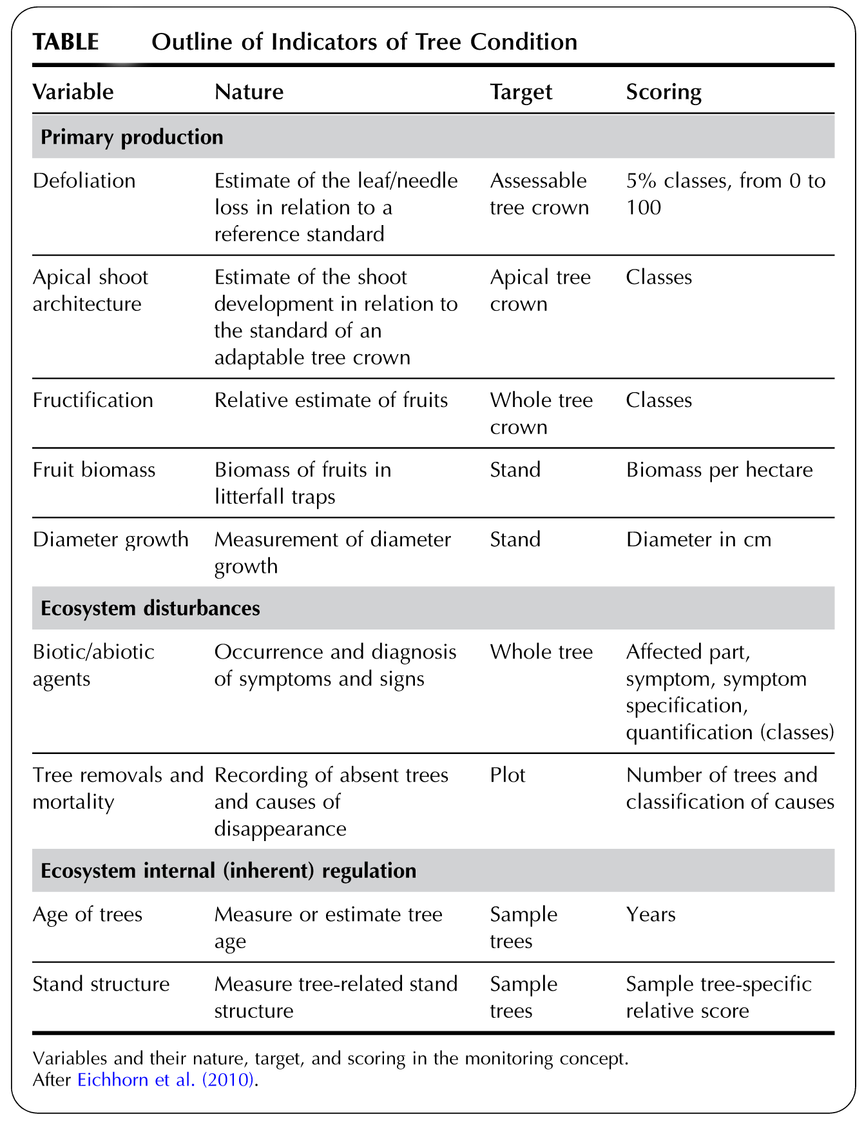

The proposed MPCA tree and forest monitoring system and protocol presented hereafter focuses mainly on direct measurements of individual trees at a Level 1 scale, as a proxy for Level 2 interactions, using the Eichhorn-Roskams (2013) seen in Table 8.1.
Direct Measurement Methods. The majority of these methods employ tree architecture and morphology as a measure and indicator of tree health. The measurements are broken down by foliation (defoliation) of the upper crown/canopy, apical shoot architecture, and fructification. The following table breaks down the areas of evaluation and assessment within each category of tree :

Area of Tree | Qualitative and Quantitative Evaluation and Assessment
Foliage | - Leaves, related to ability of tree to capture light for metabolic processes (photosynthesis), particularly noting:  - overall canopy area  - any openings in the canopy, and areas of those  - quality of leaves, noting any structure or color change  - leaf drop, patchiness, or mortality
Apical Shoots and Overall Tree Architecture and Morphology | - Trunk –  - quality and location of any damage, disruptions, and disturbance  - type of response noted to disturbance (e.g. scab, open wound, healing etc.)  - bark quality to known standards, noting any quality and quantity differences from normal  - Presence of insects, insect-related activity, and infection  - Branches –  - overall divergence from normal branching pattern (e.g. no limbs on one side of tree)  - branch mortality or abscission, presence of and location per normal growth patterns  - no leaf out and bud-related structures set, presence of and location per normal patterns  - presence of insects, insect-related activity, and infection
Fructification | - Fruit production, as indicator of reproductive success and health, infection, or stress-related response  - Quality of fruit, noting any damage, infection, or pest indications  - Quantity of fruit. Can be difficult to interpret results, as fruit abundance or deficit can indicate stress (succession-related response of reproductive proliferation and seed bank inundation prior to mortality) or success/health (succession-related response of population growth due to abundant resources; excess resources and metabolic byproducts applied seed production)
Roots | - Difficult to assess without disturbing tree, with exception of aerial root structures (not found in MN species).  - Note any presence and location of roots and root structures above soil finished grade.

SUGGESTED MONITORING PROTOCOL

The Tree Operations and Maintence Guidelines in a following section provide a series of responses to the findings from the specified monitoring. This series of responses is mainly on a Level 1, or individual basis, with limited Level 2 assessment suggested via remote sensing technologies. The collection, interpretation, and response to the larger forest (Level 2) health, requires collection and collaboration of results between individuals. Large-scale comparative and predictive metrics and an ecosystem-scale assessment system is suggested for future investigation to provide a standardized system for collection and comparison of Level 1 monitoring information.

Frequency of Monitoring. Annual tree monitoring is suggested for the crown and apical shoots (all above-ground structures). It is suggested that this could be performed with rapid assessment tools by citizens’ monitoring programs, watersheds, municipalities, or other groups. Standardization of the monitoring information collected, date of collection, procedure for collection, and reporting of monitoring for comparison of results between individuals and over larger areas is suggested.

Positions of Collecting Monitoring Information. Two points should be established and noted on a map and/or (preferred) GPS device for consistent results collection. One point (Point A) should be directly underneath the tree for assessment of leaf area coverage and canopy diameter. The second point (Point B) provides quantitative and qualitative results of tree height and vertical leaf coverage, and is suggested to be at least 50 feet from trunk to provide a fixed location for consistent evaluation as the tree grows. A GIS coverage and GPS-based system would aid in consistent evaluation and database assembly for large-scale evaluation and monitoring assessment and responses. Leaf and other tree debris can also be evaluated at any location underneath and surrounding the tree for gathering additional information regarding tree illness, injury, or stress responses.

Collected Information. Following information gathered should be assembled into a standard format. The information gathered focuses on the above-ground portion of the tree and surface root presence, on an individual/single-tree basis as the standard unit of measurement.
Please note: fructification can give ambiguous indications of overall health, and it should not be used as an independent indication of tree health. Fructification can be used in conjunction with the above-ground structural assessment as a component of the Level 1 (individual or stand) monitoring, but will be more effective as a Level 2 (larger-scale forest assessment) to indicate ecosystem-wide response to stressors, such as insect invasion and long-term drought or reduced soil moisture availability.

MONITORING PROGRAM

Level 1 Monitoring. Level 1 Tree Monitoring focuses on the individual or small unit of individuals for a field-based assessment tool. This program allows for increased ability to be performed by layperson and expert alike, but does not utilize less-accessible programs and methods such as GIS-based or model-based systems that would be more useful at a Level 2 analysis. Other methodologies – electrical conductivity within sap, chlorophyll fluorescence, glucose presence - for Level 1 monitoring were encountered in the literature review, but the tools and/or knowledge required to perform the analyses or monitoring or the detailed level of information gather were prohibitive for generalized use in this level of monitoring program. (Martinez-Trinidad, et al. 2010) It is suggested that this monitoring methodology be standardized in a rapid assessment form for data collection and comparison throughout Minnesota to better perform the Level 2 analyses and provide a greater degree of statistical confidence in results due to standardized methodology.

1. Assessing the Tree Canopy and Above-Ground Structures. Includes the leaves and leaf structures and/or needles in the tree. Please take a photo from Location A and B that captures the extent of the foliage. Take multiple images if necessary, indicating the general direction of view. Complete the following assessment of the canopy, providing additional information of photo-documentation where appropriate.
- Defoliation: a relative amount of needles or leaves are missing from the canopy as compared to a reference tree. Is there any level of defoliation noted?
□ Yes □ No Estimated % Defoliation Noted _________%

Describe the location, relative area (sq. ft.) of the defoliation, percent canopy/leaf loss (% of whole area), and any other notable information regarding each defoliation area noted from visual assessment at Locations A and B. Please take photographs as necessary, noting the general direction of view.
____________________________________________________________________________________________________________________________________________________________________________________________________________________________________
- Apical Shoot Architecture: the architecture of the most recent growth of branches in the canopy where the majority of leaves are located and arranged. Please answer all of the following questions when examining the apical shoot architecture from Locations A and B and then rate the tree on the following scoring system for the Apical Shoot Architecture.

What is the estimated length of a typical apical shoot? ________inches

Are the upper-most apical shoots alive, as indicated by color and twig turgor pressure (e.g. not dried and brittle in appearance)?
□ Yes □ No
What is the color of the typical apical shoot?

□ Lt. Brown □ Dark Brown □ Green □ Yellow □ Red □ Other, specify___________

Is there any presence of the following in the apical branch growth? Mark all that apply, and indicate general location of the noted issues.
□ spear-shaped twigs
□ short twigs
□ lack of bud structures (dormant season only for deciduous trees)
□ a large numbers of twigs emerging from the tips of the next lower level of branching
□ a lack of branch growth in one area or on one side of the tree
Please describe any of the noted issues above here:
_________________________________________________________________________________________________________________________________________________________________________________________________________________________________

Table 8.2 - Apical Shoot Scoring System (Eichhorn-Roskams 2013)

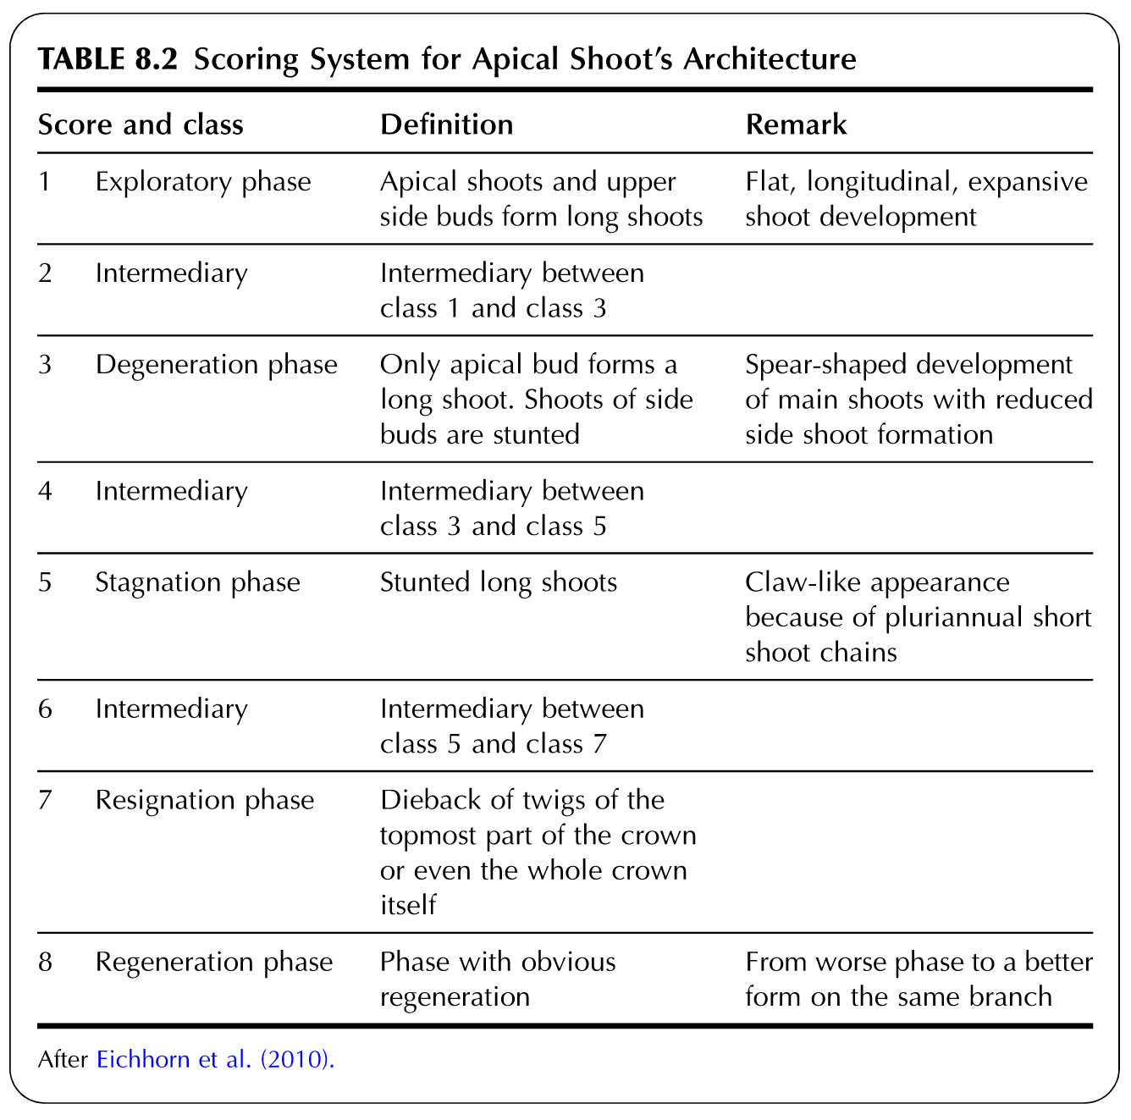

- Fructification: the fruits and fruiting bodies of trees can indicate much about the health or lack thereof of the individual. Please answer all of the following, per the following scoring system.

Is fruit present on the tree? Please only note the presence of new fruit from this year, and not “old” fruit from the previous year, as would be distinguished as wrinkled or shriveled in appearance.
□ Yes □ No

Describe the location, relative area covered, and any other notable information regarding the fruiting from Locations A and B. Please take photographs as necessary, noting the general direction of view.
____________________________________________________________________________________________________________________________________________________________________________________________________________________________________

Table 8.3 - Fructification Scoring System (Eichhorn-Roskams 2013)

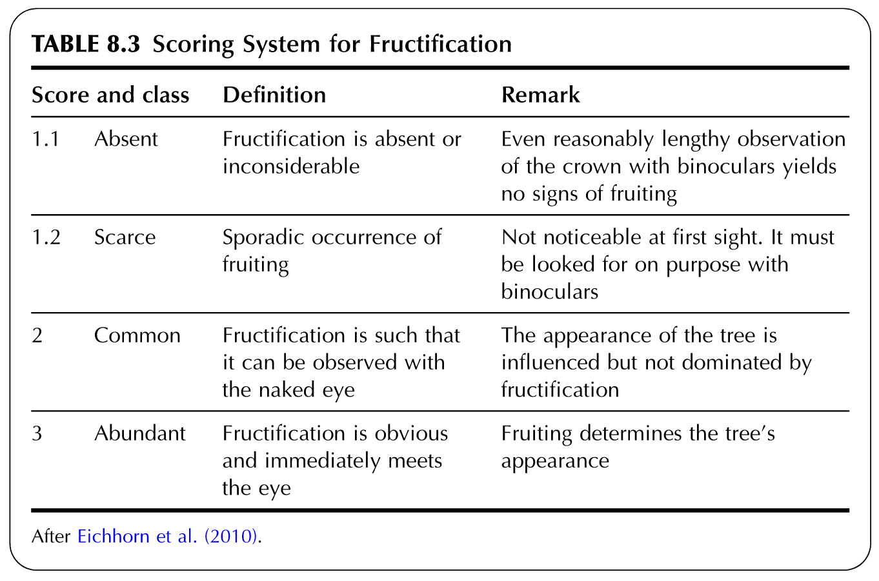

- Roots: the majority of the root system should be below ground and relatively difficult to assess and monitor, however, the presence and effects of circling/girdling roots may provide symptoms in tree morphology. Please answer all of the following:

Is there a lack of branching or a flat side observed on the tree, or are there any girdling roots observed around the main trunk at or above the soil surface? Please note the presence of these features that would indicate root-related issues.
□ Yes □ No

Describe the location and any other notable information regarding the presence of roots above ground from Locations A and B. Please take photographs as necessary, noting the general direction of view.
____________________________________________________________________________________________________________________________________________________________________________________________________________________________________

- Biotic and Abiotic Damages. These pressures are witnessed by signs – direct evidence of a damaging factor – and symptoms – indirect results or evidence of the damaging factor (e.g. leaf proliferation following a windstorm) – of tree health due to biotic and abiotic (environmental) influences. Please assess any and all of the following damages due to biotic and abiotic factors using the following questions and scoring table.
□ Leaves/needles show signs or symptoms of damage due to biotic or abiotic factors. Please note the number and location of these areas and describe the nature – color, size, affected part of the tree, etc. – of each affected area. Please refer to the following table on the Scoring System of Trees Based on Observed Signs and Symptoms :
Please describe any of the observed issues designated in the scoring system here:
____________________________________________________________________________________________________________________________________________________________________________________________________________________________________

Table 8.4 - Signs and Symptoms Scoring (Eichhorn-Roskams 2013)

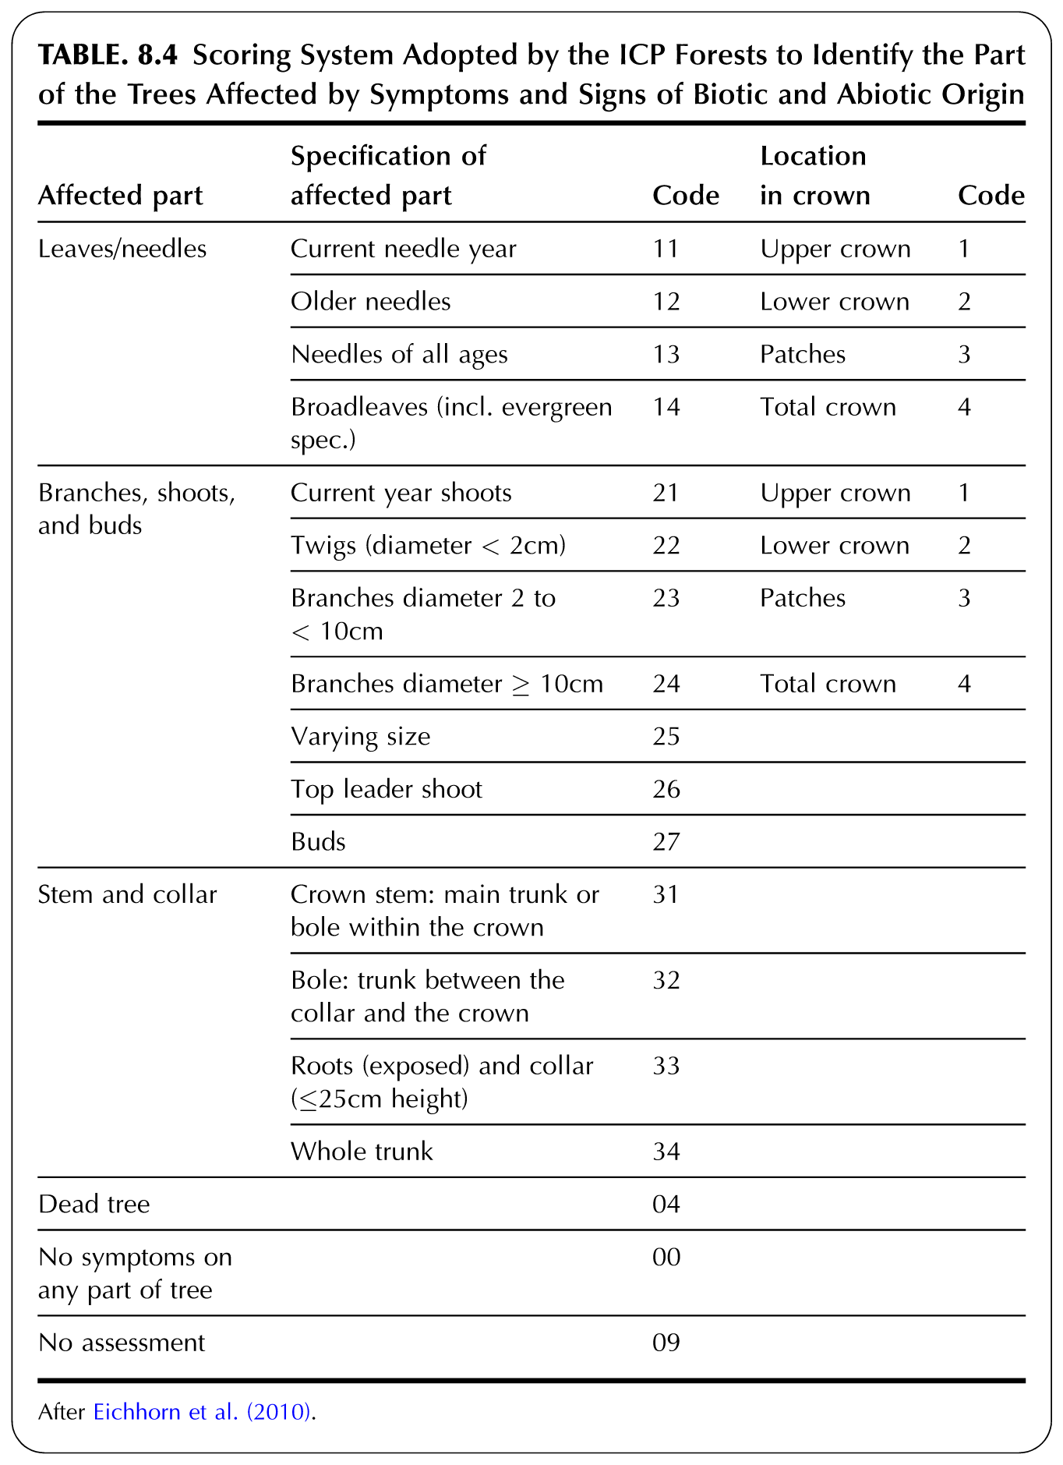

Table 8.5 – Signs and Symptoms Specification (Eichhorn-Roskams 2013)

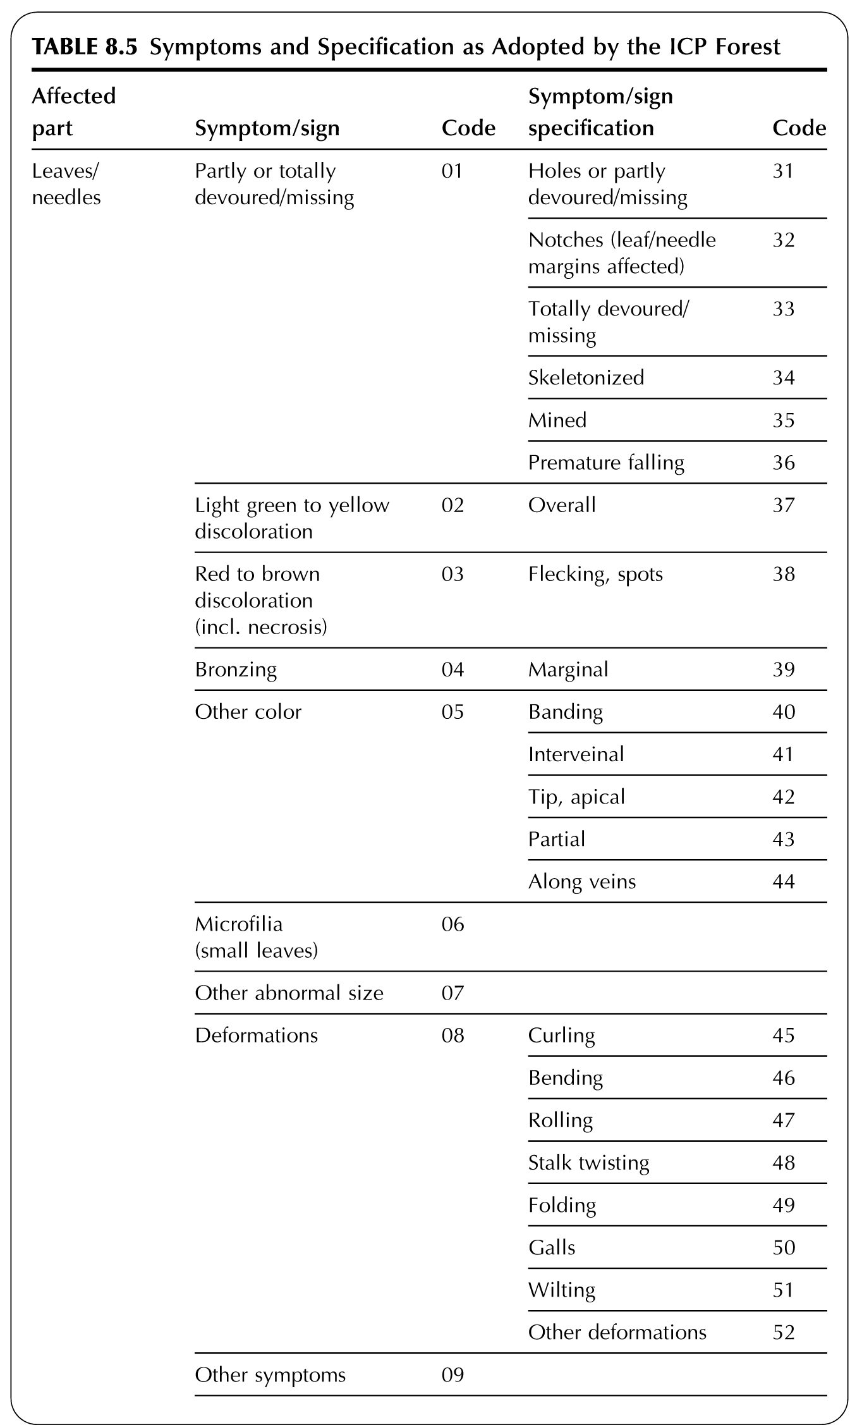
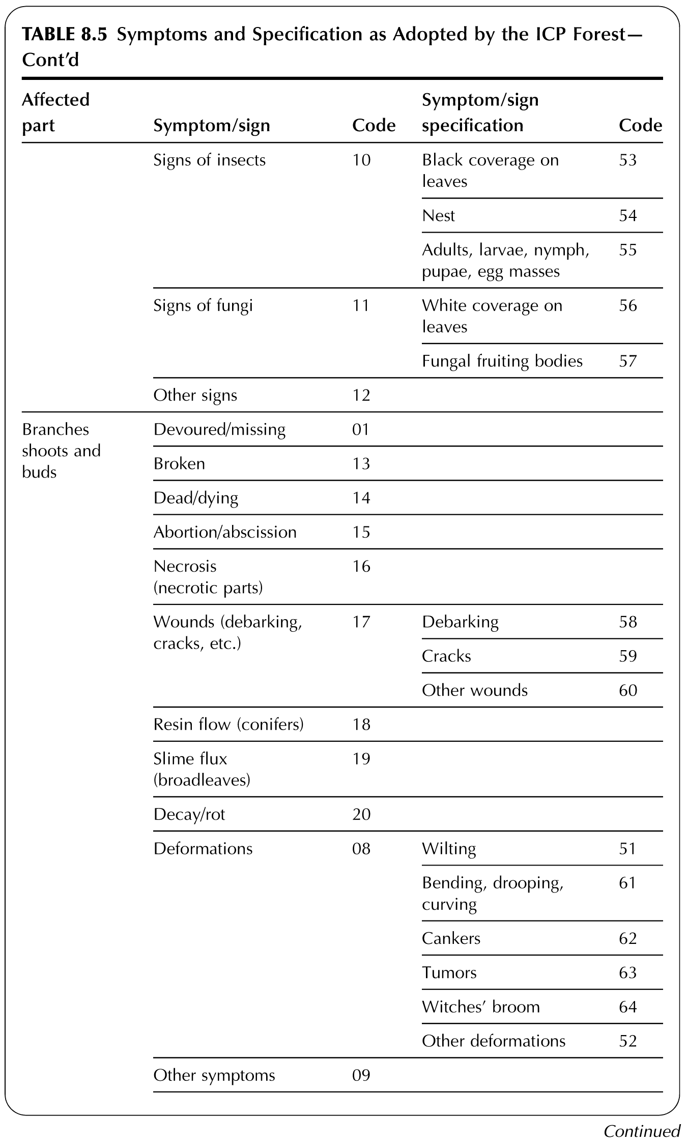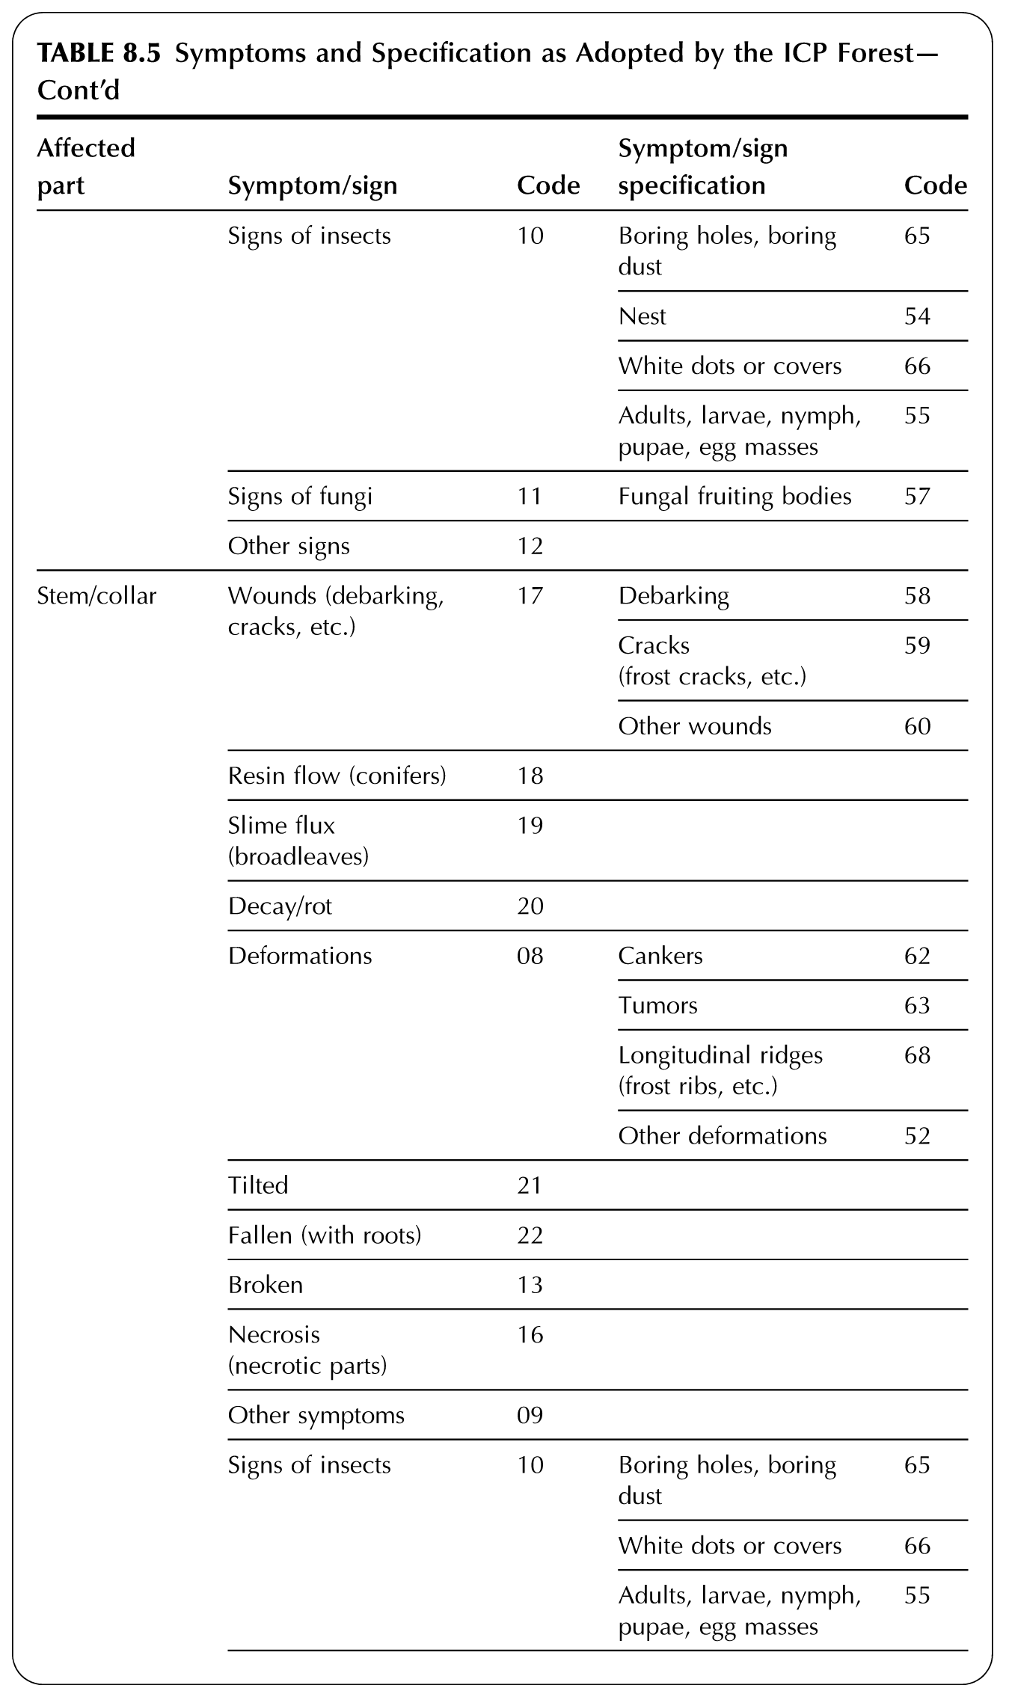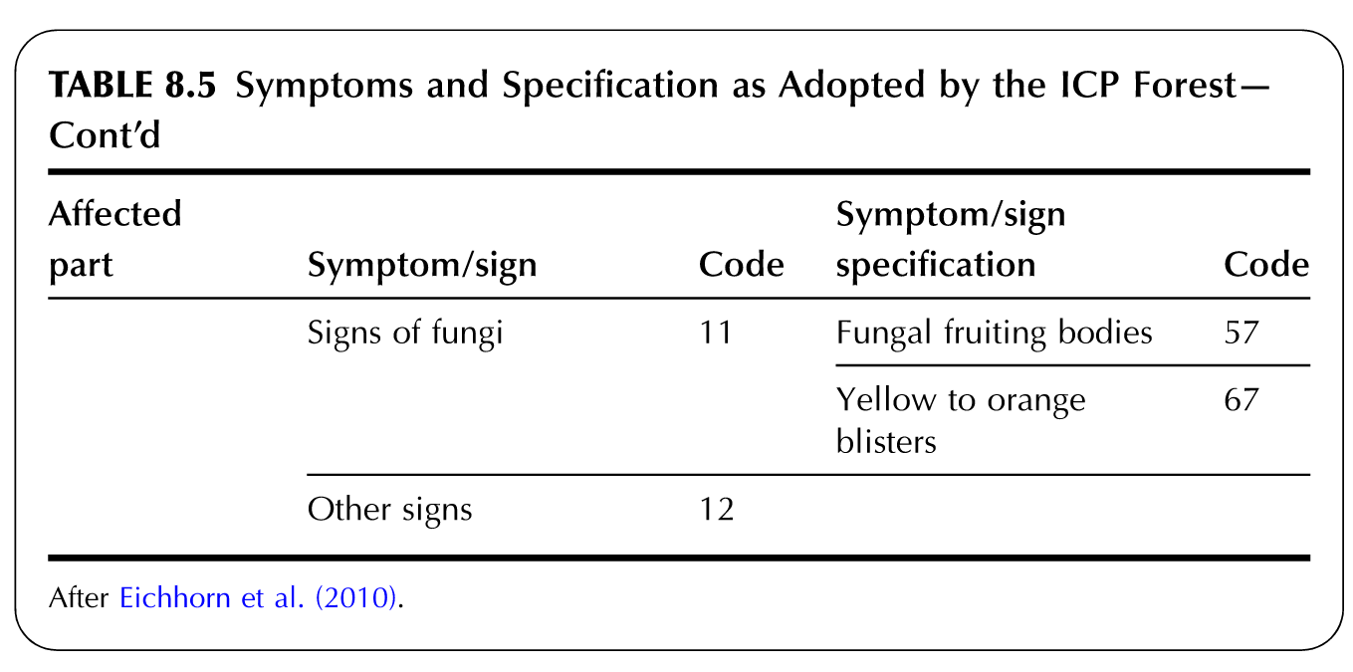

- Crown Distance Assessment. The distance between individual canopies can provide positive and negative aspects to tree health. Some positive aspects of canopies being in close proximity to their neighbors is collective support from wind and other abiotic factors, whereas some negative aspects are increased disease transmissivity, shading, and competition for finite moisture and other resources. Please rate the overall crown distance between adjacent trees in each perpendicular direction and the monitored individual using the following system shown in the Table on Relative Crown Distance.
Please describe any of the observed issues within or among the canopy relating to the adjacent canopies in the scoring system here:
____________________________________________________________________________________________________________________________________________________________________________________________________________________________________

Table 8.6 - Crown Distance Scoring (Eichhorn-Roskams 2013)

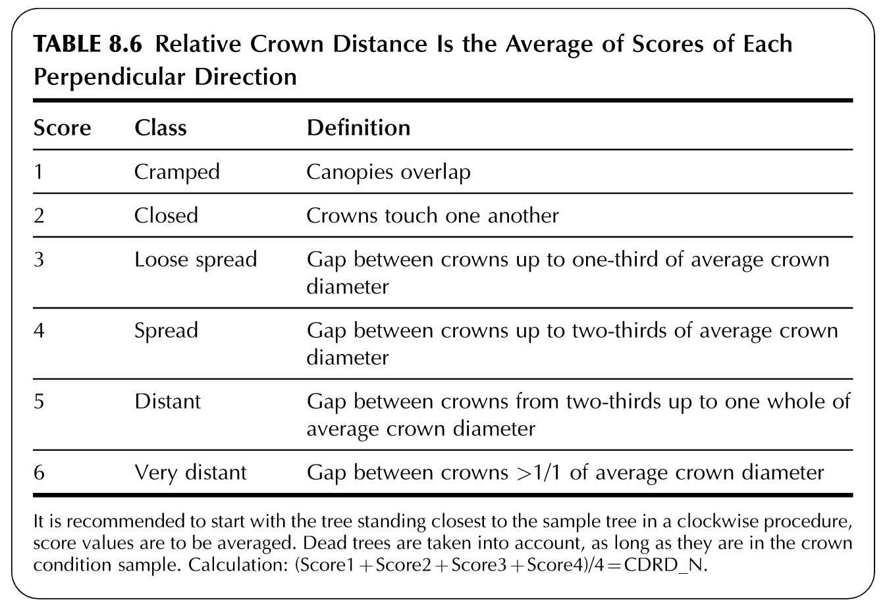

Please refer to the Maintenance Guidelines in future sections for specific guidance of response to individual tree monitoring findings.

Level 2 Monitoring. Larger-scale monitoring is difficult to assess with standard assessment tools. Large-scale monitoring of crown coverage can be performed by remote sensing methods. These methods include utilizing National Land Cover Data (NCLD) analyses, high resolution land cover gained from satellite and/or aerial sourced-photography that is interpreted by pattern for land cover, and aerial photography. (Eichhorn and Roskams 2013; USDA USFS Northern Research Station (Date Unknown)) These digital models are better adapted for these large scale monitoring efforts, using base data acquired in Level 1 Monitoring in conjunction with climatic inputs, aerial imagery, and other remotely-sensed data that might not be otherwise available or useful at a site or individual scale or level of monitoring. An effective monitoring and overall assessment of a Level 2 scale system was performed for Los Angeles using USFS iTree software, examining and assessing not only the forest health for 30+ years, but the additional impacts and ecosystem services related to the urban forest on the health of the resident population. (McPherson, et al. 2011) The application of this protocol to potential Level 2 monitoring by the MPCA warrants further investigation and implementation into monitoring protocol, data assembly, interpretation, trend analysis, composition assessment, resilience analysis, and resource allocation and prioritization.

Several free programs exist to assist in collecting and interpreting the results of Level 2 forest analyses, including Growth Simulator SILVA (Technische Universitat Munchen, Germany), FVS (USFS), TIPSY (BC CANADA Ministry of Forests, Lands, and Natural Resource Operations), and iTree (USFS). iTree is a free program with a number of sub-programs that has been generated by the US Forest Service (USFS) to assist in the measurement of a number of tree-related inputs such as evapotranspiration, canopy intereception, water use, carbon sequestration, and other factors. iTree Canopy is suggested for potential use in this Level 2 analysis due to the relative ease of inputs and availability of data required, as it is based on the Google maps imagery which is updated frequently and reflects current patterns using a relatively high-resolution satellite image source. This program may provide a standardized base of comparison and interpretation of results of Level 1 assessments to provide assessment and guidance for Level 2 monitoring, pattern and trend analysis, and large-scale responses by scientists, policy-makers, government officials, and citizens alike.

Table 8.7 - Summary of features of four types of urban forest analyses (USDA USFS NRS 2013)

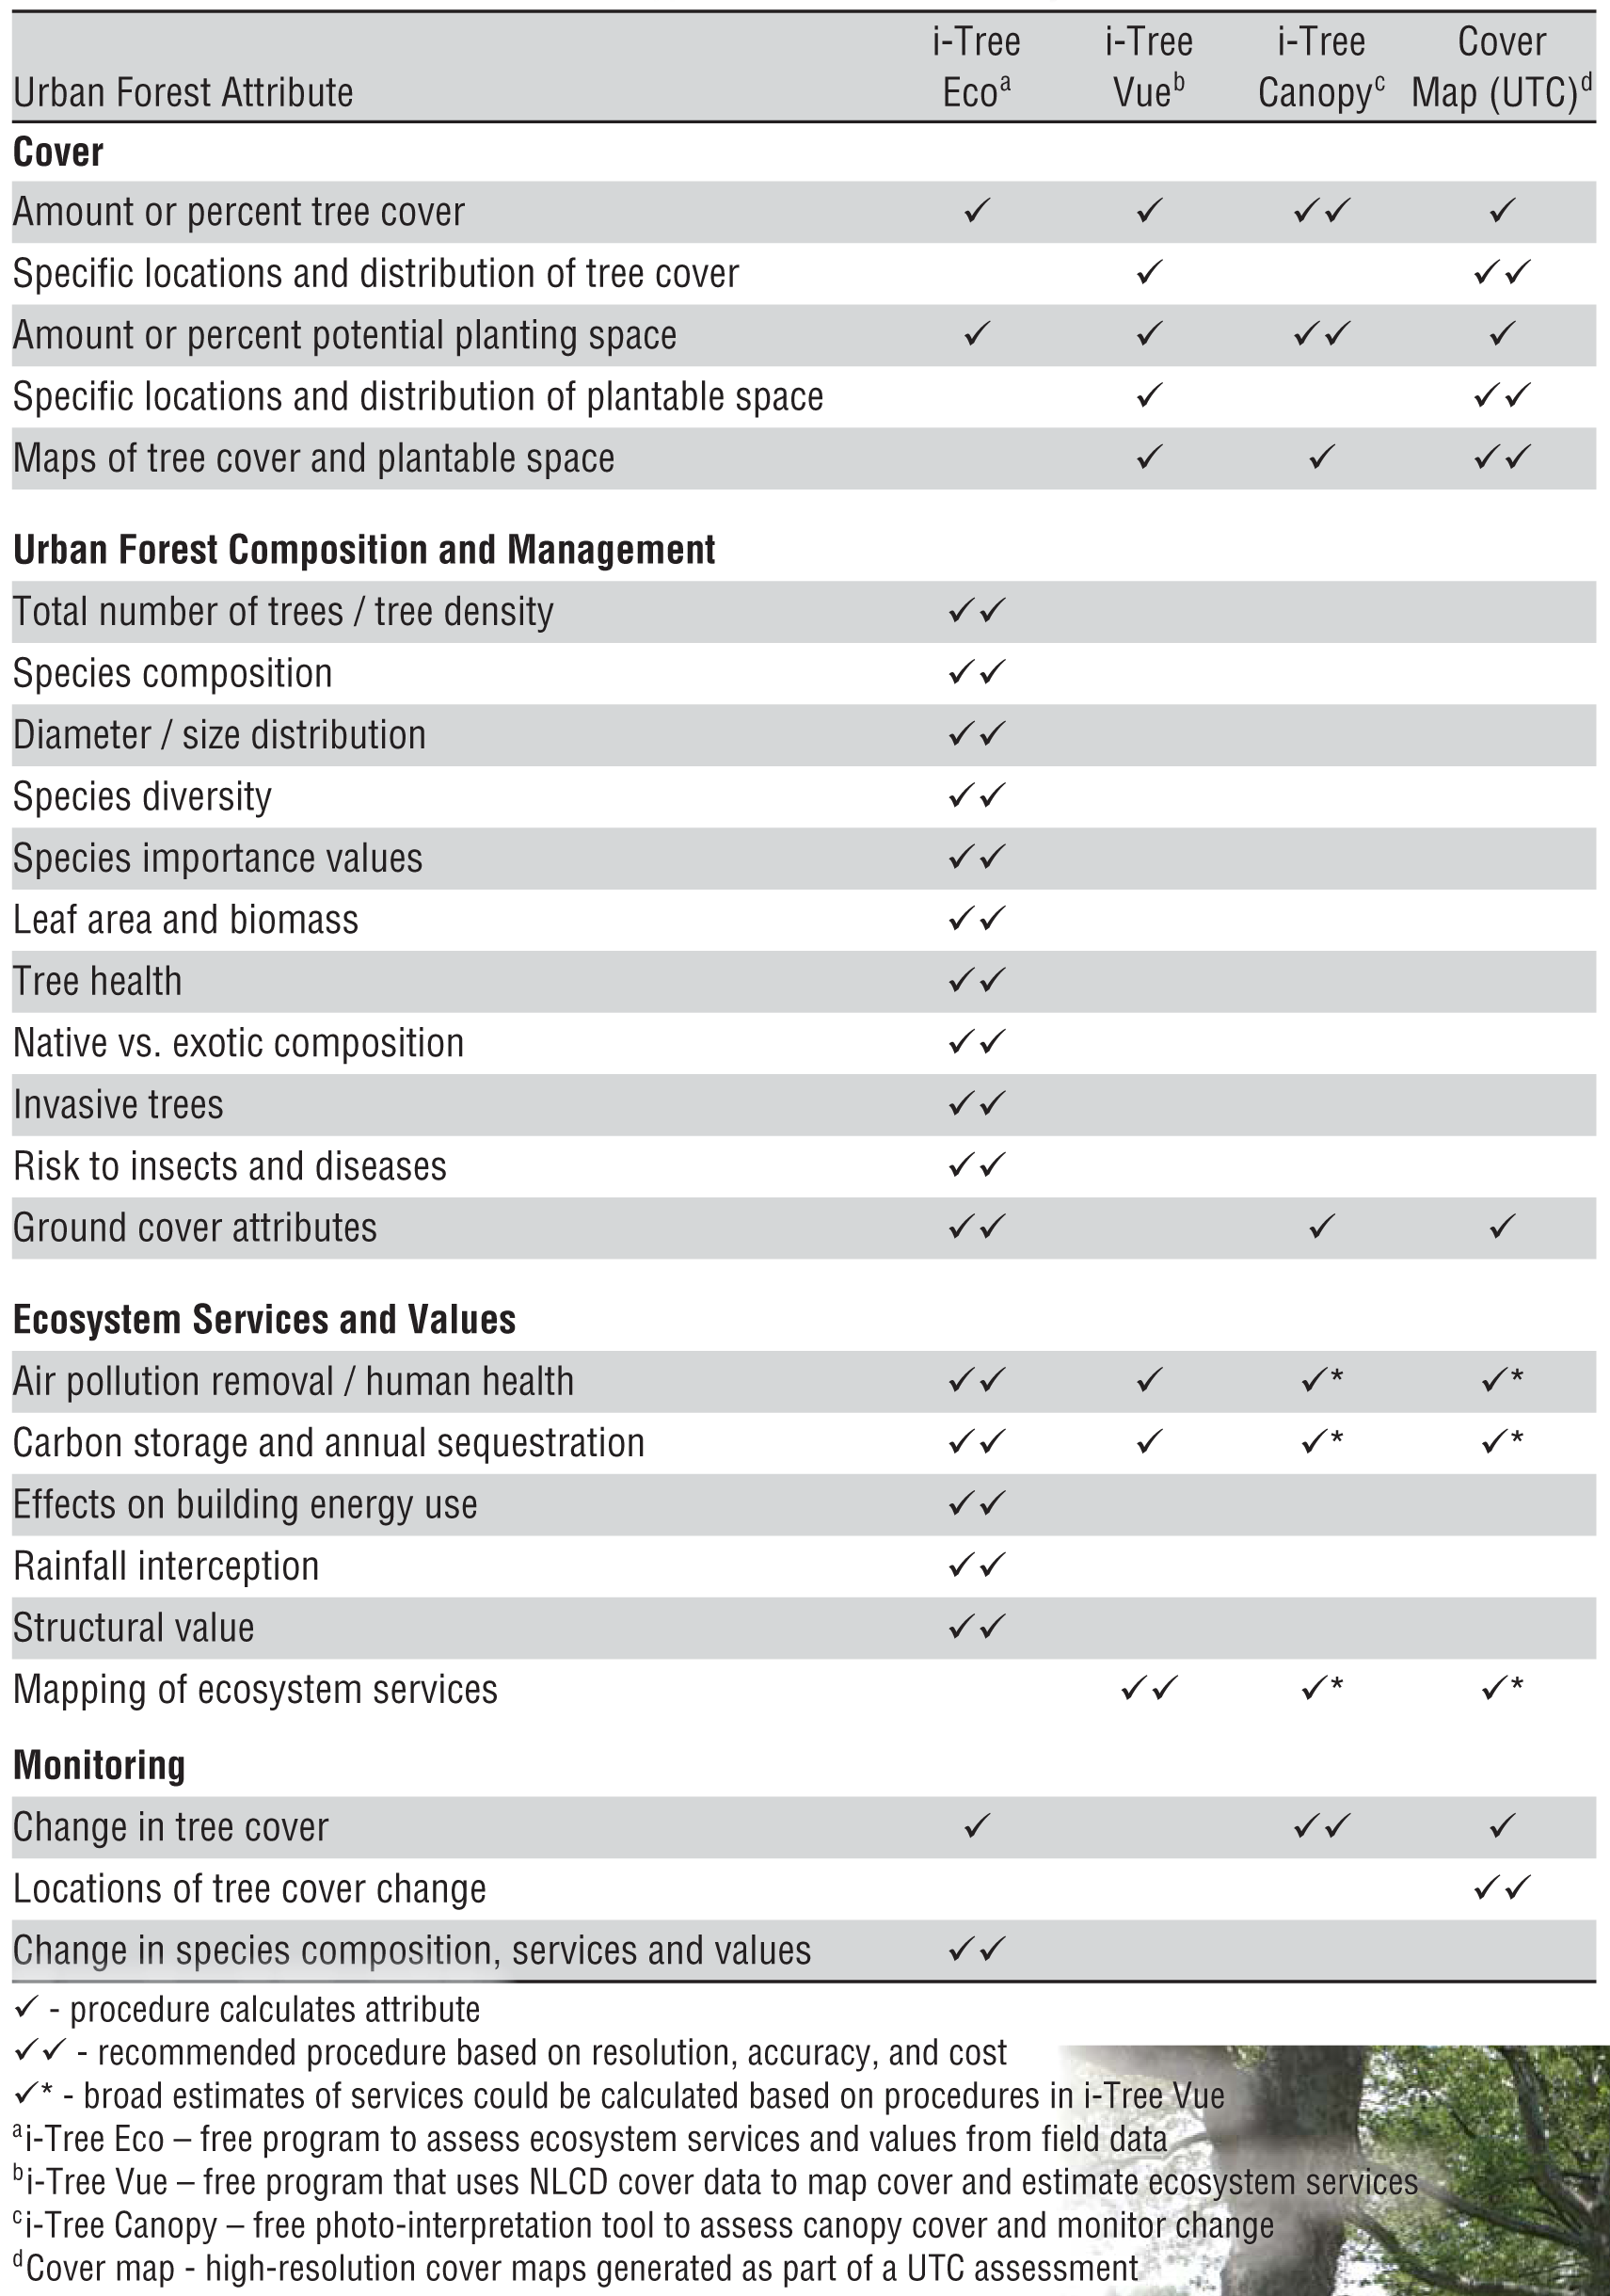

REFERENCES

Churchill, D. J., A. J. Larson, M. C. Dahlgreen, J. F. Franklin, P. F. Hessburg, and J. A. Lutz. "Restoring forest resilience: From reference spatial patterns to silvicultural prescriptions and monitoring." Forest Ecology and Management 291 (2013): 442-457.
Eichhorn, J., and P. Roskams. "Chapter 8 - Assessment of Tree Conditions." Developments in Environmental Science 12 (2013): 139-167.
Gomez-Baggethun, E., and D. N. Barton. "Classifying and valuing ecosystem services for urban planning." Ecological Economics 86 (2013): 235-245.
Hermans, C., M. Smeyers, R. M. Rodriguez, M. Eyletters, M. Strasser, and J.-P. Delhaye. "Quality assessment of urban trees: A comparitive study of physiological characterisation, airborne imaging and on site fluorescence monitoring by the OJIP-test." Journal of Plant Physiology 160 (2003): 81-90.
Hofman, J., I. Stokkaer, L. Snauwaert, and R. Samson. "Spatial distribution assessment of particulate matter in an urban street canyon using biomagnetic leaf monitoring of tree crown deposited particles." Environmental Pollution, 2012: 1-10.
Imbert, D., and J. Portecop. "Hurricane disturbance and forest resilience: Assessing structural vs. functional changes in a Caribbean dry forest." Forest Ecology and Management 255 (2008): 3494-3501.
Jim, C.-Y. "Monitoring the performance and decline of heritage trees in urban Hong Kong." Journal of Environmental Management 74 (2005): 161-172.
Jim, C.-Y. "Spatial differentiation and landscape-ecological assessment of heritage trees in urban Guangzhou (China)." Landscape and Urban Planning 69 (2004): 51-68.
Jim, C.-Y., and H. Zhang. "Defect-disorder and risk assessment of heritage trees in urban Hong Kong." Urban Forestry & Urban Greening, 2013: (12) In Press.
Jim, C.-Y., and H. Zhang. "Species diversity and spatial differentiation of old-valuable trees in urban Hong Kong." Urban Forestry & Urban Greening 12 (2013): 171-182.
Martinez-Trinidad, T., W. T. Watson, M. A. Arnold, L. Lombardini, and D. N. Appel. "Comparing various techniques to measure tree vitality of live oaks." Urban Forestry & Urban Greening 9 (2010): 199-203.
McPherson, E. G., J. R. Simpson, Q. Xiao, and C. Wu. "Million trees Los Angeles canopy cover and benefit assessment." Landscape and Urban Planning 99 (2011): 40-50.
Nagendra, H., and D. Gopal. "Street trees in Bangalore: Density, diversity, composition and distribution." Urban Forestry & Urban Greening 9 (2010): 129-137.
Niinemets, U. "Responses of forest trees to single and multiple environmental stresses from seedlings to mature plants: Past stress history, stress interactions, tolerance, and acclimation." Forest Ecology and Management 260 (2010): 1623-1639.
Nowak, D. J., and E. J. Greenfield. "Tree and impervious cover change in U.S. cities." Urban Forestry & Urban Greening 11 (2012): 21-30.
Pretzsch, H., P. Biber, and J. Dursky. "The single tree-based stand simulator SILVA: construction, application and evaluation." Forest Ecology and Management 162 (2002): 3-21.
Redfern, D. B., and R. C. Boswell. "Assessment of crown condition in forest trees: comparison of methods, sources of variation and observer bias." Forest Ecology and Management 188 (2004): 149-160.
Richardson, J. J., and L. M. Moskal. "Uncertainty in urban forest canopy assessment: Lessons from Seattle, WA, USA." Urban Forestry & Urban Greening, 2013: In Press (6).
Roy, S., J. Byrne, and C. Pickering. "A systematic quantitative review of urban tree benefits, costs, and assessment methods across cities in different climate zones." Urban Forestry & Urban Greening 11 (2012): 351-363.
USDA USFS Northern Research Station. A Guide to Assessing Urban Forests. Online Factsheet/Guide, Syracuse, NY: USDA USFS Northern Research Station, Unknown.

Please Note:

The Kestrel Design Group (including its employees and agents) assumes no responsibility for consequences resulting from the use of the information herein, or from use of the information obtained at linked Internet addresses, or in any respect for the content of such information, including (but not limited to) errors or omissions, the accuracy or reasonableness of factual or scientific assumptions, studies or conclusions, the defamatory nature of statements, ownership of copyright or other intellectual property rights, and the violation of property, privacy, or personal rights of others. The Kestrel Design Group is not responsible for, and expressly disclaims all liability for, damages of any kind arising out of use, reference to, or reliance on such information. No guarantees or warranties, including (but not limited to) any express or implied warranties of merchantability or fitness for a particular use or purpose, are made by the Kestrel Design Group with respect to such information.
The Kestrel Design Group does not endorse, approve, certify, or control references and Internet links included herein and does not guarantee the availability, accuracy, completeness, efficacy, timeliness, or correct sequencing of information in these references and links. No one should rely on the accuracy, completeness, efficacy, and timeliness of such information. Reference therein to any specific commercial product, process, or service by trade name, trademark, service mark, manufacturer, or otherwise does not constitute or imply endorsement, recommendation, or favoring by the Kestrel Design Group.

