Why is Storm Drain Stenciling Important?
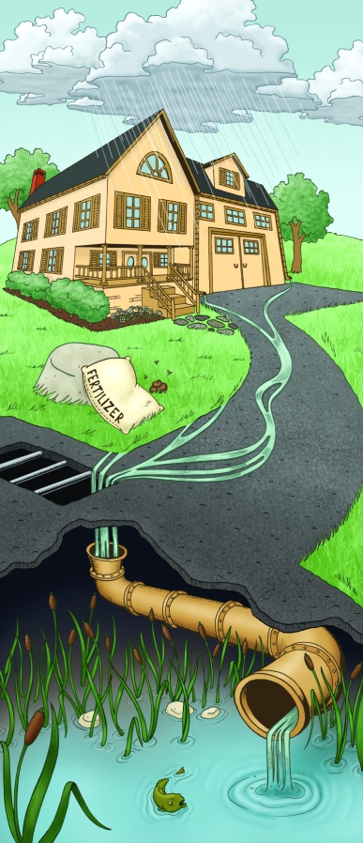
Today the biggest source of pollution is from water running off surfaces. When it rains, water runs off our houses, driveways, yards and streets into the storm drains.
Step 1. Rain falls onto our driveways, yards and houses.
Step 2. As the rain runs into the street and gutter, it collects many bad pollutants.

These pollutants are used on lawns, spill on driveways and roads, and flow into street gutters and storm drains.

What are some bad pollutants?
Step 2. As the rain runs into the street and gutter, it collects many bad pollutants.

Fertilizers, pesticides, herbicides, yard waste and other lawn care products
Step 3. The rain and bad pollutants flow through storm drains and into lakes, ponds and wetlands.

Motor oil, gasoline, and other fluids can leak from cars onto driveways and parking lots

Garbage, pet wastes and other debris

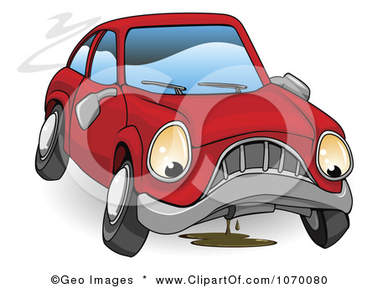
Image Credit: www.ThinkBlueMaine.org

Allowing these bad pollutants to go into a storm drain is the same dumping them in a lake.

These bad pollutants make the aquatic animals (fish, frogs, toads, birds, etc.) and plants very sick or can even make them die. The water is their home and it must be kept clean. Some pollutants also contain nutrients, which causes green, slimy algae to grow in lakes.

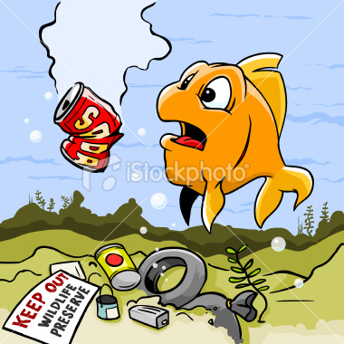
You are saving the environment!
Storm Drain Stenciling helps inform people to keep our water clean. Your stencils tell people how bad water pollution is. With this information they are more willing to keep the environment and water clean. Clean water makes swimming, boating and fishing much more fun!

Thanks for your dedication to improving water quality in the City of Burnsville!!!

Please return kit to:
The City Maintenance Facility, at 13713 Frontier Court, Burnsville 55337.
If you have questions, please contact the Natural Resources Department at 952-895-4543. Please be safe and have fun!

This storm drain stenciling kit should contain:
Paper Handouts:
- Storm drain stenciling instructions
- Map of stenciling area to be completed
- Copy of City of Burnsville’s public infrastructure map
- Door hangers to hand out to residents
- Volunteer completion report
Equipment:
- Cans of stenciling paint
- 2 handheld brooms
- Box of latex free gloves
- Putty knife to clean excess paint off of stencil (1)
- Safety vests (at least 4)
- Orange safety cones (3)
- Safety glasses (2)

