GSI PLANNING CASE STUDY: THE HIGHLAND BRIDGE PROJECT
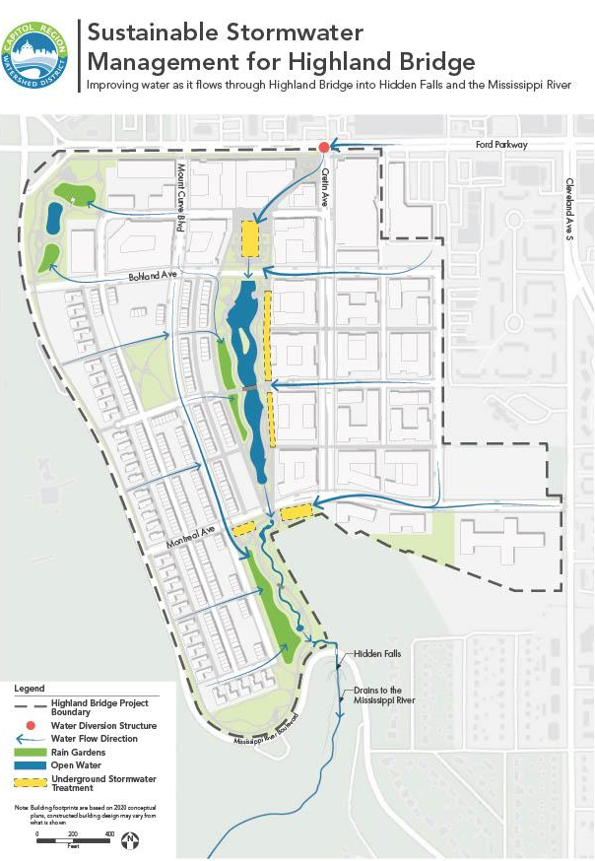
Project Summary
The Highland Bridge project (formerly Ford Redevelopment Site) is the redevelopment of roughly 122 acres of land along the Mississippi River in Saint Paul, MN that was previously home to Ford’s Twin Cities Assembly Plant. This redevelopment project converted the industrial land to residential and commercial space, including 55 acres of parks, open spaces, and waterways. This project is unique in that it uses a non-conventional stormwater management system called the “Hidden Falls Headwaters approach”. In this novel approach, stormwater from the site is captured and treated by green stormwater infrastructure (GSI), stored in concrete chambers, and eventually filtered and delivered to the Hidden Falls Creek and the site’s central water feature, a meandering open water channel surrounded by green space. This approach also daylighted and re-established the historic Hidden Falls Creek which had been previously buried and paved over.

Planning Highlights
The planning process for the Highland Bridge project was extensive and decades in the making. Early planning conversations included Ford, the City of St. Paul, and the Capitol Region Watershed District (CRWD). The initial planning group grew over time to include the city’s public works department and finance department as well as the Minnesota Pollution Control Agency (MPCA) and the surrounding community.

MPCA became involved in the planning process to provide expertise and oversight of the remediation of the legacy soil contamination from the manufacturing materials at the old Ford plant. This remediation was an essential requirement to rezone the site from industrial land to residential and commercial space. The remediation and rezoning process provided a challenging hurdle in the planning process but was necessary to execute the overall vision of an aesthetic and safe green space amidst the mixed-used development.

Another key component of the Highland Bridge project was stakeholder engagement. The public was heavily involved in the planning process, particularly in the Ford Site Zoning and Public Realm Master Plan, whose development included over 45 public meetings. The early public engagement meetings included education on traditional stormwater management mechanisms, the green stormwater infrastructure solutions considered, and the potential benefits of the GSI. Later public meetings included opportunities for the community to provide input to the project vision. The stakeholder engagement also included an online platform for the public to access project information and meeting materials, and provide feedback.This allowed more of the public to engage with the project even when not able to attend the public forums.

The planning team was able to “make the case” for integrating GSI in the project by doing a triple bottom line analysis that showed the economic, environmental, and social benefits of the Hidden Falls Headwaters approach compared to a more traditional stormwater management approach. The analysis put a monetary value to the social and environmental benefits to ultimately quantify the full value of the project to the community and showed that the project outperformed traditional stormwater management by a factor of 2. The public was largely in favor of the redevelopment and the proposed GSI as it promised more housing, a public water feature surrounded by green space, reduced traffic concerns, and other public amenities.

The city finance department played a key role in the planning process to successfully seek and obtain public funding for the project. The redevelopment project was supported through public funding with some contribution from private investments. A key component to the financing of the project was the creation and adoption of a green infrastructure overlay district ordinance (RES 20-672). This ordinance requires developers to pay a one time connection fee and an annual O&M fee that will support the continued maintenance of the stormwater management system.

Project Timeline
Concept planning began in 2007 with the formation of the Ford Site Planning Task Force. The first phase of the planning process and work involved visioning studies, remediation, and a stormwater study. The second phase of work started in 2015 and kicked off the more detailed planning process working towards a master plan. In 2017, The Ford Site Zoning and Public Realm Master Plan was adopted by the Saint Paul CIty Council. Construction on the Hidden Falls Headwaters stormwater management system began in 2020 and was largely completed by late 2021. Development on the remainder of the site began in late 2021 and buildout is estimated to take 10-12 years.

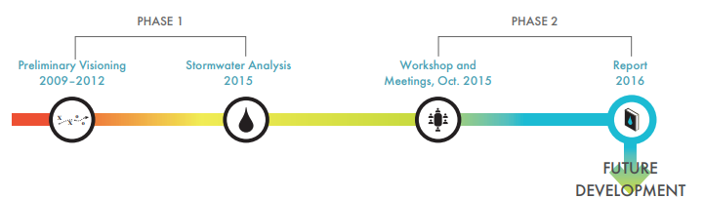

Quick facts:
- Location: St. Paul, MN
- Owner: Ryan Companies
- Designer: Barr
- Year of completion: Stormwater management components largely completed in late 2022
- Design features:
  - Shared stacked green stormwater infrastructure
  - Central water feature consisting of a meandering channel
  - Re-establishment of Hidden Falls Creek
  - Green space
- Pretreatment Features
  - Bioretention : 4.8 ac
  - Retention pond: 2.4 ac
- Total Drainage Area: 169 ac
- Total Construction Cost: projected cost 13.7M
- Documented Maintenance Practices:
  - Central Stormwater Easement requires that the city of St. Paul:
    - Maintain treatment efficiency of the central stormwater feature
    - Remove sediment, trash, debris, blockage, and pollutant buildup in the central stormwater feature and pre-treatment as well as sediment removal from any upstream structures
    - Weed and noxious species control
- Pollutant Removal
  - Total suspended solids: 28 tons/yr
  - Phosphorus: 147 lbs/yr
  - The GSI is estimated to reduce total stormwater solids by 94% and phosphorus by 75% compared to pre-development conditions.
- Is the Site Publicly Accessible: Yes
- Notable Challenges: Remediation and rezoning
- Co-Benefits
  - Added green space
  - Recreational opportunities
  - Restoration of historic creek
  - Spaces atop GSI for parks, amphitheater, meeting space etc.
  - Economically favorable compared to conventional stormwater management

https://www.stpaul.gov/sites/default/files/2022-05/Ford%20MP%20Amended%20Oct%202021%20Rev1.pdf
https://www.capitolregionwd.org/wp-content/uploads/2018/10/Ford-Site-Sustainable-Stormwater-Management-August-2016-reduced.pdf
https://www.capitolregionwd.org/projects/ford-site-redevelopment/

