Project Name | | Minnesota Stormwater Manual Harvest and Use Updates | Date | | 7-28-2016
To / Contact info | | Anne Gelbmann
Cc / Contact info | | Mike Trojan
From / Contact info | | Meghan Funke, PhD  Derek Lash, PE  Brett Emmons, PE
Regarding | | Task H. Costs
(Includes all tech team comments: August 10, 2016)

What are the total costs and cost per element of a harvesting and use system? This seems like a straight-forward question, but it can be highly dependent on the situation and context. The total cost of a harvest and use system can be divided into the four major components of a harvesting and use system:
- Collection
- Storage
- Treatment
- Distribution
The individual components required to construct each of the four systems usually depends on the site and/or use of the water. For the collection component, storm sewer pipes and roof drains may already be part of the design, thus reducing cost. The storage component is typically the largest cost item. If storage already exists at a site, such as existing wet ponds, providing storage for a harvest and use system can be done at minimal cost. Treatment costs can vary dramatically, depending on the source water and the end use, from virtually no treatment to meeting drinking water standards. Costs for distribution are usually associated with connection to an irrigation system. The location and elevation of the irrigation site in proximity to the source and storage areas affect the amount of pipes and pumps needed. If a site already has an irrigation system in place drawing from a potable water source, the distribution portion of the system costs may be minimal.
The site setting affects the cost of harvest and use systems. For example, in highly urban areas the choices for stormwater treatment may be limited and components such as storage (which is often an underground cistern) may be quite expensive on a cost/unit treatment basis. However, harvest and use may still more cost-effective than other stormwater management techniques such as green roofs or underground infiltration facilities. It is difficult to compare unit costs of harvest and use systems across different settings.

Total System Costs
The total cost of a stormwater harvest and use system varies due to the large range in the size and scale of these systems. In a Minnesota Pollution Control Agency (MPCA) survey for stormwater harvest and use systems in the Twin Cities Metropolitan Area, 26 respondents provided total system cost information, summarized in Figure 1 below. Total costs ranged from $1,500 to $1,500,000, with eight systems over $400,000. Of the 26 systems with cost information, 22 were irrigation systems ($1,500 - $1.5M), 1 was a toilet flushing system ($300,000), 1 was a toilet flushing and vehicle washing system ($57,500), and 2 were irrigation and vehicle washing systems ($10,000 - $425,000).
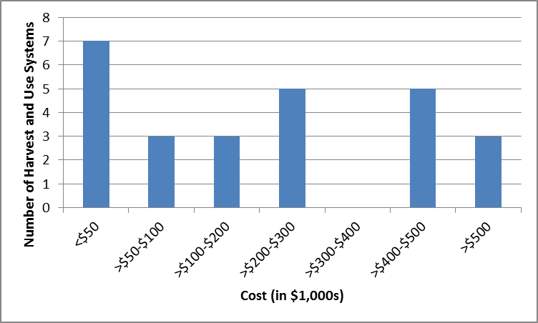
Figure 1. 2016 MPCA survey responses of total stormwater harvest and use system costs in the Twin Cities Metropolitan Area.

Individual Component Costs
Major individual component costs of stormwater harvest and use systems include land acquisition, excavation and material removal, and the storage/treatment systems. Very little detailed component cost information is currently available because costs for many of the storage and treatment systems are packaged together. Examples of harvest and use system itemized costs are discussed below.
The 2011 Met Council Stormwater Reuse Guide developed a list of stormwater harvest and use system construction activity components and cost units for developing system cost estimates, reproduced in Table 3. A cost analysis of different cistern materials was summarized by CONTECH Inc. in their 2011 Cistern Design Considerations for Large Rainwater Harvesting Systems Professional Development Advertising article, reproduced in Table 1. Some itemized component cost information was also compiled in the Texas Manual on Rainwater Harvesting, summarized in Table 2. These itemized costs include cistern and gutter costs on a per volume/length basis, and treatment system consumables (such as filters and cartridges) that must be replaced regularly as part of normal system operation and maintenance.

Table 1. Comparison of materials used for rainwater harvesting systems (Need to ask for permission to reproduce: Contech Construction Products, Inc. September 2011. Cistern Design Considerations for Large Rainwater Harvesting Systems.)
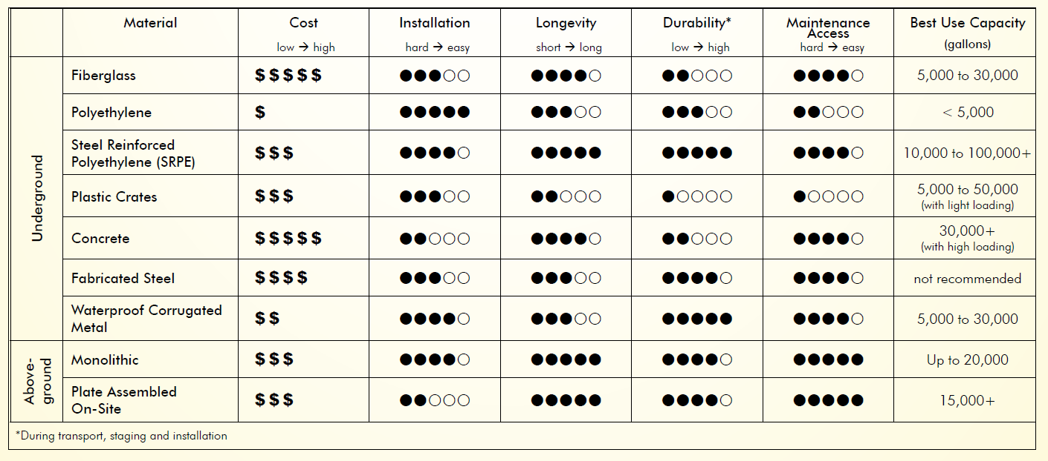

Table 2. Itemized stormwater harvest and use system component costs (Table 6-1¹ in the 2005 Texas Manual on Rainwater Harvesting)
System | System Component | Cost | Cost Recurrence
Materials | Tanks | $0.50/gallon for fiberglass to $4/gallon for wielded steel tank
 | Gutters | $0.30/foot for vinyl/plastic to $6-12/foot for aluminum/galvalume
Annual maintenance  (costs will be dependent on system size) | Cartridge Filter | $20-60 | Filter must be changed regularly
 | Reverse Osmosis Filter | $400-1,500 | Change filter when clogged (depends on turbidity)
 | UV Light Disinfection | $350-1,000; $80 to replace UV bulb | Change UV bulb every 10,000 hours or 14 months
 | Ozone Disinfection | $700-2,600; $1,200+ for in-line monitor to test effectiveness
 | Chlorine Disinfection | $1/month manual dose or a $600-3,000 automatic self-dosing system
¹ Chapter 6: Cost Estimation in 2005 Texas Manual on Rainwater Harvesting, 3rd Edition

Table 3. Stormwater Harvesting and Use Component Checklist and Cost Units (from Toolbox R.5 in the 2011 Met Council Reuse Guide)
Phase | Component | Unit | Check if required for system:
Collection | Cleaning of roof (if retrofit project) | Square foot
 | Roof washing system | Each
 | Gutters | Linear foot
 | Gutter screens | Linear foot
 | Downspouts | Linear foot
 | Scuppers | Each
 | Catch basins | Each
 | Catch basin filters | Each
 | Manholes | Each
 | Oil/water separators | Each
 | Storm sewers | Linear foot
 | Bypass valves | Each
 | First flush diverter | Each
Storage – Ponds/ basins | Site demolition | Varies
 | Excavation | Cubic foot
 | Disposal of excess soil | Cubic foot
 | Vegetation restoration | Square foot
 | Baffles at outlet | Linear foot
 | Filters at outlet | Each
 | Outlet structure | Each
 | Pumping system including pump, motor, valves, and pressure tank (for non-gravity and pressurized systems) | Varies
 | Aeration | Varies
 | Electrical supply (for pumps or aeration) | Varies
Below-ground storage | Site demolition | Varies
 | Excavation and backfill | Cubic foot
 | Imported aggregate bedding material | Cubic foot
 | Disposal of excess soil | Cubic foot
 | Vegetation or pavement restoration | Square foot
 | Pre-fabricated tanks | Each
 | Baffles, calming inlet, and/or filters, if not supplied with pre-fabricated tank | Each
 | Cast-in-place concrete tank | Varies
 | Pumping system including pump, motor, valves, and pressure tank (for non-gravity and pressurized systems) | Varies
 | Maintenance access manhole | Each
 | Electrical supply (for pumps) | Varies
Above-ground storage | Site demolition | Varies
 | Foundation – aggregate | Cubic foot
 | Foundation – concrete | Square yard
 | Pre-fabricated tanks with cover | Each
 | Baffles, calming inlet, and/or filters, if not supplied with pre-fabricated tank | Each
 | Cover, if not supplied with pre-fabricated tank | Each
 | Cast-in-place concrete tank | Varies
 | Pumping system including pump, motor, valves, and pressure tank (for non-gravity and pressurized systems) | Varies
 | Electrical supply (for pumps) | Varies
Treatment systems | Piping | Linear foot
 | Valves | Each
 | Flow meter (when needed to regulate chemical feed) | Each
 | Electrical supply | Varies
 | Maintenance access manhole (if located underground) | Each
 | Backflow prevention valves (if connected to potable water for supplemental supply and/or for filter backwash) | Each
 | Suspended & Colloidal Solids Removal Systems  - Chemical feed  - Tank with baffles or mixing device (if chemicals not fed into inline mixing device)  - Settling basin with dewatering valves for solids removal | Varies
 | Residual Suspended Solids Removal Systems  - Filter chamber containing activated carbon or other filter media, including piping and valves for bypass and backwash (for filtration systems)  - Tank with micro-bubble diffusion, dewatering valves, and surface skimmer (for dissolved air flotation systems) | Varies
 | Residual Colloidal Solids Removal Systems  - Filter chamber containing multi-media, including piping and valves for bypass and backwash (for ultrafiltration systems) | Varies
 | Dissolved Solids Removal Systems  - pH feed (for reverse osmosis systems)  - Chemical feed (for electrodialysis systems)  - Filter chamber containing semi-permeable membrane, including piping and valves for bypass and backwash (for all systems)  - Solids disposal system | Varies
 | Disinfection  - Chemical feed (for continuous chlorine disinfection)  - Tank with baffles or mixing device (for batch disinfection with chlorine)  - Contact tank with UV lights and piping (for ultraviolet disinfection)  - Tank with piping, valves, ozone diffuser (for ozone disinfection)  - Off-gas ozone destructor tank (for ozone disinfection) | Varies
Distribution | Pumping system including pump, motor, valves and pressure tank | Varies
 | Piping for distribution | Linear foot
 | Valves for pressure control, and regulating flow | Each
 | Valve boxes | Each
 | Sprinkler nozzles – impulse, spray, rotating, bubbler, or drip | Each
 | Irrigation controllers with wiring to each sprinkler (for automated control systems) | Varies
 | Drain plug (for winterization) | Each

Harvest and Use System Construction Bid Estimate Examples
Due to the large variability in harvest and use system costs, construction bid estimates are provided as examples of itemized costs.
- Installation of 3 – 29,000 gallon underground storage tanks: Table 4 summarizes the average of four contractor bids for the installation of three 29,000 gallon underground storage tanks (120” diameter x 50’ length) for an irrigation harvest and use system designed for an approximate 8 acre drainage area and an approximate 3 acre irrigation area. This estimate is for storage (3 tanks) components only. The average capital cost for one gallon of storage is $1.46 per gallon. The underground storage tank components were 71 percent of the total installation bid.
- Installation of 1 – 1,500 gallon aboveground tank harvest and use system: Table 5 summarizes the engineer’s estimate for the installation of one 15,000 gallon aboveground corrugated steel storage tank that captures rainwater from a 2,100 square foot roof connected to a hose for on-site exterior water use. This estimate is for collection (gutters), storage (tank), and distribution (hose) components. The total capital cost for one gallon of storage is approximately $20 per gallon. The aboveground storage tank components were 46 percent of the total construction estimate.

Table 4. Contractor bid averages for installation of three 29,000 gallon underground storage tanks
BASE BID ITEM | ESTIMATED QUANTITY | UNIT | UNIT PRICE AVERAGE | TOTAL AVERAGE BID
Part 1 - General and Erosion Control
MOBILIZATION | 1 | LS | $23,340 | $23,340
SEDIMENT CONTROL LOG -- INSTALL, MAINTENANCE AND REMOVAL | 267 | LF | $5 | $1,335
TEMPORARY FENCE -- INSTALL AND REMOVAL | 160 | LF | $8 | $1,280
STABILIZED CONSTRUCTION EXIT -- INSTALL, MAINTENANCE AND REMOVAL | 1 | LS | $2,410 | $2,410
EROSION CONTROL BLANKET | 424 | SY | $4 | $1,696
STORM DRAIN INLET PROTECTION -- INSTALL, MAINTENANCE AND REMOVAL | 2 | EA | $387 | $774
DUST CONTROL | 10 | HRS | $121 | $1,210
Total Part 1 |  |  |  | $32,045
Part 2 - Removals
REMOVE EXISTING SEDIMENT CONTROL LOG OR SILT FENCE | 268 | LF | $4 | $1,072
Total Part 2 |  |  |  | $1,072
Part 3 - Grading
COMMON EXCAVATION -- INCLUDES TANK TRENCH EXCAVATION AND FILL TO PROPOSED GRADE | 1955 | CY | $9 | $17,595
REMOVAL OF EXCAVATED MATERIAL | 1389 | CY | $10 | $13,890
AGGREGATE BACKFILL | 1009 | CY | $41 | $41,369
Total Part 3 |  |  |  | $72,854
Part 4 – Underground Storage Tank Components
RAINWATER HARVESTING TANK (120" DIA. X 50-FEET) | 3 | EA | $77,639 | $232,917
CONSTRUCT DRAINAGE STRUCTURE | 6 | EA | $1,153 | $6,918
CONCRETE, REINFORCED COLLAR (RISER MANHOLE CAP) | 6 | EA | $1,085 | $6,510
CONCRETE, REINFORCED COLLAR (AT RISER CONNECTION TO TANK) | 6 | EA | $1,248 | $7,488
INSTALL CASTING | 6 | EA | $1,221 | $7,326
18" HDPE PIPE | 115 | LF | $73 | $8,395
SOIL DENSITY COMPACTION TESTING | 12 | EA | $430 | $5,160
Total Part 4 |  |  |  | $274,714
Part 5 – Site Restoration
RAPID STABILIZATION | 0.42 | AC | $3,173 | $1,333
PERMANENT SEEDING | 0.42 | AC | $6,336 | $2,661
TURF ESTABLISHMENT | 1 | EA | $2,500 | $2,500
Total Part 5 |  |  |  | $6,494
Total Bid |  |  |  | $386,590
PRICE PER TANK (3 – 29,000 gallon tanks) |  |  |  | $129,060
PRICE PER TANK PER YEAR OVER 25 YEAR |  |  |  | $5,162
PRICE PER GALLON |  |  |  | $1.46
PRICE PER GALLON PER YEAR OVER 25 YEARS |  |  |  | $0.06

Table 5. Engineers estimate for installation of one 1,500 gallon aboveground corrugated steel storage tank
ITEM | ESTIMATED QUANTITY | UNIT | UNIT PRICE | TOTAL COST
RAINWATER HARVESTING PACKAGE: 1,500 GALLON ABOVE GROUND CORRUGATED STEEL TANK AND ASSOCIATED FITTINGS & ACCESSORIES, INCLUDING PUMP AND FILTER SYSTEM. (72" DIA. X 9') | 1 | EA | $15,000 | $15,000
REINFORCED CONCRETE FOUNDATION ON IMPROVED SUBGRADE | 1 | EA | $2,500 | $2,500
REMOVE EXISTING GUTTER | 60 | LF | $9 | $540
5" BOX GUTTER | 222 | LF | $10 | $2,220
GUTTER DOWNSPOUTS | 45 | LF | $15 | $675
6" HDPE PIPE | 110 | LF | $30 | $3,300
RODENT GUARD | 1 | EA | $350 | $350
SCOUR STOP MAT | 32 | SF | $30 | $960
EROSION CONTROL BLANKET | 14 | SY | $20 | $284
ENGINEER'S REPORT | 1 | EA | $2,500 | $2,500
O&M GUIDELINES | 1 | EA | $1,500 | $1,500
Total |  |  |  | $29,829

Funding Sources
There are many sources of funding that can be used to finance stormwater harvest and use systems (Table 6). Due to the high cost of these systems, more than one source of funding is often needed. Of the 26 respondents to the 2016 MPCA stormwater harvest and use system survey that provided cost and funding source information, 16 respondents utilized two or more sources of funding to finance their harvest and use system.

Table 6. Stormwater Harvest and Use Funding Sources
Funding Source | Funding Type
Watershed Organization Implementation and Cost-Share Programs | - Watershed Management Organization  - Watershed District  - Joint Power Agreement
State Agency Grants and Loans | - Met Council Stormwater Grant  - MPCA 319 Fund  - MPCA Clean Water Partnership Loans  - Clean Water Land & Legacy Amendment Clean Water Fund  - Public Facilities Authority Clean Water Revolving Fund
County Funds | - County program funds
Municipal Funds and Utility Fees | - Enterprise fund  - Stormwater utility fees  - Surface water management utility fees
Other Public Financing | - University environmental fee  - School district  - Student housing fees  - Parks operating budget
Private Financing | - Developers (to meet stormwater requirements on a restricted site or to maximize developable area)  - Local organizations (e.g. youth soccer club)

Financial Incentives and Benefits
There are many financial incentives and benefits that should be factored in to the global net cost of a stormwater harvest and use system. These include:
- Points toward U.S. Green Building Council LEED or Institute of Sustainable Infrastructure Envision ratings which demonstrate how well public entities are sustainably managing energy, material, and water resources (LEED) and planning for climate change and long-term resiliency in public infrastructure investments (Envision)
- Credit towards meeting Minnesota B3 Guidelines, a requirement for all projects that receive general obligation bond funding from the State of Minnesota, which set sustainability goals for site, water, energy, indoor environment, materials and waste
- Reduced potable water utility costs
- Reduced downstream stormwater infrastructure costs
- Increased resiliency in stormwater management and potable water systems due to reductions in stormwater volume and potable water demand
- Ecosystem services

Additional Cost Resources

Cost-Benefit Case Studies
Bill Hicks, P.E. 2008. A Cost-Benefit Analysis of Rainwater Harvesting at Commercial Facilities in Arlington County, Virginia.
Sarah Lawson, Ph.D. (Rainwater Management Solutions). Sample Rainwater Harvesting Case Study Costco Store in Northern Virginia.

System Costs
Contech Construction Products, Inc. September 2011. Cistern Design Considerations for Large Rainwater Harvesting Systems.
USEPA. January 2013. Rainwater Harvesting Conservation, Credit, Codes, and Cost Literature Review and Case Studies.

