Green Roof Example (Calculator Version 2)

A green roof is going to be constructed on an existing 0.5 (21,780 square feet) acre roof. The green roof will cover half (10,890 square feet) of the existing roof and contain media with a depth of 4 inches above the drainage system. Runoff from the entire roof will drain through the green roof. The following steps detail how this system would be set up in the MIDS calculator.
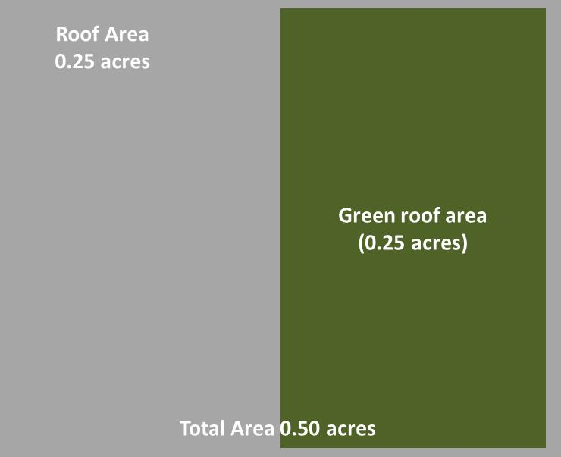
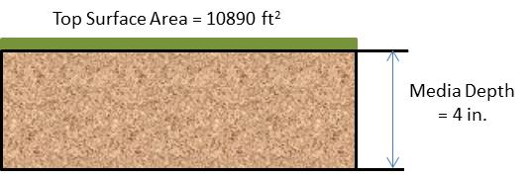

Step 1: Determine the watershed characteristics of your entire site. For this example we have a 0.5 acre site with all 0.5 acres being impervious (this is because the green roof portion is included in the impervious surface area).
Step 2: Fill in the site specific information into the “Site Information” tab. This includes entering a Zip Code (55414 for this example) and the watershed information from Step 1. Zip code and impervious area must be filled in. Other fields on this screen are optional.
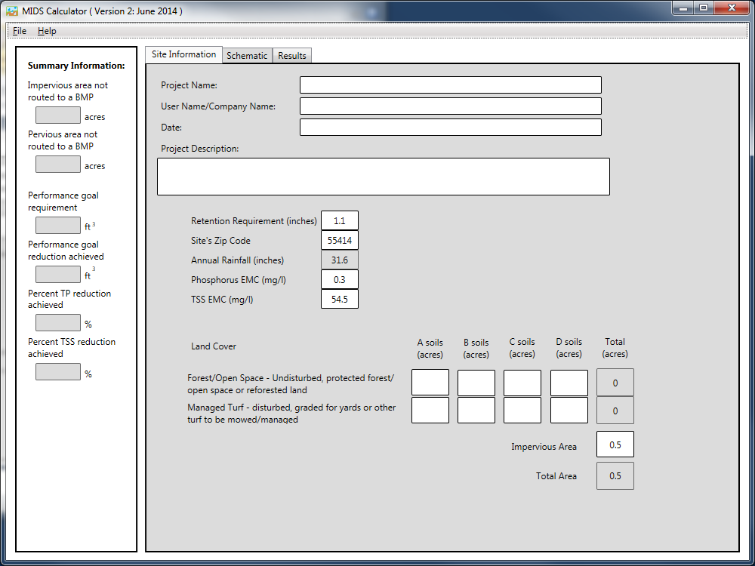

Step 3: Go to the Schematic tab and drag and drop the “Green Roof” icon into the “Schematic Window”
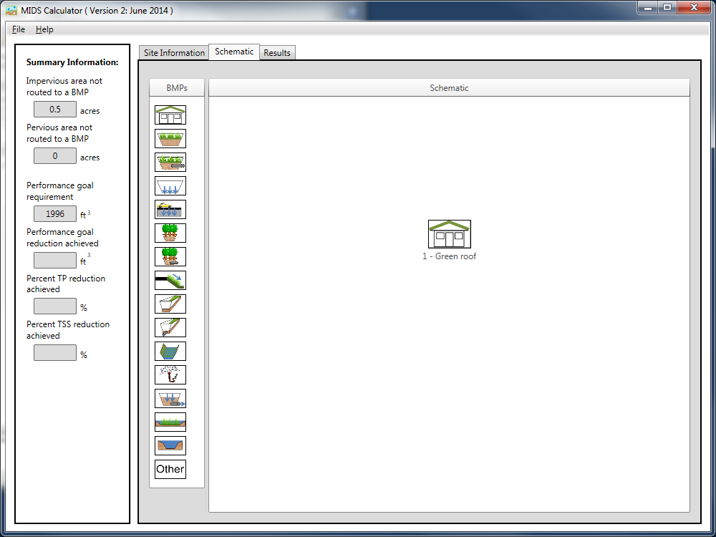

Step 4: Open the BMP properties for the green roof by right clicking on the green roof icon and selecting “Edit BMP properties”, or by double clicking on the green roof icon.
Step 5: Click on the “Minnesota Stormwater Manual Wiki” link or the “Help” button to review input parameter specifications and calculation specific to the “Green roof” BMP.
Step 6: Determine the watershed characteristic for the green roof. For this example the entire site is draining to the green roof therefore the watershed parameters include a 0.5 acre site with all 0.5 acres of impervious area. There is no routing for this BMP. Fill in the BMP specific watershed information, which is 0.5 acres of impervious cover.
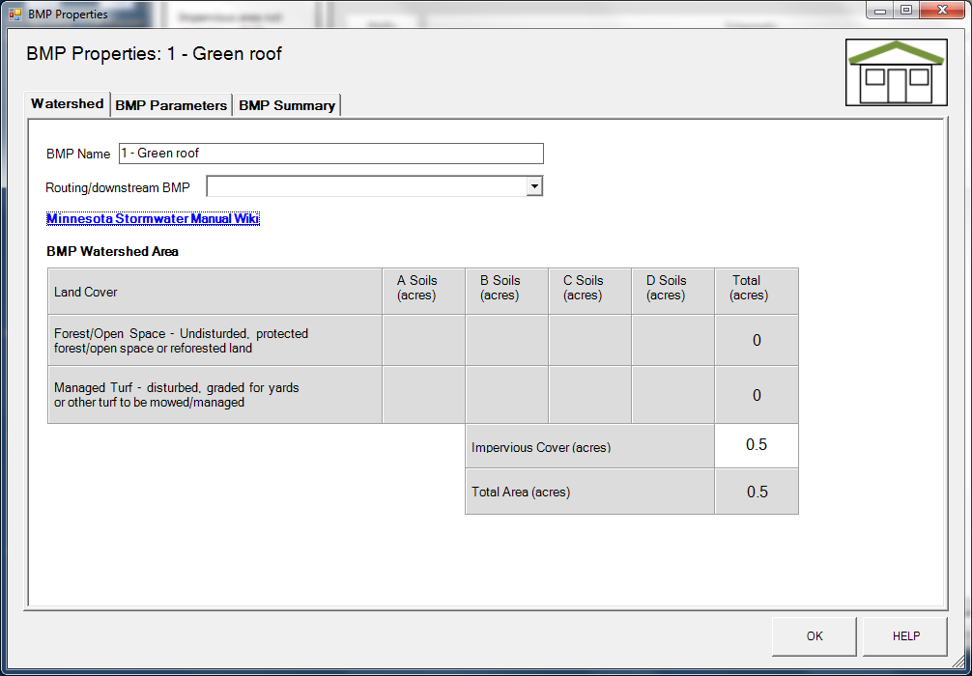

Step 7: Click on the “BMP Parameters” tab and enter in the BMP design parameters. Green roof requires two entries.
- The media depth, which is 4 inches in this example
- The surface area of the green roof, which is 0.25 acres or 10890 square feet. Note this is the area of the green roof, not the entire roof area draining to the green roof.
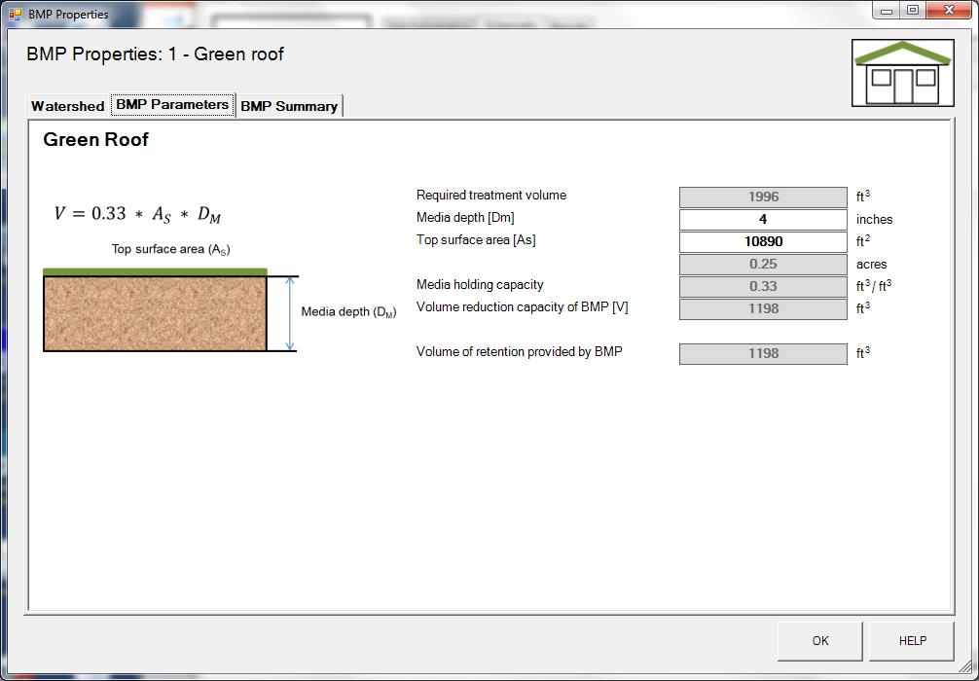

Step 8: Click on “BMP Summary” tab to view results for this BMP.
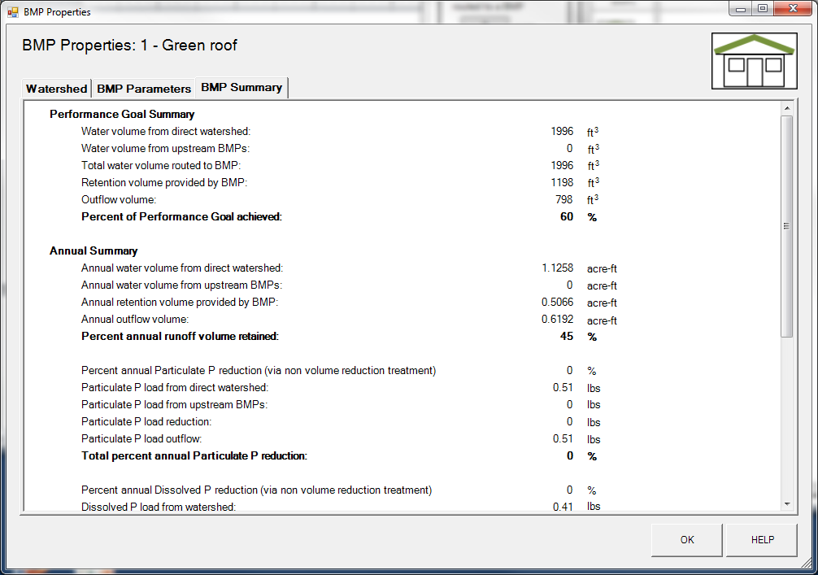

Step 9: Click on the “OK” button to exit the BMP properties screen.
Step 10: Click on “Results” tab to see overall results for the site.
