ILLICIT DISCHARGE DETECTION AND ELIMINATION PROGRAM

City of Arden Hills
Public Works Department
1245 West Highway 96
Arden Hills, MN 55112

TABLE OF CONTENTS

Introduction 2
SECTION 1: Municipal Storm System Mapping ...……...........................................3
SECTION 2: City Ordinance …............................................................................. 3
SECTION 3: Incorporating IDDE into Maintenance and Inspection Activities 3
SECTION 4: Visual IDDE Inspection Procedures 4
SECTION 5: Training Staff on Implementation of the IDDE Program ................... 7
SECTION 6: Locating Priority Areas ……............................................................... 8
SECTION 7: Response Procedures.....………………………………………………………………. 9
SECTION 8: Incident Reporting 11

APPENDIX A: Stormwater IDDE Report & Response Form
APPENDIX B: Enforcement Response Procedures (ERPs)
APPENDIX C: Dye Testing, Video Testing/Televising & Smoke Testing
APPENDIX D: Illicit Discharge Ordinance

Illicit Discharge Detection and Elimination Program
Introduction
The purpose of the Illicit Discharge Detection and Elimination (IDDE) Program is to detect and eliminate sources of pollution to the municipal separate storm sewer system (MS4) as required by the National Pollutant Discharge Elimination System/State Disposal System (NPDES/SDS) permit program, permit number: MNR040000.
The goal of this plan is to identify and then eliminate illicit discharges. Examples of illicit discharges include:
• Direct or indirect sanitary wastewater discharges that connect to the storm sewer or watercourse, such as a shop floor drain connected to a storm drain, a cross-connection between the municipal sewer and storm sewer systems, a damaged sanitary sewer line that is leaking sewage into a cracked storm sewer line, or a failing septic system that is leaking into a water course.
• Materials (e.g., used motor oil) that have been dumped illegally into a storm drain catch basin or other stormwater facility.
• Improper home or business owner activities such as washing paint brushes into a catch basin, washing new textured concrete driveways into a storm drain, draining swimming pools to the storm system (swimming pools have high pH and chlorine), excess use of fertilizers, or washing cars with chemicals that enter the storm drain system.

Additional goals of the IDDE program include:
• Improve water-quality in local waterways by reducing incidences of pollution to MS4s
• Increase awareness among municipal employees, businesses, and the general public of the direct connection between the MS4 and local waterways
• Educate municipal employees, businesses, and the general public of the hazards associated with illicit discharges and the best management practices (BMPs) available
• Facilitate consistency in response to incidences of discharges of pollutants to City’s stormwater system through a coordinated system of procedures and training of municipal employees,
The NPDES Permit sets forth the minimum elements of the plan which are listed below. These minimum elements are described throughout the remainder of this document.
• Municipal Storm Sewer System Mapping (Part III.D.3.a)
• Ordinances (that effectively prohibit illicit discharges) (Part III. D.3.b)
• Incorporating IDDE into Maintenance and Inspection Activities (Part III.D.3.c)
- Visual IDDE Inspections (Part III.D.3d)
• Staff Training (Part III.D.3e)
- Locating Priority Areas (Part III.D.3.f)
- Response Procedures (Part III.D.3.g)
- Incident Reporting (Part III.D.3.h)
Section 1: Municipal Storm System Mapping
The NPDES Phase II Permit outlines minimum information that should be included in the City’s municipal storm sewer system map:

• Location of all known municipal storm sewer conveyances 12” or greater in diameter, including the stormwater flow direction in the pipes,
- Outfalls, including a unique identification (ID) number assigned by the City, and an associated geographic number,
• Structural stormwater BMPs that are part of the City’s small MS4,
- All receiving waters.

The City has completed GIS mapping of the city's stormwater system, including all basins, pipes, ditches and stormwater facilities, including outfall identification. Updating and maintenance is ongoing. This map will be used to schedule and track maintenance activities and plan for capital improvement projects.

The GIS map information is currently not available on-line. A wall map showing the mapped system to date is available at Public Works.

All City owned stormwater facilities have been identified. Outfalls have been mapped. Stormwater BMP's are in the process of being mapped (on-going process).

Receiving waters have been prioritized and identified on the GIS Stormwater Map.

Section 2: City Ordinance
Current Ordinance
Section 1020 of the City’s current municipal code prohibits illicit discharges. Connections to the stormwater system must contain only stormwater and groundwater, otherwise they are to be eliminated. The section references the fines and penalties that can be levied against violators in accordance with Section 1020.12. The IDDE ordinance is included in the appendix for reference.

Section 3: Incorporating IDDE into Maintenance and Inspection Activities
Purpose
Potential illicit discharge problems can be revealed through outfall inspections or reports from staff, tenants, or the public as described in Section 4. When a complaint is reported, the Phase II Permit requires that a follow-up investigation be initiated within seven (7) days, on average. The follow-up investigation could include a site visit to look at the problem area, review of mapping information, review of past complaints or investigations at the location, or other data collection and review. Once a problem has been verified (either through a routine outfall inspection or follow-up to a called-in complaint) the City will begin an official illicit discharge investigation, following the procedures outlined in this section.

When an illegal dumping or illicit discharge problem is directly observed by a member of the City staff, it is generally not necessary to follow these investigation procedures. In those scenarios, the source of the problem discharge is already known. Problems revealed through direct observation are referred directly to the corrective action information in Section 7. In the event that a reported problem does not have a defined source, the procedures in this section should be followed to trace the source of the illicit discharge.

Section 4: Visual Illicit Discharge Detection Inspection Procedures
4.1 Tracing the Source
This section outlines the basic tools that can be used to trace the source of a suspected illicit discharge. Source tracing begins when a suspected problem area is identified through outfall inspections, field assessment/testing, or a complaint call. When the source of the non-stormwater discharge is not known, one of two primary methods can be used to locate the source of an illicit discharge:

• Method A – Storm Drain Network Investigations
• Method B – Drainage Area Investigations

The method used will depend on the type of information collected or reported, level of understanding of the drainage network, and existing knowledge of operations and activities on the surrounding properties. All source tracing investigations should be documented and recorded.

4.1.1 Start a File
When problems are identified, a report should be started, and assigned an incident number, creation date, case description and the primary staff contact/investigator. A report is created listing the property name, person responsible, and tracking all information related to the observed or suspected problem. The investigator assigned to the case shall keep an accurate log of labor, materials and costs associated with the investigation for invoicing the responsible party. The report should be started prior to completing any additional field work unless the nature of the discharge necessitates immediate response. In addition to filling out the report, the file should include copies of the following, if applicable:

• GIS Inspection Map;
• Photographs;
• Field notes;
• Lab testing results;
• Compliance letters sent and responses received;
• Correspondence (mail, email, telephone logs);
• Proof of corrected problems (contract and invoice or clean field investigation report).

Any field investigations, photographs, corrective actions, or other activities associated with the suspected problem area should be documented in the case log. This becomes the City’s official
record of the IDDE investigation. Additional record keeping information is included in Section 8.

4.1.2 Method A – Storm Drain Network Investigations
The source of some illicit connections or discharges can be located by systematically isolating the area from which the polluted discharge originates. This method involves progressive investigation at manholes in the storm drain network to narrow down the location where the illegal discharge is entering the drainage system. This method is best used to identify constant or frequent discharge sources such as an illicit connection from a sewer system or sink drain into the storm drainage network. One-time illegal discharges (such as a surface spill or intentional dumping into the storm drain system) should be investigated using Method B described later in this section.

Field crews should work progressively upstream from the outfall and inspect manholes until indicators reveal the discharge is no longer present. Manhole observations can be time consuming, but they are generally a necessary step before conducting other tests. In particularly large storm drain systems, it may be helpful to first identify major branches of the system and test one manhole at the downstream end of each branch. This can help to reduce the area that must be investigated.

Storm drain network investigations include the following steps:

1. Consult the drainage system map and identify the major branches. If a drainage system map is not available or major branches cannot be identified, then sketches of the system shall be made and the system shall be identified in the GIS project queue for adding to the City’s drainage system map.
2. Starting from the outfall, observe the next upstream manhole or junction to see if there is evidence of polluted discharge. As with the outfall inspections, field crews are looking for the presence of flow during dry weather, foul odors, colors or stained deposits, oily sheen, floatable materials, and/or other unusual observations.
3. Repeat observations at each upstream manhole or junction until a junction is found with no evidence of discharge; the discharge source is likely located between the junction with no evidence of discharge and the next downstream junction.
4. Work downstream from the “clean” manhole or junction to isolate the location where the polluted discharge is entering the storm drain system.
5. If discharge is evident from private property initiate private property site entry procedures.
6. Document all findings in field notes and keep them in the file.

When visual inspections are not enough to isolate the source of the illegal discharge, a number of additional field tests can be performed. These include:

• Dye testing,
• Video Testing/Televising,
• Smoke testing,

The Center for Watershed Protection’s Illicit Discharge Detection and Elimination: A Guidance Manual provides instructions for employing these testing techniques. The relevant pages from that manual are included in Appendix C.

Confirmed illicit discharge sources should be referred to the follow-up actions and corrective action procedures described at the end of this section and in Section 7.

4.1.3 Method B – Drainage Area Investigations
The source of some illegal discharges can be determined through a survey or analysis of the drainage area of the problem outfall. Drainage area investigations are particularly useful when the discharge observed at the outfall has a distinct or unique characteristic that can allow field crews to quickly determine the type of activity or non-point source that is generating the discharge. However, drainage area investigations are generally not helpful in tracing sewage discharges, since they are not related to a specific land use.

Drainage area investigations should begin with a discussion between the field crews, inspectors,
engineers, and other knowledgeable City staff to identify the type of site most likely to produce the observed discharge. Table 4-1 shows some of the activities or land uses most likely associated with specific discharge problems.

Table 4-1
Common Discharges and Potential Sources
Observed Discharge | Potential Causes
Clogging Sediment | - Construction activity without proper erosion and sediment controls  - Roadway sanding operations  - Outdoor work areas or material storage areas
Thick Algae Growth | - Fertilizer leak or spill  - Landscaping operations  - Hydroseeding following construction  - Failing or leaking septic system
Oil | - Refueling operations  - Vehicle or machinery maintenance activities
Sudsy Discharge | - Power washing of buildings  - Vehicle or equipment washing operations  - Mobile cleaning crew dumping  - Laundry or Cleaner  - Household greywater discharge
Clogged Grease | - Restaurant sink drain connection to stormwater system
Sewage | - Failing or leaking septic systems

Staff should make a list of likely discharge sources and consult City land use and drainage system maps to identify areas of likely pollutions sources near the storm drain network. Field crews should then conduct a windshield survey of the drainage area to confirm and identify potential sources of the discharge. Once potential discharge sites are identified, City staff should conduct individual site inspections to locate the specific source of the illegal discharge.

In some cases, dye testing (See Appendix C) may be needed to confirm that a suspected activity is actually draining into the storm drain network.

All drainage area investigations should be documented in field notes and entered in the report file.

4.1.4 Equipment
Prior to conducting field work, crews should assemble all required equipment (see Table 4-2) and review the outfall inspection records or water quality incident reports from the area to become familiar with the background information and potential pollution sources.

Table 4-2
Field Equipment for Source Investigations
Minimum 2 person crew | - Watch with second hand
Safety Gear – vest, work boots, cones | - Flash light or head lamp
Field Notebook/Pencils | - Tool Box – hammer, tape measure, duct tape, zip ties
Map or Aerial Photo of Inspection Area | - First Aid Kit
Digital camera w/ charged battery | - Clear sample bottles
Cell phone w/ charged battery | - Wide mouth container

4.2 Follow-Up Actions
Once the source of an illicit discharge has been identified, the investigator should notify the property owner or operator of the problem, and provide the appropriate educational materials and/or a notice of violation. This is an important first step in the corrective action process. The investigator completes the information to document the findings. The investigator can then begin working through the corrective action steps outlined in Section 7.

Section 5: Training Staff on Implementation of the IDDE Program
The City has developed a training schedule to meet the requirements of the NPDES Phase II Permit. Two primary trainings have been identified related to IDDE:

• Training for all staff that are routinely in the field to educate them on what constitutes an
illicit discharge problem and how to report suspected problems.
• Training for illicit discharge responders on proper identification, investigation, clean-up,
disposal, and reporting techniques for illicit discharges.

These trainings are generally conducted using materials developed for the IDDE program. General training will primarily include Power Point presentations, webcast material, and printed material distributed to staff at staff meetings. The City has met the permit requirement of developing a program to train all field staff, and the City will schedule follow-up trainings as needed to keep the information fresh or introduce new information acquired during implementation of the IDDE program.

Training for illicit discharge responders will also include distribution and review of this procedure manual as well as a refresher on City spill response procedures. Follow-up trainings for illicit discharge responders may take the form of debriefings following significant IDDE incidents. Debriefings allow staff to review the actions taken and identify what worked well and what should be modified for future responses.

Section 6 – Locating Priority Areas
Identification of priority areas likely to have illicit discharges, including at a minimum, evaluating land uses associated with business/industrial activities, areas where illicit discharges have been identified in the past, and areas with storage of large quantities of significant materials that could result in an illicit discharge. Based on this evaluation, the permittee shall conduct additional illicit discharge inspections in those areas identified as having a higher likelihood for illicit discharges.

6.1 Developing Priority Areas
Identifying priority areas is vital to the development of an IDDE program. This process can be broken down into three fundamental steps:

1. Use all available information to identify where illicit discharges may be found in the community;
2. Conduct dry weather field screenings to locate non-stormwater discharges;
3. Conduct water quality sampling and analysis to determine if non-stormwater discharges are present.

6.2 Locating Priority Areas
The first step in locating priority areas is to identify areas that have a high potential for illicit discharges within your community. These can be broken down into a list of commonly high probability locations where illicit discharges may be or are likely to occur.

- Locations where there have been repeated problems in the past. This includes locations with known water quality data, as well as locations where numerous complaints have been received. These areas should be known by community officials as well as other agencies that collaborate on specific problem areas. For example: Arden Hills Utilities works on many sanitary sewer problems that can impact the MS4. Utilities would be a division within Public Works that should be contacted for such information. Likewise, the MDOH, MPCA, county health department, or a variety of other agencies/groups should be contacted when compiling this information.
- Using existing information to assess where illicit discharges may be found and what waterbodies are particularly sensitive (e.g. drinking water sources, areas containing unique biodiversity, and
swimming areas).
- Older areas of a community may indicate possible locations where there will be illicit discharges detected. These locations may have a higher percentage of illegal connections and/or have deteriorating sewer lines leading to infiltration problems from the older infrastructure found in that area.
- The commercial and/or industrial areas of the community will tend to have a higher percentage of illicit discharges as well. Historically, these locations have significant numbers of illegal connections and have discharges with a high potential to affect water quality (Tuomari, 1999 and Pitt et al., 1993).
- Stormwater outfalls and structural pollution control devices should be inspected for illicit discharges during the normal inspection period for these structures/facilities.
- Areas with storage of large quantities of materials that could result in a spill or areas with many storage vessels of hazardous solids or liquids.

Priority Areas Identified by the City of Arden Hills:
Using the guidelines provided above, the City of Arden Hills staff has identified the following priority areas within the city limits:

Section 7: Response Procedures
Immediate Response Procedures
The field crew should be prepared to take immediate action in the event of encountering one of the following situations:
• Individuals actively in the process of introducing possible illegal substances or materials to the storm drain system
• Very strong chemical odor emanating from storm drain system
• Presence of fumes or smoke emanating from storm drain system
• Visible significant stream of a controlled chemical or petroleum product flowing in storm system or downstream waters
• Large chemical plume in stream or river downstream of a City outfall
• Any condition that poses or could pose an immediate threat to property, human health or safety, or aquatic life. The crew should take the following steps if one of the above situations is encountered:
• Ensure crew safety and the public by instructing people to stay clear of the area.
• Call 911 to report a major spill, active illegal dumping or a potential fire incident.
• The following offices must all be called if an unauthorized discharge of oil or hazardous material such as a spill has occurred:
a. Non-Emergency Police Dispatch at 651-767-0640; and
b. Minnesota Duty Officer at 651-649-5451.

• If a spill is encountered the following information should be recorded if possible:
a. Where is the spill?
b. What spilled?
c. How much spilled?
d. How concentrated is the spilled material?
e. Who spilled the material?
f. Is anyone cleaning up the spill?
g. Are there resource damages (e.g. dead fish or oiled birds)?
h. Who is reporting the spill?
i. Your contact information?

• If possible isolate or contain visible chemical pollution in the effected waterbody with any materials that are accessible. For small discharges earth dams, absorbent pads, and containers may be useful to contain part of the illicit discharge.
• Take detailed notes and photos/video for subsequent investigation by City or other agencies.

At a minimum, follow-up work includes contacting the Minnesota Pollution Control Agency (651-296-6300) to determine if any additional reporting or investigative actions are necessary.

7.1 Corrective Action
7.1.1 Purpose
The City will respond to identified illicit discharges, illicit connections, or illegal dumping activities using progressive enforcement actions. Corrective actions will focus first on education to promote voluntary compliance and escalate to increasingly severe enforcement actions if voluntary compliance is not obtained.

7.1.2 Voluntary Compliance
The preferred approach to address illicit discharge problems is to pursue voluntary compliance through property owner or responsible party education. Often, business operators and property owners are not aware of the existence of illicit connections or activities on their properties that may constitute an illegal discharge. In these cases, providing the responsible party with information about the connection or operation, the environmental consequences, and suggestions on how to remedy the problem may be enough to secure voluntary compliance.

Education begins during the site investigation when the operation or connection is first confirmed. Property owners and operators should be notified that the problems must be corrected in a timely manner and that the City will be conducting a follow-up site visit to verify compliance. Field staff should also provide the property operator with an educational brochure describing illicit discharge violations and a copy of the applicable City code. Field staff should also remind property owners of their obligation to report discharges to the proper agencies.

7.1.3 Operational Problems
Property owners are responsible for correcting operational problems that are leading to illegal discharges to the storm drainage system. This could include moving washing activities indoor or
undercover, covering material storage areas, locating an appropriate discharge location for liquid wastes, or other operational modifications. Through site visits and education, the City can provide technical assistance to aid property owners in identifying the required modifications.

7.1.4 Structural Problems
Most illicit connection problems will require a structural modification to correct the problem.
Structural repairs can be used to redirect discharges such as sewage, industrial, and commercial
cross-connections. Such cross-connections must be re-routed to an approved sanitary sewer system. Correcting structural problems is the responsibility of the property owner, though the City may provide technical assistance throughout the process.

Section 8 – Incident Reporting
8.1 Purpose
Illicit discharges and connections are identified through citizen reporting, interdepartmental or
interagency referral, or other routine MS4 inspection activities. The City relies on local citizens, field staff, and inspections to detect potential problem areas quickly, so that they can be addressed before they cause significant water quality degradation.

A water quality incident/spill/trouble call Hotline number (651-792-7800) is available to call to report concerns. This convenience encourages residents to participate in the reporting process and helps the City to receive timely information about problems like illegal dumping, spills, or strong odors. The City’s related MS4 maintenance activities provide opportunities to document and identify potential problems that may not be obvious to the general public.

8.2 Incident Reporting
Field staff shall be observant in their daily routines to watch for evidence of illicit discharges or unusual flows from the storm drain systems. Should a suspected discharge be discovered, it must be reported to the City of Arden Hills at 651-792-7800 (office).

When a suspected illicit discharge is observed, the employee may elect to fill out a City of Arden Hills Stormwater IDDE Report & Response Form (Appendix A). However, if a suspected illicit discharge is observed, to assist the City the information that should be recorded at a minimum is:

►Location ►Date ►Time
►License plate number (if applicable) ►And take photos

Once this information is submitted to the City a field investigation of the discharge shall occur. The employee initially observing the suspect discharge need NOT approach the potential violator at the time of the incident. However, if the violator does not appear threatening, personal information for the Illicit Discharge Reporting & Tracking Form would be beneficial.

Once recorded, incident information is referred to the appropriate City department and/or staff person for follow-up. In most cases, IDDE problems should be referred to the City for further investigation. Staff will either follow the investigation procedures in Section 6 to identify the source of the problem or, if the source is known, the corrective action procedures outlined in Section 7 will apply.

APPENDIX A

Stormwater IDDE Report & Response Form

Stormwater IDDE Report & Response Form
I. Incident Report Incident Number: _____
Date/Time: __________________AM / PM Received By: __________________________________
Location: ____________________________________________________________________________
Initial Report of Conditions: _____________________________________________________________
____________________________________________________________________________________
Reported By: ______________________________ Phone: _____________________________________
II. Investigation
Date: ________________ By: ____________________
Location Description/Storm Drain ID/Outfall: ________________________________________________
Discharge Entered Storm Drain System/Receiving Waters? ___Yes ___No
Material Type
- Hazardous Sediment Wastewater
- Oil/Grease Other_____________ Unknown
Est. Quantity: ________________________
Additional Information: _________________________________________________________________
Sample(s) Collected: ____ Yes _____No Photo(s) Taken: ____ Yes _____No
Observed Land Use
- Residential
- Commercial/Industrial Stormwater Permit ___Yes ___No ___Unknown
- Public
Direct/Constructed Connections Found? ___ Yes ___ No
Source Description: _____________________________________________________________________
Source/Responsible Party: _______________________________________________________________
III. Action and Closure
Referred To: _____________________________ Date: ________________________________________
Action Taken: _________________________________________________________________________
_____________________________________________________________________________________
Date Closed: ____________________

APPENDIX B

Enforcement Response Procedures (ERPs)

APPENDIX C

Dye Testing, Video Testing/Televising & Smoke Testing

Excerpts from The Center for Watershed Protection’s:
Illicit Discharge Detection and Elimination: A Guidance Manual for Program Development and Technical Assessments

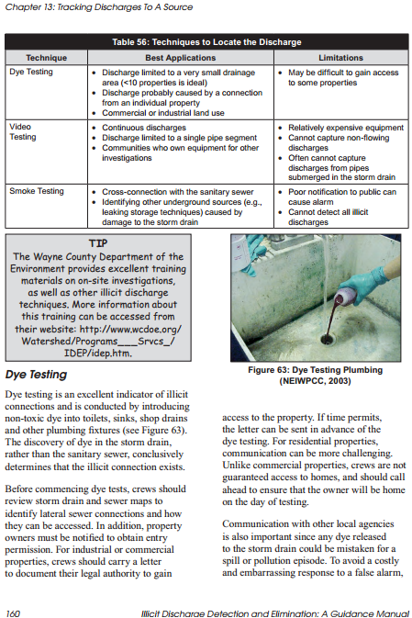
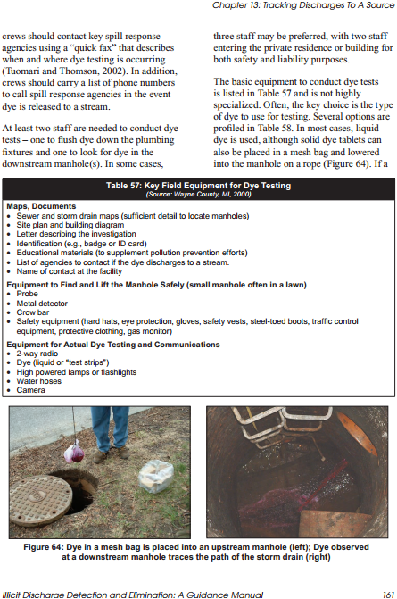
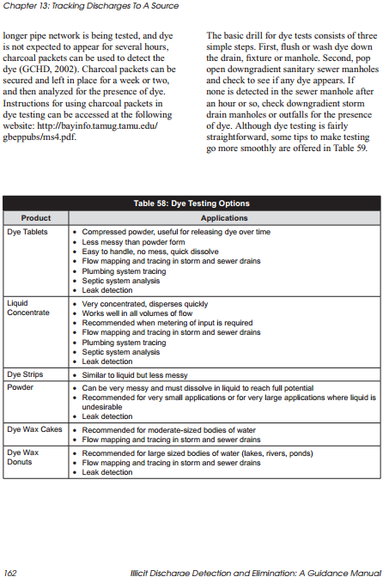
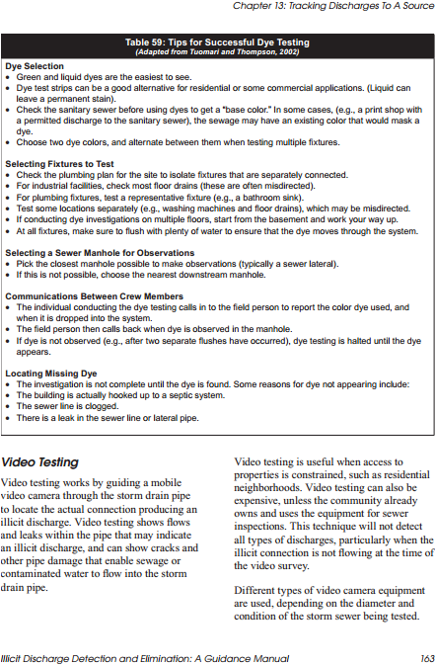
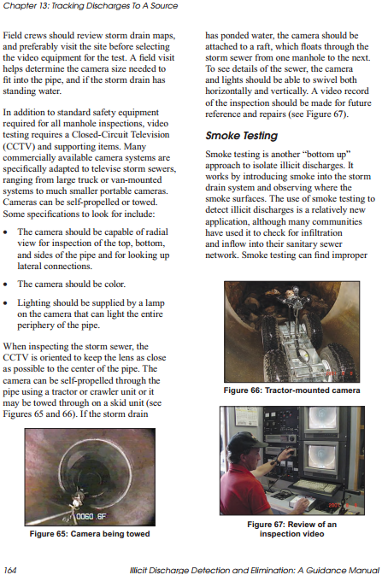
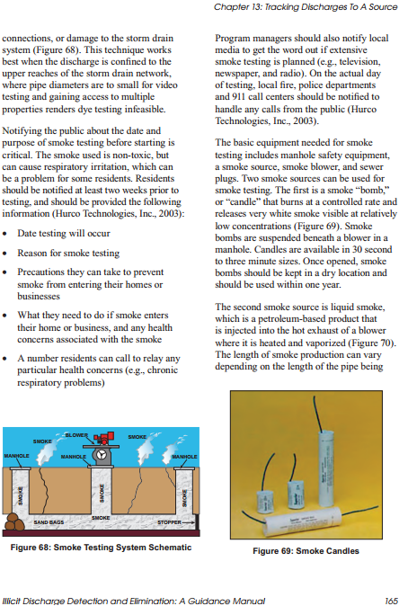
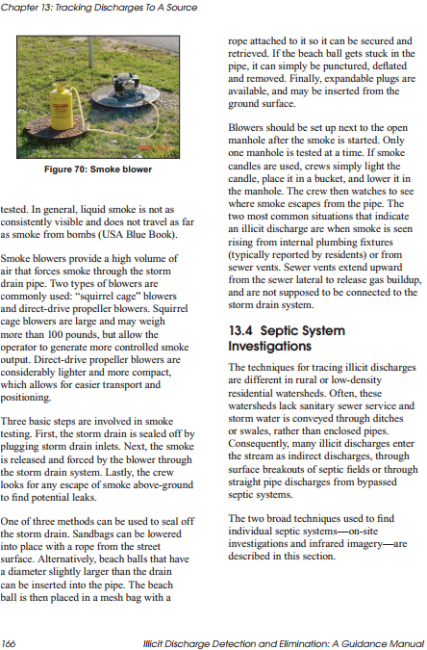

APPENDIX D

Illicit Discharge Ordinance

