Other (Version 2)

An iron enhanced sand filter is going to be constructed in a watershed that contains a 1.4 acre parking lot surrounded by 0.8 acres of pervious area (Turf area). All of the runoff from the watershed will be treated by the sand filter. The soils across the area have a unified soils classification of SM (HSG type B soil). The following steps detail how this system would be set up in the MIDS calculator. Through a literature search and study of the designed iron enhanced sand filter it was determined that the addition of iron in the filter media would provide an additional 60% annual dissolved phosphorus load reduction.
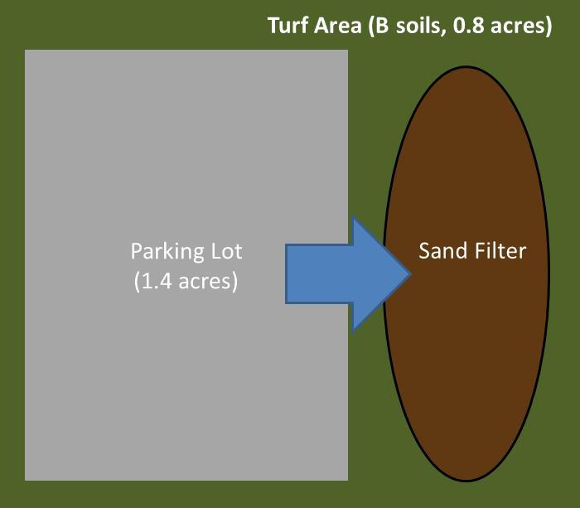
Step 1: Determine the watershed characteristics of your entire site. For this example we have a 2.2 acre site with 1.4 acres of impervious area and 0.8 acres of pervious turf area in type B soils. The pervious area includes the area of the sand filter.

Step 2: Fill in the site specific information into the “Site Information” tab. This includes entering a Zip Code (55414 for this example) and the watershed information from Step 1. Zip code and impervious area must be filled in or an error message will be generated. Other fields on this screen are optional.
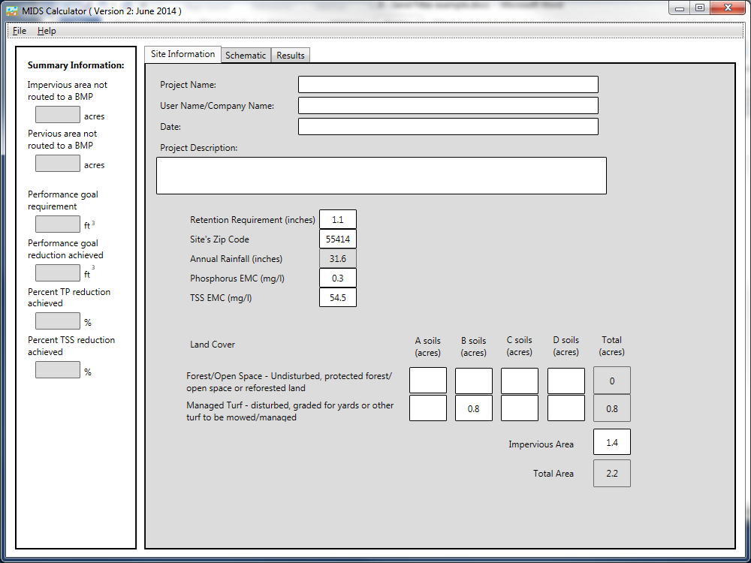
Step 3: Go to the Schematic tab and drag and drop the “Sand Filter” icon and the “Other” icon into the “Schematic Window”.
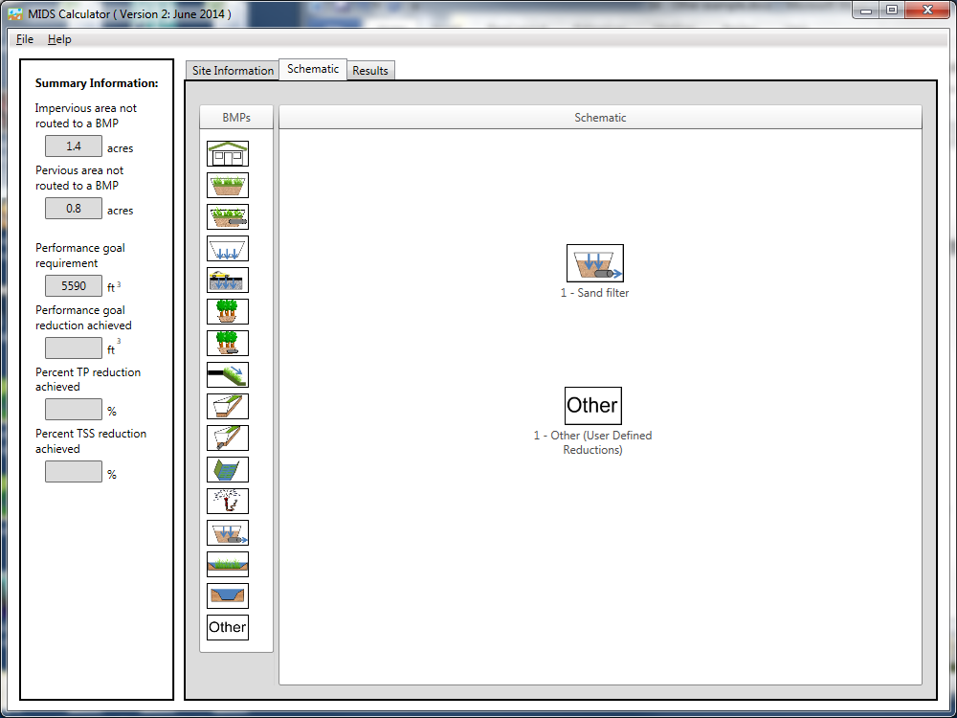
Step 4: Open the BMP properties for the Sand filter by right clicking on the “Sand filter” icon and selecting “Edit BMP properties”, or by double clicking on the “Sand filter” icon.
Step 5: Click on the “Minnesota Stormwater Manual Wiki” link or the “Help” button to review input parameter specifications and calculation specific to the “Sand filter” BMP.
Step 6: Determine the watershed characteristic for the sand filter. For this example the entire site is draining to the sand filter. The watershed parameters therefore include a 2.2 acre site with 1.4 acres of impervious area and 0.8 acres of pervious turf area in type B soils. Route the sand filter to the “Other” BMP. Fill in the BMP specific watershed information (1.4 acres on impervious cover and 0.8 acres of Managed turf in B soils).
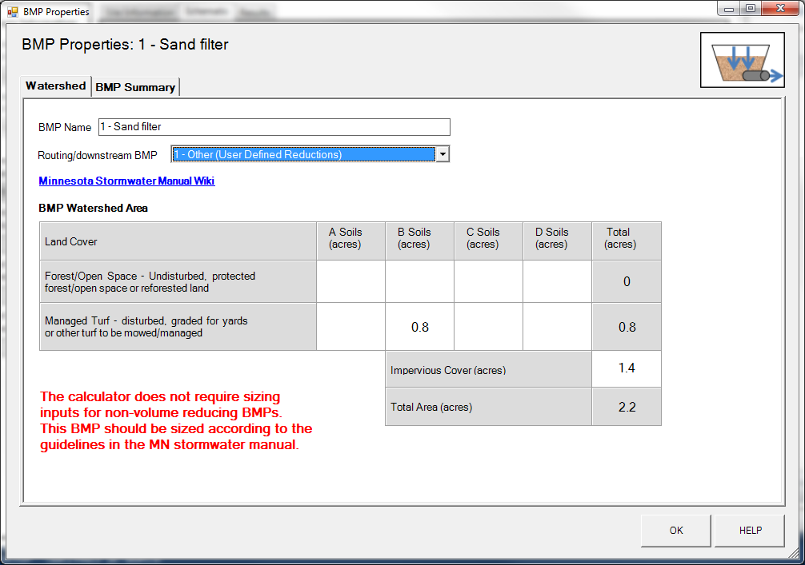
Step 7: Design parameters are not required for the sand filter BMP. Click on “BMP Summary” tab to view results for this BMP. Notice that the sand filter alone does not provide any dissolved phosphorus reduction.
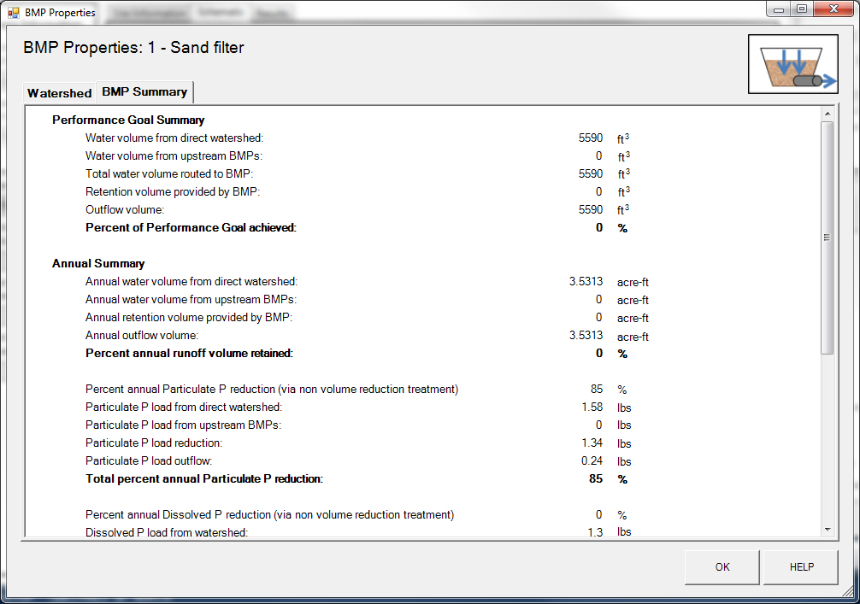
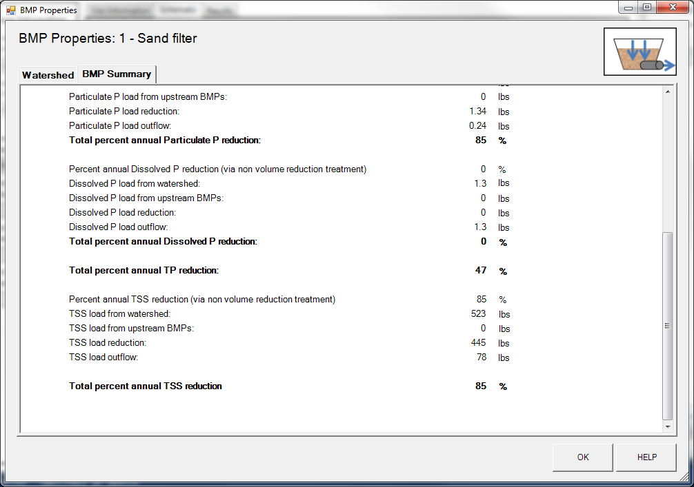
Step 8: Click on the OK button to exit the BMP properties window
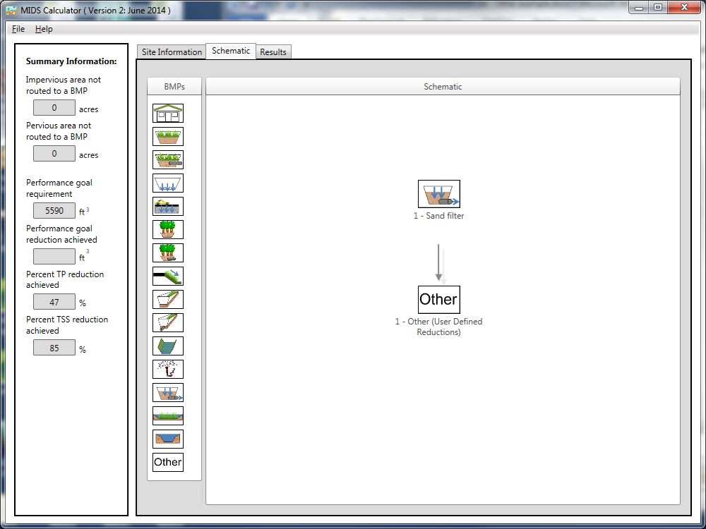
Step 9: Open the BMP properties for the Other BMP by right clicking on the “Other” icon and selecting “Edit BMP properties”, or by double clicking on the “Other” icon.
Step 10: Click on the “Minnesota Stormwater Manual Wiki” link or the “Help” button to review input parameter specifications and calculation specific to the “Other” BMP.
Step 11: Determine the watershed characteristic for the Other. For the other BMP represents the iron enhancement to the sand filter. Therefore, no additional watershed parameters are needed. Change the name to something descriptive.
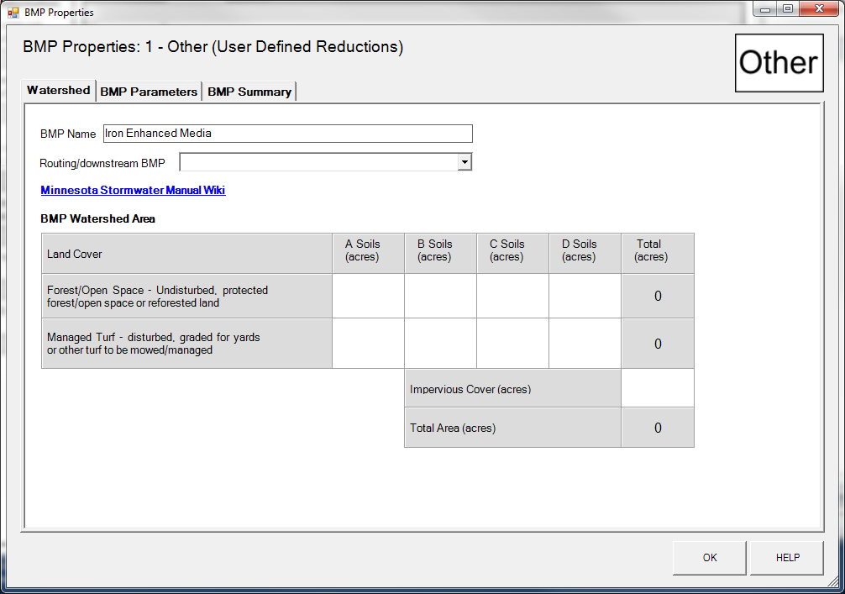

Step 12: Determine the BMP design parameters. For the Other BMP the user must define the following.
- BMP volume capacity
- percent annual runoff volume reduction
- percent dissolved phosphorus removed annually via non volume reduction treatment
- percent particulate phosphorus removed annually via non-volume reduction treatment
- total suspended sediments (TSS) removed annually via non-volume reduction treatment
For this example the other BMP represents the added dissolved phophrus removal provided by enhancing the sand media with iron. In the percent dissolved phosphorus removed annual via non volume reduction treatment enter a value of 60%.
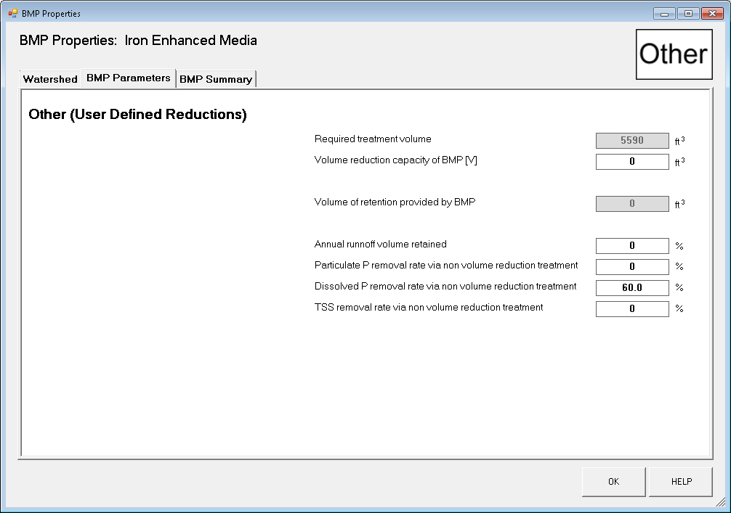
Step 13: Click on “BMP Summary” tab to view results for this BMP.
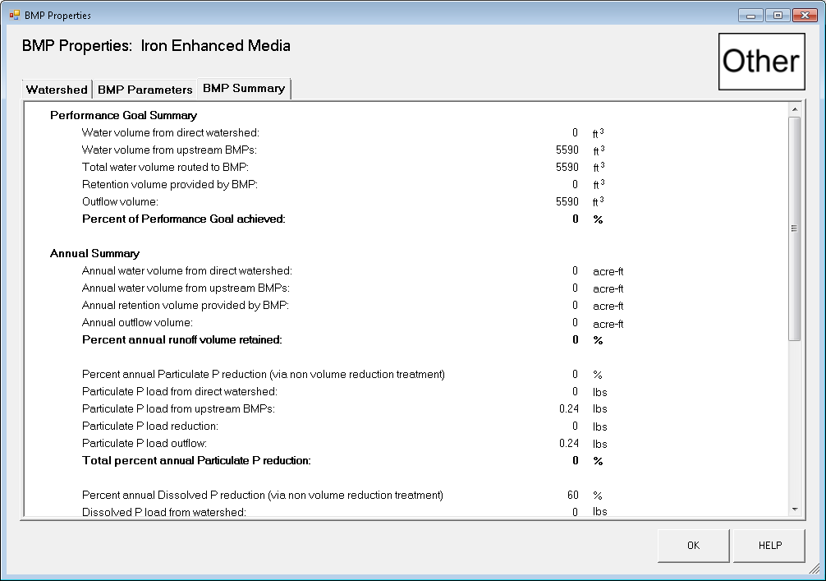

Step 14: Click on the “OK” button to exit the BMP properties screen.
Step 15: Click on “Results” tab to see overall results for the site.
