**1.0 Suitability**

* 1. **General**

Iron-enhanced sand filters are filtration Best Management Practices (BMPs) that incorporate filtration media mixed with iron. The iron removes several dissolved constituents, including phosphate, from stormwater. Iron-enhanced sand filters may be particularly useful for achieving low phosphorus levels needed to improve nutrient impaired waters. Iron-enhanced sand filters could potentially include a wide range of filtration BMPs with the addition of iron; however, iron is not appropriate for all filtration practices due to the potential for iron loss or plugging in low oxygen or persistently inundated filtration practices. Here iron-enhanced filtration is limited to two types:

* Iron-enhanced sand filter basin (analogous to surface sand or media filters in the Minnesota Stormwater Manual)
* Iron-enhanced sand bench in wet ponds

Iron-enhanced sand filters may be applied in the same manner as other filtration practices and are more suited to urban land use with high imperviousness and moderate solids loads. Iron-enhanced sand filters are more suitable to conditions with minimal groundwater intrusion or tailwater effects. Because the primary treatment mechanisms are filtration and chemical binding and not volume reduction, vegetating the filter is not needed and may impair the filter function. All of the iron-enhanced sand filters require underdrains that serve to convey filtered and treated stormwater and to aerate the filter bed between storms. The exit drain from the iron-enhanced sand filter should be exposed to the atmosphere and above downstream high water levels in order to keep the filter bed aerated.

Iron-enhanced sand filters may be used in a treatment sequence, as a stand-alone BMP, or as a retrofit. If an iron-enhanced sand filter basin is used as a stand-alone BMP, an overflow diversion is recommended to control the volume of water, or more specifically, the inundation period in the BMP. As with all filters, it is important to have inflow be relatively free of solids or to have a pre-treatment practice in sequence.

**1.2 Function within Stormwater Treatment Sequence**

The iron-enhanced sand filter basin may be used in conjunction with other structural controls. The iron-enhanced sand filter bench is constructed along the perimeter of a pond that provides pretreatment. Placement of a plunge pool or some sort of pre-treatment upstream of an iron-enhanced sand filter basin is recommended to extend the lifespan of the filter.

**1.3 MPCA Permit Applicability**

*See MPCA permits.*

**Iron-Enhanced Filtration Overview**

*Iron-enhanced sand filters are filtration BMPs that incorporate filtration media mixed with iron that binds several dissolved stormwater constituents including phosphate*

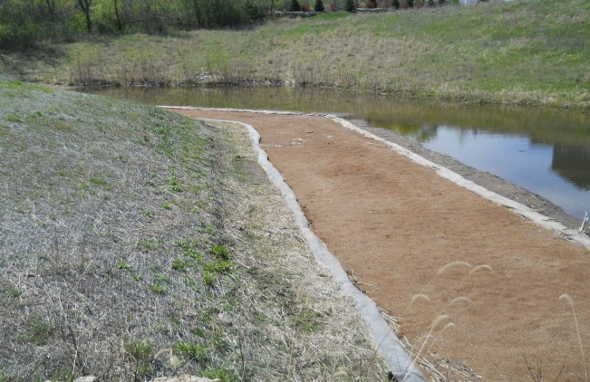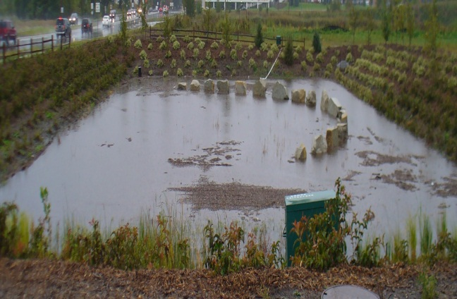

*Iron-enhanced sand bench, Prior Lake, MN. Photo courtesy of Ross Bintner.*

*Iron-enhanced sand filter basin, Maplewood, MN. Photo courtesy of Brian Huser.*

**Design Criteria**

* Water quality sizing for filtration (see Section 6.0) applicable to iron-enhanced sand filters
* Iron by weight no less than 5 percent but no greater than 8 percent (Erickson et al., 2012, and presentation by John Gulliver, September 2012) of iron-sand mixture. The iron weight range is based upon high surface area iron filing material that is approximately 90 percent elemental iron. Estimates of longevity and performance will need to be proportionately adjusted according to the percent composition of elemental iron for alternative iron materials. The alternative materials should not have elevated levels of other contaminants such as other metals and oils.
* Filter draw down within 48 hours of storm completion to avoid filter fouling and to prepare the filter for next storm event
* Minimal tailwater to allow aeration of filter bed between storm events
* Use of filter fabric around drain pipe or between media layers discouraged (e.g., no sock) due to clogging and aeration suppression effects
* Head (top of filter to outlet invert) of 2-6 feet recommended depending upon application
* Pre-treatment REQUIRED for sand filtration beds

**Benefits**

* Removal of several colloidal and dissolved constituents, including color and phosphates
* High pollutant removal rates
* Use as a retrofit for existing ponds and other stormwater BMPs
* Good for nutrient impaired water
* Could be used at sites with certain types of restrictions where infiltration is not appropriate or feasible

**Limitations**

* New technology with somewhat limited phosphorus removal performance history
* Best for urban watersheds or runoff with moderate sediment loads
* Lifespan of iron-enhanced filtration practice potentially reduced by clogging or iron loss
* Head required for treatment and draw down of filter between storms
* Tailwater effects may restrict siting of filters
* Vegetation should not be allowed to grow over the iron enhanced media. Decomposed vegetation may reduce oxygen in the filter media and cause a chemical change in the iron resulting in filter media fowling.

**Description**

Iron-enhanced sand filters are filtration BMPs that incorporate filtration media mixed with iron to enhance treatment performance. Iron is mixed evenly with the filtration media (typically sand) prior to or during the placement of the iron-media mixture in the filtration bed. Iron from several sources (Bachard and Heyvaert, 2005, and Erickson et al., 2011), such as chopped steel wool and iron filings, may be used, but iron must be elemental iron to enable the iron to gradually rust and convert to a form that can react with stormwater constituents. Finely-ground cast iron (approximately 90% elemental iron) recycled from scrap iron is the source and form of iron typically used in full scale systems in Minnesota. Performance data and recommendations for iron mass in filtration media that are provided in this document are based upon iron filings. Estimates of longevity and performance will need to be proportionately adjusted according to the percent composition of elemental iron for alternative iron materials.

In addition to filtering particles, the primary advantage of iron-enhanced filtration is that it removes dissolved constituents including phosphate, color and some metals by chemically binding. Dry or wet pre-treatment is REQUIRED prior to media filter treatment for all filters, unless influent is relatively free of solids (pre-treatment volume equivalent to at least 25% of the computed Vwq is RECOMMENDED). Iron-enhanced sand filters can be used as a retrofit to existing BMPs or in new construction. If the iron-filtration bed remains oxygenated, iron will be retained in the bed. Iron-filtration beds that are persistently deoxygenated risk iron loss or migration and clogging.

**1.4. Design Variants**

**1.4.1 Iron-Enhanced Sand Filter Basin**

An iron-enhanced sand filter basin is similar to a surface sand filter (see other section of Minnesota Stormwater Manual) with iron mixed evenly throughout a portion of the filtration media. Surface sand filter design and operating parameters also applicable to iron-enhanced sand filter basins include: the use of a flow splitter to control inflow volume, REQUIRED pre-treatment per the MPCA’s General Construction Stormwater Permit, filtration bed depth (approximately 18”), and use of perforated pipes (or other appropriate drain pipe design) in a gravel bed to drain the filter. To prepare the BMP for runoff from the next storm event and because the filter bed contains iron which can foul the filter, the bed should drain within 48 hours of storm completion. See Figure 1 in Section 6.1.1 for a conceptual design drawing.

If the iron-enhanced sand filter lies below the groundwater table, an impermeable liner may be necessary to prevent groundwater inflows. The MPCA highly recommends that a filtration system with less than 3 feet of separation to the seasonally saturated water table have an impermeable liner. The draft MPCA Construction Stormwater Permit REQUIRES a filtration system with less than 3 feet of separation to seasonally saturated soils to have an impermeable liner.

**1.4.2 Iron-Enhanced Sand Bench in Wet Ponds**

An iron-enhanced sand bench in wet ponds consists of a wet pond with an iron-sand trench along the perimeter of the pond. The elevation at the top of the trench is at the normal water elevation of the pond. During a storm event, water rises above the trench elevation and fills the live storage area of the pond. Stormwater will filter through the bench with excess stormwater bypassing the bench. Along with watershed, storm event, and pond geometry variables, the volume of stormwater passing through the bench will depend upon the outlet structure design.

Many of the design and operating considerations of an iron-enhanced sand filter basin also apply to the iron-enhanced sand bench. In addition to the 48-hour drain dry time, to prevent pond drawdown below the normal water level and allow the trench to dry and aerate, a geomembrane liner needs to be placed or the soils between the pond and the sand bench need to be prepared to inhibit infiltration from the pond into the trench. See Figure 2 in Section 6.1.2 for a conceptual design drawing.

**1.5 Retrofit Suitability**

All of the iron-enhanced sand filters covered here are suitable as retrofits and may be best employed downstream or in conjunction with existing wet ponds or other settling basins. The iron-enhanced sand filter basin should not be placed downstream of a pond or wetland that delivers an unabated flow of stormwater to the filter. If the filter bed is not allowed to drain dry to promote bed aeration, it is possible that the bed may become anaerobic and cause filtration bed fouling or iron loss.

**1.6 Special Receiving Waters Suitability**

Table 1 provides guidance regarding the use of filtration practices in areas upstream of special receiving waters. The corresponding information about other BMPs is presented in the respective sections of this Manual.

**Table 1. Design Restrictions for Special Waters**

|  |  |  |  |  |  |
| --- | --- | --- | --- | --- | --- |
| **BMP Group** | **Stormwater Management Category** | | | | |
| **A Lakes** | **B Trout Waters** | **C Drinking Water** | **D Wetlands** | **E Impaired Waters** |
| Iron-Sand Filters | Preferred | Preferred | Preferred | Preferred | Preferred |

**1.7 Cold Climate Suitability**

The iron-enhanced sand filter basin and the iron-enhanced sand filter bench in wet ponds are both suitable for cold climates.

**1.8 Water Quantity Treatment**

Iron-enhanced sand filters do not provide water quantity control. (*Currently, no volume reduction credit is given for iron-enhanced sand filtering systems. Volume losses through evapotranspiration and infiltration below an underdrain are being investigated for all BMPs and will be applied if it is deemed appropriate.)*

**1.9 Water Quality Treatment**

Although iron-enhanced sand filters can remove solids, the primary water quality benefit of iron-filters is the removal of dissolved constituents. Limited solids and phosphorus removal data are available for full scale treatment systems. Data that are available are provided in Table 2 for an iron-enhanced sand bench that was constructed for a wet pond in Prior Lake, Minnesota and an iron-enhanced sand filter basin constructed in Maplewood, Minnesota. The outflow concentrations can be used to assess how well a BMP is performing and the potential benefits to down-gradient receiving waters.

Iron-enhanced sand filters are not designed to discharge a part of the effluent to groundwater nor are they designed to treat all runoff events. The water quality benefit of the iron-enhanced sand filter should only be accrued based on the volume of water that is treated by the BMP.

**Table 2. Pollutant concentrations and removals for iron-enhanced sand filters**

|  |  |  |  |  |  |  |
| --- | --- | --- | --- | --- | --- | --- |
| **Practice** | **TSS Out (mg/L)** | **TSS Removal (%)** | **TP Out (mg/L)** | **TP Removal (%)** | **Phosphate Out (mg/L)** | **Phosphate Removal (%)** |
| I-E SFB1 | ND3 | ND | ND | ND | 0.015 | 70 |
| I-E SB2 | 2 | 92 | 0.025 | 71 | 0.010 | 50 |

1. Parallel iron-enhanced sand filter benches in a wet pond. Values are from an average of two parallel 7.2% and 10.7% iron by weight iron-enhanced sand benches reported by Erickson et al. 2012. Averages are from a total of five storms monitored from July through September 2010. Values reported as below the detection limit were set equal to one-half the detection limit when calculating average phosphorus at the outlet and percent removals.

2. Iron-enhanced sand filter basin. Values are from an average of 19, 19, and 11 (for TP, TSS, and phosphate, respectively) storm events monitored from April through September 2010. For phosphate, only storms with above detection limit data at the inlet were used to calculate removals. Phosphate data below detection limits at the outlet were set equal to one-half the detection limit (0.01 mg/L) when calculating an average and removal rates. Data were collected by the Ramsey-Washington Metro Watershed District and reported by Barr Engineering Company, December, 2010.

3. ND is “not determined”.

**1.10 Limitations**

The following general limitations should be recognized when considering installation of an iron-enhanced filtration practice:

* Lifespan of the filter potentially limited by repeated clogging and cleaning cycles
* Disposal of the iron-sand bed material will be required when the iron is consumed
* Iron-sand filtration offers limited water quantity control
* Accumulation of senesced and decomposed plant material in the filter bed (e.g., due to leaf litter accumulation or if vegetation is allowed to grow on the filter bed) may cause low oxygen conditions and iron loss or fouling over time

**2.0 Major Design Elements**

**2.1 Physical Feasibility Initial Check**

Before deciding to use an iron-enhanced sand filter for stormwater management, the designer should consider several items that affect the feasibility of using such a practice at a given location. The following list of considerations will help in making an initial judgment as to whether a filtration device is the appropriate BMP for the site.

**Drainage Area**: In addition to the practical size limitations of constructing a properly functioning (e.g., designing a filter than can drain properly and can be accessed for maintenance) iron-enhanced sand filter basin or sand bench in wet ponds, treatment objectives and credit needs will determine the drainage area that can be treated. Runoff volume is a function of soil type and watershed imperviousness. Given space availability or other factors that will dictate filter *treatment volume capacity* (VT, defined in Section 6.0). Section 6.1.2 provides figures (Figure 3 and 4) that can be used to determine percent of total runoff volume that can be treated given soil type, watershed imperviousness, and treatment volume capacity-VT.

**Site Topography and Slopes:** Sloped areas immediately adjacent to practice are RECOMMENDED to be less than 20% but greater than 1%, to promote positive flow towards the practice. Iron-enhanced sand filters do not require any slope to promote treatment.

**Soils:** No restrictions or sizing adjustments are required by soil type.

**Depth to Water Table and Bedrock**: The draft MPCA General Construction Stormwater Permit REQUIRES that an impermeable liner be constructed for a filtration system with less than 3 feet of separation from the seasonally saturated soils or from bedrock.

**Site Location/Minimum Setbacks:** A minimum setback of 50 feet between a stormwater pond and a water supply well is REQUIRED by the Minnesota Department of Health Rule 4725.4350. For purposes of this guidance, a stormwater pond is assumed to include a stormwater filtration system.

**Karst:** There are no special requirements for iron-enhanced sand filters in karst terrain. All of the iron-enhanced sand filters require underdrains that serve to convey filtered and treated stormwater and to aerate the filter bed between storms. It is recommended that an impermeable liner along the bottom of the filtration media be used if the filtration system is located in active karst areas.

**2.1.1 Conveyance**

Conveyance design elements for filtration (see other section of Minnesota Stormwater Manual) are largely applicable to iron-enhanced filtration with the following exceptions:

* When a flow splitter is not used, the maximum size of the contributing drainage area will be a function of filter size (filter surface area and live storage) for an iron-enhanced sand filter basin, and live storage and outlet design for an iron-enhanced sand bench in a wet pond (see Section 6.0).
* Use of permeable filter fabric around the drain pipe or between media layers is NOT RECOMMENDED as the filter fabric may clog, reduce infiltration into the drain pipe, or limit aeration of the filter media.

**2.2 Pre-Treatment**

The pre-treatment requirements for media filters apply to iron-enhanced sand filter basins. Pre-treatment is provided by the wet ponds associated with iron-enhanced sand filter benches.

**2.3 Treatment**

The treatment guidelines applicable to filtration (see other section of Minnesota Stormwater Manual) are also applicable to iron-enhanced filtration.

**2.4 Landscaping**

The MPCA REQUIRES that impervious area construction be completed and pervious areas established with dense and healthy vegetation (see other section of Minnesota Stormwater Manual) prior to introduction of stormwater into a filtration practice. The MPCA RECOMMENDS that the iron-sand filter surface be maintained free of vegetation or grasses. Ground cover can be used to stabilize the banks of the live storage zone above the elevation of the sand filter surface. Shrubs or other woody plants can be planted above live storage.

**3.0 Operation and Maintenance**

**3.1 Overview**

Iron-sand filter bed clogging poses the greatest operational and maintenance challenge of all filters. Poor drainage of the filter due to clogged filter surface, inlet, outlet, and underdrains, and persistent tailwater has the potential to cause the iron to foul and move within or be lost from the filter bed. When the iron is comple**t**ely consumed after some time of operation, the entire iron-sand filter bed will need to be replaced. The operating life span has been estimated using iron-enhanced sand columns for phosphate retention to be 35 years (Erickson, et al. 2012). However, this has not been verified in the field. Currently the operating lifespan of the iron material is not known and other indicators will need to be used to judge the filter bed condition such as reduced phosphorus removal performance or a reduction in the clarity of the stormwater treated by the iron-sand filter bed (see Section 3.4).

**3.2 Design Phase Maintenance Considerations**

Implicit in the design guidance in the previous section is the fact that many design elements of filtering systems can minimize the maintenance burden and maintain pollutant removal efficiency. Key examples include: limiting drainage area, providing easy site access (REQUIRED), and providing adequate pre-treatment (REQUIRED).

**3.3 Construction Phase Maintenance**

Proper construction methods and sequencing play a significant role in reducing problems with operation and maintenance (O&M). In particular, with iron-enhanced sand filter construction, the most important action for preventing operations and maintenance difficulties is to ensure that the contributing drainage area has been fully stabilized prior to bringing the practice on line (this is a REQUIRED practice).

Inspections during construction are needed to ensure the iron-enhanced sand filter is built in accordance with the approved design and standards and specifications. Detailed inspection checklists should be used that include sign-offs by qualified individuals at critical stages of construction, to verify the contractor’s interpretation of the plan is acceptable with the designer. An example construction phase inspection checklist for filtration is included in another section of Minnesota Stormwater Manual. This list is also applicable to iron-enhanced sand filters.

**3.4 Post-Construction Operation and Maintenance**

Similar to other filtration practices, iron-enhanced sand filters require maintenance. Without regular maintenance, iron-sand filtration media can become clogged and the filter may not be able to convey water. This can lead to stagnant water, iron fouling, and reduction or elimination of pollutant removal capacity.

A maintenance plan clarifying maintenance responsibility is REQUIRED. Effective long-term operation of iron-sand filters necessitates a dedicated and routine maintenance schedule with clear guidelines and schedules. Post-construction considerations provided in the filtration section of the Minnesota Stormwater Manual are also applicable to iron-enhanced sand filters.

During the operating life of an iron-enhanced sand filter, phosphorus of several forms and other stormwater constituents will bind to the iron. Currently the operating lifespan of the iron material is not known and other indicators will need to be used to judge the iron-enhanced sand filter bed condition, such as reduced phosphorus removal performance or a reduction in the clarity of the stormwater treated by the iron-enhanced sand filter. If performance declines notably, the iron-enhanced sand media may need to be replaced. Due to iron’s capacity to bind with several stormwater constituents (e.g., fluoride, sulfide, bicarbonate, natural organic matter, and phosphate); analysis of the iron and phosphorus content of the iron-enhanced sand bed can only provide an approximation of the remaining phosphate binding capacity. Total phosphorus at the outlet of the iron-sand filter that consistently exceeds 60 to 70 ug/L may be used as an indicator that the phosphorus binding capacity of the iron-enhanced sand bed has been consumed. If this condition is true, then it is recommended that samples be taken from the iron-sand bed and analyzed for total phosphorus and total iron. Total phosphorus to total iron ratios that exceed 5 mg phosphorus per g of elemental iron (Erickson et al., 2007) indicate the phosphorus binding capacity of the iron-sand bed is exhausted and should be replaced.

**4.0 Design: Iron-Enhanced Sand Filtration Basins**

Iron-enhanced sand filtration basins are analogous to media filters (see the Filtration section of the Minnesota Stormwater Manual). Figure 1 illustrates a conceptual design drawing of an iron-enhanced sand filtration basin. The basic design elements of an iron-enhanced sand filter basin include:

* Inlet that directs and controls maximum flows to the basin.
* Basin that includes a storage volume (see Section 6.0) above the filter bed.
* Iron-sand filtration bed (iron-enhanced sand filters should be no less than 5 percent but no greater than 8 percent iron by weight to prevent clogging, see Erickson et al., 2012, and presentation by John Gulliver, September 2012). The 5 to 8 percent range is based upon iron filing material that is approximately 90 percent elemental iron with a size distribution approximately equal to that of C33 sand.
* The iron and sand need to be thoroughly mixed. If mixing with a rototiller, 20 passes may be required.
* Normal and flood control outlet.
* Subsurface drains at the filter bed bottom to drain the bed. The outlet of these subsurface drains should be exposed to the atmosphere and above the downstream high water level to allow the filter to fully drain.
* The underdrain may consist of corrugated polyethylene pipe with slits not holes to prevent loss of sand and minimize clogging. If holes are used, the pipe should be covered with pea gravel.
* Filter draw down within 48 hours of storm completion to avoid filter fouling and to prepare the filter for next storm event.
* Minimal tailwater to allow aeration of filter bed between storm events.

**5.0 Design: Iron-Enhanced Sand Filtration Bench in Wet Ponds**

An iron-enhanced sand filtration bench in a wet pond (Figure 2) is essentially a wet extended detention pond (as defined in another section of the Minnesota Stormwater Manual) with a permanent pool and a flood pool. The outlet structure of the pond is designed such that the water in the flood pool during and after a storm event is held above the elevation of the iron-enhanced sand filter bench, thereby allowing water to filter through the bench. The basic design elements of an iron-enhanced sand filter basin include:

* Iron-enhanced sand filter of desired width and length (see Section 6.0) sited along the perimeter of the wet pond (iron-enhanced sands filters should be no less than 5 percent but no greater than 8 percent iron by weight to prevent clogging, see Erickson et al., 2012, and presentation by John Gulliver, September 2012). The 5 to 8 percent range is based upon iron filing material that is approximately 90 percent elemental iron with a size distribution approximately equal to that of C33 sand.
* Outlet structure that controls the flood pool elevation and can receive the filter bed drain.
* Subsurface drains at the filter bed bottom to drain the bed. The outlet of these subsurface drains should be exposed to the atmosphere and above the downstream high water level to allow the filter to fully drain.
* Impervious barrier (typically geotextile liner, for example HDPE) between the pond and the trench to minimize seepage from the pond into the trench.
* Filter draw down within 48 hours of storm completion to avoid filter fouling and to prepare the filter for next storm event.
* The underdrain may consist of corrugated polyethylene pipe with slits not holes to prevent loss of sand and minimize clogging. If holes are used, the pipe should be covered with pea gravel.

**6.0 Credits**

Credits in the MIDS calculator are applied in terms of a performance goal volume reduction and annual TP and TSS reductions. Currently, no volume reduction credit is given for iron-enhanced filtering systems. Volume losses through evapotranspiration and infiltration below an underdrain are being investigated for all BMPs and will be applied if it is deemed appropriate.

**6.1 Total Phosphorus Reduction**

Annual TP reductions were divided into two components: particulate phosphorus (PP) and dissolved phosphorus (DP). Each of the three filtering systems was assumed to provide zero DP reduction without the incorporation of iron in the filter media. It was also assumed that of TP, 55% is PP and 45% is DP. Using these assumptions the TP removal can be described by the following equation:

$R_{TP}={0.55*R}_{PP}+0.45*R_{DP}$ Eq. 1

where *R* is the removal efficiency for each of the phosphorus constituents. The removal efficiency for *RPP* is based on the annual TP reductions provided by each of the filtering BMPs without the inclusion of iron in the filter media. It was assumed that all removal of phosphorus in these systems is provided through the removal of particulate phosphorus. Therefore, the *RTP* reductions can be converted to RPP using the above equation by setting *RDP* to 0 (Table 3).

**Table 3. Total P and Particulate P removal from BMPs without iron in the filter media**

|  |  |  |
| --- | --- | --- |
| **BMPs without iron** | ***RTP*** | ***RPP*** |
| Stormwater pond | 50%1 | 91% |
| Sand filter | 45%1 | 85% |

1. Source (CWP & CSN 2008)

*RDP,* once iron is added to the filter media, can be broken down into the product of the DP removal effectiveness of iron-enhanced sand and the fraction of the annual runoff that passes through the sand filter. This assumes that the volume of annual runoff that bypasses the sand filter and the BMP through an overflow structure receives no treatment of the dissolved portion of the phosphorus loading. Thus, *RDP* can be represented by:

$R_{DP}=R_{Fe}*\frac{V_{F}}{V_{T}}$ Eq. 2

where *RFe* is the removal efficiency of an iron-enhanced sand filter (determined by experiments and monitoring shown in Table 2 to be approximately 60%), *VF* is the annual volume of runoff filtered, and *VT* is the total annual volume of runoff. The ratio of *VF* to *VT* will be called *F*, which is the fraction of the total annual runoff volume that is filtered by the sand filter. Therefore, the equation for total phosphorus removal can be rewritten as:

$R_{TP}=0.55*R_{PP}+0.45*60\%*F$ Eq. 3

To calculator the total phosphorus removal efficiency for each BMP, *F*, or the fraction of annual runoff that passes through the sand filter, must be calculated. This calculation is made in a two-step process.

The first step is to calculate the treatment volume of the BMP based on design parameters. The treatment volume represents the amount of water that the BMP is capable of holding at any one time. The second step is to use modeling results (i.e., from the P8 model) to convert the treatment volume into a percent annual runoff volume filtered.

**6.1.1 Treatment Volume Calculation**

The treatment volumes of the various BMPs are defined as the amount of water that can be stored by the BMP above the filter media at any given time. All of this water is able to pass through and be treated by the filter media. Iron-enhanced sand filters should be designed to drain in 48 hours, so the filter media should be designed to discharge the entire treatment volume below the outflow in no more than 48 hours (24 hours if the BMP drains into a trout stream). The limiting factor in the discharge rate of the sand filter can be the saturated hydraulic conductivity of the sand media, the surface area of the sand filter, or the capacity of the underlying underdrain. The designer must consider these factors when determining the volume of potential treatment. The treatment volume calculations for each of the three filter BMPs are described below.

**Iron-Enhanced Sand Filter Basin**

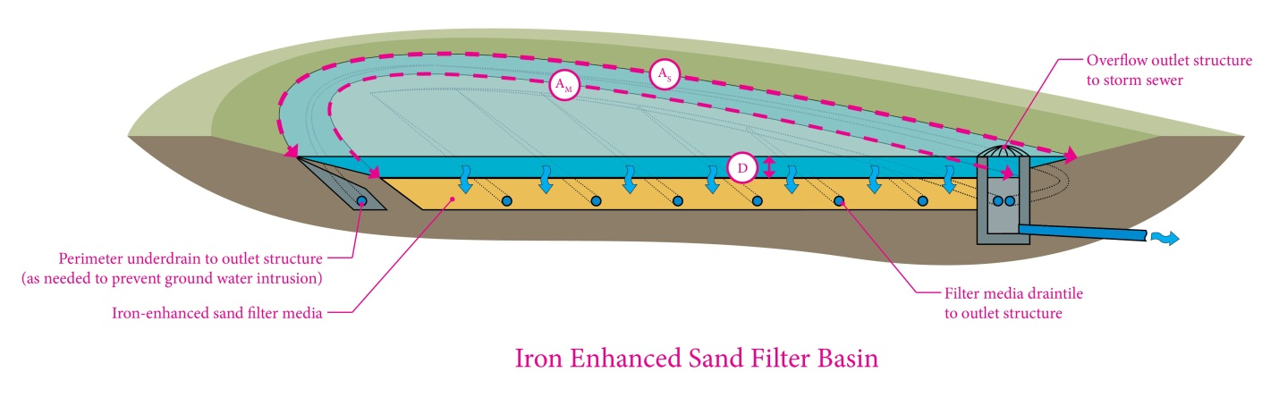

**Figure 1: Iron-enhanced sand filter basin schematic showing parameters used to calculate the treatment volume capacity**

The treatment volume capacity of the iron-enhanced sand filter basin is calculated using the parameters shown in Figure 1 in combination with the following equation:

$V_{T}=\left(\frac{A_{S}+A_{M}}{2}D\right)$ Eq. 4

Where VT is the treatment volume capacity of the sand filter, AS is the surface area of the sand filter at the basin overflow, AM is the surface area of filter media, D is the depth of water between overflow outlet structure and the sand filter media.

The designer must make sure that the final treatment volume is able to drain through the filter media and out the underdrain within the require drawdown time. If this criterion is not met, the designer should redesign the system to meet the requirement.

**Iron-Enhanced Sand Filter Bench in Wet Ponds**

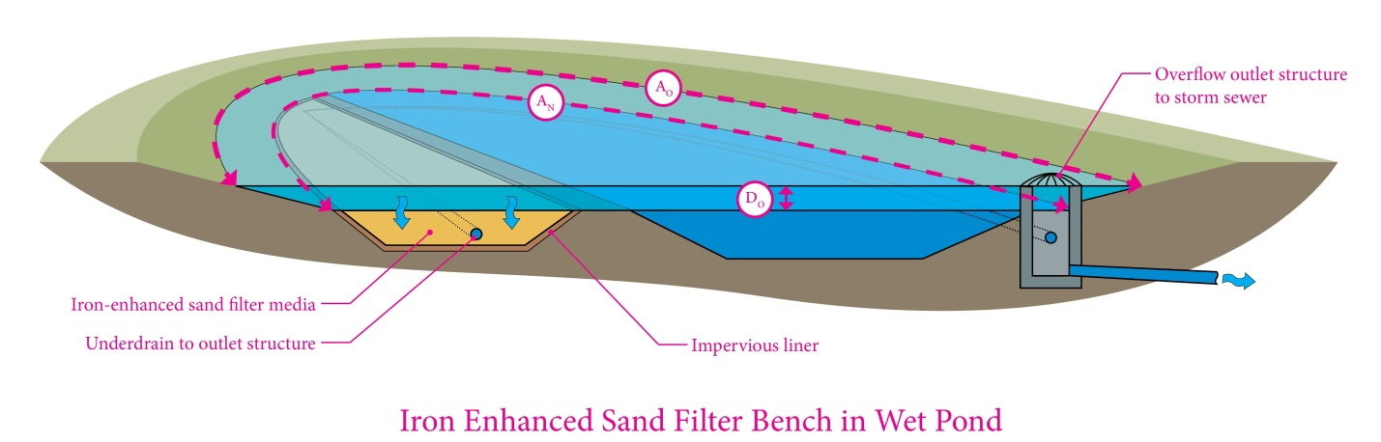

**Figure 2: Iron-enhanced sand filter bench in wet pond schematic showing parameters used to calculate the treatment volume capacity**

The treatment volume capacity of the iron-enhanced sand bench in wet ponds is calculated using the parameters shown in Figure 2 in combination with the following equation:

$V_{T}=\left(\frac{A_{N}+A_{O}}{2}D_{O}\right)$ Eq. 5

where VT is the treatment volume capacity of the filter bench, AN is the surface area of the pond at the normal water level (NWL), AO is the surface area of the pond at overflow outlet structure elevation, DO is the depth of water between the outflow structure elevation and the normal water level.

The designer must make sure that the final treatment volume is able to drain through the filter media and out the underdrain within the required drawdown time. If this criterion is not met, the designer should redesign the system to meet the requirement.

**6.1.2 Percent Annual Runoff Volume Filtered**

Once the treatment volume is calculated for the BMP, this value is converted to the fraction of annual runoff volume treated (*F*) using the treatment volume capacity (VT) of the iron-enhanced sand filter, tributary watershed size, soils and imperviousness of the watershed. Below is a description of the methods employed to determine the fraction of runoff treated.

The P8 model was used to calculate runoff from several hypothetical 10‑acre development scenarios with varying levels of imperviousness and different soil types. Twenty hypothetical watersheds were included in the P8 modeling analysis, including type A, B, C and D soils with 10%, 20%, 50%, 70% or 90% imperviousness. Through the use of look up tables created from P8 modeling results, treatment volumes were converted into a percent annual volume filtered.

Watershed runoff volumes from pervious areas were computed in P8 using the SCS Curve Number method. Pervious curve numbers were selected for each hypothetical watershed based on soil type and an assumption that the pervious areas within the hypothetical development would be open space areas in fair to good condition. References on SCS curve numbers provide a range of curve numbers that would apply to pervious areas in fair to good condition. Pervious curve numbers of 39, 65, 74, and 80 were used for hydrologic soil groups A, B, C, and D, respectively.

Depression storage represents the initial loss caused by such things as surface ponding, surface wetting, and interception. As previously discussed, the P8 model utilizes the SCS Curve Number method to estimate runoff from pervious areas. For impervious areas, runoff begins once the cumulative storm rainfall exceeds the specified impervious depression storage, with the runoff rate equal to the rainfall intensity. An impervious depression storage value of 0.06 inches was used for the P8 simulation.

The P8 model requires hourly precipitation and daily temperature data; long-term data was used so that watersheds and BMPs can be evaluated for varying hydrologic conditions. The hourly precipitation and average daily temperature data were obtained from the National Weather Service site at the Minneapolis-St. Paul International Airport. The simulation period used for the P8 analysis was January 1, 1955 through December 31, 2004 (50 years).

For the P8 analysis, the 50-year hourly dataset was modified to exclude the July 23-24, 1987 “super storm” event, in which 10 inches of rainfall fell in six hours. This storm event was excluded because of its extreme nature and the resulting skew on the pollutant loading and removal predictions. Excluding the July 23-24, 1987 “super storm”, the average annual precipitation throughout the 50-year period used for the P8 modeling was 27.7 inches.

Infiltration basins were used to simulate the amount of water treated by each BMP. Infiltration basins were sized for a range of treatment volumes with depths of 1.5 feet and infiltration rates of 5.3 inches per hour to simulate flow through a sand media as reported by Rawls et al. 1998. Infiltration basins were modeled using each of the drainage characteristic combinations of soils type and impervious surfaces. The final results from the modeling were total runoff volume reductions based on the size of the basin and infiltration rate. This runoff reduction was converted to percent annual reduction based on the total inflow into the system and the total overflow. The percent annual reduction represents the annual percent runoff volume that passes through the BMP and is treated. Modeled results are shown in Figures 3 and 4. Figure 3 shows the model results for the iron-enhanced sand filter bench and Figure 4 shows the model for the iron-enhanced sand filter. The figures can be used to determine the annual runoff volume filters (F) using the BMPs treatment volume (VT)/total drainage area ratio. The calculated runoff volume filtered (*F*) can then be plugged into the equation to calculate RTP (see example in Section 6.3). Results are divided by watershed soil type and percent impervious surfaces.



**Figure 3: P8 modeling results for the iron-enhanced sand filter bench. Relationships are used to calculate annual runoff Volume filtered (F).**



**Figure 4: P8 modeling results for the iron-enhanced sand filter bench. Relationships are used to calculate annual runoff Volume filtered (F).**

**6.2 Annual TSS Reduction**

The annual TSS reduction provided by each of the filter BMPs is based on values reported in CWP & CSN, 2008 (Table 4). The TSS removal from the iron-enhanced sand filter bench in wet ponds BMP is based on the annual TSS reduction found in a stormwater pond. The TSS removal from the iron enhanced sand filter BMP is based off of value reported for TSS removal in a sand filter.

**Table 4. Annual TSS removal from BMPs**

|  |  |
| --- | --- |
| **BMPs without iron** | ***RTSS*** |
| Stormwater pond | 84%1 |
| Sand filter | 85%1 |

1. Source (CWP & CSN 2008)

**6.3 Credit Calculation Example (Iron-Enhanced Sand Filter Basin)**

A 2 acre site with 50% impervious and hydrologic soil group B soils is routed to an iron-enhanced sand filter basin. The depth between the overflow structure and the sand filter bed (D) is 1.5 feet. The area of the sand filter at the overflow structure (AS) is 1,000 ft2 and the surface area of the sand filter (AM) is 800 ft2. Using Eq. 4 for the iron-enhanced sand filter basin, VT is calculated to be 1350 ft3 or 0.031 acre-ft.

$$V_{T}=\left(\frac{1,000 {ft}^{2}+800{ft}^{2}}{2}1.5 ft\right)=1350 {ft}^{3}$$

The ratio between the BMP treatment volume [VT] and the drainage area then becomes 0.0155 feet (1350 ft3/2 acres * 43560 ft2/1 acre). This value can be used with Figure 4 for a watershed with HSG B soils and 50% impervious to get a percent of annual runoff volume filtered (F) of 88%, as shown in Figure 5. Plugging the value of F into Eq. 3 results in an annual TP removal rate (RTP) of 71%.



$$R_{TP}=0.55*0.85+0.45*60\%*0.88=71\%$$

**Figure 5: Example of an Iron Enhanced Sand Filter Basin with a Watershed of Type B soils and 50% impervious area**

**7.0 References**

Banchand, P.A. M., and A. Heyvaert. 2005. Adsorptive Media Investigations and Testing for Improved Performance of Stormwater Treatment Systems in the Tahoe Basin. Prepared for Placer County Department of Public Works, Auburn, CA, and California Tahoe Conservancy, South Lake Tahoe, CA. Prepared by Bachand and Associates, and U.C. David Tahoe Research Group.

Barr Engineering Company. 2010. Iron-enhanced sand filter monitoring – 2010. December 28, 2010 Report to the Ramsey-Washington Metro Watershed District.

Center for Watershed Protection & Chesapeake Stormwater Network (CWP & CSN), 2008. *Technical Memorandum: The Runoff Reduction Method*. April 18, 2008

City of Bellevue Utilities Department and Shapiro and Associates. 1999. Lakemont storm water treatment facility monitoring program. Final Report. City of Bellevue Utilities Department. 301 116th Avenue SE. Bellevue, WA 98009-9012.

Claytor, R.A., and T.R. Schueler. 1996. Design of stormwater filtering systems. Prepared by The Center for Watershed Protection. 8391 Main Street, Ellicott City, MD 21043. Prepared for Chesapeake Research Consortium. (410) 461-8323.

Erickson, A.J., Gulliver, J.S., and P.T. Weiss. 2012. Capturing phosphates with iron enhanced sand filtration. Water Research. Vol. 26, pp. 3032-3042.

Erickson, A.J., Gulliver, J.S., and P.T. Weiss. 2011. Removing dissolved phosphorus from stormwater. 12nd International Conference on Urban Drainage, Porto Alegre/Brazil, 10-15 September 2011.

Erickson, A.J. and J.S Gulliver. 2010. *Performance Assessment of an Iron-Enhanced Sand Filtration Trench for Capturing Dissolved Phosphorus*, Project Report No. 549, St. Anthony Falls Laboratory, University of Minnesota, Minneapolis, Prepared for the City of Prior Lake, Minnesota

Erickson, A.J., Gulliver, J.S, Weiss, P.T., and B.J. Huser. 2010. Iron-enhanced sand filtration for stormwater phosphorus removal. 7th International Urban Watershed Management Conference. The University of Auckland, New Zealand, February 21-24.

Erickson, A.J., Gulliver, J.S., and P.T. Weiss. 2007. Enhanced sand filtration for storm water phosphorus removal. Journal of Environmental Engineering. pp. 485-497. May 2007.

MNDOT 2005. *MnDOT Standard Specifications Book*, Division III – Materials, Minnesota Department of Transportation, St. Paul, Minnesota.

Minnesota Pollution Control Agency (MPCA). 2008. *Minnesota Stormwater Manual, Version 2.*

Rawls, W. J., Gimenez, D., Grossman, R. 1998. Use of soil texture, bulk density, and slope of the water retention curve to predict saturated hydraulic conductivity. Transaction of the ASAE. Vol. 41(4): 983-988.