**REPORT FOR OBJ1.TASK 5: CONSTRUCTION SPECIFICATIONS & CONSTRAINTS**

To: MPCA

From: The Kestrel Design Group Team (The Kestrel Design Group Inc, with Dwayne Stenlund – Minnesota Department of Transportation, James Urban – Urban Trees and Soils)

Date: October 18, 2013

Re: Contract CR5332

**SCOPE**

Develop and submit construction design specifications for tree stormwater BMPs. This applies to new tree installations. If there is insufficient information in the literature to support development of specifications, guidelines shall be developed. The specifications or guidelines will include considerations of BMP type (e.g. open, closed, or partially-open tree pits), soil properties, cold climate, and groundwater constraints (e.g. karst settings):

* 1. Review state-of-the-art literature to identify existing construction specifications or guidelines and identify existing construction practices for trees used as stormwater BMPs. Consider different variations of tree BMPs in the review.
  2. Review literature and identify special construction considerations. Examples include but may not be limited to soil suitability, cold climate considerations, groundwater considerations, and need for stormwater pretreatment of pollutants.
  3. Review the literature and identify tree planting surface cover considerations including boulevard soil ripping/compost augmentation, rain gardens, and boulevard swale designs.
  4. Provide a recommendation to the PM regarding whether specifications or guidelines will be developed.
  5. Prepare and submit a Technical memo that summarizes construction specifications or guidelines. If specifications are developed, include CAD drawings.
  6. Prepare a final report that provides construction specifications or guidelines for tree BMPs, including graphics.
  7. Incorporate recent research collected at the University of North Carolina state and by the Center for Watershed Protection into the reports.

**LIST OF FIGURES**

Figure 5.1: Schematic Drawing of Suspended Pavement System Using Soil Cells and Pervious Pavement used for Bioretention

Figure 5.2 Trees planted in suspended pavement on Tryon Street Mall, Charlotte, NC

Figure 5.3: Silva Cells

Figure 5.4: Silva Cell installation at MARQ 2 project, Minneapolis, MN

Figure 5.5: Silva Cell installation at MARQ 2 project, Minneapolis, MN

Figure 5.6: Conceptual diagram of CU-Structural Soil™ including stone-on-stone compaction and soil in interstitial spaces used as a base course for pavements

Figure 5.7: Typical streetscape with tree planted in CU structural soil

Figure 5.8: Typical sand based structural soil drawing

**REPORT**

**General Bioretention Construction Guidelines and Specifications**

Standard keys to success in bioretention construction apply to trees for bioretention, including, for example, the following keys listed below.

**Plan for Feasible Temporary and Permanent Erosion and Sediment Control Techniques and Sequencing**

* Plan for temporary and permanent erosion and sediment control techniques, sequencing, and pay items, and prepare a thorough SWPPP plan.
* Examples techniques include compost logs (MnDOT 2573) and plastic sheeting (MnDOT 2575), and diversion berms (MnDOT 2573).
* Plan to minimize or avoid soil compaction to the extent feasible. Techniques include for example, using driveable mats, using tracked machinery, and machinery with long arms to avoid having to drive in tree trenches.
* Designating a stormwater supervisor to make sure someone is responsible for erosion and sediment control.

**Plan for Snow Storage During (if applicable) and after Construction**

**Construction Administration and Communication with Contractor**

* Effective communication during pre-construction meeting.
* Include “check points” in specifications with timelines – points of inspection which must be approved before proceeding to next step of construction. These will vary depending on specific project, but will include, for example, approval of required submittals, and required testing, such as, for example infiltration tests.
* Ensure checkpoints are approved prior to proceeding to next steps. Where applicable, require signature by Contractor, Designer, and Chief Inspector prior to proceeding to next step.
* Require submittals for material to be used, including, sources and certifications where applicable.
* Specify required tests and tolerances.

See the bioretention section of the Minnesota Stormwater Manual for other construction guidelines and specifications.

**Construction Guidelines and Specifications Specifically for Trees for Bioretention**

In addition to general bioretention guidelines and specifications, the following guidelines and specifications apply specifically to trees for stormwater design:

1. **See Task 4 for tree material, tree installation, and soil quality and volume specifications.**
2. **Tree opening guidelines**

* Tree openings need to be large enough to allow for trunk flare. Minimum recommended tree opening dimension is five feet by five feet.
* The use of tree grates is discouraged in order to protect the tree root flare.
* Tree openings need to be protected from foot and vehicular traffic.

1. **Tree spacing guidelines**

* For street trees, a minimum spacing of 30’ on center is recommended for large trees to allow their canopies to grow to their full size. This also makes it easier to provide adequate soil volumes for each tree.

1. **Guidelines for providing rootable soil volume for tree root growth and bioretention under pavement**

Where there is not enough open space for traditional bioretention, several techniques exist to protect soil volume under pavement from traffic compaction so that this soil can be used both for bioretention and tree root growth. Examples of these techniques include:

1. Structural cells
2. Rock based structural soil
3. Sand based structural soil
4. Soil boxes

Each of the above techniques is described and compared below. Links to construction guidelines are also provided.

1. **Suspended Pavement**

 In areas that do not have enough open space to grow large trees, techniques like suspended pavement can be used to extend tree rooting volume under HS-20 load bearing surfaces and create favorable conditions to grow large trees in urban areas. This rooting volume can also be used for bioretention (see Figure 5.1 for an example schematic drawing of suspended pavement used for bioretention). While suspended pavement has been built in several different ways, all suspended pavement is held slightly above the soil by a structure that “suspends” the pavement above the soil so that the soil is protected from the weight of the pavement and the compaction generated from its traffic.

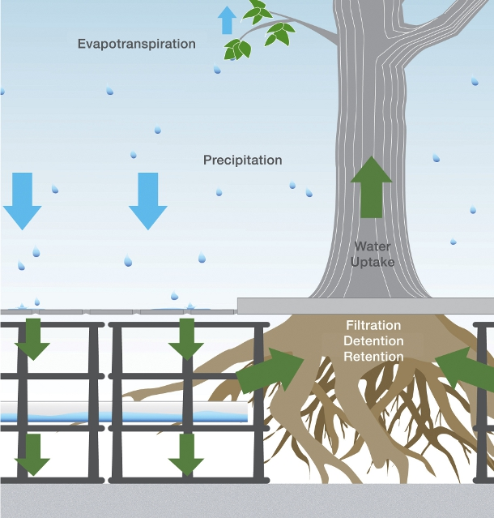

Figure 5.1: Schematic Drawing of Suspended Pavement System Using Soil Cells and Pervious Pavement used for Bioretention (Image from http://www.deeproot.com/blog/blog-entries/meeting-c3-requirements-with-headquarters-in-menlo-park-ca)

One of the earliest examples of trees grown in suspended pavement is in Charlotte, North Carolina, where a reinforced concrete sidewalk was installed over the top of poured in place concrete columns. Figure 5.2 shows the trees 26 years after planting. While this is an effective way to grow large trees, it is labor intensive and requires intensive surveying to ensure that column heights are precise.

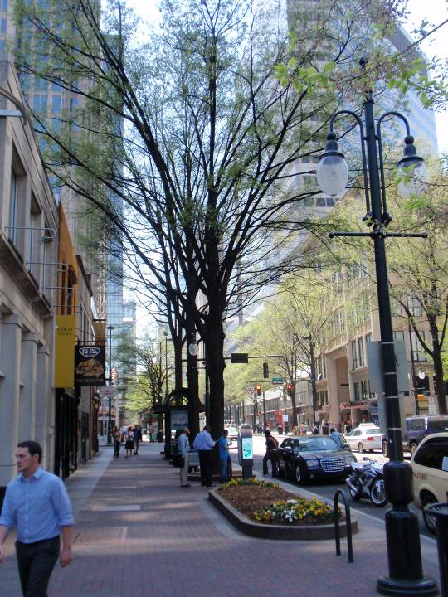

Figure 5.2 Trees planted in suspended pavement on Tryon Street Mall, Charlotte, NC (Image source: The Kestrel Design Group, Inc).

A more recently developed, and less labor intensive, technique to build suspended pavement is through the use of soil cells, like, for example, Silva Cells, modular proprietary pre-engineered structural cells manufactured by Deeproot Green Infrastructure.  The modular design allows flexibility to size the rooting/bioretention volume as needed for each site. Underground utilities can be accommodated within Silva Cells systems. The Silva Cell system consists of silva cell frames that are 48'' (1200 mm) long x 24'' (600 mm) wide x 16'' (400 mm) high (see Figure 5.3). Frames can be stacked up to three high, and a deck is installed above the top frame. An air space between the top of the soil and the deck prevents tree roots in the upper soil layers from lifting the overlying pavement.

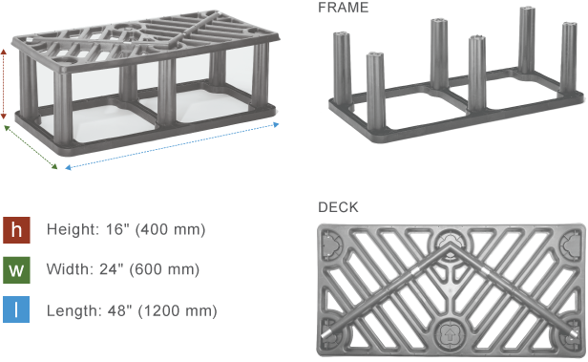

Figure 5.3: Silva Cells(Image from <http://www.deeproot.com/products/silva-cell/overview>)

Because this soil in the Silva Cells is protected from compaction from loads on pavement above the cells, a wide range of soils can be used in the Silva Cells, so soil can be tailored to desired functions (e.g. tree growth and stormwater management). See Task 4 for recommended soil for Silva Cell systems that are used as stormwater BMPs.

The Silva Cell system can support vehicle loading up to AASHTO H-20 rating of 32,000 lbs. (14,500 kgs) per axle. According to Deeproot’s website “This rating refers to the ability of a roadway to safely accommodate 3-4 axle vehicles, such as a large semi-truck and trailer.” The cells are made of “an ultra high-strength compound of glass and polypropylene, with galvanized steel tubes to add support and prevent plastic creep.”

Construction documents and specifications for a wide range of Silva Cell applications can be found on Deeproot Green Infrastructure’s website, available September 2013 at:

<http://www.deeproot.com/products/silva-cell/resources>

Many other resources are available on their website including, for example:

* Summary of structural loading capacity testing
* General cost information
* Many resources for installation, including installation instructions and a video of installation guidelines
* Case studies
* Lifecycle cost analysis

See Task 12, Case Studies, for a description of the “MARQ2” project, a local project in downtown Minneapolis, that incorporated 173 tree/Silva Cell systems as tree stormwater BMP’s.

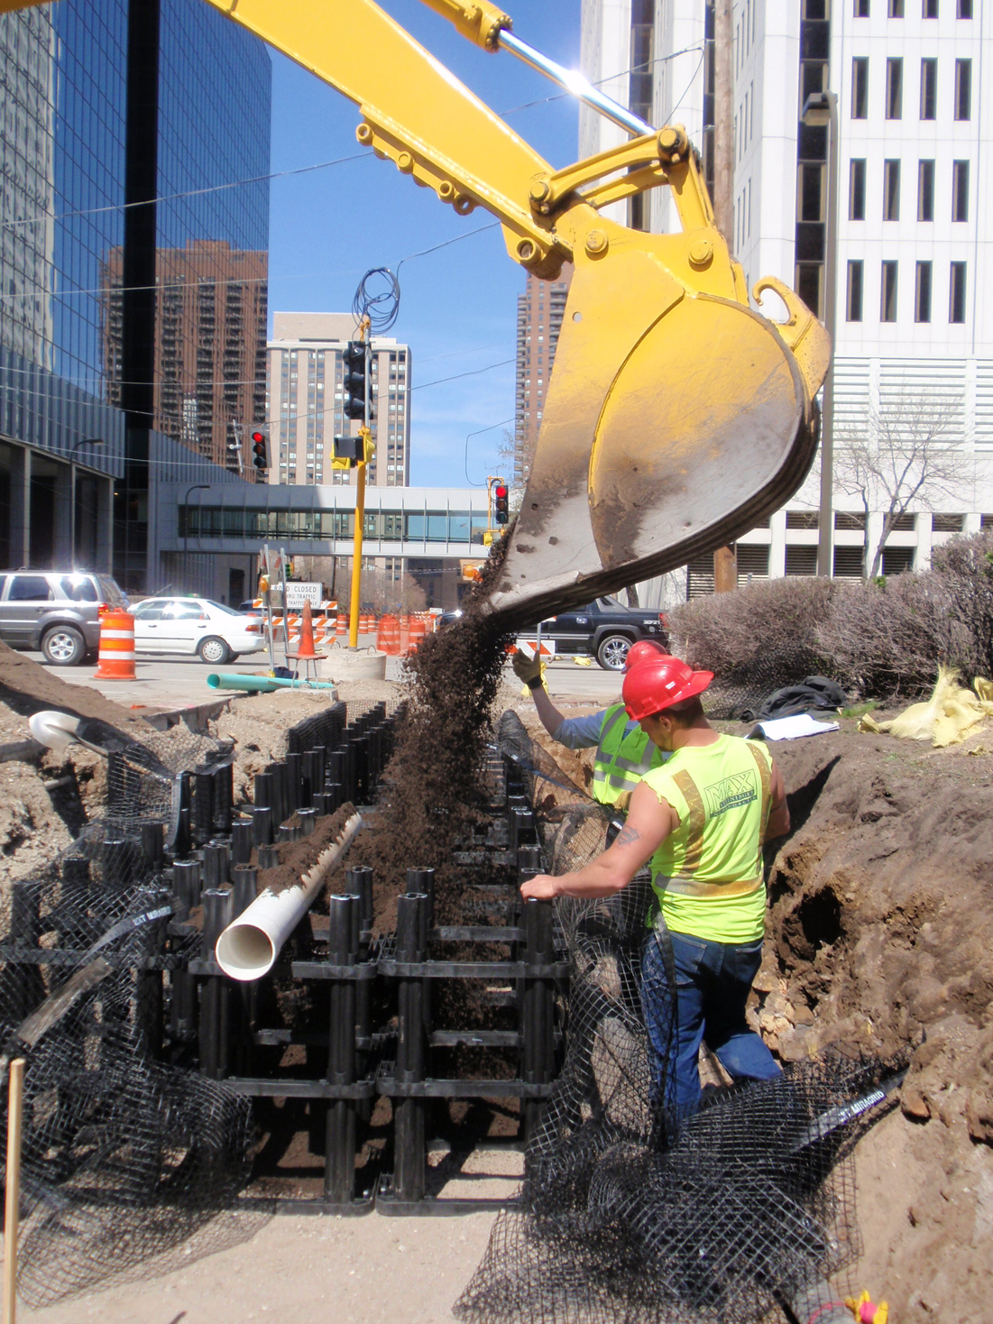

Figure 5.4: Silva Cell installation at MARQ 2 project, Minneapolis, MN (Source: Kestrel Design Group, Inc.)

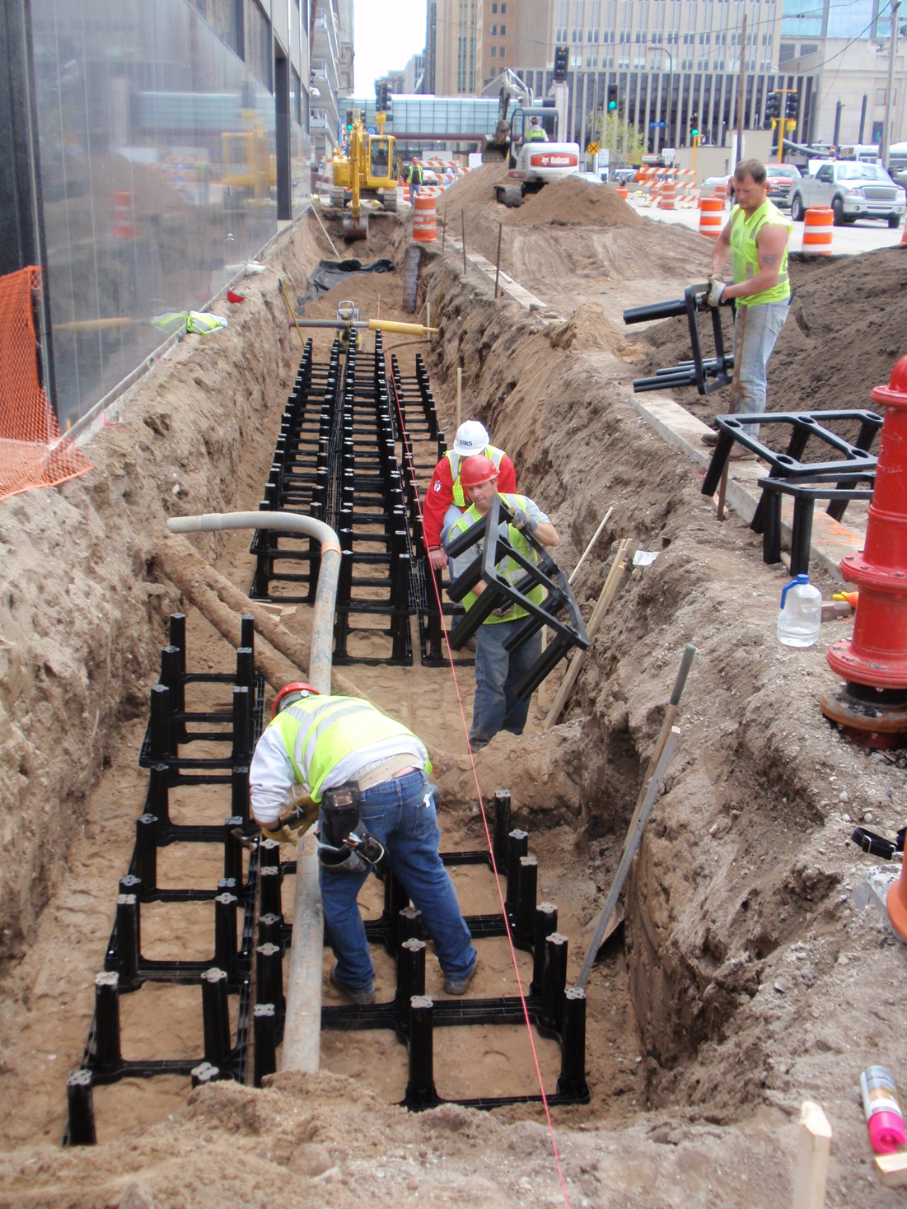

Figure 5.5: Silva Cell installation at MARQ 2 project, Minneapolis, MN (Source: Kestrel Design Group, Inc.)

1. **Rock Based Structural Soils**

Rock based structural soils are engineered to be able to be compacted to 95% Proctor density without impeding root growth.

Rock based structural soils are typically gap graded engineered soils with the following components:

* Stones to provide load bearing capacity and protect soil in its void spaces from compaction
* Soil in rock void spaces for tree root growth
* Tackifier to keep the soil uniformly distributed in the rock void spaces (tackifier is only found in some kinds of rock based structural soil).

**Stone lattice**

Desired characteristics for the stone base used in rock based structural soils include:

* The stones should be uniformly graded and crushed or angular for maximum porosity, compaction, and structural interface (Bassuk et al 2005).
* Mean pore size should be large enough to accommodate root growth (Lindsey 1994).
* Significant crushing of stone should not occur during compaction (Lindsey 1994).

According to UC Davis (1994), 2 inch stones would be able to support most tree roots. Because limestone has been found to crush on some projects, granite stone is recommended.

**Soil**

Soil needs to have adequate nutrient and water holding capacity to provide for the tree’s needs.

**Tackifier**

The tackifier, if used, should be non-toxic and non-phototoxic.

See Figure 5.6 for a diagram of how structural soils create uncompacted pore space available for soil and tree roots.

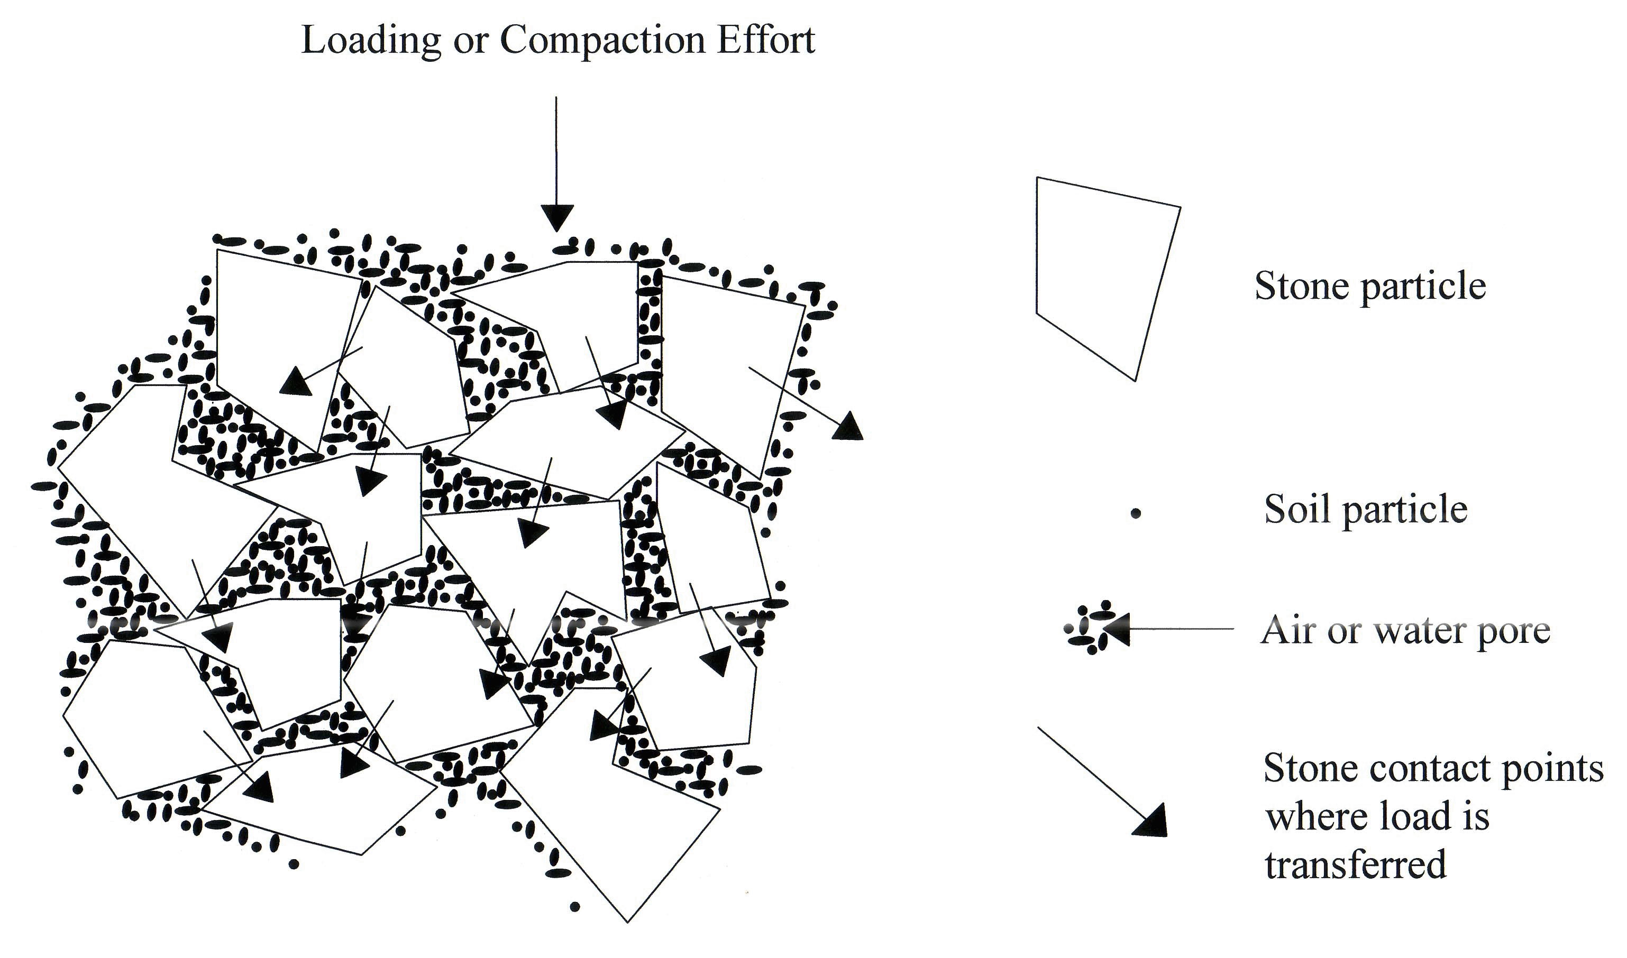

Figure 5.6: Conceptual diagram of CU-Structural Soil™ including stone-on-stone compaction and soil in interstitial spaces used as a base course for pavements (from Cornell University website at <http://www.hort.cornell.edu/uhi/outreach/csc/graphics.html>).

.

Figure 5.7 shows a typical section of a streetscape using structural soils to grow trees.

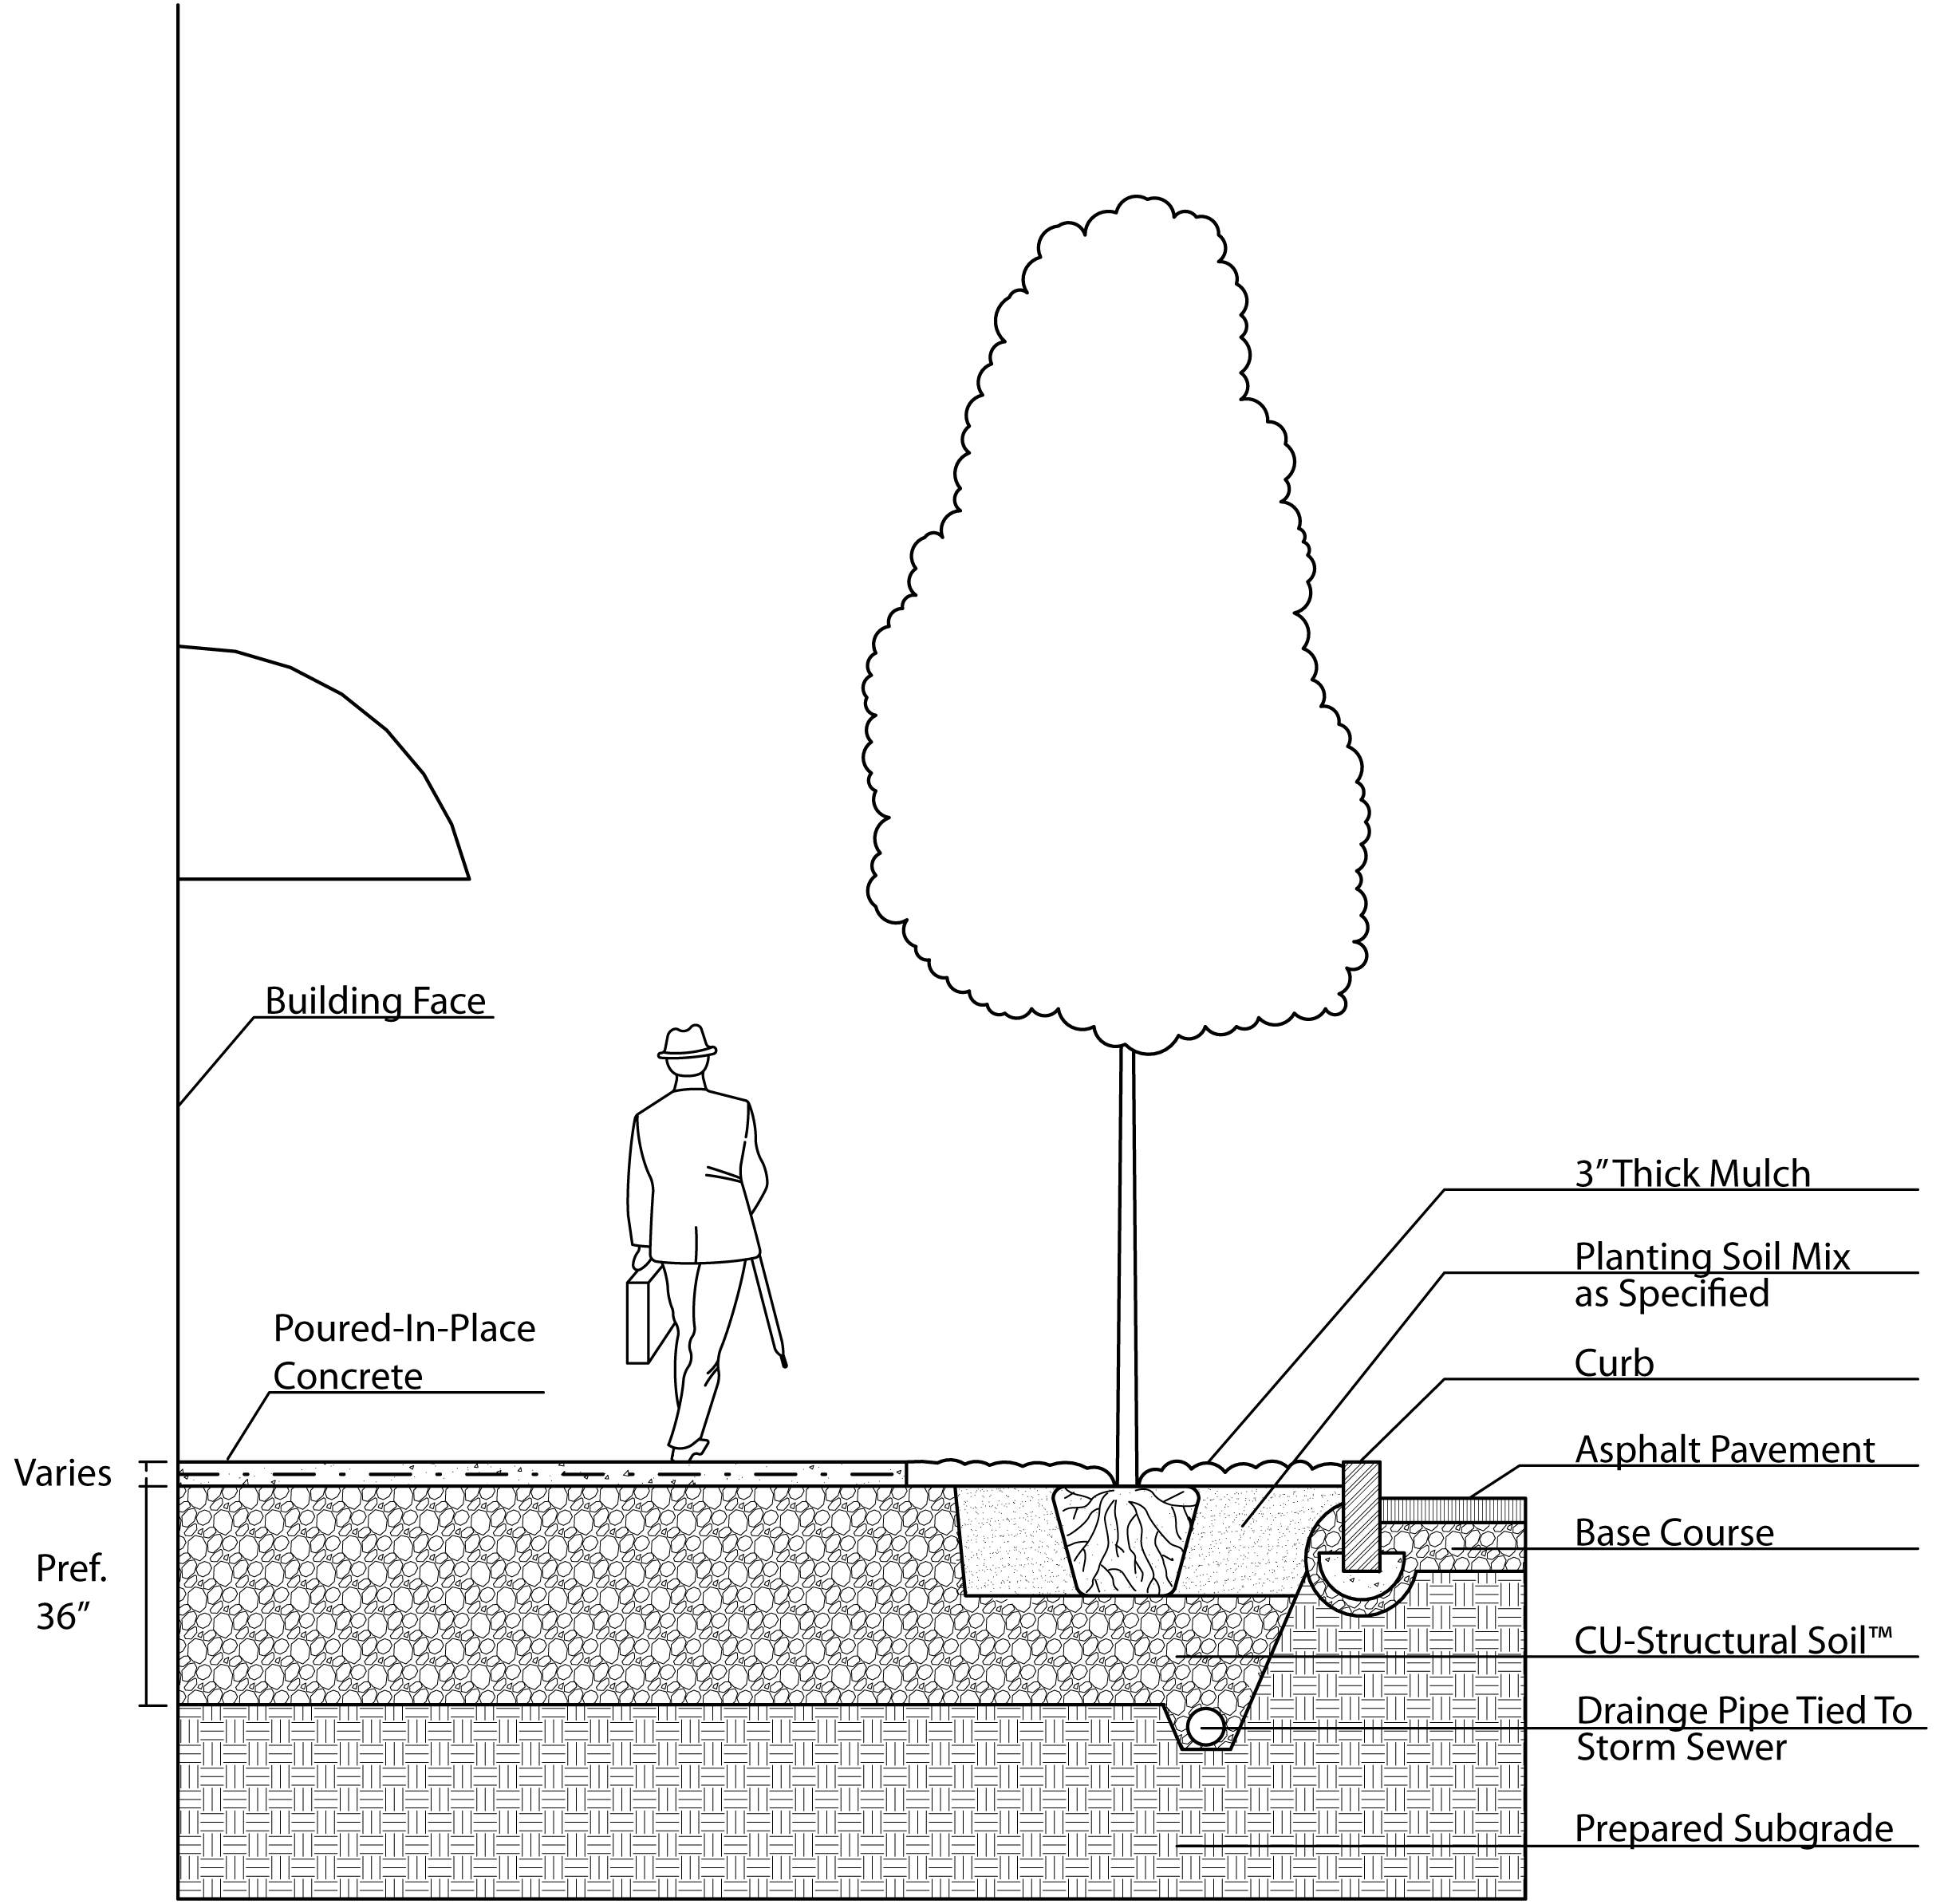

Figure 5.7 Typical streetscape with tree planted in CU structural soil: (from Cornell University website at <http://www.hort.cornell.edu/uhi/outreach/csc/graphics.html>)

Many more construction drawings are available on Cornell University’s website at <http://www.hort.cornell.edu/uhi/outreach/csc/graphics.html>, including, for example:

* Detail and plan for using structural soil in a planting island
* Detail and plan for using structural soil in a limited soil volume planter
* Detail for using structural soil with permeable pavers
* Detail for structural soil breakout zone

**Types of structural soils**

Several types of rock based structural soils have been developed, including, for example:

* Cornell University (CU) structural soil: 80% stone with size ranging from 0.75 to 1.5 inches and 20% loam to clay loam soil with minimum 20% organic matter, by dry weight, and hydrogel to uniformly mix the stone and soil (CU 2005). Patented formula available only from licensed producers to ensure quality control.
* University of California (UC) Davis structural soil: 75% lava rock (0.75 inches)and 25% loam soil (by volume) (Xiao and McPherson 2008).
* Stalite structural soil: 80% Stalite, a porous expanded slate rock (0.75 inches), and 20% sandy clay loam soil (by volume)(Xiao and McPherson 2008).
* Swedish structural soil

**Design considerations for trees growing in structural soil**

**Soil pH**

Care must be taken to select species tolerant of structural soil pH. For example, if limestone based structural soil is used, trees tolerant of alkaline pH must be selected, as limestone can raise the pH of soil to 8.0 or higher (Bassuk 2010 soil debate, Urban 2008).

**Drainage Rate**

Because rock based structural soils drain quickly (>24 inches per hour), designers should select tree species tolerant of extremely well drained soils (Bassuk 2010).

**Volume of rock based structural soil needed for healthy tree growth**

Because only 20% of the volume of a rock based structural soil is actually soil, a greater total volume of rock based structural soil is needed compared to growing the same size tree in a sandy loam soil. A pot study by Loh et al (2003) found that 5 parts of structural soil were needed to provide the soil value of 1 part of loam soil (Loh et al, 2003). Similarly, an on-going study at Bartlett Tree labs is finding that over the past 9 years, trees growing in loam soil in suspended pavement have been consistently outgrowing trees growing in equal volumes of rock based structural soils, stalite soil, and compacted soil. See Task 4.1.C “Research Comparing Value of Rock Based Structural Soil to Traditional Tree Soils” for more information on these studies.

Based on the above studies, Urban (2008) recommends:

“Given the extreme inefficiency of the ratio of excavated volume to soil usable by the tree, strips of structural soil less than 20 feet wide might be better constructed as soil trenches or structural cells, where more soil can be included for less cost. A 5-foot wide soil trench set of structural cells…will provide more soil usable by the tree than a 20 foot wide trench of soil/aggregate structural soil.

Soil/aggregate structural soils may have applications as a transition to other options, and to add soil in places where other options may not be practical. These might include tight, contorted spaces and fills around utility lines and against foundations where full compaction is required (p. 306)”

**More information about rock based structural soils is available online, for example, at:**

* Cornell University’s website at: <http://www.hort.cornell.edu/uhi/outreach/>
* A joint website by Cornell University’s, Virginia Tech, Rutgers University, and University of California Davis: http://urbanforestry.frec.vt.edu/stormwater/

1. **Sand based structural soil**

Sand based structural soils were first developed in Amsterdam when some trees were in poor condition because of an “unfavorable rooting environment” (Couenberg 1993). Because the natural soils in Amsterdam, bog-peat, was non-load bearing, the top 2 meters of soil had been replaced with a medium coarse sand, which had insufficient nutritional value. Amsterdam soils were developed in an effort to grow better trees but still provide adequate bearing capacity for pavement bearing light loads, such as sidewalks. The Dutch studied various mixes for tree growth, soil settlement, and several other parameters. The resulting Amsterdam Tree Soil contains medium coarse sand with 4-5% organic matter and 2-4 % clay by weight and also meets other criteria, including, for example, (1) the medium coarse sand must meet specific gradation requirements, (2) soil mix must be free of salt, (3) mix must contain less than 2% particles below 2µm, and (4) amount of particles below 2µm must be considerably less than the amount of organic materials (Couenberg 1993).

All medium coarse sand (the layer above the Amsterdam Tree Soil) is compacted to 95% to 100% Proctor density. Amsterdam tree soil is not compacted to 100% density, but “is compacted until the soil has a penetration resistance between 1.5 and 2 MPascal (187 to 250 PSI)...Comparison of soil density values after filling with soil density at 100% Proctor Density has shown that soil density of Amsterdam Tree Soil after filling amounts to 70-80% Proctor Density” (Couenberg 1993).

Amsterdam Tree Soil was found to settle 19 mm [0.75 inches] in 3 years compared to the surrounding pavement, which was acceptable according to Dutch standards (Couenberg 1993), but may not be acceptable to many communities in the US to minimize risk of litigation related to trip and fall hazards.

The standard design in Amsterdam includes the following from bottom to top (see Figure 5.8):

* Ground water table 1 – 1.2 m below ground level
* Saturation zone 10-20 cm
* Layer of compacted, non-saturated sand
* Amsterdam tree soil compacted in 2 layers of 40-50 cm
* Compacted layer of 10 cm medium coarse sand for paving.
* Pavement, typically concrete pavers 30x 30 x 5 cm (Couenberg 1993)

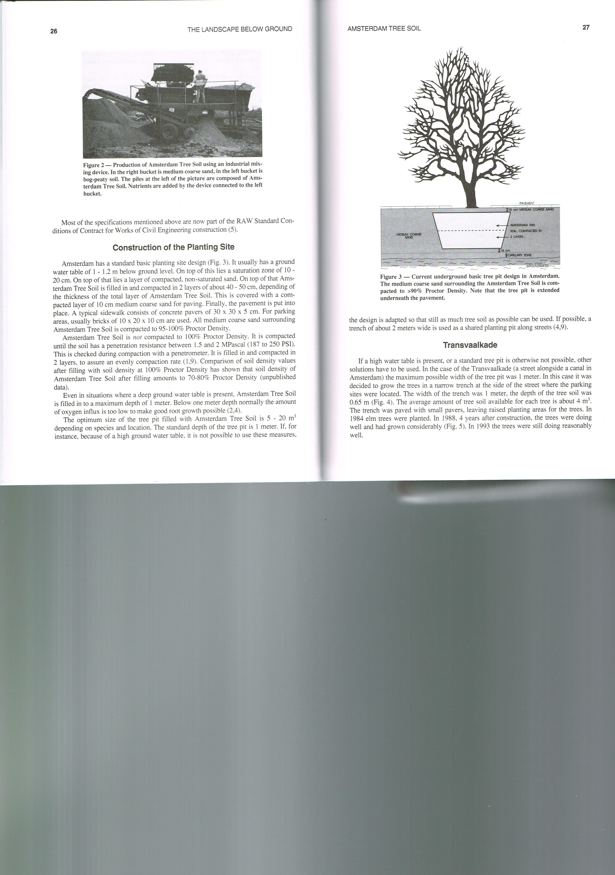

Figure 5.8: Typical sand based structural soil drawing (Image source: Couenberg 1993)

While Amsterdam sand based soils work well in Amsterdam, trees grown in Amsterdam soils in Minnesota would likely need significant irrigation, as they have low water holding capacity. Amsterdam receives an average of 36 inches of rain per year, which is higher than the range of average yearly rainfall in Minnesota. Rainfall events are also more frequent and lower intensity in Amsterdam than in Minnesota. Summer temperatures are also higher in Minnesota than in Amsterdam, resulting in higher water needs by trees. According to Couenberg (1993), who helped develop Amsterdam soils “the Amsterdam tree soil has been developed in an area where there is sufficient rainfall. If this soil is used in other climatic areas, adaptations to the tree pit will have to be made after the local situation has been monitored.”

Most of Amsterdam also has a high water table which is controlled to have almost no seasonal fluctuation, and groundwater wicks up into tree rooting zones by capillary action, so trees always have access to water from the ground water table. According to Urban (2008), “tests of Amsterdam planting soil in other locations in Europe without high water tables showed less promising results with overly dry soil, which required significant supplemental water.”

So, in summary, sand based structural soils may be a viable in Minnesota if (1) some settlement is acceptable with light structural loads, and (2) trees are irrigated.

1. **Soil boxes**

Soil boxes are concrete boxes designed for bioretention. They are typically proprietary products, such as, for example, the boxes made by Filterra and Contech.

Rooting volume capacity of these boxes is typically limited to large shrubs. Soil volumes provided by these boxes are typically not sufficient to grow healthy large trees. A standard 6’x6’ Filterra box, for example, provides 72 c.f. of soil, assuming a 2’ depth of soil. Given that the recommended soil volume for trees is 2 cubic feet of soil per 1 square foot of tree canopy, this is only enough to support a tree with a 5’ radius canopy.

**REFERENCES**

Bassuk, Nina. 2010. Using CU-Structural Soil to Grow Trees Surrounded by Pavement. In The Great Soil Debate Part II: Structural soils under pavement. ASLA Annual Meeting Handout. Available August 2013 from <http://www.asla.org/uploadedFiles/CMS/Meetings_and_Events/2010_Annual_Meeting_Handouts/Sat-B1The%20Great%20Soil%20Debate_Structural%20Soils%20Under%20Pavement.pdf>

Bassuk, Nina, Jason Grabosky, and Peter Trowbridge. 2005. Using CU-Structural Soil™ in the Urban Environment. Available August 2013 from http://www.hort.cornell.edu/uhi/outreach/pdfs/custructuralsoilwebpdf.pdf

Couenberg Els. A.M. 1993. Amsterdam Tree Soil. In: The Landscape Below Ground. Proceedings of an international workshop on tree root development in urban soils.

Grabosky, Jason, Edward Haffner, and Nina Bassuk. 2009. [Plant Available Moisture in Stone-soil Media for Use Under Pavement While Allowing Urban Tree Root Growth](http://www.hort.cornell.edu/uhi/research/articles/auf35(5).pdf). Arboriculture & Urban Forestry 35(5): 271-278.

Lenth, John and Rebecca Dugopolski (Herrera Environmental Consultants), Marcus Quigley, Aaron Poresky, and Marc Leisenring (Geosyntec Consultants). 2010. Filterra® Bioretention Systems: Technical Basis for High Flow Rate Treatment and Evaluation of Stormwater Quality Performance. Prepared for Americast, Inc.

Lindsey, Patricia, Ed. 1994. The Design of Structural Soil Mixes for Trees in Urban Areas – Part II. Growing Points 1(2). University of California. Available August 2013 from http://ucanr.edu/sites/EH_RIC/newsletters/Vol1_No2_199437635.pdf.

**Please Note:**

The Kestrel Design Group (including its employees and agents) assumes no responsibility for consequences resulting from the use of the information herein, or from use of the information obtained at linked Internet addresses, or in any respect for the content of such information, including (but not limited to) errors or omissions, the accuracy or reasonableness of factual or scientific assumptions, studies or conclusions, the defamatory nature of statements, ownership of copyright or other intellectual property rights, and the violation of property, privacy, or personal rights of others. The Kestrel Design Group is not responsible for, and expressly disclaims all liability for, damages of any kind arising out of use, reference to, or reliance on such information. No guarantees or warranties, including (but not limited to) any express or implied warranties of merchantability or fitness for a particular use or purpose, are made by the Kestrel Design Group with respect to such information.

The Kestrel Design Group does not endorse, approve, certify, or control references and Internet links included herein and does not guarantee the availability, accuracy, completeness, efficacy, timeliness, or correct sequencing of information in these references and links. No one should rely on the accuracy, completeness, efficacy, and timeliness of such information. Reference therein to any specific commercial product, process, or service by trade name, trademark, service mark, manufacturer, or otherwise does not constitute or imply endorsement, recommendation, or favoring by the Kestrel Design Group.