BMPs in Series Example

The Mississippi Watershed Management Organization office in northeast Minneapolis contains multiple BMPs that are routed to one another before the water reaches the Mississippi River. This site contains a cistern that receives runoff from part of the building’s roof and is used to irrigate a 0.25 acre area, a green roof, a series of infiltration tree boxes that treats overflow from the cistern, permeable pavement, a bioretention basin without an underdrain and a bioretention basin with an underdrain. The flow of water and location of the BMPs are displayed in the figure below. All watershed information and BMP parameters for this site are displayed in the tables below. This example will show how to enter all of the BMPs, route them to the appropriate downstream BMP and view the results.

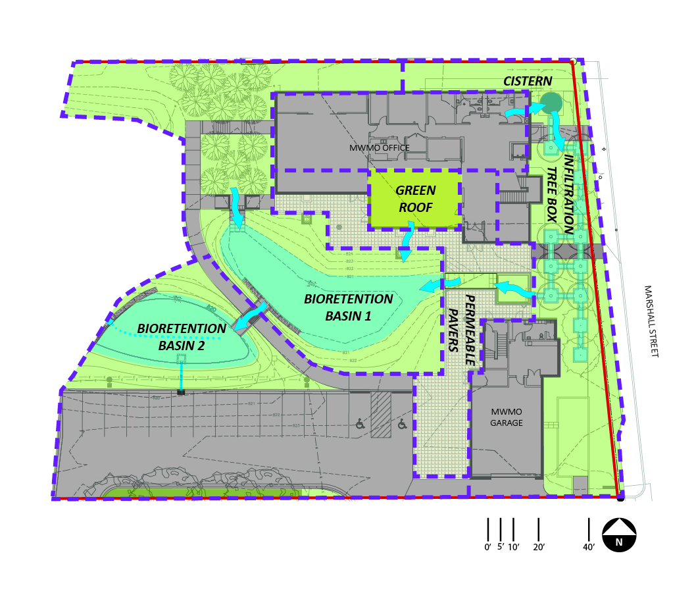
Zip code: 55418

 |  |  | Land Cover (acres)
 | Watershed | Soil type (HSG) | Turf-disturbed | Forest-undisturbed | Impervious | Total (acres)
 | Cistern | B | 0 | 0 | 0.08 | 0.08
 | Tree Box | B | 0.11 | 0 | 0.07 | 0.18
 | Basin 1 | B | 0.17 | 0 | 0.03 | 0.20
 | Green Roof (1) | B | 0 | 0 | 0.02 | 0.02
 | Permeable Pavers (2) | B | 0 | 0 | 0.08 | 0.08
 | Basin 2 | B | 0.12 | 0 | 0.15 | 0.24
 | Total |  | 0.40 | 0 | 0.43 | 0.80
 | Notes:
(1) | For "Site Information", Green roof area is considered impervious area. 4" media depth. Entire watershed is a green roof (871 sf)
(2) | For "site Information", Permeable pavers are considered impervious area. 2,614 sf of pavers with 870 sf of roof draining onto the pavers

 | Watershed | BMP Description | Surface Area at Overflow (ft²) | Surface Area at Media Surface (ft²) | Surface Area at Underdrain (ft²) | Bottom surface Area (ft²) | Overflow Depth (ft) | Total Media Depth (ft) | Depth Below Underdrain (ft)
 | Cistern (1) | Harvest and re-use/Cistern | 50 | NA | NA | 50 | 10 | NA | NA
 | Tree Box (2) | Tree trench system/Box (w/o underdrain) | NA | 650 | NA | 650 | NA | 6.0 | NA
 | Basin 1 | Bioretention basin (w/o underdrain) | 2200 | 1282 | NA | NA | 1 | NA | NA
 | Green Roof | Green Roof | NA | 871 | NA | NA | NA | 4 inches | NA
 | Permeable Pavers (3) | Permeable Pavement | NA | NA | 2614 | 2614 | NA | NA | 1.0
 | Basin 2 (4) | Bioretention basin (with elevated underdrain) | 1546 | 1250 | 1200 | 1110 | 1 | 3.0 | 1.3
 | Notes:
(1) | Irrigates a 0.25 acre area at 1 in/week from May through September. Is offline during offseason.
(2) | Media porosity -field capacity = 0.30. Median field capacity - wilting point is 0.07. 6 deciduous, small sized trees are planted in the tree boxes.
(3) | For "Site Information", Permeable pavers are considered impervious area. 2,614 sf of pavers with 871 sf of roof draining onto the pavers. Media Porosity=0.40
(4) | Media field capacity - wilting point = 0.15. Media porosity - field capacity = 0.35. Planting media mix = C, P content of media is less than 30 kg/mg, and no soil amendments have been added

Step 1: Determine the watershed characteristics for the entire site. For this example we have a 0.8 acre site with 0.43 acres of impervious area and 0.37 acres of turf cover in B soils.
Step 2: Fill in the site specific information into the “Site Information” tab. This includes entering a Zip Code (55418 for this example) and the watershed information in Step 1. Zip code and impervious area must be filled in or an error message will be generated. Other fields on this screen are optional.
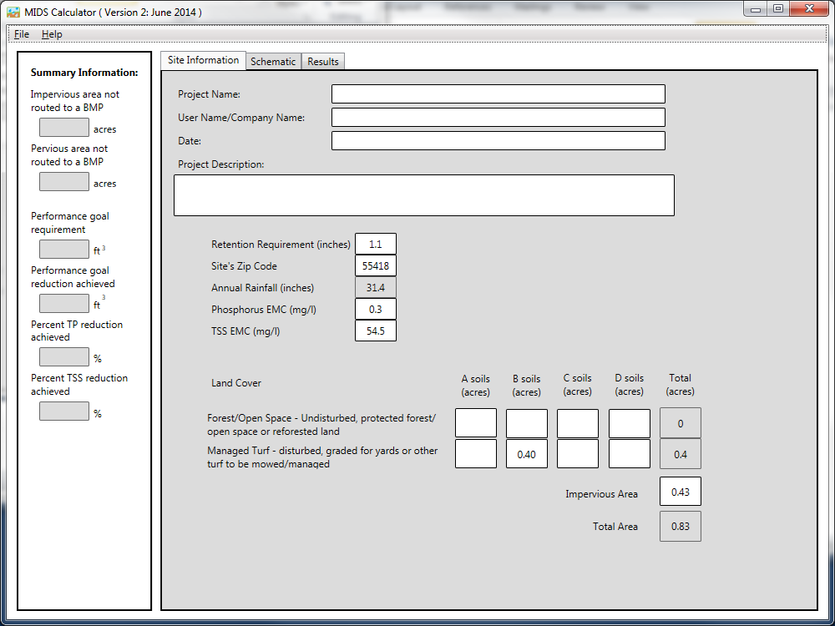

Step 3: Goto the Schematic tab and drag and drop the BMPs into the “Schematic Window”. BMPs in this example include a Harvest and re-use/Cistern, a Tree trench system/Box (w/o underdrain), a permeable pavement BMP, a green roof, a bioretention basin without an underdrain and a bioretention basin with an underdrain.
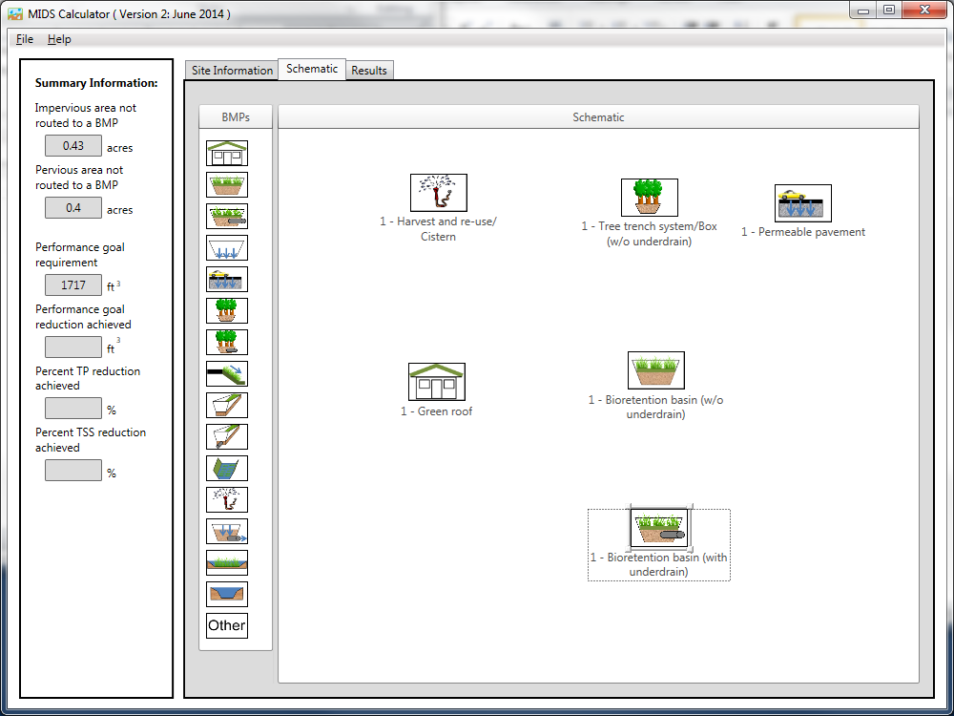

Step 4: Open the BMP properties for the Cistern by right clicking on the “Harvest and re-use/Cistern” icon and selecting “Edit BMP properties”, or by double clicking on the “Harvest and re-use/Cistern” icon.
Step 5: Determine the watershed characteristic for the cistern. For this example 0.08 acres of impervious area is draining to the cistern. Enter in the watershed information, change the name to cistern and route to the Tree trench system/Box BMP.

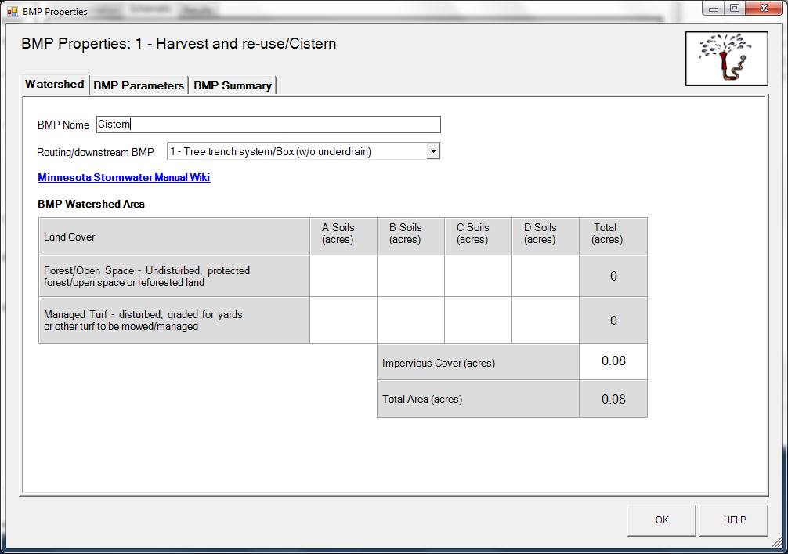

Step 7: Enter in the BMP design parameters into the “BMP parameters” tab. Harvest and re-use/Cistern requires the following entries:
- Reuse storage volume equal to the cistern volume of 500 .
- Irrigation application area equals 0.25 acres.
- Irrigation application rate of 1 inch/week.
- Irrigation start month equal to May.
- Irrigation end month equal to September.
- Does the system go offline during off season – Yes
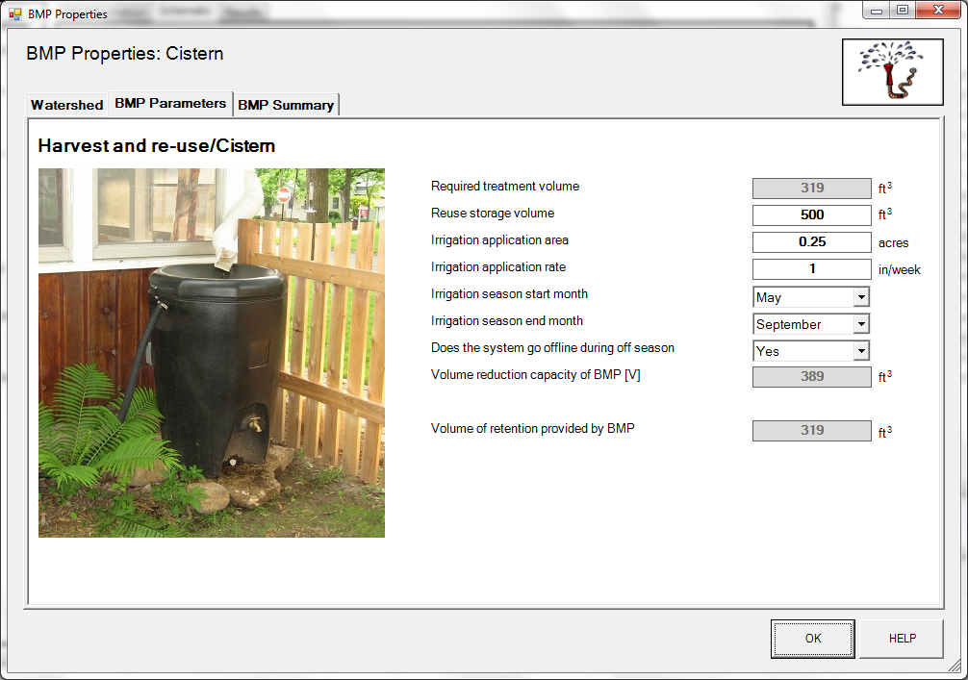

Step 8: Close the BMP properties window for cistern by clicking OK.
Step 9: Open the BMP properties for the tree box by right clicking on the “Tree trench system/Box (w/o underdrain)” icon and selecting “Edit BMP properties”, or by double clicking on the “Tree trench system/Box (w/o underdrain)” icon.
Step 10: Determine the watershed characteristic for the tree box. The watershed parameters for the tree box include a 0.18 acre site with 0.07 acres of impervious area and 0.11 acres of pervious turf area in type B soils. Enter in the watershed information. Change the name and route the BMP to the bioretention basin without an underdrain.
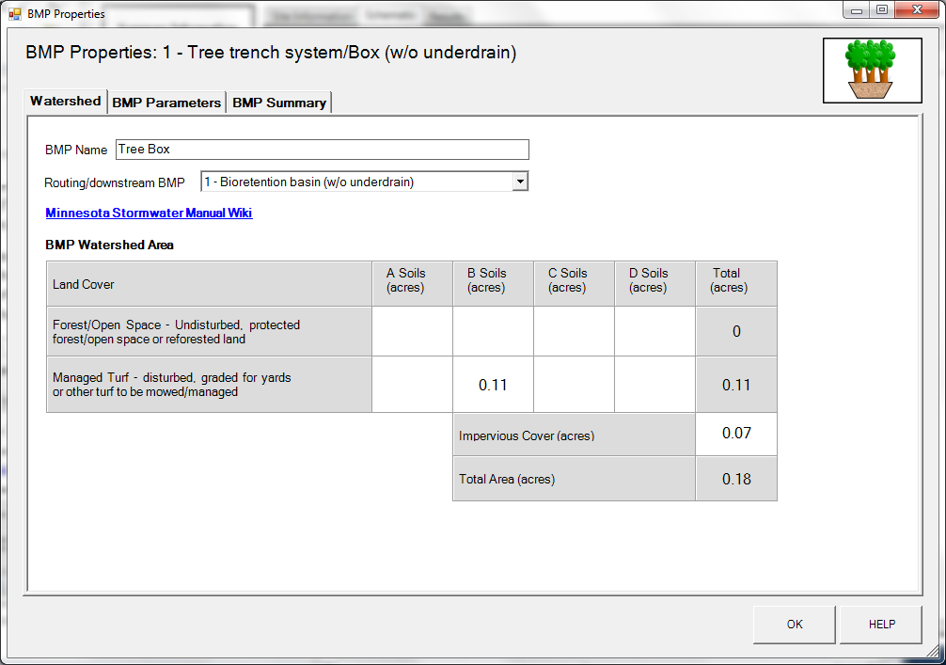

Step 11: Enter in the BMP design parameters into the “BMP parameters” tab. Tree trench systems require the following entries.
- Surface area at media surface which is 650 square feet;
- Bottom surface area (area at media-soil interface) which is 650 square feet;
- Media depth which is 6 feet;
- Media field capacity minus wilting point which is 0.07 cubic feet per cubic foot;
- Media porosity minus field capacity which is 0.30 cubic feet per cubic foot;
- Tree type is Deciduous;
- Tree Size is Small;
- Number of Trees is 6;
- Underlying soil – Hydrologic Soil Group which is SM (HSG B; 0.45 in/hr) from the dropdown box; and
- Required drawdown time (hrs) which is 48 from the dropdown box.
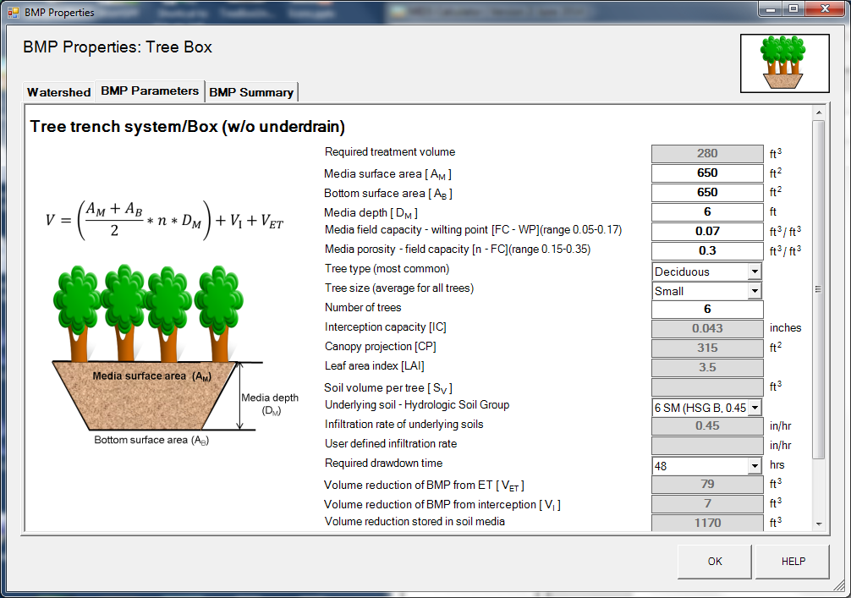
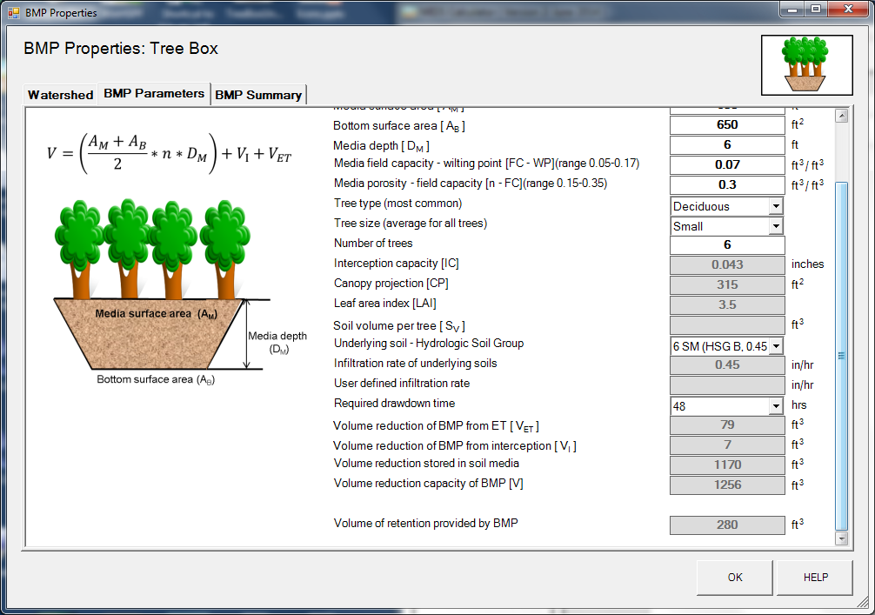
Step 12: Close the BMP properties window for tree box by clicking OK.
Step 13: Open the BMP properties for the permeable pavement by right clicking on the “Permeable pavement” icon and selecting “Edit BMP properties”, or by double clicking on the “Permeable pavement” icon.
Step 14: Determine the watershed characteristic for the permeable pavement. The watershed parameters for the permeable pavement include a 0.08 acre site with all of it being impervious. Enter in the watershed information. Change the name and route the BMP to the bioretention basin without an underdrain.

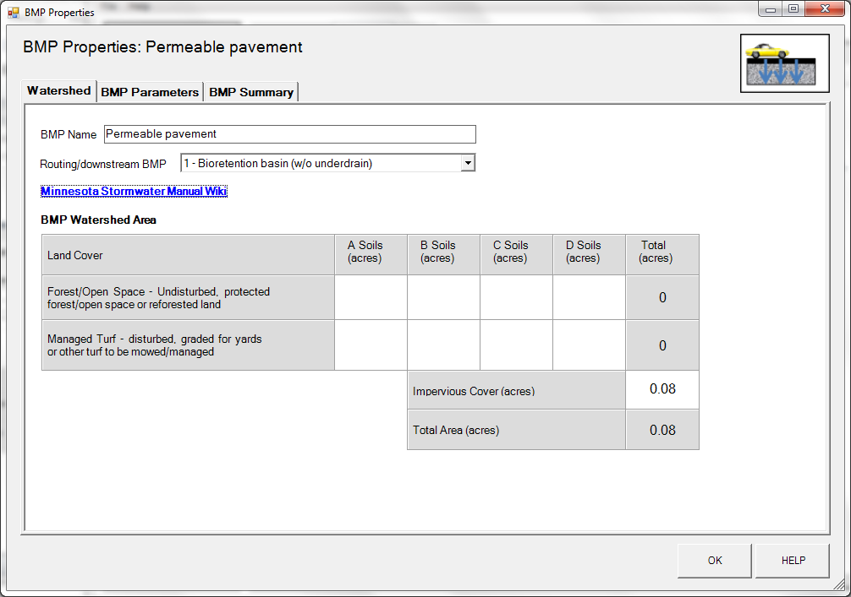

Step 15: Enter in the BMP design parameters into the “BMP parameters” tab. Permeable pavement requires the following entries:
- Surface area at underdrain. This area is 2614 square feet.
- Bottom surface area is 2614 square feet.
- The depth below the underdrain is 1 foot.
- The media porosity is 0.4 cubic feet per cubic foot.
- Will the soil require compaction – No.
- Underlying soil – Hydrologic Soil Group, which is 6 SM (HSG B, 0.45 in/hr).
- Required drawdown time, which is 48 hours.

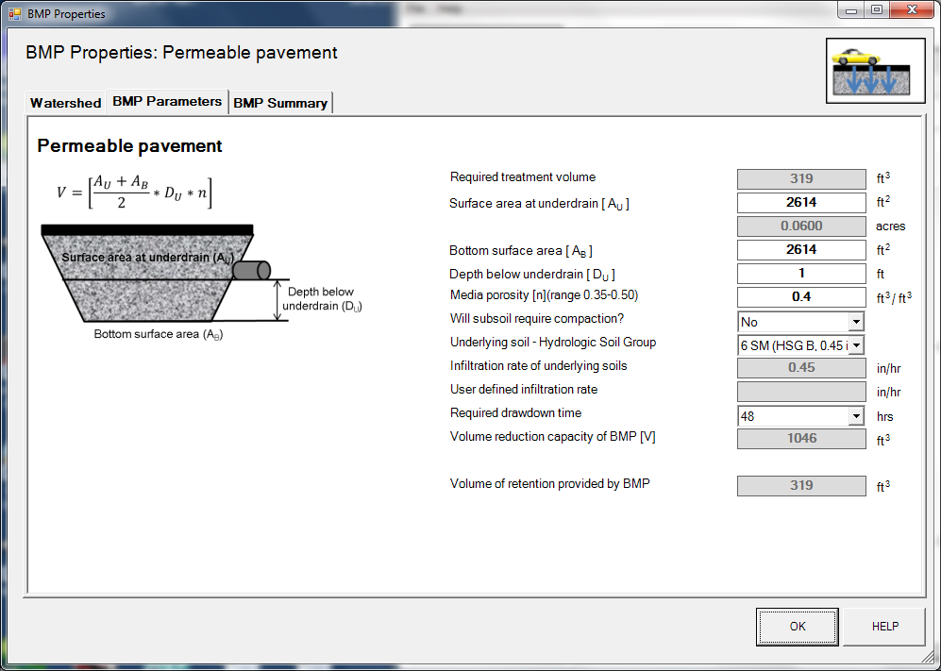

Step 16: Close the BMP properties window for permeable pavement by clicking OK.
Step 17: Open the BMP properties for the Basin 1 by right clicking on the “Bioretention basin (w/o an underdrain)” icon and selecting “Edit BMP properties”, or by double clicking on the “Bioretention basin (w/o an underdrain)” icon.
Step 18: Determine the watershed characteristic for the bioretention basin without an underdrain. The watershed parameters for Basin 1 include a 0.2 acre site with 0.03 acres of impervious area and 0.17 acres of pervious turf area in type B soils. Enter in the watershed information. Change the name and route the BMP to the bioretention basin with an underdrain.
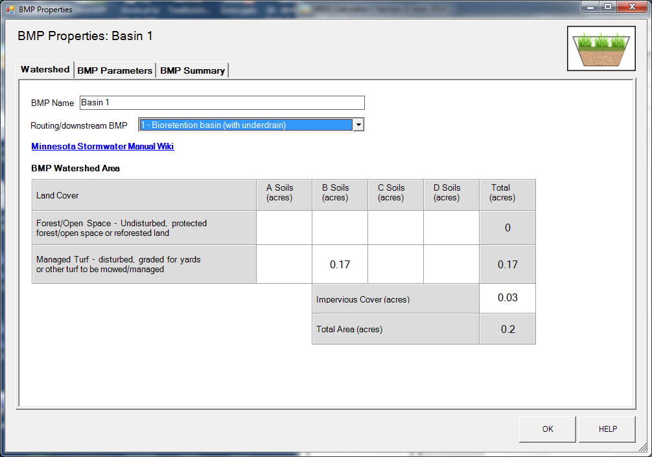

Step 19: Click on the “BMP Parameters” tab and enter the BMP design parameters. Bioretention basin without an underdrain requires the following entries.
- Overflow surface area which is 2200 square feet;
- Bottom surface area which is 1282 square feet;
- Overflow depth which is 1 foot;
- Underlying soil – Hydrologic Soil Group which is SM (HSG B; 0.45 in/hr) from the dropdown box; and
- Required drawdown time (hrs) which is 48 from the dropdown box.

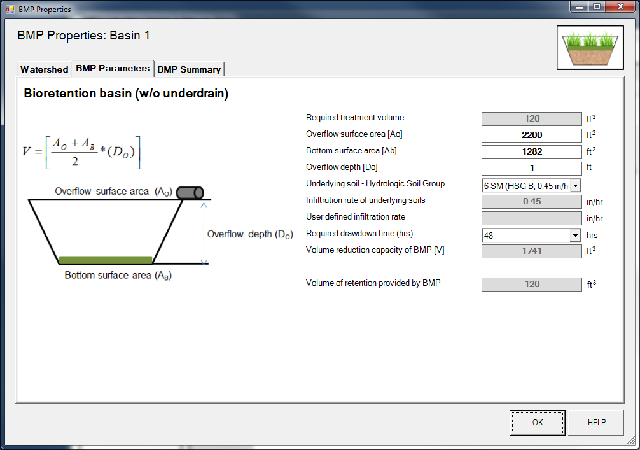

Step 20: Close the BMP properties window for Basin 1 by clicking OK.
Step 21: Open the BMP properties for the Basin 2 by right clicking on the “Bioretention basin (with an underdrain)” icon and selecting “Edit BMP properties”, or by double clicking on the “Bioretention basin (with an underdrain)” icon.
Step 23: Determine the watershed characteristic for the bioretention basin with an underdrain. The watershed parameters for Basin 2 include a 0.27 acre site with 0.15 acres of impervious area and 0.12 acres of pervious turf area in type B soils. Enter in the watershed information and change the name.

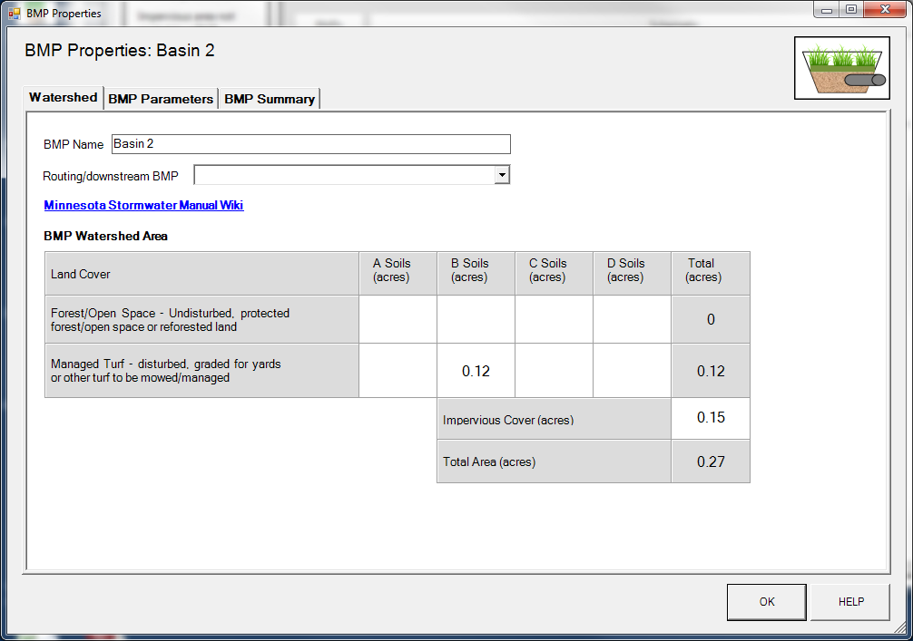

Step 23: Enter in the BMP design parameters into the “BMP parameters” tab. Bioretention basin with an underdrain requires the following entries.
- Is the underdrain elevated above native soils – Yes;
- Are the sides of the basin lined with an impermeable liner – No;
- Is the bottom of the basin lined with an impermeable liner – No;
- Surface area of overflow which is 1546 square feet;
- Surface area at media surface which is 1250 square feet;
- Surface area at underdrain which is 1200 square feet;
- Bottom surface area (area at media-soil interface) which is 1110 square feet;
- Overflow depth which is 1 foot;
- Total media depth which is 3 feet;
- Depth below underdrain which is 1.3 foot;
- Media field capacity minus wilting point which is 0.15 cubic feet per cubic foot;
- Media porosity minus field capacity which is 0.35 cubic feet per cubic foot;
- Is a tree(s) planted in the BMP – No;
- Bioretention planting media mix which is Media Mix C;
- Is the P content of the media less than 30 mg/kg which auto fills to “Yes” for Media Mix C;
- Is a soil amendment used – No;
- Underlying soil – Hydrologic Soil Group which is SM (HSG B; 0.45 in/hr) from the dropdown box; and
- Required drawdown time (hrs) which is 48 from the dropdown box.
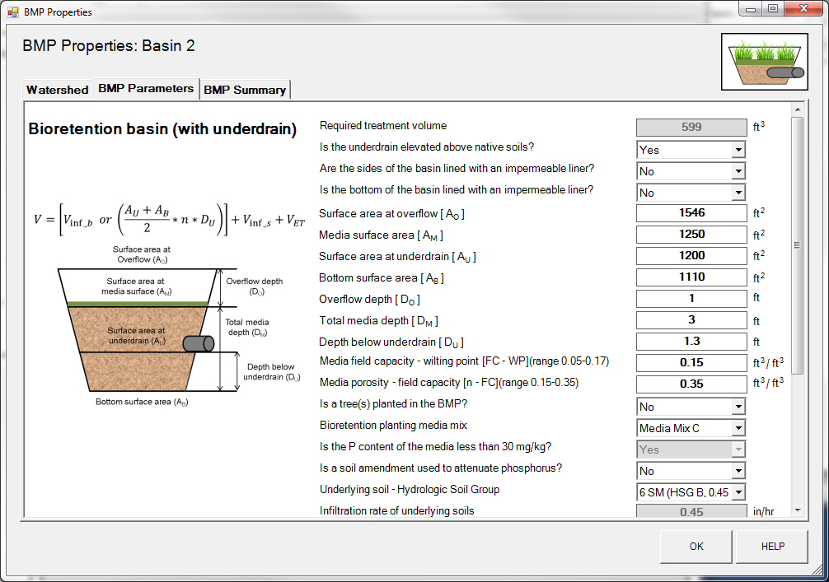
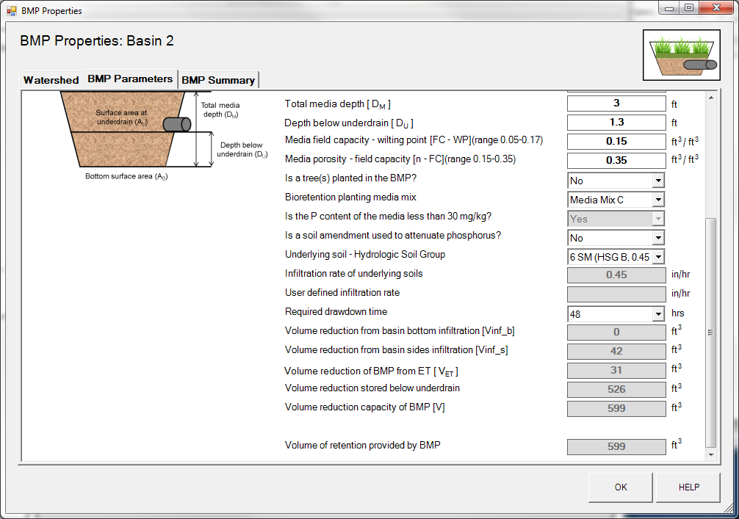

Step 25: Close the BMP properties window for Basin 2 by clicking OK.
Step 26: Open the BMP properties for the green roof by right clicking on the “Green roof” icon and selecting “Edit BMP properties”, or by double clicking on the “Green roof” icon.
Step 27: Determine the watershed characteristic for the green roof. The watershed parameters for the green roof include a 0.02 acre site all impervious. Enter in the watershed information. Change the name and route the green roof to Basin 1.
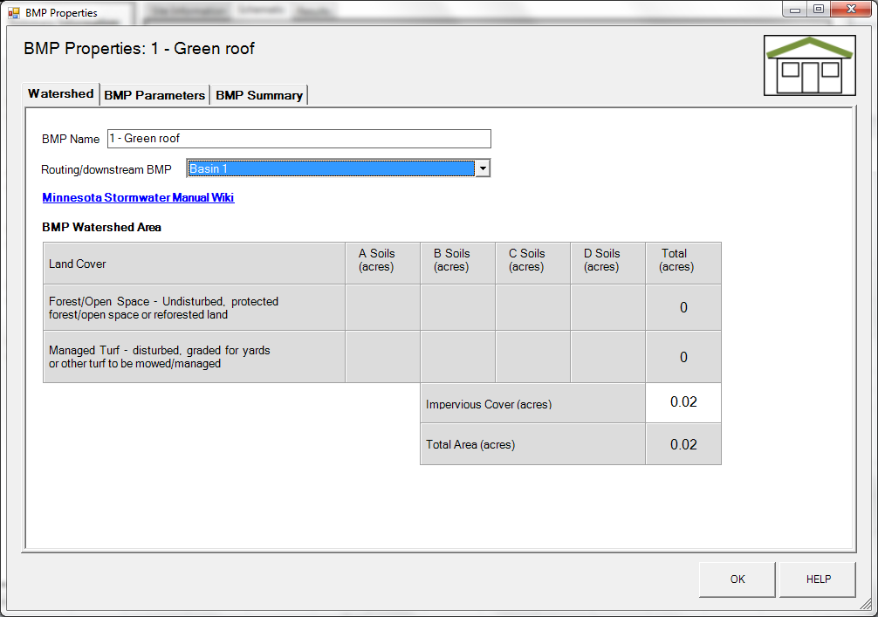

Step 28: Click on the “BMP Parameters” tab and enter in the BMP design parameters. Green roof requires two entries.
- The media depth, which is 4 inches in this example
- The surface area of the green roof is 871 square feet.

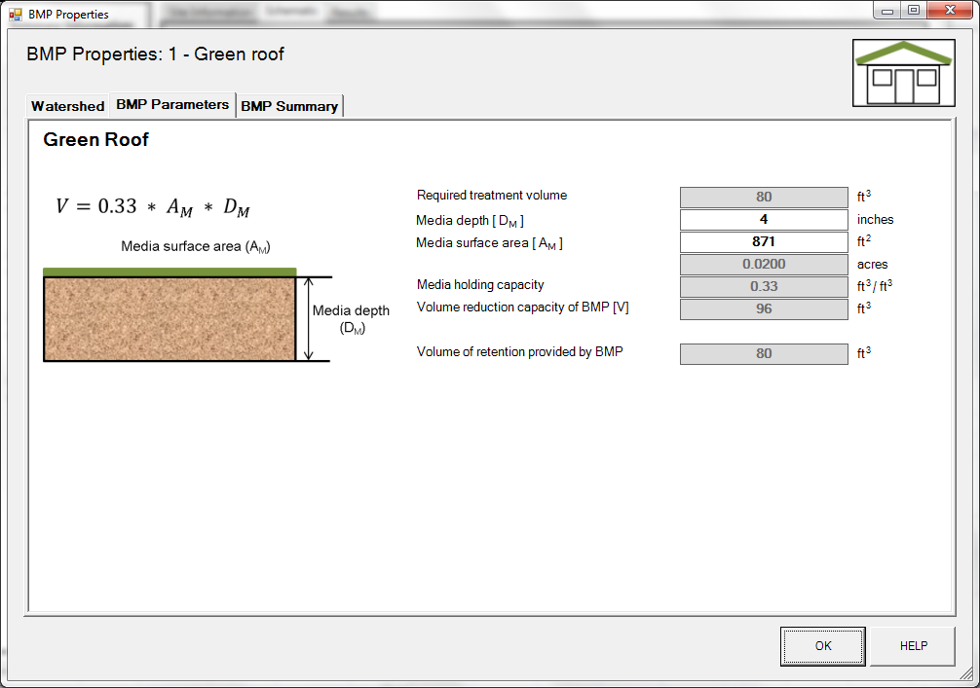

Step 29: Close the BMP properties window for the green roof. Check the routing by looking at the “Schematic tab” to make sure all of the BMPs are routed correctly.

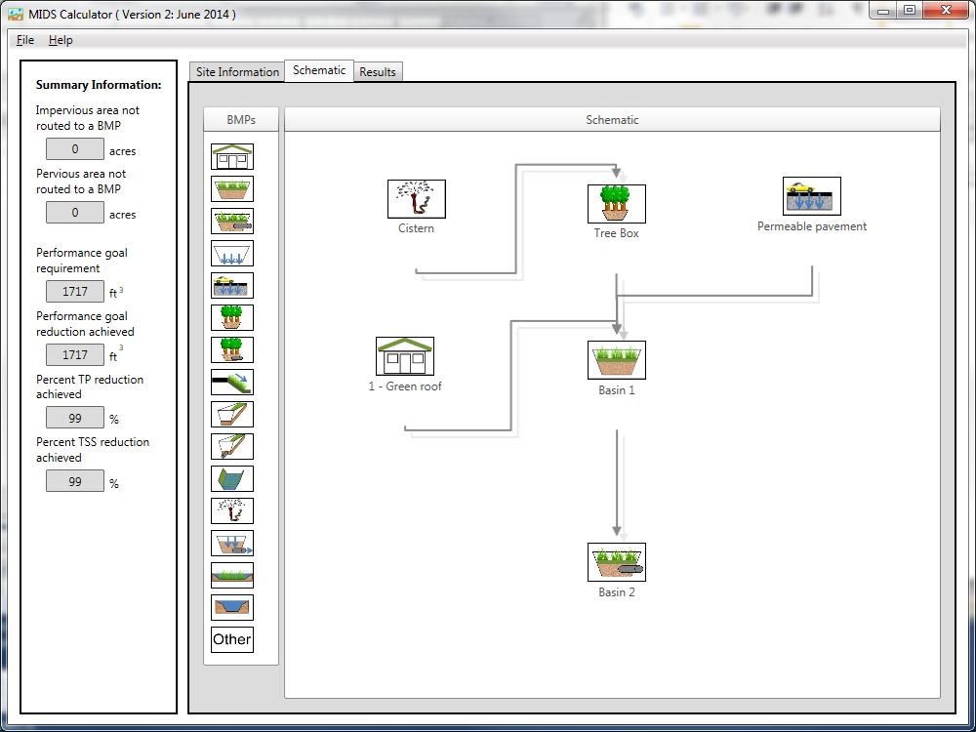

Step 30: Go to the “Results tab” and review the results.

