Infiltration Basin/Underground Infiltration (Calculator Version 2)

An infiltration basin is to be constructed in a watershed that contains a 1.4 acre parking lot surrounded by 0.8 acres of pervious area (turf area and the infiltration BMP area). All of the runoff from the watershed will be treated by the infiltration basin. The soils across the area have a unified soils classification of SM (HSG type B soil). The infiltration basin is designed to have 1 foot of ponding depth below the overflow point (e.g. surface outlet or invert of a pipe). The surface area of the infiltration basin at the overflow point will be 6534 square feet. The surface area will be 5600 square feet at the soil/media surface. Following the MPCA Construction Stormwater General Permit requirement, the infiltration basin needs to drawdown in a 48 hour time period. The following steps detail how this system would be set up in the MIDS calculator.

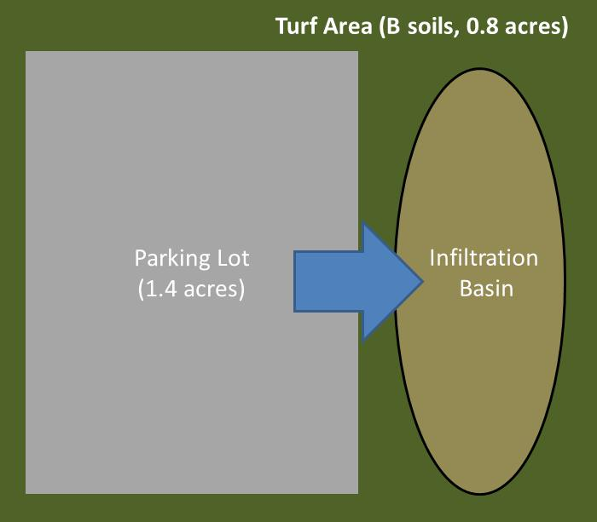
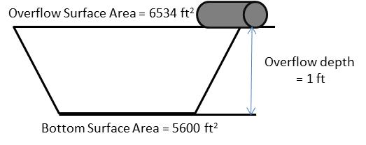
Step 1: Determine the watershed characteristics of your entire site. For this example we have a 2.2 acre site with 1.4 acres of impervious area and 0.8 acres of pervious area in type B soils. The pervious area includes the turf area and the area of the infiltration basin.

Step 2: Fill in the site specific information into the “Site Information” tab. This includes entering a Zip Code (55414 for this example) and the watershed information from Step 1. The Managed Turf area includes the turf area and the area of the infiltration basin. Zip code and impervious area must be filled in or an error message will be generated. Other fields on this screen are optional.

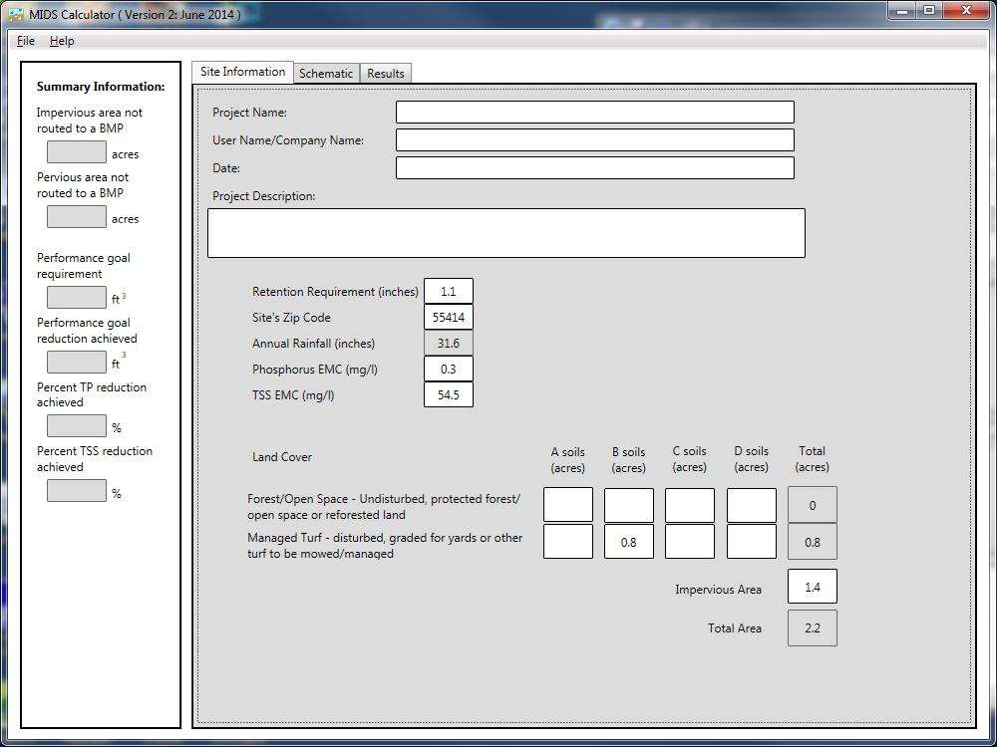

Step 3: Go to the Schematic tab and drag and drop the “Infiltration basin/Underground Infiltration” icon into the “Schematic Window”
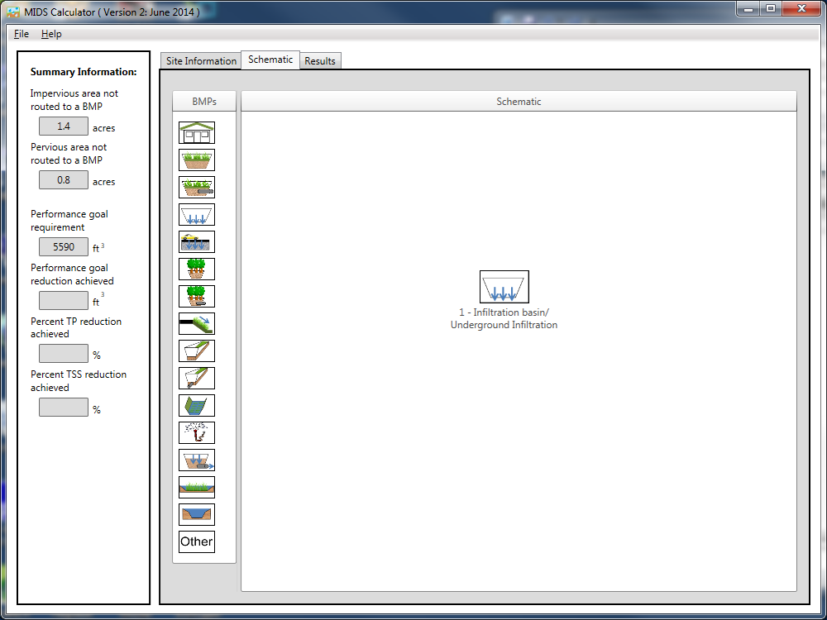
Step 4: Open the BMP properties for the infiltration basin by right clicking on the “Infiltration basin/Underground infiltration” icon and selecting “Edit BMP properties”, or by double clicking on the “Infiltration basin/Underground Infiltration” icon.
Step 5: Click on the “Minnesota Stormwater Manual Wiki” link or the “Help” button to review input parameter specifications and calculation specific to the “Infiltration basin/Underground infiltration” BMP.
Step 6: Determine the watershed characteristics for the infiltration basin. For this example the entire site is draining to the infiltration basin. The watershed parameters therefore include a 2.2 acre site with 1.4 acres of impervious area and 0.8 acres of pervious turf area in type B soils. There is no routing for this BMP. Fill in the BMP specific watershed information (1.4 acres on impervious cover and 0.8 acres of Managed turf in B soils).
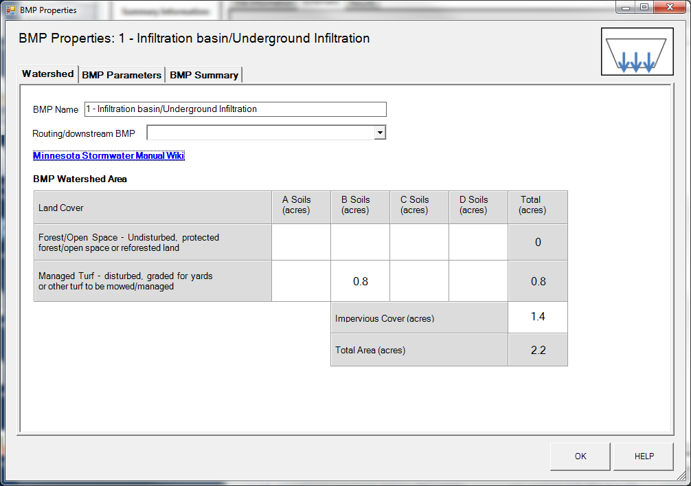

Step 7: Enter in the BMP design parameters into the “BMP parameters” tab. Infiltration basin/Underground Infiltration requires the following entries.
- Overflow surface area which is 6534 square feet;
- Bottom surface area which is 5600 square feet;
- Overflow depth which is 1 foot;
- Underlying soil – Hydrologic Soil Group which is 6 SM (HSG B, 0.45 in/hr); and
- Required drawdown time which is 48 hours.

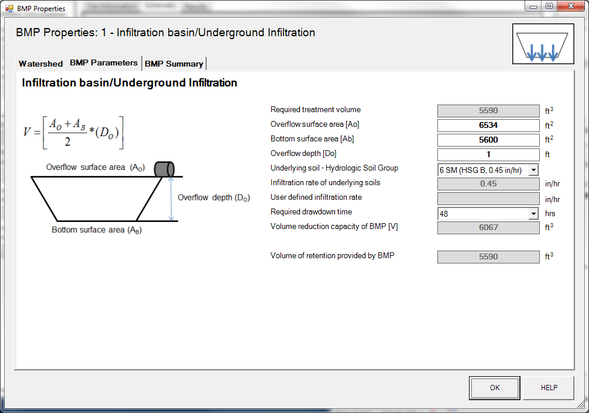

Step 8: Click on “BMP Summary” tab to view results for this BMP.
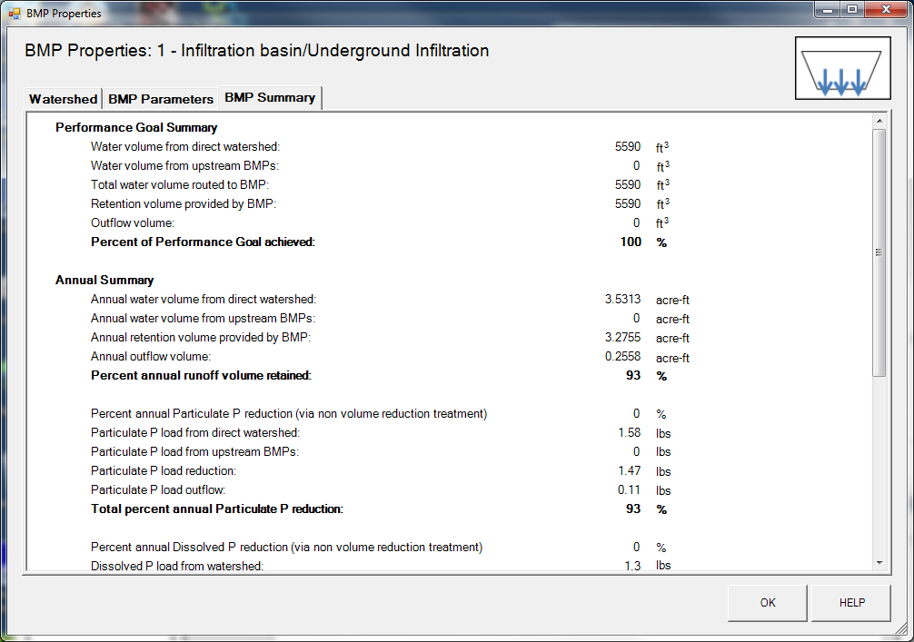

Step 9: Click on the “OK” button to exit the BMP properties screen.
Step 10: Click on “Results” tab to see overall results for the site.
