Swale Side Slope

The swale side slope BMP is used in combination with one of the three main channel BMPs (Swale Main Channel, Swale Main Channel (with an underdrain), or Wet Swale). This BMP should not be used as a standalone BMP as the credits were determined as part of a swale system. The swale side slope must receive stormwater runoff from the direct watershed through sheet flow over the entire channel length. If the stormwater flow is channelized when it reaches the swale side slope, the swale main channel component should be used without the swale side slope component. The swale side slope BMP represents one side slope of a swale system. If a swale contains two side slopes that each receives runoff through sheet flow from impervious surfaces, two swale side slopes should be used in the calculator and routed to the corresponding swale main channel BMP. Credit toward the performance goal for a swale side slope is given based on infiltration into the soils. Due to the fact that the performance goal is an instantaneous credit following the kerplunk method, a relationship between an annual volume reduction and the instantaneous credit was created. All pollutants in the infiltrated water are credited as being reduced.

MIDS calculator user inputs for swale side slope
For swale side slope BMPs, the user must input the following parameters to calculate the stormwater volume and pollutant load reductions.
- Watershed tab
  - BMP Name: this cell is auto-filled but can be changed by the user.
  - Routing/downstream BMP: if this BMP is part of a swale system and water is being routed from this BMP to a main channel swale, the user selects the name of the BMP from the dropdown box to which water is being routed. All water must be routed to a single BMP. Note that the user must include the BMP receiving the routed water in the Schematic tab or the BMP will not appear in the dropdown box. This BMP can only be routed to a main channel swale.
  - BMP Watershed Area: BMP watershed areas are the areas draining directly to the BMP. Values can be added for four soil types (Hydrologic Soil Groups (HSG) A, B, C, D) and for three Land Cover types (Forest/Open Space, Managed Turf and impervious). The surface area of the BMP should be included as a managed turf land cover under the hydrologic soils group of the native soils located under the BMP. Units are in acres.
- BMP Parameters tab
- Side slope [H:V]: The user selects from a drop down menu the ratio between the horizontal (H) and vertical (V) components of the side slope (H:V). The values available for selection are 3:1, 4:1, 5:1, 6:1, and 7:1. By selecting a horizontal to vertical side slope ratio, the corresponding “Side slope” (%) will populate automatically. This value should be an average for the length of the swale.
- Flow path length: This is the average horizontal distance between the highest elevation point and lowest elevation point of the side slope perpendicular to the main channel throughout the length of the swale. This could also be described as the width of the side slope. Units are in feet.
- Channel length: This is the length of the side slope from the farthest point upstream to the farthest point downstream of the main channel. Flow must be sheet flow over the entire channel length (if not, channel length should be adjusted to only cover areas where sheet flow occurs). Units are in feet.
- Underlying soil - Hydrologic Soil Group: The user selects the most restrictive soil (lowest hydraulic conductivity) within three feet of the soil surface of the swale side slope. There are 14 soil options that fall into 4 different Hydrologic Soil Groups (Hydrologic Soil Group (HSG) A, B, C, or D) for the user. These correspond with soils and infiltration rates contained in this Manual. Once a soil type is selected, the corresponding infiltration rate will populate in the “Infiltration rate of underlying soils” field. The user may also select “User Defined.” This selection will activate the “User defined infiltration rate” cell allowing the user to enter a different value from the value in the predefined selection list. The maximum allowable infiltration rate is 1.63 inches per hour.
- Manning’s n (Vegetation): The user selects a type of vegetation cover on the swale side slope, which populates a corresponding Manning’s n. The vegetation types are mowed turf or native grasses. Mowed turf would be selected if the side slope is mowed on a consistent basis. Native grasses would be selected if the side slope is left to grow or is mowed infrequently. Once a vegetation cover is selected, the corresponding Manning’s n will populate in the “Manning’s n” field. The user may also select “User Defined.” This selection will activate the “User Defined Manning’s n” cell allowing the user to enter a value different from the values in the predefined selection list.
- BMP Summary Tab: The BMP Summary tab summarizes the volume and pollutant reductions provided by the specific BMP. It details the performance goal volume reductions and annual average volume, dissolved P, particulate P, and TSS load reductions. Included in the summary are the total volume and pollutant loads received by the BMP from its direct watershed, from upstream BMPs and a combined value of the two. Also included in the summary, are the volume and pollutant load reductions provided by the BMP, in addition to the volume and pollutant loads that exit the BMP through the outflow. This outflow load and volume is what is routed to the downstream BMP if one is defined in the Watershed tab. Finally, percent reductions are provided for the percent of the performance goal achieved, percent annual runoff volume retained, total percent annual particulate phosphorus reduction, total percent annual dissolved phosphorus reduction, total percent annual TP reduction, and total percent annual TSS reduction.

Model input requirements and recommendations
The following are requirements for inputs into the MIDS calculator. If the following are not met, an error message will inform the user to change the input to meet the requirement.
- Infiltration rates of the underlying soils are restricted to being below 1.63 inches/hour.
- The Manning’s n value must be less than or equal to 1.

Methodology

Required Treatment Volume
“Required treatment volume,” or the volume of stormwater runoff delivered to the BMP, equals the performance goal (1.1 inches or user-specified performance goal) times the impervious area draining to the BMP. Since no BMP can be routed to a swale side slope, no additional water can be routed to the swale side slope from an upstream BMP. Stormwater is delivered to the BMP instantaneously following the Kerplunk method.

Volume Reduction
The volume reduction achieved by a BMP compares the capacity of the BMP to the required treatment volume. The “Volume reduction capacity of BMP [V]” is calculated using BMP inputs provided by the user. A swale side slope does not have storage capacity similar to other BMPs in the MIDS calculator. Volume reduction occurs through infiltration as the stormwater travels over the side slope. To obtain an instantaneous stormwater volume credit for a swale side slope, annual volume reductions were determined and converted to a volume retention capacity credit that follows the Kerplunk method.
To determine the volume loss credit given for a swale side slope, the P8 water quality model was used. 55 years of hourly rainfall data were modeled for swale side slopes with various configurations of side slope, flow path length, channel length, soil infiltration rate and Manning’s n parameters. The model results provided annual average volume reduction rates. The model results were used to create relationships between the swale modeling parameters and annual percent stormwater volume reductions using multivariate regression. The developed relationship is used with the user provided inputs to calculate an annual percent stormwater volume reduction for the swale side slope in the calculator.
The next step is to convert the annual percent stormwater volume reduction to an instantaneous stormwater volume reduction that follows the Kerplunk method used for other BMPs. This is accomplished through the use of performance curves (add link to addendum) developed from multiple modeling scenarios. The performance curves use the annual volume reduction percentage, the infiltration rate of the underlying soils, the contributing watershed percent impervious area, and the size of the contributing watershed to calculate the “Volume reduction capacity of BMP [V]”.
The “Volume of retention provided by BMP” is the amount of volume credit the BMP provides toward the performance goal. This value is equal to the “Volume reduction capacity of BMP [V]”, calculated using the above method, as long as the volume reduction capacity is less than or equal to the “Required treatment volume.” If the volume reduction capacity is greater than “Required treatment volume”, then the BMP volume credit is equal to “Required treatment volume.” This check makes sure that the BMP is not getting more credit than the amount of water it receives. For example, if the BMP is oversized the user will only receive credit for “Required treatment volume” routed to the BMP.

Pollutant Reduction
Pollutant load reductions are calculated on an annual basis. For this BMP, pollutant reduction is provided through infiltration only. The annual volume reduction is calculated using the relationship between the P8 modeling results and the swale design parameters discussed in the volume reduction section. A 100 percent pollutant removal rate is applied to the stormwater infiltrated on an annual basis for total suspended solids, dissolved phosphorus, and particulate phosphorus. Pollutants not removed through infiltration are routed to the downstream swale main channel.
NOTE: The user can modify event mean concentrations (EMCs) on the Site Information tab in the calculator. Default concentrations are 54.5 milligrams per liter for total suspended solids (TSS) and 0.3 milligrams per liter for total phosphorus (particulate plus dissolved). The calculator will notify the user if the default is changed. Changing the default EMC will result in changes to the total pounds of pollutant reduced.

Routing
The swale side slope BMP is designed to be part of a system with a corresponding swale main channel BMP. Therefore, a swale side slope BMP can only be routed to one of the three main channel BMPs: Swale Main Channel, Swale Main Channel (with underdrain), or Wet Swale. The swale side slope BMP should not be used as a standalone BMP. It should always be used in combination with one of the three main channel BMPs. The swale side slope BMP requires sheet flow over its surface area to receive credit. Therefore, no other BMP can be routed to the swale side slope BMP. It can only receive runoff from the direct watershed.

Assumptions for swale side slope
The following general assumption applies in calculating the credits for a swale side slope. If this assumption is not followed, the volume and pollutant reduction credits cannot be applied.
- The swale side slope has been properly designed, constructed and will be properly maintained according to specifications for filtration systems.
- The swale side slope is being used in combination with one of the tree main channel components.

Images


Symbol for Swale side slope in MIDS calculator

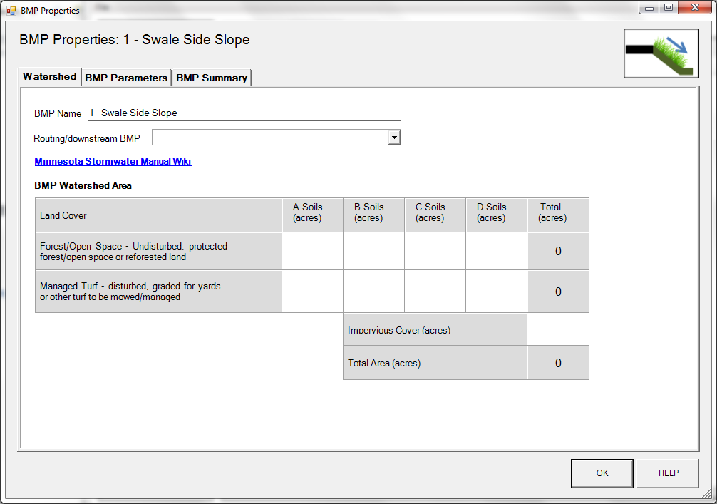
BMP watershed area parameters

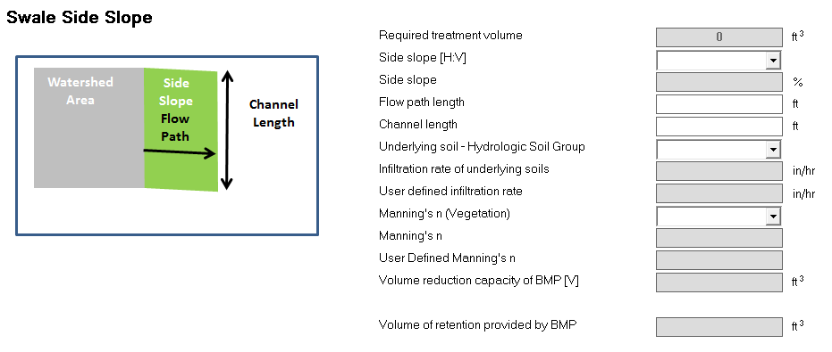
Screen shot from MIDS calculator showing user inputs needed for the swale side slope BMP.

