REPORT for OBJ2.TASK 8
DESIGN SPECIFICATIONS
To: MPCA
From: The Kestrel Design Group Team
The Kestrel Design Group Inc, with Dr. William Hunt, PE, Ryan Winston, PE, Dwayne Stenlund – Minnesota Department of Transportation, Dr. John Gulliver, PE – University of Minnesota
Date: July 31, 2013
Re: Contract CR5332

TASK 8 SCOPE

Obj2.Task 8: Design Specifications

Update and incorporate new information, consistent with NPDES stormwater permit requirements and the most recent version of the MIDS calculator, on design specifications for bioretention and infiltration BMPs.
- Review literature pertaining to design specifications for the following topics. As part of the review identify conditions that could lead to scour, re-suspension and pollutant load flushing during high flow events. The review shall consider the following:
- The maximum ponding depth for infiltration basins;
- Underdrain sizing;
- Drainage area contributing to the BMP;
- Use of engineered media;
- Off-line design (high flow bypass);
- Vegetation;
- Maximum flow path through a BMP; and
- Use of multiple cells in a BMP.
- Identify areas where the current Manual requires updating. Prepare and submit a Technical memo that makes recommendations for updates to existing design specifications for infiltration and bioretention BMPs. Recommendations must be consistent with NPDES stormwater permit requirements and with specifications used in the MIDS calculator.
- Following review of the Technical memo by the PM, at the request of the PM, develop and submit draft design specifications for infiltration and bioretention BMPs. This includes CAD drawings and other graphics and a short description of the design specification. Specifications must be consistent with NPDES stormwater permit requirements and with specifications used in the MIDS calculator.
- Prepare and submit final design specifications, including documents and graphics. Specifications must be consistent with NPDES stormwater permit requirements and with specifications used in the MIDS calculator.

LIST OF FIGURES (figures in precedents not included)

Figure 8.1. Off-line bypass system employed by bioretention cell in Portland, OR.
Figure 8.2. Concrete box (internal) outlet structure for grassed bioretention cell
Figure 8.3. Bioretention cell at maximum ponding depth (left) and broad crested weir overflow (at right)

LIST OF TYPICAL BIORETENTION DETAILS

Bioretention Plan – Offline
Bioretention Plan – Online
Bioinfiltration
Biofiltration with underdrain at bottom
Biofiltration with elevated underdrain
Biofiltration with internal water storage
Biofiltration with liner
Biofiltration planter – plan
Biofiltration planter – section
Biofiltration- parking median – plan
Biofiltration- parking median – section
Cleanout
Underdrain valve

REPORT

- THE MAXIMUM PONDING DEPTH FOR INFILTRATION BASINS;

Current Manual (with comments):

Bioretention
Ponding design depths have been kept to a minimum to reduce hydraulic overload of in-situ soils/soil medium and to maximize the surface area to facility depth ratio, where space allows. Where feasible ponding depths should be no greater than 6 inches The maximum allowable pooling depth is 18 inches. It is RECOMMENDED that the elevation difference from the inflow to the outflow be approximately 4-6 feet when an under-drain is used. The REQUIRED drawdown time for bioretention practices is 48 hours or less from the peak water level in the practice” (p. 385)

Infiltration/Recharge, Infiltration/Filtration/Recharge facility section drawings show “Depth Required to drain practice in 48 hours or less not to exceed 18”

Infiltration Basins:
The depth of an infiltration practice is a function of the maximum drawdown time and the design infiltration rate. The REQUIRED drawdown time for infiltration practices is 48hours or less, and so the depth of the practice should be determined accordingly.

Why have a maximum depth?
  - Limit depth and duration of submergence of plants improve plant survivability
  - Reduce mosquito habitat
  - Minimize compaction of in-situ soils
  - Minimize clogging
  - Maximize contact time
  - Safety – prevent drowning
  - Aesthetics - unattractive if too deep

Discussion and Decisions from Workshops February 26-27:

Mike Trojan’s meeting notes:

  - Two considerations are plant effects and safety
  - For bioretention systems, the maximum depth is primarily controlled by vegetative considerations. Generally we want drawdown in 24 hours or less, although this varies with plant species. Shrubs, trees, grass can take flooded conditions longer.
  - The recommended maximum depth varies with soil type and could vary with vegetative type. Recommend a maximum depth of 18 inches for bioretention in A soils. In B soils the calculator will define the maximum depth. For people not using the calculator, guidance in the Manual can help move people to a decision about max depth.
  - For infiltration systems, the max depth is 4 feet and this is based on safety.
  - Suggestion to link max depth to an infiltration rate and get away from use of A, B, C, and D soils.
  - Concerns that 18 inches will lead to some mortality and a need for plant replacement.
  - Would be nice to have a table that illustrates water tolerance for different plant species. Can perhaps use existing information from Volume 1 of Plants for Stormwater Design (http://www.pca.state.mn.us/index.php/water/water-types-and-programs/stormwater/stormwater-management/plants-for-stormwater-design.html). In general can utilize dry-tolerant plants on A soils and wet-tolerant plants on C soils.
  - 6 inch max depth is used when we have little to no site data.

Additional Guidance Regarding Maximum Depth for Plants:

Varying species of trees, shrubs and perennials have widely varying flooding tolerances. To design a bioretention system with plants tolerant of bioretention hydrology, ensure that plants can tolerate anticipated flooding frequency, depth, and duration. Plants for stormwater design (http://www.pca.state.mn.us/index.php/water/water-types-and-programs/stormwater/stormwater-management/plants-for-stormwater-design.html) provides these characteristics for most native plants commonly used in stormwater BMP design in MN. Experience has shown that at least as many plants in bioretention systems die from not enough water as from too much water. Ensure that selected plants can also tolerate dry periods, as bioretention soils are typically have a high sand content and are dry between rain events.

Precedents (with comments):

Infiltration basins:

NCDENR Stormwater BMP Manual Chapter16: Infiltration Devices, Revised: 07-23-09:
The storage volume must completely draw down to the seasonally high water table under
seasonally high water conditions within 5 days

Wisconsin Department of Natural Resources. 2004. Infiltration Basin (Acre-Feet) (1003) Conservation Practice Standard.
Maximum ponding depth 24 inches
Maximum surface pool drawdown time: 24 hours

Bioretention:

NCDENR Stormwater BMP Manual Chapter 12: Bioretention, Revised: 07-24-09:
Ponding depth shall be 12 inches or less. Nine inches is preferred.

Puget Sound 2012 LID Manual:
Maximum ponding depth for bioretention 12 inches
Maximum surface pool drawdown time: 24-48 hours

Virginia DCR. 2010. Stormwater Design Specification No. 9. Bioretention. Version 1.7.

Micro-Bioretention (Rain Garden) Design Criteria¹
Level 1 Design (RR 40 TP: 25) | Level 2 Design (RR: 80 TP: 50)
Maximum Ponding Depth = 6 inches

Bioretention filter or basin
Level 1 Design (RR 40 TP: 25 ) | Level 2 Design (RR: 80 TP: 50)
Maximum Ponding Depth = 6 to 12 inches 2 | Maximum Ponding Depth = 6 to 12 inches 2

Micro-Bioretention or Rain Gardens. These are small, distributed practices designed to treat runoff from small areas, such as individual rooftops, driveways and other on-lot features in single-family detatched residential developments. Inflow is typically sheet flow, or can be concentrated flow with energy dissipation, when located at downspouts.

Bioretention Basins. These are structures treating parking lots and/or commercial rooftops, usually in commercial or institutional areas. Inflow can be either sheetflow or concentrated flow. Bioretention basins may also be distributed throughout a residential subdivision, but ideally they should be located in common area or within drainage easements, to treat a combination of roadway and lot runoff.

Pennsylvania decade old bioretention site (Villanova University campus):

18 inches deep and functioning effectively (Emerson and Traver 2008)

Wisconsin Department of Natural Resources. 2010. Bioretention for Infiltration (1004) Conservation Practice Standard.
Maximum ponding depth for bioretention 12 inches
Maximum surface pool drawdown time: 24 hours

Bannerman, R. Wisconsin Department of Natural Resources 2012 ppt
How Do We Respond to Larger Depths?
1. Keep 12 inches until further evaluation (Michael Barrett).
2. Do sensitivity analysis to determine conditions for 2 foot depth – 18 inches already used by others
(Delaware Green Technologies Design Manual)
3. Do not consider 3 or 4 Feet.
1. Looks like dry pond
2. Safety problem
3. Inviting frequent failure (Michael Clar)

- UNDERDRAIN SIZING;

Current Manual (with comments):

“It is HIGHLY RECOMMENDED that bioretention areas with under-drains be equipped with a
minimum 8” diameter under-drain in a 1’ deep gravel bed. Increasing the diameter of the underdrain
makes freezing less likely, and provides a greater capacity to drain standing water from
the filter. The porous gravel bed prevents standing water in the system by promoting drainage.
Gravel is also less susceptible to frost heaving than finer grained media. It is also HIGHLY
RECOMMENDED that a pea gravel diaphragm and/or permeable filter fabric be placed between
the gravel layer and the filter media.”

Recommendations:

- Minimum diameter of pipe for underdrain systems is four inches.
- Installing at least 2 underdrains for each bioretention system is recommended in case one clogs.
- Include at least 2 observation /cleanouts for each underdrain: one at the upstream end and one at the downstream end.
- Cleanouts shall be at least 4” diameter vertical non-perforated schedule 40 PVC pipe, and extend to the surface.
- Cleanouts shall be capped with a watertight removable cap.
- Underdrains shall be constructed of Schedule 40 or SDR 35 smooth wall PVC pipe.
- A utility trace wire is required for all buried piping.
- For under-drains that daylight on grade, a marking stake and animal guard is required (from Dakota County guidelines).
- The under-drain shall have an accessible knife gate valve on its outlet to allow the option of operating system as either bioinfiltration, biofiltration system or both. The valve shall enable the ability to make adjustments to the discharge flow so the sum of the infiltration rate plus the under-drain discharge rate equal a 48 hour draw-down time for the Water Quality Volume. (See Typical Under-Drain Valve Detail) (from Dakota County guidelines).
- Solid sections of non-perforated PVC piping and watertight joints shall be used wherever the under-drain system passes below berms, down steep slopes, makes a connection to a drainage structure or daylight on grade (from Dakota County guidelines).
- Procedure to size underdrains is typically left up to project engineer by other stormwater manuals. If MPCA wishes to include an example of a method to size underdrains, the method excerpted from the North Carolina precedent would be a good example.

Precedents (with comments):

NCDENR Stormwater BMP Manual Chapter 12: Bioretention, Revised: 07-24-09:

Sizing

Section 5.7 discussed specific underdrain sizing requirements. The need for an underdrain is driven by the permeability of the in-situ soil. If the in-situ soil has a high permeability, the system can be designed as an infiltration type bioretention facility with no underdrains. If in-situ soil permeability is less than 2 inches/hour the bioretention facility will likely have an underdrain system. If the in-situ soil drains more
slowly than the planting media, then designer should include an explanation of how how water will drain from the media. In general, bioretention BMPs in the Piedmont region of North Carolina will require underdrains. The underdrain system will connect to another BMP or to the conveyance system. Due to the risk of underdrain clogging, designers are encouraged to install more than one underdrain of smaller diameter in order to facilitate drainage. The minimum diameter of pipe for underdrain systems is four inches. As previously discussed, an up-turned elbow may be used. Clean-out pipes must be provided (minimum one per every 1,000 square feet of surface area). Clean out pipes must be capped. An example of a clean out pipe is provided in Figure 12-6. This design could be improved by increasing the height of the clean out pipe to about eight inches so that it is less likely to be damaged by maintenance equipment.

Other relevant notes regarding underdrains

Underdrain systems are utilized in several BMP designs, and can have many different configurations. All piping within the underdrain system shall have a minimum slope of 0.5 percent and shall be constructed of Schedule 40 or SDR 35 smooth wall PVC pipe.

The underdrain pipes shall be designed to carry 2-10 times the maximum flow exfiltrating from the BMP medium. Choose a value within this range to reflect the expected stability of the drainage area. This maximum flow is computed from Darcy's law and assuming maximum ponding and complete saturation along the depth of the medium. Manning's formula is then used to size the pipe. The minimum size of pipe shall be 4-inch diameter.

The spacing of collection laterals shall be no greater than 10 feet center to center, and a minimum of two pipes should be installed to allow for redundancy (Hunt and White, 2001). A minimum of 4 rows of perforations shall be provided around the diameter of the pipe (more for pipes 10 inches in diameter and larger), and the perforations shall be placed 6 inches on center within each row for the entire length of the drainage lateral. Perforations shall be 3/8-inch in diameter.
The underdrain pipes shall have a minimum of 3 inches of washed #57 stone above and on each side of the pipe (stone is not required below the pipe). Above the stone, either filter fabric or two inches of choking stone is required to protect the underdrain from blockage. Avoid filter fabric if there is any question about the future stability of the drainage area. Above the filtering device, a minimum of 2 inches of washed sand shall be installed. Choking stone (#8 or #89) in lieu of filter fabric is recommended if there is potential for higher sediment loads that would lead to clogging. Pipe socks are also not recommended.

The number of pipes needed for the underdrain system is determined using the following 4-step process.

1. Determine flow rate through the soil media and apply a safety factor of 10 (this is now the underdrain design flow, Q).
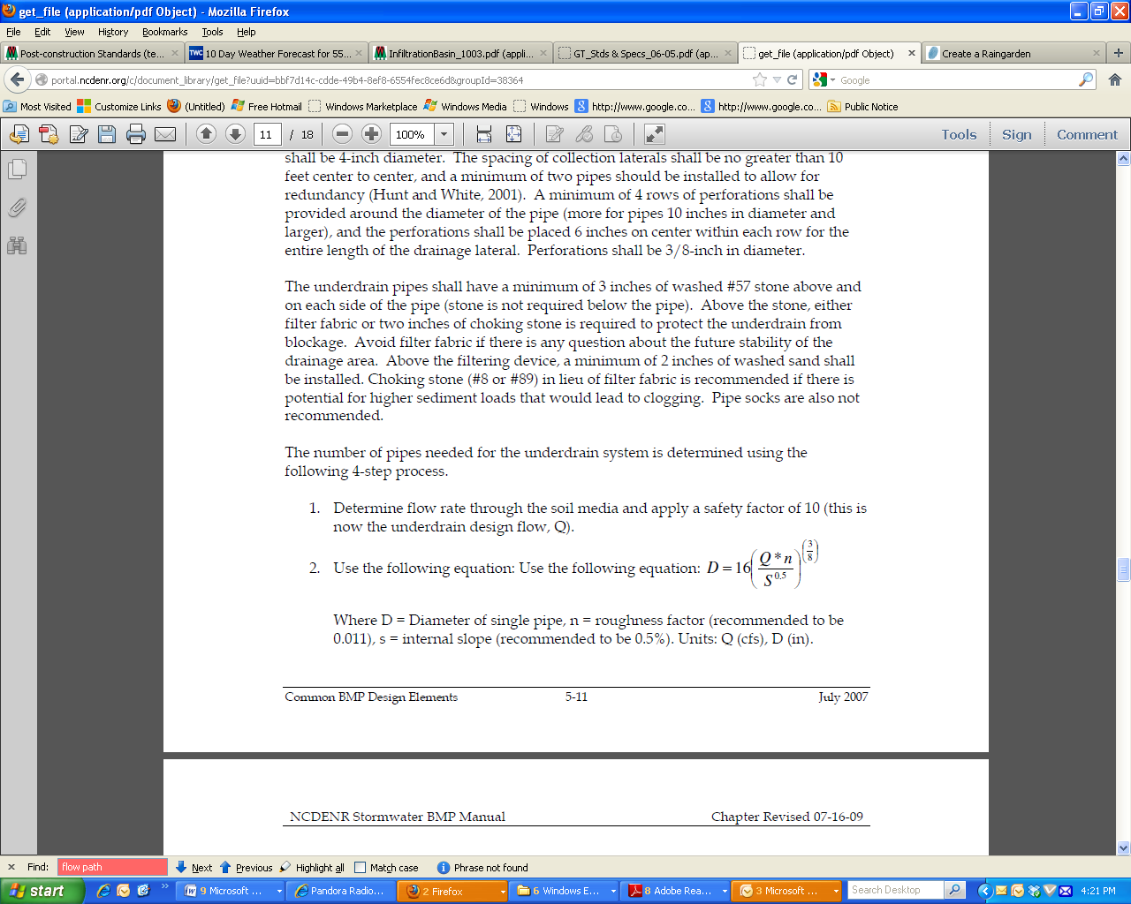

Where D = Diameter of single pipe, n = roughness factor (recommended to be
0.011), s = internal slope (recommended to be 0.5%). Units: Q (cfs), D (in).

3. The only unknown is D. This is the diameter of a single pipe that could carry allthe water were it to be the only underdrain. Pipe diameters are typically either 4inches or 6 inches. Table 5-1 below converts "D" (in inches) to an equal number of 4 or 6 inch underdrains at 0.5% slope.

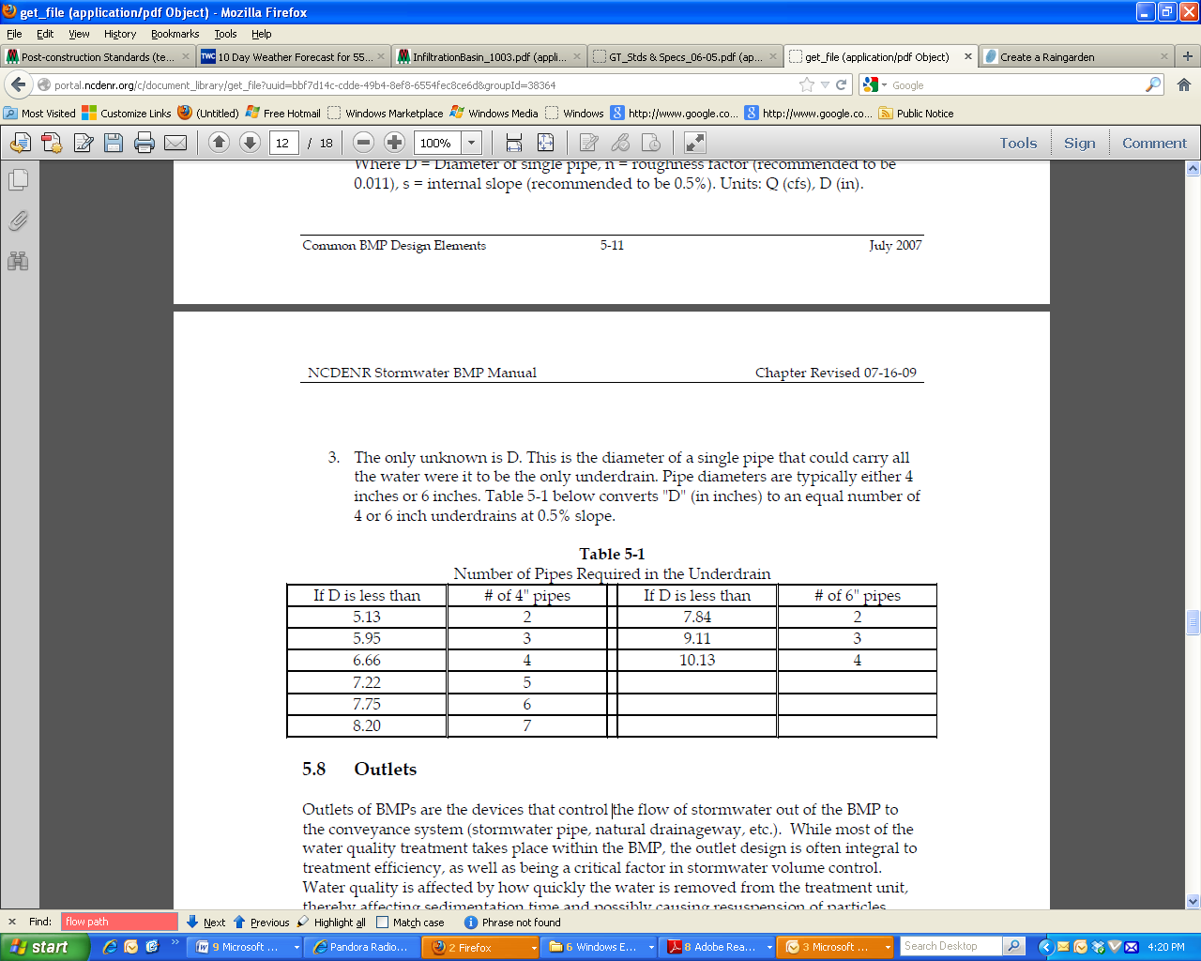
The need for an underdrain is driven by the permeability of the in-situ soil. If the in-situ soil has a high permeability, the system can be designed as an infiltration type bioretention facility with no underdrains. If in-situ soil permeability is less than 2 inches/hour the bioretention facility will likely have an underdrain system. If the in-situ soil drains more slowly than the planting media, then designer should include an explanation of how water will drain from the media. In general, bioretention BMPs in the Piedmont region of North Carolina will require underdrains. The underdrain system will connect to another BMP or to the conveyance system. Due to the risk of underdrain clogging, designers are encouraged to install more than one underdrain of smaller diameter in order to facilitate drainage. The minimum diameter of pipe for underdrain systems is four inches. As previously discussed, an up-turned elbow may be used. Clean-out pipes must be provided (minimum one per every 1,000 square feet of surface area). Clean out pipes must be capped. An example of a clean out pipe is provided in Figure 12-6. This design could be improved by increasing the height of the clean out pipe to about eight inches so that it is less likely to be damaged by maintenance equipment.

Internal Water Storage Zones (IWS)
An Internal Water Storage Zone (IWS) can be created by the addition of an elbow in the underdrain piping at a 90º angle vertically perpendicular to the horizontal underdrain, either in retrofit conditions or in new installations. This up-turned elbow on underdrains can force water to remain longer in the bottom of the cell, creating a saturated internal water storage zone (IWS). If this zone remains saturated long enough, anaerobic conditions are created, promoting denitrification and increased N removal (Passeport et al., 2009).
There are several benefits to using upturned elbows and IWS. The IWS works for both pollutant and peak flow reduction as anaerobic conditions can be created to increase nitrogen removal. It also allows more water to infiltrate into the surrounding soils. If an upturned elbow is installed correctly in sufficiently permeable soils, it may only rarely generate outflows. The use of upturned elbows and an IWS is especially beneficial in the Sandhills and Coastal Plain where surrounding sandy soils can be ideal for infiltration, reducing outflows and surface water runoff. Additionally, upturned elbows can also be used in the Piedmont and Mountain areas of North Carolina when surrounding soils are of appropriate infiltration capacity. There can be a thermal benefit to IWS use as water is pulled from the coolest zone at the bottom of the cell. This is especially beneficial for temperature reductions in trout waters. Finally, there is often a cost benefit for using upturned elbows, both for new installations and retrofits. In new installations, there is a cost-savings associated with installation since the invert of the outlet is not as deep. Often with IWS there can be less trenching and fewer materials associated with using it. In retrofits, upturned elbows can be cheaply added to existing Bioretention cells where increased N & P removal rates are needed. Additionally, cells with IWS can be added as retrofits even in areas with restricted outlet depth.

In order for an internal water storage zone to work correctly, the underlying soils must have some permeability. In general, if the underlying soils are Group A or B soils with a low clay content, then the IWS will be effective. If soils are too compacted, water will not infiltrate and may stagnate in the lower portion, causing problems for the BMP. Media depth above the bottom gravel and underdrain layer must be at least 3 feet. The top of IWS should be separated from the outlet and bowl surface by at least 12, but ideally 18 inches. See Figure 12-3c.

Figure 12-3c
Bioretention Cell showing IWS Zones
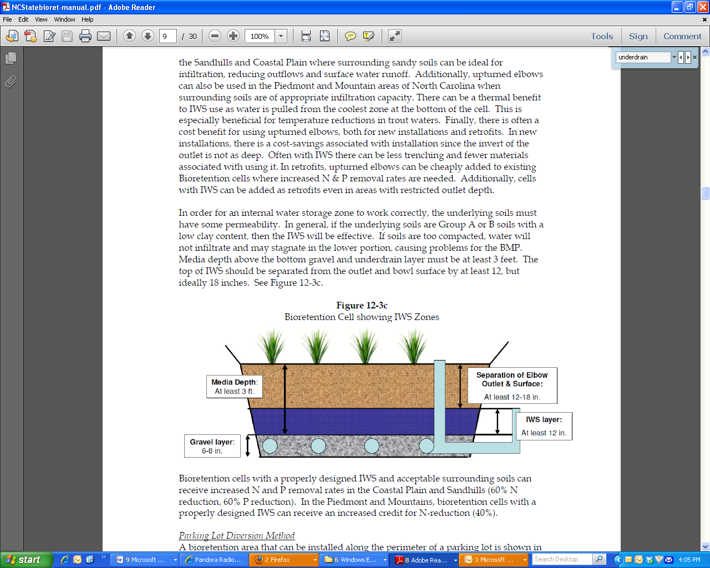

Bioretention cells with a properly designed IWS and acceptable surrounding soils can receive increased N and P removal rates in the Coastal Plain and Sandhills (60% N reduction, 60% P reduction). In the Piedmont and Mountains, bioretention cells with a properly designed IWS can receive an increased credit for N-reduction (40%).

Puget Sound 2012 LID Manual:

- Slotted, thick-walled plastic pipe, min 4” pipe, slotted subsurface drain PVC per ASTM D 1785 SCH 40
- Slots cut perpendicular to the long axis of pipe, arranged in 2 rows spaced on 45 degree centers and cover ½ of the circumference of the pipe
- Install with slots oriented on top or bottom of pipe

Virginia DCR. 2010. Stormwater Design Specification No. 9. Bioretention. Version 1.7.

Micro-Bioretention (Rain Garden) Design Criteria
Level 1 Design (RR 40 TP: 25) | Level 2 Design (RR: 80 TP: 50)
Underdrain: corrugated HDPE or equivalent. | Underdrain: corrugated HDPE or equivalent, with a minimum 6-inch stone sump below the invert; OR none, if soil infiltration requirements are met

Bioretention Filter and Basin Design Criteria
Level 1 Design (RR 40 TP: 25 ) | Level 2 Design (RR: 80 TP: 50)
Underdrain (Section 6.7) = Schedule 40 PVC with clean-outs | Underdrain & Underground Storage Layer (Section 6.7) = Schedule 40 PVC with clean outs, and a minimum 12-inch stone sump below the invert; OR, none, if soil infiltration requirements are met (Section 6.2)

Wisconsin Department of Natural Resources. 2010. Bioretention For Infiltration (1004) Conservation Practice Standard.

Underdrain – A perforated underdrain pipe is required unless there is no suitable pipe outlet or
the risk of infiltration failure at the native soil interface is minimal. The risk of infiltration failure is assumed to be minimal if the design infiltration rate of the native soil is determined to be at least 3.6 inches/hour, as determined using DNR Technical Standard 1002, “Site Evaluation for Stormwater Infiltration.”
a. Pipe Location - The underdrain pipe shall be placed at the top of the gravel or sand storage layer.
b. Size and Material – The pipe shall have a minimum diameter of 6 inches and be made of flexible pipe or other material approved by the administering authority. The pipe shall be capable of withstanding expected traffic loads over portions of the pipe extending beyond the soil planting bed.
c. Orifice Diameter – The underdrain orifice shall be restricted as necessary so that the design infiltration rate plus the underdrain flow rate equals the design draw down rate. The restriction shall be achieved by using an adjustable restrictor plate or valve. The restriction device shall be accessible for adjustment.
d. Perforations – The total opening area of all perforation holes combined shall be sufficient to allow the underdrain pipe to discharge at full capacity, as would occur if there were no orifice restriction. The amount of perforation shall be increased to provide a margin of safety but shall not be so great as
to compromise structural integrity of the pipe material.
e. Pipe Protection – The underdrain pipe shall be protected from clogging by use of filter fabric or a filter sock. If the storage layer is sand, a filter sock shall be used. A cover ofpea gravel may also be used.
(1) Pea Gravel – If used, the pea gravel layer shall be at least 4 inches thick. Pea gravel shall be washed. Pea gravel shall be large enough to prevent its falling through the perforations of the under-drain pipe.
(2) Filter Fabric – Filter fabric shall cover the underdrain pipe and shall not extend laterally from either side of the pipe more than two feet. The fabric shall meet the specifications of Wisconsin Standards and Specifications for Highway and Structure Construction, Section 645.2.4, Schedule Test B, 2003 edition, or an equivalent approved by the administering authority. Filter Sock - The openings in the fabric shall be small enough to prevent sand particles from entering the underdrain pipe. The flow rate of the fabric shall be capable of passing water at a rate equal to or greater than the flow rate capacity of the total combined perforations in the underdrain pipe. In addition, the fabric shall meet the other requirements of Wisconsin Standards and Specifications for Highway and Structure Construction, Section 612.2.8(1-3), 2003 edition, or an equivalent approved by the administering authority.

Dakota County Soil and Water Conservation District. 2011. Low Impact Development Standards
For Dakota County, Minnesota.

2.44 Perforated under-drains shall be slotted single wall HDPE piping, at least 4 inches in diameter, with circular knit polymeric filament filter sock per ASTM D6707-01. MnDot 3733 Type I sewn seam non-woven fabric shall not be used. The invert of the under-drain shall be bedded in Mix B or washed sand, 30 inches below the soil surface and extend the length of the bioretention cell. A utility trace wire is required for all buried piping. For under-drains that daylight on grade, a marking stake and animal guard is required. (Avoid designs that surround the under-drain with drain rock wrapped in filter fabric)
2.45 The under-drain shall have an accessible knife gate valve on its outlet to allow the option of operating system as either bioinfiltration, biofiltration system or both. The valve shall enable the ability to make adjustments to the discharge flow so the sum of the infiltration rate plus the under-drain discharge rate equal a 48 hour draw-down time for the Water Quality Volume. (See Under-Drain Valve Detail)
2.46 Solid sections of non-perforated PVC piping and watertight joints shall be used wherever the under-drain system passes below berms, down steep slopes, makes a connection to a drainage structure or daylight on grade.

Green Technology: The Delaware Urban Runoff Management Approach

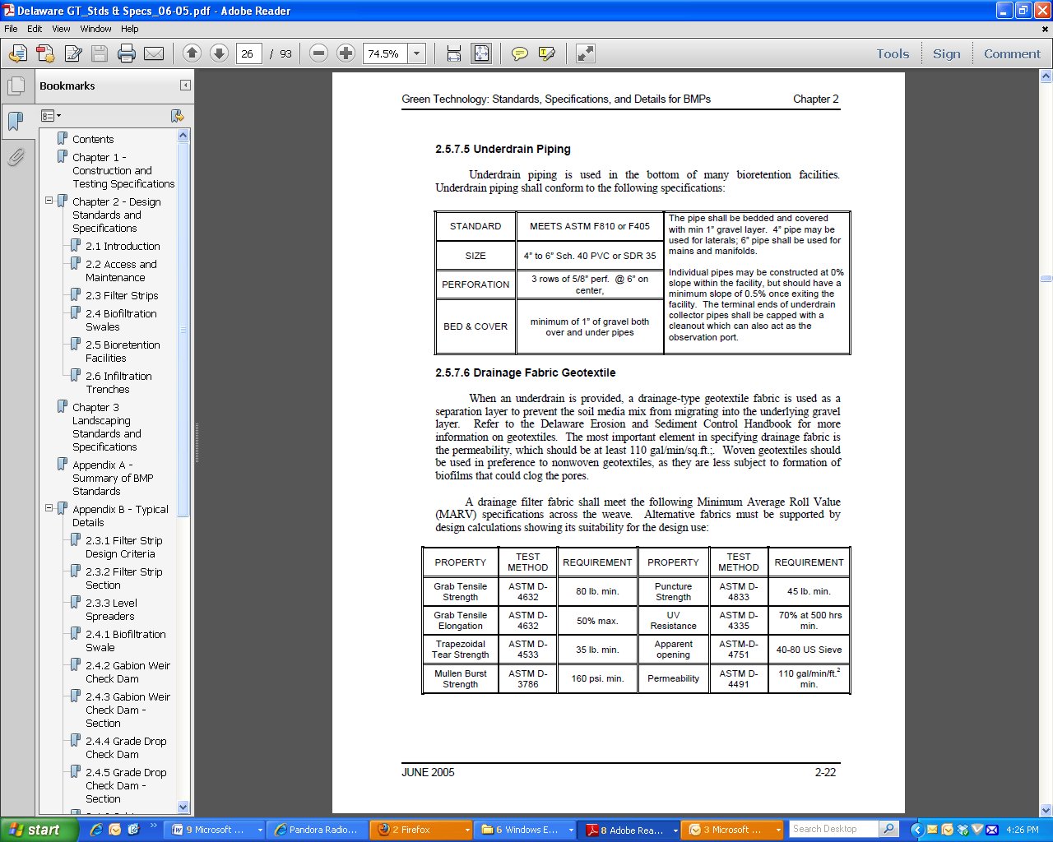

When an underdrain is provided, a drainage-type geotextile fabric is used as a separation layer to prevent the soil media mix from migrating into the underlying gravel layer. Refer to the Delaware Erosion and Sediment Control Handbook for more information on geotextiles. The most important element in specifying drainage fabric is the permeability, which should be at least 110 gal/min/sq.ft.;. Woven geotextiles should be used in preference to nonwoven geotextiles, as they are less subject to formation of biofilms that could clog the pores.

- DRAINAGE AREA CONTRIBUTING TO THE BMP;

Current Manual:

- 2 AC Max; 1/2 AC Max Impervious Drainage Area For Filtration Design (Per Practice) p. 373
- 2 AC Max; 1/2 AC Max Impervious Drainage Area For Infiltration Design (Per Practice) p. 373
- Less than 1 acre maximum and ½ acre impervious maximum per infiltration design practice is RECOMMENDED. (p. 383)

Discussion and Decisions from Workshops February 26-27:

- Maximum drainage area for infiltration basin is typically 5 acres, but can be greater if:
- Properly designed, constructed, and maintained
- Adequate pretreatment is provided
- Delete maximum impervious area from manual

Precedents:

Bioretention:

NCDENR Stormwater BMP Manual Chapter 12: Bioretention, Revised: 07-24-09:
5 acre maximum drainage area

Puget Sound 2012 LID Manual:

If a bioretention facility serves a drainage area exceeding 1 acre, a groundwater mounding analysis should be done

Virginia DCR. 2010. Stormwater Design Specification No. 9. Bioretention. Version 1.7.

Bioretention cells work best with smaller contributing drainage areas, where it is easier to achieve flow distribution over the filter bed. Typical drainage area size can range from 0.1 to 2.5 acres and consist of up to 100% impervious cover. Three scales of bioretention are defined in this specification: (1) micro-bioretention or Rain Gardens (up to 0.5 acre contributing drainage area); (2) bioretention basins (up to 2.5 acres of contributing drainage area); and (3) Urban Bioretention (Appendix 9-A). Each of these has different design requirements (refer to Tables 9.2 and 9.3 above). The maximum drainage area to a single bioretention basin or single cell of a bioretention basin is 5 acres, with a maximum recommended impervious cover of 2.5 acres (50% impervious cover) due to limitations on the ability of bioretention to effectively manage large volumes and peak rates of runoff. However, if hydraulic considerations are adequately addressed to manage the potentially large peak inflow of larger drainage areas (such as off-line or low-flow diversions, forebays, etc.), there may be case-by-case instances where the plan approving authority may allow these recommended maximums to be adjusted. In such cases, the bioretention facility should be located within the drainage area so as to capture the Treatment Volume (Tv) equally from the entire contributing area, and not fill the entire volume from the immediately adjacent area, thereby bypassing the runoff from the more remote portions of the site.

Micro-Bioretention or Rain Gardens
Level 1 Design (RR 40 TP: 25) | Level 2 Design (RR: 80 TP: 50)
Sizing: Filter surface area (sq. ft.) = 3% ² of the contributing drainage area (CDA). | Sizing: Filter surface area (sq. ft.) = 4% ² of the CDA (can be divided into different cells at downspouts).
Maximum contributing drainage area = 0.5 acres; 25% Impervious Cover (IC) ²
²Micro-Bioretention (Rain Gardens) can be located at individual downspout locations to treat up to 1,000 sq. ft. of impervious cover (100% IC); the surface area is sized as 5% of the roof area (Level 1) or 6% of the roof area (Level 2), with the remaining Level 1 and Level 2 design criteria as provided above. If the Rain Garden is located so as to capture multiple rooftops, driveways, and adjacent pervious areas, the sizing rules above should apply.

Bioretention filter or basin
Level 1 Design (RR 40 TP: 25 ) | Level 2 Design (RR: 80 TP: 50)
Sizing (Section 6.1):  Surface Area (sq. ft.) = (T^{v}– the volume reduced by an upstream BMP) / Storage Depth ¹ | Sizing (Section 6.1):  Surface Area (sq. ft.) = [(1.25)(T_{v}) – the volume reduced by an upstream BMP] /Storage Depth ¹
Recommended maximum contributing drainage area = 2.5 acres

Micro-Bioretention or Rain Gardens. These are small, distributed practices designed to treat runoff from small areas, such as individual rooftops, driveways and other on-lot features in single-family detatched residential developments. Inflow is typically sheet flow, or can be concentrated flow with energy dissipation, when located at downspouts.

Bioretention Basins. These are structures treating parking lots and/or commercial rooftops, usually in commercial or institutional areas. Inflow can be either sheetflow or concentrated flow. Bioretention basins may also be distributed throughout a residential subdivision, but ideally they should be located in common area or within drainage easements, to treat a combination of roadway and lot runoff.

Wisconsin Department of Natural Resources. 2010. Bioretention For Infiltration (1004) Conservation Practice Standard.
Maximum drainage area = 2 acres

- USE OF ENGINEERED MEDIA – see separate document;

- OFF-LINE DESIGN (HIGH FLOW BYPASS);

Current Manual (with comments):

Offline design is required In Karst topography and with trout streams

P 380
It is HIGHLY RECOMMENDED that bioretention practices be designed off-line. Off-line facilities are defined by the flow path through the facility. Any facility that utilizes the same entrance and exit flow path upon reaching pooling capacity is considered an off-line facility.

P 381
1.10. Water Quantity Treatment
Bioretention practices are not typically suitable for providing water quantity control. It is HIGHLY RECOMMENED that bioretention practices be designed off-line. Off-line facilities are defined by the flow path through the facility. Any facility that utilizes the same entrance and exit flow path upon reaching pooling capacity is considered an off-line facility. However they may be design to safely pass large storm flows while still protecting the ponding area, mulch layer and vegetation. In limited cases, a bioretention practice may be able to accommodate the channel protection volume, Vcp, in either an off-line or on-line configuration, and in general they do provide some (albeit limited) storage volume. Bioretention can help reduce detention requirements for a site by providing elongated flow paths, longer times of concentration, and volumetric losses from infiltration and evapotranspiration. Experience and modeling analysis have shown that bioretention can be used for stormwater management quantity control when
facilities are distributed throughout a site to reduce runoff and maintain the pre-existing time of concentration. This effort can be incorporated into the site hydrologic analysis (see also Chapter
8 and Appendix B). Generally, however, it is HIGHLY RECOMMENDED that in order to meet site water quantity or peak discharge criteria, another structural control (e.g., detention) be used in conjunction with a bioretention area.

INFILTRATION

P 431
1.2. Function within Stormwater Treatment Train
Infiltration practices may be located at the end of the treatment train or they can be designed as off-line configurations where the water quality volume is diverted to the infiltration practice.

P 437
Typically, infiltration systems are designed with one or more pre-treatment facilities or they are designed as off-line facilities.

P 448
5.3.5 Keep Infiltration Practices “Off-line” until Construction Is Complete
It is REQUIRED that sediment and runoff be kept completely away from the infiltration area during construction. Thus, infiltration practices should never serve as sediment control devices during site construction. It is HIGHLY RECOMMENDED that construction of infiltration practices be suspended during snowmelt or rainfall, in order to prevent soil smearing, clumping, or compaction.

Team Summary:

High-flow bypass systems are utilized to safely discharge stormwater when bioretention cells fill and reach their maximum ponding depth. This will occur during storms exceeding the water quality design storm. There are typically three types of high-flow bypass systems which are split into two categories: off-line and on-line. Whenever possible, off-line designs are preferable, as they reduce the potential for internal erosion in the bioretention cell. Off-line facilities are defined by the flow path through the bioretention cell. Any facility that utilizes the same entrance and exit point upon reaching maximum ponding depth is considered an off-line system. This is typically achieved with a curb cut set at the intended elevation of maximum ponding or through the use of some other upstream diversion, which results in flow bypass down the gutter when the cell has filled. This type of bypass is often simple to utilize in retrofit situations (commercial and transportation applications) where existing drainage infrastructure is present. An example of an off-line bioretention cell is shown in Figure 8.1.

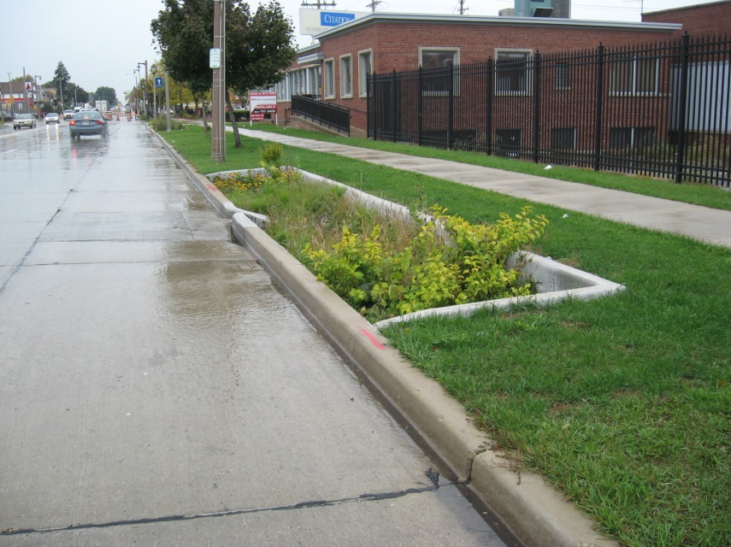
Figure 8.1. Off-line bypass system employed by bioretention cell in Portland, OR.

Where off-line designs are not achievable, bioretention practices shall be designed to route high flows on the shortest flow path across the cell to avoid scour in the bioretention practice. The overflow location should be placed as close as practicable to the inlet(s). No matter the bypass design, energy dissipation should always be provided at the inlet(s) to avoid high flow velocity and associated turbulence which can re-suspended particulates and cause erosion in the bioretention cell.

Two types of on-line bypass systems may also be used: an internal drainage inlet or a broad crested (or compound) weir. Concrete box drop structures may be used to provide an overflow for bioretention cells; however, they should be located away from the inlet(s) to provide an elongated flow path and prevent short-circuiting (Figure 8.2). These internal drainage structures may be tied into the existing drainage infrastructure, which is an attractive benefit in commercial applications. When using these high-flow bypass devices, it is critical to set the brink-of-overflow elevation properly, otherwise the cell will not function properly when construction is complete. In a tree-shrub-mulch cell, the internal drainage inlets should have a system of screens to prevent loss of mulch. These overflow devices should be designed to safely pass the design discharge.

In certain situations, a broad crested or compound weir in the berm of the bioretention cell will be the best option to convey overflow (Figure 8.3). This will typically be the case in residential, institutional, and rural bioretention applications, where the overflow can tie in to an existing surface conveyance (swale or ditch). Weir structures may be constructed of pressure-treated lumber, cast-in-place concrete, or precast concrete. The invert of the weir should be set at the intended brink-of-overflow elevation. This type of bypass structure should be designed to non-erosively bypass the design discharge
.

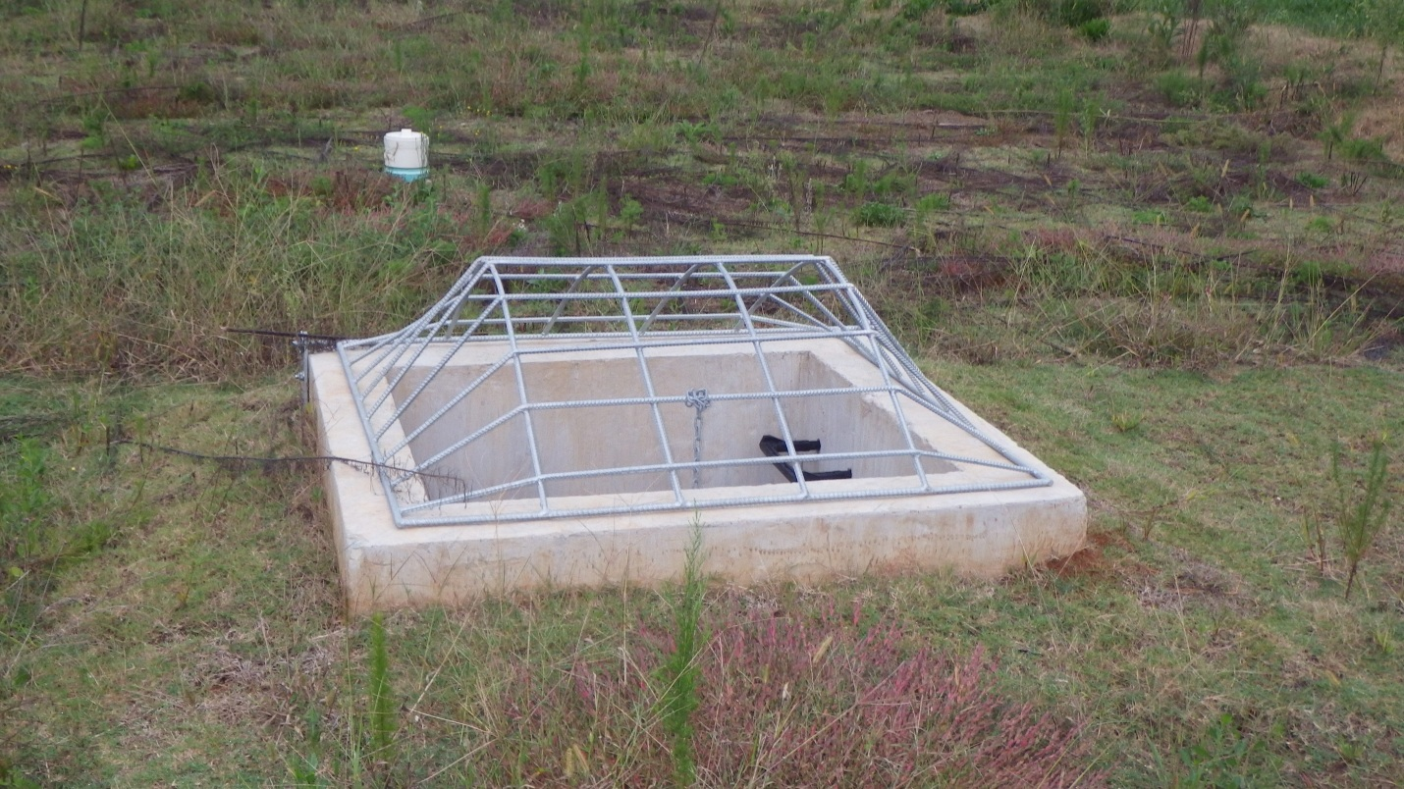
Figure 8.2. Concrete box (internal) outlet structure for grassed bioretention cell.

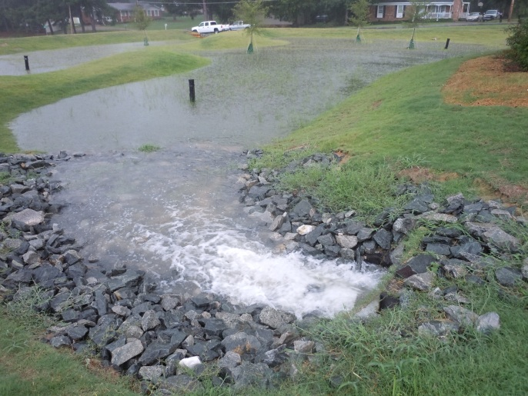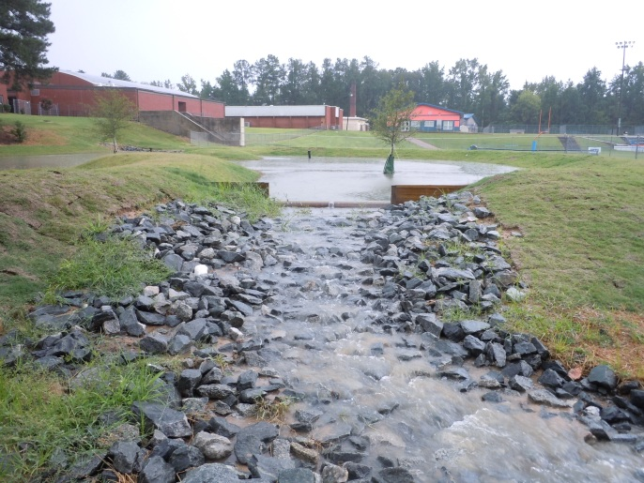
Figure 8.3. Bioretention cell at maximum ponding depth (left) and broad crested weir overflow (at right).

No matter the type of overflow device used, it is important that the designer provide non-erosive flow velocities at the outlet point to reduce downstream erosion. During the 10-year or 25-year storm (depending on local drainage criteria), discharge velocity should be kept below 4 ft/s for grassed channels. Erosion control matting or rock should be specified if higher velocities are expected.

- VEGETATION;

Current Manual and Suggested Updates:

It is REQUIRED that impervious area construction is completed and pervious areas established with dense and healthy vegetation prior to introduction of stormwater into a bioretention practice. Landscaping is critical to the performance and function of bioretention areas. Therefore, a landscaping plan is HIGHLY RECOMMENDED for bioretention areas. RECOMMENDED planting guidelines for bioretention facilities are as follows:
- Vegetation should be selected based on a specified zone of hydric tolerance. Plants for Stormwater Design by the Minnesota Pollution Control Agency is a good resource.
- Native plant species should be specified over non-native species. Hardy native species that thrive in our ecosystem without chemical fertilizers and pesticides are the best choices.
- Many bioretention facilities feature wild flowers and grasses as well as shrubs and some trees.
- Woody vegetation should not be specified at inflow locations.
- Trees should not be planted directly overtop of under-drains and may be best located along the perimeter of the practice.
- Salt resistant vegetation should be used in locations with probable adjacent salt application, i.e. roadside, parking lot, etc.
- Fluctuating water levels following seeding (prior to germination) can cause seed to float and be transported. Seed is also difficult to establish through mulch, a common surface component of bioretention. It may take up to two growing seasons to establish the function and desired aesthetic of mature vegetation via seeding. Therefore mature plantings are recommended over seed.

OTHER EDITS/ADDITIONS SUGGESTED BY KESTREL TEAM:

- Change above bullet to (suggested edits in blue italics): “Fluctuating water levels following seeding (prior to germination) can cause seed to float and be transported, resulting in bare areas that are more prone to erosion and weed invasion than vegetated areas. Seed is also difficult to establish through mulch, a common surface component of bioretention. It may take more than two growing seasons to establish the function and desired aesthetic of mature vegetation via seeding. Therefore plugs, bare root plants or potted plants are recommended over seed for herbaceous plants, shrubs, and trees. Erosion control mats pre-vegetated with herbaceous plants are also acceptable. For turf, sod is recommended over seed.”

- If a minimum coverage of 50% is not achieved after the first growing season, a reinforcement planting is required.

EDIT/ADDITION SUGGESTED BY KESTREL TEAM:

- Require at least 50% of specified vegetation cover at end of the first growing season
- Require at least 90% of specified vegetation cover at end of the third growing season
- If cover requirements are not met, supplement plantings to meet project specifications
- Note: percent coverage requirements will need to be tailored to project goals and vegetation. For example, percent cover required for turf after 1 growing season would likely be 100%; whereas it would likely be lower for other vegetation types.

- Bioretention area locations should be integrated into the site planning process, and aesthetic considerations should be taken into account in their siting and design.

Related Objectives/Tasks:
- See task 9i for “importance of plant establishment as a factor for performance and length”
- See Task 9v for “Operation and maintenance requirements for both the vegetation establishment period and the remaining life of the practice for bioretention BMPs”

Precedents:

Bioretention:

NCDENR Stormwater BMP Manual Chapter 12: Bioretention, Revised: 07-24-09:
A minimum of one (1) tree, three (3) shrubs, and three (3) herbaceous species should be incorporated in the bioretention planting plan unless it is a grassed cell. A diverse plant community is necessary to avoid susceptibility to insects and disease.
Many additional specifications.

Virginia DCR. 2010. Stormwater Design Specification No. 9. Bioretention. Version 1.7.

Native plant species are preferred over non-native species, but some ornamental species may be used for landscaping effect if they are not aggressive or invasive.

Micro-Bioretention (Rain Garden) Design Criteria1
Level 1 Design (RR 40 TP: 25) | Level 2 Design (RR: 80 TP: 50)
Vegetation: turf, herbaceous, or shrubs (min = 1 out of those 3 choices). | Vegetation: turf, herbaceous, shrubs, or trees (min = 2 out of those 4 choices).

Bioretention Filter and Basin Design Criteria
Level 1 Design (RR 40 TP: 25) | Level 2 Design (RR: 80 TP: 50)
Planting Plan (Section 6.8): a planting template to include turf, herbaceous vegetation, shrubs, and/or trees to achieve surface area coverage of at least 75% within 2 years. | Planting Plan (Section 6.8): a planting template to include turf, herbaceous vegetation, shrubs, and/or trees to achieve surface area coverage of at least 90% within 2 years. If using turf, must combine with other types of vegetation 1.

Micro-Bioretention or Rain Gardens. These are small, distributed practices designed to treat runoff from small areas, such as individual rooftops, driveways and other on-lot features in single-family detatched residential developments. Inflow is typically sheet flow, or can be concentrated flow with energy dissipation, when located at downspouts.

Bioretention Basins. These are structures treating parking lots and/or commercial rooftops, usually in commercial or institutional areas. Inflow can be either sheetflow or concentrated flow. Bioretention basins may also be distributed throughout a residential subdivision, but ideally they should be located in common area or within drainage easements, to treat a combination of roadway and lot runoff.

Wisconsin Department of Natural Resources. 2010. Bioretention For Infiltration (1004) Conservation Practice Standard.

- Rootstock and plugs shall be used in establishing trees, shrubs and herbaceous perennials. Seed shall not be used to establish vegetation.
- Plants shall be native to the area and capable of withstanding the environmental conditions of the bioretention device such as insect and disease infestations, drought, water level fluctuations and regional temperature variations. Vegetation shall be salt tolerant when the bioretention device is likely to receive runoff containing salt-based deicers.
- Turf grass shall not be used to vegetate the bioretention device, although it may be used in the pretreatment area.
- Invasive plants and noxious weeds shall not be used.

Dakota County Soil and Water Conservation District. 2011. Low Impact Development Standards
For Dakota County, Minnesota.
Proper vegetation selection is a critical component of bioretention systems. Follow Blue Thumb planting recommendations and base plant selection on: zone of hydric tolerance, native over non-native species. Hardy native wild flowers, grasses, shrubs, trees that thrive without fertilizer and pesticides are preferred.

Green Technology: The Delaware Urban Runoff Management Approach
Because of this, clump-forming herbaceous plants and woody plants with root systems that penetrate deeply into the soil profile and develop macropores are recommended. Native grasses, forbs, shrubs, and trees also require relatively minimal maintenance, and are more effective than non-natives in conserving ecology. For these reasons, native plant materials are the preferred choice for bioretention facilities. Nonnative plants with similar characteristics are also acceptable, provided that they are specified by qualified landscape designers familiar with the properties required.

- MAXIMUM FLOW PATH THROUGH A BMP;

Current Manual: not addressed

Recommendations and Notes:

- While flow path length is important for stormwater wetlands, it is less important for bioretention. Vertical flow (filtration) is more important than horizontal flow for effective bioretention treatment.

Precedents (with comments):

Bioretention :

NCDENR Stormwater BMP Manual Chapter 12: Bioretention, Revised: 07-24-09:
The geometry of the cell shall be such that no dimension is less than 10 feet (width, length, or radius). This is to provide sufficient space for plants.

Virginia DCR. 2010. Stormwater Design Specification No. 9. Bioretention. Version 1.7.

Bioretention Filter and Basin Design Criteria
Level 1 Design (RR 40 TP: 25 ) | Level 2 Design (RR: 80 TP: 50)
Geometry (Section 6.3):  Length of shortest flow path/Overall length = 0.3; OR, other design methods used to prevent short-circuiting; a one-cell design (not including the pre-treatment cell). | Geometry (Section 6.3):  Length of shortest flow path/Overall length = 0.8; OR, other design methods used to prevent short-circuiting; a two-cell design (not including the pretreatment cell).

Bioretention basins must be designed with an internal flow path geometry such that the treatment mechanisms provided by the bioretention are not bypassed or short-circuited. Examples of short-circuiting include inlets or curb cuts that are very close to outlet structures (see Figure 9.7 below), or incoming flow that is diverted immediately to the underdrain through stone layers. Short-circuiting can be particularly problematic when there are multiple curb cuts or inlets.

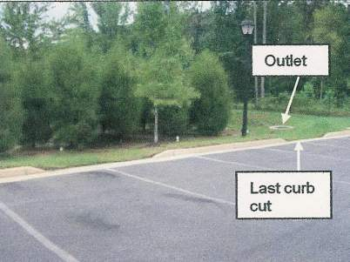

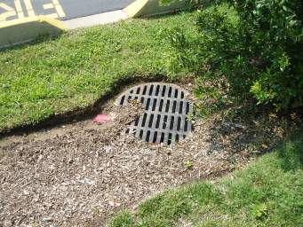

Figure 9.7. Examples of Short-Circuiting at Bioretention Facilities

In order for these bioretention areas to have an acceptable internal geometry, the “travel time” from each inlet to the outlet should be maximized, and incoming flow must be distributed as evenly as possible across the filter surface area.

One important characteristic is the length of the shortest flow path compared to the overall length, as shown in Figure 9.8 below. In this figure, the ratio of the shortest flow path to the overall length is represented as:

Equation 9.5. Ratio of Shortest Flow Path to Overall Length

SFP / L
Where:
SFP = length of the shortest flow path
L = length from the most distant inlet to the outlet

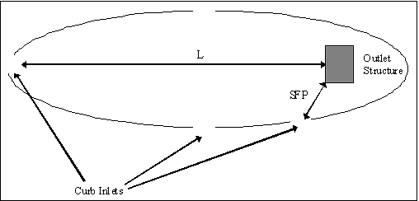

Figure 9.8. Diagram showing shortest flow path as part of BMP geometry

For Level 1 designs, the SFP/L ratio must be 0.3 or greater; the ratio must be 0.8 or greater for Level 2 designs. In some cases, due to site geometry, some inlets may not be able to meet these ratios. However, the drainage area served by such inlets should constitute no more than 20% of the contributing drainage area. Alternately, the designer may incorporate other design features that prevent short-circuiting, including features that help spread and distribute runoff as evenly as possible across the filter surface.

Note: Local reviewers may waive or modify the guideline for the shortest flow path ratio in cases where (1) the outlet structure within the bioretention area is raised above the filter surface to the ponding depth elevation; and (2) the filter surface is flat.

With regard to the first condition stated in the note above, field experience has shown that soil media immediately around a raised outlet structure is prone to scouring, erosion and, thus, short-circuiting of the treatment mechanism. For example, water can flow straight down through scour holes or sinkholes to the underdrain system (Hirschman et al., 2009). Design options should be used to prevent this type of scouring. One example is shown in Figure 9.9.

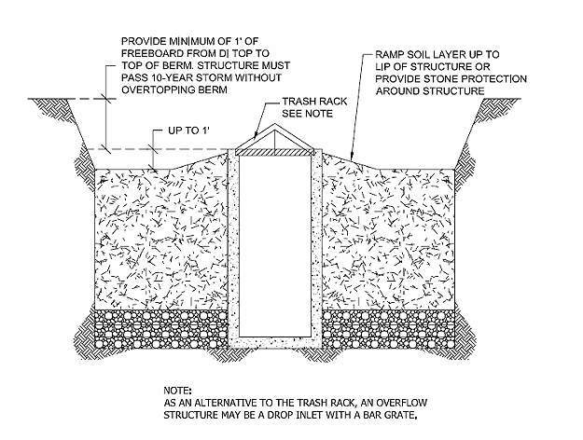
Figure 9.9. Typical Detail of how to prevent bypass
or short-circuiting around the overflow structure

The designer should ensure that incoming flow is spread as evenly as possible across the filter surface to maximize the treatment potential.

Dakota County Soil and Water Conservation District. 2011. Low Impact Development Standards
For Dakota County, Minnesota.

Where off-line designs are not achievable, bioretention practices shall be designed to route high flows on the shortest flow path across the cell to provide the least disturbance and displacement of the Water Quality Volume to be treated. Energy dissipation to avoid high flow velocity turbulence is required.

- USE OF MULTIPLE CELLS IN A BMP

Recommendations and Notes:

While one large bioretention cell will often perform just as well as multiple smaller cells if sized and designed appropriately, one large cell is generally less costly than multiple smaller cells. This is due to the simpler geometry and grading requirements of one large cell, as well as a reduction in piping and outlet strutures. Multiple smaller cells do however provide greater redundancy, i.e. if one large cell fails, more function is lost than if just one of multiple cells fail. Multiple cells are also more feasible than one large cell in steep terrain (slopes >5%), where they can be terraced to match the existing grade.

Precedents:

Bioretention:

NCDENR Stormwater BMP Manual Chapter 12: Bioretention, Revised: 07-24-09:
Individual units are well suited for use in small areas, and multiple, distributed units can provide treatment in large drainage areas.

Virginia DCR. 2010. Stormwater Design Specification No. 9. Bioretention. Version 1.7.

In steep terrain, land with a slope of up to 15% may drain to a bioretention area, as long as a two cell design is used to dissipate erosive energy prior to filtering. The first cell, between the slope and the filter media, functions as a forebay to dissipate energy and settle any sediment that migrates down the slope. Designers may also want to terrace a series of bioretention cells to manage runoff across or down a slope. The drop in slope between cells should be limited to 1 foot and should be armored with river stone or a suitable equivalent.

Level 1 Design (RR 40 TP: 25 ) | Level 2 Design (RR: 80 TP: 50)
Geometry (Section 6.3):  Length of shortest flow path/Overall length = 0.3; OR, other design methods used to prevent short-circuiting; a one-cell design (not including the pre-treatment cell). | Geometry (Section 6.3):  Length of shortest flow path/Overall length = 0.8; OR, other design methods used to prevent short-circuiting; a two-cell design (not including the pretreatment cell).

Wisconsin Department of Natural Resources. 2010. Bioretention For Infiltration (1004) Conservation Practice Standard.

Individual units are well suited for use in small areas, and multiple, distributed units can provide treatment in large drainage areas.

REFERENCES FOR TASKS 8 AND 9

Alexander, R. 1999. Compost Market Grows with Environmental Applications. BioCycle 40(4): 43-48.

Bannerman, Roger. 2013. Personal Communication.

Bannerman, R. 2012. WDNR What Are We Learning About Selecting a Soil Media for Bioretention Systems? Presentation to NASECA February 2, 2012.

Barrett, M.E., M. Limouzin, and D. F. Lawler. 2013. Effects of media and plant selection on biofiltration performance.Journal of Environmental Engineering. In press.

Dakota County Soil and Water Conservation District. 10/25/2012. Dakota County Jenson Lake Stormwater Retrofit Project Factsheet.

Dakota County Soil and Water Conservation District. 2011. Low Impact Development Standards
For Dakota County, Minnesota.

Denman, L., P. May, and P. Breen. 2006. An investigation of the potential to use street trees and their root zone soils to remove nitrogen from urban storm water. Australian Journal of Water Resources 1(3): 303-311.

Emerson, C. H., and R.G. Traver. 2008. Multiyear and seasonal variation of infiltration from storm-water best management practices. Journal of Irrigation and Drainage Engineering. 134(5): 598–605.

Gulliver, J.S., A.J. Erickson, and P.T. Weiss (editors). 2010. Stormwater Treatment: Assessment. and Maintenance. University of Minnesota, St. Anthony Falls. Minneapolis, MN. http://stormwaterbook.safl.umn.edu/Laboratory.

Hathaway, J. M., Hunt, W. F., Graves, A. K., and Wright, J. D. (2011). “Field evaluation of bioretention indicator bacteria sequestration in Wilmington NC.” J. Environ. Eng., 137(12), 1103–1113.

Henderson, C.F.K. 2009. The Chemical and Biological Mechanisms of Nutrient Removal from Stormwater in Bioretention Systems. Thesis. Griffith School of Engineering, Griffith University.

Hinman, C. 2009. Technical Memorandum. Bioretention Soil Mix Review and Recommendations For Western Washington. Prepared for: Puget Sound Partnership.

Hinman, C., and B. Wulkan. 2012. Low Impact Development. Technical Guidance Manual for Puget Sound. Publicaiton No. PSP 2012-3.

Hong, E. Y., E.A. Seagren, and A. P. Davis. 2006. Sustainable oil and grease removal from synthetic stormwater runoff using bench-scale bioretention studies. Water Environment Research, 78(2): 141–155.

Hunt, W.F. and W.G. Lord. 2006. Bioretention Performance, Design, and Construction and Maintenance. North Carolina Cooperative Extension Service.

Hunt, W., Davis, A., and Traver, R. 2012. Meeting Hydrologic and Water Quality Goals through Targeted Bioretention Design. J. Environ. Eng., 138(6), 698–707.
doi: 10.1061/(ASCE)`EE.1943-7870.0000504

Isensee, Mike. 2013. Personal Communication.

LeFevre, G.H., M. Raymond, P. Hozalski, J. Novak. 2012a. The role of biodegradation in limiting the accumulation of petroleum hydrocarbons in raingarden soils. Water Research 46: 6753-6762.

Lefevre, G.H., P.J. Novak, R.M. Hozalski. 2012b. Fate of naphthalene in laboratory-scale bioretention cells: implications for sustainable stormwater management. Environmental Science and Technology 46(2):995-1002.

Lucas, W.C. 2005. Green Technology: The Delaware Urban Runoff Management Approach. Prepared For Delaware Department of Natural Resources And Environmental Control Division of Soil And Water Conservation.

Lucas, W. C. and M. Greenway. (2007a) A Comparative Study of Nutrient Retention Performance
In Vegetated and Non-Vegetated Bioretention Mecocosms. Novatech 2007 Session 5.2.

Lucas, W. C. and M. Greenway. (2007b) Phosphorus Retention Performance in Vegetated and NonVegetated Bioretention Mecocosms Using Recycled Effluent. Conference Proceedings: Rainwater and Urban Design Conference 2007. Downloaded from http://www.hidro.ufcg.edu.br/twiki/pub/ChuvaNet/13thInternationalConferenceonRainwaterCatchmentSystems/Lucas_W.pdf

Lucas, W. C. and M. Greenway. 2008. Nutrient Retention in Vegetated and Non-vegetated Bioretention Mesocosms. Journal of Irrigation and Drainage Engineering. 134 (5): 613-623.

Lucas, W. C. and M. Greenway. 2011a. Hydraulic Response and Nitrogen Retention in Bioretention Mesocosms with Regulated Outlets: Part I—Hydraulic Response. Water Environment Research 83(8): 692-702.

Lucas, W. C. and M. Greenway. 2011b. Hydraulic response and nitrogen retention in bioretention mesocosms with regulated outlets: part II--nitrogen retention. Water Environment Research 83(8): 703-13.

Lucas, W. C. and M. Greenway. 2011. Phosphorus Retention by Bioretention Mesocosms Using
Media Formulated for Phosphorus Sorption: Response to Accelerated Loads. Journal of Irrigation and Drainage Engineering.137(3): 144–153.

McPherson, E. G., J.R. Simpson, P.J. Peper, S.E. Maco, S.L. Gardner, S.K. Cozad, Q. Xiao. 2006. Midwest Community Tree Guide: Benefits, Costs and Strategic Planting PSW-GTR-199. USDA Forest Service, Pacific Southwest Research Station, Albany, CA.

Milandri, S.G., K.J. Winter, S.B.M. Chimphango, N.P. Armitage, D.N. Mbui, G.E. Jackson, and V. Liebau. 2012. The performance of plant species in removing nutrients from stormwater in biofiltration systems in Cape Town. Water SA. 38(5): 655-662.

North Carolina Department of Environment and Natural Resources. 2009. Stormwater BMP Manual Chapter 5: Common BMP Design Elements. Revised 07-16-09. http://portal.ncdenr.org/c/document_library/get_file?uuid=bbf7d14c-cdde-49b4-8ef8-6554fec8ce6d&groupId=38364

North Carolina Department of Environment and Natural Resources. 2009. Stormwater BMP Manual Chapter 12: Bioretention. Revised 07-24-09. http://portal.ncdenr.org/c/document_library/get_file?uuid=199a62d4-3066-4e24-a3f1-088c6932483a&groupId=38364

North Carolina Department of Environment and Natural Resources. 2009. Stormwater BMP Manual Chapter 16: Infiltration Devices. Revised 07-23-09. http://portal.ncdenr.org/c/document_library/get_file?uuid=05164012-4410-4c98-8771-c2507346585e&groupId=38364

Perrin, C., L. Milburn, L. Szpir, W. Hunt, S. Bruce, R. McLendon, S. Job, D. Line, D. Lindbo, S. Smutko, H. Fisher, R. Tucker, J. Calabria, K. Debusk, K.C. Cone, M. Smith-Gordon, J. Spooner, T. Blue, N. Deal, J. Lynn, D. Rashash, R. Rubin, M. Senior, N. White, D. Jones, W. Eaker. 2009. Low Impact Development: A Guidebook for North Carolina (AG-716). NC Cooperative Extension Service, NC State University. http://www.ncsu.edu/WECO/LID

Read, J., T.D. Fletcher, T. Wevill, A. Deletic. 2010. Plant Traits that Enhance Pollutant Removal from Stormwater in Biofiltration Systems. Int. J. Phytoremediation, 12, 34–53.

Read, J., T. Wevill, T.D. Fletcher, A. Deletic. 2008. Variation Among Plant Species in Pollutant Removal from Stormwater in Biofiltration Systems. Water Res., 42, 893–902.

Saxton, K. E., and W. Rawls. 2005. Soil Water Characteristics: Hydraulics Property Calculator. USDA Agricultural Research Service and USDA-ARS, Hydrology and Remote Sensing Laboratory. http://hydrolab.arsusda.gov/soilwater/Index.htm. Accessed March 2007.

Selbig, W.R., and N. Balster. 2010. Evaluation of turf-grass and prairie-vegetated rain gardens in a clay and sand soil: Madison, Wisconsin, water years 2004–08: U.S. Geological Survey, Scientific Investigations Report 2010–5077, 75 p.

Virginia DCR. 2010. Stormwater Design Specification No. 9. Bioretention. Version 1.7.

Wisconsin Department of Natural Resources. 2010. Bioretention For Infiltration
(1004) Conservation Practice Standard.

Please Note:

The Kestrel Design Group (including its employees and agents) assumes no responsibility for consequences resulting from the use of the information herein, or from use of the information obtained at linked Internet addresses, or in any respect for the content of such information, including (but not limited to) errors or omissions, the accuracy or reasonableness of factual or scientific assumptions, studies or conclusions, the defamatory nature of statements, ownership of copyright or other intellectual property rights, and the violation of property, privacy, or personal rights of others. The Kestrel Design Group is not responsible for, and expressly disclaims all liability for, damages of any kind arising out of use, reference to, or reliance on such information. No guarantees or warranties, including (but not limited to) any express or implied warranties of merchantability or fitness for a particular use or purpose, are made by the Kestrel Design Group with respect to such information.
The Kestrel Design Group does not endorse, approve, certify, or control references and Internet links included herein and does not guarantee the availability, accuracy, completeness, efficacy, timeliness, or correct sequencing of information in these references and links. No one should rely on the accuracy, completeness, efficacy, and timeliness of such information. Reference therein to any specific commercial product, process, or service by trade name, trademark, service mark, manufacturer, or otherwise does not constitute or imply endorsement, recommendation, or favoring by the Kestrel Design Group.

