Minnesota Stormwater Manual Updates, Phase 2
<Note to MPCA: we recommended that hyperlinks to the applicable MPCA Construction Stormwater General Permit be included where appropriate on the stormwater Wikipedia page, highlighted in yellow>

Dewatering practices: chemical treatment and sediment filtration
Dewatering is defined by the MPCA Construction Stormwater General Permit (2018) as “the removal of surface or ground water to dry and/or solidify a construction site to enable construction activity.” Dewatering usually involves using a pump to drain a trench, pit, or other low area. The water that is removed from a construction site, however, is often sediment laden, which can have negative impacts on nearby water resources if discharged without treatment.
Sediment filtration in dewatering practices involves the separation of sediment and other particles from the stormwater by passing it through a silt fence, bag filter, or other permeable medium that will trap a high percentage of the particles. This process does not require chemical treatment but can be used in conjunction with chemical treatment. In chemical treatment, compounds such as polymers and alum are used to bind small clay particles and other pollutants, making their removal easier.
Sediment filtration practices are generally effective at removing larger particles by settling, but smaller particles such as clay and fine silt tend to remain in suspension longer than the typical design retention times for these BMPs. Chemical treatment followed by sediment filtration during dewatering can reduce turbidity and associated pollutants in discharge water that are not effectively removed with sedimentation alone.
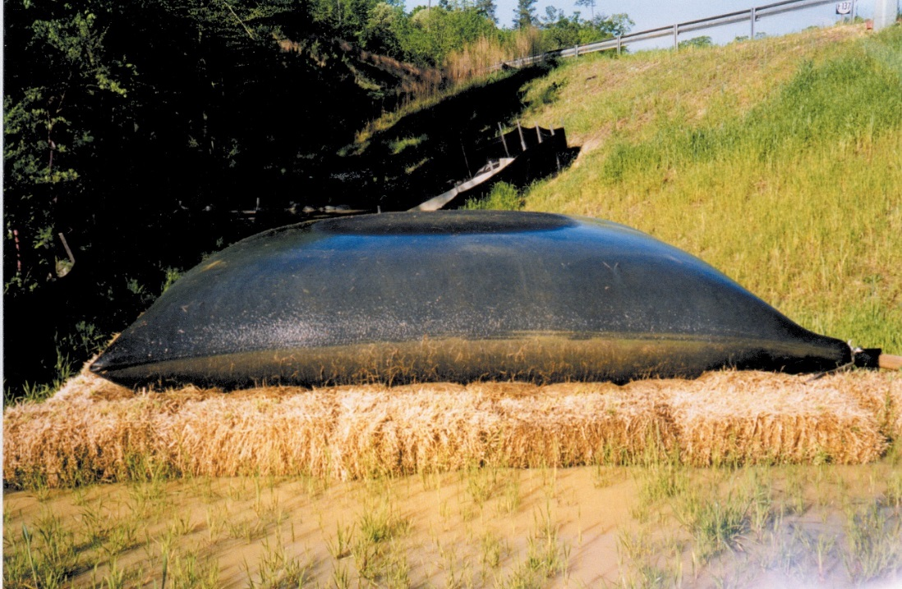
Typical dewatering sediment filter bag. For best results, place bag on a flat, vegetated area. (Source: Tetra Tech)

Purpose and function
Construction sites often have trenches, pits or low lying areas, whether from the site’s existing topography or from excavated areas, that can fill with rain water. This water often needs to be removed and discharged from the area to allow work to continue as scheduled, and to prevent accidents and damage to the structural integrity of the site. Dewatering also may be necessary to remove accumulated water and sediment when maintaining or closing out sediment traps and basins at the end of the project, when removing sediment control measures. Dewatering activities can produce highly turbid discharge water.
Sediment filtration and chemical treatment practices can be used to meet turbidity, or small particle, requirements that cannot be met with conventional sedimentation control treatments such as basins or berms. When used in conjunction with gravity settling, filtration can remove sediment as small as fine silt (0.5 µm). Chemical treatment can be conducted on a batch or flow-through basis and uses the processes of coagulation and flocculation. Chemicals such as polymers and alum destabilize the small suspended particles and cause them to flocculate into larger masses that can then settle out in a treatment tank or be removed through filtration. For more information on chemical treatment practices, see http://www.dot.state.mn.us/research/TS/2014/201425.pdf.
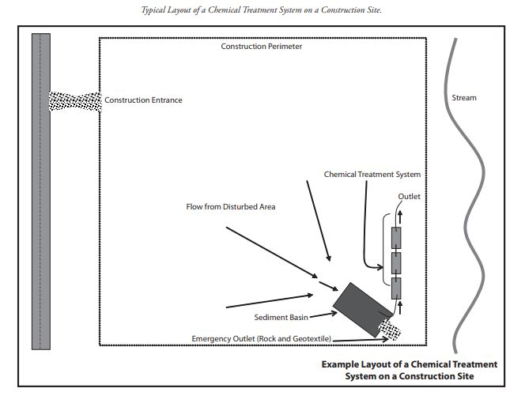
Example layout of a dewatering system with chemical treatment system on a construction site (Source: Federal Highway Administration US DOT, 2008).

Applicability
Water to be discharged from the site should be evaluated to determine turbidity, particle size, and volume. These factors will guide the selection and sizing of the appropriate BMP(s) – i.e., small volumes of relatively clear groundwater from an excavation may be discharged into a silt fence enclosure at an infiltration site, while flows with large (e.g., sand) particles may be successfully treated via silt fence filtration. For trenches and pits, dewatering needs can be greatly reduced by only excavating areas where construction can be completed in the short term – i.e., hours, rather than days or weeks. For example, trenching pipeline beds immediately before laying the pipe minimizes groundwater inflow to the trench, and thus the need for high-volume dewatering. Sediment concentrations in dewatering discharges from large pits and sediment basins can be reduced significantly by using floating (i.e., “skimmer”) inlet pipes that are suspended just below the surface, where water clarity is usually highest.
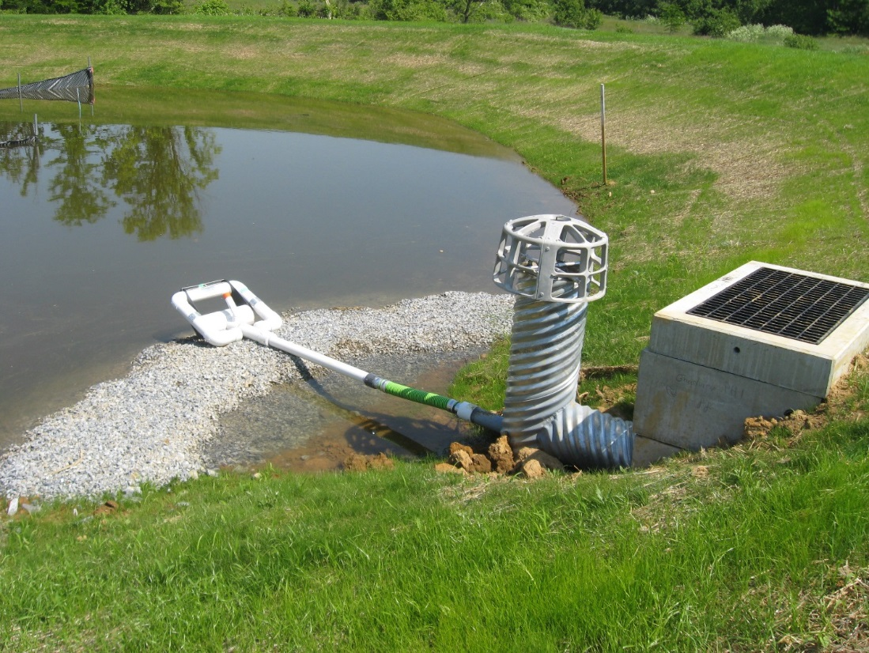
Floating skimmer discharge inlets draw clarified water from just below the surface. Note this skimmer rests on a rock berm when the basin is drawn down, to prevent discharge of muddy bottom water and/or clogging. (Source: Lancaster County, PA Conservation District)
Chemical treatment is applicable when particle sizes are too small and buoyant for simple settling processes or filtration and can be accomplished by either batch or flow-through treatment (discussed below). This practice can reliably reduce turbidity (small particles) and associated pollutants when preceded by treatment by sediment traps or basins or similar BMPs that remove larger particles through gravity settling. Likewise, properly selected sediment filters can also be used in conjunction with sediment traps or basins or similar BMPs to remove fine sediment that contributes to turbidity. The use of stormwater filtration does not require prior approval; however, if treatment chemicals are used, the specific chemicals and chemical treatment systems must be described in the site’s SWPPP and must be approved by the appropriate permitting authority to ensure that treated stormwater discharged from the construction site is not toxic to aquatic organisms. For example, some cationic polymers may increase toxicity risks to fish and other aquatic organisms if not managed and used properly. Anionic polymers are much less toxic, and are widely used for construction stormwater applications. (For more information, see https://www.fhwa.dot.gov/clas/pdfs/BestManagementPracticesforChemicalTreatmentSystems.pdf, and consult product material safety data sheets and product specifications.)

Site applicability
Dewatering practices are applicable to all construction sites where excess water needs to be removed and discharged, particularly excavated areas where water collects and does not otherwise drain off, such as trenches, pits, sediment basins, and traps. Accumulated water and sediment must be removed from these practices during construction to ensure their effectiveness throughout the construction process.
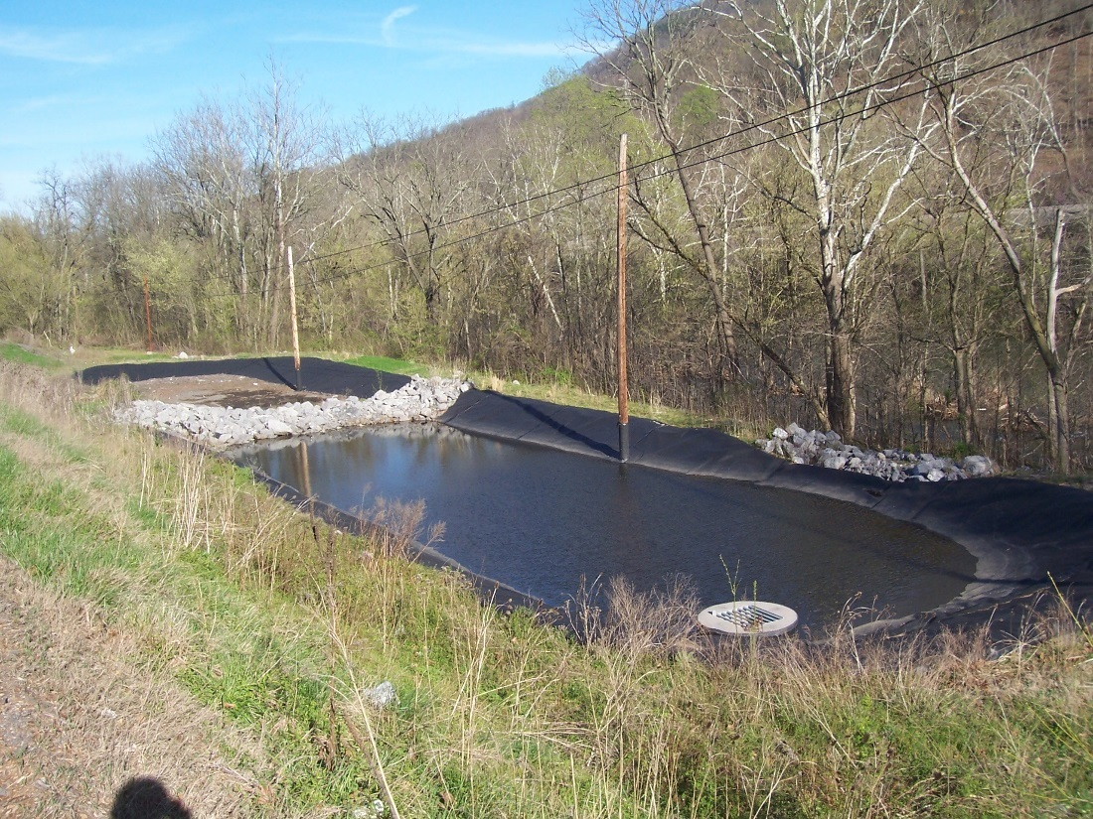
Temporary dewatering sediment trap. Note trap liner, which prevents additional sedimentation via erosion of the banks, and stone berm forebay, which removes large particles before flows enter secondary basin for settling prior to exiting through the outlet riser (bottom right). (Source: Tetra Tech)
Water pumped from low areas of construction sites can contain high concentrations of suspended soils, resulting in high turbidity. These fine particles may already be suspended in water or may have become suspended due to the pumping process. Dewatering discharge to surface waters is not permitted until adequate treatment is achieved such that the discharge will not negatively impact the receiving water and aquatic ecosystems. Chemical treatment and sediment filtration should be considered where turbid discharges to sensitive waters cannot be prevented using sediment basins and traps and other traditional BMPs.

Permit applicability
The MPCA Construction Stormwater General Permit (2018) has several requirements regarding sediment filtration and chemical treatment used in conjunction with dewatering activities (Section 10: Dewatering and Basin Draining). For example:
- (Section 10.2) All turbid and sediment-laden waters related to dewatering must be discharged to a temporary or permanent sediment basin on the project site unless infeasible.
- (Section 10.4) Permittees must discharge all water from dewatering or basin-draining activities in a manner that does not cause erosion or scour in the immediate vicinity of discharge points or inundation of wetlands in the immediate vicinity of discharge points that causes significant adverse impact to the wetland.
- (Section 10.3) Oil and grease separators or other suitable filtration devices must be used if discharge water contains oil or grease.
Additional permit language pertaining to chemical treatment is discussed below.
Specific permit language
Chemical treatment
Specifically, Section 5.22 of the MPCA Construction Stormwater General Permit (2018) states: “The SWPPP must describe any specific chemicals and chemical treatment systems used for enhancing the sedimentation process and how it achieves compliance with item 9.18.”
Section 9.18 states: “Permittees must use polymers, flocculants, or other sedimentation treatment chemicals in accordance with accepted engineering practices, dosing specifications and sediment removal design specifications provided by the manufacturer or supplier. The permittees must use conventional erosion and sediment controls prior to chemical addition and must direct treated stormwater to a sediment control system for filtration or settlement of the floc prior to discharge.”
Discharge
Section 10.2 states: “Permittees must discharge turbid or sediment-laden waters related to dewatering or basin draining (e.g., pumped discharges, trench/ditch cuts for drainage) to a temporary or permanent sediment basin on the project site unless infeasible. Permittees may dewater to surface waters if they visually check to ensure adequate treatment has been obtained and nuisance conditions (see Minn. R. 7050.0210, subp. 2) will not result from the discharge. If permittees cannot discharge the water to a sedimentation basin prior to entering a surface water, permittees must treat it with appropriate BMPs such that the discharge does not adversely affect the surface water or downstream properties.”
Section 10.4 states: “Permittees must discharge all water from dewatering or basin-draining activities in a manner that does not cause erosion or scour in the immediate vicinity of discharge points or inundation of wetlands in the immediate vicinity of discharge points that causes significant adverse impact to the wetland.”
Filtration requirements
Section 10.3 states: “If permittees must discharge water containing oil or grease, they must use an oil-water separator or suitable filtration device (e.g., cartridge filters, absorbents pads) prior to discharge.”
Section 10.5 states “If permittees use filters with backwash water, they must haul the backwash water away for disposal, return the backwash water to the beginning of the treatment process, or incorporate the backwash water into the site in a manner that does not cause erosion.”

Effectiveness
Various practices can be used for sediment removal from dewatering discharge. Sedimentation is primarily effective at removing larger sized particles, while filtration and chemical treatment can also remove the fine particles. These approaches are less effective for dissolved nutrients and metals that are non-adsorbed . Effectiveness of chemical treatment depends greatly on the pH and temperature of the water being treated.
Expected performance benefits for various dewatering practices

 | Dewatering Best Management Practices
 | Sedimentation/ Settling Only (Sediment Traps/ Basins) | Filtration Only (Silt Fence, Dewatering Bag, Geotextile, etc.) | Pretreatment¹ + Chemical Flocculants + Settling/Filtration **
Water Quantity
Flow attenuation | Secondary benefit | Little or no benefit | Little or no benefit
Runoff volume reduction | Secondary benefit | Little or no benefit | Little or no benefit
Soil erosion | Little or no benefit | Little or no benefit | Little or no benefit
Sediment control | Good results | Better results | Best results
Nutrient loading² | Good results | Better results | Best results
Total suspended solids | Good results | Better results | Best results
Total phosphorus² | Good results | Better results | Best results
Heavy metals | Good results | Better results | Best results
Floatables | Little or no benefit³ | Good results | Good results³
Oil and grease | Little or no benefit³ | Some benefit | Some benefit³
¹ Pretreatment via settling and/or filtration.
² For soil-borne nutrients; i.e., not dissolved forms.
³ Benefit can be significantly improved with the use of a floating skimmer for discharge.

Planning considerations
Evaluate dewatering needs and select BMPs consistent with discharge water location, turbidity, particle size, volume, and other pollutants present. Locate BMPs away from waterbodies and areas subject to flooding if possible. Plan treatment train configurations to remove large particles and attenuate flow first (e.g., silt fence/sediment traps), add flocculants next (socks, blocks, etc.), and then remove floc particles via filtration or settling. Size BMPs and treatment trains to handle the 2-year, 24-hour storm. Ensure equipment access to accommodate removal of accumulated sediment.
All appropriate safety precautions must be followed when handling chemicals, and designs must consider and minimize all hazards related to the particular chemicals used. Consult material safety data sheets for chemical application, mixing, and use information, and keep them with the SWPPP for further reference. Chemical safety equipment should be stored on site in a lockable shed and should include the chemical injector, secondary containment (for acid, caustic, buffering compound, and treatment chemical), emergency shower and eyewash, and monitoring equipment including a pH meter and turbidimeter. Any tanks or ponds should have ladders, steps, or similar features extended from top to bottom. Per Section 12.3 of the MPCA Construction Stormwater General Permit (2018), “Permittees must place… treatment chemicals under cover (e.g., plastic sheeting or temporary roofs) or protect them by similarly effective means designed to minimize contact with stormwater.”
The use of chemicals for treatment requires review and approval by the appropriate permitting authority to ensure they are not toxic to aquatic organisms. Additionally, specific chemicals and chemical treatment systems used for enhancing the sedimentation process must be described in the site’s SWPPP. For more information, see http://www.dot.state.mn.us/research/TS/2014/201425.pdf.

Design
Dewatering filters
Dewatering bags, wire-reinforced silt fence enclosures, geotextiles, fiber log berms, rock berms, and other filters can be used effectively for many dewatering applications. Soil infiltration of dewatering flows is also highly effective. The key to success is to ensure that 1) the filter traps the target size range and desired volume of particles, and 2) flow volumes do not overwhelm the filtering site. Follow the manufacturer’s recommendations regarding the use of dewatering bags, silt fences, geotextiles, and other filters, and monitor the filters regularly for performance and maintenance needs. Filters are often used in conjunction with chemical treatment to remove flocculated soil particles prior to final discharge. Frequent cleaning of the filter media will be required.
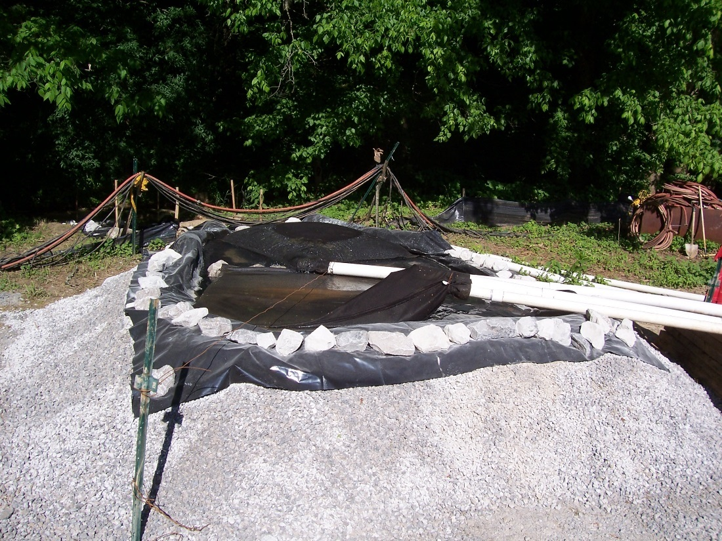
Downflow dewatering filter constructed from pea gravel. Note sediment filter bag on pipe outlet, which functions as primary removal media. Plastic basin liner extends down stone embankment to basin bottom, allowing downward flows through media while preventing bypasses through the embankment. (Source: Tetra Tech).
Sedimentation facilities
Sedimentation facilities for dewatering include wire-reinforced silt fence enclosures – which perform double duty as both filters and settling devices, sediment basins and traps, tanks, fabricated enclosures, and other settling vessels. Sedimentation facility sizing and design must consider particle size, flow volumes, and flow velocity/turbulence to ensure proper settling time and storage volume. At a minimum, sediment basins and traps should be designed with 3,600 cu ft of storage volume per acre of upstream drainage area. Sediment removal in traps and basins can be improved through the use of in-basin flow baffles, silt fence partitioning, and increased sizing / flow path design. Sedimentation facilities are often used in conjunction with chemical treatment to remove flocculated soil particles prior to final discharge.
Chemical treatment–flow-through
Typical construction site application of flow-through chemical treatment involves the addition of a flocculant (e.g., chitosan, polyacrylamide, etc.) to pretreated stormwater flows via contact with a polymer-containing sock or block. Pretreatment usually involves the filtration and/or sedimentation processes described above, along with minimization of non-target inputs from the site – such as upland runoff, litter, debris, and other pollutants. Chemically treated – i.e., flocculated – flows are then routed to a filter or sedimentation basin/vessel for sediment removal prior to final discharge.
Flows involving a more complex mix of challenges in terms of pH and pollutants may require more sophisticated methods for treatment. At a minimum, an advanced flow-through chemical treatment system consists of:
- A stormwater collection system,
- An untreated stormwater storage pond (such as a sediment basin), and
- A chemically enhanced sand filtration system.
In an advanced flow-through chemical treatment system, stormwater is collected at interception point(s) on the site and is diverted by gravity or by pumping to a stormwater storage pond or other stormwater holding area. It is important that the holding area is large enough to provide adequate storage until treatment occurs. Stormwater is then pumped from the stormwater holding area to the chemically enhanced sand filtration system where a coagulant is added. Adjustments to pH may be necessary before coagulant addition. The sand filtration system in an advanced flow-through chemical treatment system continually monitors the stormwater effluent for turbidity and pH. If the discharge water is out of an acceptable range for turbidity or pH, the water is returned to the untreated stormwater pond where it will begin the treatment process again. Applicable discharge limits may be established by the MPCA Construction Stormwater General Permit (2018) or a site-specific discharge permit.
Chemical treatment–batch treatment
Dewatering flows can also be treated in batches, rather than via flow-through contact with the flocculants. Batch treatment is often used for dealing with fine clays, where runoff can be captured and stored, allowing time for chemical mixing and sedimentation prior to discharge. Batch treatment on construction sites typically involves the use of a sediment pond, trap, or other vessel (e.g., dumpster, tank, etc.) as a site for mixing powdered or granular batches of the flocculant with known volumes of stormwater. Treated water in the basin or vessel can be discharged from the upper portion of the water column after allowing sufficient time for floc settling. Discharges of treated water can also be routed through a filter for additional sediment removal.
An engineered batch treatment system may be required in cases where complex treatment challenges exist. A typical engineered batch chemical treatment system for these more challenging situations consists of:
- A stormwater collection system
- A stormwater storage pond (such as a sediment basin)
- Pumps
- A chemical feed system
- Lined treatment cells (minimum of two; can be ponds or tanks)
- System for filtering and monitoring
Prior to chemical treatment, the pH of the stormwater to be treated should be held within the range that is recommended for the chemical used (typically between 6.5 and 8.5). The pH of the stormwater can be altered with the application of carbon dioxide (acidic) or a base such as sodium bicarbonate (baking soda). A batch chemical treatment system consists of four main steps:
- Coagulation: coagulants such as polymers are added to disrupt negative charges on fine particles and allow them to flocculate. Rapid mixing is used to encourage thorough and even dispersion of the coagulant.
- Flocculation: gentle mixing is used to bind fine particles together to form larger particles that settle more rapidly.
- Clarification: settling of the particles, which is largely depending on water temperature and water movement (currents). Warmer temperatures reduce viscosity and density and increase the rate at which particles settle. Quiescent water is necessary to allow settling and minimize resuspension of particles.
- Filtration: the chemically treated stormwater is filtered to enhance removal of flocculated sediment. Effluent should be continually monitored for turbidity and pH to ensure treatment is acceptable.
Multiple treatment cells allow for clarification of chemically treated water in one cell while the other cell(s) are being filled or emptied. It is recommended that the stormwater storage system and treatment cells be sized to hold 1.5 times the volume of runoff generated from the site during the 10-year, 24-hour storm event to minimize bypass of untreated water. However, bypass should be provided around the chemical treatment system into a settling pond to accommodate large storm events.
The following is a list of chemicals typically used for treating turbidity (subject to local, state, or federal requirements; the appropriate permitting authority should be contacted for additional information and conditions of use):
List of chemicals typically used for treating turbidity (Source: adapted from FHWA, 2008)
Chemical Type | Chemical Name | Description
Polymers | Chitosan | Made from chitin. Rapidly binds to suspended sediment. Unlikely to adversely affect aquatic life.
Polymers | Anionic Polyacrylamide (PAM) | Synthetic polymer; includes a wide variety of chemicals based on acrylamide unit. Ensure that the product selected is anionic -- cationic products are toxic to aquatic environments. Flocculate should be removed via filtration or sedimentation.
Other additives | Diallyldimethyl ammonium chloride (DADMAC) | Positively charged monomer that binds negatively charged sediment particles into flocs. Can exhibit a strong aquatic toxicity.
Other additives | Gypsum | Naturally and widely occurring mineral made up of calcium sulfate and water.
Other additives | Alumª | Aluminum sulfate material widely used in water treatment industry. Often more efficient than gypsum but can acidify treated water if overdosed.
Other additives | Aluminum and iron chloridesª | Cations that bridge negatively charged sediment particles, causing them to coagulate and settle.
- Alum and aluminum and iron chlorides are also frequently used in Minnesota to coagulate soluble phosphorus out of stormwater and water bodies.
As noted above, sediment filtration can be used in conjunction with gravity settling (e.g., sediment ponds and sediment traps) or as the filtering process in sophisticated flow-through or batch chemical treatment processes. There are two main types of sediment filtration methods: rapid and slow filtration. Slow sediment filtration uses gravity to move water through a system and is most typically used on the treatment line of construction stormwater as does not have a backwash system. Rapid filtration is typically used in treating water and wastewater, as the automatic backwash system allows for higher hydraulic flow rates.
Filters must be designed to control the treated stormwater velocity and peak volumetric flow rate from the system to reduce erosion and sedimentation at the outlet. Sizing of the stormwater pond should be consistent with sediment basin standards.
There are several types of filters that have varying turbidity reduction efficiencies. Sand media filters are available with automatic backwashing features that can filter to 50 µm particle size. Screen or bag filters can filter down to 5 µm. Fiber wound filters can remove particles down to 0.5 µm. Filters should be sequenced from the largest to the smallest pore opening. Sediment removal efficiency depends on the particle size distribution in the dewatering discharge being treated.
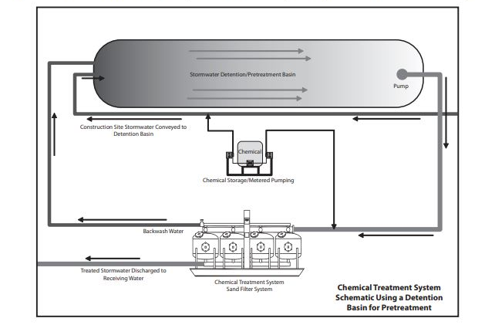
Example schematic of a chemical treatment and sand filtration system. Using an existing detention basin for pretreatment, is often more cost effective than pretreatment tanks. (Source: Federal Highway Administration US DOT, 2008)

Construction recommendations and specifications
Before installing dewatering facilities, evaluate upland areas for their potential to contribute excessive amounts of runoff water, sediment, and other pollutants to the dewatering site and dewatering BMPs. Address any flow, sediment, and pollutant concerns prior to installing the dewatering facilities. The MnDOT Standard Specifications for Construction (2018 Edition) include several specifications relevant to chemical treatment and sediment filtration of discharge water from construction dewatering activities.
MnDOT Specification 2573.3 Part A includes guidance for dewatering and pumping for turbid or sediment laden water. Part A.5 (page 514) states: “Provide a water treatment plan for turbid or sediment laden water. Submit the water treatment plan to the Engineer before pumping. Do not begin work until the Engineer accepts the water treatment plan including any contractor required permits. Include in the water treatment plan the use of sediment traps, vegetative filter strips, flocculants, or other water treatments per 3875, ‘Water Treatments’. Protect the discharge location of the dewatering process from erosion. Unless otherwise required by the contract, provide and install the BMPs to control erosion and suspended sediment during the dewatering or pumping operation.”
Specification 2573.3 Part N covers the use of flocculants in conjunction with installed sediment and erosion control BMPs and includes the following guidance:
- Part N (Flocculants) states: “Apply flocculants in conjunction with installed sediment and erosion control BMP’s. Do not apply flocculants directly to public waters (i.e. lakes, wetlands, streams). Apply flocculants in a contained area and assure thorough mixing into the water. Before applying a flocculant, test the pH and temperature of the storm water. Apply flocculant within the manufacturer's specified ranges. Allow from 15 to 20 min retention time for clay size particles to settle, ensuring that the discharge of the treated water is visually the same as the receiving water.”
- Part N.1 (Liquid Flocculant) states: “Hydraulically apply liquid flocculant over the surface of the water to be treated. Dilute the liquid flocculant concentrate to form a stock solution. Apply the stock solution at the manufacturer recommended rate to yield 1 ppm in the final treated water volume.”
- Part N.2 (Flocculant Sock) states: “Securely anchor the flocculant sock in an area where the water to be treated will flow over the sock. Do not leave flocculant socks in standing, stagnant water.”
- Part N.3 (Granular Flocculant) states: “Mix granular based flocculant with water in a tank to form a stock solution. Hydraulically apply the stock solution at the manufacturer’s recommended rate to yield 1 ppm in the final treated water volume.”
MnDOT Specification 2573.4 prescribes “method of measurement” related to flocculants. Part L (Flocculants, page 519) states: “The Engineer will measure liquid flocculant by the volume of liquid flocculant concentrate used. The Engineer will not include the water used to dilute the concentrate. The Engineer will measure flocculant sock by each provided. The Engineer will measure granular flocculant by the weight used and placed. The Engineer will not include the water used to dissolve and dilute the granular flocculant.”
MnDOT Specification 2573.5 prescribes “basis of payment” related to temporary sediment traps and basins. Part I (Pay Items, page 521) states that payment by the Department for flocculant socks, liquid flocculant, and granular flocculant (Item No. 2573.502, 2573.506, and 2573.508, respectively) shall be calculated based on units of each, gallon, and pound, respectively. These specifications are important when considering cost implications of these practices, discussed further below.
MnDOT Specification 3875 (Water Treatment) outlines requirements for water treatment that is used to reduce turbidity from dewatering discharge. Specifically,
- 3875.1 (Scope) states: “Provide water treatment methods to minimize turbid water levels from dewatering practices that discharge to receiving waters.”
- 3875.2 (Requirements) includes the following which are applicable to chemical treatment and/or sediment filtration:
  - Part B.2 (In-line Flocculant Sock) states: “Provide a flocculant per 3898, “Flocculants,” in the hose connecting one containment facility to another. Locate the flocculant sock after the pump.”
  - Part B.3 (In-line Pressurized Filter Systems) states: “Provide a portable water quality monitoring system consisting of sand media, pressurized bags, or cartridges to produce required turbidity or chemical reduction. Use liquid flocculants in accordance with 3898, ‘Flocculants,’ if necessary. Provide a portable water quality monitoring system meeting the discharge requirements shown on the plans.”
Regarding the use of flocculants, MnDOT Specification 3898 (Flocculants) provides the following specific information:
- 3898.1 (Scope) states: “Provide naturally derived additives for coagulating dispersed clays, and reducing turbidity in storm water runoff and use flocculants as part of a designed storm water treatment system.”
- 3898.2 (Requirements) states: “Use environmentally benign flocculants that are biodegradable and consist of natural origin biopolymers to improve water quality and protect aquatic biota. Use flocculants meeting the following requirements detailed by each type.”
  - Part A (Liquid Flocculant) states: “Store the flocculant in a concentrated liquid state. Ensure the manufacture’s label is affixed to the container and lists the percent of concentration in the container and the application dose rate. Obtain the Engineer’s verification of the dose rate calculations before applying to the treatment system.”
  - Part B (Flocculant Sock) states: “Use flocculant in a gelatin-like state, packaged in individual compartments of the encasing sock material. Ensure the encasing material allows water to flow through it so the water comes in contact with the gelatin-like flocculant material. Use a Flocculant Sock with attachment anchor cords or grommets for use in pipes, sediment control filter systems, and ditch bottoms. Provide a Flocculant Sock capable of treating at least 250,000 gal. of the water flowing through it.”
  - Part C (Granular Flocculant) states: “Store the flocculant in a granulated state. Ensure the manufacture’s label is affixed to the bag or container and states the purity of the product and the application mixing rate. Obtain the Engineer’s verification of the dose rate calculations before applying the treatment system.”
- 3898.3 (Sampling and Testing) states: “Before delivery and use on the project, submit to the Engineer a Certificate of Compliance and MSDS for approval.”

Inspection and maintenance
Chemical treatment, sedimentation sites, and sediment filtration systems should be monitored continuously to ensure periodic maintenance (e.g., sediment removal and disposal) and adherence to permit compliance requirements. The systems should also be monitored to ensure proper types and concentrations of treatment chemicals (pH adjustment chemicals and coagulants), flow rates, settling times, turbidity, and influent and effluent pH.
Screening equipment, geotextiles, dewatering bags, and fiber filters should be inspected to ensure they are clear and not clogged with sediment. Screens, bags, and fiber filters must be cleaned and/or replaced when they become clogged.
Sediment should be removed from the storage and treatment pond as necessary. Typically, sediment removal is required at least once during a wet season and at the decommissioning of the chemical treatment system or storage ponds. When a sediment collection area has reached one-third of its capacity, the sediment should be removed and taken to a location where it can be stabilized (i.e., with vegetation) or buried to prevent off-site transport. Filtration media and equipment that cannot be reused should be disposed of according to applicable local, state, and federal regulations (see https://www.pca.state.mn.us/waste/solid-waste).

Costs
Treatment cost for construction water flocculation has been reported as between $0.01 to $0.03/gallon for continuous reactor (in line) treatment, and $0.08/gallon for batch reactor (off line) treatment. The Federal Highway Administration reported costs of $0.022 per gallon for a chitosan and sand filtration based system discharging at a rate of nearly one million gallons per month. The cost dropped to $0.009 per gallon as the discharge rate approached five million gallons per month.
The following links provide estimated BMP costs based on MnDOT data summarizing average bid prices:
Sediment Traps and Basins: https://stormwater.pca.state.mn.us/index.php?title=Unit_costs_related_to_sediment_traps_and_basins
Sediment Filtration: https://stormwater.pca.state.mn.us/index.php?title=Perimeter_controls_for_disturbed_areas_-_Average_Bid_Prices
BMP costs for chemical treatment practices are not reported by MnDOT, however total costs for may be significant. This is largely due to the equipment required and cost of the chemicals. Chemical treatment practices, however, are able to reduce turbidity in runoff significantly, and therefore the overall cost-benefit of the practice should be considered in the context of requirements and site conditions.

Reference materials
Except where more stringent requirements are presented in this guidance, BMPs shall comply with MnDOT and other state requirements. Primary design references include:
- 2019 MPCA Fact Sheet on Dewatering and Basin Draining
https://www.pca.state.mn.us/sites/default/files/wq-strm2-107.pdf
- MnDOT Erosion Control Handbook II
https://www.dot.state.mn.us/environment/erosion/pdf/2006mndotecfieldhandbook.pdf
- 2018 Minnesota NPDES/SDS Construction Stormwater General Permit
https://www.pca.state.mn.us/water/construction-stormwater
- 2018 MnDOT Standard Specifications for Construction
http://www.dot.state.mn.us/pre-letting/spec/
- MnDOT: Flocculation Treatment BMPs for Construction Water Discharges (2014)
http://www.dot.state.mn.us/research/TS/2014/201425.pdf
- Lakeville MN: Understanding the SWPPP – Basin Draining Practices and Pollution Prevention
https://lakevillemn.gov/DocumentCenter/View/260/Dewatering-Information-PDF
The following is a list of additional resources that are not specific to Minnesota:
- Caltrans: Field Guide to Construction Site Dewatering (2014)
http://www.dot.ca.gov/hq/construc/stormwater/field-guide-to-construction-site-dewatering.pdf
- Draft 2019 Stormwater Management Manual for Western Washington (Volume II, BMPs C250 and C251)
https://fortress.wa.gov/ecy/ezshare/wq/permits/Flare/Draft2019SWMMWW.htm
- Federal Highway Administration (FHWA): Best Management Practices for Chemical Treatment Systems for Construction Stormwater and Dewatering (2008).
https://www.fhwa.dot.gov/innovativeprograms/pdfs/centers/local_aid/BestManagementPracticesforChemicalTreatmentSystems.pdf
- Iowa Statewide Urban Design and Specification (SUDAS) Design Manual (2013) (Chapter 7E-28)
http://www.iowasudas.org/manuals/manual.cfm?manual=design

Buffer zones
A buffer zone is natural, undisturbed area that borders a body of water with the objective of protecting and enhancing water quality and habitat by restricting construction activities and maintaining existing vegetation. The buffer includes the vegetation, exposed rock, or barren ground that exists prior to commencement of earth-disturbing activities. Buffer zones are sometimes called riparian buffers.
There are two separate but complementary regulations regarding implementation and preservation of buffer zones in the state of Minnesota: the “Buffer Law” (Amended 2017) and the directives of the MPCA Construction Stormwater General Permit (2018) that require preservation of buffer zones both during and after site disturbance related to construction activities. The specific requirements of each regulation are dependent on how the adjacent waterbody is classified; this is discussed further below.
Minnesota’s Buffer Law was signed into law in 2015 and amended in 2016 and 2017. Under the Buffer Law requirements, contiguous perennially rooted vegetative buffers of 50-foot width must be provided along all public waterways including lakes, reservoirs, wetlands, rivers, and streams. Further, buffers of 16.5-foot width must be provided along public ditches. Per the regulations, these buffer zones were required on all applicable parcels adjacent to public waters by November 1, 2017 and adjacent to public ditches by November 1, 2018. Minnesota DNR has developed an interactive Buffer Map to help landowners determine if their property is identified for buffer protection; the Buffer Map can be accessed at: http://arcgis.dnr.state.mn.us/gis/buffersviewer/. The most recent and complete version of the Buffer Law, as well as related resources, can be accessed through the Minnesota Board of Water and Soil Resources at: http://bwsr.state.mn.us/buffers/.
The guidance included in this section pertains specifically to the buffer zone that is required to be preserved during and after construction activities per the conditions of MPCA’s Construction Stormwater General Permit (2018).

Purpose and function
The buffer zone in the MPCA Construction General Permit is intended to restrict earth disturbing activities and maintain existing vegetation within the sensitive area adjacent to surface waters. Buffer zones protect and enhance water quality and aquatic habitat by providing shade that moderates sunlight and water temperature, infiltrating and slowing runoff flows, trapping sediment and other pollutants in stormwater, providing habitat for fish and wildlife, and stabilizing shorelines and preventing erosion. Buffers also provide visually appealing shorelines, all of which can improve surrounding property values. Maintaining buffer zones during construction is important to preserving these benefits.
Buffer zones should not be used as stand-alone stormwater practices for a construction site and should be paired with other stormwater management and erosion and sedimentation control practices.
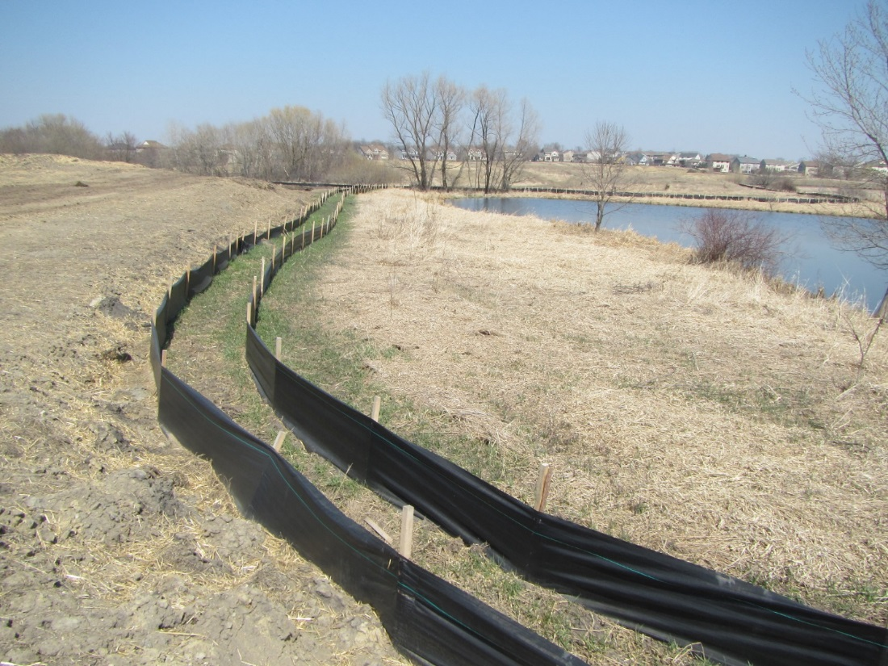
Double silt fence perimeter controls installed in the protected buffer zone around a water body, required when the full 50 ft buffer is not feasible. Silt fence perimeter controls mark the beginning of the buffer zone. Note that the perimeter controls must be at least five feet apart unless limited by a lack of available space. (Source: MPCA Stormwater Flickr)

Applicability
Per the conditions of MPCA’s Construction Stormwater General Permit (2018), buffer zones are required during and after construction activities depending on (1) the proximity of the project’s disturbed area to the adjacent surface water, and (2) the nature of the adjacent surface water. The specific conditions used to determine buffer zone applicability for each individual site are discussed below.

Site applicability
MPCA’s Construction Stormwater General Permit defines a natural buffer as “an area of undisturbed cover surrounding surface waters within which construction activities are restricted.” The permit further states that the “natural buffer includes the vegetation, exposed rock, or barren ground that exists prior to commencement of earth-disturbing activities.” The permit has two distinct buffer zone requirements, each with a different purpose:
- Near any surface waters: a temporary undisturbed natural buffer zone 50-feet in width must be preserved during construction adjacent to surface waters when the surface water is located within 50-feet of the project’s disturbed area and when stormwater from the site flows to the surface water. This temporary buffer zone must be used in combination with other sediment and erosion control BMPs. Surface waters applicable to this requirement include lakes, wetlands, rivers, and streams. Buffer zones are not required during construction adjacent to ditches (including road, county, and judicial ditches), storm drain inlets, stormwater conveyance channels, or sediment basins.

- Near special waters: a permanent undisturbed natural buffer zone 100-feet in width must be preserved at all times adjacent to any “special water” to protect the waterbody from stormwater runoff and preserve scenic quality. The 100-foot buffer zone must be maintained both during construction and as a permanent feature post construction.
Natural buffers must remain undisturbed and must not be used as sediment treatment areas or as storage areas for construction equipment or materials. As noted above, a 100-foot buffer is required surrounding waters classified by the state as “special waters.” Examples of special waters include the Mississippi River, Lake Superior, scenic or recreational river segments, wilderness areas, trout streams, and calcareous fens. A 50-foot buffer is required around all other surface waters. The 50-foot buffer does not apply if there is no stormwater discharging to the surface water, if all stormwater flows have been diverted from the site, or if the adjacent water body is classified as a ditch, storm drain inlet, stormwater conveyance channel, or sediment basin. MPCA has developed an online mapping tool to identify proximity to special waters: https://pca-gis02.pca.state.mn.us/CSW/index.html.
In most cases, the buffer zone prior to construction activities will consist of stable soils, natural vegetation, and other erosion-resistant features such as rock, woody debris, etc. In cases where the soils in the buffer are actively eroding prior to construction, and discharging sediment-laden runoff to the adjacent waterbody, the permittee should consider stabilizing the buffer area prior to construction. Addressing this situation in the SWPPP and discussing possible stabilization approaches with the permitting authority will help to avoid any misunderstandings regarding responsibility for unstable conditions in the buffer. Additional critical planning considerations for buffer zones are discussed below in Planning considerations, including the proper procedure for measuring buffer zone distance.

Permit applicability
The MPCA Construction Stormwater General Permit (2018) has several requirements regarding buffer zones. For example:
- Temporary natural buffers are required for all surface waters.
- Permanent natural buffers are required for all surface waters identified by MPCA as special waters.
- Both 50- and 100-foot buffers should be delineated in a SWPPP.
- The 50-foot buffer does not apply if there is no stormwater discharging to the surface water or if all stormwater flows have been diverted from the site.
Specific permit language
Location and sizing
Regarding the location of other sediment control BMPs on site relative to buffer zones, the MPCA Construction Stormwater General Permit Section 9.2 (2018) states: “…Permittees must locate sediment control practices upgradient of any buffer zones.”
Regarding placement of stockpiles related to construction activities, Section 9.10 states: “Permittees must locate stockpiles outside of natural buffers or surface waters, including stormwater conveyances such as curb and gutter systems unless there is a bypass in place for the stormwater.”
Regarding site disturbance in proximity to surface waters, Section 9.17 states: “Permittees must preserve a 50 foot natural buffer or, if a buffer is infeasible on the site, provide redundant (double) perimeter sediment controls when a surface water is located within 50 feet of the project's earth disturbances and stormwater flows to the surface water. Permittees must install perimeter sediment controls at least 5 feet apart unless limited by lack of available space. Natural buffers are not required adjacent to road ditches, judicial ditches, county ditches, stormwater conveyance channels, storm drain inlets, and sediment basins. If preserving the buffer is infeasible, permittees must document the reasons in the SWPPP. Sheet piling is a redundant perimeter control if installed in a manner that retains all stormwater.”
Regarding placement of other stormwater practices within buffer zones, Section 14.8 states: “Permittees must locate temporary basins outside of surface waters and any buffer zone required in item 23.11.” Additionally, Section 18.9 states: “Permittees must locate [wet sedimentation] basins outside of surface waters and any buffer zone required in item 23.11.”
Regarding site disturbance in proximity to special waters, Section 23.11 states: “Permittees must include an undisturbed buffer zone of not less than 100 linear feet from a special water (not including tributaries) and must maintain this buffer zone at all times, both during construction and as a permanent feature post construction, except where a water crossing or other encroachment is necessary to complete the project. Permittees must fully document the circumstance and reasons the buffer encroachment is necessary in the SWPPP and include restoration activities. This permit allows replacement of existing impervious surface within the buffer. Permittees must minimize all potential water quality, scenic and other environmental impacts of these exceptions by the use of additional or redundant (double) BMPs and must document this in the SWPPP for the project.”
SWPPP requirements
Regarding SWPPP requirements related to buffer zones, Section 5.12 states: “Permittees must identify locations of 50' buffer zones as required in item 9.17 and 100' permanent buffer zones as required in item 23.11, on plan sheets in the SWPPP.” Delineation of buffer areas in SWPPPs is highly recommended.

Effectiveness
Buffer vegetation intercepts overland flows, traps sediment, promotes infiltration, and retains nutrients. The preservation of a buffer zone is not considered a standalone best management practice for construction stormwater but a protective area around a water body to remain undisturbed during or after construction activities. Buffer zones are effective at reducing flow velocity, shoreline erosion, and sediment and nutrient removal. For more information on the effectiveness of buffers see the MS4 fact sheet on Vegetated Swales and Buffer Strips in the Minnesota Stormwater Manual (https://stormwater.pca.state.mn.us/index.php?title=MS4_fact_sheet_-_Vegetated_Swales_%26_Buffer_Strips).

Planning considerations
Measuring buffer zone distance
The buffer zone distance is measured horizontally from the water’s ordinary high water level (OHWL) mark. An OHWL is defined in Minnesota Statute 1034.005 Subd. 14 as the boundary of basins, watercourses, public waters wetlands and:
- The ordinary high water level is an elevation delineating the highest water level that has been maintained for a sufficient period of time to leave evidence upon the landscape, commonly the point where the natural vegetation changes from predominantly aquatic to predominantly terrestrial;
- For watercourses, the ordinary high water level is the elevation of the top of the bank of the channel; and
- For reservoirs and flowages, the ordinary high water level is the operating elevation of the normal summer pool.
OHWL elevations can be found on the Minnesota Department of Natural Resource’s webpage here: https://www.dnr.state.mn.us/waters/surfacewater_section/hydrographics/ohw.html. Local DNR hydrologists should be contacted prior to construction design and planning activities to determine if any special requirements exist.
When required buffer distance is infeasible
As discussed in Permit applicability, redundant sediment control BMPs are required in the event that the required buffer distance is infeasible; in other words, in addition to perimeter control BMP(s), an additional level of protection must be installed that can reasonably be expected to provide the same or better pollutant removal than the natural buffer zone.
Encroachment on the buffer zone
As discussed in Permit applicability, exceptions to the buffer zone rules may be allowed when a water crossing or other encroachment are necessary to complete projects, as well as other cases where construction within a buffer zone is unavoidable (e.g., for buffer restoration or maintenance). Per Section 23.11 of MPCA’s permit, “Permittees must fully document the circumstance and reasons the buffer encroachment is necessary in the SWPPP and include restoration activities.” If the installation of additional stormwater treatment BMPs for buffer restoration is not feasible due to space or other constraints, then construction activity encroaching on the buffer zone is not allowed.
Replacement or relocation of impervious surfaces
Existing impervious surfaces within a buffer zone can be replaced by new impervious surfaces as long as (1) the new impervious surfaces are the same size as or smaller than the existing impervious surfaces, and (2) the new impervious surfaces are not closer to the water body than the existing impervious surfaces. Any environmental or scenic impacts relative to existing conditions as a result of replacement or relocation of impervious surfaces must be mitigated and documented in the SWPPP. Permittees should contact MPCA during the design phase of the project to determine which additional BMP(s) may be necessary and to ensure appropriate restoration measures are implemented.

Design
The preservation of a buffer zone is not considered a standalone best management practice for construction stormwater but a protective area around a water body to remain undisturbed during or after construction activities. As such, there are no specific buffer zone design recommendations with respect to construction stormwater. Enhancement of sections of a buffer zone that are actively eroding and contributing sediment or other pollutants to the adjacent surface water is both allowed and encouraged. Such enhancements – which must be addressed in the SWPPP and approved by the permitting authority – can include targeted grading if necessary, seeding and mulching, application of rolled erosion control products, and other measures intended solely to address the actively eroding areas (i.e., naturally vegetated and stable areas should remain undisturbed). More information on buffer enhancement including recommended plant species is provided in the MS4 fact sheet on Vegetated Swales and Buffer Strips in the Minnesota Stormwater Manual.

Construction recommendations and specifications
At a minimum, activities within the buffer should be restricted through the use of construction fencing, flagging, signage, or other means. Disturbed areas upgradient from the buffer must be managed via appropriate perimeter controls, such as silt fencing, stormwater diversion berms/ditches, sediment traps, fiber logs, or other BMPs that prevent sediment-laden runoff from entering the buffer.
As noted above, where areas within the buffer are actively eroding they should be stabilized via carefully targeted management practices prior to construction. Where encroachment within the buffer is permitted in accordance with permit conditions, the double perimeter controls (e.g., silt fencing) must be sited, installed, and maintained properly. Use of wire-reinforced silt fence or rock berms is recommended where heavy stormwater volumes are expected to flow toward the buffer. Placing the required double line of perimeter controls more than five feet apart will help in vegetation establishment and maintenance. Addressing upgradient flow volume, erosion, and sediment movement conditions will greatly reduce the stress on BMPs protecting the buffer. Information on optional natural buffer zone enhancement is provided in the Design section above.

Inspection and maintenance
The natural buffer zones that are required during and after construction activities (either temporary or permanent depending on the classification of the adjacent surface water) should require little maintenance once their required widths (50 feet for surface waters and 100 feet for special waters) are established. The following guidelines are recommended to ensure optimal function of buffer zones for protection of surface water quality:
- Inspect buffer delineations regularly to determine if the flags or other markers remain in the correct position and to ensure that construction activity remains outside of buffer delineation (buffer zone remains undisturbed).
- Immediately address muddy runoff flows into or through the buffer zone by adding regular or wire-reinforced silt fencing, rock berms, fiber logs, sediment traps, or stabilizing upland areas.
- Do not place or store equipment or materials within the established buffer zone.
- Do not remove or mow vegetation within buffer zones unless necessary to remove invasive species or enhance vegetation with the zone (e.g., mowing to enhance grass stands).

Costs
There are no costs specific to the preservation of a buffer zone during construction activities. Depending on site conditions, overall costs of the construction may potentially be higher than if a buffer zone was not required.

Reference materials
Except where more stringent requirements are presented in this guidance, BMPs shall comply with MnDOT and other state requirements. Primary design references include:
- MnDOT Erosion Control Handbook II
https://www.dot.state.mn.us/environment/erosion/pdf/2006mndotecfieldhandbook.pdf
- 2018 Minnesota NPDES/SDS Construction Stormwater General Permit
https://www.pca.state.mn.us/water/construction-stormwater
- MPCA Guidance: Temporary natural buffers for surface waters and permanent buffers for special waters (September 2018; wq-strm2-30)
https://www.pca.state.mn.us/sites/default/files/wq-strm2-30.pdf
- 2018 MnDOT Standard Specifications for Construction
http://www.dot.state.mn.us/pre-letting/spec/
- 2017 MPCA Stormwater Manual MS4 fact sheet - Vegetated Swales & Buffer Strips
https://stormwater.pca.state.mn.us/index.php?title=MS4_fact_sheet__Vegetated_Swales_%26_Buffer_Strips
- Minnesota Board of Water and Soil Resources: Minnesota Buffer Law
http://bwsr.state.mn.us/buffers/
- 2003 MPCA Plants for Stormwater Design
https://www.pca.state.mn.us/sites/default/files/pfsd-section1.pdf

Riprap
Riprap is a permanent layer of large, angular stone, cobbles, or boulders that is typically used to armor, stabilize, and protect the soil surface against erosion and scour in areas of concentrated flow or wave energy. Riprap is typically placed along graded ditch, channel, and shoreline banks over geotextile, which prevents erosional undercutting. It can also be used with other mixed size rock to construct retention berms for sediment traps and check dams protecting high volume/velocity culvert inlets. The Minnesota Department of Transportation classifies riprap by type as random riprap or hand-placed riprap, depending on the method of placement and the stone size specified.

Purpose and function
Riprap is used to stabilize areas on a construction site with high erosive power by increasing surface roughness and slowing the velocity of runoff. Applicable areas on a site may include inlets and outlets of storm pipes and culverts, bridges, slopes drains, storm drains, and other areas where concentrated runoff may occur. Riprap is also effective for protecting and stabilizing slopes, channels, streambanks, and shorelines.

Applicability
As discussed above, there are many applications where riprap is more desirable than other erosion control practices. Although riprap is not often considered aesthetically pleasing, it can be one of the most effective methods of erosion prevention and is particularly desirable in areas where conditions prohibit establishment of vegetation (for example, areas where velocities are too great for vegetation to withstand). Compared to other erosion control practices, riprap is relatively simple to install and maintain. However, riprap is typically more expensive to install compared to vegetation (i.e., due to equipment and handling costs) and does not provide some of the secondary benefits provided by vegetated practices (e.g., habitat enhancement).

Site applicability
Riprap is useful in areas in which the powers of erosion outweigh the stabilization capacity of other erosion control practices such as vegetative control and mulching. As noted above, riprap is especially useful for armoring channel and ditch banks, lake shorelines, and for sediment trap berms and high-volume/velocity check dams. Because of the “hard” look of riprap, its higher overall cost, the growing popularity of vegetated solutions using turf reinforcement matting and other products, and the difficulty in removing it after installation, contractors should ensure that the post-construction site design specifically includes riprap before using it during construction. Riprap may be unstable on very steep slopes. For slopes steeper than 2:1, consider using materials other than riprap for erosion protection such turf reinforcement matting over seed, open-cell articulated concrete mats, or other slope protection geogrid products/matrices.
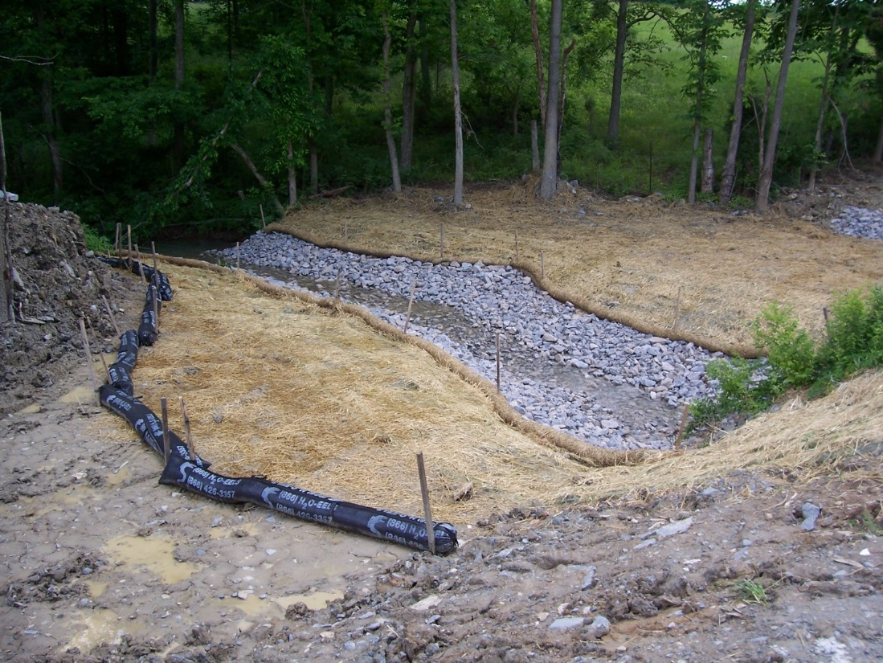
Riprap lined channel where water velocity is highest. Note alternative erosion control mats on either side of channel. (Source: Tetra Tech)

Permit applicability
Riprap as a stabilization measure
Riprap is often used for stabilization for construction sites. Section 25.30 of the MPCA Construction Stormwater General Permit (2018) defines stabilization and specifically identifies riprap as an appropriate stabilization measure, stating: “’Stabilize’, ‘Stabilized’, ‘Stabilization’ means the exposed ground surface has been covered by appropriate materials such as mulch, staked sod, riprap, erosion control blanket, mats or other material that prevents erosion from occurring. Grass seeding, agricultural crop seeding or other seeding alone is not stabilization. Mulch materials must achieve approximately 90 percent ground coverage (typically 2 ton/acre).”
Because stabilization is required and essential for most construction activities, it is mentioned numerous times throughout the 2018 Permit. While “riprap” is not specifically mentioned in these instances, it is implicitly included due to its widespread acceptance as an effective stabilization practice. As noted above, before using riprap the site manager should check with the design engineer to ensure that the post-construction configuration includes riprap prior to its installation. In many cases it may be far less expensive to install the post-construction vegetation with whatever stabilization matrix is called for (e.g., turf reinforcement mat, articulated concrete mat, geogrid, etc.) during construction, rather than having to place and then later remove riprap. Several key locations in the permit that mention stabilization are noted below.
- (Erosion Prevention Practices) Section 8.4 states: “Permittees must stabilize all exposed soil areas, including stockpiles. Stabilization must be initiated immediately to limit soil erosion when construction activity has permanently or temporarily ceased on any portion of the site and will not resume for a period exceeding 14 calendar days. Stabilization must be completed no later than 14 calendar days after the construction activity has ceased. Stabilization is not required on constructed base components of roads, parking lots and similar surfaces. Stabilization is not required on temporary stockpiles without significant silt, clay or organic components (e.g., clean aggregate stockpiles, demolition concrete stockpiles, sand stockpiles) but permittees must provide sediment controls at the base of the stockpile.”
- (Erosion Prevention Practices) Section 8.5 states: “For Public Waters that the Minnesota DNR has promulgated "work in water restrictions" during specified fish spawning time frames, permittees must complete stabilization of all exposed soil areas within 200 feet of the water's edge, and that drain to these waters, within 24 hours during the restriction period.”
- (Erosion Prevention Practices) Section 8.6 states: “Permittees must stabilize the normal wetted perimeter of the last 200 linear feet of temporary or permanent drainage ditches or swales that drain water from the site within 24 hours after connecting to a surface water or property edge. Permittees must complete stabilization of remaining portions of temporary or permanent ditches or swales within 14 calendar days after connecting to a surface water or property edge and construction in that portion of the ditch temporarily or permanently ceases.”
- (Discharges to Special and Impaired Waters) Section 23.9 states: “Permittees must immediately initiate stabilization of exposed soil areas, as described in item 8.4, and complete the stabilization within seven (7) calendar days after the construction activity in that portion of the site temporarily or permanently ceases.”
Riprap as an energy dissipation measure
In additional to stabilization, riprap is also used as an energy dissipation measure to reduce the erosive force of concentrated stormwater and prevent scour. Section 25.8 of the MPCA Construction Stormwater General Permit (2018) defines energy dissipation as “methods employed at pipe outlets to prevent erosion caused by the rapid discharge of water scouring soils.” Energy dissipation is mentioned at several locations in the Permit:
- (Erosion Prevention Practices) Section 8.9 states: “Permittees must provide temporary or permanent energy dissipation at all pipe outlets within 24 hours after connection to a surface water or permanent stormwater treatment system.”
- (Temporary Sediment Basins) Section 14.7 states: “Permittees must provide energy dissipation for the basin outlet within 24 hours after connection to a surface water.”
- (Wet Sedimentation Basin) Section 18.6 states: “Permittees must design basin outlets to prevent short-circuiting and the discharge of floating debris. Basin outlets must have energy dissipation.”

Effectiveness
When properly designed and installed riprap can be an effective erosion control practice for armoring slopes and channel banks. When used as a containment berm (e.g., as a sediment trap), riprap can help to control sediment. The following table provides information on the expected performance benefits for riprap when used for erosion control.
Expected performance benefits for riprap
Water Quantity
Flow attenuation | Little or no design benefit
Runoff volume reduction | Little or no design benefit
Water Quality
Pollution prevention
Soil erosion | Primary design benefit
Sediment control | Little or no design benefit
Nutrient loading | Little or no design benefit
Pollutant removal
Total suspended solids | Little or no design benefit
Total phosphorus | Little or no design benefit
Heavy metals | Little or no design benefit
Floatables | Little or no design benefit
Oil and grease | Little or no design benefit

Planning considerations
Riprap is often required in places that are not easy to get to, yet it is often the really tough places to reach that experience riprap failure (MnDOT, 2006). The following considerations are essential when planning riprap installation for a construction site:
- Riprap should be placed as soon as possible after site disturbance begins before additional water is concentrated into the drainage system.
- When designing riprap systems, well-graded riprap should be used rather than uniform riprap because it will form a dense and flexible cover that can adapt well, even on uneven surfaces. Uniform riprap also requires more intensive labor to install compared to graded riprap.
- Use the appropriate size rock for the discharge or flow velocity. If in doubt, go with larger rather than smaller. Water will carry away rock that is not sufficiently sized.
- Make sure that the rock is angular and variably sized. Along with the largest diameter needed for the flow rate of the discharge, include enough small, sharp-edged rock to lock the large rock in place.
- Riprap should always be underlain by a filter material consisting of granular material or a nonwoven geotextile fabric to prevent underlying soil from “piping” through the riprap stone. The bedding or geotextile fabric must be sized properly in order to prevent erosion or undermining of the underlying soils. If filter material is not used, the rock will become buried in the soil on which it was placed.
All of these considerations are discussed in greater detail in Design and Construction recommendations and specifications.
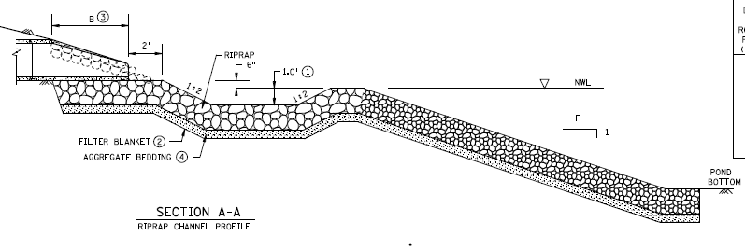
Profile of a riprap lined channel to stormwater pond with a slope of 2:1. Channel is lined with a non-woven geotextile blanket and aggregate bedding prior to the layer of riprap. (Source: MnDOT)

Design
Under sizing riprap could greatly reduce its effectiveness. Follow MnDOT standards and specifications on riprap size and quality to ensure maximum effectiveness (see Construction recommendations and specifications). The following design recommendations apply to riprap.
Site preparation
Before laying riprap, filter material should be placed on a prepared surface in accordance with site plans unless otherwise required by the contract. The foundation surface should be relatively smooth and free of stones, sticks, or other debris. Filter material can be either granular filter or nonwoven geotextile filter, unless specified in the contract. The primary function of a filter material or filter fabric is to prevent soil from “piping” through the riprap stone.
If using granular material, spread the filter material to a minimum thickness of at least 6 inches over the prepared foundation. If using a geotextile, ensure that the fabric liner is pulled taut with no folds or creases before anchoring in place (if needed) with stables or anchor pins. To prevent water from flowing beneath fabric, overlap edges by at least a foot and a half in the downhill or downstream direction. Riprap should be placed over the geotextile fabric no later than seven (7) days after the fabric is laid. Avoid tearing, puncturing, or shifting the fabric and do not operate equipment on top of the geotextile or stones after placement. Geotextile filter material should not be used under hand placed or grouted riprap unless required by the contract.
If placing geotextile on slopes steeper than 3:1 (horizontal to vertical), anchor the geotextile in consecutive trenches on the contour at least every 15 feet. Geotextile should not be used on slopes exceeding 2:1 (horizontal to vertical).
Riprap sizing
Random riprap consists of various sizes of stone that produce a dense, uniform, stable layer of stone with no large voids. Large individual stones may measure up to 2 cubic ft and weigh 50 lbs or more. There is no minimum weight for smaller stones required for filling in between these individual stones. Use of the smaller rock prevents undercutting and erosion by flowing water, and helps to keep the larger rock in place.
Stone selected for riprap installations must meet MnDOT Specifications 3601 (Riprap Material), including the following:
- Each individual stone has at least one fractured face;
- Free of soil or other debris before placement;
- Contains less than ten (10) percent of the following by weight:
  - Stones with defects that could cause excessive deterioration or degradation during service such as cracks or seams;
  - Stone with a width or thickness less than thirty (30) percent of the length;
- If using carbonate quarry/bedrock material used in total or in part, the portion of the insoluble residue passing the #200 sieve is no greater than 10 percent; and
- 100% virgin materials must be used for riprap and granular filter.
Riprap sizing should also account for the expected velocity of water. The table below provides recommended sizing of riprap rock based on velocity.
Riprap size will increase with velocity. Maximum riprap rock size in diameter for different velocities. (Source: Adapted from New York State Standards and Specifications for Erosion and Sediment Control, 2016).
Rock riprap maximum size based on velocity of flow
Velocity (feet per second) | d_{max} (inches)
5.0 | 6
8.5 | 12
10 | 18
12 | 24
15 | 36

Additional information on riprap sizing for energy dissipation can be found here: Sediment control practices – outlet dissipation
Riprap placement
When placing stones, care should be taken to not puncture the base fabric. Drop stones from a height not exceeding one (1) foot unless the base fabric is sufficiently covered with granular cushion (about 6 inches deep) in which case stones can be dropped up from a height of up to three (3) feet. Riprap should be placed starting at the lowest elevation and working upwards.
Random riprap should be position in such a way as to provide a uniform distribution of the various sizes of stone and to produce a dense, interlocked layer of stones. After placement, the surface of the riprapped area should be leveled to be flush with the surrounding ground to produce a reasonably uniform appearance and the thickness required by the contract.
For hand-placed riprap, embed the stones in the foundation material, with the axis of the stone that most nearly approximates the contract-required thickness of riprap laid perpendicular to the foundation slope. Lay stones with the least practicable space between them. Position the stones to stagger the joints up the slope. Place each stone to allow the foundation material and adjacent stones to carry its mass. Use selected stones set to line and grade to define the ends and edges of each riprap area. After laying the larger stones, fill the spaces between the stones with firmly seated, smaller stones to produce a uniform surface.
For fully grouted riprap, use clean stone and, ensure grout fills the spaces between stones throughout the entire thickness of the riprap. Stones should be thoroughly wetted immediately before placing the grout, and the surface should be swept with a stiff broom after pouring grout to finish. (See https://www.dot.state.mn.us/bridge/hydraulics/resources/matrixriprapsummarysheet.pdf for further information on grouted riprap).
After placing riprap, ensure that each riprapped area has a minimum thickness of at least eighty (80) percent of the thickness per the contract requirements, and an average of at least ninety-five (95) percent of the thickness when measured at right angles to the face.
The Construction recommendations and specifications discussed in the next section elaborate on these design recommendations.
While the use of riprap to armor high-velocity channels provides superior erosion protection in most cases, there are notable non-stormwater drawbacks in some situations. For example, riprap extending from the waterline of a channel or lake up to a structure (e.g., roadway, bridge, bulkhead, building, etc.) can block normal wildlife movement along the water’s edge. This situation can create a hazard to wildlife and to vehicle traffic, if deer and other animals are forced out onto a roadway. Riprap may also be undesirable aesthetically in some settings, due to the “hard” look of large chunks of rock where vegetation normally would be found, such as along a channel bank or lakeshore.
The strategic use of mulch, compost, topsoil, and vegetation in the final design can ameliorate these concerns. Transportation engineers in Minnesota have been successfully incorporating wildlife passage benches [LINK TO https://www.dot.state.mn.us/d7/projects/hwy22mapleton/passage-bench.pdf] through sections of riprapped slope, using these materials to construct a walkable pathway in places where riprap may create a migration obstacle (e.g., under bridges). The passage bench resembles a hiking trail cutout on a slope. Mulch, compost, and topsoil is placed over the riprap walkway bench to ease the passage of animals over the rock. Where large rock may create voids that are difficult to fill with organic materials, smaller rock and geotextile can be used to create a base.
A similar approach can be used where aesthetical concerns regarding riprap may be present. Mulch, compost, and topsoil can be sprinkled and spread liberally above the normal waterline in the riprap to support the type of planted or emergent vegetation usually found along channels and lakeshores. After a few years of growth, the vegetation will begin to soften and even obscure the look of the riprap – and even help to hold it in place, against the shear stress of moving water and wave action. This approach can be employed on conventional riprap applications and where rock-filled gabion baskets are used.

Construction recommendations and specifications
Riprap
The MnDOT Standard Specifications for Construction (2018 Edition) include several specifications related to riprap.
MnDOT Specification 2511 is dedicated entirely to riprap; specifically, (2511.1) “providing and placing stone riprap, with or without grouting, as a protective covering on earth slopes, piers, abutments, walls, or other structures, where the soil is susceptible to erosion.” Further, “The Department classifies riprap by type as random riprap or handplaced riprap, depending on the method of placement and the stone size specified.”
MnDOT Specification 2511 Part A includes guidance for placement of riprap, stating: “Provide and place stone riprap as shown on the plans or as directed by the Engineer. Excavate and shape the foundation for the riprap, with or without filter material, to the cross-sections as shown on the plans, unless otherwise directed by the Engineer. Compact loose foundation material before placing the riprap or filter material. If the contract requires, place a layer of riprap at least a 1 ft thick on a filter material, unless otherwise required by the contract or directed by the Engineer. Grout riprap as required by the contract or as directed by the Engineer. Place the riprap on a filter layer consisting of granular material or geotextile. Fully grouted riprap is not allowed in public waters.”
MnDOT Specification 2511 Part B discusses placement of filter material under riprap, stating: “Place filter material under the riprap unless otherwise required by the contract. The Contractor may choose the type of filter material, except as required by the contract.” Per Part B, filter material may either be granular or geotextile material. Parts B.1 (Granular Filter) and B.2 (Geotextile Filter) provide detailed guidance on proper placement, dimensions, and applicable site conditions for the use of granular filter or geotextile filter materials in conjunction with riprap. In all cases, ensure that the geotextile underlayer is properly staked to the slope in accordance with manufacturer’s recommendations to ensure it remains in place as the stone is installed.
MnDOT Specification 2511 Part C provides detailed guidance for placement of riprap stone, including Random Riprap (Part C.1) and Hand-Placed Riprap (Part C.2). Further, Part D describes proper procedures for grouting riprap, and Part E provides guidance on required thickness when placing riprap.
MnDOT Specification 2511.4 prescribes “method of measurement” related to riprap. Part A (Riprap) states: “If measuring riprap of each type and class by volume, the Engineer will calculate the volume based on the actual surface dimensions as staked and the thickness shown on the plans or specified in the special provisions. If measuring riprap of each type and class by mass, the Engineer will calculate the mass based on scale tickets of materials delivered and placed within the staked areas.” Further, Part B (Filter Materials) states: “If measuring filter materials by weight, the Engineer will calculate the weight based on scale tickets of material delivered and placed within the staked areas. If measuring filter materials by volume, the Engineer will calculate the volume based on the actual surface dimensions as staked and the thickness as shown on the plans. The Engineer will measure geotextile filter material by area based on the actual surface dimensions as staked, with no allowance for overlaps or seams.”
MnDOT Specification 2511.5 prescribes “basis of payment” related to riprap, stating: “The contract unit price for riprap of each type and class includes the cost of providing the materials, excavating and preparing the foundations, and placing the riprap stone, grouting, and filter materials as required by the contract. The Department will pay for filter materials of the type specified, if included in the contract.” Further, 2511.5 states that payment by the Department for riprap and filter material will be based on the following schedule:
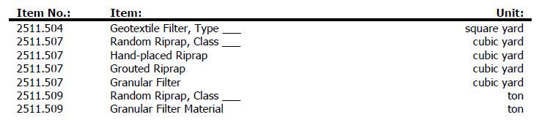
The relevant specifications noted above in 2511.4 (Method of Measurement) and 2511.5 (Basis of Payment) are important when considering cost implications of these practices, discussed further below.
Riprap material
MnDOT Specification 3601 provides materials specifications for “riprap material,” including (3601.1) “stone and filter layer material for use in random or hand-placed riprap, gabion, and revet mattress construction.” Specification 3601.2 Part A.1 provides specifications related to quality of riprap stone, stating: “Provide stone of the quality approved by the Department and meeting the following requirements:
- Each individual stone has at least one fractured face.
- Is free of soil or other debris before placement.
- Contains less than 10 percent of the following by weight:
  - Stones with defects that could cause rapid or excessive deterioration or degradation during service, such as cracks or seams;
  - Stones with a width or thickness less than 30 percent of the length.
- For carbonate quarry/bedrock material used in total or in part for riprap, the portion of the insoluble residue passing the #200 sieve is no greater than 10 percent.
- Use 100% virgin materials for riprap and granular filter.
To determine suitable quality of stone, [MnDOT] may consider the results of laboratory tests, the performance of the stone under natural exposure conditions, the performance of the riprap from the same or similar geological formations or deposits, or other tests or criteria.”
MnDOT Specification 3601 Part A.2.a provides guidance for random riprap by referring the user to Table 3601-1, which outlines gradation requirements for random riprap.
MnDOT standard riprap gradations (Source: adapted from MnDOT (2018) Table 3601-1)
Weight |  | Size |  | Approximate Percent of Total Weight Smaller than Given Weight
lb | kg | in | mm | Riprap Class
 |  |  |  | I | II | III | IV | V
2,000 | 900 | 30 | 750 | – | – | – | – | 100
1,000 | 450 | 24 | 600 | – | – | – | 100 | –
650 | 300 | 21 | 525 | – | – | – | – | 75
400 | 180 | 18 | 450 | – | – | 100 | – | –
250 | 113 | 15 | 375 | – | – | – | 75 | 50
120 | 55 | 12 | 300 | – | 100 | 75 | 50 | –
50 | 22 | 9 | 225 | – | 75 | 50 | – | –
15 | 7 | 6 | 150 | 100 | 50 | – | – | 10
5 | 2 | 4 | 100 | – | – | – | 10 | –
2 | 1 | 3 | 75 | 50 | – | 10 | – | –
– | – | 2 | 50 |  | 10 | – | – | –
– | – | 1 | 25 | 10 | – | – | – | –

MnDOT Specification 3601 Part A.2.b describes requirements for hand-placed riprap, stating: “Provide individual stones with a weight of at least 50 lb. The Department will not require a minimum weight for smaller stones required for filling in the narrow openings between individual stones (chinking).”
MnDOT Specification 3601 Part B provides guidance for filter material to be used in conjunction with riprap. Per Part B.1.a, granular filter material to be used under Class I random riprap shall meet the Class 5 gradation requirements of Table 3138-3, and granular filter material to be used under other riprap shall meet the requirements of Table 3601-2.
MnDOT specifications for granular filter material under Class I random riprap (Source: adapted from MnDOT (2018) Table 3138-3)
Granular Filter Material Under Class I Random Riprap
Sieve Size | Percent Passing by Weight
2 inch | –
1 ½ inch | 100
1 inch | –
¾ inch | 70 – 100
⅜ inch | 45 – 90
No. 4 | 35 – 80
No. 10 | 20 – 65
No. 40 | 10 – 35
No. 200 | 3 – 10

MnDOT specifications for granular filter material under all other riprap (Source: adapted from MnDOT (2018) Table 3601-2)
Granular Filter Material Under All Other Riprap
Sieve Size | Percent Passing by Weight
6 inch | 100
3 inch | 75 – 95
1 inch | 35 – 75
No. 4 | 10 – 40
No. 10 | 5 – 25
No. 40 | 0 – 10
No. 200 | 0 – 5

Per MnDOT Specification 3601 Part B.2, geotextile filter to be used with riprap shall meet the requirements of Specification 3733. MnDOT Specification 3733.1 notes the following regarding use of geotextiles under riprap:
- Use Type 3 under Class I and Class II random riprap
- Use Type 4 under Class III and Class IV random riprap and hand-placed riprap on slopes no steeper than 3:1, horizontal to vertical
- Use Type 7 under Class III and Class IV random riprap on slopes steeper than 3:1, horizontal to vertical, and under Class V random riprap
Geotextile Types 3 and 4 must meet the following specifications, per 3733.2.B:
MnDOT specifications for geotextile under riprap (Source: adapted from MnDOT (2018) Table 3733-1)
Geotextile Properties for Use Under Riprap
Geotextile Property | Test Method (ASTM) and Units | Type 3 (under Class I and Class II random riprap) (a) | Type 4 (under Class III and Class IV random riprap and hand-placed riprap, slopes up to 3:1) (a) | Type 7 (under Class III and Class IV random riprap, slopes > 3:1) (a)(b)
B1 Grab Tensile Strength minimum, each principal direction | D4632 lb | 100 | 200 | 300
B2 Elongation minimum, each principal direction | D4632 percent | 50 | 50 | 50
B3 Seam Breaking Strength minimum (c) | D4632 lb | 90 | 180 | 270
B4 Apparent Opening Size (AOS) maximum (d) | D4751 U.S. Std. sieve size | 50 | 50 | 50
B5 Permittivity minimum (e) | D4491 falling head sec⁻¹ | 0.5 | 0.5 | 0.5
B6 Puncture strength minimum | D6241 lb | – | – | –
B7 Wide Width Strip Tensile Strength minimum each principal direction | D4595 lb/ft | – | – | –
(a) Minimum Average Roll Values (MARV) based on average of at least three tests per swatch.
(b) Needle-punched nonwoven. Do not use thermally bonded (heat-set) fabric.
(c) Adhere to this requirement if the contract requires or allows seams. Strength specifications apply to factory and field seams. Use thread for sewing that has strength of at least 25 lb . Sew seams with a Federal Type 401 stitch using a two-spool sewing machine, and install seams facing upward. For seaming with adhesives, see the Approved/Qualified Products List available at the Department’s website.
(d) For U.S. sieve sizes, the AOS Number must be equal to or greater than the number specified.
(e) Permittivity: P = K/L, where K = fabric permeability and L = fabric thickness.

Refer to MnDOT Specification 3733 for additional requirements pertaining to use of geotextile under riprap (pages 655-658).

Inspection and maintenance
In general, riprap should be inspected after high flows to ensure deficiencies are identified and corrected early. Recommended inspection and maintenance activities for riprap include the following:
- Confirm that the riprap type and dimensions are consistent with the design specifications.
- Inspect the riprap for dislodged stones for filter materials.
- Replace rock or other components that have become dislodged.
- Immediately repair damages to geotextile fabric.
- Inspect riprap systems for signs of erosion and scour or sediment accumulation.
- Remove accumulated material including sediment, trash, and woody debris from riprap.
- If riprap stones continue to wash away, consider replacing them with larger stones.

Costs
Riprap costs are typically much higher than other forms of erosion control. The following table summarizes estimated BMP costs based on MnDOT data summarizing average bid prices for awarded projects in 2017.
Unit costs related to riprap (Source: MnDOT 2017 Average Bid Prices)
Bid Item | Item Description | Units | Average Price
2511501/00010 | Random riprap Class Special | cubic yard | $39.00
2511501/00011 | Random riprap Class I | cubic yard | $64.10
2511501/00012 | Random riprap Class II | cubic yard | $74.82
2511501/00012 | Random riprap Class II | ton | $38.20
2511501/00013 | Random riprap Class III | cubic yard | $66.12
2511501/00013 | Random riprap Class III | ton | $51.50
2511501/00014 | Random riprap Class IV | cubic yard | $65.27
2511501/00014 | Random riprap Class IV | ton | $47.09
2511501/00015 | Random riprap Class V | cubic yard | $71.64
2511505/00010 | Hand-placed riprap | cubic yard | $750.00
2511604/00200 | Articular concrete riprap | square yard | $75.51
2511607/00011 | Random riprap special | cubic yard | $47.33
2511607/00012 | Random riprap (matrix) | cubic yard | $465.25
2511607/00120 | Install random riprap | cubic yard | $47.00

Reference materials
Except where more stringent requirements are presented in this guidance, BMPs shall comply with MnDOT and other state requirements. Primary design references include:
- MnDOT Erosion Control Handbook II
https://www.dot.state.mn.us/environment/erosion/pdf/2006mndotecfieldhandbook.pdf
- 2018 Minnesota NPDES/SDS Construction Stormwater General Permit
https://www.pca.state.mn.us/water/construction-stormwater
- 2018 MnDOT Standard Specifications for Construction
http://www.dot.state.mn.us/pre-letting/spec/
The following is a list of additional resources that are not specific to Minnesota:
- Iowa Statewide Urban Design and Specification (SUDAS) Design Manual (2013) (Chapter 7E-10)
http://www.iowasudas.org/manuals/manual.cfm?manual=design
- Massachusetts Erosion and Sediment Control Guidelines for Urban and Suburban Areas: A Guide for Planners, Designers, and Municipal Officials (2003)
http://prj.geosyntec.com/npsmanual/riprap.aspx
- New York State Standards and Specifications for Erosion and Sediment Control (2016)
https://www.dec.ny.gov/docs/water_pdf/2016nysstanec.pdf

