REPORT

Summary of Green Roof Water Quality Benefits (See also Task 2)

Beck summarizes the water quality benefits of green roofs as follows:

“Rainwater flowing off conventional roofs has been shown to pick up pollutants from both the roof substrate and from atmospheric deposition and to transport these pollutants off the rooftops (Ammann et al., 2003; Van Metre and Mahler, 2003). Conventional rooftop runoff has been shown to exceed drinking water guidelines (Meera and Ahammed, 2006), and particle-bound contaminants in runoff from
conventional roofs are suspected to contribute to sediment toxicity in receiving water bodies (Van Metre and Mahler, 2003). Metal rooftops have been shown to be a source of cadmium and zinc, and asphalt shingles have been shown to be a source of lead in runoff water (Thomas and Greene, 1993; Van Metre and Mahler, 2003). Polyaromatic hydrocarbons have been observed in runoff water from several roofing materials, which may indicate that roofs collect atmospheric deposition that is then transported
by the runoff water (Gadd and Kennedy, 2001; Van Metre and Mahler, 2003).

The water quality of runoff from greenroofs is typically thought of as being of better quality than stormwater runoff from conventional roofs. Notable exceptions are water-soluble nutrients and metals attached to soil particles that the water has taken up as it travels through the greenroof soil matrix.”

While many research studies have found an increase in phosphorus in green roof runoff compared to conventional roofs, several have found green roofs to be beneficial even for phosphorus reduction.

According to Kohler and Schmidt, “Green Roofs can be very effective as method for improving water quality. A recent study in Charlotte, North Carolina, showed that in addition to heavy metal pollutants, 10-30 percent of nitrogen and phosphorus pollutants contributed to streams and lakes are derived from runoff from urban roofs. These pollutants are the principal culprits in degrading aquatic habitat. Dust containing a range of pollutants accumulates on roofs until it is washed off with next rainfall.”

Phosphorus

Summary

Much research has been conducted in recent years on the effects of green roofs on phosphorus runoff concentrations. While many research studies have found an increase in phosphorus in green roof runoff compared to conventional roofs, several have found green roofs to be beneficial even for phosphorus reduction. Many of those that do show green roofs leaching phosphorus found that the amount phosphorus leached decreased with time. The ones that do not leach phosphorus are generally older roofs that are not fertilized.

Berndtsson’s (2010) literature review of green roof water quality benefits concluded the following regarding green roofs and phosphorus:

“Precipitation water generally contains phosphorus in very small concentrations. Urban runoff may be contaminated by phosphorus originating in, for instance, fertilizers used in urban gardening,
birds’ droppings, and animals’ excreta. Green roofs established with soil that is enriched with nutrients (in the form of compost or addition of artificial fertilizer) and green roofs that are being fertilized
are commonly a source of phosphorus (Bliss et al., 2009; Czemiel Berndtsson et al., 2006; Monterusso et al., 2004; Moran et al., 2005; Teemusk and Mander, 2007). Some studies find that almost all released phosphorus is in the form of phosphates and that there are examples of green roofs which do not show release of phosphorus (Czemiel Berndtsson et al., 2006; Czemiel Berndtsson et al., 2009). Others find that concentrations of total phosphorus in green roof runoff water are significantly higher than concentrations of phosphate phosphorus (Teemusk and Mander, 2007). Köhler et al. (2002) conclude that, regarding the phosphates, the loads reduction is dependent on the water volume reduction within the green roof. They also observe that the reduction of phosphate phosphorus load increases with time. During four consequent years Köhler et al. (2002) observed the following annual degrees of reduction of phosphate phosphorus load: 26%, 61%, 64%, and 80%. This is attributed to the vegetation development but may also be linked to the age of the roof and the subsequent annual loss of phosphorus from the
soil. Thus phosphate leakage from a green roof can be linked to the roof age and fertilization routines.” [see summary of Kohler et al 2002 below for more detail on that publication]

Above is from Berndtsson, J. C. (2010). “Green roof performance towards management of runoff water quantity and quality: A review.” Ecological Engineering, 36, 351 – 360.

Literature Review

A representative sampling of studies on the effects of green roofs on phosphorus runoff concentrations is summarized below.

To keep the results of the following studies in perspective, consider that The Minnesota Stormwater Manual (MPCA, 2008), currently uses the following EMC’s:

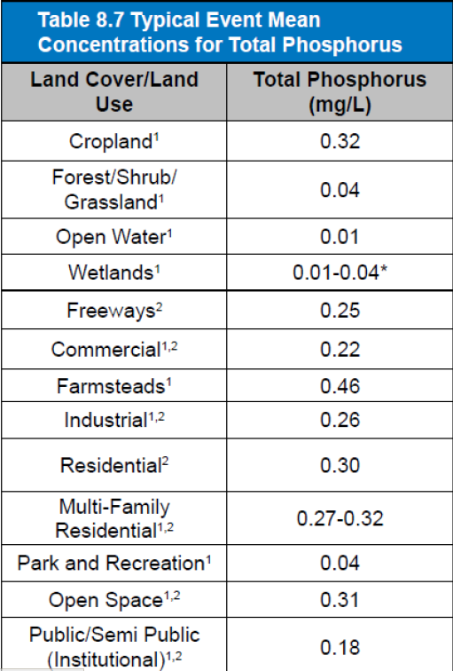

Phosphorus concentrations in rainfall and in runoff from conventional roofs are generally low compared to the EMC’s for developed land uses. For example:

- Toland et al (2012) found runoff concentrations from conventional roofs (sloped metal roof, flat bitumen roof, and sloped asphalt roof) to vary between 0.03 and 0.04 mg/L.
- Hunt et al found TP in rainfall to be an average of 0.024 mg P/L in Asheville, NC.

Carpenter, D.D., Kaluvakolanu, P. 2011. Effect of roof surface type on stormwater run-off
from full-scale roofs in a temperate climate. Journal of Irrigation and Drainage
Engineering 137:161-169.

- “The study location (Southfield, Michigan) is in a northern temperate climate with four distinct seasons. The average winter temperature in Southfield is 27.5°F, and the average summer temperature is 71.6°F (NOAA 2004). The area receives approximately 85.3 cm of precipitation annually, with a 2-year 24-hour storm producing 14.6 cm of rainfall, and a 100-year 24-hour storm producing 28.1 cm (Huff and Angel 1992).”
- Compared runoff from 153 m² asphalt, 84.7 m² gravel ballasted, and 325.2 m² extensive green roofs.
- Planted in 2005 with 7 species of Sedums, irrigated for 2 years, then irrigation was discontinued. Monitored water quality in 2008.
- 10.16 cm deep growing medium with less than 6% organic matter by weight.
- Longest green roof flow path: 20.7 m
- Green roof slope (V:H): 1:24
- “With regard to water quality, there was significant variability between individual rainfall events, and the nutrient removal and water-quality performance portion of the investigation is inconclusive. However, the data provide some indication that a green roof could be effective at reducing nutrient and solid loadings.”
- Total phosphate:
- Monitored 5 water quality events with rainfall greater than 1.27 cm in a 24 hour period.
- Total phosphate concentrations of the green roof were lower than those of the asphalt and gravel roof, but not at the p = 0.05 significance level.
- Asphalt and green roof exhibited higher total phosphate mass than the gravel roof – BUT green roof was 2.12 times as big as asphalt roof and 3.84 times as big as gravel roof: Mass per unit area was 0.00575 g/m2 for asphalt roof; 0.00194 g/m2 for green roof; and 0.00059 g/m2 for gravel roof.

U.S. Environmental Protection Agency, 2009. Green Roofs for Stormwater Runoff
Control. EPA-600-R-09-026. USEPA, Washington, DC.

- “Runoff from three green roofs, two flat-asphalt control roofs, and one roof divided between detention and a green-roof system without plants, was collected in rain barrels and sampled for various water constituents following various precipitation events at the Penn State Green Roof Center, University Park, PA.”
- Samples from 5 precipitation events were analyzed for phosphorus.
- “Phosphorous (P) concentration and loading in runoff from all five sampled precipitation events was higher from the green than the flat asphalt roofs.
- “Runoff phosphorous concentration from the media roof section was higher than either green or flat asphalt roof runoff, mainly due to a very high concentration in the first event sampled (March 28, 2005; 2.53 mg/L). It is likely that this was due to the media being less than a year old. For the other measured events, phosphorous concentrations were similar for green and media roofs.”
- “The average concentration of phosphorous 0.41 mg/L (CV = 0.45) in green roof runoff (Table 4-3) compares well to the total phosphorous event mean concentration (EMC) reported for landscaped residential areas by the National Urban Runoff Program (NURP) studies (EPA, 1983) 0.383 mg/L (CV = 0.69) and the National Stormwater Quality Database (Pitt et al., 2004), 0.30 mg/L (CV = 1.1).”

Hunt, W.F., A.M. Hathaway, J.T. Smith, J. Calabria. 2006. Choosing the Right Green Roof Media for Water Quality. Greening Rooftops for Sustainable Communities Conference, Boston, 2006 Proceedings.

Field studies in Raleigh, NC and Asheville, NC.

Raleigh:
- Size: 1400 s.f. green roof adjacent control roof
- Slope: 7%
- Vegetation: succulents (Sedum and Delosperma)
- Growing Medium: average soil depth 4 inches
- Monitored for portions of 2 years.
- Phosphorus leached out of growing medium; leaching did not decrease with time over the duration of the 2 year experiment

Asheville, NC:
- Size: 2800 s.f.
- Pitch: 3.5 to 12
- Used 2 revised media composed of lower percentages of compost (10%), and yard waste instead of cow manure
- Growing Medium:
- Average depth 4 inches
- growing medium on half roof: Carolina Stalite: 80% expanded slate, 10% sand, 10% organic matter (yard waste – grass clippings)
- growing medium on other half of roof: ERTH products (80% expanded clay, 10% sand, 10% organic matter - biosolids surrounding peanut hulls)
- Monitored six rain events between July 2004 and November 2005
- Effluent TP concentration of both growing media was much lower than in Raleigh, NC, and 2 other North Carolina green roofs, but still higher than TP in rainfall. Effluent from Stalite growing media with yard waste compost had significantly lower TP than that from ERTH growing medium with biosolids compost (see table). Average green roof TP in mg P/L for Stalite green roof was lower than TP EMC for cropland, freeways, commercial, industrial, residential, multi-family residential, and open space in 2008 MN Stormwater Manual.



Berghage, R. D. Beattie, A. Jarret, and T. O’Connor. 2007. Greenroof Runoff Water quality. In: Greening Rooftops for Sustainable Communities, Minneapolis, 2007, Proceedings:

Monitored 5 green roof test plots on small buildings at the Center for Green Roof Research at Rock Springs, PA from January 2005 to May 2006.

Sampled precipitation events ranged from 0.07 in. on 3/4/05 to 3.2 in. on 10/8/05.

Total precipitation from the sampled storms was 16.15 in.

Sampled events included rain, snow and freezing rain.

“Concentration of phosphorous, potassium, calcium and magnesium in runoff from green roofs was higher than from non-greened flat roofs. Total loading for these nutrients was also greater from green than non-green roofs. For example figures 7 and 8 show results for P and K, Ca and Mg were similar. Although concentration was consistently greater in runoff from green roofs, most of the difference in total loading resulted from one event early in the measurement period in the spring. Loadings from events in the summer were for the most part not different between green and non-green roofs. It is likely that nutrient leaching from green roofs follows a seasonal leaching pattern similar to that observed in agricultural fields related to plant growth, water and nutrient uptake, and biomass turnover.”
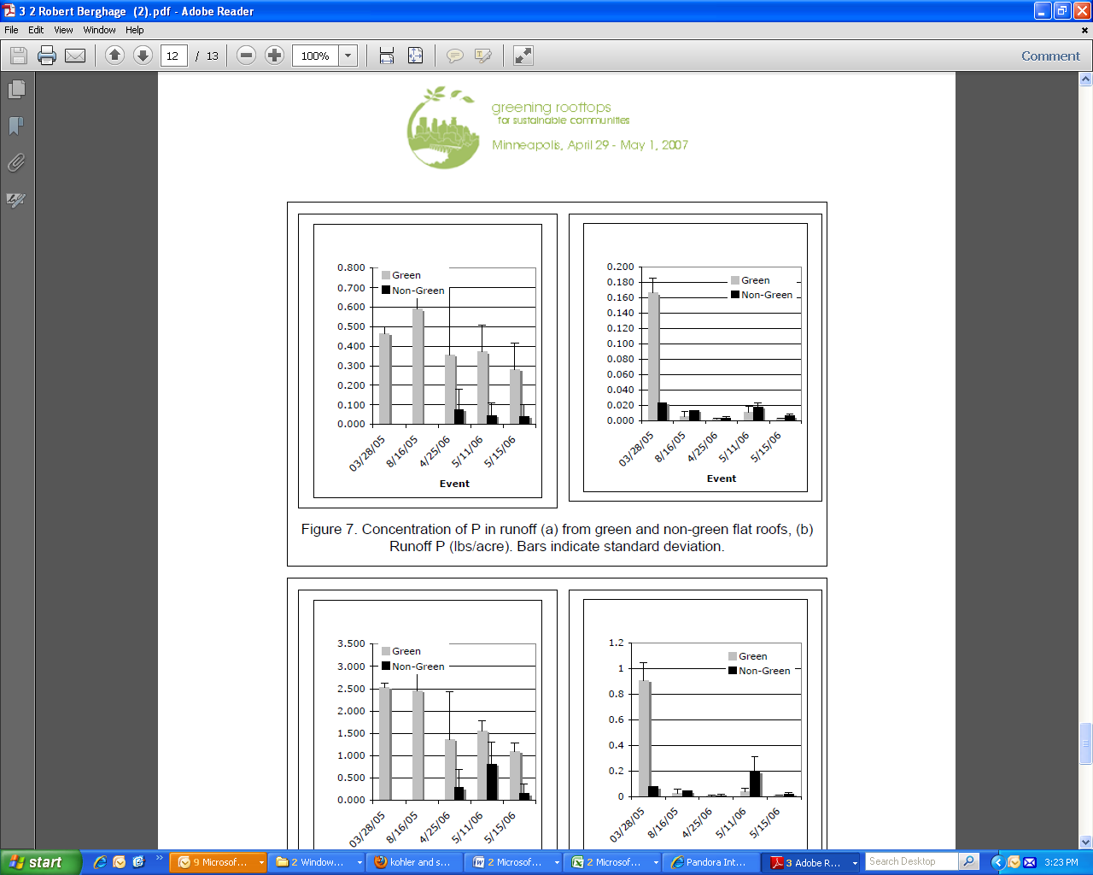

Berndtsson, J.C., L. Bengtsson, K. Jinno. 2009. Runoff water quality from intensive and extensive vegetated roofs. Ecological Engineering 35: 369-380:

Monitored 2 roofs: 1 extensive and 1 intensive

Extensive green roof: Malmo, Sweden
- Average annual precipitation: 600mm
- Vegetation: prefabricated sedum-moss vegetation layer
- Growing Medium: 3-cm deep; made of crushed lava, natural calcareous soil, clay, and
shredded peat; organic content in the soil is 5%
- Slope: 2.6%
- Fertilization: fertilized spring 2001 and spring 2002;
- Monitoring: monitored 4 precipitation events during May-June 2005

Intensive green roof: Fukuoka City, Japan
- Average annual precipitation: 1600mm
- Vegetation: more than 70 species; dominated by trees and shrubs
- Growing Medium: 0.4 m deep; Aquasoil; artificial inorganic lightweight soil made of perlite.
- Monitoring: monitored 5 precipitation events during November 2005 and April 2006

Results from both roofs:

Phosphorus release is observed from the extensive vegetated roof (primarily as phosphate), but not from the intensive vegetated roof

“Release of phosphorus was observed from the extensive roof S, most of it in the form of PO4–P. In contrast, the intensive vegetated roof showed no release of phosphorus (Fig. 4). The probable source of phosphorus to runoff water from the extensive vegetated roof S is fertilizer used in previous years
and phosphorus available from the roof soil. Recall that the latest recorded fertilization took place 2 years before the sampling. Also, Moran et al. (2005) showed substantial release of Tot-P from two studied vegetated roofs in North Carolina, USA. Tot-P concentrations as found by Moran et al. (2005)
varied between 0.6 and 1.5 mg/l with an average about 1mg/l, which is three times more than found in our study for the roof S. The rainfall concentrations registered by Moran et al. (2005) were about 0.05 mg/l comparing to 0.02 mg/l (Sweden) and 0.01 mg/l (Japan) found in our study. According to Moran et al. (2005), phosphorus in runoff originated from the soil nutrients which contained compost material. Mason et al. (1999) in their study of roof runoff infiltration through soil showed that PO4–P behaved conservatively during infiltration... It can be concluded that phosphorus release from vegetated roofs can be linked to use of fertilizer and the composition of soil material.”

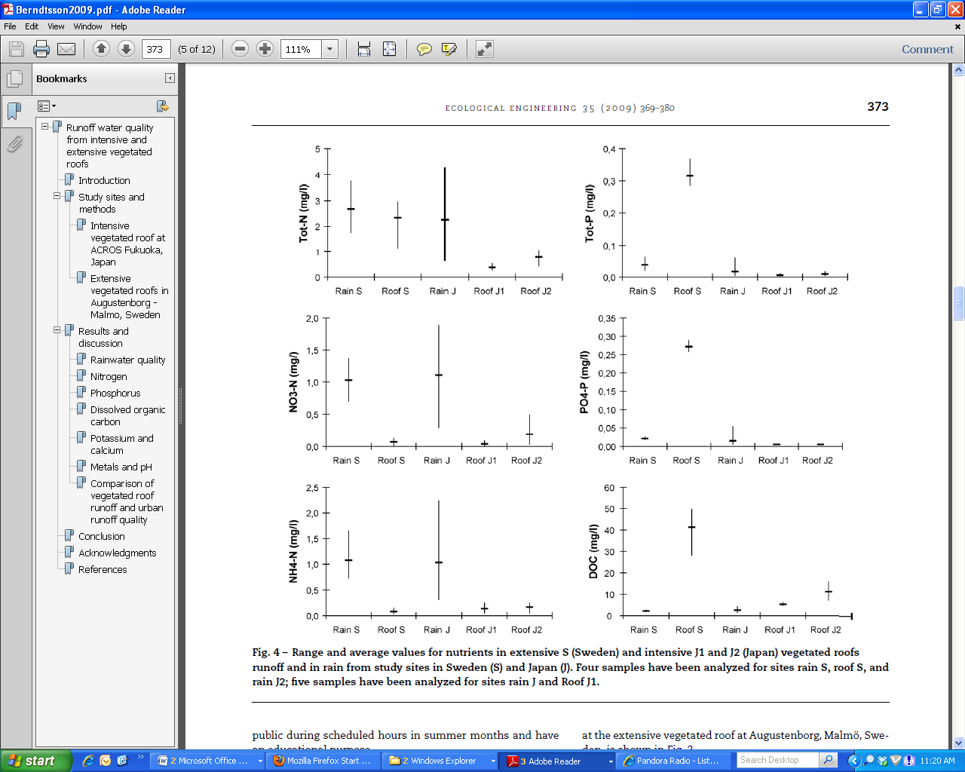
Figure x: Range and average values for nutrients in extensive S (Sweden) and intensive J1 and J2 (Japan) vegetated roofs runoff and in rain from study sites in Sweden (S) and Japan (J). Four samples have been analyzed for sites rain S, roof S, and rain J2; five samples have been analyzed for sites rain J and Roof J1

Czemiel Berndtsson, J., Emilsson, T., Bengtsson, L., 2006. The influence of extensive vegetated roofs on runoff water quality. Sci. Total Environ. 355, 48–63.

- Studied 4 extensive green roofs that varied in age over a range of 7 years.
- Vegetation: Sedum-moss
- Growing medium: 3 cm deep; crushed lava, natural calcareous soil, clay, and shredded peat, in compliance with the FLL standards.
- Most of the studied vegetated roofs contribute phosphorus to the runoff, with the exception of the oldest roof (which also was never fertilized).
- One of the vegetated roofs was fertilized the year of planting and the year after that, another one was fertilized just once, another one was never fertilized, and it is uncertain whether or not the fourth one was ever fertilized.
- Phosphorus in the vegetated roof runoff appeared mainly in phosphate form, which might mean that it comes from fertilizers.
- Rainwater in the studied areas during the study period was relatively uncontaminated.
- Two unvegetated roofs did not significantly influence the content of phosphorus and nitrogen.
- The vegetated roofs all behave as a sink for nitrogen.

Kohler M, Schmidt M, Grimme FW, Laar M, de Assuncao Paiva VL, Tavares S. Green roofs in temperate climates and in the hot-humid tropics—far beyond the aesthetics. Environ Manag Health 002;13(4):382–391.

Unfertilized research plots of the TU in Berlin showed phosphate removal starting in the first year after planting, increasing every year thereafter.

The figures below show, (1) pollutant removal as a percentage of input, and (2) increasing phosphate retention as green roof vegetation matures, of input of research plots of the TU Berlin.

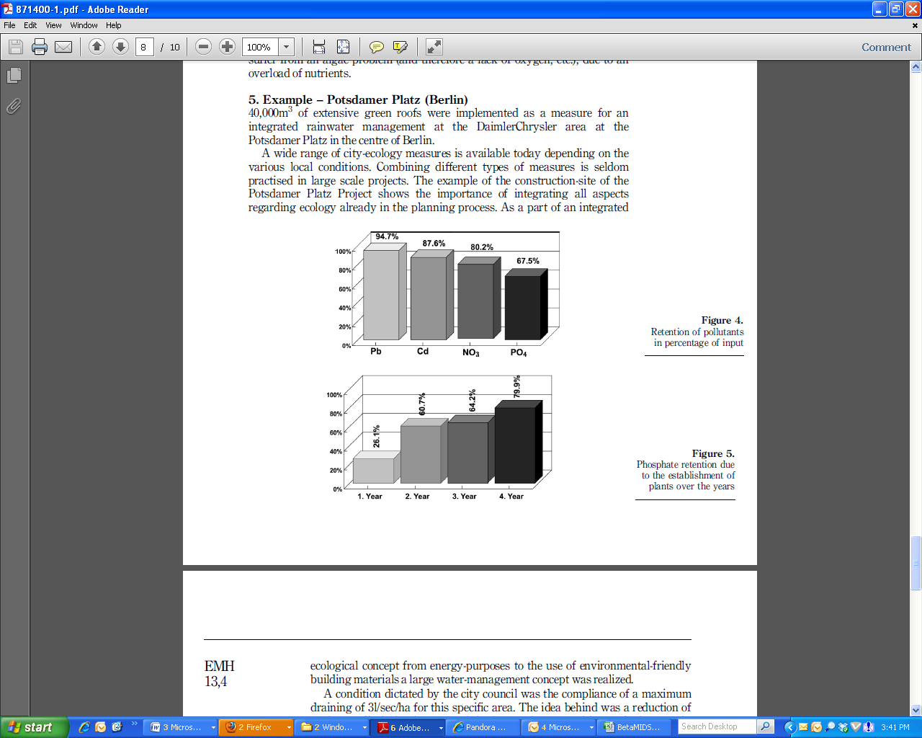

Van Seters, T., Rocha, L., and MacMillan, G. Evaluation of the runoff quantity and quality performance of an extensive green roof in Toronto, Ontario. Proceedings of the Greening Rooftops for Sustainable Communities, Minneapolis, 2007.

- Three year study comparing a 241 m2 extensive greenroof to an adjoining 131 m2 shingled roof in Canada.
- Growing medium is 140 mm think, composed of crushed volcanic rock, compost, blonde peat, cooked clay, and washed sand, planted with wildflowers.
- Green roof was irrigated every night during the first summer, and only when soil moisture fell below a pre-established threshold after the first summer, which was on average once every 2 days.
- Water quality was monitored for 21 events during the 2003 and 2004 monitoring seasons.
- “Loads of most stormwater contaminants in green roof runoff were lower than from the adjacent conventional roof. Exceptions included constituents, such as calcium, magnesium, and total phosphorus, which were either naturally present in the media or were added to promote plant growth. ..Total phosphorus was the only variable that raised a significant concern because concentrations were several times higher than the Ontario receiving water standard of 0.03 mg/L.”
- “Most of the phosphorus was transported as phosphate, which is more biologically available than particulate phosphorus, and thus presents a more serious concern. Over the monitoring period, 86% of green roof total phosphorus loads were in the form of soluble phosphate, compared to only 46% from the control roof.”
- “Mean concentrations of total phosphorus and phosphate in 2004 were less than one third of concentrations observed in 2003 (Figure 5). However, in both years, green roof concentrations and loads were higher than those of the control roof. The decrease in green roof concentrations likely represents a process of leaching whereby soil phosphorus is gradually flushed from the growing medium during the first year or two of operation.”

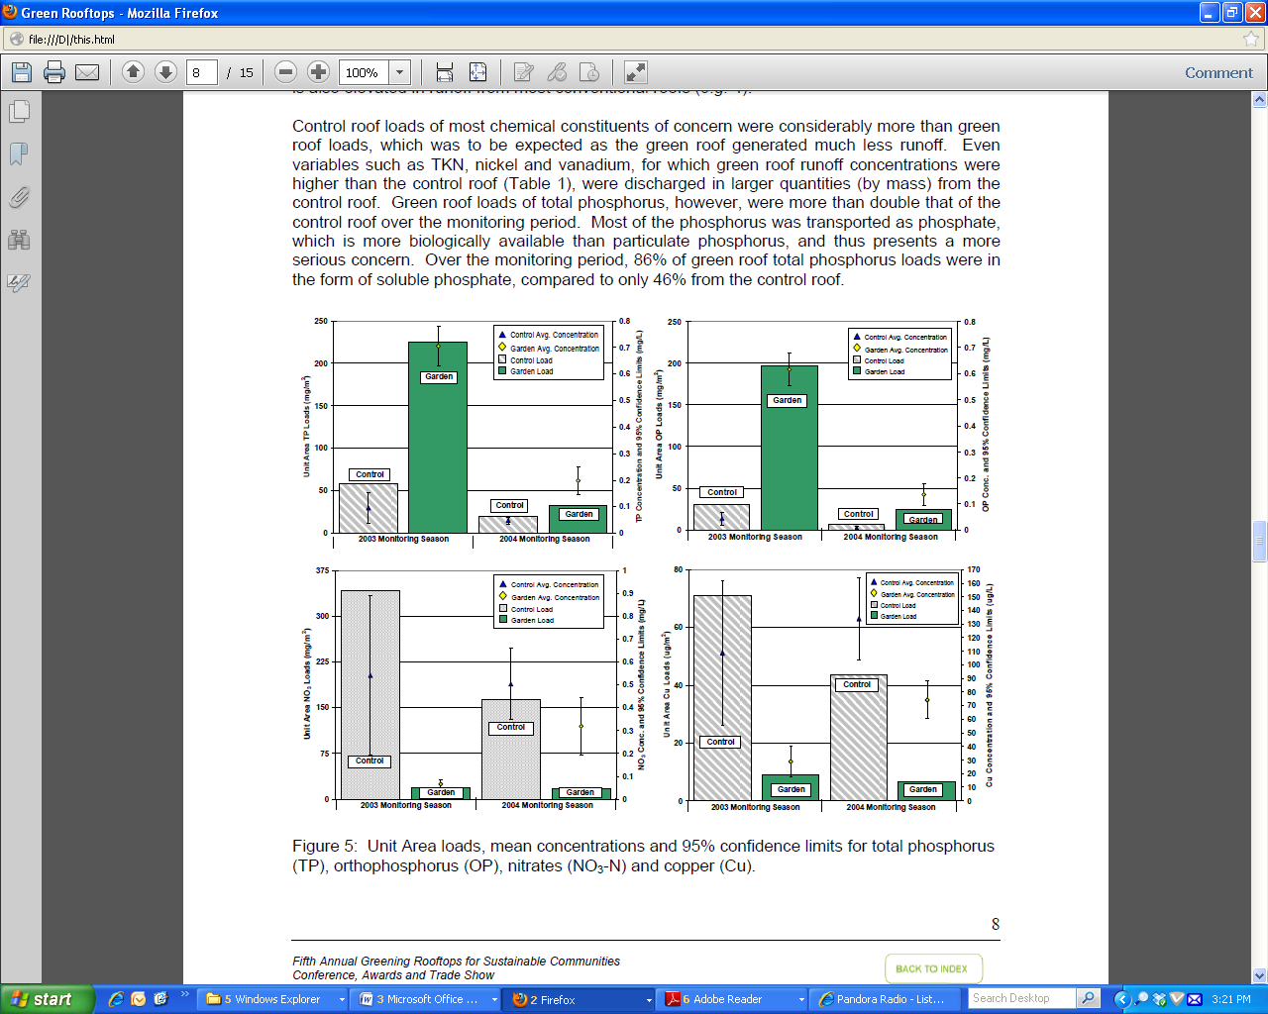
Teemusk, A. and Mander, U. Rainwater runoff quantity and quality performance from
a greenroof: The effects of short-term events. Ecological Engineering. 2007. 30, 271:

Compared runoff from an extensive green roof in Estonia to a modified bituminous green roof during three rainfall events and snow cover melting and reports the following:

- “The quality of the runoff water varies depending on the character of the runoff and the pollutants accumulated on the roof.”
- “When rain and runoff were moderate, values of COD, BOD₇, and concentrations of total N and total P were higher on the bituminous roof.”
- “In samples taken during a heavy rainstorm, the components were less concentrated, as the rain washed more phosphates and nitrates off the greenroof.”
- “In snow melting water, the concentrations of all components were greater on the greenroof.”

Berghage, R. Penn State Center for Green Roof Research.Green Roof Media Nutrient Testing, Nutrient Management, and Runoff Water Quality. Presentation to NASA Workshop.

- Recommends a P concentration between 2 and 20 ppm in green roof growing media, as measured with Saturated Paste Extraction Method With DPTA Test, for optimal balance between healthy plant growth and minimal leaching into green roof runoff, based on analysis of hundreds of green roof soil samples compared to plant vigor and cover.

Recommendations:

- Recommended value for P reduction: 0 unless on-site monitoring shows P reduction
- Require growing medium with P to be between 2 and 20 ppm per SME soil test.
- Prohibit fertilization unless P levels in growing medium fall below range listed above.
- When P fertilization is needed because P levels in growing medium fall below range listed above, use slow release fertilizer. Conventional P fertilizer shall be prohibited.
- Investigate effectiveness of soil additives for P retention.

Similarly to bioretention, green roofs can leach phosphorus if the soil is high in phosphorus, or if P fertilizer is used on the green roof. Research should therefore be conducted to evaluate whether or not the same phosphorus binding additives that are improving P removal of bioretention (such as, for example, iron filings, Aluminum water treatment residuals, and Imbrium) would also be effective to improve P reduction on green roofs (see Task 7 of Objective 2, Bioretention).

Research on long term effects of biochar on green roof performance is also recommended, as research by Beck (2010) found that “Addition of 7% biochar by weight to Pro-Gro extensive mix, a soil designed for greenroofs, resulted in several benefits including: a decrease of nitrogen, phosphorus, and organic carbon concentrations entering into the rainfall runoff, increased water retention, and reduced turbidity of rainfall runoff.”

TSS

The Minnesota Stormwater Manual (MPCA, 2008) uses the following Typical Event Mean Concentrations for TSS:

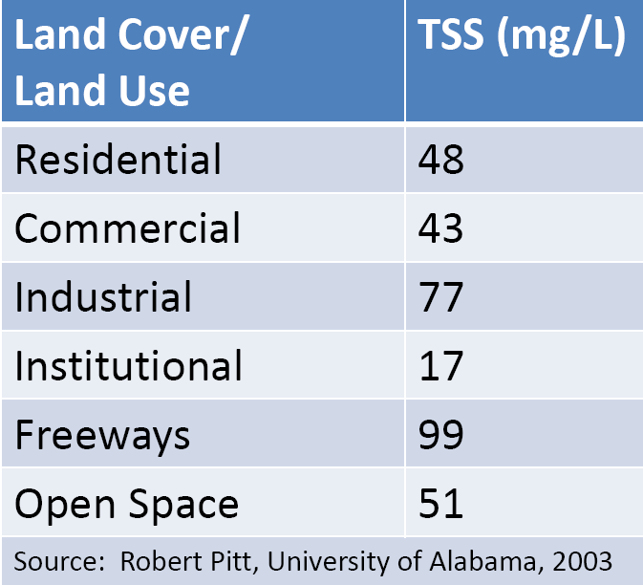

Roof runoff TSS concentrations are typically very low, <<10 mg/L), and often <2 (irreducible)
(Toland et al, 2012, Wilson et al under review).

Very few studies have investigated green roof TSS reduction. The primary removal mechanism for TSS is filtration in the top few inches of soil. Since a green roof is therefore expected to filter TSS as well as bioretention, but likely would have a lower TSS load, green roofs could reasonably be given at least the same TSS removal credit as bioretention until further data is available specific to green roof TSS reduction (see recommendations below).

Literature Review

Van Seters, T., Rocha, L., and MacMillan, G. Evaluation of the runoff quantity and quality performance of an extensive green roof in Toronto, Ontario. Proceedings of the Greening Rooftops for Sustainable Communities, Minneapolis, 2007.

- Three year study comparing a large extensive greenroof to an adjoining shingled roof in Canada.
- Mean concentration of TSS in green roof runoff was lower than from control roof.

Berghage, R. D. Beattie, A. Jarret, and T. O’Connor. 2007. Greenroof Runoff Water quality. In: Greening Rooftops for Sustainable Communities, Minneapolis, 2007, Proceedings.

“The most noticeable difference between runoff from the green roofs and runoff from an equivalent flat roof was the color of the water, which was yellow for the runoff from green roofs…

The color most likely is the result of organic matter (humic acids) in the medium. The runoff looks very similar to the leachate obtained from potted plants or other containerized planting systems. Although the runoff is colored it is quite clear. The turbidity of the runoff was slightly higher for green roofs than non-green roofs but was not significantly influenced by roof type (Figure 2). Turbidity from green roofs and flat roofs was very similar, with the exception of a couple of events in the spring of 2005 (Figure 2). The events where green roof turbidity was elevated were events where very little runoff was collected. It seems likely that the elevated turbidity in these samples was related to the small amount of runoff.”

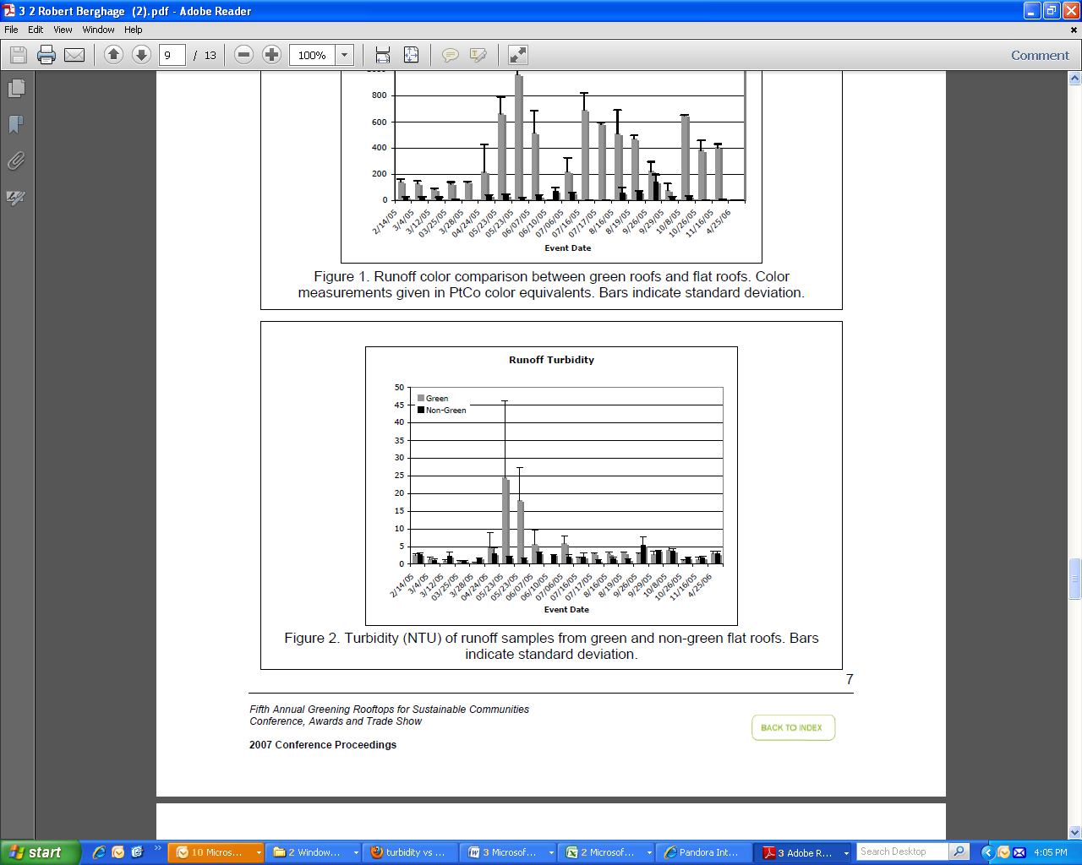

Carpenter, D.D., Kaluvakolanu, P. 2011. Effect of roof surface type on stormwater run-off
from full-scale roofs in a temperate climate. Journal of Irrigation and Drainage
Engineering 137:161-169.

- Compared runoff from 153 m² asphalt, 84.7 m² gravel ballasted, and 325.2 m² extensive green roofs.
- Planted in 2005 with 7 species of Sedums, irrigated for 2 years, then irrigation was discontinued.
- 10.16 cm deep growing medium with less than 6% organic matter by weight.
- Longest green roof flow path: 20.7 m
- Green roof slope (V:H): 1:24
- TSS results:
- Monitored 5 water quality events with rainfall greater than 1.27 cm (0.5 inch) in a 24 hour period.
- “There was significant variability between rainfall events, and the nutrient removal and water quality performance of the investigation is inconclusive. However, the data provide some indication that a green roof could be effective at reducing nutrient and solid loadings.”
- Green roof exhibited significantly higher TSS concentration than the asphalt and gravel ballasted roofs - BUT green roof had much less volume of runoff.
- When TSS concentration was converted to total mass, both the green and asphalt roofs had significantly higher TSS compared with the stone roof – BUT green roof was 2.12 times as big as asphalt roof and 3.84 times as big as gravel roof. MASS PER UNIT AREA for asphalt roof = 3.29 g/m2; for green roof = 2.91 g/m2; for stone roof = 1.20 g/m2

Morgan, S., Alyaseri, I., and Retzlaff, W. (2011). “Suspended solids in and turbidity of runoff
from green roofs.” International J. of Phytoremediation, 13 Suppl 1:179-93.
- Indoor pot study with grow lights
- Growing media: compared 4 growing media, each consisting of 1 of the 4 following aggregates mixed with 20% composted pine bark:
- Haydite
- Arkalyte
- Lava
- Bottom Ash
- Vegetation: 5 species of Sedum plugs
- Watered pots every 15 days with distilled water
- “The results showed that there were elevated levels of TSS and turbidity in the runoff that decreased over time for all growth media. “
- “Both TSS and turbidity are affected by the type of growth media. Lava and haydite had higher mean TSS and mean turbidity than arkalyte and bottom ash.“
- “Vegetation reduced the mean turbidity and mean TSS of the first flush by an average of 53% and 63%, respectively, but generally had no statistically significant effect thereafter. “
- “The results indicate that the media, rather than the vegetation, has a greater effect on TSS and turbidity in the runoff. “
- Plant cover ranged from about 15% to about 63% during the duration of the study.
- The soil with the highest vegetation cover (lava) also had the greatest average mass of suspended solids.

NCDENR Stormwater BMP Manual – Rooftop Runoff Management, February 2013 DRAFT
“International research has shown that TSS (and metals) are not discharged from green roofs at significant concentrations, therefore 85% TSS removal credit is given.”

Recommendations
- Require erosion protection at all times
- % TSS reduction = 85%

References

Berghage, R. D. Beattie, A. Jarret, and T. O’Connor. 2007. Greenroof Runoff Water quality. In: Greening Rooftops for Sustainable Communities, Minneapolis, 2007, Proceedings.

Berghage, R. Penn State Center for Green Roof Research.Green Roof Media Nutrient Testing, Nutrient Management, and Runoff Water Quality. Presentation to NASA Workshop.

Berndtsson, J. C. (2010). “Green roof performance towards management of runoff water quantity and quality: A review.” Ecological Engineering, 36, 351 – 360.

Berndtsson, J.C., L. Bengtsson, K. Jinno. 2009. Runoff water quality from intensive and extensive vegetated roofs. Ecological Engineering 35: 369-380.

Carpenter, D.D., Kaluvakolanu, P. 2011. Effect of roof surface type on stormwater run-off from full-scale roofs in a temperate climate. Journal of Irrigation and Drainage Engineering 137:161-169.

Berndtsson, C.J.,T. Emilsson, and L. Bengtsson. 2006. The influence of extensive vegetated roofs on runoff water quality. Sci. Total Environ. 355, 48–63.

Gikas, D.G. and A.T.Vassilios. 2012. Assessment of water quality of first-flush roof runoff and harvested rainwater. Journal of Hydrology 466–467:115–126.

Hunt, W.F., A.M. Hathaway, J.T. Smith, J. Calabria. 2006. Choosing the Right Green Roof Media for Water Quality. Greening Rooftops for Sustainable Communities Conference, Boston, 2006 Proceedings.

Kohler M, Schmidt M, Grimme FW, Laar M, de Assuncao Paiva VL, Tavares S. Green roofs in temperate climates and in the hot-humid tropics—far beyond the aesthetics. Environ Manag Health 002;13(4):382–391.

Morgan, S., Alyaseri, I., and Retzlaff, W. (2011). “Suspended solids in and turbidity of runoff from green roofs.” International J. of Phytoremediation, 13 Suppl 1:179-93.

NCDENR Stormwater BMP Manual – Rooftop Runoff Management, February 2013 DRAFT.

Teemusk, A. and Mander, U. Rainwater runoff quantity and quality performance from a greenroof: The effects of short-term events. Ecological Engineering. 2007. 30, 271.

Toland, D. C., B. E. Haggard, and M. E. Boyer. 2012. Evaluation Of Nutrient Concentrations In Runoff Water From Green Roofs, Conventional Roofs, And Urban Streams. Transactions of the ASABE 55(1): 99-106.

U.S. Environmental Protection Agency, 2009. Green Roofs for Stormwater Runoff Control. EPA-600-R-09-026. USEPA, Washington, DC.

Van Seters, T., Rocha, L., and MacMillan, G. Evaluation of the runoff quantity and quality performance of an extensive green roof in Toronto, Ontario. Proceedings of the Greening Rooftops for Sustainable Communities, Minneapolis, 2007.

Wilson, C. E., Hunt, W. F., Winston, R. J., and Smith, P. K. (2013). "Assessment of a Rainwater Harvesting System as a Component of a Low Impact Development in Raleigh, NC." Water, Science, and Technology. Under Review.

Please Note:

The Kestrel Design Group (including its employees and agents) assumes no responsibility for consequences resulting from the use of the information herein, or from use of the information obtained at linked Internet addresses, or in any respect for the content of such information, including (but not limited to) errors or omissions, the accuracy or reasonableness of factual or scientific assumptions, studies or conclusions, the defamatory nature of statements, ownership of copyright or other intellectual property rights, and the violation of property, privacy, or personal rights of others. The Kestrel Design Group is not responsible for, and expressly disclaims all liability for, damages of any kind arising out of use, reference to, or reliance on such information. No guarantees or warranties, including (but not limited to) any express or implied warranties of merchantability or fitness for a particular use or purpose, are made by the Kestrel Design Group with respect to such information.
The Kestrel Design Group does not endorse, approve, certify, or control references and Internet links included herein and does not guarantee the availability, accuracy, completeness, efficacy, timeliness, or correct sequencing of information in these references and links. No one should rely on the accuracy, completeness, efficacy, and timeliness of such information. Reference therein to any specific commercial product, process, or service by trade name, trademark, service mark, manufacturer, or otherwise does not constitute or imply endorsement, recommendation, or favoring by the Kestrel Design Group.

