Section 1
Overview of Stormwater Infiltration
Stormwater infiltration is the process by which rainfall and stormwater runoff flows into and through the subsurface soil. Stormwater infiltration occurs when rainfall lands on pervious surfaces, when runoff flows across pervious surfaces, and when runoff is collected and directed to a stormwater infiltration Best Management Practice (BMP).
Current stormwater management policies encourage, when appropriate, maximizing the infiltration of stormwater to reduce the volume of runoff discharging to surface waters. In addition to reducing runoff volume, stormwater infiltration helps reduce stormwater pollutant loading to surface waters. Many factors influence the rate and volume of stormwater infiltration including soil characteristics, storage capacity, and vegetation. These and other factors are discussed in further detail in subsequent sections. Once stormwater infiltrates into the soil, it has the potential to enter the groundwater and become part of the subsurface flow.
For the purposes of this section, infiltration BMPs are considered those without underdrains. BMPs with underdrains have been classified as filtration BMPs and are discussed in the filtration section of this manual.
1.1 Basic Concepts of Stormwater Infiltration
Stormwater runoff is considered to be any water that runs off pervious and impervious surfaces after a rainfall or snowmelt event, with a greater percentage running off from impervious surfaces. In urban areas, runoff can constitute approximately 30 to 55 percent of the water budget (Figure 1.1). In comparison, runoff may constitute as little as 10 percent in forested or rural areas (FISRWG, 1998).
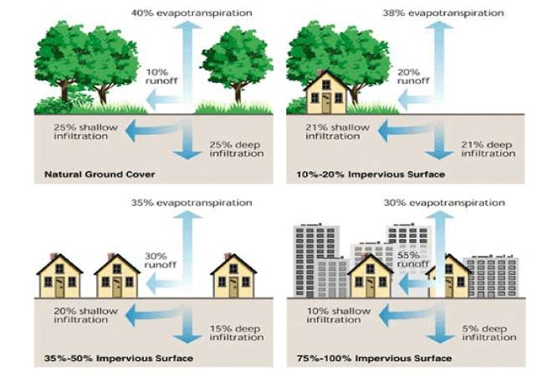
Figure 1.1 Relationship between impervious cover and surface runoff. (Source: Stream Corridor Restoration: Principles, Processes, and Practice (1998). By the Federal Interagency Stream Restoration Working Group (FISRWG) (15 Federal agencies of the U.S.))
1.1.1 Role of Stormwater Infiltration in the Natural Water Cycle
The increase in impervious surfaces can disrupt the natural water cycle and alter the surrounding environment via the decrease of groundwater recharge and the increase of water directly flowing to surface waters. As a likely consequence, this can lead to a reduction in the baseflow to streams, a decrease in the elevation of the groundwater table, and transport of sediment and pollutant loads into surface waters. A more detailed explanation of stormwater runoff and its effects on the environment can be found here.
Stormwater infiltration in urban areas can be enhanced by the disconnection of impervious surfaces and by the improvement of pervious surfaces such as turf. Impervious surface disconnection is the direction or redirection of stormwater runoff from impervious surfaces (e.g., sidewalks, parking lots, rooftops, etc.) onto pervious surfaces such as a roof drain discharging onto a lawn. Redirection of impervious surface runoff to pervious areas promotes infiltration and reduces overall site runoff. The reduction in site runoff from impervious surface disconnection can vary considerably depending on many factors including the size of the contributing drainage area, size and infiltration capacity of the soils, vegetation in the area receiving the additional stormwater, slope and site grading and other site conditions. Stormwater infiltration can also be enhanced by improvement of pervious surfaces, such as amending soil with compost to increase the water holding capacity of the soil.
In new developments, stormwater infiltration is often intended to mimic the natural hydraulic cycle. Stormwater infiltration in re-development aims to mitigate changes in the urban water cycle brought about by increases in impervious surfaces caused by the urbanization. Infiltration can achieve the following objectives:
- Decrease peak runoff flow rates
- Decrease the volume of stormwater runoff
- Reduce stormwater pollutant loading to surface waters
- Promote retention and breakdown of contaminants in the soil/act as a pollutant barrier between the land surface and groundwater
- Increase groundwater recharge
- Preserve base flow in streams
- Reduce thermal impacts of stormwater runoff
Typically, stormwater from disconnected impervious surfaces is routed to a stormwater BMP. Infiltration BMPs achieve the above objectives by capturing, retaining, and infiltrating stormwater. Infiltration BMPs consist of:
- Infiltration basins
- Infiltration trenches
- Bioretention-bioinfiltration (most often a rain garden)
- Permeable pavements
- Tree trenches/tree boxes (sometimes considered a form of bioretention)
Small and medium sized infiltration BMPs are often located at the beginning of a stormwater treatment train, while larger systems are often placed at the end of the train. These BMPs can also be installed as off-line treatment systems. Infiltration BMPs are most suitable in sites with permeable soils and sufficient separation from the seasonally high groundwater table, bedrock, and polluted sites.
Please note that while infiltration practices can remove some types of physical and chemical pollutants, careful consideration should be given to implementing stormwater infiltration practices in potential stormwater hotspots (PSH) or at sites with known pollution issues such as brownfields. This is discussed further in Sections 2.7 and 2.8.
1.1.2 Factors Affecting Stormwater Infiltration
Several interrelated factors that control the infiltration of stormwater into the soil/subsurface are described below. It is important to clarify the terms soil and subsurface (these terms are used interchangeably in this report). In general, the soil and/or subsurface is the material that is directly below the ground surface. When an engineered media is used, the soil or subsurface actually refers to the material underneath the engineered media (see Figure 1.2).
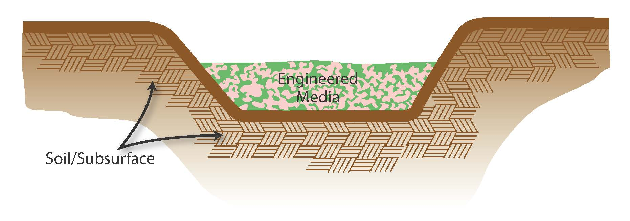
Figure 1.2 Distinction between engineered media and soil (Source: CDM Smith)
- Infiltration rate. The infiltration rate (IR) is one of the main factors affecting the performance of an infiltration BMP. While design rates do exist, it is HIGHLY RECOMMENDED that the rates be measured in-situ. Information on how to find the IR in the field can be found here. Designers should test soil at fully saturated conditions (saturated hydraulic conductivity or K_{sat}) to obtain the most conservative rate. All design and credit information contained in the MPCA’s stormwater manual is based on the assumption of saturated soil. Average K_{sat} values are found here, however, they should be used as a reference only.
- Evapotranspiration rate. The evapotranspiration (ET) rate is the sum of evaporation and plant transpiration. It is an important function when the infiltration BMP relies at least in part on vegetation for its stormwater management. The average ET rate in Minneapolis and St. Paul from 2001 to 2010 was 0.16 in/day. It should be noted that this is a general value and is subject to variation due to several coarse and fine-scale conditions. Figure 1.3 provides the estimated mean annual evapotranspiration rate, in centimeters, throughout Minnesota between 1971 and 2000. Detailed records for certain areas of Minnesota are available on the Minnesota Department of Natural Resources Climate Summaries and Publications web site.
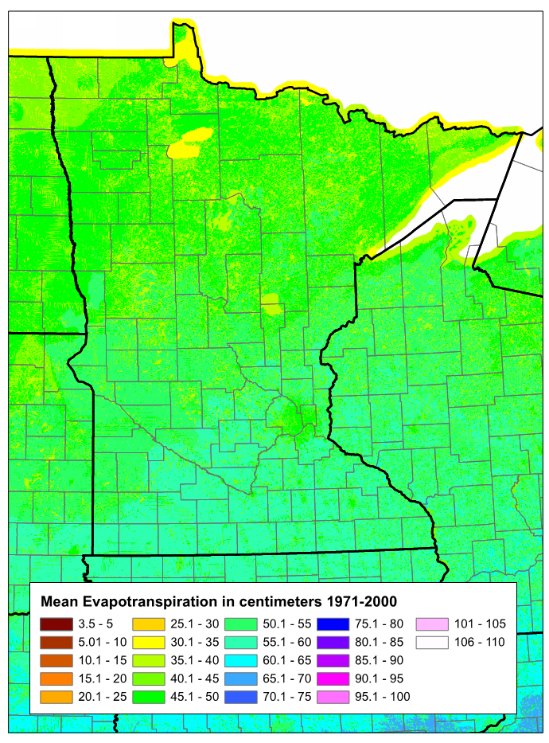
Figure 1.3 Average Evapotranspiration Rates for Minnesota (Source: US Geological Survey, with permission).
- Storm intensity. When the intensity of the storm is greater than the IR of the soil, runoff may occur (WEF, 2012). This is due to the fact that as storm intensity increases, the storage on the surface and in the subsurface macropores is more quickly exhausted and the soils rapidly reach saturation.
- Antecedent soil moisture condition. The antecedent moisture condition, or the moisture condition of the soil prior to the storm event, will affect the space available in the subsurface for infiltration. High antecedent moisture conditions reduce the amount of pore space available for infiltration, which in turn decreases the amount of runoff water entering the soil.
- Soil type. In general, infiltration is more rapid in coarser soils (e.g., medium to coarse sands or gravels) than in fine grained soils (e.g. silts and clays).
- Bulk density of the soil. As the bulk density of the soil increases, the IR generally decreases. The average bulk density of soil based on different land uses or activities can be found here.
- Temperature. Infiltration rates tend to decrease as temperature decreases. This is due to the increase in viscosity of the stormwater at lower temperatures (Lin et al., 2003; Braga et al., 2007; Emerson and Traver, 2008).
1.1.3 Limitations and Disadvantages of Stormwater Infiltration
The following general limitations should be recognized when considering infiltration BMPs.
- Failure can occur due to improper design and/or siting.
- Infiltration BMPs may not be appropriate for sites with soils having a low infiltration capacity.
- Infiltration BMPs may not be appropriate for areas with steep slopes.
- Infiltration BMPs are susceptible to clogging by sediment and other debris, and may require a greater amount of maintenance compared to other BMPs.
- Algae growth within the BMP can block the infiltration of runoff into the subsurface (WEF, 2012).
- Infiltration BMPs are not ideal for stormwater runoff from land uses or activities with the potential for high loads of certain pollutants. The Minnesota CGP prohibits infiltration of runoff from vehicle fueling areas and certain industrial practices.
- Infiltration BMPs may increase the risk of groundwater contamination depending on subsurface conditions, pollution concentrations in the runoff, and aquifer susceptibility.
- Wide-scale implementation is required to significantly reduce the rate and volume of discharge to downstream surface waters, especially in areas with a high density of impervious surfaces (WEF, 2012).
1.2 Pollutant Fate and Transport for Stormwater Infiltration
As stormwater travels across the land surface into infiltration BMPs, it can pick up various water quality pollutants and deliver them to the subsurface. There is concern that these pollutants have the ability to travel through the vadose zone and ultimately impact the groundwater. Whether or not this will occur depends on the type and amount of pollutant present, the volume of infiltration, the type of infiltration BMP, and subsurface conditions.
1.2.1 Typical Stormwater Pollutants
Common stormwater pollutants and their characteristics are discussed below. Table 1.1 summarizes the common sources of the pollutants while Table 1.2 provides typical pollutant concentrations in stormwater runoff. The concentrations are based on data from the International Stormwater Database.

Table 1.1 Common Pollutants of Concern and Sources in Stormwater Runoff (Adapted from USGS, 2014)
Contaminant | Contaminant Source¹
Nitrogen | Naturally occurring from vegetation decomposition; fertilizers; farm-animal waste; faulty septic system
Chloride | Salts applied to roads and parking lots during the winter; mineral dissolution
Copper | Industrial and domestic waste, mining, mineral leaching, automobile parts and fluids
Zinc | Industrial waste; automobile parts and fluids
Manganese | Found naturally in sediment and rocks; mining waste; industrial waste; automobile parts and fluids
Nickel | Naturally occurring; stainless steel and alloy products; mining; refining; automobile parts and fluids
Cadmium | Small amounts are naturally occurring; industrial discharge; mining waste; automobile parts and fluids
Chromium | Old mining operations; fossil-fuel combustion; mineral leaching; automobile parts and fluids
Pesticides | Residential use of lawn care products; commercial landscaping; animal wastes; municipal right-of-ways; agriculture; feedlots
Cyanide | Road salt; fertilizer production
PAHs | Auto emissions; elicit discharge; asphalt pavement (driveways, roadways and parking lots) with coal tar sealants²; ;
VOCs | Crude oil; insecticides; varnishes; paints; gasoline products; degreasers; municipal maintenance activities
Oil and Grease | Gasoline products; plastics; dyes; rubbers; polishes; solvents; crude oil; insecticides; inks; varnishes; paints; disinfectants; paint removers; degreasers; automobile fluids
Pathogens including fecal coliform and E. coli | Domestic sewage; animal waste; plant or soil material
¹The list of sources is for stormwater runoff only
² MPCA, 2014
Source: USGS, 2014, with permission

Table 1.2 Concentrations of Contaminants Found in Stormwater
Land Use |  | TSS (mg/L) | NO₂+NO (mg/L) | TN (mg/L) | TP (mg/L) | Chloride² (mg/L) | Cu (ug/L) | Zn (ug/L) | Ni (ug/L) | Cd (ug/L) | Cr (ug/L) | Cyanide² (ug/L) | Oils and Grease | VOC² (ug/L) | Pesticides^{2,4} (ug/L) | Fecal² Coliform | E. coli² | Fecal Streptococci² | E. Coli | F. S.
Commercial
Number of sites |  | 56 | 50 | 13 | 56 | -- | 60 | 62 | 40 | 51 | 38 | 2 | 44 | 4 | 1 | 4 | -- | 3
Number of observations |  | 857 | 786 | 77 | 948 | -- | 785 | 867 | 291 | 543 | 294 | 6 | 394 | 160 | 6 | 19 | -- | 7
% of samples above detection |  | 98.7% | 98.9% | 97.4% | 94.5% | -- | 85.0% | 99.2% | 51.5% | 38.1% | 52.0% | 0%³ | 65.5% | 65.5% | 0% | 73.7% | -- | 100%
Minimum |  | <0.5 | <0.1 | <1.5 | <0.01 | -- | <0.2 | <0.3 | <1 | <0.03 | <0.7 | n/a | <0.5 | <0.05 | n/a | <200 | -- | 24,000
Maximum |  | 2,385 | 8.2 | 18.1 | 4.27 | -- | 569.1 | 3,050.5 | 110 | 80 | 100 | n/a | 359 | <20 | n/a | 28,000 | -- | 310
Median¹ |  | 52 | 0.6 | 1.75 | 0.2 | -- | 17 | 110 | 7 | 0.94 | 6 | n/a | 5 | 0.7 | n/a | 450 | -- | 3,100
 | Industrial
 | Number of sites | 58 | 51 | 13 | 57 | 1 | 65 | 67 | 43 | 60 | 42 | 2 | 48 | 3 | -- | 6 | -- | 4
 | Number of observations | 619 | 536 | 85 | 638 | 10 | 569 | 627 | 300 | 525 | 312 | 9 | 370 | 144 | -- | 32 | -- | 12
 | % of samples above detection | 99.5% | 97.0%% | 95.3% | 95.1% | 50.0% | 85.1% | 98.9% | 58.0% | 48.6% | 72.4% | 0%³ | 59.7% | 10.4% | -- | 90.6% | -- | 91.7%
 | Minimum | <1 | <0.02 | <1.5 | <0.02 | <2 | <0.2 | <0.5 | <2 | <0.03 | <0.7 | n/a | <0.5 | <0.05 | -- | <1 | -- | <1
 | Maximum | 2,490 | 8.4 | 15.2 | 7.9 | 7.8 | 1,360 | 8,100 | 120 | 334 | 150 | n/a | 408 | <20 | -- | 3,6000,000 | -- | 48,000
 | Median¹ | 75 | 0.68 | 1.7 | 0.23 | 6 | 19 | 155 | 11.5 | 1.4 | 10 | n/a | 5 | 0.06 | -- | 3,950 | -- | 24,000
Residential
Number of sites |  | 146 | 127 | 20 | 148 | 2 | 147 | 151 | 77 | 114 | 72 | -- | 95 | 7 | 1 | 10 | 3 | 4
Number of observations |  | 2257 | 1,772 | 131 | 2,380 | 19 | 1,743 | 2,013 | 418 | 1,123 | 408 | -- | 694 | 210 | 6 | 94 | 19 | 23
% of samples above detection |  | 99.9% | 99.0% | 98.5% | 98.2% | 26.3 | 86.5% | 97.0% | 42.2% | 40.4% | 48.8% | -- | 56.8% | 20.1% | 0% | 85.9% | 100% | 95.7%
Minimum |  | <0.5 | <0.03 | <1.5 | <0.01 | <2 | <0.2 | <0.5 | <0.5 | <0.03 | <0.7 | -- | <0.5 | <0.05 | n/a | <1 | 10 | <1
Maximum |  | 4,168 | 66.4 | 18.3 | 19.90 | 18.3 | 590 | 14,700 | 100 | 70 | 70 | -- | 419 | 3,42 | n/a | 5,230,000 | 35,000 | 200,000
Median¹ |  | 58 | 0.60 | 2.24 | 0.26 | 5.5 | 11 | 69.9 | 6 | 0.5 | 4 | -- | 4 | 1.1 | n/a | 9,400 | 1,000 | 23,500
Open Space
Number of sites |  | 15 | 13 | 4 | 15 | -- | 12 | 12 | 9 | 8 | 7 | 3 | 9 | 1 | -- | 2 | 1 | --
Number of observations |  | 105 | 109 | 13 | 111 | -- | 44 | 49 | 38 | 41 | 36 | 13 | 26 | 5 | -- | 6 | 5 | --
% of samples above detection |  | 97.1% | 92.7% | 92.3% | 93.7% | -- | 64.4% | 65.3% | 23.1% | 39.0% | 36.1% | 15.4% | 34.6% | 60.0% | -- | 100% | 100% | --
Minimum |  | <1 | <0.1 | <0.5 | <0.01 | -- | <0.8 | <5 | <2 | <0.04 | <0.7 | <0.01 | <1 | <0.2 | -- | 1,900 | 100 | --
Maximum |  | 4,168 | 3.4 | 3.3 | 0.76 | -- | 210 | 390 | 100 | 8 | 120 | 0.08 | 11 | 0.84 | -- | 63,000 | 4,700 | --
Median¹ |  | 58 | 0.5 | 1.1 | 0.05 | -- | 8.2 | 26.5 | 18 | 0.24 | 5 | 0.07 | 2.12 | 0.77 | -- | 2,150 | 1,100 | --
Source: International Stormwater Database Version 3 (Updated 2008).

¹Samples with results below the detection limit were not used when calculating the median value
²Data was selected from states with a similar climate to MN. The appropriate states were determined using Figure 1.3 from the Stormwater BMP Design Supplement for Cold Climates document (http://vermont4evolution.files.wordpress.com/2011/12/ulm-elc_coldclimates.pdf)
³All samples were below the detection limit
⁴Data is for trans-1,3-Dichloropropene and bromomethane

Nitrogen
Nitrogen can be found in many forms in the stormwater runoff/infiltrating water, with the most common forms being ammonia, nitrate, and nitrite. Nitrate is estimated to be the most common nonpoint-source groundwater contaminant in the world (Gurdak & Qi, 2012). Despite its high solubility, nitrite is detected with much less frequency than nitrate because nitrite oxidizes rapidly to form nitrate. Total nitrogen (TN) was detected in approximately 97 percent of the 4,077 samples submitted to the International Stormwater Database and included in Table 1.2, nitrate was detected in 100 percent of 12 samples, and nitrite was detected in 83 percent of 6 samples.
In regards to the toxicity of nitrogen, ammonia and nitrate are two forms of particular concern. As ammonia undergoes nitrification, it uses large amounts of oxygen. This in turn can kill fish and other aquatic wildlife. When nitrate contaminates drinking water at high levels, it can lead to the phenomenon known as “blue baby syndrome” which affects babies less than 6 months old (Prey et al., 2000). Nitrates and nitrites have not been classified as carcinogenic, however a metabolic pathway exists that lead to formation of N-nitroso compounds, some of which are carcinogenic. (ATSDR, 2011). Areas at risk for contamination of shallow groundwater due to nitrogen are shown in Figure 1.4. Below is a list of some of the characteristics of nitrogen (Pitt et al., 1994, 1999; Weiss et al., 2008, ATSDR, 2011):
Mobility: Mobile
Solubility: High
Abundance in stormwater: Low/moderate
Toxicity: Variable. Toxicity depends on the type of nitrogen present
Degradation potential: High
Adsorption/absorption: Low
Plant uptake: High
Potential transport to groundwater: Low/moderate. Transport potential is based on the fact that there is only a low to moderate abundance of nitrogen in stormwater runoff. In areas where the levels are higher, the potential will be much higher.

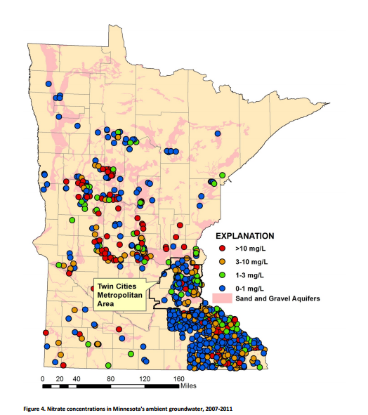

Figure 1.4 Nitrate Contamination in Minnesota Groundwater (Source: “Condition of Minnesota’s Groundwater, 2007-2011, MPCA”, with permission)
Chloride
Chloride in stormwater often comes from the salts used in road surface deicing agents. Only limited data was found in the International Stormwater Database for chloride concentrations in stormwater runoff. Chloride was detected in approximately 38 percent of the 29 samples that were submitted to the Database and included in Table 1.2. Only sites in northern climates were included in this analysis.
At elevated concentrations, chloride can become toxic to aquatic life. Elevated levels of chloride can also result in low oxygen conditions, leading to the release of phosphorous and metals sorbed to the solids (Novotny et al., 2008). In addition, high levels of chloride will increase the density of the water, causing the salt containing water to settle to the bottom of the water body. This results in stratification and disrupts lake mixing patterns (New Hampshire Department of Environmental Services). Below is a list of some of the characteristics of chloride (Pitt et al., 1999; Nieber et al., 2014):
Mobility: Mobile
Abundance in stormwater: Seasonally high
Solubility: High
Toxicity: Low
Degradation potential: Low
Adsorption/absorption: Low
Plant uptake: Low
Potential transport to groundwater: High
Cyanide
Cyanide is often found in road salt where it is used as an anti-caking agent. Another source of cyanide is discharge from industrial facilities. Only limited data was found in the International Stormwater Database for cyanide concentrations in stormwater runoff. Cyanide was detected in approximately 10 percent of the 23 samples submitted to the Database and included in Table 1.2. As with chloride, only sites in northern climates were included.
Cyanide is an extremely toxic pollutant. It prevents the body from using oxygen and at a sufficient concentration it can lead to death. Low exposure can cause headache or dizziness (ATSDR, 2006). Chronic exposure can lead to nerve damage or thyroid problems. Below is a list of some of the characteristics of cyanide (ATSDR, 2006; EPA Technical Factsheet: Cyanide, N.D.):
Mobility: Fairly mobile
Solubility: Variable. Solubility depends on the form of cyanide present
Toxicity: High
Abundance in stormwater: Seasonal
Degradation potential: Variable but generally moderate. At high enough concentrations, cyanide may become toxic to the microorganisms, which will diminish the biodegradation potential.
Adsorption/absorption: Variable. Nitriles and soluble cyanides (e.g. hydrogen and potassium cyanide) have low absorption potential while insoluble forms may sorb to soil particles.
Plant uptake: Low
Potential transport to groundwater: Low
Metals
A nationwide analysis of stormwater runoff by Pitt et al. (2004) found metals in almost all samples tested. Of primary concern are cadmium, copper, lead, and zinc (Nieber et al., 2014). The aforementioned metals were detected at varying frequencies in the sites that were reported in the International Stormwater Database and included in Table 1.2. Cadmium was detected in 42 percent of 2,234 samples, copper in 86 percent of 3,125 samples, lead in 75 percent of 2,667 samples, and zinc in 98 percent of 3, 552 samples.
At trace concentrations, several of these metals are essential to human life. At higher concentrations they may be a concern. Cadmium has the potential to bioaccumulate in the ecosystem, and at high enough concentrations, it can kill aquatic life. In humans, cadmium has been found to lead to kidney damage (ATSDR, 2012). Copper is toxic to both human and animal life. Short term exposure often results in gastrointestinal distress while long term exposure can lead to kidney damage. People with Wilson’s Disease are especially vulnerable to the effects of copper (ATSDR, 2004). Lead toxicity targets the nervous system and long term exposure may result in a decreased performance in tests that measure the function of the nervous system. Lead can also result in anemia or a small increase in blood pressure. At high concentrations, lead can damage the brain and kidneys (ATSDR, 2007). Zinc is toxic to aquatic life and can effect human health if it is ingested at levels 10 to 15 times higher than the amount needed for general health. Zinc can cause stomach cramps, nausea, and vomiting. Long term exposure can lead to anemia and a decrease in good cholesterol. Zinc may also have an effect on reproduction, though this has not been confirmed (ATSDR, 2005). Below is a list of some of the characteristics of pesticides (Pitt et al., 1994; Weiss et al., 2008; ATSDR, 2004, 2005, 2007, 2012):

Mobility: Very low/intermediate
Solubility: Low
Abundance in stormwater: Low/high
Toxicity: Variable.
Degradation potential: Low
Adsorption/absorption: High
Plant uptake: Low
Potential transport to groundwater: Low, with the exception of zinc.
Pesticides
Pesticides in stormwater runoff come from land application of insecticides, herbicides, fungicides, rodenticides, and algaecides. Only limited data was found for pesticides in the International Stormwater Database. Pesticides were not detected in any of the 12 samples submitted to the Database and included in Table 1.2. In a summary of studies and sampling events presented in Pitt et al., (1994), pesticides such as diazionon, Malathion, 2,4-D, fungicides, dacthal, as well as many others were detected in stormwater runoff. A 1990 study by the EPA found 46 pesticides in the groundwater of 35 states. In Minnesota specifically, 14 types of pesticides were detected (Pitt et al., 1994).
Pesticides have been linked to cancer, birth defects, nerve damage, and many other disorders. Some only effect the workers in direct contact with the pesticides, while others can affect people “downstream”. Below is a list of some of the characteristics of metals (Pitt et al., 1994):
Mobility: Intermediate/mobile
Toxicity: High
Abundance in stormwater: Low/moderate
Solubility: Variable
Degradation potential: Variable. Degradation ranges from days to years.
Adsorption/absorption: Variable, but generally moderate to high
Plant uptake: Variable. Herbicides are more likely to be taken up by plants than insecticides, for example.
Potential transport to groundwater: Variable, though mainly low to moderate. Fungicides and nematocides are the most mobile, owning to the fact that they must be mobile in order to reach their target (Pitt et al., 1999). See Armstrong and Llena (1992) for the mobility potential of several common pesticides, or Pitt et al., (1999) for a summary of that information.
Organic Pollutants Other than Pesticides
Other organic pollutants commonly detected in storm water runoff include polynuclear aromatic hydrocarbons (PAHs) and volatile organic carbons (VOCs). While it is being found that many of these chemicals have the ability to be broken down in the subsurface, there is still the potential for them to reach the groundwater, especially if the right microbial organisms are not present.
PAH
Common examples of PAHs include napthlene, benzo(a)pyrene, chrysene, and pyrene. While the health risks vary with the different types of PAHs, they are generally highly toxic (ASTDR, 1995). Even small concentrations are a concern. No information was given in the International Stormwater Database on specific PAHs.
The health effects of PAHs will depend on the type of PAH present. Benzo(a)pyrene for example causes reproductive difficulties and leads to an increased risk of cancer. In general, PAHs with a higher molecular weight are more toxic, less soluble, and more persistent in the environment. Below is a list of some of the characteristics of PAHs (Pitt et al., 1994; ASTDR, 1995):
Mobility: Varies but generally low/intermediate
Toxicity: High
Abundance in stormwater: Varies
Solubility: Low/Moderate
Degradation potential: Variable. The potential for degradation depends on the types of microorganisms present in the soil as well as they type of contaminant. See Haritash and Kaushile (2009) for a review of the biodegradation process.
Adsorption/absorption: High
Plant uptake: Low
Potential transport to groundwater: Variable. Transport potential is dependent on the molecular weight. In general, the PAHs with the lower molecular weight have a moderate to high transportation potential while the heavier PAH have a low potential. Tables 2 and 3 in Pitt et al., (1999) provide a summary of the mobility of many common PAHs.
VOCs
Examples of common VOCs are the BTEX (benzene, toluene, ethylbenzene, and xylene) and MTBE (methyl tert-butyl ether) groups. Fairly limited data on VOC were found in the International Stormwater Database. VOC were detected in 31 percent of the 519 samples submitted to the Database and included in Table 1.2. In a study published by the USGS in 2006 (Lawerence, 2006), VOCs were detected in 90 to 98 percent of the aquifers tested, though the concentrations were generally low (Figure 1.5). The Minnesota Department of Health estimates that 3 to 6 percent of all public water supplies and 2 to 4 percent of all water supplies in Minnesota contain detectable levels of VOCs (MN Department of Health, N.D.).
The health effects of VOCs vary depending on the type present. Often times VOCs effect the nervous system, kidneys and/or liver. Some are carcinogens, while other may cause irritation when in contact with the skin (MN Department of Health, N.D.). Below is a list of some of the characteristics of VOCs (Pitt et al., 1994; Lawerence, 2006):
Mobility: Mobile
Toxicity: High
Abundance in stormwater: Low
Solubility: Variable but generally low to medium
Degradation potential: Variable. It is dependent on the type of VOC, presence of certain microbial species, availability of carbon sources, and environmental conditions.
Adsorption/absorption: Low
Plant uptake: Low
Potential transport to groundwater: Moderate. In a report by USGS in 2006, VOCs were detected at in 90 percent - 98 percent of the aquifers tested throughout the U.S., though concentrations were generally low (Figure 1.4).

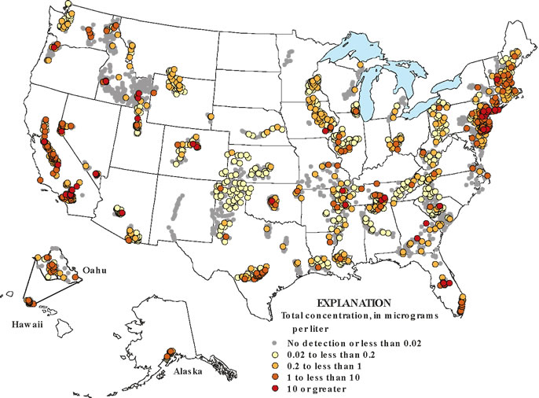

Figure 1.5 Levels of VOCs found in aquifers throughout the United States (Source: Zogorski, 2006, with permission)

Pathogens
Pathogens, or disease causing organisms, can be broken into three categories: bacteria, protozoa, and viruses. Examples of the different types of pathogens are provided in Table 1.3.
Table 1.3 Pathogen types and examples (adapted from Urban Waterways: Removal of Pathogens in Stormwater, North Carolina, N.D.)
Type | Example Pathogens (disease)
Bacteria | Salmonella (Salmonellosis), Escherichia coli (E. coli) O125:H7 (Gastroenteritis), Vibrio cholera (Cholera), and Salmonella typhi (Typhoid fever)
Protozoa | Giardia lamblia (Giardiasis), Cryptosporidium (Cryptosporidiosis), Entamoeba histolytica (amoebic dysentery
Virus | Hepatitis A (infectious hepatitis), Rotavirus (Gastroenteritis, Adenovirus (respiratory disease, gastroenteritis)

Many of these pathogens are commonly found in runoff and may pose a threat to human health. Fecal coliform and E.coli bacteria are the commonly used indicators of pathogen presence. E. coli was found in 100 percent of the 24 samples submitted to the International Stormwater Database and included in Table 1.2. Fecal coliforms were detected in 86 percent of the 151 samples submitted to the Database. Clark and Pitt (2007) found fecal streptococci and E. coli in 94 and 95.5 percent, respectively, of the municipal separate stormsewer outfalls they tested (presented in Nieber et al., 2014). Select pathogens are discussed in further detail below. Please note that the mobility of these pathogens is based on the worst case scenario (i.e. sand/low organic soils).
Coliforms (including fecal coliforms and E. coli)
Total coliforms includes fecal coliforms and E. coli. Fecal coliform is a bacteria associated with both human and animal waste. E. coli is a subset of the fecal coliforms. Overall, most strains of E. coli are harmless, although some are in fact pathogenic. Those that are pathogenic may cause, among other things, diarrhea, urinary tract infections, respiratory illness, and pneumonia. Fecal coliforms and E. coli are often used as indicator organisms because their presences often indicates that other, more pathogenic organisms are present. There is growing evidence, however, that these organisms might not correlate well with the presence or absence of viruses and other pathogens. Some people are moving towards using total coliforms, though E. coli and fecal coliforms are still common. Below is a list of some of the characteristics of coliforms (Clark and Pitt, 2007 [as presented in Nieber et al., 2014]; some information is based on characteristics of other bacteria in Pitt et al., 1994):
Abundance in stormwater: Likely present
Mobility: Low/intermediate
Potential transport to groundwater: Low/moderate
Giardia lamblia (Giardia)
Giardia is protozoan pathogen that causes gastrointestinal illness if ingested. Specifically, it can cause diarrhea, stomach or abdominal cramps, upset stomach or nausea, and dehydration (CDC, 2012). Below is a list of some of the characteristics of Giardia (Based on protozoa characteristics provided in Pitt et al., 1994):
Abundance in stormwater: Likely present
Mobility: Low/intermediate
Potential transport to groundwater: Low/moderate
Cryptosporidium
Like Giardia, Cryptosporidium is a protozoan pathogen that causes gastrointestinal illnesses if ingested. Common symptoms are stomach or abdominal cramps, nausea, severe diarrhea, and dehydration. If a person is immuno-compromised, this pathogen can be fatal. Below is a list of some of the characteristics of Cryptosporidium (Based on protozoa characteristics provided in Pitt et al., 1994):
Abundance in stormwater: Likely present
Mobility: Low/intermediate
Potential transport to groundwater: Low/moderate
Enterovirus
The group Enterovirus is made up of many different viruses, including polio. Often times a person who becomes infected with a non-polio Enterovirus does not become sick. Of those that do, common symptoms range from symptoms similar to the common cold up to an infection of the heart or brain which could lead to paralysis. Below is a list of some of the characteristics of Enterovirus (Pitt et al., 1994):
Abundance in stormwater: Likely present
Mobility: High
Potential transport to groundwater: High

1.2.2 Pollutant Fate and Transport
Subsurface soil has the ability to remove some types of pollutants through a process called natural attenuation. Natural attenuation refers to the “reduction in mass or concentration of a compound in groundwater over time or distance from the source of constituents of concern due to naturally occurring physical, chemical, and biological processes, such as; biodegradation, dispersion, dilution, adsorption, and volatilization” (ASTM, 2003). It is emerging as a viable, and in some cases the preferred remedy for dealing with contaminated groundwater. It is often the preferred remedy because natural attenuation does not transfer the pollutants from one location to another but rather breaks them down in place, often into non-toxic end products.
The breakdown is often times performed by bacteria that naturally inhabit many of the ground water environments, or by die-off, such as with pathogens. More and more it is being discovered that bacteria are able to break down chemicals once thought to be virtually non-biodegradable. For example, components of gasoline such as benzene, toluene, ethylbenzene, and xylene (BTEX) are now known to biodegrade in ground water to carbon dioxide and water. Other contaminants, including chlorinated solvents (e.g., dry-cleaning solvents), can also biodegrade under particular conditions. In some cases, natural biodegradation may break down contaminants in ground water faster than they can be removed by engineered systems. Other types of removal that can occur include filtration, adsorption, and sedimentation.
Natural attenuation is not always a completely effective remedy by itself. In cases where the contamination is spreading more quickly than it can naturally break down, where drinking-water wells are in close proximity, where the characteristics of the pollutant does not lend itself to natural attenuation, or when toxic breakdown products occur, engineered systems are needed. Whether or not a pollutant will be removed from the stormwater runoff is determined by the characteristics of the chemical and subsurface conditions. Further discussion on the removal of the pollutants discussed in Section 1.2.1 is provided below.
Nitrogen
When nitrogen containing compounds are present in the subsurface, there is a potential for nitrate to contaminate of groundwater. Nitrogen removal can be complicated. As shown in Figure 1.6, nitrogen in the root zone can be taken up by plants. In the vadose (unsaturated) zone, ammonium and ammonia undergo nitrification to become nitrite (NO₂⁻) and then nitrate (NO₃⁻). This process requires aerobic bacteria. If an anoxic zone is present, denitrification may occur within the infiltration BMP. When undergoing denitrification, the nitrate is reduced to molecular nitrogen (N₂) (WEF, 2012). If no anoxic zone is present, or the right bacteria are not present, the anoxic zone is incapable of converting all the nitrate to molecular nitrogen, the nitrate will continue to leach down to the groundwater. Other removal mechanisms for nitrogen besides nitrification and denitrification are sedimentation and plant metabolism.
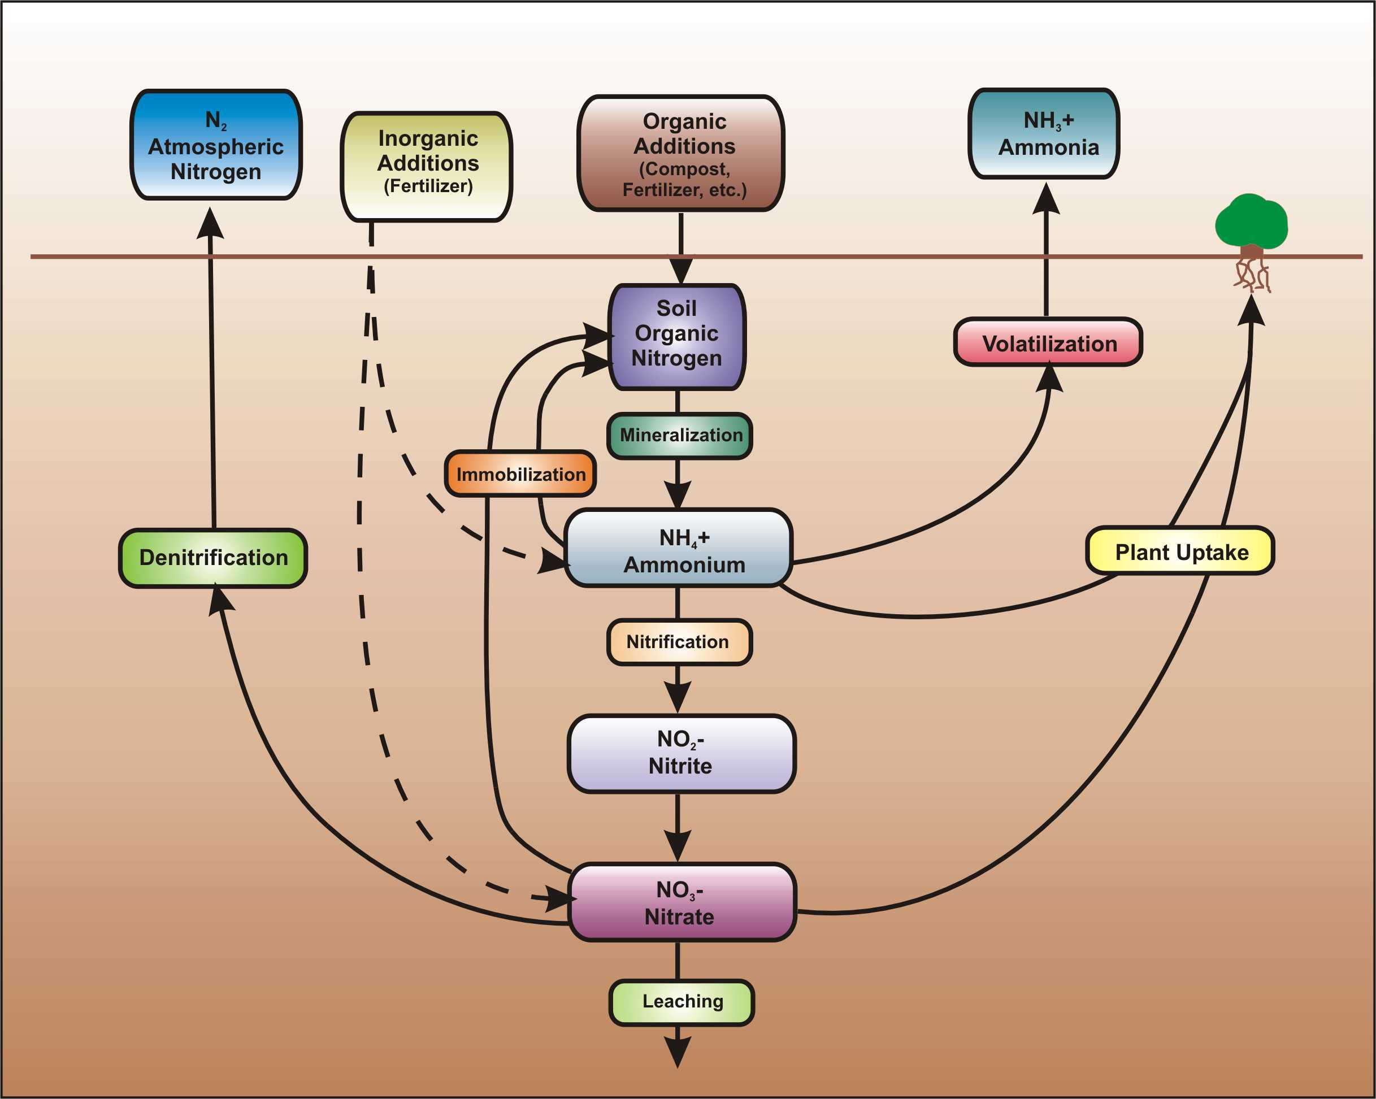
Figure 1.6 Process of nitrification and denitrification

(Source: Low Impact Development Center / LID-stormwater.net http://www.lid-stormwater.net/greenroofs_benefits_ncycle.htm, with permission)

As stated previously, due to the low concentrations in stormwater runoff, nitrate has only a low to moderate potential to contaminate the groundwater. If the concentrations are high, however, the contamination potential increases.
Chloride
Chloride has a high potential to contaminate groundwater. It is soluble, non-filterable, and does not sorb to solids (Levelton Consultants Ltd., 2008). There is no effective removal mechanism for chlorides. Rather than being removed, chloride concentrations are usually found to increase as infiltrated stormwater passes through the soil (Pitt et al., 1999).
Cyanide
At the soil surface, cyanide compounds will form hydrogen sulfide and evaporate into the atmosphere. In the soil, cyanide is fairly mobile but will most likely biodegrade under aerobic and anaerobic conditions, at low concentrations (ATSDR, 2006).
Metals
Metals can be found in a dissolved state or bound to suspended solids in stormwater, with most bound to suspended solids. As such, metals are easily filtered out. Metals do not biodegrade, so they can accumulate and persist for long periods of time (Weiss et al., 2008). Unless the soils are disposed of, there is the potential for the metals to remobilize due to weakening bonds brought about when environmental conditions change. If the metals do remobilize, or they are not filtered out near the surface to begin with, they will move further into the subsurface where a decrease in potential bonding sites has been observed (Hossan et al., 2007). This decrease in bonding sites makes it more likely that the metals will reach the groundwater.
Pitt et al. (1994) states that nickel and zinc have the highest groundwater contamination potential, while chromium and lead have only a moderate potential. This is based on their adsorption potential, which is provided below. Lead has the highest potential (Nieber et al., 2014):
lead > copper > nickel > cobalt > zinc > cadmium
Other common removal mechanisms are precipitation, ion exchange, and plant metabolism. For plant accumulation, the tendency of the metals to be taken in by the plant are provided below, with zinc having the highest tendency (Sun and David, 2007, as reported in Nieber et al., 2014):
zinc > copper > lead > cadmium
Pesticides
The majority of pesticides appear to be broken down via microbial degradation, however, some such as DDT, can persists for years (Balovsek, n.d.). Groundwater contamination will occur when the residence time of the pesticide in the vadose zone is less than that of the time it takes the pesticide to be broken down or transformed (Pitt et al., 1994). Pitt et al. (1994) concluded that those pesticides with half-lives greater than 30 days will pose the greatest risk to the groundwater. See Armstrong and Llena (1992) (as presented in Pitt et al., 1994) for more information on pesticide fate and transport.
PAHs
In general, PAHs with a higher molecular weight are more toxic, less soluble, and more persistent in the environment. PAH removal is not fully understood or as well studied as other pollutants (Weiss et al., 2008). Common removal mechanisms are oxidation, photolysis, volatilization, and biological degradation.
VOCs
VOCs have a high vapor pressure meaning they volatilize quickly. If the VOCs reach the subsurface and groundwater, much of the removal will come from degradation. A detailed description of the properties of the various VOCs, and well as their degradation potentials, can be found in the 2006 USGS report (Lawerence, 2006).
Pathogens
In general, protozoa and larger bacteria pose only a low to intermediate risk to groundwater contamination. This is due to their larger size, which allows them to be filtered out near the surface. Viruses on the other hand are much smaller and have a greater ability to survive in the subsurface, and therefore pose more of a threat to groundwater. Table 1.4 provides more information on pathogen removal in the subsurface.
Table 1.4: Factors affecting the fate and transport of pathogens within the subsurface
Factor | Description | Source
Soil Texture | Filtration is generally more effective in fine grained soils (i.e. silts and clays. This process is generally only significant when the average size of the pathogen is greater than 5% of the average pore space meaning protozoa and some bacteria may be removed this way but not viruses | Karathanasis et al., 2007  Ginn et al., 2002
Soil cation exchange capacity | The process by which the pathogen becomes attached to the soil particles. It is most effective with viruses and smaller bacteria. Adsorption generally increases as the clay content in the soil increases and increases as soil pH decreases. | Bitton and Gerba, 1994  Lewis et al., 1980
Soil moisture content | Moisture content appears to be one of the most influential factors in determining the survival time of pathogens. In general the survival time will increase as the moisture content increases. | Beard, 1940  Kibby et al., 1987
Temperature | Temperature is another significant factor. In general, survival time increases as temperature decrease. | McFeters and Stuart, 1972  Kibby et al., 1978
pH | Survival time of pathogens appears greatest when soil is near neutral pH and decreases as the pH moves away from that range. | McFeters and Stuart, 1972
Organic content | The increased presence of organic content has been found to increase the survival time of pathogens, as well as to allow for the potential for some re-growth. This may be due not only to the presence of available nutrients but also to the fact that organic matter has the ability to retain moisture. | Lewis et al., 1980  Tate, 1978
Predation | Microbial predators in the sub-surface have been found to reduce the concentration of pathogens in the soil and water (Tate, 1978). | Tate, 1978

1.2.3 Summary
In general, particulate pollutants (such as total suspended solids [TSS]) and those pollutants that primarily bind to particulates (such as metals) are easily removed by the filtration process within the infiltration BMPs. Soluble contaminants on the other hand, such as chloride, have the potential to be carried for some distance and may eventually reach the groundwater table. Protozoa and larger bacteria are more easily removed from the system than smaller bacteria and viruses. The approximate location of pollutant removal is shown in Figure 1.7. Table 1.5 provides a summary of the common removal mechanisms.
Of particular concern are mobile toxic organics (gasoline, solvents), nitrates, viruses and chloride. If it is possible to do so, these contaminants should be removed from the stormwater prior to infiltration. To accomplish this, an appropriate pretreatment technique is needed. Any runoff containing toxic material that will not bind to soils, be easily removed, or excess volume that cannot infiltrate, should be diverted away from the infiltration BMP to another treatment device.
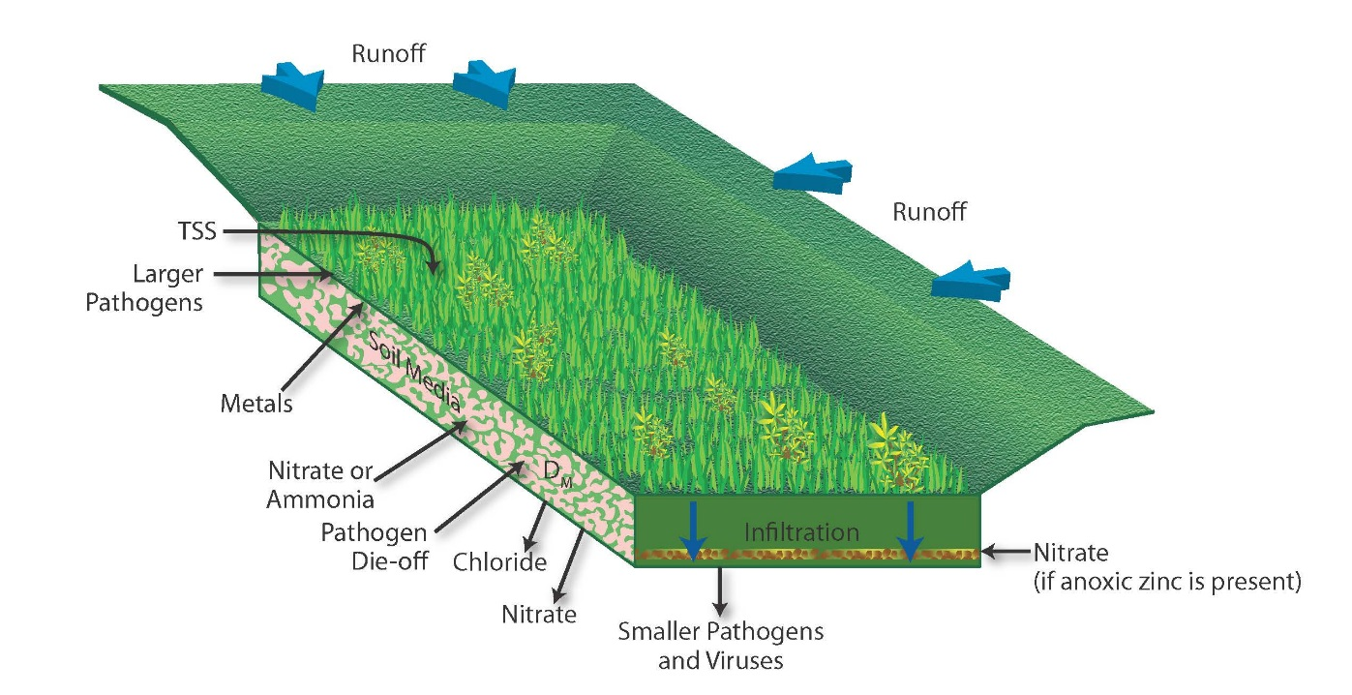
Figure 1.7 Pollution removal process in the subsurface (Source: CDM Smith)
Table 1.5 A summary of the pollution removal mechanisms (Adapted from Horner, 1994 as reported in the Wisconsin Storm Water Manual Part 2 (n.y.)
Mechanism | Pollutants affected | Promoted by
Sedimentation | Solids, BOD, pathogens, particulate COD, P, N, metals, synthetic organics | Low turbulence
Filtration | Same as sedimentation | Fine, dense herbaceous plants, constructed filters
Soil Incorporation | All | Medium-fine texture
Precipitation | Dissolved P, metals | High alkalinity
Sorption - Adsorption | Dissolved P, metals, synthetic organics | High soil Al, Fe, high soil organics (Met), circumneutral pH
Sorption - Ion Exchange | Dissolved metals | High soil cation exchange capacity
Oxidation | COD, petroleum hydrocarbons, synthetic organics | Aerobic conditions
Degradation - Photolysis | Same as oxidation | High light
Degradation - Volatilization | Volatile petroleum hydrocarbons, synthetic organics | High temperature and air movement
Degradation -Biological Degradation | BOD, COD, petroleum hydrocarbons, synthetic organics | High temperature and air movement
Plant Metabolism | P, N, metals | High plant surface area
Pathogen Die-off | Pathogens | Plant excretions
Nitrification | NH3-N | Dissolved oxygen >2 mg/L, low toxicants, temperature >5-7°C, circumneutral pH
Denitrification | NO3 + NO2-N | Anaerobic, low toxicants, temperature >15°C

1.2.4 Additional Studies
Good monitoring data on the groundwater impact of infiltrating stormwater are rare, but there are efforts underway today to document this. Weiss et al. (2008) provides a literature review regarding the potential for soil and groundwater contamination due to infiltration practices. Pitt et al. (1999) provides information on the potential for specific pollutants to contaminate the groundwater. The EPA has also published a list of studies that look at the groundwater impacts from, among other things, infiltration BMPs. Selected other studies are described below.
Metropolitan Council, 2014. The authors studied the potential for common stormwater contaminants to reach the groundwater in the Twin Cities Metropolitan Area, Minnesota. Practices studied were an infiltration basin near the St. Paul campus of the University of Minnesota, an infiltrating rain garden at Como Park, and an infiltration gallery at Beacon Bluff. The investigation lasted 18 months and the contaminants of concern included chloride, nitrate, phosphorus, various heavy metals, and petroleum hydrocarbons. Also included in the report is a literature review regarding stormwater infiltration practices and the fate and transport of common contaminants. The results of the experiments and of the literature review indicated that nitrate contamination was not a concern. Chloride, however, is a concern and a reduction in winter salt use was recommended. The study also found that the BMPs studied had the ability to capture dissolved metals and petroleum hydrocarbons. In addition, pathogens and suspended solids were filtered out while viruses were not.
Dechesne et al., 2005. The authors studied the long-term potential for clogging and soil pollution from infiltration basins located in Lyon, France. The age of the basins ranged from 10 to 21 years. The authors studied cadmium, copper, lead, zinc, total organic carbon, total hydrocarbons, and particulates. The result of their investigation showed that the concentration of pollutants was greatest in the topsoil layer and decreased with depth. Even after 21 years of operation, most of the pollutants did not travel deeper than 30 to 40 centimeters below the surface. The exception was zinc, which was the most mobile.
Fischer, 2003. The authors sampled 16 monitoring wells installed in infiltration basins and 30 shallow groundwater wells located in an area with sandy soil and a shallow groundwater table. Wells were installed 3 feet (1 meter) into the groundwater table. Samples were collected biannually (summer and winter) from 1997 to 1999. Samples collected within the infiltration basins had a greater detection frequency for petroleum hydrocarbons than the background samples, and samples from below the basin detected certain pesticides with more frequency than the background samples. On the other hand, herbicides were found more often in the back ground samples, along with chlorinated hydrocarbons. The authors concluded that the increased volume of water traveling through the infiltration BMP diluted the background chemicals and also increased the levels of the pollutants entering via the stormwater runoff. This indicates that some pollutants can reach the groundwater table through infiltration BMPs.
Mikkelsen et al., 1997. The authors looked at infiltration basins and heavy metals, PAHs, and absorbed organically bound halogens (AOX) commonly found in runoff from roads in north-western Switzerland. Surface soils and subsurface sediments had high concentrations of these pollutants; however, the concentrations dropped rapidly with depth and were greatly reduced by the time the water left the infiltration basin. This indicates that the surface and subsurface of the infiltration BMP was able to retain the pollutants studied here. Overall, the authors concluded that stormwater infiltration did not pose a great risk to the underlying groundwater table. Pollutants however did build up in the soil to environmentally critical contaminant levels, meaning that the soils would pose a waste disposal problem if the soils were to be removed in the future.
1.3 Pre-Treatment Considerations for Stormwater Infiltration
Infiltration BMPs are susceptible to clogging from the trash, debris, and suspended sediments present in runoff. Pretreatment can remove debris and coarser sediments in an easier-to-maintain pre-treatment device that will extend the life and reduce maintenance for the infiltration BMP.
If work is being done under an MPCA Permit, then it is REQUIRED that some form of pre-treatment be installed upstream of an infiltration BMP. In all other cases pretreatment is highly recommended. Pretreatment is of particular importance in the following situations (Figure 1.8):
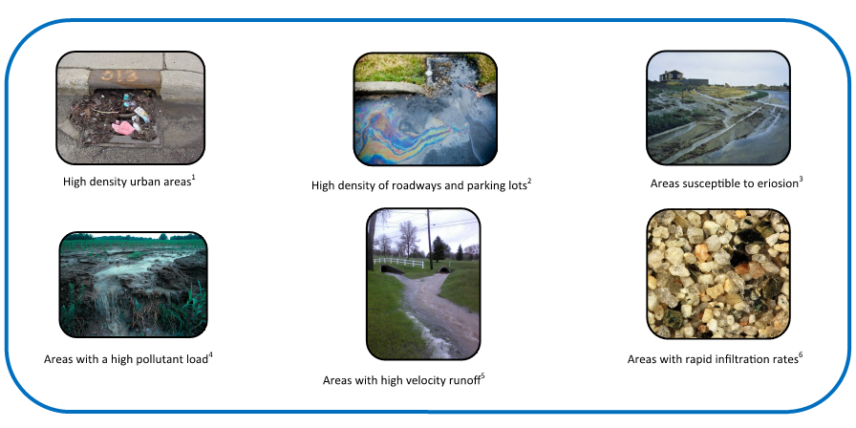
Figure 1.8 Times when pretreatment is of particular importance (Source: ¹Environmental Health and Safety, Western Michigan University, with permission) Storm Water; ²Winegrad, Gerald. 2015. Chesapeake Bay Action Plan; ³WI DNR. 2012. Soil Erosion from New Construction.⁴Betts, Lynn. 1999. Runoff of Soil & Fertilizer. ⁵Hoogestraat, Galen. 2013. Runoff Flowing through Arrowhead Golf Course. ⁶Sepp, Siim. 2011. Rounded Fine-Grained Eolian Sand Sample from the Gobi Desert.

- High density urban areas. High density urban areas are more likely to contain high concentrations of trash, sediments, and pollutants which can be carried by the stormwater runoff. High density urban areas contain a higher concentration of roadways; of particular concern with roadways are trash, debris and sediments (making pre-treatment an important part of the BMP) as well as metals and chlorides.
- Areas with high potential for erosion. Areas that are susceptible to erosion are of concern because of high sediment loads that reduce the BMP’s infiltration capacity. This will clog the infiltration BMP.
- Areas where stormwater has a high pollutant load. Areas with a high pollutant load, or the presence of certain pollutants that are not easily removed from runoff are a concern because they have the potential to contaminate the groundwater
- Storm sewers that convey runoff at a high velocity. A high velocity will keep sediment in suspension. Pretreatment should be installed to facilitate the proper settling of the sediment, which will prevent clogging. In addition, high velocities can reduce the volume of runoff that can be infiltrated.
1.3.1 Common Pretreatment Methods
Forebays (small sediment basins) are the most common pretreatment method, though there are many others, including cisterns, drain inlet inserts, green roofs, oil/water separators, proprietary settling/swirl chambers, vegetated filter strips, and vegetated swales. It is important to note that many of these pretreatment techniques will require routine maintenance. A summary of the unit processes employed by each of the pretreatment techniques can be found in Table 1.6. A more detailed description of each processes can be found in Section 1.3.2.
Forebays. Forebays, also known as plunge pools, are small basins upstream of other BMPs that dissipate the velocity of the incoming water and provide stilling, sedimentation, and trapping of gross pollutants.
Cisterns. Cisterns are tanks located above or below ground that are used for storing a specific amount of runoff for the purpose of non-potable reuse (e.g. irrigation or vehicle washing). Small cisterns are also known as rain barrels. These completely remove the runoff from the treatment train and, therefore, provide 100 percent pollution reduction from the volume of water retained. Cisterns are often used to collect stormwater runoff from rooftops (termed rainwater harvesting), but they can also be used to intercept runoff from other impervious areas.
Drain Inlet Inserts. Drain inlet inserts are devices placed into stormwater drains or catch basins to remove pollutants from stormwater prior to entering the storm sewer system. These inserts utilize an inert filter material, such as polypropylene, to enhance pollutant removal (WEF, 2012). Drain inlet inserts have the ability to remove debris, trash, large sediments and, if a filter material is present, can also remove oils/greases and other pollutant types.
Green roofs. Green roofs capture rainfall on a roof top vegetated surface before the rainfall is allowed to become runoff. These are located at the beginning of the stormwater treatment train to provide volume reduction and to prevent runoff from collecting pollutants associated with rooftops. As green roofs employ a media for the vegetation, they are often times not effective at removing phosphorous and do not get credit for phosphorous removal in this Manual.
Oil/water separators. Oil/water separators are structures designed specifically to remove petroleum hydrocarbons, grease, sand, and grit. These separators can be split into two categories, American Petroleum Institute (API) separators and coalescing plate separators (WEF, 2012). API separators are a larger vault with baffles which enhance hydraulic efficiency. Coalescing plate separators use sloped plates or extruded tubes to achieve sediment and oil removal, and are smaller than the API structures.
Proprietary settling/swirl chambers. Proprietary settling/swirl chambers or concentrators, also known as hydrodynamic devices, cause the stormwater to move in a circular motion which enhances the settling out of sediments. These devices often remove solids, oils/grease, floatable sand, and other larger debris from stormwater runoff.
Vegetated filter strips. Vegetative filter strips reduce the velocity of stormwater runoff, allowing the sediments to settle out. Filter strips work best when receiving runoff as sheet flow, making them suitable alongside roads, parking lots, and other paved surfaces.
Vegetated swale. Vegetated swales are similar to vegetated filter strips. These devices are better suited for concentrated flow in addition to sheet flow of runoff. The flow path through the swale allows for the settling and filtration of coarse particles, and limited infiltration.
1.3.2 Additional Studies
Mohamed, Lucke, and Boogaard, 2013. The authors looked at the potential to increase the effective life of permeable pavement systems by first routing the runoff through a swale. The study took place in Australia with the objective of determining the variation in pollutant removal performance along the length of the swale. The experiment showed that the grassed swales studied were effective at removing the sediment from the runoff, and would thus slow down the rate at which the permeable pavement would become clogged. The authors concluded that excessively long swales are not a cost effective solution because most of the removal happens in the first 10 meters. They also concluded that removal of 50 percent of the TSS would significantly increase the life span of the permeable pavements.
Browne, Deletic, Fletcher, and Mudd, 2011. The authors developed a dynamic two dimensional variably saturated flow model that allows a user to represent the storage and clogging of an infiltration trench. The authors modeled the hydrologic effectiveness of infiltration trenches and infiltration basins with no clogging, clogging for 10 years, and clogging for 50 years. The BMPs were modeled in sandy loam and sandy clay. The results showed that there was a significant decrease in the hydrologic effectiveness of the BMPs in sandy loam after 10 years of clogging, and another decrease after 50 years of clogging. With the BMPs in the sandy clay, there was no noticeable decrease after 10 years of clogging, but there was a decrease after 50 years. The results of this experiment show that pre-treatment can increase the lifespan of an infiltration BMP.
Table 1.6 Unit Processes of Stormwater Treatment Techniques (Adapted from WEF, 2008)
 | Hydraulic / Volume  Control |  |  |  |  |  | Physical  Mechanisms |  |  |  |  |  |  |  | Biological Mechanisms |  |  | Other Mechanisms
 | Peak flow attenuation | Runoff volume reduction | Infiltration | Dispersion | Evapotranspiration | Runoff collection and usage | Sedimentation | Flotation | Laminar separation | Swirl concentration | Sorption | Precipitation | Coagulation | Filtration | Plant metabolism | Nitrification/denitrification | Organic compound degradation | Pathogen dieoff | Temperature reduction | Disinfection
Pre-Treatment Techniques
Vegetated filter strips |  |  | X | X |  |  | X |  |  |  |  |  |  | X | X |  |  |  | X
Vegetated swale |  |  | X | X |  |  |  |  |  |  |  |  |  | X | X |  |  |  | X
Forebays |  |  |  |  |  |  | X | X
Street/ parking lot sweeping |  |  |  |  |  |  | X
Proprietary settling/swirl chambers | X |  |  |  |  |  | X | X |  | X
Oil/water separators |  |  |  |  |  |  | X | X | X
Green roofs | X |  |  | X | X |  |  |  |  |  | X |  |  |  | X |  |  |  | X
Cisterns |  |  |  |  |  | X
Drain inlet inserts |  |  |  |  |  |  | X |  |  |  |  |  |  | X
Primary Treatment Techniques
Infiltration basin | X | X | X |  |  |  | X | X |  |  | X | X | X |  |  | X | X | X | X | X
Infiltration trench | X | X | X |  |  |  | X |  |  |  | X | X | X |  |  | X | X | X | X | X
Bioretention | X | X | X |  | X | X¹ | X | X |  |  | X | X | X | X | X | X | X |  | X | X
Permeable pavement | X | X | X |  |  | X¹ |  |  |  |  | X | X | X |  |  |  | X | X | X | X
Tree trench/tree box |  | X | X |  | X |  |  |  |  |  |  |  |  |  | X
Enhanced turf |  |  | X |  |  |  |  |  |  |  |  |  |  |  | X
¹If underdrain is present

1.3.1 Mechanisms of Pollutant Removal in BMPs
Table 1.6 listed the unit processes of the BMPs for volume control, physical processes, biological processes, and chemical processes. The volume control and physical processes are illustrated in Figure 1.9, biological processes in Figure 1.10, and chemical processes in Figure 1.11. These controls/processes are described in more detail below.
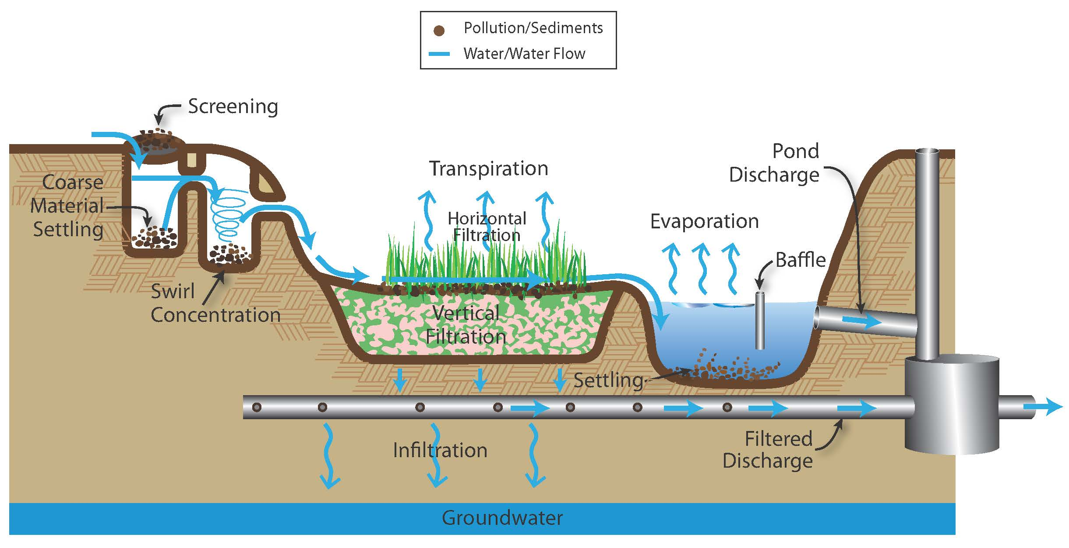
Figure 1.9 Volume control and physical processes illustration (Source: CDM Smith)
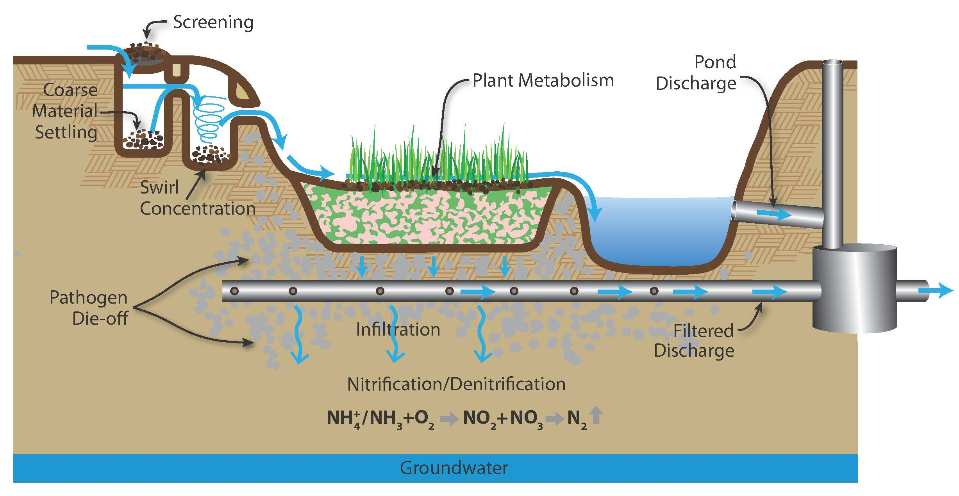
Figure 1.10 Biological processes illustration (Source: CDM Smith)
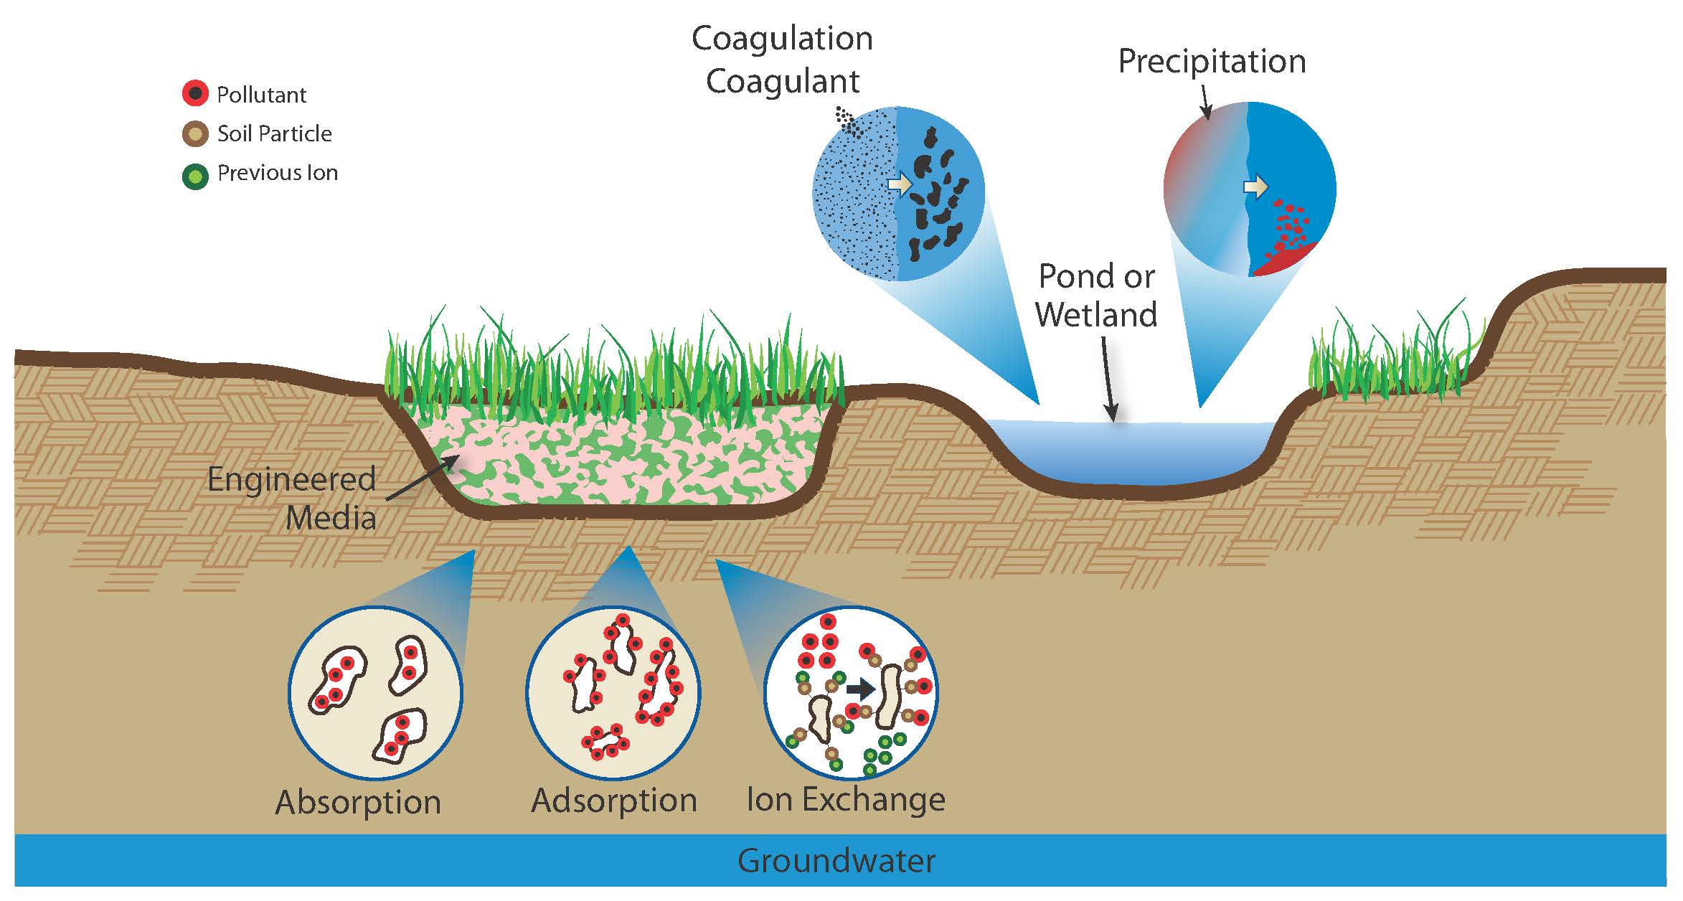
Figure 1.11 Chemical control processes illustration (Source: CDM Smith)
Volume Control
Peak flow attenuation. Peak flow attenuation is the process by which the peak stormwater runoff discharge is reduced and the total volume of stormwater flow is spread out over a longer period of time. The result is a broad, more flat hydrograph (DNR) (See Figure 1.12)
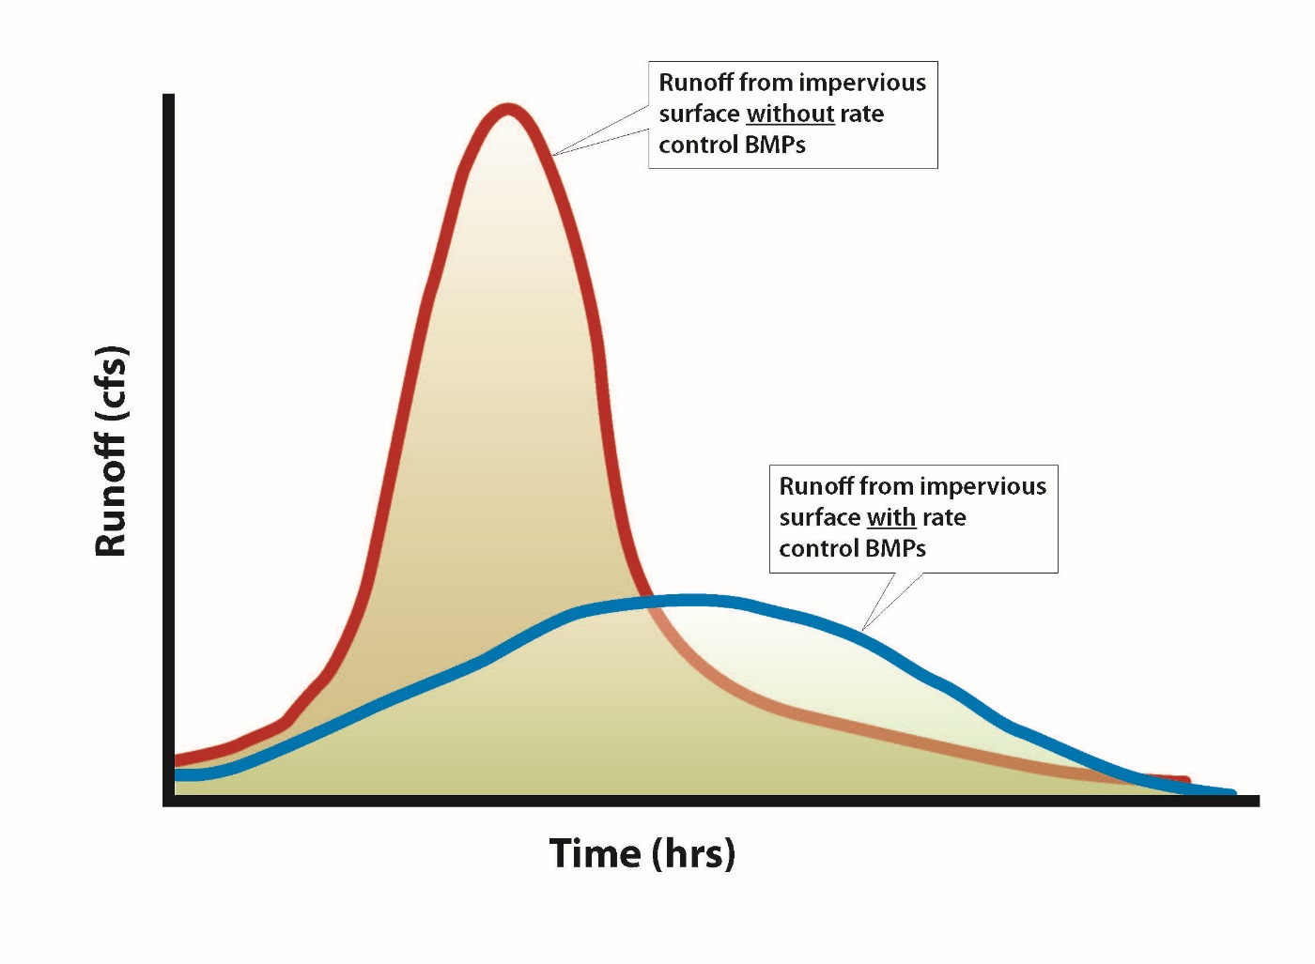
Figure 1.12 Change in the hydrograph due to the presence of infiltration BMPs (Source: CDM Smith)
Runoff volume reduction. Runoff volume reduction means that a portion of the runoff is removed from the system, and the overall runoff volume is decreased (WEF, 2012).
Runoff Collection. Runoff collection is the process by which runoff is captured and stored for a later use. Storage varies from cisterns and rain barrels up to large water tanks and ponds (WEF, 2012).
Infiltration. Infiltration is the process by which the stormwater enters into the subsurface. It is different from filtration in the fact that the water is not ultimately collected by any underdrain system, but rather the infiltrated water continues to move down into the subsurface and groundwater table, or moves laterally as subsurface flow (Erickson et al., 2013). Infiltration does not only achieve volume control and peak flow attenuation, but also contributes to pollution reduction.
Evaporation. Evaporation is the process by which water changes from a liquid to a gas. It can occur from plant interception, depression storage, and from within the soil. Evaporation from interception occurs when rain falling on a vegetative surface is intercepted by leaves or blades. The water captured then evaporates back into the atmosphere. Evaporation from depression storage occurs when the runoff is captured in puddles or ponded areas. The water trapped in these areas evaporates back into the atmosphere. Soil evaporation is different than depression storage evaporation because it occurs within the soil rather than on the surface of the soil. As water right near the surface evaporates, water from deeper in the soil profile moves upward to replace that water (WEF, 2012).

Physical Processes
Sedimentation. Sedimentation is the process by which solids are removed from the stormwater runoff via settling (Erickson et al., 2013).
Screening. Screening is the process by which gross pollutants are removed through straining devices with large openings (WEF, 2012).
Transpiration. Transpiration is the process by which water vapor passes into the atmosphere through the vascular system of plants (WEF, 2012).
Filtration. Filtration is the retention of suspended particles as the water passes through a granular media or vegetation. The predominate mechanism of filtration is straining, which occurs when particles are too large to pass through the void space in the media (Erickson et al., 2012).
Flotation. Flotation is when materials (e.g., plastic bags, petroleum hydrocarbons, light solids) remain on the surface of the water because they have a specific gravity that is less than the water (WEF, 2012).
Temperature reduction. Temperature reduction is the process by which stormwater with a high temperature will cool due to the fact that it is in contact with a surface (i.e., ground, air, etc.) at a lower temperature (Erickson et al., 2013).
Laminar separation. Laminar separation is a process by which certain pollutants are removed from stormwater using laminar flow conditions. Laminar conditions can be achieved by using plates or tubes to calm the water. Turbulence (even mild turbulence) will lead to a reduction in the removal of oil droplets and fine sediments from the runoff WEF, 2012).
Swirl concentration. Swirl concentration is a process by which stormwater runoff is routed through cylindrical shaped devices that create a vortex. This swirling motion helps to enhance the separation of particles from the stormwater (WEF, 2012).
Biological Processes
Pathogen die-off. Pathogen die-off is the process by which pathogens are inactivated via death. Factors that affect pathogen die-off can be found in Table 1.4.
Plant metabolism. Plant metabolism is the process by which plants take in certain nutrients (which can be pollutants in stormwater) to aid in the plant growth (WEF, 2012). This is one of the main mechanisms by which phosphorous is removed from stormwater runoff.
Degradation. Degradation is the process by which pollutants are broken down into less harmful components. Bacteria often play an important role in degradation and have been found to degrade pesticides, petroleum compounds, and other anthropogenic organics.
Nitrification/denitrification. Nitrification/denitrification is the process by which nitrogen is removed from stormwater. With nitrification, ammonium (NH₄⁺) or ammonia (NH₃) is oxidized to form nitrite (NO₂⁻) and then nitrate (NO₃⁻). It is an aerobic process (requires oxygen) and requires the presence of Nitrosomonas and Nitrobacters type bacteria to form nitrite and nitrate, respectively. Denitrification is the process by which nitrate is reduced to form molecular nitrogen (N₂). It occurs in anaerobic conditions (no oxygen) with the aid of different types of bacteria (WEF, 2012).
Chemical Processes
Precipitation. Precipitation is the process by which inorganic dissolved species join together to form a settleable or filterable particulate. This process can occur naturally or with the aid of chemicals. Natural precipitation occurs without the purposeful addition of chemicals. For example, if the stormwater has sufficient calcium and alkalinity, calcium phosphates may form which are more easily removed from the system. Chemical precipitation is the result of the addition of a substance that will aid in the formation of the precipitates. For example, the addition of alum and sodium aluminate into water can aid in the removal of phosphorous (WEF, 2012).
Coagulation. Coagulation is the process by which smaller particles collect together to form larger particles. This allows the particles to then settle out. Chemicals can be added to aid the removal of silts, clays, or other dissolved pollutants. The process of coagulation is twofold. First, the particles must be destabilized. Suspended small particles tend have a negative charge and repel each other and, by destabilizing the charge, the smaller particles will begin to join together. The joining of these particles is the second step, flocculation. Flocculation can occur naturally (e.g., wind in a wet basin) or mechanically (e.g. paddles) (WEF, 2012).
Sorption. There are three types of sorption; adsorption, absorption, and ion exchange. Adsorption is when pollutants bind to the surface of a soil particle. If the chemical equilibrium changes in the future, the pollutants can desorb and continue to travel downward towards the groundwater table. With absorption, a pollutant penetrates the soil and attaches at a molecular level. With ion exchanged, existing less “interesting” ions are replaced with ions of greater interest to the media (WEF, 2012).
1.4 Stormwater Infiltration BMPs
Infiltration BMPs include, but are not limited to:
- Infiltration basins
- Infiltration trenches
- Bioretention areas (most often a rain garden)
- Permeable pavements
- Tree trenches/tree boxes
- Underground infiltration
Infiltration BMPs are preferred in areas tributary to lakes, trout waters, and wetlands, unless the target TMDL pollutant is a soluble nutrient or chloride. Infiltration BMPs are preferred in surface water drinking supply areas, but are restricted from being used in groundwater drinking water source areas if potential stormwater pollution sources are evident.
A brief summary of each infiltration BMP is given below, along with a link to find more information. Table 1.6 provides a reference for the unit processes associated with each BMP.
1.4.1 Infiltration Basin
An infiltration basin is a natural or constructed impoundment that captures, temporarily stores, and infiltrates a design volume of water.
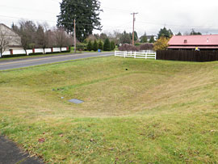
Figure 1.13 Infiltration Basin (Source: Cark County, Washington, with permission)

Table 1.7 Applications and Treatment Capabilities of Infiltration Basin
Applications |  | Treatment Capabilities^{1,2}  (Low = < 30%; Medium = 30-65%; High = 65 -100%)
Residential | Yes | TSS | High⁵
Commercial | Yes | TN | Med/High
Ultra urban | Limited³ | TP | Med/High
Industrial | Yes⁴ | Chloride | Low
Highway/Road | Limited | Metals | High
Recreational | Yes | Oils and Grease | High
-- | -- | Pathogens | High
Sources: Schueler, 1987; EPA, 2003a and 2003b; Birch et al., 2005; California Stormwater Manual, 2009; Pennsylvania Stormwater Manual, 2006
¹Underground infiltration systems will have different pollutant removal capabilities than what is provided in this table. These systems may have a wider application range, however, there is concern that they do not provide adequate treatment of the pollutants.
²This is only for the portion of flow that enters the infiltration basin; by-passed runoff does not receive treatment.
³Due to a size restriction
⁴Unless the infiltration practice is located in an industrial area with exposed significant materials or from vehicle fuelling and maintenance areas. Infiltration BMPs are PROHIBITED in these areas.
⁵Assumes adequate pre-treatment

1.4.2 Infiltration Trench
An infiltration trench is a shallow excavated trench that is backfilled with a coarse stone aggregate allowing for the temporary storage of runoff in the void space of the material in addition to the storage above the aggregate within the trench.
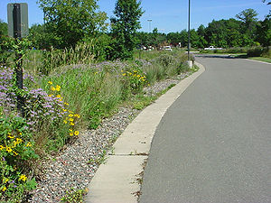
Figure 1.14 Photo of an infiltration trench in Lino Lakes (NEED PERMISSION)

Table 1.8 Applications and Treatment Capabilities of Infiltration Trenches
Applications |  | Treatment Capabilities¹  (Low = < 30%; Medium = 30-65%; High = 65 -100%)
Residential | Yes | TSS⁴ | High
Commercial | Yes | TN | Med/High
Ultra urban | Limited² | TP | Med/High
Industrial | Yes³ | Chloride | Low
Highway/Road | Yes | Metals | High
Recreational | Yes | Oils and Grease | High
-- | -- | Pathogens | High
Sources: Schueler, 1987, 1992; USEPA 1993a, 1993b; Maniquiz et al., 2010; NPRPD, 2007; California Stormwater Manual, 2009; Pennsylvania Stormwater Manual, 2006
¹This is only for the portion of flow that enters the infiltration trench; by-passed runoff does not receive treatment.
²Due to a size restriction
³Unless the infiltration practice is located in an industrial area with exposed significant materials or from vehicle fuelling and maintenance areas. Infiltration BMPs are PROHIBITED in these areas.
⁴Assumes adequate pre-treatment

1.4.3 Bioinfiltration Basins
Bioinfiltration basins, often called a rain gardens, use soil (typically engineered media or mixed soil) and native vegetation to capture runoff and remove pollutants.
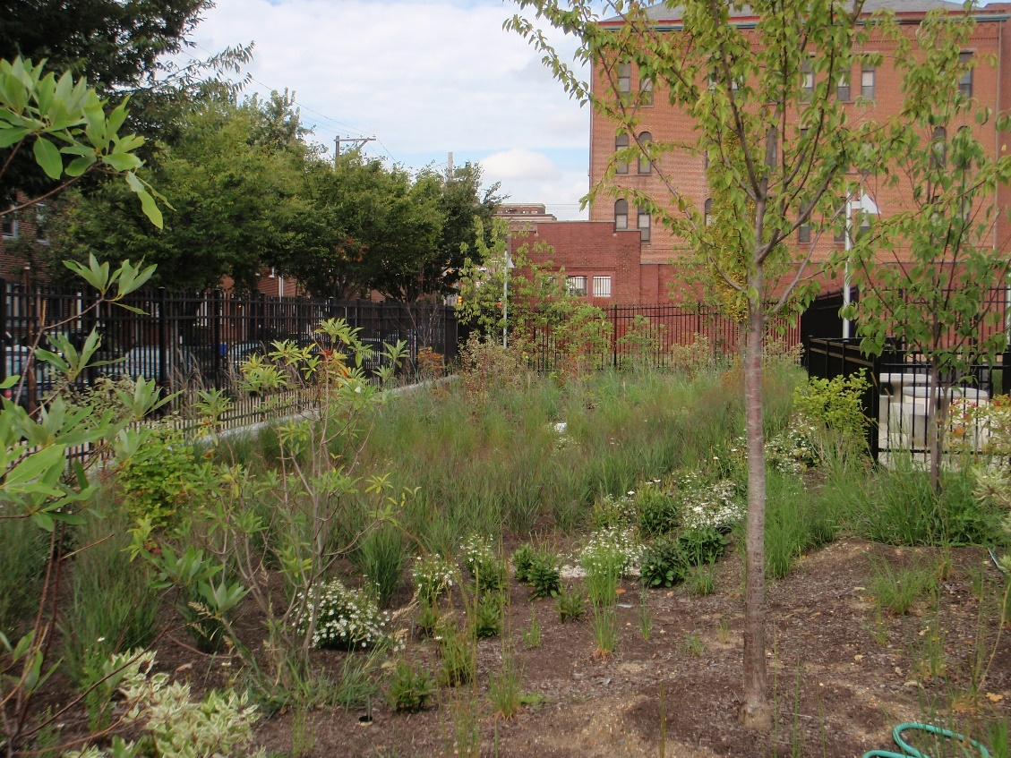
Figure 1.15 Bioinfiltration Basins (Source: CDM Smith)

Table 1.9 Applications and Treatment Capabilities of Bioinfiltration
Applications |  | Treatment Capabilities¹  (Low = < 30%; Medium = 30-65%; High = 65 -100%)
Residential | Yes | TSS | High³
Commercial | Yes | TN | Low/Med⁴
Ultra Urban | Limited | TP | Med/High⁵
Industrial | Yes² | Chloride | Low
Highway/Road | Yes | Metals | High
Recreational | Yes | Oil and Grease | High
-- | -- | Pathogens | High
Sources: EPA Factsheet, 1999; Davis et al., 2001, 2003, 2006; Hsieh and Davis, 2005; Hong et al., 2006; Hunt et al., 2006; NPRPD, 2007; Li and Davis, 2009; Diblasi et al., 2009; Passeport et al., 2009; Brown et at., 2011a, b; Komlos et al., 2012; Denich et al., 2013; Li and Davis, 2013; California Stormwater BMP
¹This is only for the portion of flow that enters the bioinfiltration basin; by-passed runoff does not receive treatment.
²Unless the infiltration practice is located in an industrial area with exposed significant materials or from vehicle fuelling and maintenance areas. Infiltration BMPs are PROHIBITED in these areas.
³Assumes adequate pre-treatment
⁴This assumes no raised underdrain
⁵Certain soil mixes can actually leach P. See the comparison of pros and cons of bioretention soil mixes here.

1.4.4 Permeable Pavement
Permeable pavements allow stormwater runoff to pass through surface voids into an underlying stone reservoir/ subbase for temporary storage and/or infiltration. They are suitable for driveways, trails, parking lots, and roadways with lighter traffic.
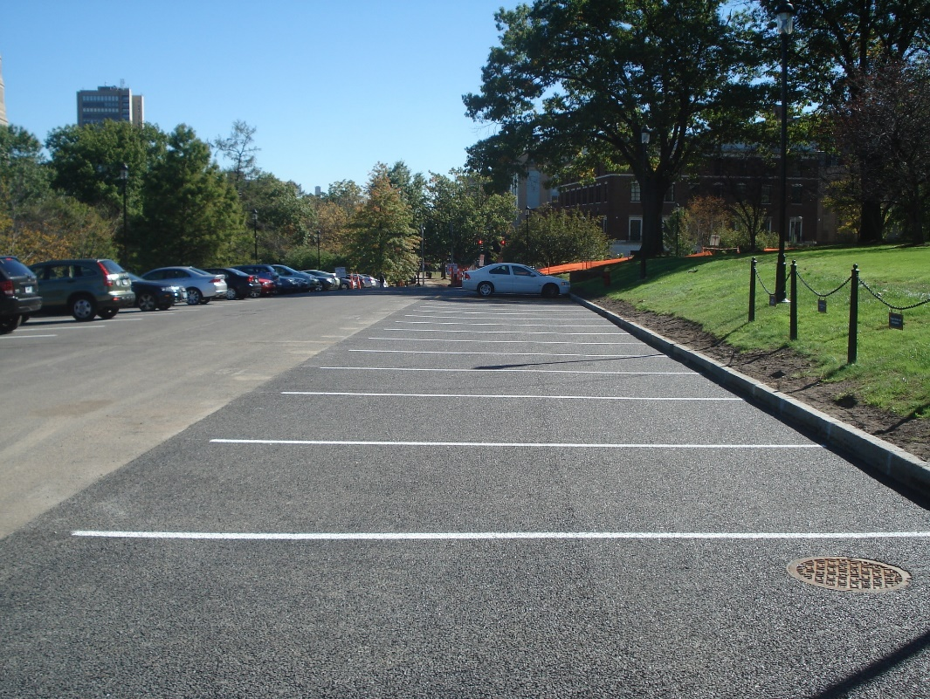
Figure 1.16 Permeable Pavement (Source: CDM Smith)

Table 1.10 Applications and Treatment Capabilities of Permeable Pavement
Applications¹ |  | Treatment Capabilities²  (Low = < 30%; Medium = 30-65%; High = 65 -100%)
Residential | Yes | TSS | High⁴
Commercial | Yes | TN | Med/High
Ultra urban | Yes | NItrate | Med/Low
Industrial³ | Yes | TP | Med/High
Retrofit | Yes | Chloride | Low
Highway/Road | Yes | Metals | High
Recreational | Yes | Oils and Grease | High
-- | -- | Pathogens | --⁴
Source: Schueler, 1987; Pratt et al, 1999; Adams, 2003; Brattebo and Booth, 2003; Adams, 2003; Bean et al, 2007; SEMCOG, 2008; International Stormwater Database, 2012
¹Recommended for pedestrian-only areas, low-volume roads, low speed areas, overflow parking areas, residential driveways, and alleys and parking stalls. More limitations can be found here.
²This is only for the portion of flow that enters the permeable pavement; by-passed runoff does not receive treatment.
³Unless the infiltration practice is located in an industrial area with exposed significant materials or from vehicle fuelling and maintenance areas. Infiltration BMPs are PROHIBITED in these areas.
⁴Assumes adequate pre-treatment
⁴Insufficient Data

1.4.5 Tree Trench/Tree Box
Tree trenches and tree boxes (collectively called tree BMPs), consist of trees planted within underground storage reservoirs designed to retain a volume of runoff for the purpose of uptake by trees. They are a variant of bioretention BMPs.

Figure 1.17 Tree Box (Source: CDM Smith)

Table 1.11 Applications and Treatment Capabilities of Tree Trench/Tree Box
Applications |  | Treatment Capabilities¹  (Low = < 30%; Medium = 30-65%; High = 65 -100%)
Residential | Yes | TSS | High³
Commercial | Yes | TN | Low/Med
Ultra Urban | Yes | TP | Med/High⁴
Industrial | Yes² | Chloride | Low
Highway/Road | No | Metals | High
Recreational | Yes | Oil and Grease | High
-- | -- | Pathogens | High
Source: File:Trees Tasks 2 and 13 Water quality benefits.docx
¹This is only for the portion of flow that enters the tree trench/tree box; by-passed runoff does not receive treatment.
²Unless the infiltration practice is located in an industrial area with exposed significant materials or from vehicle fuelling and maintenance areas. Infiltration BMPs are PROHIBITED in these areas.
⁴Assumes adequate pre-treatment
⁴Certain soil mixes can actually leach P. See the comparison of pros and cons of bioretention soil mixes here.

1.4.6 Underground Infiltration and Dry Wells
Underground infiltration systems and dry wells have been installed below parking lots and other impervious surfaces on sites where insufficient space exists for a surface infiltration system. They are designed to temporarily store stormwater runoff before slowly infiltrating the water into the subsurface (Connecticut, 2004). There are concerns about the effectiveness of these systems. One concern is that underground infiltration may meet the U.S. Environmental Protection Agency (EPA) definition of a Class V injection well. Class V injection wells are defined as any bored, drilled, or driven shaft, or any dug hole that is deeper than its widest surface dimension. Class V injection wells can also be an improved sinkhole, or a subsurface fluid distribution system (from U.S. EPA, June 2003). In Minnesota Class V injection wells are permitted by the USEPA. Minimum requirements for installing, permitting, and operating a Class V well is defined by the USEPA.
The MPCA is concerned about the overall pollutant removal effectiveness of those underground infiltration systems that do not meet the definition of a Class V injection well. The document released by the Transport Research Synthesis titled “Issues of Concern Related to Underground Infiltration Systems for Stormwater Management and Treatment” provides a good overview of the concerns related to underground infiltration systems (MNDOT, 2009). Issues identified in this report include:
- There is potential that an underground infiltration system meets the criteria of a Class V injection well.
- There is insufficient knowledge of the fate of pollutants in the subgrade below the buried infiltration systems.
- Roadways and parking lots with high volumes of traffic have higher concentrations of certain pollutants, including heavy metals and PAHs. Pretreatment devices, such as sumps, may be necessary to protect the subgrade and groundwater.
- Underground systems do not allow for the pollutant removal that is accomplished through biological activity and vegetation uptake.
- The minimum separation requirement of 3 feet between the bottom of the infiltration system and the seasonally high groundwater elevation may be insufficient for adequate pollutant removal. Additional study is recommended.
- Maintenance of underground systems is critical for effective pollutant removal. However, access for maintenance is challenging. There are concerns that the difficult access is preventing owners from properly maintaining these systems.
1.5 Surface and Groundwater Impacts from Stormwater Infiltration
1.5.1 Water Quality
Infiltration BMPs that are properly sited, designed, constructed, and maintained have a positive impact on surface water and may have either a positive or negative impact on groundwater. These impacts are described in more detail below.
Surface Water
Infiltration systems reduce or prevent the discharge of both the volume of stormwater runoff and its associated pollutants to surface waters. The result is 100 percent removal efficiency of certain pollutants from discharge to surface waters for the portion of runoff that infiltrates.
Properly sited, designed, and constructed infiltration systems will accommodate the volume of runoff generated from the REQUIRED water quality volume, bypass excess runoff, and infiltrate the water quality volume within 48 hours. In no case should the by-passed volume be included in the infiltration BMP pollutant removal calculation. It may be included in calculations for any downstream BMP the excess runoff may be routed to.
Groundwater
While infiltration BMPs may result in 100 percent pollutant removal efficiency of certain pollutants from surface water, it may also result in an impact to the ground water. Once in an infiltration BMP, the pollutants will either remain in the internal workings of the infiltration BMP itself, will be transformed, or will be transported through the BMP where pollutants may be retained in the subsurface below the BMP or be transported to the groundwater. Infiltration practices can remove a wide variety of stormwater pollutants through physical, chemical, and biological processes. Those pollutants not removed by these processes within the infiltration BMP or vadose zone will enter into the groundwater. Whether or not a pollutant will impact the groundwater depends on the pollutant present and subsurface conditions. Information on the fate and transport of chemicals is contained in Section 2 and the removal efficiencies of infiltration BMPs is contained in Section 4 of this Infiltration chapter.
1.5.2 Water Quantity
There are several goals for infiltration BMPs in Minnesota in regards to water quantity. One is to reduce the amount of water discharged overland to lakes and streams. Another is to increase groundwater recharge and stream baseflow.
1.5.3 Groundwater Mounding
The localized groundwater surface may temporarily rise below an infiltration BMP, creating a condition termed groundwater mounding. Mounding can occur in areas where the volume of water entering the subsurface is greater than the soil is able to convey away (Susilo, 2009). Infiltration BMPs in particular have the potential to cause a groundwater mound, given the right subsurface conditions, because they direct the recharge to a specific area (Machusick and Traver, 2009). Figure 1.18 illustrates this concept.
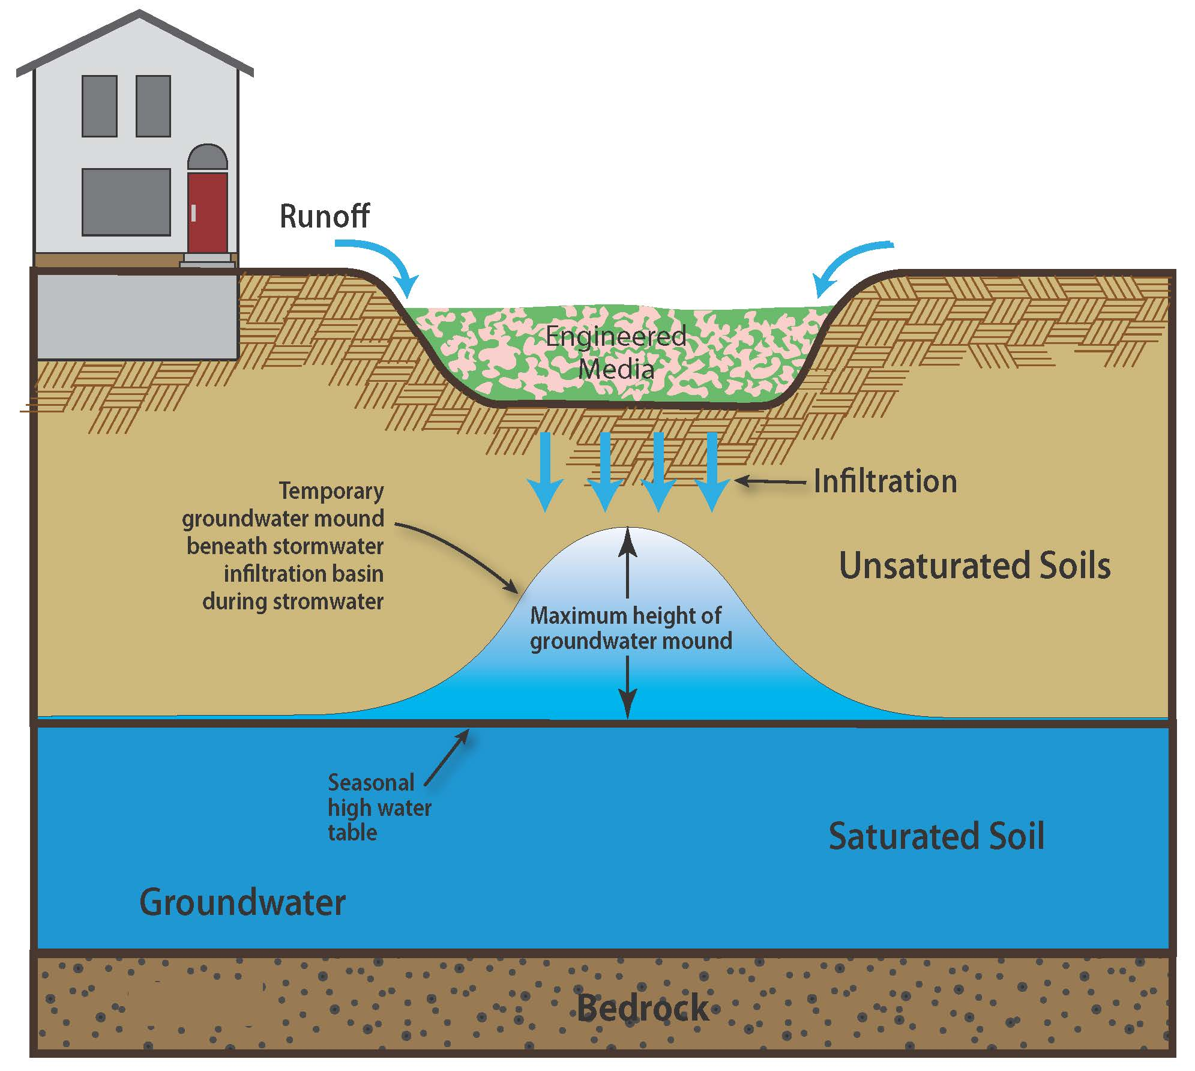
Figure 1.18 Groundwater mounding (Source: CDM Smith)
When is Groundwater Mounding a Problem?
The vadose zone is the unsaturated depth of in-situ (existing) soil below the infiltration BMP. Contaminants that are not captured within the BMP may be attenuated within this zone. The temporary rise of the groundwater elevation caused by mounding will decrease the available vadose zone which may decrease the removal of certain pollutants. If the mound reaches the base of the infiltration BMP, then the hydraulic gradient (direction of water movement) shifts from vertical to horizontal and significantly slows the movement of water through the soil. Groundwater mounds that significantly widen below the base of an infiltration BMP may damage underground utilities, basements and building structures if the mounds are high enough and there is not enough separation between the mound and structures (Machusick and Traver, 2009).
When Should a Mounding Analysis be Conducted?
A mounding analysis is a way to determine the likelihood that a groundwater mound will occur. A mounding analysis should be performed if one or more of the following conditions exist:
- Low saturated hydraulic conductivity. Soils with low saturated hydraulic conductivity do not dissipate the infiltrating water quickly, allowing for the water to accumulate below the base of the infiltration BMP.
- Thin vadose zone. Mounding is more likely to occur in areas with a shallow groundwater table (thin vadose zone).
- Low aquifer thickness. Groundwater aquifers that are thick are able to dissipate infiltrating water. Alternatively, aquifers with low thickness are less able to dissipate the water. The maximum height of a mound tends to decrease as the thickness of the aquifer increases (Carleton, 2010).
- Large and/or non-rectangular basin. Under the same conditions, circular, hexagonal and triangular basins have been found to have higher groundwater mound than rectangular basins (Domey, 2006).
- Close Proximity to a Polluted Site. If a mound on one site extends to an adjacent property it will raise the groundwater elevation at that property. This is of particular concern if the adjacent site is contaminated since the mound could facilitate the movement of the contaminant plume (Nimmer et al., 2010).
- Close Proximity to a Building or Structure or Underground Utility. When infiltration basins are just vertically above or within 10 horizontal feet of a building, structure, or underground utility, a mounding analysis should be conducted.
- Close Proximity to Other Infiltration BMPs. The presence of multiple BMPs can compound the effect of mounding (Maimone et al., 2011). For example, a study in Syracuse, New York modeled the impact of multiple infiltration BMPs and found that there was the potential for a 0.2 to 0.7 meter mound to form due to close proximity. The height depended on the arrangement of the basins and the soil characteristics.
How to Predict the Extent of a Mound
Both analytical and numerical methods exist that can predict the extent of a groundwater mound. The most widely known and accepted analytical method is based on the work by Hantush (1967). A simple Excel spreadsheet of the Hantush Method was created by the USGS and can be found here. This method requires the user to input information on the recharge rate, specific yield, horizontal hydraulic conductivity, dimensions of the infiltration BMP, and the initial thickness of the unsaturated zone. The result is considered by experts to be a simplified version of the actual site conditions. The Hantush method can be limited by the assumptions which include no storage loss, uniform and horizontal infiltration, and vertical sides to the BMP. If these assumptions are violated then a more robust numerical method should be used.
A common numerical method is to model site conditions using computer simulations. MODFLOW is the most widely used among the many programs that exist. While numerical modeling can provide a more accurate representation of site conditions, it also requires the user to have considerable training in order to develop the model and run simulations, and interpret the results.

Case Studies
Machusick and Traver, 2009. The authors studied the effect of stormwater infiltration from an infiltration BMP at the Villanova campus on the shallow unconfined aquifer below. The study was conducted from November 2007 to August 2008. The BMP was a vegetated basin with a 0.53 hectare drainage area and was designed to infiltrate the first 2.5 cm of stormwater runoff. Four monitoring wells were installed to provide continuous monitoring of the groundwater below and around the basin. Monitoring well (MW) 1 was located upgradient, MW-3 was located downgradient, and MW-2 and MW-4 were located adjacent to the site. The results of the experiment show that for storms smaller than 1.9 cm, the upgradient well (MW1) exhibited a larger increase in the groundwater table than the wells closer to the site (i.e., MW2 and MW3). For storms that were larger than 1.9 cm, the reverse was observed. One important note is that the rise in groundwater at MW-2 was attenuated prior to MW-3, meaning the mound did not extend that far laterally. The observed rise in the groundwater at the different monitoring wells was not found to correlate with the amount of rainfall. Infiltration rate was found to be the primary factor that affected the amount of groundwater mounding that occurred, with temperature being the factor that most influenced the change in infiltration rates between stormwater events.
Thomas and Vogel, 2012. The City of Boston, MA has been periodically experiencing a decline in groundwater elevations over the past century. To try to combat this, the City enacted a code that requires that any new development or redevelopment project install stormwater recharge BMPs. Since the implementation of the code in 2006, 69 recharge BMPs have been installed which has resulted in an estimated 163,450 gallons of recharge per 1-inch storm event. In order to estimate the effect that these recharge BMPs would have on the groundwater level, regional multivariate regression models were developed. The regional groundwater model was developed through the use of groundwater level measurement at 234 observation wells which started between 1999 and 2005 and went through 2009. The final results of the study indicate that the recharge BMPs led to an increase in groundwater elevations. In addition, the model developed during the study can be used by the City to determine the potential impact of future BMPs. While not directly related to groundwater mounding, this study provides some information on the impact of multiple BMPs in one area.

