Soil Health Scientific Literature and Resource Review

Introduction
This resource contains literature and resources compiled as part of an extensive review of studied improvements to infiltration and stormwater due to soil health for the PCA Stormwater Section Soil Health Project that occurred from 2025-2026. Many of these resources were used to inform the final products developed for the MN Stormwater Manual. Others were compiled to understand the scientific and regulatory landscape surrounding soil health.
This document was considered an intermediate product and as such, is not highly formatted or necessarily a clean final product. However, we believe this resource could be helpful for others working in this field to reference, and it provides full references to work cited in the four new Manual pages on Soil Health, so we are making it available for download. An associated second product to this is the spreadsheet SoilHealthImpacts_2026.06.30 also available for download, which compiled numeric information from the studies referenced here and also contains analyses completed by the contractor to produce Soil Health Impacts on Water Storage & Hydraulic Conductivity – Soil Health & Water Storage, which is a tool to visualize how changes to the bulk density (compaction) and organic matter content of soils changes their ability to hold water.
This work was conducted or overseen by Dr. Beth Fisher, subcontracted by LimnoTech as a soil scientist for this project.

Practices and infiltration response

Aeration in urban soil with measurements of infiltration
Atkinson, J. L., McCarty, L. B., & Bridges, W. C. (2012). Effect of core aerification frequency area impacted and topdressing rate on turf quality and soil physical properties. Agronomy Journal, 104(6), 1710–1715. https://doi.org/10.2134/AGRONJ2012.0224
Aeration by core removal was performed on golf course soils and then infiltration measured 14 +/- 2 days after using double ring infiltrometer (30.5 cm outer ring size). Measurements were two days after irrigation for consistent soil moisture. Infiltration was not affected by percent of surface area impacted by aeration cores. “Infiltration rates were 46 and 25% higher in treatments with one aerification event compared to treatments with two and three aerification events, respectively.”

“In similar studies, infiltration rate increased following core cultivation. McCarty et al. (2007) measured infiltration to be 58 to 188% higher after core cultivation when compared to the untreated while Bunnell et al. (2001) determined infiltration to increase 37 to 58% after core cultivation.”

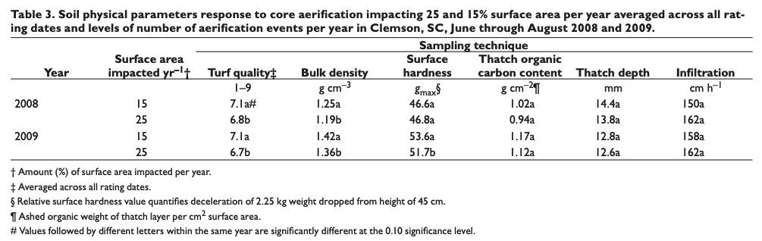
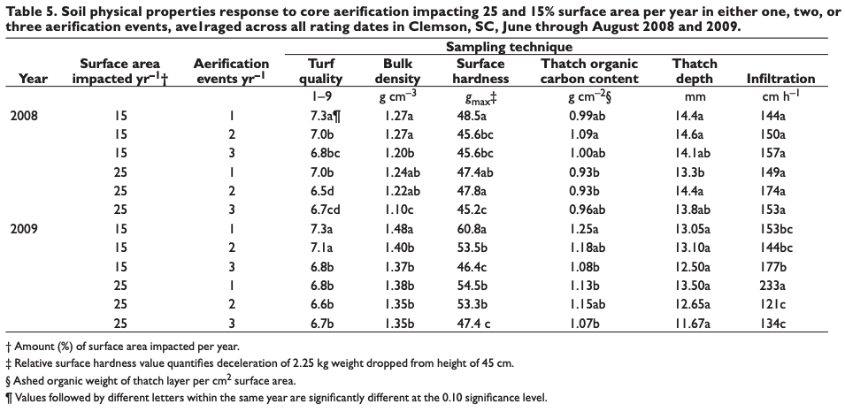

Logsdon, S., and Sauer, P. (2017). Improved or unimproved urban areas effect on soil and water quality.

Study with aeration and compost amendment found that compost did not export nutrients in rainfall simulation. Bulk density decreased from 1.42 to 1.32 Mg/m3. Where compost + aeration were applied, the soil also held more water.

Biochar
Akpinar, D., Chowdhury, S., Tian, J., Guo, M., Barton, S., & Imhoff, P. T. (2023). Understanding a wood-derived biochar’s impact on stormwater quality, plant growth, and survivability in bioretention soil mixtures. Journal of Environmental Management, 348, 119359. https://doi.org/10.1016/J.JENVMAN.2023.119359
- Greenhouse study with bioretention soil media (BSM) growing switchgrass, addition of 4% biochar to high sand content (no mulch) BSM the media increased infiltration by 67% and plant available water by 52%. BSM with moderate sand and compost/mulch (no biochar) had statistically similar results.
- Biochar mix also improved removal of total Nitrogen and nitrate by 28-35%. Total Nitrogen and Total Phosphorus to groundwater was 10 and 7 times less than the biochar-free mix that had compost.
- Biochar in the mix also resulted in longer time before plants wilted.
Abrol, V., Ben-Hur, M., Verheijen, F.G.A. et al. Biochar effects on soil water infiltration and erosion under seal formation conditions: rainfall simulation experiment. J Soils Sediments 16, 2709–2719 (2016). https://doi.org/10.1007/s11368-016-1448-8
- Paper behind paywall, info from preview. High-intensity rainfall simulated experiments in agriculturally significant, erosion- and seal-prone soils in Israel: non-calcareous loamy sand and calcareous loam. 2% biochar from mixed wood chip applied to non-calcareous loamy sand significantly increased final infiltration rates by 1.7x compared to 0% biochar control. "These effects persisted throughout a second rainfall simulation, and were attributed to an increase in soil solution Ca and decrease in Na, and a subsequently decreased sodium adsorption ratio (SAR)." Biochar had no significant effect on final infiltration rates for the calcareous loam, but reduced soil loss by 1.3x. "These results confirm that biochar addition may be a tool for soil conservation in arid and semi-arid zone soils."
Busscher, Warren J., Jeffrey M. Novak, D Eifion Evans, Don W. Watts, M. A. S. Niandou and Mohamed Ahmedna. “Influence of Pecan Biochar on Physical Properties of a Norfolk Loamy Sand.” Soil Science 175 (2010): 10-14.
Lab study on Ap horizon Norfolk loamy sandy soil. "Powdered switchgrass (added at 0 or 10 g/kg) and pecan shell biochar (added at 0, 5, 10, or 20 g/kg of soil) added to soil treatments and incubated. Pecan shell biochar did not improve infiltration rates. "Because others have reported improvements that we did not see, our results may be a characteristic of the biochar feedstock, pecan shells, or of the way the biochar was produced."
Biochar decreased soil penetration resistance; switchgrass addition also decreased it by end of experiment. Mixed results on effects of aggregation and water-holding capacity.
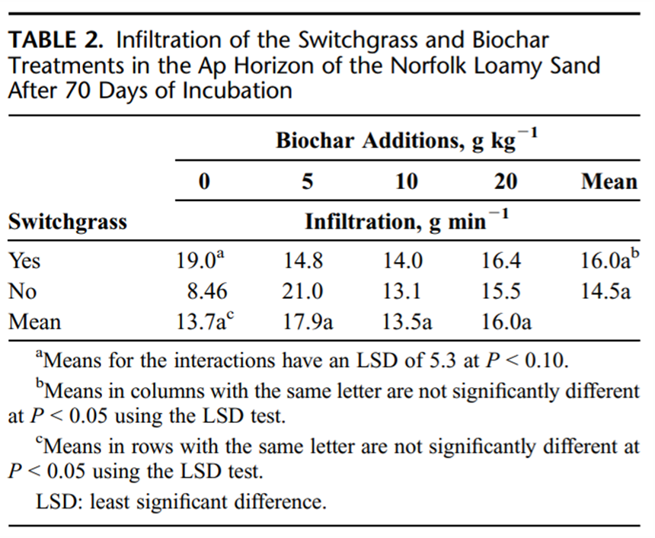

Compost and infiltration (includes decompaction)
Agassi, M., Hadas, A., Benyamini, Y., Levy, G. J., Kautsky, L., Avrahamov, L., & Zhevelev, H. (1998). Mulching Effects of Composted MSW On Water Percolation and Compost Degradation Rate. Compost Science & Utilization, 6(3), 34–41. https://doi.org/10.1080/1065657X.1998.10701929
Referenced in Kranz (2020) paper
Study looks at the effect of composted municipal solid wastes (CMSW) on water percolation (% change percolation rate). Simulated rainfall environment in lab conditions. Typical loess soil (Calcic Haploxeralf) packed in boxes and covered with 0, 100, 200, 300 m3/ha of CMSW or mixed with 200 m3/ha of CMSW. With surface CMSW treatments, 85% of rain water percolated into soil, vs 52% for mixed CMSW and 42% for control. 100 m3/ha of CMSW was enough to control runoff in the lab, but larger amounts may be needed in the field to provide complete mulching of the soil surface.
Study also looked compost degradation via CMSW mineralization (estimated from CO2 evolution)
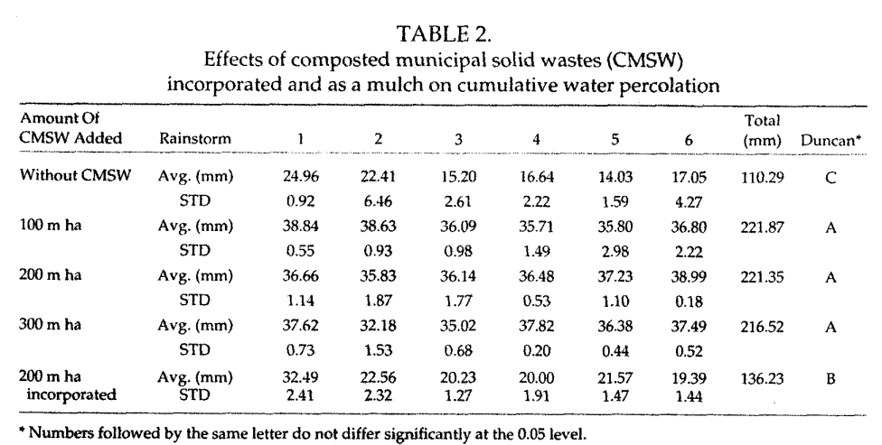
Alshraah, S. H., Kranz, C. N., McLaughlin, R. A., & Heitman, J. L. (2024). Wildflowers and compost amendment can improve infiltration in soils impacted by construction. Journal of the American Water Resources Association, 60(3), 784–795. https://doi.org/10.1111/1752-1688.13202
Compost improved infiltration at two sites (46%–50%). Wildflowers improved infiltration at all sites (30%–43%) compared to grass.
They found that (1) compost with grass increased infiltration rate compared to no-compost with grass, (2) no-compost with wildflowers increased infiltration rate compared to no-compost with grass, and (3) compost with wildflowers had the same infiltration rate as compost with grass.
Chen, Y., Day, S. D., Wick, A. F., & McGuire, K. J. (2014). Influence of urban land development and subsequent soil rehabilitation on soil aggregates, carbon, and hydraulic conductivity. Science of The Total Environment, 494–495, 329–336. https://doi.org/10.1016/J.SCITOTENV.2014.06.099
Comparative study of four restoration methods on 24 plots with trees planted found that deep compost incorporation and breaking of subsurface compaction is important urban soil restoration because the study’s significant finding was a doubling of hydraulic conductivity in the subsurface treatments compared with undisturbed plots. The study also found that the subsurface hydraulic conductivity increased approximately 6–11 times compared with soils under typical land development practices. The study found that soil macro-aggregates stored carbon.
Chen, Y., Day, S. D., Wick, A. F., Strahm, B. D., Wiseman, P. E., & Daniels, W. L. (2013). Changes in soil carbon pools and microbial biomass from urban land development and subsequent post-development soil rehabilitation. Soil Biology and Biochemistry, 66, 38–44. https://doi.org/10.1016/j.soilbio.2013.06.022
- Urban development often results in surface soil removal and compaction of the subsoil. In a study with three rehabilitation treatments and one control in 24 plots the treatment that incorporated compost to 60cm depth, replaced the A-horizon partially, and tilled resulted in higher soil carbon, more aggregate-protected carbon, and higher microbial biomass carbon than the other treatments at 15-30 cm depth (Chen et al., 2013). The authors have a separate paper about the soil hydraulic properties in the study.

Chen, S. (2015). Evaluation of compost topdressing, compost tea and cultivation on tall fescue quality, soil physical properties and soil microbial activity (Master’s thesis). University of Maryland, College Park. Retrieved from https://api.drum.lib.umd.edu/server/api/core/bitstreams/4d489dde-f9e0-4109-b580-f69b3e40b0c0/content
3 year study, suburban Maryland (fertilized and mowed 2x/month during growing season turf), Russett and Christana complex soil. Soil infiltration rates measured by constant head double ring method.
Study looks at effect of no fertilizer, sewage sludge based biosolids compost, yard trimming compost, and synthetic N fertilizer on soil infiltration rates, vs an untreated control. No statistically significant difference in rates, depending on treatment. All treatments hand applied at rate of 156 kg N/ha/yr in late Sept or Oct.
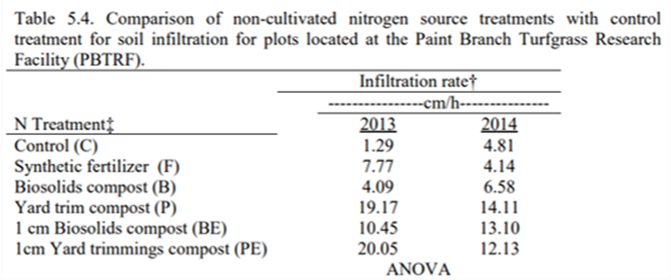
Cogger, C. G. (2005). Potential compost benefits for restoration of soils disturbed by urban development. Compost Science and Utilization, 13(4), 243–251. https://doi.org/10.1080/1065657X.2005.10702248;SUBPAGE:STRING:ABSTRACT;WGROUP:STRING:PUBLICATION

Lit review of agriculture with a focus on extending results to disturbed urban soils.

Infiltration or porosity increased after compost amendment in 5 of 9 studies (not reported in other studies). In 3 of the 9 studies, available water was measured and saw an increase.

From the study: Martens and Frankenberger (1992) found that infiltration increased by 18-25% in the third year of the study and attributed it to aggregate stability.

Ries et al. (2004) studied turf and found infiltration only improved in their highest compost application rate.

“Research on the effects of compost quality, rate, and depth of incorporation for lawn and landscape establishment in different environments would strengthen the scientific basis for recommendations to improve soils degraded by urban development. The areas of greatest research need are the effects of compost amendments on water relations in urban landscapes, including water use, plant moisture stress, and runoff.”
Compost application is beneficial to turf establishment. Landschoot and McNitt (1994) found that compost treatments increased infiltration.

Das, T. K., Kabir, A., Zhao, W., Stenstrom, M. K., Dittrich, T. M., & Mohanty, S. K. (2023). A review of compaction effect on subsurface processes in soil: Implications on stormwater treatment in roadside compacted soil. Science of The Total Environment, 858, 160121. https://doi.org/10.1016/J.SCITOTENV.2022.160121
- Literature review. Adding sand could mitigate the effects of compaction in urban soil to improve infiltration, increasing infiltration rate by 22-fold. Compaction reduced infiltration rate in soil by two orders of magnitude, except in sandy soil. Compaction increased bulk density by 18%. Sand was found to resist compaction better than soil aggregates, which preserved macropore flow better than soil only media.
- They said that according to (Yvan et al., 2012), adding earthworms to compacted soils could improve infiltration by making macropores. (Beth’s note: studies from Yoo Lab, UMN indicate that worms cease to burrow through sandy soil.)
- Natural processes suggested include bio drilling (Williams and Weil, 2004) to help allow root systems to grow into compacted layers. Also suggested tillage radish, which reduced overall compaction by 40% and increased porosity by 44% according to Raut and Dick (2020).
- They mention several other soil amendments, but did not give data from the papers because they were seeking to find information on compaction.
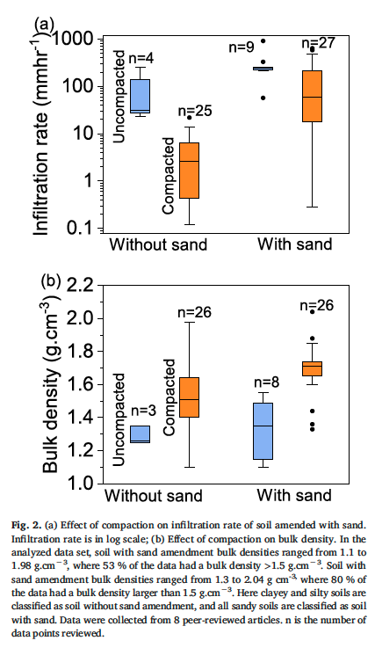

Ebissa, G., & Desta, H. (2022). Review of urban agriculture as a strategy for building a water resilient city. City and Environment Interactions, 14. https://doi.org/10.1016/j.cacint.2022.100081

- Literature review of 109 articles explored how urban agriculture can mitigate flood risk. Referenced a modeling study by Jiang and McBean (2021) that found that urban land use has the capacity to suppress 100-year floods into 25-year flooding equivalent. But the Jiang and McBean study didn’t mention urban agriculture and the model is out of the scope of this work.

Edwards, Naim, Nicholas Medina, and Elizabeth Asker. “Mixing Cover Crops Suppresses Weeds and Roto-Till Reduces Urban Soil Penetration Resistance and Improves Infiltration.” Soil and Tillage Research 231 (2023): 105708. https://doi.org/10.1016/j.still.2023.105708
Study site at MSU extension facility in Detroit for urban ag; urban Technosol soil. Formerly a school building/playground until 2016. Compost applied to plots before treatments. Soil infiltration measured using aluminium cylinder + time for 1 L to pass.
Study looked at no-till (manual long-tined broadfork for gardens/small farms, 10 cm deep), roto-tiller (20 cm deep), and tractor-till (subsoiler+moldboard plot+roto-tiller attached to tractor) + cover cropping (weed suppression mix, perennials, mix to alleviate compaction, and null/existing vegetation only). "This study suggests that cover crops can generally affect infiltration, though perennials notably didn't have significant effects on infiltration rates." "Based on these findings, roto-till (alongside compost) can be an effective practice to specifically improve urban soil water infiltration, at least in the short-term, after which no-till may prevail."
“Roto-till resulted in significantly faster infiltration compared to no-till (15%), unlike tractor-till, suggesting that roto-till management can generally be effective for improving infiltration and drainage. This result could be explained by medium intensity roto-till increasing soil macro-porosity, which compared to micro-pores bind water less tightly, allowing soil water to flow faster. In contrast, the tractor diffused tillage energy across deeper soil volume, lowering the density of any added soil macro-pores and thereby making it easier for soil particles to settle back together, whereas no-till may have needed more time to improve macro-porosity via OM effects on soil structure." “Medium-intsenity tillage may offer more balanced trade-offs for lowering soil penetration, resistance, promoting infiltration, and feasibly minimizing weeks, and that cover crops can help reduce weeds under low-till."
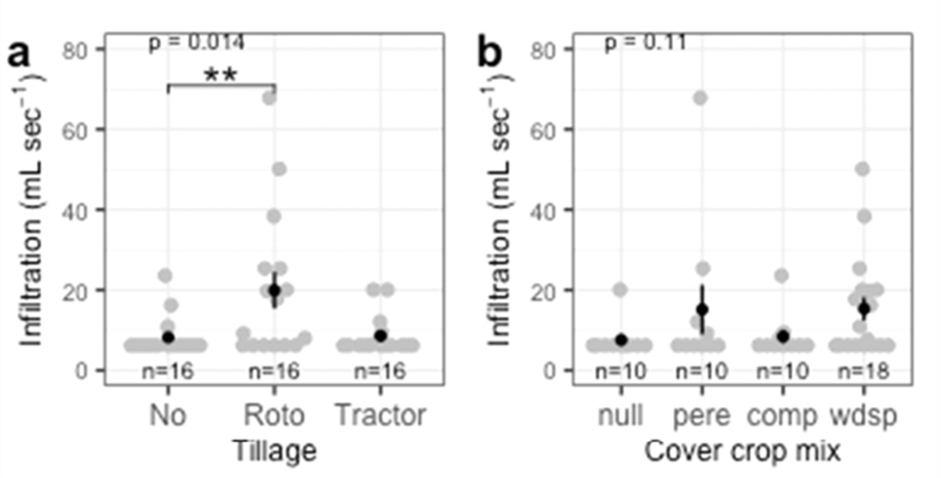
Note: Null=existing vegetation/no manipulation; pere=perennial (hairy vetch, red clover, wheat); comp=plants to alleviate compaction (forage radish, crimson clover, cereal ryegrass); wdsp=weed suppression mix
Islam, M. M., McLaughlin, R. A., Austin, R., Kranz, C. N., & Heitman, J. L. (2024). Compost incorporation and wildflowers introduction for stormwater infiltration and erosion-control vegetation cover establishment in post-construction landscapes. Journal of Environmental Management, 369, 122324. https://doi.org/10.1016/J.JENVMAN.2024.122324
Plots with grass, wildflowers, and grass-wildflowers were amended with 30% and no compost. Compost increased infiltration by 2-3 times no compost treatments. Compost amended plot with 60-40 grass-wildflower mix had rapid establishment of vegetation in first 12 months, whereas all plots exhibited similar coverage from months 13-24. Infiltration was measured with a constant head single ring infiltrometer with a 10 cm diameter. They did not observe a difference with vegetation types.

Kranz, C. N., McLaughlin, R. A., Johnson, A., Miller, G., & Heitman, J. L. (2020). The effects of compost incorporation on soil physical properties in urban soils – A concise review. Journal of Environmental Management, 261. https://doi.org/10.1016/j.jenvman.2020.110209
In a 25 paper meta-analysis compost applied on degraded urban soils generally decreased bulk density, increased infiltration, increased hydraulic conductivity, increased water content, and increased plant available water. Where runoff was studied, sites had initial nutrient export, but saw a decrease in sediment loss, probably associated with better grass growth on the composted sites.

Statement of data needs: “Additional research on the effects of compost rate, incorporation depth, and compost source materials is needed to strengthen our understanding of how this organic amendment affects highly disturbed subsoils in a one-time application. …Future research should focus on optimizing compost rates and incorporation depths to maximize soil physical properties for soil-water relations and vegetation reestablishment.”

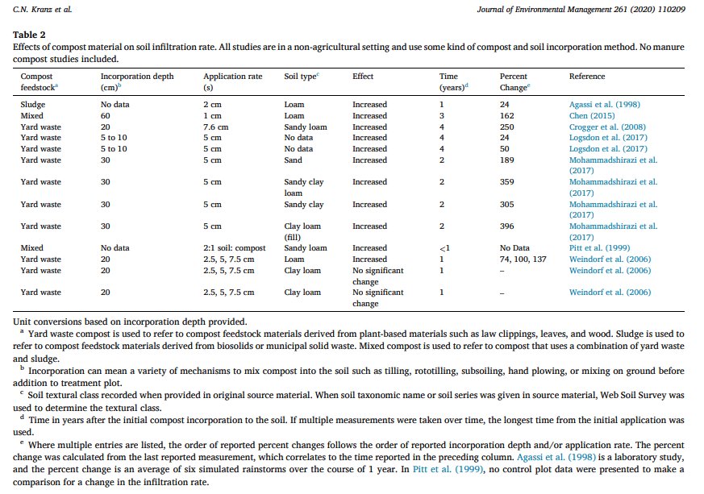

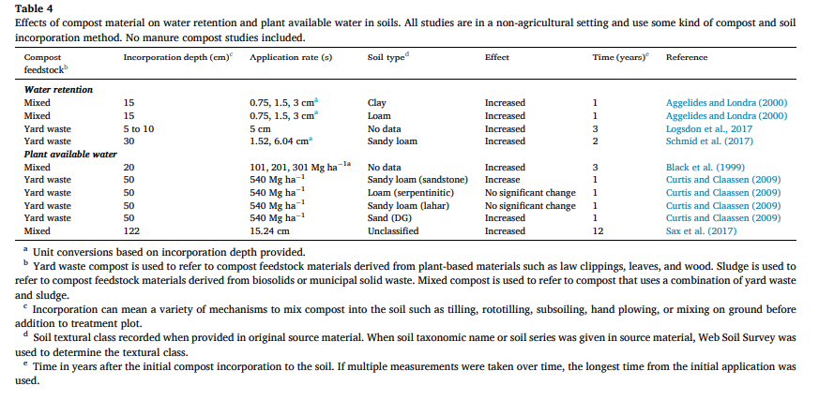

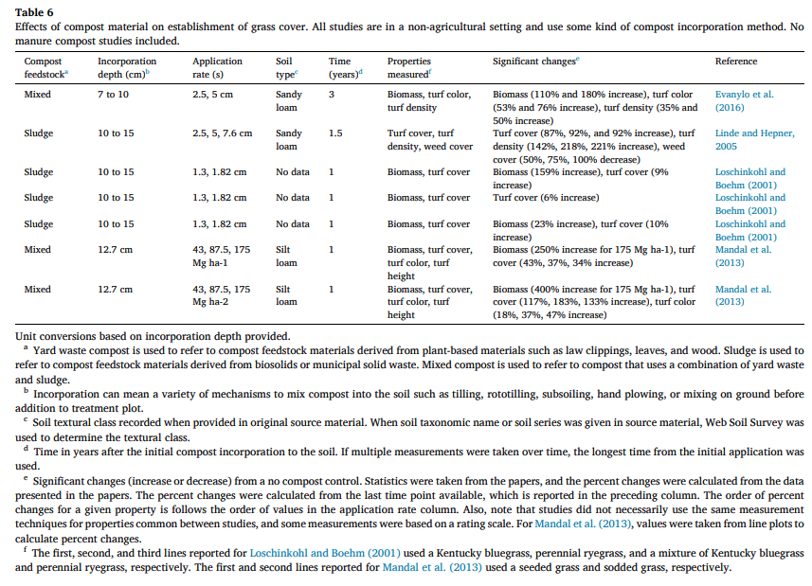

Logsdon, S. D., Sauer, P. A., Shipitalo, M. J., Logsdon, S. D., Sauer, P. A., & Shipitalo, M. J. (2017). Compost Improves Urban Soil and Water Quality. Journal of Water Resource and Protection, 9(4), 345–357. https://doi.org/10.4236/JWARP.2017.94023
Compost addition in urban restoration reduced bulk density. Compost plus prarie grasses (compared with bluegrass) increased infiltration, decreased runoff and soil loss, and reduced loss of orthophosphorus.
McDaniel, M. D., Thompson, G. L., & Sauer, P. (2024). Decompaction and organic amendments provide short-term improvements in soil health during urban, residential development. Journal of Soil and Water Conservation, 79(4), 169–179. https://doi.org/10.2489/JSWC.2024.00111;WGROUP:STRING:PUBLICATION
The title says what we need (this is one of the Pat Sauer papers): Decompaction and organic amendments provide short-term improvements in soil health during urban, residential development (McDaniel et al., 2024).
Fatemeh Mohammadshirazi, Richard A. McLaughlin, Joshua L. Heitman, Virginia K. Brown (2017), A multi-year study of tillage and amendment effects on compacted soils. Journal of Environmental Management, Volume 203, Part 1, Pages 533-541. https://doi.org/10.1016/j.jenvman.2017.07.031.
"Study shows tillage reduced bulk density and increases infiltration rates in post-construction settings.
Study looks at effects of tillage (none vs 15 cm vs 30 cm) w/ and w/o amendments (compost (5 cm depth, made from sawdust/tree and shrub trimmings/leaves/wood chips combo, or yard wastes), cross-linked polacrylamide (xPAM), and gypsum) on soil compaction, infiltration rate, and vegetative growth. Sites prepped by removing topsoil and compacting exposed subsoil Tillage increased infiltration at all sites, and effect remained after ~3 years for one site. Compost and xPAM usually didn't affect infiltration rates.
Infiltration rate for compacted soil usually <1 cm/hr initially, but increases after several years to 10 cm/hr, attributed to vegetation as roots grew deeper."
"5 experimental post-construction sites in North Carolina (Coastal Plain/sand, mountains/sandy clay loam, Piedmont 1/sandy clay, Piedmont 2/sandy clay, Piedmont 3/clay loam fill), 2.5 yr study. Infiltration rates measured using Cornell Sprinkle infiltrometer."
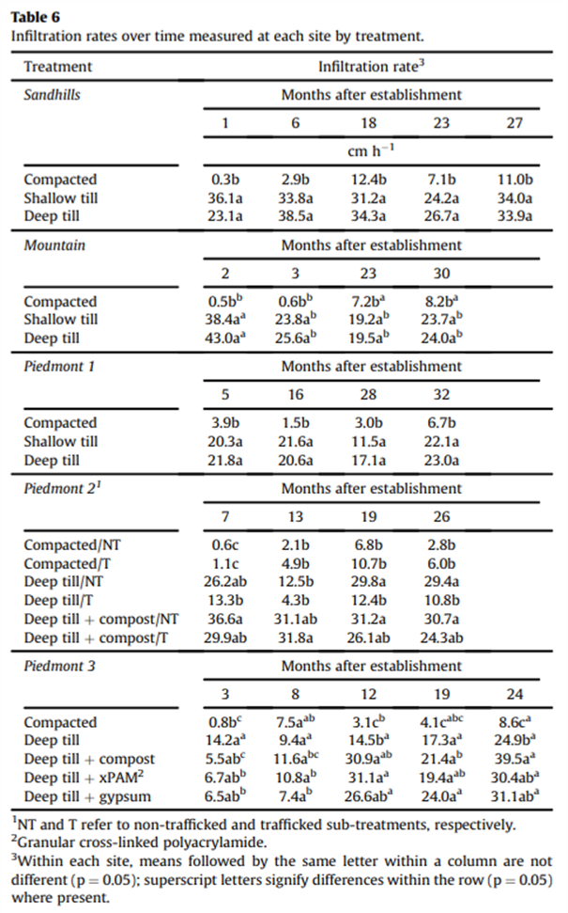

Olson, N. C., Gulliver, J. S., Nieber, J. L., & Kayhanian, M. (2013). Remediation to improve infiltration into compact soils. Journal of Environmental Management, 117, 85–95. https://doi.org/10.1016/j.jenvman.2012.10.057
In an urban restoration experiment comparing tillage, tillage + compost, and no treatment, tillage decreased soil strength and was ineffective at improving infiltration capacity of the soil. Tillage + compost reduced soil strength and compaction and increased infiltration. Untreated soil generated more runoff than treated soil (Olson et al., 2013).
Rivers, E. N., Heitman, J. L., McLaughlin, R. A., & Howard, A. M. (2021). Reducing roadside runoff: Tillage and compost improve stormwater mitigation in urban soils. Journal of Environmental Management, 280. https://doi.org/10.1016/j.jenvman.2020.111732
In a road side stormwater experiment found that compared with tillage alone, tillage + compost reduced runoff, decreased bulk density, improved vegetation establishment, reduced sediment export, and reduced dissolved nutrient and metal concentrations.

Schneider, S., Coquet, Y., Vachier, P., Labat, C., Roger‐Estrade, J., Benoit, P., Pot, V., & Houot, S. (2009). Effect of Urban Waste Compost Application on Soil Near‐Saturated Hydraulic Conductivity. Journal of Environmental Quality, 38(2), 772–781. https://doi.org/10.2134/JEQ2008.0098;WGROUP:STRING:PUBLICATION
Compost addition for 6 years in silt loam soil on cultivated plots increased infiltration rates at near soil saturation for all treatment cases: plowpan, interfurrow, compacted, and noncompacted zones within the heterogeneous plowed layer. Compost-amended plots remained stable in their hydraulic properties after 6 months.

Despite infiltration increasing, all of the plots experienced a decrease in hydraulic conductivity, possibly due to hydrophobicity of the compost.

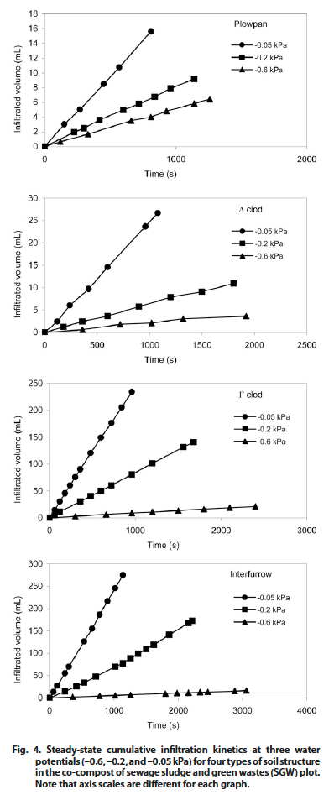

Schwartz, Stuart S., and Brennan Smith. (2016) “Restoring Hydrologic Function in Urban Landscapes with Suburban Subsoiling.” Journal of Hydrology 543, Part B: 770–781. https://doi.org/10.1016/j.jhydrol.2016.10.051

Study looks at suburban suboiling (combination of soil decompaction and compost amendment) after removing impervious asphalt playground at public school in Baltimore, vs untreated reference site and topsoiling. Suburban subsoiling had significantly higher infiltration, with median rates (6.6 cm/hr) 50x greater than median rates for topsoiled field (0.13 cm/hr); it reduced mean annual runoff (simulated) by more than factor of 30 compared to standard grading and topsoiling.

"In this field-scale comparison with standard grading and landscaping practices, suburban subsoiling supported the highest infiltration rates, with the densest turf cover, highest soil organic matter and root zone soil moisture, and the lowest soil bulk density."
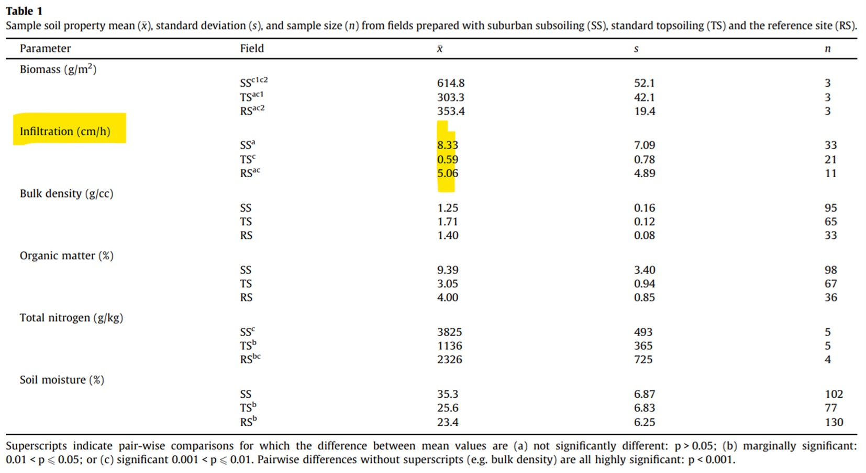
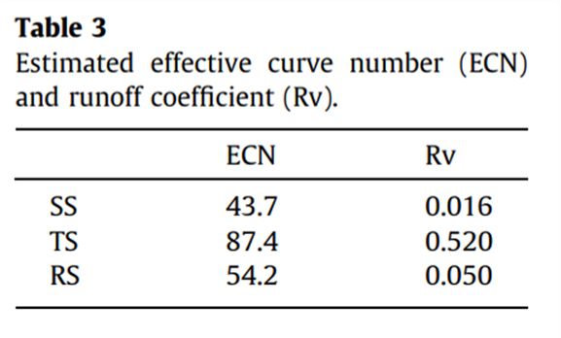
Schwartz, S. S., & Smith, B. (2021). Cultivating Stormwater Services with Soil Decompaction and Amendment. Journal of Hydrologic Engineering, 26(1), 04020059. https://doi.org/10.1061/(ASCE)HE.1943-5584.0002031
- SchwartzSmith-2021-JHydrolEng-CultivatingStormwaterServices.pdf is a field study at Taneytown, Maryland
  - standard turf (ST)
  - suburban subsoiling (SS) (alluding to the adaptation of agricultural subsoiling practices to urban landscapes)
- Subsoiling, defined here as decompaction and compost amendment increased mean infiltration by more than an order of magnitude. Bulk density decreased by 28%, organic matter increased by 82%, and potential rooting depth increase by 20-30 cm.
- Data used in Schwartz 2021

Schwartz, S. S. (2021). The effectiveness of soil decompaction for stormwater management (Report No. MD-21-SHA/UMBC/02-1). Center for Urban Environmental Research and Education & University of Maryland, Baltimore County; Maryland State Highway Administration, Office of Policy & Research. https://rosap.ntl.bts.gov/view/dot/60230
- Extremely valuable field & modeling study.
- See 2. MDOT 2021 (Schwartz 2021) study & Stormwater BMP in Regulatory Review tab
Sileshi, R., Pitt, R., & Clark, S. (2015). Impacts of Soil Texture, Structure, and Compaction on Bioinfiltration Device Performance: Results of Lab and Field Investigations. Low Impact Development Technology: Implementation and Economics, 2, 4–15. https://doi.org/10.1061/9780784413883.002
Unable to access full article, so this is from the abstract.
Used double ring infiltrometers in a large biofilter, in addition to rain events and lab tests. Soil compaction has dramatic, detrimental effects on infiltration. Sand addition in clay media/soils helps minimize the decreased infiltration observed for clay soils.

Tirpak, R. A., Afrooz, A. N., Winston, R. J., Valenca, R., Schiff, K., & Mohanty, S. K. (2021). Conventional and amended bioretention soil media for targeted pollutant treatment: A critical review to guide the state of the practice. Water Research, 189, 116648. https://doi.org/10.1016/J.WATRES.2020.116648
Explores bioretention soil media (BSM) and compares it with alternative organic and inorganic amendments. One note here is that infiltration that is too fast fails to provide sufficient contact time with soil/media to remove pollutants through adsorption.

Decompaction practices (see compost section for additional)
Weill, A., 2015. A guide to Successful Subsoiling. CETAB+: Victoriaville, Quebec CA. p. 43 p. https://cetab.bio/system/files/publications/weill_2015._guide_to_successful_subsoiling._cetab.pdf

Plant diversity, including trees
(most prairie studies are in turfgrass or compost section)
Orta-Ortiz, M. S., & Geneletti, D. (2022). What variables matter when designing nature-based solutions for stormwater management? A review of impacts on ecosystem services. In Environmental Impact Assessment Review (Vol. 95). https://doi.org/10.1016/j.eiar.2022.106802
Dense tree canopies with high leaf area index and thick, rough bark, combined with grass + shrub understory vegetation reduce volume of runoff. High organic matter content increased soil structure and porosity in all types of urban vegetation contexts, increasing infiltration rates.
Complexity of understory vegetation improved infiltration (from Wang et al. 2018):
- Forest with shrub and grass 10.74 cm/hr
- Forest with grass 7.98 cm/hr
- Forest with bare soil 5.19 cm/hr
High sand content and non-compaction improved soil porosity, which resulted in better infiltration (from Phillips et al. 2019).
- Non-compacted soil 8.84 cm/hr
- Severely compacted soil 1.88 cm/hr
Presence and decomposition of leaf debris (“leaf litter”) on forest floor resulted in positive correlation between organic matter content and infiltration rate.

Øster Mortensen, E., Abalos, D., Rasmussen, J. (2025). Well-designed multi-species grassland mixtures enhance both soil carbon inputs and aboveground productivity, Agriculture, Ecosystems & Environment, Volume 385, https://doi.org/10.1016/j.agee.2025.109578.

“Increasing species diversity in managed grasslands may serve multiple environmental purposes, especially when legumes are included.”

Mostly reported soil C and N responses to plant mixture variations and fertilization experiments.
Su, L., Yang, Y., Li, X., Wang, D., Liu, Yanchun, Liu, Yinzhan, Yang, Z., & Li, M. (2018). Increasing plant diversity and forb ratio during the revegetation processes of trampled areas and trails enhances soil infiltration. Land Degradation and Development, 29(11), 4025–4034. https://doi.org/10.1002/LDR.3173
Agriculture rangeland grassland restoration of human trampled areas and trails showed soil infiltration increased with diversity of species and aboveground biomass. Infiltration was measured using a pump device and a camera that tracked the wetted area for 60 minutes.
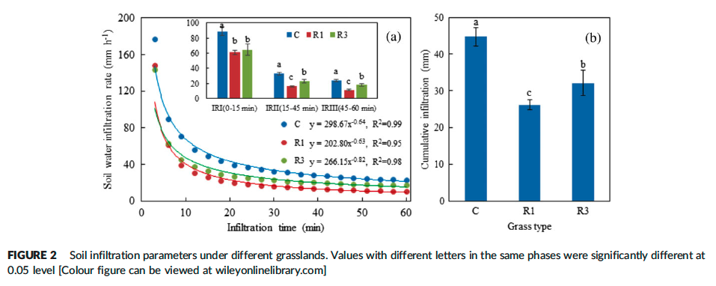
C grassland had not been trampled since 2000 and has 40% grass and 60% forb
R1 grassland was trampled during 2013 and 2016 and is 99% grass
R3 grassland was trampled from 2011 to 2014 and was in recovery since 2014 and has ~65% grass and 35% forb
Study happened in August 2017
Owais Khan and Klamerus-Iwan, 2025. Impact of the management of the lower level of urban greenery on water retention in urban ecosystems. Urban Forestry & Urban Greening
Volume 112, October 2025, 128886. Available at: https://www.sciencedirect.com/science/article/abs/pii/S1618866725002201

- Research in Krakow, Poland in 2023 looked at different vegetation covers/management (mowed vs non-mowed vs flower meadows) on soil water retention properties (current water storage capacity, water storage capacity after 4 and 24 hrs, VWC, infiltration, temp, soil temp, air temp, humidity)
- “Establishment of flower meadows and non-mowed lawns should be encouraged in urban areas to conserve soil water, but mainly to reduce the heat island effect and improve the microclimate.”

Rain gardens (see also Turfgrass)
Buzzard, V., Gil-Loaiza, J., Graf Grachet, N., Talkington, H., Youngerman, C., Tfaily, M. M., & Meredith, L. K. (2021). Green infrastructure influences soil health: Biological divergence one year after installation. Science of The Total Environment, 801, 149644. https://doi.org/10.1016/J.SCITOTENV.2021.149644
Green Infrastructure (rain garden and water collection systems in a residential setting) found significantly higher soil microbial diversity and richness after one year, but chemical indicators did not show significant change after one year.
Collins, K. A., Lawrence, T. J., Stander, E. K., Jontos, R. J., Kaushal, S. S., Newcomer, T. A., Grimm, N. B., & Cole Ekberg, M. L. (2010). Opportunities and challenges for managing nitrogen in urban stormwater: A review and synthesis. Ecological Engineering, 36(11), 1507–1519. https://doi.org/10.1016/j.ecoleng.2010.03.015
Study included a literature review and survey and did not directly assess “soil health” in stormwater, but their bioretention systems are essentially leveraging soils to grow plants and store water. Rain gardens or bioswales (bioretention systems) tend to be effective at removing N through plant uptake, denitrification, adsorption, immobilization, and storage in soil organic matter. Long drainage times increase contact and are more effective at removing N in bioretention systems. The impact of soil texture had mixed results for nitrate removal efficiency in bioretention systems. Vegetated open channels were sometimes a sink for small rainfall events and sometimes a source of N export, and channels with dense vegetation with well-developed roots were more effective during the growing seasons at reducing N than stone lined channels (Collins et al., 2010).
The study found that dry ponds are effective at removing particulate pollutants, but not effective at removing nitrate and ammonium. Wet ponds do not serve to reduce runoff, but are promising for N removal, especially when the ponds have vegetation and long residence time of water. Mature green roofs may be a nitrogen sink. Permeable pavers have mixed results with respect to N removal without bioreactors intended to promote denitrification. Filters tended to reduce N. Constructed wetlands had wide variability in removing N.
Prudencio, L., & Null, S. E. (2018). Stormwater management and ecosystem services: A review. Environmental Research Letters, 13(3). https://doi.org/10.1088/1748-9326/AAA81A
Major findings of this meta-analysis of green infrastructure work are largely focused on what concepts are discussed in the papers instead of which practices are successful at improving ecosystem services.

Soil texture and properties
Rawls, W. J., Pachepsky, Y. A., Ritchie, J. C., Sobecki, T. M., & Bloodworth, H. (2003). Effect of soil organic carbon on soil water retention. Geoderma, 116(1–2), 61–76. https://doi.org/10.1016/S0016-7061(03)00094-6
Soil texture alone was not the best predictor of water retention at field capacity (-33 kPa) or wilting point (-1500 kPa). Instead, a combination of texture + taxonomic order + organic carbon content were better predictors of soil water retention. High organic carbon increases water retention for all soil textures, but sandy soil is the most sensitive to water retention changes at low organic carbon contents.
Robinson, D. A., Nemes, A., Reinsch, S., Radbourne, A., Bentley, L., & Keith, A. M. (2022). Global meta-analysis of soil hydraulic properties on the same soils with differing land use. Science of The Total Environment, 852, 158506. https://doi.org/10.1016/J.SCITOTENV.2022.158506
Soil texture alone is not responsible for soil porosity and hydraulic conductivity. Instead, soil structure, largely from biological processes must be included in models for soil hydrology (Robinson et al., 2022). See Figure 1 from the publication:
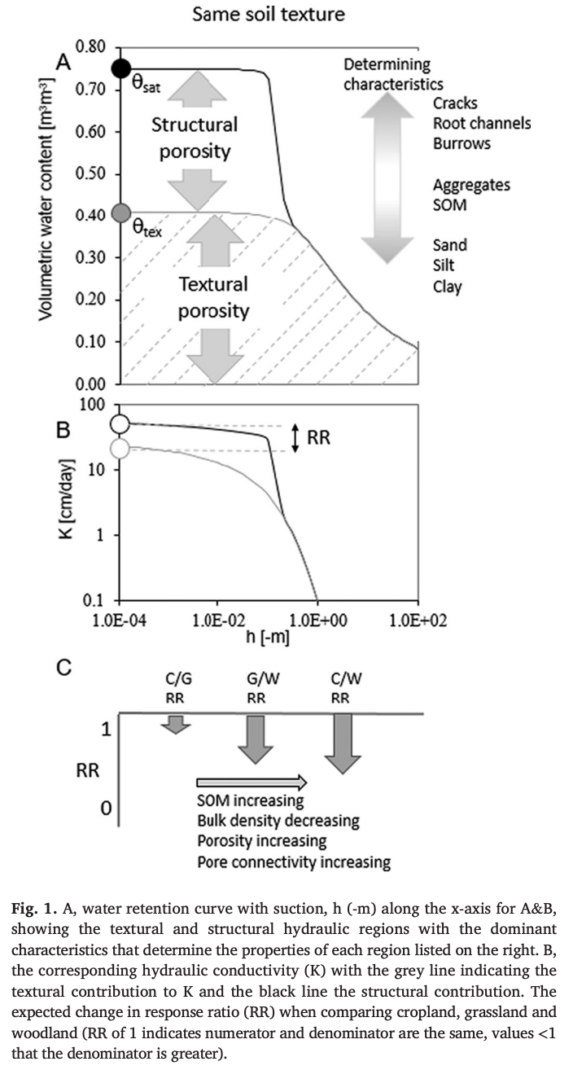

MN Stormwater Manual (Accessed Feb 16, 2026). Soil health, assessment, and management: Soils properties and processes: Saturated hydraulic conductivity. https://stormwater.pca.state.mn.us/soil_hydrologic_properties_and_processes#Saturated_hydraulic_conductivity

U.S. Department of Agriculture (USDA) (1986). “Technical Release 55 (TR-55). Urban Hydrology for Small Watersheds.” 2nd Edition. Natural Resources Conservation Service, USDA, Washington, DC. https://www.nrc.gov/docs/ML1421/ML14219A437.pdf
Appendix A Hydrological Soil Groups, updated 1999.
Hydrologic Soil Group | Typical Soil Texture | Water Transmission Rates from TR-55 (in/hr)
A | Sand, loamy sand, or sandy loam | >0.30
B | Silt loam or loam | 0.15 - 0.30
C | Sandy clay loam | 0.05 - 0.15
D | Clay loam, silty clay loam, sandy clay, silty clay, or clay | 0.0 - 0.05

NOTE: Many recent publications still refer to these.
- NOAA Quick Reference (2022): Hydrologic Soils Group
- EPA national stormwater calculator web app user's guide – version 3.4.0 | epa (2022)
U.S. Department of Agriculture (USDA) (2009). “National Engineering Handbook, Part 630 - Hydrology, Chapter 7 – Hydrologic Soil Groups.” Natural Resources Conservation Service, USDA, Washington, DC. https://directives.nrcs.usda.gov/sites/default/files2/1712930597/11905.pdf
Major revision to NRCS TR-55, based on research findings.
Introduces idea that:
- Well-aggregated or low-bulk density soils may be placed in a higher HSG group than indicated by texture alone
- Assignment is based on saturated hydrologic conductivity at 50-100 cm AND >100 depths, according to this table:
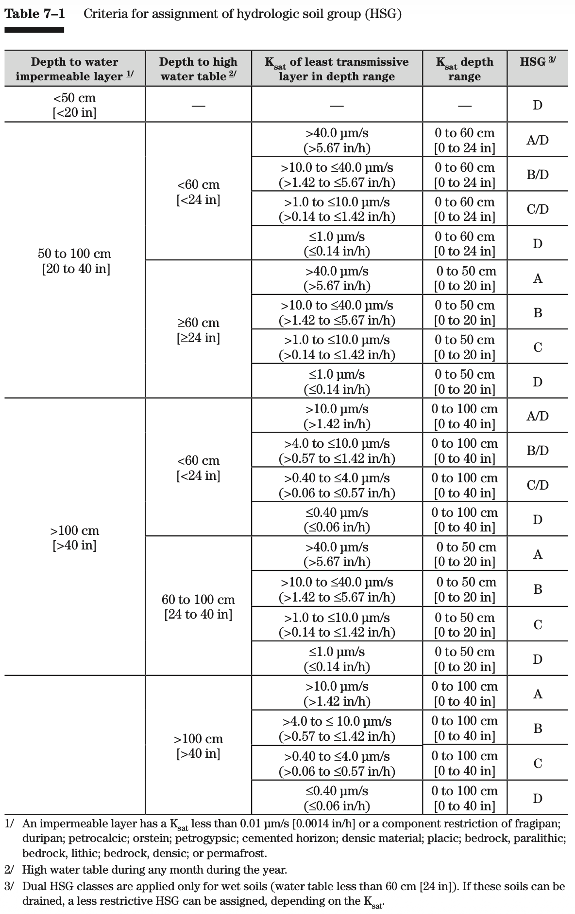

U.S. Department of Agriculture (USDA) (2025). “National Engineering Handbook, Part 630 - Hydrology, Subpart C – Hydrologic Soil Groups.” Natural Resources Conservation Service, USDA, Washington, DC. https://directives.nrcs.usda.gov//sites/default/files2/1749747316/Subpart%20C%20%E2%80%93%20Hydrologic%20Soil%20Groups.pdf
Landing page: https://directives.sc.egov.usda.gov/landingpage/baa0aa98-43b0-425b-8973-23fb930eebaa
Looks very similar to USDA 2009, but with an expanded introduction, paragraph numbering, and slight reorganization..

Turfgrass and infiltration
Cogger, C., Hummel, R., Hart, J., & Bary, A. (2008). Soil and Redosier Dogwood Response to Incorporated and Surface-applied Compost. HortScience, 43(7), 2143–2150. https://doi.org/10.21273/HORTSCI.43.7.2143

“All treatments significantly increased the infiltration rate of water into the underlying soil compared with the unamended control (Table 3). Both bark and compost increased infiltration rates with no interaction between the two amendments. Surface-applied compost had the same effect on infiltration rates as incorporated compost. Protecting the soil surface with bark or compost mulch was as effective as incorporating compost into the soil at improving infiltration in this experiment.”
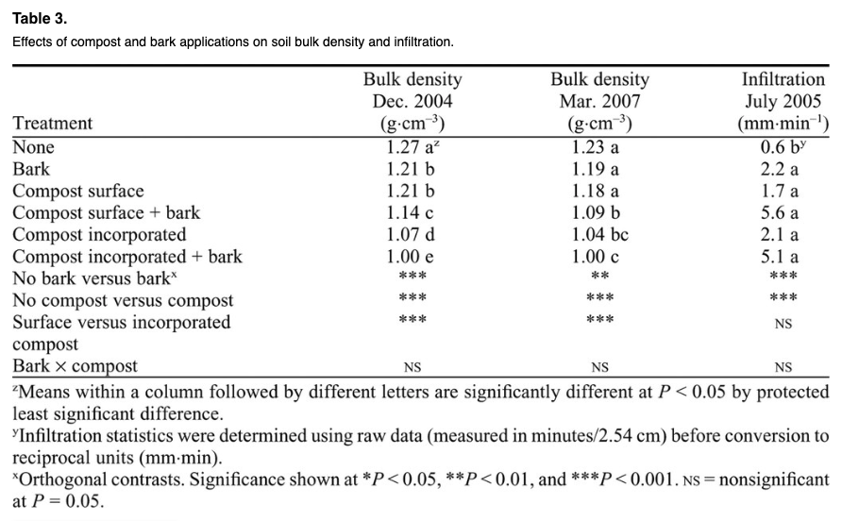

Easton, Z. M., & Petrovic, A. M. (2004). Fertilizer Source Effect on Ground and Surface Water Quality in Drainage from Turfgrass. Journal of Environmental Quality, 33(2), 645–655. https://doi.org/10.2134/jeq2004.6450
As turfgrass shoot density increases, the infiltration rate also increases (regression y=2.20x + 1.23). Where shoot density ~5 shoots per cm, the infiltration was 10.7 cm/h. Where shoot density was ~10 shoots per cm, infiltration was 24.5 cm/hr. (Values gleaned from plot digitizer.)
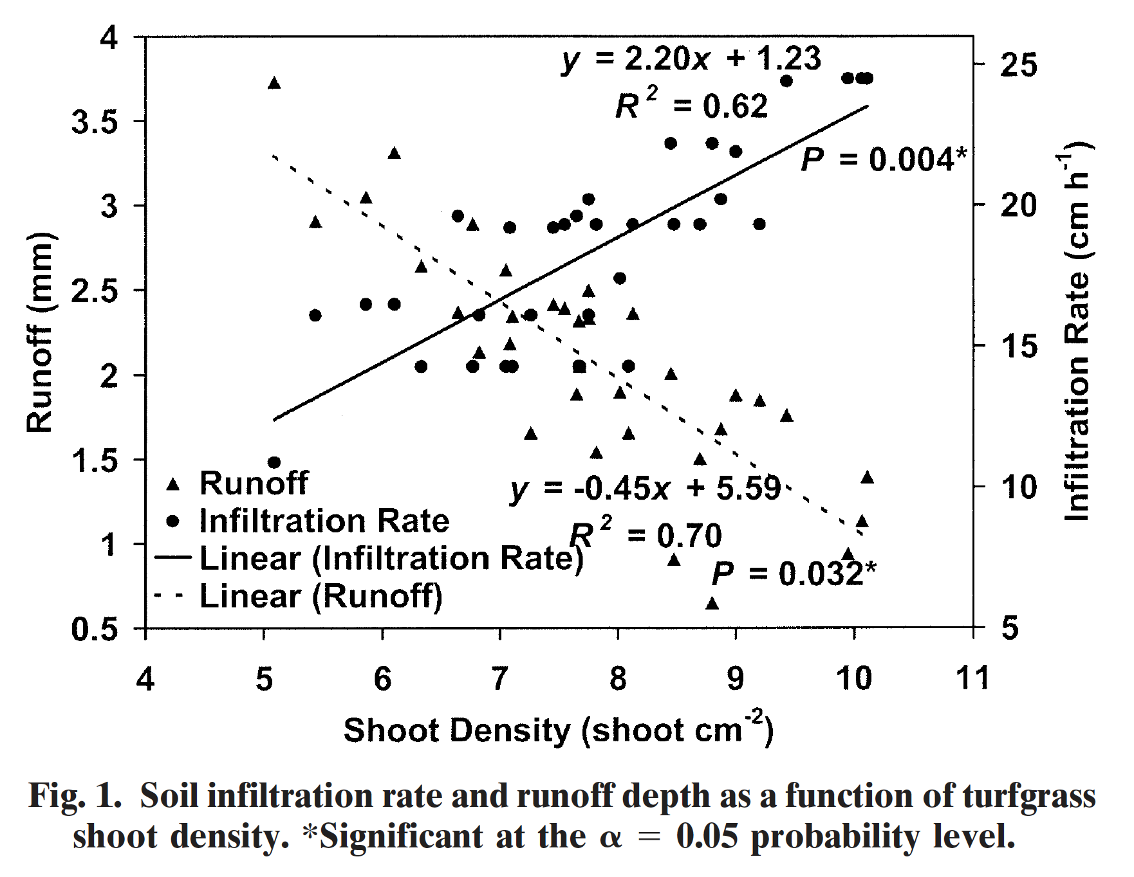

Heavenrich, H., & Hall, S. J. (2016). Elevated soil nitrogen pools after conversion of turfgrass to water-efficient residential landscapes. Environmental Research Letters, 11(8), 084007. https://doi.org/10.1088/1748-9326/11/8/084007
Converting turfgrass to water-efficient landscapes like xeriscapes, rain gardens, and water-wise landscapes was found to export nitrate (4 times higher compared to turfgrass, with largest N pools 9-13 years after turfgrass removal) in Phoenix, AZ.
Kelling, K. A., & Peterson, A. E. (1975). URBAN LAWN INFILTRATION RATES AND FERTILIZER RUNOFF LOSSES UNDER SIMULATED RAINFALL. Proc Soil Sci Soc Am, 39(2), 348–352. https://doi.org/10.2136/SSSAJ1975.03615995003900020031X
“the presence of textural and compaction discontinuities within the soil profile, formed during building and lawn construction, was probably the greatest factor affecting infiltration. Where these discontinuities were distinct, water intake was reduced to about 35% of that for a lawn with an undisturbed profile”

Beth’s understanding of this sentence is that a continuous lawn infiltrates better than a patchy lawn. This is apparently a seminal publication, so I sought it out by interlibrary loan.

Focus of the paper appears to be mostly about timing of fertilizer to minimize loss.

With respect to infiltration, they noticed the impact of compaction, even in areas where there was more foot traffic from a clothesline.

Plots 4 and 5 were undisturbed and not compacted due to construction. Reporting their value as (7.3+8.8)/2=0.05 cm/hr as the baseline for other measurements. All other plots were compacted by construction and restored with 5-10 cm of topsoil and 15-30 cm of subsoil. Soils were silt loam grading into sandy loam till at 60 cm. The year of construction is unclear and the duration of undisturbed turfgrass was also not stated.

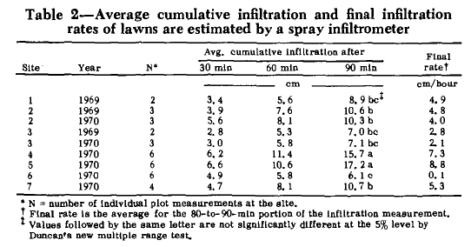

Langner, A. N., Manu, A., & Nath, D. A. (2013). Dynamic Soil Properties across a Suburban Landscape. Soil Science Society of America Journal, 77(4), 1284–1293. https://doi.org/10.2136/SSSAJ2012.0239
Iowa State research that evaluated changes in soil quality indicators (bulk density, organic carbon, pH, inorganic carbon) over time (new vs older developments) for suburban homes in Iowa (all loamy soils)
- Bulk density higher in newer developments; increase significantly with depth possible because of increased compaction from newer and heavier equipment in newer developments and improved aggregation and structural development in soils in older areas
- Organic carbon decrease with time, depth
- pH increased with time of development and depth
- Soils may “rebound” with time in terms of BD and OC
- “Marked changes began in 1980s when topsoil was being stripped and not replaced from sites and more mass grading and on-site vehicular traffic became common”
Construction of urban developments alters soil properties. Bulk density is higher in new construction sites compared with older sites in the same soil type and neighborhood. New developments also had significantly lower soil organic carbon (0.49 g/kg for early 2000’s development vs 4.49 g/kg for pre-1939 development. Where calcareous till was the parent material, the newly disturbed soils had a higher pH (Langner et al., 2013). The impact of disturbance in urban settings diminishes on decadal time scales.
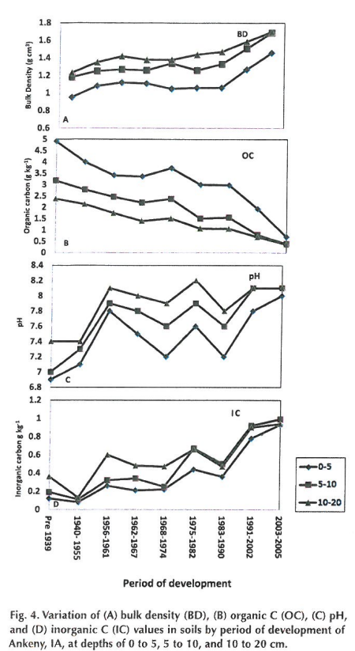

Nocco, M. A., Rouse, S. E., & Balster, N. J. (2016). Vegetation type alters water and nitrogen budgets in a controlled, replicated experiment on residential-sized rain gardens planted with prairie, shrub, and turfgrass. Urban Ecosystems 2016 19:4, 19(4), 1665–1691. https://doi.org/10.1007/S11252-016-0568-7

Calculated water budgets for three vegetation conditions: prairie, shrub, and turfgrass. Experiment was on biorentention cells in field. They don’t report infiltration rates.

Prairie vegetation was found to decrease soil moisture and increase storage capacity compared with shrubs and turfgrass.
“To the best of our knowledge, this is the first controlled, replicated study to demonstrate that when exposed to the same rainfall patterns and evaporative demand, certain vegetation types, such as prairie, will decrease the antecedent soil moisture and increase the storage capacity of rain gardens compared to other vegetation types, such as shrubs and turfgrass.”
See Selbig 2010 USGS report of this study that more clearly conveys infiltration results.

Patton, A. J. (2025). Why mow?: A review of the resulting ecosystem services and disservices from mowing turfgrass. Crop Science, 65(1), e21376. https://doi.org/10.1002/CSC2.21376

Mowing and turf grass literature review of the ecosystem services (30) and disservices (24) of mowing turfgrass. Extensive table of literature.

As they pertain to infiltration:

Ecosystem Service:
- Infiltration increases with shoot density, and frequent mowing increases shoot density (Easton & Petrovic,2004; Pirchio et al., 2018)
- Decreased erosion from mowing increasing infiltration: (Easton & Petrovic, 2004; Gutierrez & Hernandez, 1996)

Ecosystem Disservice:
- Mowing with heavy equipment increased bulk density and concentrations of certain nutrients, which decreased infiltration. Vandermeeren, 2023
  - Mitigation suggestion: Use lightweight mowers or increase turf height to cushion against soil compaction (Carrow & Petrovic, 1992).

Note: “disservices that result from alternative landscapes must also be considered. Monteiro (2017) summarized the lost ecosystem services that would result from utilization of alternative surfaces instead of turfgrass. Depending on the alternative landscape surface, whether meadow, garden, landscape bed, ground cover, or hardscape, the following disservices may occur: increased soil erosion and reduced water infiltration, reduced atmospheric cooling and carbon sequestration, decreased water and air purification, decreased area for sports and recreation, increased storm water management issues, and increased fire hazard (Monteiro, 2017).”
Peach, M. E., Ogden, L. A., Mora, E. A., & Friedland, A. J. (2019). Building houses and managing lawns could limit yard soil carbon for centuries. Carbon Balance and Management 2019 14:1, 14(1), 9-. https://doi.org/10.1186/S13021-019-0124-X
Soil carbon and nitrogen were lower in lawns than in fields or forests, except where residents left lawn clippings to senesce in place after mowing. Bulk density of lawns was higher than field and forest.
Petrovic, A. M., & Easton, Z. M. (2005). The role of turfgrass management in the water quality of urban environments. International Turfgrass Society Research Journal, 10(November 2014).

Doesn’t report infiltration.

Robbins, P., & Birkenholtz, T. (2003). Turfgrass revolution: measuring the expansion of the American lawn. Land Use Policy, 20(2), 181–194. https://doi.org/10.1016/S0264-8377(03)00006-1
Conversion of agricultural, wetland, and forest systems with monoculture turfgrass lawns has resulted in a lot of chemical and water use in urban and suburban areas. In Franklin County, OH, the lawn area occupies ~23% of the land (Robbins & Birkenholtz, 2003).

Selbig, W. R., & Balster, N. (2010). Evaluation of Turf-Grass and Prairie-Vegetated Rain Gardens in a Clay and Sand Soil, Madison, Wisconsin, Water Years 2004-08. U.S. Geological Survey Scientific Investigations, 5077, 72.
In a 5-year study of rain gardens proportionately sized to capture rain water from adjacent roofs in a 5:1 ratio, the rain gardens were able to store and infiltrate most of the runoff from the roofs. Sandy rain gardens retained and infiltrated 100% of runoff, as did prairie plants in clay. Turf rain gardens exhibited occasional runoff. Sandy soil exhibited higher infiltration than clay soils. Prairie plants exhibited higher median infiltration rates than turf grass is the same soil type. Soil structure and root systems in the prairie planted systems were able to overcome and break through a limited clay layer, appearing well-drained, whereas turf in the same soil conditions had evidence of a perched water table and root limitations.

Other research and references on soil health

Soil Water Storage Capacity & Hydraulic Conductivity

Hudson, B.E., 1994. Soil Organic Matter and Available Water Capacity. Journal of Soil and Water Conservation, Vol. 49, No. 2. p. 189-194
- https://www.tandfonline.com/doi/abs/10.1080/00224561.1994.12456850
- This paper is the most often paper cited on this topic, including by Iowa ISWMM, NRCS, UMN Extension, and many others.

Huntington, T.G., 2007. Available water capacity and soil organic matter. Encyclopedia of soil science, pp.139-143.
- https://www.researchgate.net/profile/Thomas-Huntington/publication/258046417_Available_Water_Capacity_and_Soil_Organic_Matter/links/02e7e5283b6199f67d000000/Available-Water-Capacity-and-Soil-Organic-Matter.pdf
- 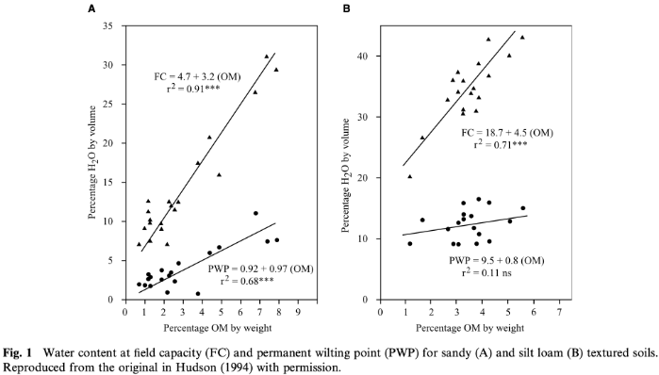
- 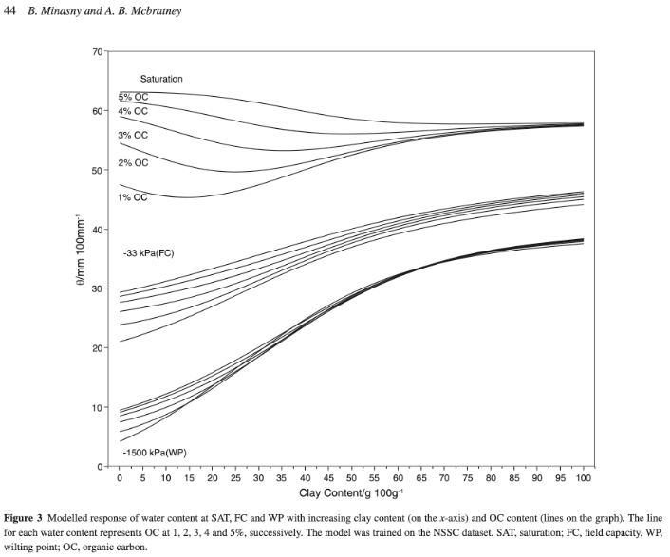

Michel, C., V. Andréassian, and C. Perrin (2005), Soil Conservation Service Curve Number method: How to mend a wrong soil moisture accounting procedure?Water Resour. Res., 41, W02011, doi:10.1029/2004WR003191.
Discussion of problems with Soil Conservation Service Curve Numbers.
Minasny, B. and McBratney, A.B., 2018. Limited effect of organic matter on soil available water capacity. European journal of soil science, 69(1), pp.39-47.\
- https://bsssjournals.onlinelibrary.wiley.com/doi/10.1111/ejss.12475
- Limited effect of soil organic matter levels on available water capacity - NSW (Video)
- 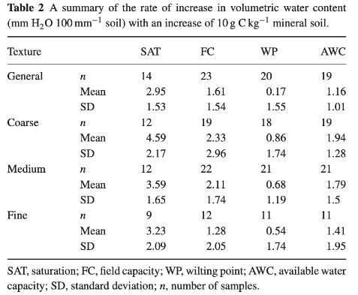

Saxton, K.E. and Rawls, W.J. (2006), Soil Water Characteristic Estimates by Texture and Organic Matter for Hydrologic Solutions. Soil Sci. Soc. Am. J., 70: 1569-1578. https://doi.org/10.2136/sssaj2005.0117

Soil water characteristics based on USDA database of soil texture at soil organic matter. Combined with tension and conductivity relationships. This dataset is the base of the Hydrolab model by USDA.

Zhang, Y. and Schaap, M.G., 2017. Weighted recalibration of the Rosetta pedotransfer model with improved estimates of hydraulic parameter distributions and summary statistics (Rosetta3). Journal of Hydrology, 547, pp.39-53.
- https://www.sciencedirect.com/science/article/abs/pii/S0022169417300057
- Python package: https://github.com/usda-ars-ussl/rosetta-soil, actively maintained
- ROSETTA was used by Robinson 2022 and Schwartz 2021

Penetration resistance relative to bulk density, and soil water content

Best practices emerging from the literature:
- Soil penetration resistance changes with soil moisture content. For most soil textures, the resistance decreases with increasing moisture. For clay textures, the resistance increases with increasing moisture. Therefore, use caution when interpreting low resistance in wet soils. Standardizing soil moisture conditions prior to penetrometer measurements is critical for appropriate representation.
- Bulk density measurements, if they can be accomplished without compaction, will not be influenced by soil water content.
- Make soil penetration measurements near field capacity water content. Or if soils are dry, take penetrometer measurements before and after double-ring infiltration (and don’t do ring infiltration where the penetrometer has probed).
- Undisturbed soils, which allow for soil structures to form through biological processes (stable aggregates) are durable and resist compaction. Water content is the most significant relationship to penetration resistance in soils with stable, biologically built, soil structures.

Unger, P. W., & Jones, O. R. (1998). Long-term tillage and cropping systems affect bulk density and penetration resistance of soil cropped to dryland wheat and grain sorghum. Soil and Tillage Research, 45(1–2), 39–57. https://doi.org/10.1016/S0167-1987(97)00068-8
“some strength factor largely independent of bulk density and affected by water content strongly influences penetration resistance of no-till soil”
“Soil bulk density and penetration resistance always increased with depth and water content often increased.”
Penetration resistance was most commonly a function of bulk density and water content. Penetration resistance was often observed to have an inverse relationship with water content.
In the no-till soil treatment, water content was significantly related to penetration resistance, but bulk density was not. The soil structures that are able to form in no-till settings by soil organisms and root penetration were durable, and supported improved trafficability of no-till soils.
Study was dryland, great plains, U.S. and crops were winter wheat and grain sorghum.

Vaz, C. M. P., Bassoi, L. H., & Hopmans, J. W. (2001). Contribution of water content and bulk density to field soil penetration resistance as measured by a combined cone penetrometer–TDR probe. Soil and Tillage Research, 60(1–2), 35–42. https://doi.org/10.1016/S0167-1987(01)00173-8
Penetration resistance decreased after irrigation, but the maximum resistance was at the same depth interval in both the wet and dry treatments. The bulk density maximum was at the same depth interval as the maximum penetration resistance.
The study found that the bulk density effect on penetration resistance decreases as water content increases. Penetration resistance increases exponentially with decreasing water content.

Vaz, C. M. P., Manieri, J. M., de Maria, I. C., & Tuller, M. (2011). Modeling and correction of soil penetration resistance for varying soil water content. Geoderma, 166(1), 92–101. https://doi.org/10.1016/J.GEODERMA.2011.07.016

Penetration resistance was lowest for very wet soils, except for very wet clay soils, in which case penetration resistance increased. At a matric potential of -10 kPa the penetration resistance measurements were least affected by soil texture. Dry soils (-1500 kPa) exhibited a maximum penetration resistance in soil with 35% clay.
Note on matric potential: Matric potential values of -10 to -30 kPa are the range considered field capacity. Field capacity is stated as a range because it depends on soil texture. Field capacity water is held by capillary forces; adding water above field capacity (less negative value, where 0 is saturation) is often too much for plants to access because the water is able to move by gravitational force, and this amount of water often limits soil aeration. Gravitational water is also of concern because this water is how leached nutrients and chemicals leave the soil.
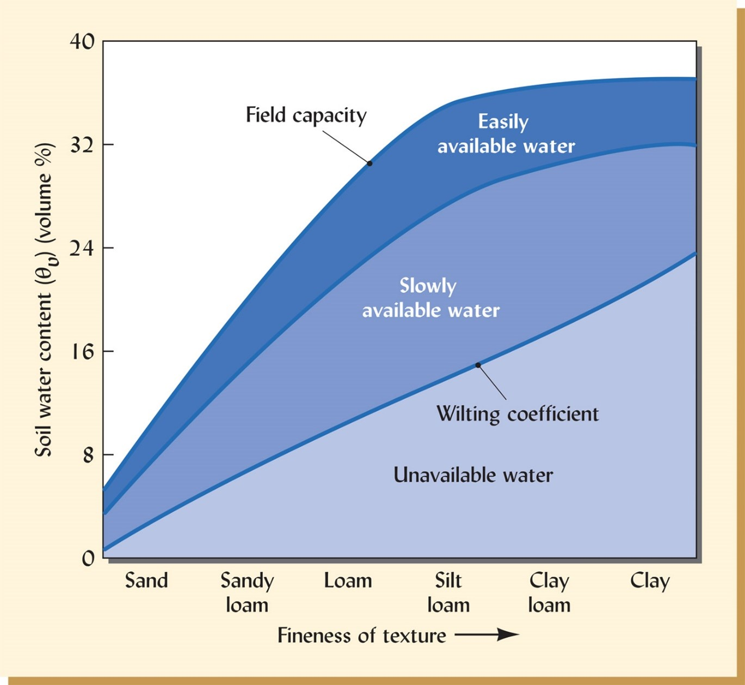
From Brady & Weil, Nature and Property of Soils.
Vazquez, L., Myhre, D.L., Hanlon, E.A. and Gallaher, R.N., 1991. Soil penetrometer resistance and bulk density relationships after long‐term no tillage. Communications in soil science and plant analysis, 22(19-20), pp.2101-2117.
https://www.tandfonline.com/doi/epdf/10.1080/00103629109368561

Daddow, R.L. and Warrington, 1983. Growth-limiting soil bulk densities as influenced by soil texture. Watershed Systems Development Group, USDA Forest Service.
- https://forest.moscowfsl.wsu.edu/smp/solo/documents/RPs/daddow_warrington_root_limiting_bulk_density.pdf
- Based on agricultural crops, which are reasonable proxies for most herbaceous vegetation, but not plants with strong tap roots (i.e. tillage radish)
- “for many situations there appears to be an upper limit or threshold soil bulk density value where resistance to root penetration is so high that plant root growth is essentially stopped (O'Connell 1975). Restricted root penetration and elongation reduces the volume of soil that can be exploited by a plant for essential nutrients and water, which can cause a reduction in total growth. This threshold bulk density will be referred to as "growth-limiting" bulk density (GLBD).”



Cofer, T.L., 2019. Radish cover crop growth and compaction alleviation potential in southeastern coastal plain soils (Master's thesis, Auburn University).
- https://etd.auburn.edu/bitstream/handle/10415/6976/Radish%20Cover%20Crop%20Growth%20and%20Compaction%20Alleviation%20Potential.pdf
- Greenhouse experiments with sandy loam showed that Tillage and Smart Radish roots could not penetrate into a hardpad layer that was compacted to 1.72 to 1.83 g cm-3

Topsoil stockpile management

Best practices emerging from the literature:
- Keep stockpiles as small and short-lived as possible
- Avoid long-term storage (>1 year if possible)
- Keep soils dry/covered
- Time stripping and spreading carefully, ideally same season, avoid winter and wet season
- Use post-spreading deep decompaction (e.g., ripping)

Mackenzie, D. D., & Anne Naeth, M. (2019). Native seed, soil and atmosphere respond to boreal forest topsoil (LFH) storage. PLOS ONE, 14(9), e0220367. https://doi.org/10.1371/JOURNAL.PONE.0220367

Study of topsoil stockpiles in northeastern Alberta (boreal forest) found that anaerobic soil conditions developed quickly after stockpile construction and remained for depths >1 meter. Smaller stockpiles (0.05, 1.0, 3.0 meter) eventually developed anoxic conditions. Seeds and rhizomes were buried in the stockpiles and only two species with hard seed coats survived and were able to germinate (Geranium bicknellii and Dracocephalum parviflorum). Soil nutrients also became soluble in the stockpiles. (Mackenzie & Anne Naeth, 2019)

Fischer, A., Singh, J. P., Van Hamme, J., Bottos, E., & Fraser, L. H. (2025). Investigating impacts from topsoil stockpile height on soil microbial communities. Frontiers in Microbiomes, 4, 1607677. https://doi.org/10.3389/FRMBI.2025.1607677/

Interior British Columbia, study found that microbial diversity declined and community structure shifted with increasing stockpile depth. 6-year-old, 25-meter-deep topsoil stockpile that has been added to over the years.
(Fischer et al., 2025)

Golos, P. J., & Dixon, K. W. (2014). Waterproofing topsoil stockpiles minimizes viability decline in the soil seed bank in an arid environment. Restoration Ecology, 22(4), 495–501. https://doi.org/10.1111/REC.12090;

Study in an arid climate in Australia found that dry conditions are better for seed viability in stockpiles than under warm and moist conditions. When topsoil was stored for two years, compared with one year, the study saw lower seedling emergence (68% lower) and species richness (30% lower). When stockpiles were covered the seedling emergence was 3.5 fold higher after two years than uncovered piles. (Golos & Dixon, 2014)

Rokich, D. P., Dixon, K. W., Sivasithamparam, K., & Meney, K. A. (2000). Topsoil handling and storage effects on woodland restoration in Western Australia. Restoration Ecology, 8(2), 196–208. https://doi.org/10.1046/J.1526-100X.2000.80027.X

In a woodland with mesic mediterranean climate, decline of seedling establishment was as follows, with fresh topsoil as baseline:
• After 1 year, 54% of seedlings established
• After 3 years, 34% of seedlings established
Timing of stripping and spreading also mattered. If these activities happened during winter instead of autumn, this depressed seedling establishment. If stockpiles were spread during the wet season this depressed seedling establishment. If soil was stockpiled in winter and spread in spring, this depressed seedling establishment.
Ripping of topsoil and subsoil to 80 cm following spreading of topsoil resulted in no loss of seedling establishment. No difference in seedling recruitment from the topsoil was found for soil spread to 10 and 30 cm depth.
(Rokich et al., 2000)

Ground cover during construction
John M. Lichter and Patricia A. Lindsey (1994). Arboriculture & Urban Forestry (AUF) July 1994, 20 (4) 205-209; DOI: https://doi.org/10.48044/jauf.1994.037
Silt loam soil.
Vehicle traffic most severely compacts soil in the 0-10 cm surface depth in the untreated plots.
In their study, 15 cm mulch, 15 cm mulch over geotextile, 15 cm mulch over plastic grid, 10 cm gravel, 10 cm gravel over geotextile, treatments all resisted soil compaction better than ¾ inch construction grade plywood.
None of the treatments eliminated compaction.
“Compaction may be minimized by selecting lightweight equipment with wide, smooth, low pressure tires; directing traffic routes away from designated landscape areas; and limiting equipment use to periods when the soil is relatively dry”
15 cm layer of mulch was recommended, but thicker is more effective.

Preserve tree root zones and fence them to truly prevent compaction (fence other areas to fully protect from traffic).

These two might support the 0-4 inch statement.
Gregory, J., Dukes, M., Jones, P., and Miller, G. (2006). “Effect of urban soil compaction on infiltration rate.” J. Soil Water Conserv., 61(3), 117–124. (https://www.tandfonline.com/doi/abs/10.1080/00224561.2006.12435870)

Friedman, D., Montana, C., Welle, P., Smith, C., and Lamm, D. (2001). “Impact of soil disturbance during construction on bulk density and infiltration in Ocean County, New Jersey.” Ocean County soil conservation district, Schnabel Engineering Associates, USDA Natural Resources Conservation Service, Forked River, NJ. (https://rucore.libraries.rutgers.edu/rutgers-lib/37015/)

Basic science of soil aggregates

Lehmann, J., Kinyangi, J. & Solomon, D. Organic matter stabilization in soil microaggregates: implications from spatial heterogeneity of organic carbon contents and carbon forms. Biogeochemistry 85, 45–57 (2007). https://doi.org/10.1007/s10533-007-9105-3

Study of micro-aggregates and how they store carbon. Contains nice illustration of clay particles and carbon forming and protecting carbon in micro-aggregates. Illustration misses the variety of organic matter such as fungi in the illustration.

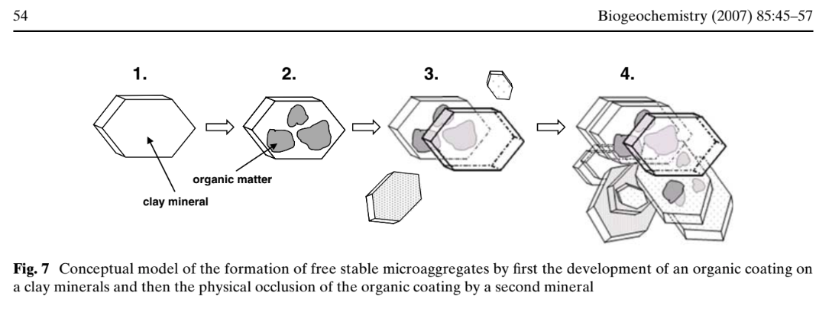

TISDALL, J.M. and OADES, J.M. (1982), Organic matter and water-stable aggregates in soils. Journal of Soil Science, 33: 141-163. https://doi.org/10.1111/j.1365-2389.1982.tb01755.x

Seminal paper on soil aggregates showing the organic binding agents. Roots and fungal hyphae stabilize micro-aggregates, which is controlled by soil management.

Yudina and Kuzyakov, 2023. Dual nature of soil structure: The unity of aggregates and pores, Geoderma, Volume 434, https://doi.org/10.1016/j.geoderma.2023.116478.

Importance of aggregates for soil function.

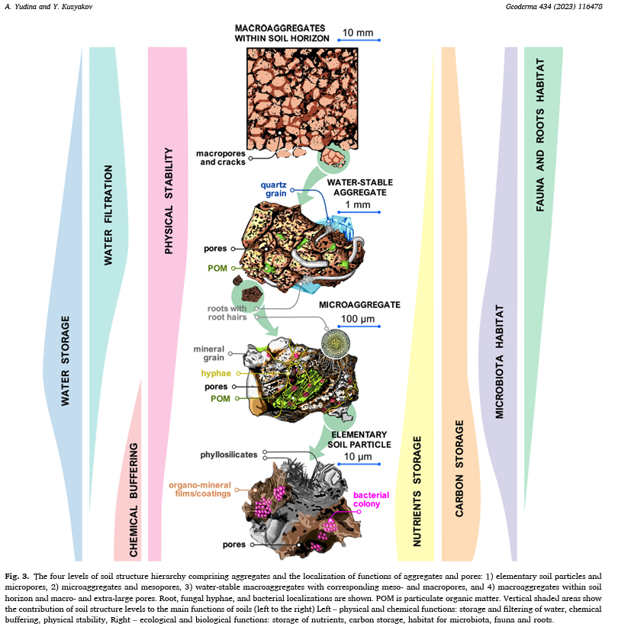

Chemicals in urban soil/water
Gunstone T, Cornelisse T, Klein K, Dubey A and Donley N (2021) Pesticides and Soil Invertebrates: A Hazard Assessment. Front. Environ. Sci. 9:643847. doi: 10.3389/fenvs.2021.643847
Pesticides pose a threat to soil invertebrates.

Yang, J. L., & Zhang, G. L. (2015). Formation, characteristics and eco-environmental implications of urban soils – A review. Soil Science and Plant Nutrition, 61, 30–46. https://doi.org/10.1080/00380768.2015.1035622
Focus of this work is on metal and chemical contamination of urban soils.
Zaller, J. G., Heigl, F., Ruess, L., & Grabmaier, A. (2014). Glyphosate herbicide affects belowground interactions between earthworms and symbiotic mycorrhizal fungi in a model ecosystem. Scientific Reports 2014 4:1, 4(1), 5634-. https://doi.org/10.1038/srep05634
Glyphosate in a greenhouse study found decrease in arbuscular mycorrhizal fungi and heavier but less active earthworms. Infiltration was reduced and leaching of glyphosate was significant.
Bueno de Mesquita, C. P., Solon, A. J., Barfield, A., Mastrangelo, C. F., Tubman, A. J., Vincent, K., Porazinska, D. L., Hufft, R. A., Shackelford, N., Suding, K. N., & Schmidt, S. K. (2023). Adverse impacts of Roundup on soil bacteria, soil chemistry and mycorrhizal fungi during restoration of a Colorado grassland. Applied Soil Ecology, 185, 104778. https://doi.org/10.1016/J.APSOIL.2022.104778
“Bacterial and archaeal communities were more affected by Roundup Promax than eukaryotic communities, with decreases in phylogenetic diversity and changes in community structure following Roundup Promax applications, particularly after five applications. More critically, the colonization of plant roots by arbuscular mycorrhizal fungi decreased significantly in plots receiving even just two applications of Roundup Promax, and dark septate endophytes decreased after four applications. Our work shows that Roundup Promax had multiple negative effects on soil biota in this field study due to either direct effects or indirect effects mediated through plant removal. Our results suggest that repeated herbicide applications are especially damaging to soil health and microbe-plant associations. These effects in turn could severely hamper the ability of native plants to establish during ecosystem restoration projects. “
Bacteria, archaea, and mycorrhizal fungi populations decreased with Roundup Promax, especially for repeated applications.
van Bruggen, A. H. C., Finckh, M. R., He, M., Ritsema, C. J., Harkes, P., Knuth, D., & Geissen, V. (2021). Indirect Effects of the Herbicide Glyphosate on Plant, Animal and Human Health Through its Effects on Microbial Communities. Frontiers in Environmental Science, 9. https://doi.org/10.3389/FENVS.2021.763917
Review paper indicates that soil microbial communities change with glyphosate use, especially long-term use. Glyphosate and its degradation products typically stay in the soil 1000 days, but the products linger longer in clay soils due to sorption with mineral particles.

Earthen berms like MNDOT uses for topsoil:
From Warren Tuel when asked about peer-reviewed publications:
I’m not aware of anything we have on hand that was used to develop this method of perimeter control. Auburn University has done some research on alternative perimeter control using berms such as topsoil, slash mulch, etc… I don’t believe we go into this detail on the berms in our facility design guide. I’ll keep this in mind and send you anything I might come across as a reference.

Beth explored publications from Auburn and found that earthen berm is not used in the same manner in these papers as MNDOT. I failed to find studies that took topsoil, rolled it, and used that as a control berm, plus measure to preserve topsoil during construction. Several of the Auburn studies appear to compare erosion trapping mechanisms, but that was not the scope of this study and the Stormwater Manual appears to cover these topics already.

Modeling of urban infiltration and runoff
Berthier, E., Andrieu, H., & Creutin, J. D. (2004). The role of soil in the generation of urban runoff: Development and evaluation of a 2D model. Journal of Hydrology, 299(3–4), 252–266. https://doi.org/10.1016/j.jhydrol.2004.08.008
Model seeking to determine the role of soil in urban runoff. Soil contributed 14% to runoff with the main factors causing soil to release water were water table in the soil prior to rain event and soil water storage capacity. The study did not consider soil health or different vegetation treatments on the soil.
Coville, R. C., Kruegler, J., Selbig, W. R., Hirabayashi, S., Loheide, S. P., Avery, W., Shuster, W., Haefner, R., Scharenbroch, B. C., Endreny, T. A., & Nowak, D. J. (2022). Loss of street trees predicted to cause 6000 L/tree increase in leaf-on stormwater runoff for Great Lakes urban sewershed. Urban Forestry and Urban Greening, 74. https://doi.org/10.1016/j.ufug.2022.127649
The model i-Tree Hydro simulated a paired catchment experiment with validation of field observations. The study found that street trees reduced runoff by 64L per square meter of canopy. The largest explanation for model results was the interception and retention of rain water on trees. Potential evapotranspiration had some effect at avoiding runoff, but the effect of interception by the trees was much greater (461,000 L interception and 12,000L evapotranspiration between cut and no-cut simulations).
Kinnell, P. I. A. (2019). A Review of the Science and Logic Associated with Approach Used in the Universal Soil Loss Equation Family of Models. Soil Systems 2019, Vol. 3, Page 62, 3(4), 62. https://doi.org/10.3390/SOILSYSTEMS3040062
The Universal Soil Loss Equation (USLE) and the revised versions (RUSLE and RUSLE2) are based on a unit of land that is bare soil with 9% slope that is cultivated up and down the slope. The equation intends to predict a long term, 20 year average annual soil loss (A) from sheet and rill erosion. The equation is based on empirical studies that consider rainfall (R), erosivity (K, eventually developed based on soil properties), slope length (L), slope gradient (S), crop and management (C), and conservation practices (P). The equations did not consider deposition. Refinements of the original equation include adjustments for localized variations, the impact of ponding on low slope zones, and the impact of intensity and quantity of rainfall events. RUSLE removed some of the empirical considerations and RUSLE2 changed the timeline of the model and sought to accommodate more needs of conservation planners and model deposition. In 2016 NRCS gave notice to end the use of RUSLE2 and replace it with the Water Erosion Prediction Project (WEPP). Difficulty in predicting runoff is a complication for all of the erosion models. The main purpose of these models is to guide agricultural land managers in soil conservation in their cropping systems and practices, assess erosion problems over a wide area and track changes with time, and regulate compliance of conservation practices.

Regulation and codes for urban soil quality
Also see Regulatory Review tab
Hanks, D., & Lewandowski, A. (2003). Protecting Urban Soil Quality: Examples for Landscape Codes and Specifications. USDA Natural Resources Conservation Services.
Functions of soil health for urban settings:
Nutrient cycling: healthy soils hold, store, and filter nutrients. Where plants are present, the soil is able to release nutrients to plants, which minimizes leaching and release of nutrients in surface water and groundwater.
Water-holding: healthy soils can receive (infiltrate) and store water, which offsets or prevents erosion and runoff. To do this at full capacity, soils need perennial plants creating a root system to hold the soil in place and create spongy soil structure.
Growth substrate: Soil serves as a place for plants to take root, which also increases biological activity in the soil, which promotes nutrient recycling and decompacts the soil to promote infiltration and water storage.
O’Riordan, R., Davies, J., Stevens, C., Quinton, J. N., & Boyko, C. (2021). The ecosystem services of urban soils: A review. Geoderma, 395. https://doi.org/10.1016/j.geoderma.2021.115076
Urban soil water is disconnected from the assessments of ecosystem services pertaining to soil water is a conclusion of this meta-analysis. This paper simply looks at how many publications per year were made for each topic, but it does not summarize the findings of the papers.

Guide Review

Practical Guides to Soil Health

Preliminary studies showing the benefits of improved soil health for stormwater

NCDOT (McLaughlin 2020)
McLaughlin, R. A., Ashraah, S. H., Haselton, A. M., Heitman, J. L., Carley, D. S., & Tarpy, D. R. (2020, November 17). Storm water infiltration and pollinator habitat zones along highways (Report No. FHWA/NC/2017-27). North Carolina Department of Transportation Research and Development Unit; U.S. Department of Transportation, Federal Highway Administration. https://rosap.ntl.bts.gov/view/dot/60604
- Study on how incorporating compost and/or using wildflowers as substitute for grass can provide greater infiltration potential
- “Our results suggest that this approach is a viable practice and could be integrated with stormwater mitigation practices in urban areas with best management practices and low impact developments.”

MDOT (Schwartz 2021)
Schwartz, S. S. (2021). The effectiveness of soil decompaction for stormwater management (Report No. MD-21-SHA/UMBC/02-1). Center for Urban Environmental Research and Education & University of Maryland, Baltimore County; Maryland State Highway Administration, Office of Policy & Research. https://rosap.ntl.bts.gov/view/dot/60230
- Report on field and modeling studies to support a BMP
- Prototype BMP (initial framework for quantifying BMP credits) of soil decompaction + compost amendment for stormwater BMP in MD. For these practices and specific endpoints (healthy soil 5% OM, topsoiled urban soil 4", 6-in suburban subsoiling, 9" suburban subsoiling), effective curve numbers (ECN) were developed.
  - Figure 9 shows results from Taneytown test site
  - Table 3 showed at Taneytown test site w/ sandy-loam for decompaction treatment
    - Infiltration: 0.04 to 8.7 in/hr (estimate 3.0 after settling)
    - Effective Curve Number (ECN) from 86 to 60 (63 after settling)
  - Table 4 & Figure 3 showed modeled results based on synthesis of observations
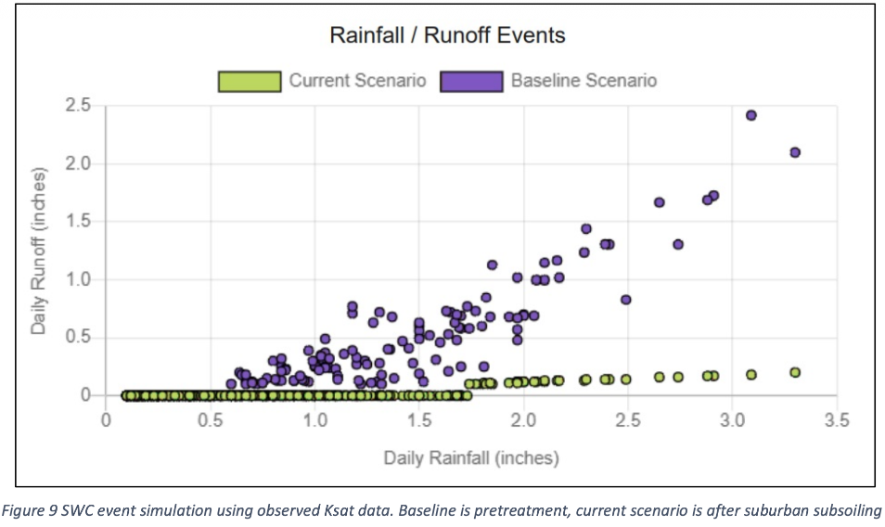
- BMP Protocol for Soil Decompaction and Amendment

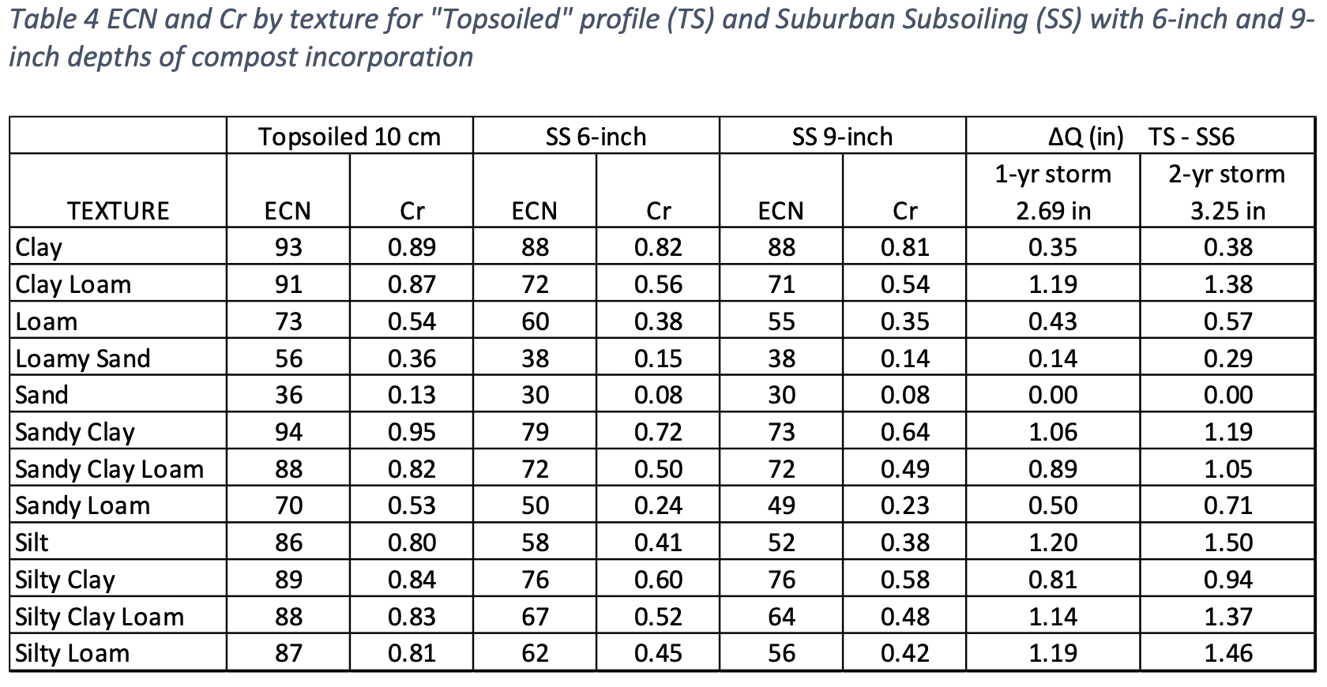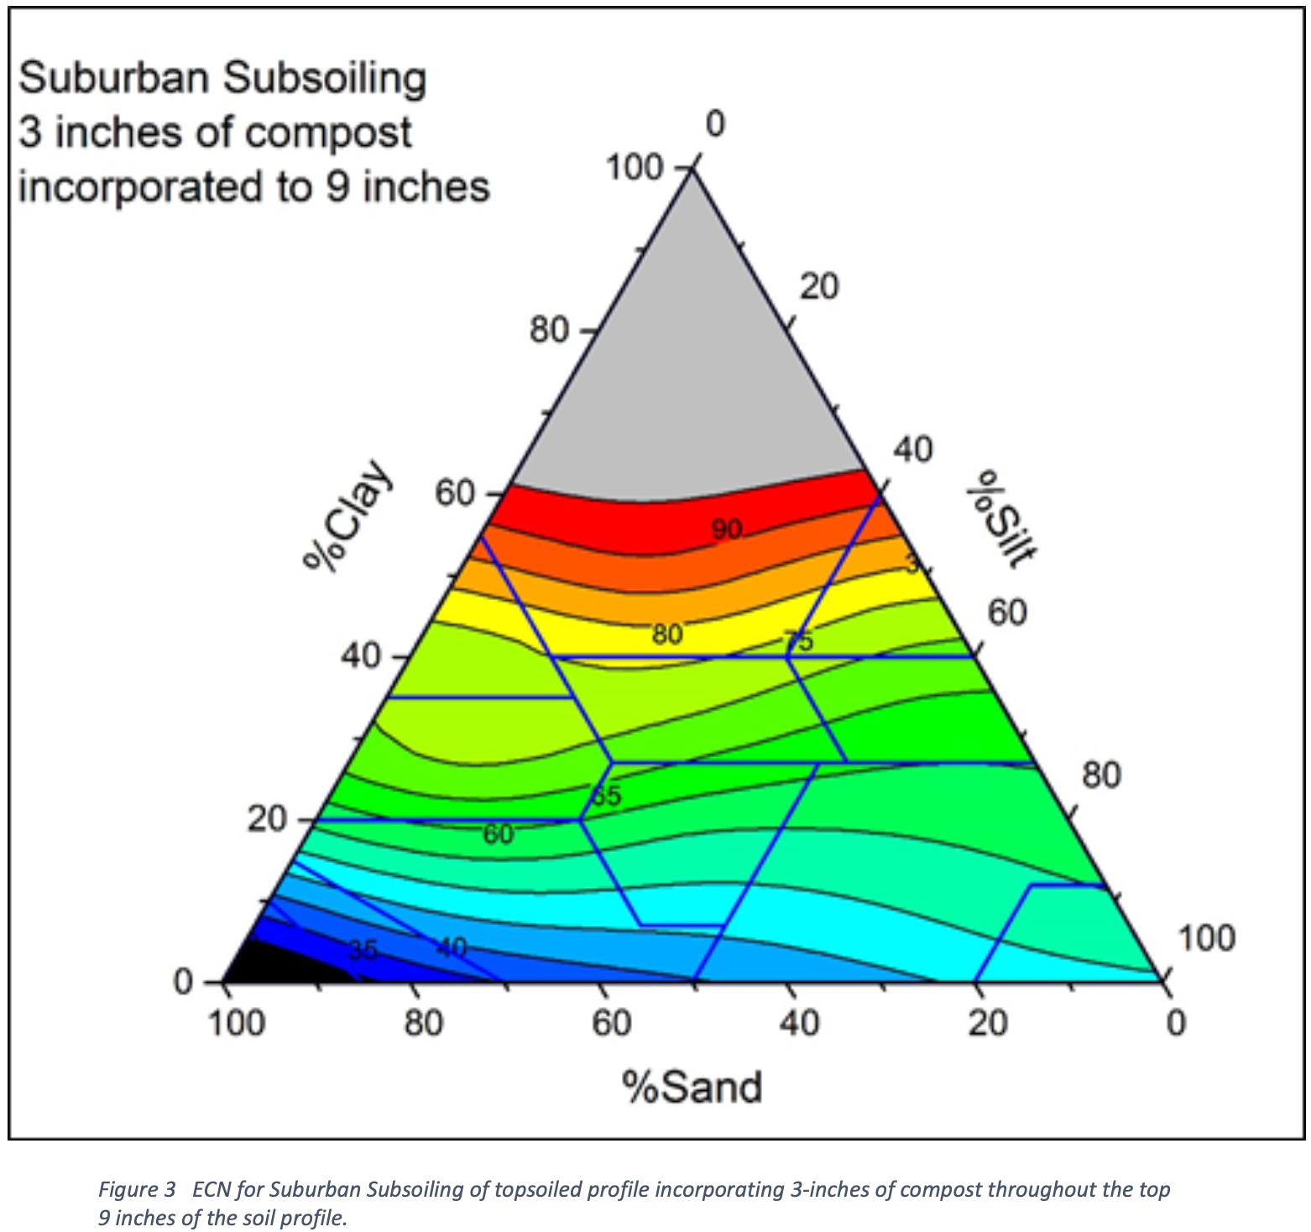

Chesapeake Bay Program.
Chesapeake Bay Program, 2016. Recommendations of the Expert Panel to Define Removal Rates for Disconnecting Runoff from Impervious Areas onto Amended Soils or Treatment in the Stormwater Conveyance System. Available at: https://d18lev1ok5leia.cloudfront.net/chesapeakebay/documents/Impervious_Disconnection_Expert_Panel_Report_WQGIT_approved_December_2016.pdf
- Recommendations on disconnecting runoff from impervious areas onto amended soils or treatment. Expert panel to recommend nutrient and sediment load reductions using disconnection of existing impervious area runoff from stormwater drainage systems as a new BMP for credit towards Watershed Implementation Plans
- 75 publications + state and DC stormwater design guidance reviewed
- Doesn’t link to soil health, but 2 references to soil amendments. “The addition of soil amendments is also recognized as a suitable method for reducing runoff through increased infiltration. The list of potential amendments for soil is quite extensive.”

Adaptive Management & Conservation Planning

Horne 2018 Informing Environmental Water Management Decisions
Horne, A.C., Szemis, J.M., Webb, J.A. et al. Informing Environmental Water Management Decisions: Using Conditional Probability Networks to Address the Information Needs of Planning and Implementation Cycles. Environmental Management 61, 347–357 (2018). https://doi.org/10.1007/s00267-017-0874-8
Figure: https://www.researchgate.net/figure/The-adaptive-management-cycle-showing-the-planning-outer-loop-and-implementation-inner_fig1_317359031


USGS. Monitoring and Adaptive Management Process for Restoration Plan
https://www.usgs.gov/media/images/monitoring-and-adaptive-management-process-restoration-plan


TNC. THE OPEN STANDARDS FOR THE PRACTICE OF CONSERVATION
Slides: https://www.nature.org/content/dam/tnc/nature/en/documents/nz/NZ_CS_240222_Intro_to_CS_PW.pdf
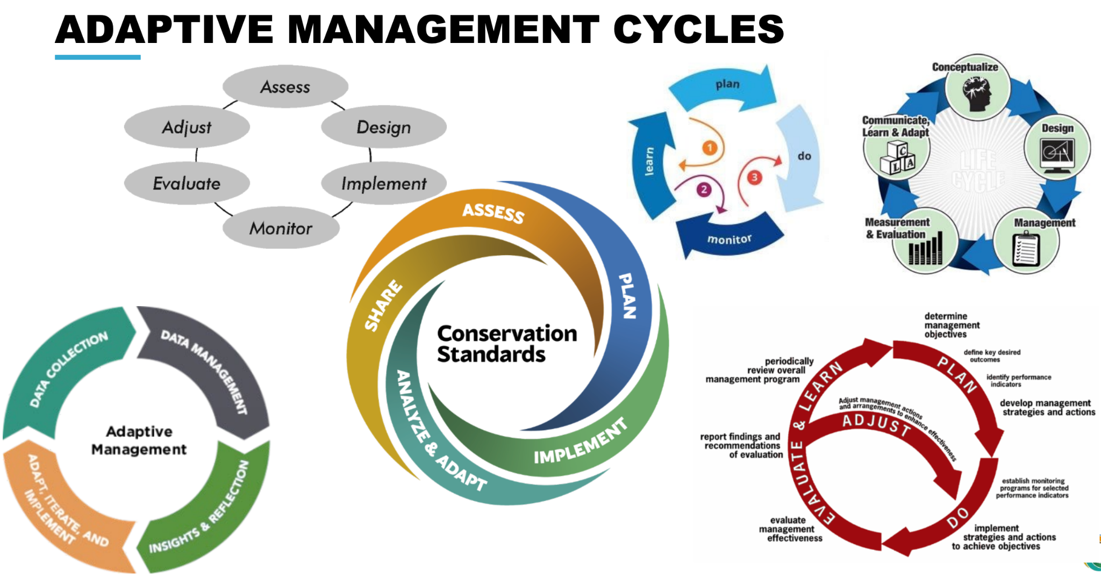


NRCS Conservation Planning Website
https://www.nrcs.usda.gov/getting-assistance/conservation-technical-assistance/conservation-planning
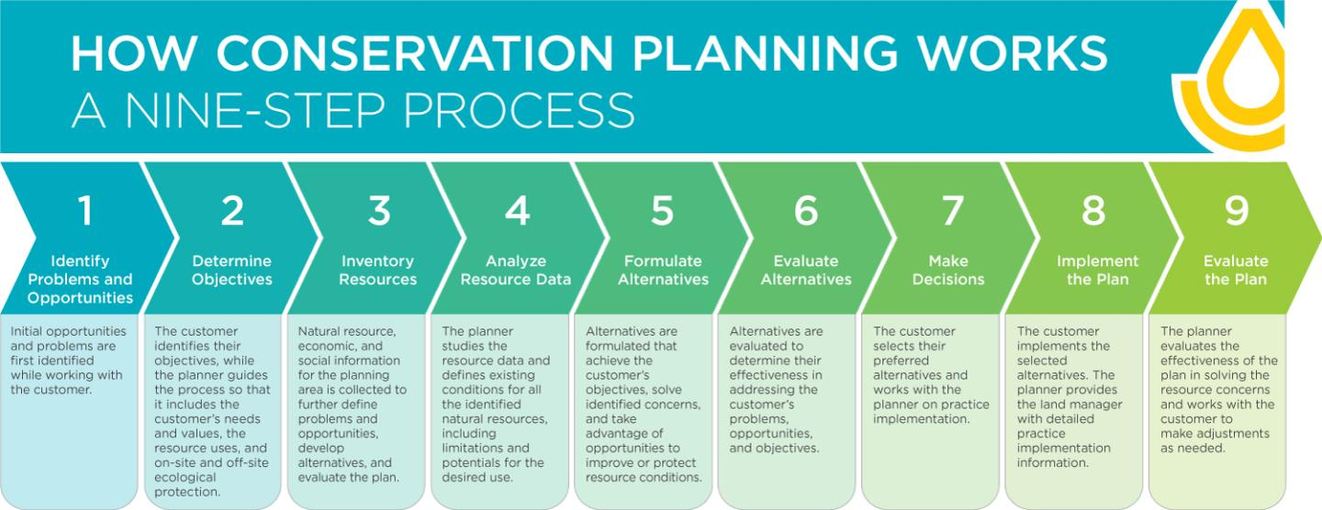
- Conservation Planning and Delivery Fact Sheet
- National Conservation Planning Partnership Brochure

Rogers 2020 What is adaptive management and how does it work
Rogers, P. and Macfarlan, A., 2020. What is adaptive management and how does it work. Better evaluation: Monitoring and evaluation for adaptive management, working paper, 2, pp.2021-11.
https://www.betterevaluation.org/sites/default/files/2021-11/MandE_for_Adaptive_Management_WP2_What_Is_AM_%26_how_does_it_work_202009.pdf

EcoShape Adaptive Management Strategy
https://www.ecoshape.org/en/knowledge-articles/adaptive-management-strategy/


USGS 2009 Adaptive management Tech Guide
Williams, B.K., Szaro, R.C. and Shapiro, C.D., 2009. Adaptive management: the US Department of the Interior technical guide. USGS Report, p.62.
https://www.doi.gov/sites/doi.gov/files/migrated/ppa/upload/TechGuide.pdf

Guides to assess soil health

Forestland In-Field Soil Health Assessment (FIFSHA) Guide
Soil Health Technical Note No. 470-08, 2024. https://directives.nrcs.usda.gov/sites/default/files2/1729877419/TN%20470-08%20FIFSHA%20Guide.pdf

NOTE: We recommend adopting (or adapting) this simple established approach to assess soil health, that can be performed quickly and inexpensively.
Intended for conservation planners to assess soil health in forests using in-field observations of several key indicators. Each indicator has a score of 1-5 as a quick, in-field assessment. The assessment methods for soil cover, soil disturbance intensity, soil structure, water stable aggregates, soil fauna/biological diversity, and roots could be well utilized in an urban soil assessment kit with additional indicators specific to urban soils.

Indiana Urban Soil Health program. Urban Soil Health Resources.
Urban Soil Health, 2025. “Resources.” Webpage. Available at: https://insmallfarms.org/resources/
- NOTE: Seems all about urban ag, so of limited value.
- Points to resources for
  - Background on urban ag and urban soils
  - Site evaluation
  - Soil testing
  - Soil contamination
  - Conservation practices

NRCS Landing Page for Soil Health Assessment
https://www.nrcs.usda.gov/conservation-b asics/natural-resource-concerns/soil/soil-health/soil-health-assessment
Has a comprehensive list of soil health measurements delineated by physical, chemical, biological. They have a short summary sheet of soil quality indicators that looks like a good resource.

NRCS 2008 Soil Quality Indicators: SoilStructure&Macropores (flyer)
https://www.nrcs.usda.gov/sites/default/files/2022-10/Soil%20Structure%20and%20Macropores.pdf .

NRCS 2008 Soil Quality Indicators: AggregateStability (flyer)
https://www.nrcs.usda.gov/sites/default/files/2022-10/nrcs142p2_051276.pdf

NRCS 2015 Soil Quality Indicators: Physical, Chemical, and Biological Indicators for Soil Quality Assessment and Management (flyer)
https://www.nrcs.usda.gov/sites/default/files/2022-10/indicator_sheet_guide_sheet.pdf

NRCS 2024c Tech Note 470-03. Urban Soil Health Site Eval.
USDA, 2024c. Site Evaluation for Urban Soil Health. Technical Note No. 470-03. Available at: https://directives.nrcs.usda.gov/sites/default/files2/1712940857/35719.pdf
Focus of the resource is mostly on urban agriculture. It has a thorough overview of considerations for contamination of urban soils (mostly for growing food), but no consideration for the intersection of soil health for stormwater.

NRCS 2024a Tech Note 470-02. Basics of Urban Soil Health
USDA, 2024. Basics of Urban Soil Health. Technical Note No. 470-02. Available at: https://directives.nrcs.usda.gov/sites/default/files2/1712940852/35715.pdf

- A thorough and concise overview of the considerations for soil health in urban areas with a small discussion on stormwater with respect to compaction.
- A key consideration for soil health assessments in urban areas – determine which type of soil is present:
  - More native soil
  - HAHT soil
  - Some type of created soil or soilless media that has been introduced (e.g. for gardening)
- Defines resource concerns – soil conditions that signal a degradation of the soil resource to the extent that it impairs the sustainability and intended land uses for that soil
  - Compaction – assess with specialized tools (e.g. penetrometer) or visual and tactile indicators of soil hardness
  - Tests for lead and other contaminants – essential BMP for soil health. Typically 3 recommendations: recommendations: (1) little to no health risk at the site, (2) some health risk, and (3) too high a risk for intended use.
- Refers to NRCS Cropland In-Field Soil Health Assessment (IFSHA) (USDA NRCS 2019b) for assessment protocols.
  - https://www.nrcs.usda.gov/sites/default/files/2022-10/Cropland_InField_Soil_Health_Assessment_Guide.pdf
  - 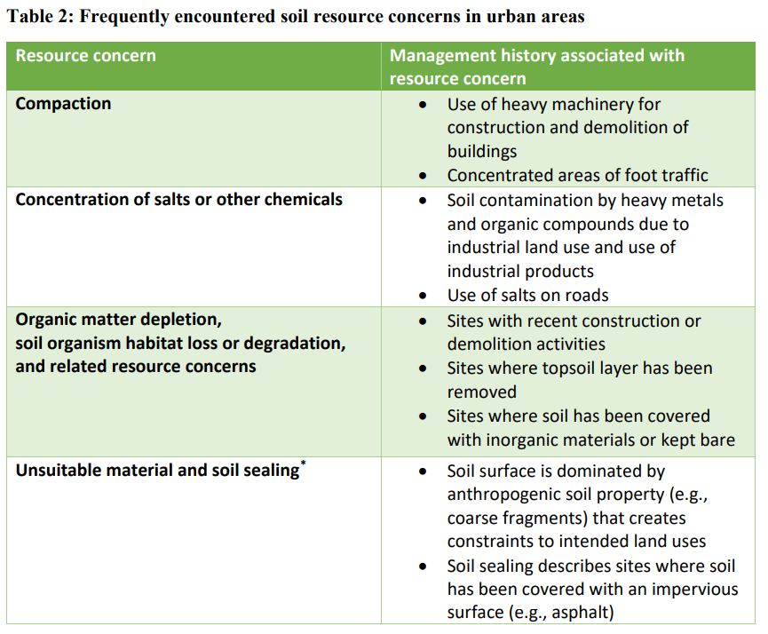

Cornell Soil Health Manual
Moebius-Clune et al., 2016. Comprehensive Assessment of Soil Health. The Cornell Framework, 3rd Edition. Available at: https://www.css.cornell.edu/extension/soil-health/manual.pdf
Thorough guide to assessment of soil health. Focus is not urban or stormwater, but the manual covers urban areas. Has a field score card that could be a useful building block for urban assessments.

NRCS Web Soil Survey
https://www.nrcs.usda.gov/resources/data-and-reports/web-soil-survey
Limited use for urban soils, but this is where to see how NRCS WSS has the soils mapped for any site in the US. Also available as a smartphone app called “Soil Web” which is useful for in-field assessments. https://websoilsurvey.nrcs.usda.gov/app/

- NRCS and National Cooperative Soil Survey partners are working to update urban soil survey data
- Does not provide timeline of updates for urban soils specifically

Iowa Stormwater Management Manual Ch. 5
Iowa DNR, 2016. Chapter 5- Section 6 Soil Quality Management and Restoration. Available at: https://www.iowadnr.gov/media/8642/download?inline

- Directly relevant to soil health in stormwater, this manual includes assessment and detailed guidance for restoration based on soil types and conditions found in Iowa, with many transferable concepts to Minnesota soils.
- Provides 2 methods for SQR (soil quality restoration) on undisturbed sites
  - Protect from compaction
  - Preserve undisturbed areas with certain topsoil/soil qualities (good soil structure, adequate porosity, HSG A or B, etc.)
- Provides 8 methods for SQR, 2 on undisturbed sites and 6 on disturbed sites
  - Specifications for topsoil requirements, tillage, mowing, etc.
- Provides water quality volume management guidelines
  - References Hudson, 1994: determining available water storage based on relationship between available soil water and % organic matter in soil
    - Higher OM, higher storage capacity
    - If OM content know, can use Hudson (1994) data to determine available water storage volume for every inch of depth of restored/preserved soil → project storage within profiles of 4, 6, and 8 inches
    - 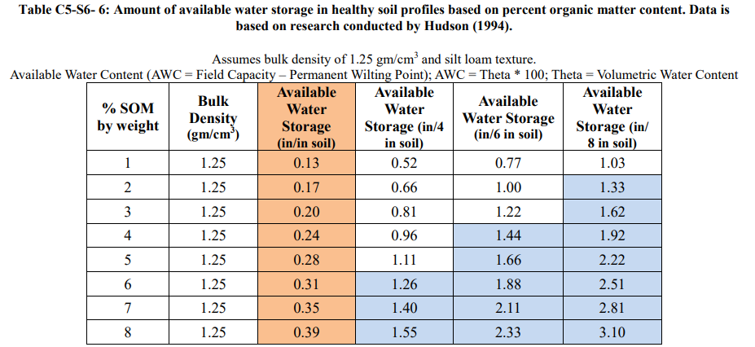

Guides to improve soil health

NRCS Webpage. Four Principles of Soil Health.
NRCS, n.d. Soil Health. Webpage. https://www.nrcs.usda.gov/conservation-basics/natural-resource-concerns/soil/soil-health

- Details four principles of a Soil Health Management System (in agricultural contexts):
  - Maximize presence of living roots
  - Minimize disturbance
  - Maximize soil cover
  - Maximimize biodiversity
- Links to other pubs
  - NRCS 2024a Tech Note 470-02. Basics of Urban Soil Health
- Also listed in 3. Practical guides to assess soil health

NRCS 2024a Tech Note 470-02. Basics of Urban Soil Health.
USDA, 2024. Basics of Urban Soil Health. Technical Note No. 470-02. Available at: https://directives.nrcs.usda.gov/sites/default/files2/1712940852/35715.pdf

- NOTE: This could fully replace the “Basic Soil Science Concepts” section of the Manual
- What is a restoration target for urban soils?
- States that the NRCS four principles to manage health soils can be applied to improve soil conditions at urban sites
- Details key characteristics of urban soils.
  - Soil scientists have established new criteria for describing highly altered soils and proposed Artesols, a new soil order that recognizes human impacts as a key soil-forming factor
  - Human-altered and human-transported (HAHT) soils have been substantially modified by humans, usually to support buildings and transportation infrastructure in cities. HAHT soils often include human artifacts like cement-building materials and brick.
  - 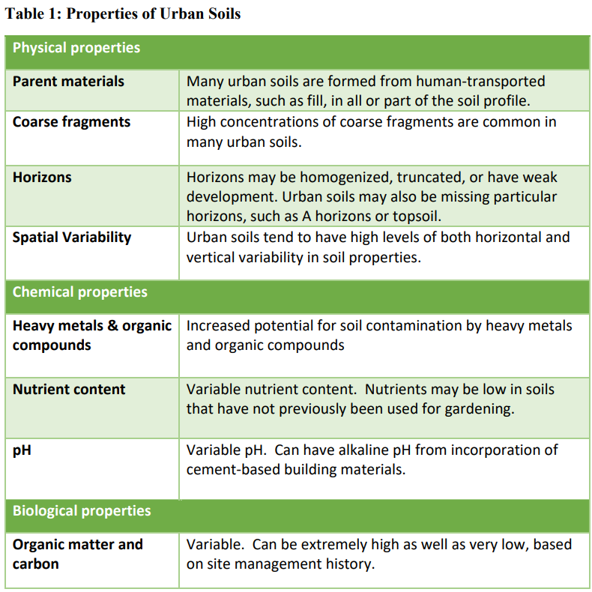
- Improving resource concerns in urban areas
  - Compaction – compost application; intensive cover cropping; raised beds to eliminate foot traffic
  - Concentration of salts and other chemicals – Assume urban sites have contamination risk and used raised beds wherever feasible; for low to moderate contamination risk, add soil organic matter, adjust soil pH to optimal levels with lime to reduce bioavailability of lead; establishing a cover of vegetation or mulch to act as a barrier
  - Organic matter depletion – organic amendments, such as soil, mulch, and compost
  - Unsuitable material and soil sealing – import additional soil materials and remove (i.e. unseal) impervious surfaces; create raised garden beds for urban agriculture

NRCS 2024b Tech Note 470-04. Urban Ag. Soil Health Practices.
USDA, 2024b. Conservation Practices for Soil Health in Urban and Small-Scale Agriculture. Technical Note No. 470-04. Available at: https://directives.nrcs.usda.gov/sites/default/files2/1714580563/TN%20470-04%20Conservation%20Practices%20for%20Soil%20Health%20in%20Urban%20and%20Small%20Scale%20Agriculture.pdf

- Small scale of urban agriculture and urban green spaces provides an opportunity to implement conservation practices that may improve soil conditions over relatively short timeframes
- States that the NRCS four principles to manage health soils can be applied to improve soil conditions at urban sites
- 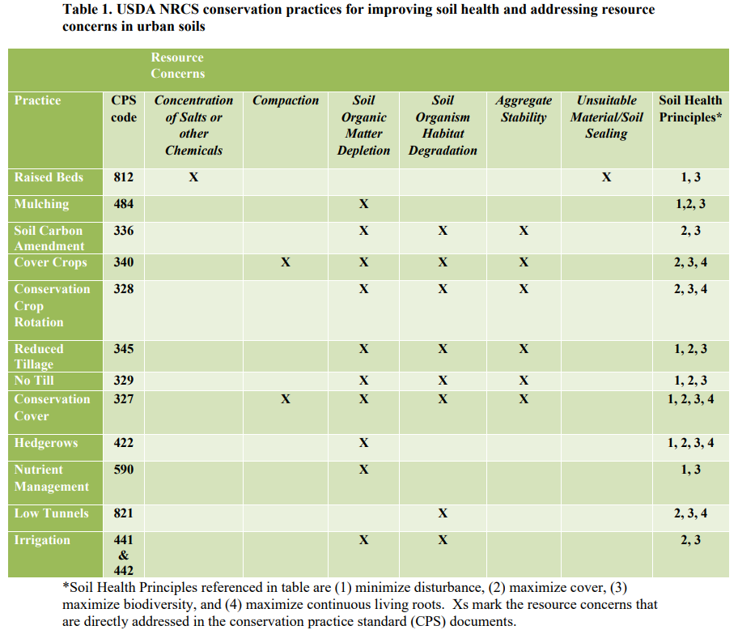
- Raised beds – applies to sites where existing soil is not suitable for in-ground cultivation of crops; often used on sites with poor material high concentrations of coarse fragments, or potential contamination issues
  - Fill boxes with potting soil, manufactured topsoil, compost, and occasionally native soil material
- Mulching – cost-effective; use diverse mulch materials for different management goals; natural mulches generally preferred to synthetic materials
- Soil carbon amendment – via compost and biochar
- Cover cropping – e.g. in small-scale raised beds
- Conservation crop rotation – useful to have small-scale crop plans (other resources available)
- Reduced till – implement permanent beds; use power harrows, spaders, breadforks, or hand tools as alternative to rototillers
- No till – use tarping or occultation, mulching like sheet mulching or lasagna gardening
- Conservation cover – establish permanent vegetation cover, particularly native perennial plantings
- Hedgerow planting
- Nutrient management – soil nutrient testing to determine existing nutrient stocks and soil chemical properties
- Low tunnels – temporary structures to support cover materials, like spun-bonded fabrics
- Irrigation management

Soils for Salmon primer. McDonald.
McDonald, n.d. Soils for Salmon: Integrating Stormwater, Water Supply, and Solid Waste Issues in New Development and Existing Landscapes. Webpage. Available at: https://chesapeakestormwater.org/wp-content/uploads/2022/07/3288-3.pdf
- Background on the connection between soil and (storm)water in the Puget Sound region
- More detail on BMPs in new development areas
  - Retaining and reusing native soil and vegetation
  - Reduce construction footprint, minimize soil compaction
  - Amend disturbed soils with compost
- New construction BMPs
  - Retain and protect native topsoil & vegetation (esp. trees!)
  - Minimize construction footprint
  - Store and reuse topsoil from site
  - Retain “buffer” vegetation along waterways
  - Restore disturbed soils by tilling 2-4" of compost into upper 8-12" of soil (or deeper) before planting. (Use a tractor-mounted ripper to loosen compacted layers within 12” of surface.)
- Existing landscape BMPs
  - Retrofit soils by tilling in compost when re-landscaping
  - Mulch beds with organic mulches (leaves, wood chips, compost), and topdress turf with compost
  - Avoid overuse of soluble chemical fertilizers and pesticides, which may damage soil life
- How to implement soil strategy around the region
  - Include soils BMPs in policy and regulation (stormwater management manuals, management plans)
  - Public and professional education
  - Technical standards
  - Implement – in developments, residential street retrofits, road landscaping and slope erosion control in Department of Transportation projects
- Future challenges include
  - developing standard specs and inspection procedures for soil amendments; additional research and field tests
  - Quantification of improvement in stormwater detention on different soil types
  - Appropriate credit for soil amendment in stormwater models
  - Outreach to stormwater management professionals, especially to development community: builders, contractors, planners, developers

Soils for Salmon: Building Soil Webpage.
Soils for Salmon, n.d. Building Soil. Webpage. Available at: https://www.soilsforsalmon.org/
- 5 BMPs during construction
- Retain and protect native topsoil and vegetation where practical
- Restore construction-disturbed soils, to restore healthy soil functions, by:
  - Stockpiling and reusing good quality site soil, or
  - Tilling 2-3” of compost into poor site soils, or
  - Brining in 8” of compost-amended topsoil
- Loosen compacted subsoil, if needed, by ripping to 12” depth
- Mulch landscape beds after planting
- Protect restored soils from erosion or re-compaction by heavy equipment
- Note: Wash state stormwater permits require these soil BMPs
- Website has other resources on background science; soil restoration, compost quality and compost use; etc.
  - Many videos.

Caltrans Soil Amendment Guidance. 2024
Caltrans, 2024. Soil Amendment Guidance for Infiltration and Stormwater Treatment. Task Number: 3237. Available at: https://dot.ca.gov/-/media/dot-media/programs/research-innovation-system-information/documents/research-notes/task3237-rns-11-24-a11y.pdf

- Appears to be a progress report on a funded study. The study results would be more helpful.
- Amending soil under various conditions to comply with NPDES permit requirements for post-construction stormwater treatment controls
  - Permit requires Caltrans to prioritize soil-based BMPs
  - Permit gives consideration to BMPs that can infiltrate the amount of water from the 85th percentile 24-hour storm
- Installing soil amendments adjacent to roadsides is a challenge because of vehicle traversability
- Project evaluates stormwater infiltration volumes and flowrates when amending with compost and biochar; project (field pilots, guidance doc development) ending in June 2025. No other info available.

Iowa Stormwater Management Manual Ch. 5
Iowa DNR, 2016. Chapter 5- Section 6 Soil Quality Management and Restoration. Available at: https://www.iowadnr.gov/media/8642/download?inline

- Directly relevant to soil health in stormwater, this manual includes assessment and detailed guidance for restoration based on soil types and conditions found in Iowa, with many transferable concepts to Minnesota soils.
- Provides 2 methods for SQR (soil quality restoration) on undisturbed sites
  - Protect from compaction
  - Preserve undisturbed areas with certain topsoil/soil qualities (good soil structure, adequate porosity, HSG A or B, etc.)
- Provides 8 methods for SQR, 2 on undisturbed sites and 6 on disturbed sites
  - Specifications for topsoil requirements, tillage, mowing, etc.
- Provides water quality volume management guidelines
  - References Hudson, 1994: determining available water storage based on relationship between available soil water and % organic matter in soil
    - Higher OM, higher storage capacity
    - If OM content know, can use Hudson (1994) data to determine available water storage volume for every inch of depth of restored/preserved soil → project storage within profiles of 4, 6, and 8 inches

General Mills – Regenerative agriculture webpage
General Mills, 2026. Keeping our planet healthy. Webpage. Available at: https://www.generalmills.com/how-we-make-it/healthier-planet/environmental-impact/regenerative-agriculture

- 5 core principles to regenerative ag (similar to NRCS principles)
  - Minimize disturbance
  - Maximize diversity (plants and animals)
  - Keep the soil covered year-round
  - Maintain a living root year-round
  - Integrate livestock
  - Understanding context (not included in survey)
- 5 outcomes than can be measured
  - Above-ground biodiversity (measured in self assessment survey below)
  - Water
  - Healthy soil (measured in self assessment survey below)
  - Herd well-being
  - Farmer economic resilience (measured in self assessment survey below)
- Additional tool for farmers: General Mills Regenerative Agriculture Self-Assessment
  - Survey has baseline questions about proportion of fields (“fields have a living root in the ground for at least 130 days), pesticide use, tillage; livestock acres
  - Survey results tell farmers about % of their land that meets a regenerative ag principle
  - 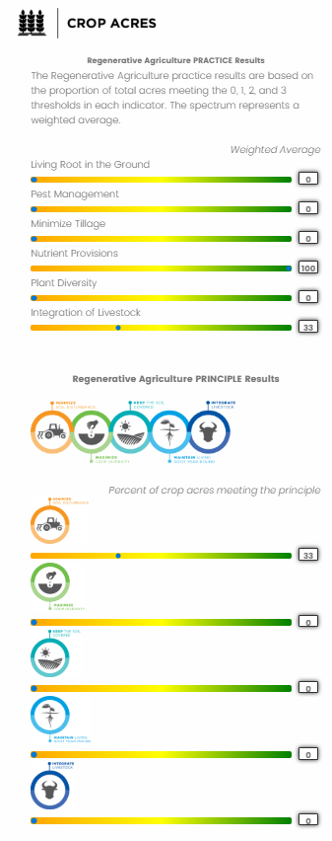

Requirements or credits for soil protection or restoration

Seattle Department of Construction & Inspections
City of Seattle, 2021. Stormwater Code. Available at: https://www.seattle.gov/documents/Departments/SDCI/Codes/StormwaterCode/2021SWCodeFinalClean.pdf [RL2]
- Minimum requirements for different projects (e.g. parcel-based projects, roadway projects, single-family residential projects, etc.) related to soil amendment (retain/protect undisturbed soil and amend disturbed topsoil)
- The minimum requirements for all projects don’t include soil health (only soil stabilization, retaining top layer)

King County, WA Post-Construction Soil Standard
King County, 2026. KC Code, Chapter 16.82. Webpage. https://kingcounty.gov/en/dept/dnrp/buildings-property/green-sustainable-building/green-building/soil-standard
- King County Post-Construction Soil Standard
- Permit holders must preserve topsoil, restore soils with compost, and other measures. Replaced topsoil must meet these requirements:
  - Minimum of 8 inches thick
  - Contains organic matter content of 5% dry weight for turf areas and 10% dry weight for planting beds
  - Have a pH suitable for the proposed landscape plants
- Quick Guide: Achieving the Post-construction Soil Standard - King County GreenTools Green Building program

New York State
New York State Stormwater Management Design Manual, n.d. Chapter 5, Section 5.1: Planning for Green Infrastructure: Preservation of Natural Features and Conservation Design
- WQ_{v} credits given for:
  - Soil restoration (could not find how much this practice goes towards a WQ_{v} credit) required for development with disturbed soil
- 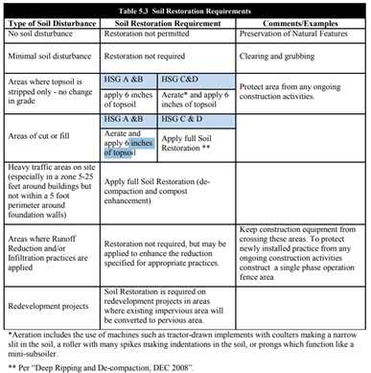
  - Other GI practices:
    - Natural area conservation
    - Forest retention areas
    - Tree planting/tree pit

Washington, DC
DC Department of Energy and the Environment, 2020. Stormwater Management Guidebook. Available at: https://doee.dc.gov/node/610622
- DC has Stormwater Retention Credit Trading Program. Unclear if soil restoration is a BMP under the SRC (applicants can propose BMPs)
- Soil compost amendment requirements following compaction, e.g. achieve minimum organic matter content of 5%

Carver County, MN
Carver County, MN, 2025. § 153.62(B) Topsoil Management Standards. Code of Ordinances Local legislation current through Ord. 111-2025, passed 7-25-25. Available at: https://codelibrary.amlegal.com/codes/carvercounty/latest/carverco_mn/0-0-0-24089
- Requirement. A minimum of six inches of topsoil must be provided in all green space areas of the project. Requirements for pH, compaction

Washington State Department of Ecology
WDOE Stormwater Management Manual for Western Washington, 2010. Webpage. Available at: https://ecology.wa.gov/getattachment/4569b90a-217a-40d2-a997-49adb8db5d86/SoilBMP.pdf
- BMP TM.13. “Post construction soil quality and depth”
  - Guidelines for establishing a minimum soil quality and depth (preserving topsoil, reducing compaction, soil amendments)
- They provide specific steps for implementing – steps aimed at designers/implementers/developers
  - They include amendment options
  - They include guide for developing a Soil Management Plan (SMP) that must be approved as part of construction permit application
  - They include a field guide to verifying soil quality and depth, aimed at professional inspectors
- “Flow reduction credits can be taken in runoff modeling when this BMP is used as part of dispersion design” under certain conditions

City of Grand Rapids
City of Grand Rapids, MI. (n.d.). Stormwater credit trading program. https://www.grandrapidsmi.gov/Government/Departments/Development-Center/Stormwater-Credit-Trading-Program
- Credit trading Program based on volume of stormwater treated from Green Stormwater Infrastructure
- Credits given for Non-Structural Best Management Practices, but nothing specific to soil health/soil restoration
  - Minimal disturbance area (delineate)
  - Protect natural flow pathways
  - Protect sensitive areas
  - Native revegetation
  - Stormwater disconnect
- Uses design infiltration rates from Wisconsin Department of Natural Resources (2004) 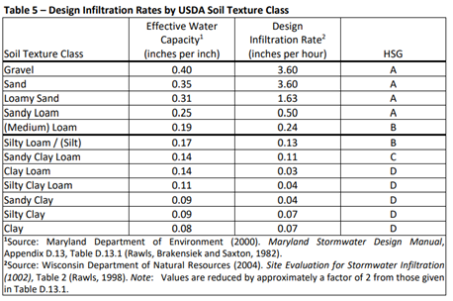

Chesapeake Bay
USDA, 2020. Stormwater Credits for Trees: Chesapeake Bay Case Study. Available at: https://www.fs.usda.gov/sites/default/files/fs_media/fs_document/Chesapeake-Case-Study-GSI-FS-1146a.pdf
- “ BMP credits are earned for urban tree canopy expansion for dispersed plantings over turf or impervious surface and urban forest planting”

Arlington County, VA
Arlington county, 2023. Stormwater Credit Manual. Available at: https://www.arlingtonva.us/files/sharedassets/public/v/5/projects/documents/stormwater-credit-manual-april-2023.pdf
- Single and Multi- Family Residential and Non-Residential Credits are available for new voluntary conservation landscaping
  - Requires soil amendment/compost, mulching and plant receipts (including receipts)
  - tree planting
  - rain garden
  - Doesn’t phrase it as “soil heath”

Iowa DNR
Iowa DNR, 2016. Chapter 5- Section 6 Soil Quality Management and Restoration. Available at: https://www.iowadnr.gov/media/8642/download?inline
- Iowa SQR credits for WQv: Iowa Stormwater Management Manual Ch. 5
- OM in soils can be used for water quality volume management
- “In cases where a preserved or SQR area to be used as a water quality BMP does not have sufficient area to fully manage the WQv for the upstream impervious area, partial credit may be given.”

MDOE: Maryland Department of the Environment.
Maryland Department of the Environment, 2020. Accounting for Stormwater Wasteload Allocations and Impervious Acres Treated. Maryland MS4 Accounting Guidance: Soil Restoration Credit. Available at: https://mde.maryland.gov/programs/water/StormwaterManagementProgram/Documents/2020%20MS4%20Accounting%20Guidance.pdf
- “Soil restoration is the process of enhancing the porosity of soils compacted by human activity in urban areas…involves the excavation or tilling of the compacted soils and amending the tilled soils, typically with compost.”
- Soil restoration techniques used in conjunction with another BMP that incorporates soil ripping/restoration doesn’t receive separate credit
- 2 levels of restoration for EIA credit
  - Level 1: moderate compaction; soils ripped to 15 inches
  - Level 2: severe compaction or more permeable soil profile (HSG B or C); soil excavated to 20 inches
- Related:
  - 2. MDOT 2021 (Schwartz 2021) study & Stormwater BMP

