REPORT FOR OBJ1.TASK 7: MAINTENANCE A.K.A. O&M GUIDELINES
To: MPCA
From: The Kestrel Design Group Team (The Kestrel Design Group Inc, with Dr. William Hunt, PE and Ryan Winston, PE - North Carolina State University, Dwayne Stenlund – Minnesota Department of Transportation, James Urban – Urban Trees and Soils)
Date: October 18, 2013
Re: Contract CR5332

SCOPE

Develop and submit maintenance guidelines for trees. The guidelines will include consideration of BMP type (e.g. open, closed, or partially-open tree pits, etc.), soil properties, cold climate, and groundwater constraints (e.g. karst settings). Guidelines shall be provided for new and existing trees:
  - Review state-of-the-art literature to identify existing maintenance guidelines and practices for trees, including graphics and considering different variations of tree BMPs.
  - Review literature and identify special maintenance considerations and incorporate these into the guidelines. Examples include but may not be limited to soil suitability, cold climate considerations, groundwater considerations, and need for stormwater pretreatment of pollutants.
  - Considering the factors described above, develop a maintenance checklist or boilerplate form that can be used for conducting tree inspections.
  - Prepare and submit a Technical memo summarizing draft maintenance guidelines. At a minimum the guidelines will address pruning, mulching and other amendments, supplemental watering, maintenance agreements, tree inspection, inlet/outlet pipe inspection, and trash and debris removal. Include a maintenance checklist or boilerplate form for conducting tree inspections.
  - Prepare a final report that provides maintenance guidelines for tree BMPs, including graphics.

LIST of FIGURES

Figure 7.1: Girdling roots beginning to develop
Figure 7.2: Girdling roots encircling tree trunk
Figure 7.3: Example of soil too high above root collar
Figure 7.4: Soil and Mulch need to be removed from root collar yearly
Figure 7.5: Loosen and remove the soil around the base of the tree until the first set of roots is found
Figure 7.6: Example of illustrated step by step maintenance instructions.

LIST of TABLES

Table 7.1: Tree health troubleshooting guidelines

REPORT

Requiring Owner to sign a maintenance agreement to receive stormwater credits can help ensure trees receive adequate maintenance.

The following maintenance tasks are required for trees for stormwater.

- Maintenance Inspections

Perform maintenance inspections per the attached maintenance checklist, and perform actions needed per the inspection.

- Supplemental Watering

Newly planted trees need to be watered regularly. In the first three years after planting, trees typically need about 1.5 gallons of water per inch of trunk diameter whenever the soil feels dry or slightly damp in the top six inches (Johnson et al 2008), and a minimum of once a week during the first growing season. However, the amount of water the tree needs will depend on many factors, including soil type, drainage and weather. Soil moisture sensors can also be used to automate watering whenever the soil is dry enough to need watering.

Many people have found that one of the most reliable ways to ensure trees receive adequate water during the establishment phase is to minimize labor involved, by using watering bags or an automated watering system.

Watering bags are cone shaped bags that hold about 20 gallons of water and zip around the tree trunk. They can be used for trees with a caliper between 1” and 8”. Once they are manually filled with water, they release water slowly directly above the root package, providing a slow, deep, watering without losing any water to runoff evaporation. They are reusable and inexpensive, and easy to use.

Once the tree has rooted out of the root package, watering should be tapered off to encourage the tree to grow deep, wide-spreading roots.

Depending on factors such as, tree species, soil type, perviousness of the surface above the tree rooting zone, weather, and how much stormwater is directed to the tree, mature trees may also require supplemental watering during extended droughts. Urban trees are especially prone to drought as urban areas are typically warmer and there is often less pervious surface above the rooting zone of an urban tree.

Soil moisture should be checked and trees watered as needed from spring until the soil freezes in the fall. Water whenever soil is dry 3 inches below the soil surface.

Too much water can kill trees just as easily as not enough water, especially in compacted and degraded urban soils, so ensure trees receive enough water but are not overwatered.

To mimic the pre-settlement hydrological cycle as closely as possible by increasing both evapotranspiration and infiltration, harvest runoff, for example, from adjacent impervious surfaces, and use harvested runoff to irrigate trees. In urban areas dominated by impervious surfaces, evapotranspiration and infiltration are typically lower than in the pre-settlement hydrological cycle. Using harvested water to irrigate trees will increase both evapotranspiration and infiltration, and more closely mimic the pre-settlement hydrological cycle.

- Straightening Trees

Maintain all plants in a plumb position throughout the warranty period. Straighten all trees that move out of plumb including those not staked. Plants to be straightened should be excavated and the root ball moved to a plumb position, and then re-backfilled.

- Mulching And Other Amendments

Mulch

Wood mulch provides many benefits to the tree, including, for example, weed and turf suppression, and increased moisture retention. It also improves bioretention pollutant reduction function and increases the organic matter content of the soil.

Maintain a ring of mulch as wide as possible, 2 to 3 inches deep, around each tree. Ideally each tree should have at least an area two feet in diameter for each inch of tree trunk diameter, with a minimum mulch ring diameter of eight feet for trees with a stem diameter three inches or less (Gilman 2013). This may not be feasible in urban areas. Where the tree opening does not permit an eight foot wide mulch ring, make the mulch ring as large as the tree opening permits (see Task 5 for minimum tree opening size).

Do not pile mulch against the trunk of the tree, and place only a thin layer, if any, mulch over the root ball. According to Gilman (2013), “This keeps the trunk dry and allows rainwater, irrigation, and air
to easily enter the root ball. Mulch resting on the trunk or layered too thick can kill the plant by starving it of oxygen, killing the bark, causing stem and root decay, preventing hardening off, encouraging rodent damage to the trunk, keeping soil too wet, and repelling water. Mulch on the root ball has little impact on water lost from the tree since most of the moisture that leaves the root ball does so by transpiration, not evaporation. Only a small amount (< 10%) leaves the root ball by evaporation from the surface of
the root ball.”

Other amendments

According to Gilman (2013), “No amendments of any kind are necessary in the backfill soil because extensive research clearly shows that they typically do not increase survival nor growth after planting.”

Fertilizer

Most trees generally do not need to be fertilized regularly, especially if they are receiving nutrient rich stormwater.

Trees should not be fertilized with nitrogen unless diagnosis by an arborist deems it necessary. Other nutrients should be applied only if soil tests indicate soil has insufficient nutrients.

If soil tests or diagnosis by an arborist indicate a need to fertilize:

- Do not apply more fertilizer than the soil lab or arborist recommends. Overdosing could leach nutrients into downstream water bodies and could harm the tree.
- Water well before and after fertilizing.
- Fertilize in the fall after the tree has lost its leaves, or in the spring before buds develop.
- If fertilizer is needed, use a slow release fertilizer.
- Protecting the tree trunk

The bark of young deciduous trees should be protected with a trunk guard to prevent rabbits, mice, and deer from damaging the trunk. Trunk wounding can create long term damage.

Install light colored plastic tubing, or ¼ inch mesh hardware cloth around the trunk with 1 to 4 inches of space between the guard and the trunk.

The guard should extend one to two feet above the snowline for protection from small rodents, and as tall as possible for deer protection. It should be pushed into the ground or mulch about an inch: enough to secure it but not enough to damage the roots. The guard should be in place at a minimum during winter months, but can be left in place year round if it does not touch the trunk.

Enlarge or remove trunk guard once there is no longer at least 1 inch between the tree trunk and tree guard.

- Removing Stakes

Staking, if used, should be removed 1-2 years after planting. Check staking and tree guying material at the end of the first growing season after planting. If the tree is stable without the stake and guying material, remove stake and guys. If tree is unstable, retie guying to stake and remove stake and guying at the second growing season after planting.

- Pruning

Trees are pruned for safety, health and aesthetics.

Johnson et al (2008) recommend the following pruning frequency:
- once in year 2 or 3 after planting,
- every three years during years 4-10 after planting
- more than 10 years after planting: every 5 years for deciduous trees, and as needed for evergreens.

Check with your city or town to see if they have laws regarding pruning.

Never prune trees or branches that are within 10 feet of utility lines; contact the utility company.

Pruning guidelines can be found, for example, in:

- Pages 18-23 of Johnson, Jill; Gary Johnson; Maureen McDonough; Lisa Burban; and Janette Monear. 2008. Tree Owner's Manual for the Northeastern Midwestern United States. United States of Agriculture, Forest Service, Northeastern Area, State and Private Forestry, NA-FR-04-07. Downloaded August 2013 from http://na.fs.fed.us/pubs/uf/tom/090202_tom_lr.pdf
- The University of Florida’s pruning guidelines, viewed August, 2013 at http://hort.ufl.edu/woody/pruning.shtml, last modified March 26, 2013
- Dr. Gilman’s book on pruning: Gilman, Ed. 2011. Illustrated Guide to Pruning, 3rd edition. Cengage Learning: Independence, KY.
- Check tree health

Check tree for mower and weed whip damage, vandal damage, and animal damage. Also inspect leaves, branches, crown and trunk for signs of insect or disease problems, including, for example, the signs in table 7.1. Contact an arborist if needed. Guidance on how to hire an arborist can be found, for example, on page 28 of Johnson et al 2008, and on the International Society of Arboriculture’s website at: http://www.treesaregood.org/treecare/hire_arborist.aspx (available August 2013).

Table 7.1: Tree health troubleshooting guidelines (adapted from Johnson et al 2008)
If you see: | Potential cause: | You should:
TRUNK
A flat-sided trunk at the base of the tree | Encircling root restriciting the flow of water and nutrients between the roots and rest of the tree | Excavate to check for encircling root
Bark damage near the bottom of the tree | Rodent or string trimmer | Apply mulch/trunk guard to protect from future damage
An elm tree with liquid oozing from the trunk | Slime flux or wetwood | Not worry about health
BRANCHES
An elm tree with bright yellow leaves on one or two branches | Dutch elm disease | Immediately call the University* or an arborist
Webs in the branches or webs covering the tips of branches | Fall webworm or Eastern tent caterpillar | Not worry about health
Many branch tips snipped off and laying on the ground | Squirrel damage | Not worry about health
Black clumps on branches of a cherry tree | Black knot | Call for advice*
Very little growth | Many | Call for advice*
Hole in trunk or branches | Many | Call for advice*
LEAVES
Leaves sticky and covered with a black velvety coating (like soot) | Piercing, sucking insect and sooty mold | Not worry. Hose down the leaves to get rid of sap.
Leaves wilted | Many | Call for advice*
Spots on leaves | Many | Call for advice*
Small leaves | Many | Call for advice*
Sparse leaves | Many | Call for advice*
Yellow or brown leaves | Many | Call for advice*
Holes in leaves | Insect feeding | Not worry about health
Bumps on leaves | Many | Not worry about health
*Call an arborist or other qualified professional

- Check tree safety

Johnson et al 2008 recommends checking trees after storms for the following signs of potential danger:

- “Broken, dead, or hanging branches
- Cracks, fungi, and cavities
- Weak trunk or branch unions
- Encircling root compressing the trunk (a flat sided trunk at the ground level is a good indicator)
- Recent lean (especially if the soil or grass has lifted on one side).”

If any of the above are found, contact an arborist. Guidance on how to hire an arborist can be found, for example, on page 28 of Johnson et al 2008, and on the International Society of Arboriculture’s website at: http://www.treesaregood.org/treecare/hire_arborist.aspx (available August 2013).

- Check for Girdling Roots and Correct

Roots that encircle the trunk will likely cause health or safety problems. Remedy girdling roots at planting. Check for girdling roots (roots that encircle the trunk, see Figures 7.1-7.3) every 4-5 years after planting and if girdling roots are found, contact an arborist for treatment (Johnson et al 2008). Girdling roots can be removed if caught early.

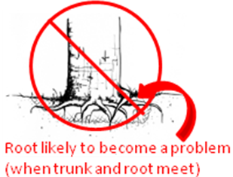
Figure 7.1: Girdling roots beginning to develop (adapted from Johnson et al 2008)

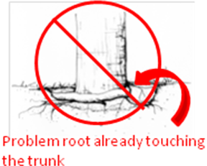
Figure 7.2: Girdling roots encircling tree trunk (adapted from Johnson et al 2008)

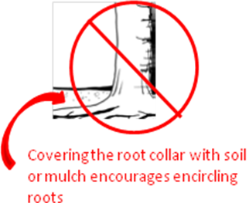
Figure 7.3: Example of soil too high above root collar (adapted from Johnson et al 2008)

- Clean Root Collar

Girdling roots are encouraged if root collar is covered with soil or mulch. Clean root collar once a year by removing soil and mulch until the first set of roots is exposed (see Figures 7.4-7.5). Removing soil with a wet-dry vacuum (Johnson et al 2008) or air spade speeds the work without harming the roots.

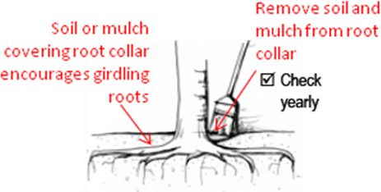

Figure 7.4: Soil and Mulch need to be removed from root collar yearly (adapted from Johnson et al 2008)

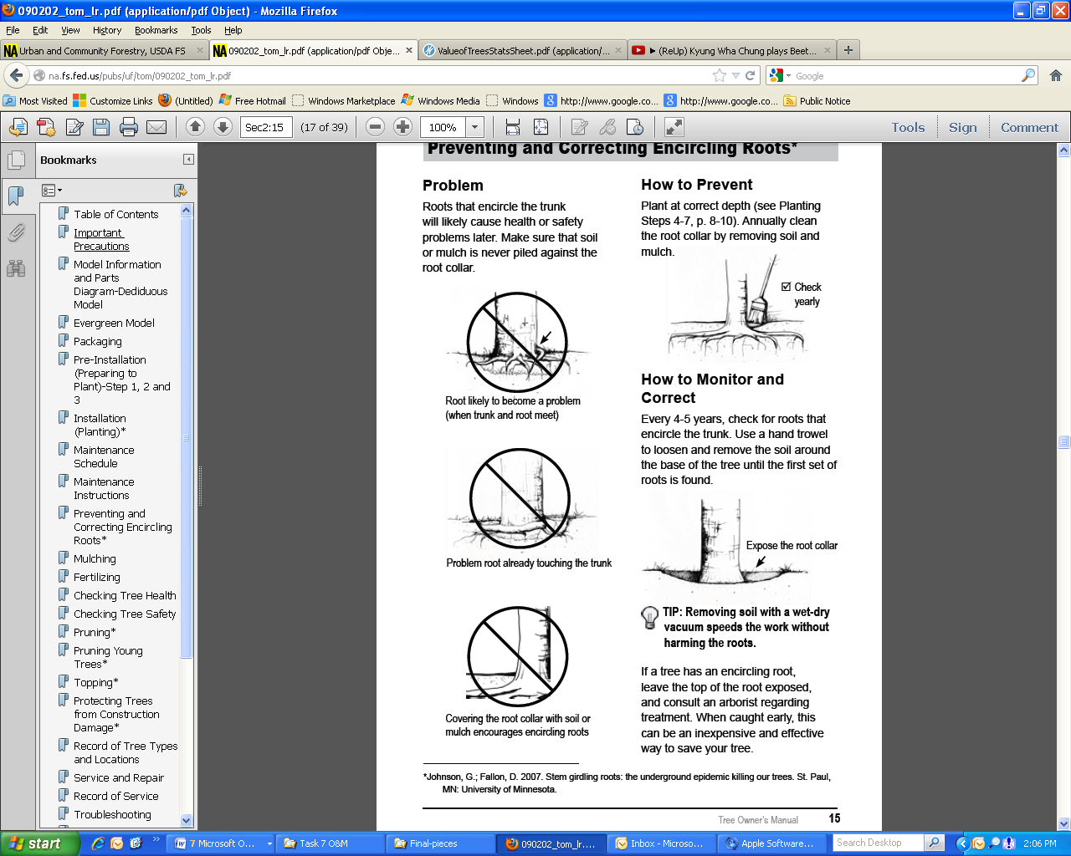

Figure 7.5: Loosen and remove the soil around the base of the tree until the first set of roots is found (from Johnson et al 2008)

A succinct, illustrated, step by step, laminated sheet of instructions for the maintenance operator, such as illustrated, for example, in Figure 7.6 can help communicate maintenance requirements.

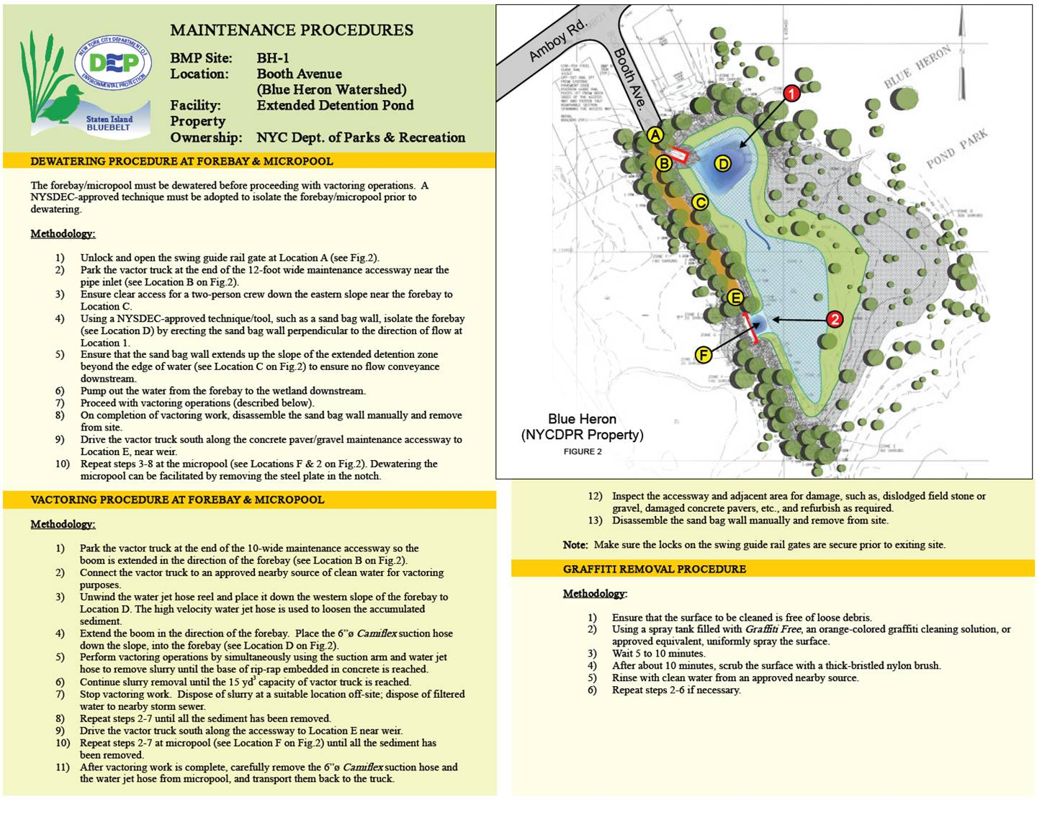
Figure 7.6: Example of illustrated step by step maintenance instructions.

REFERENCES

Gilman, Edward F. 2011. Specifications for Planting Trees and Shrubs in the Southeastern U.S. Document ENH856. Environmental Horticulture, Florida Cooperative Extension Service, Institute of Food and Agricultural Sciences, University of Florida. Downloaded August 2013 from http://edis.ifas.ufl.edu/pdffiles/EP/EP11200.pdf.

Johnson, Jill; Gary Johnson; Maureen McDonough; Lisa Burban; and Janette Monear. 2008. Tree Owner's Manual for the Northeastern Midwestern United States. United States of Agriculture, Forest Service, Northeastern Area, State and Private Forestry, NA-FR-04-07. Downloaded August 2013 from http://na.fs.fed.us/pubs/uf/tom/090202_tom_lr.pdf

Gilman, Edward F. 2013. Sample planting specifications for trees. Environmental Horticulture Department, University of Florida Gainesville. Downloaded August 2013 from http://hort.ifas.ufl.edu/woody/abbreviated-planting-specs.shtml

Gilman, Ed. 2011. Illustrated Guide to Pruning, 3rd edition. Cengage Learning: Independence, KY.

Urban, J. 2012. Draft Tree Planting Specification, Prepared for 2012 International Society of Arboriculture Conference.
Please Note:

The Kestrel Design Group (including its employees and agents) assumes no responsibility for consequences resulting from the use of the information herein, or from use of the information obtained at linked Internet addresses, or in any respect for the content of such information, including (but not limited to) errors or omissions, the accuracy or reasonableness of factual or scientific assumptions, studies or conclusions, the defamatory nature of statements, ownership of copyright or other intellectual property rights, and the violation of property, privacy, or personal rights of others. The Kestrel Design Group is not responsible for, and expressly disclaims all liability for, damages of any kind arising out of use, reference to, or reliance on such information. No guarantees or warranties, including (but not limited to) any express or implied warranties of merchantability or fitness for a particular use or purpose, are made by the Kestrel Design Group with respect to such information.
The Kestrel Design Group does not endorse, approve, certify, or control references and Internet links included herein and does not guarantee the availability, accuracy, completeness, efficacy, timeliness, or correct sequencing of information in these references and links. No one should rely on the accuracy, completeness, efficacy, and timeliness of such information. Reference therein to any specific commercial product, process, or service by trade name, trademark, service mark, manufacturer, or otherwise does not constitute or imply endorsement, recommendation, or favoring by the Kestrel Design Group.

