REPORT FOR OBJ1.TASKS 2 and 13: WATER QUALITY BENEFITS OF TREES AND URBAN FORESTS FOR STORMWATER MANAGEMENT
To: MPCA
From: The Kestrel Design Group Team (The Kestrel Design Group Inc, with Dr. William Hunt, PE and Ryan Winston, PE - North Carolina State University, Dwayne Stenlund – Minnesota Department of Transportation, James Urban – Urban Trees and Soils)
Date: October 15, 2013
Re: Contract CR5332

SCOPE

Report for the following parts of Tasks 2 and 13 (bold italicized below)

Obj1.Task 2: Use of Trees and Urban Forests for Stormwater management:
    - Benefits of trees and urban forestry for stormwater management, including a range of volume reduction and pollutant removal (phosphorus and total suspended solids) for tree BMPs;

Obj1.Task 13: Specific Storm Water Credit Model:
Kestrel will prepare a draft and a final report summarizing design criteria and associated volume reduction stormwater credits for trees including an executive summary, recommendations, specific discussion, and conclusion. The report shall include credits for water volume, phosphorus, and total suspended solids.

LIST OF FIGURES

Figure 2.13.1: FRP concentration (mg P L-1) of leachate over time from planted and unplanted profiles receiving stormwater. The dashed, horizontal line indicates the stormwater input concentration.

Figure 2.13.2: The effect of species on FRP concentration (mg P L-1) of leachate from medium SHC soil profiles receiving stormwater. The horizontal dashed line represents the stormwater input concentration.

LIST OF TABLES

Table 1: Summary of Bioretention Water Quality Cleansing Mechanisms for Common Stormwater Pollutants

Table 2: Pollutant Reduction from Natural Runoff Single Events

Table 3: Pollutant Reduction from Natural Runoff Multiple Storm Events

Table 4: Pollutant Reduction from Synthetic Runoff I

Table 5: Ann Street and Orange Street EMC and percent removal summary (units in mg/L)

REPORT

Bioretention systems with urban trees provide water quality benefits through the same mechanisms as standard bioretention systems. Based on the limited research to date, we recommend providing the same credits for bioretention with trees as proposed in Objective 2 for “traditional” bioretention (see Task 10 of bioretention).

The soil, trees, and microbes in a bioretention system with trees work together as a system to improve water quality of stormwater that falls on the tree and/or is filtered through the soil volume. Some pollutants are adsorbed or filtered by soil, others are taken up or transformed by plants or microbes, and still others are first held by soil and then taken up by vegetation or degraded by bacteria, “recharging” the soil’s sorption capacity in between rain events. Table 1 below summarizes some of the main bioretention pollutant reduction mechanisms.
Table 1: Summary of Bioretention Water Quality Cleansing Mechanisms for Common Stormwater Pollutants
Pollutant | Bioretention Cleansing Mechanism
TSS | Sedimentation and filtration (e.g. Davis et al 2009)
Metals | Filtration of particulate metals, sorption of dissolved metals into mulch layer (e.g. Davis et al, 2009), plant uptake (e.g. Toronto and Region Conservation, 2009)
Nitrogen | Sorption; uptake by microbes and plant material, uptake into recalcitrant soil organic matter (e.g. Henderson, 2008)
Phosphorus | Sorption, precipitation, plant uptake, uptake into recalcitrant soil organic matter (e.g. Henderson, 2008)
Pathogens | Filtration, UV light, competition for limited nutrients, predation by protozoa and bacterial predators (e.g. Zhang et al 2010)
Hydrocarbons | Filtration and sorption to organic matter and humic acids, then degraded by soil microbes (e.g. Hong et al 2006)

Several recent literature reviews of lab and field studies of bioretention pollutant removal have concluded that bioretention systems have the potential to be one of the most effective BMPs for pollutant removal. In bioretention, high concentration and load reductions are consistently found for: suspended solids, metals, polycyclic aromatic hydrocarbons (PAH), and other organic compounds. Nutrient (dissolved nitrogen and phosphorus) removal has been more variable. Healthy vegetation has been found to be especially crucial for removal of dissolved nitrogen and phosphorus, hence the importance of large trees. Several studies that have compared vegetated media to unvegetated media have found that the presence of vegetation substantially improves TP and TN retention, as vegetated media is much more effective than unvegetated media at removing PO₄ from solution and preventing NO₃ leaching from media (e.g. Henderson et al 2007, Lucas and Greenway 2007a, 2007b, 2008, May et al 2006). Not only has vegetation been shown to significantly improve nutrient removal, trees also benefit from the nutrients in stormwater (May et al 2006), with greater growth in height and greater root density compared with those irrigated with tap water, turning stormwater nutrients into an asset.

Summary of Literature Review on Range Of Pollutant Removal (Phosphorus and Total Suspended Solids) For Tree BMPs

Breen 2004, Denman 2006, Denman 2011

Experimental setup:

- Tested mesocosms in Australia with several combinations of street trees and soils for growth and nutrient reduction. The mesocosms were 240 mm diameter columns cut into 600 mm lengths, with a soil depth of 500 mm.
- Compared 4 tree species with varying tolerances to waterlogging (from low to high) and an unplanted control; included 3 evergreen and 1 deciduous species: Eucalyptus polyanthemos (red box), Lophostemon confertus (brush box), Callistemon salignus (willow bottlebrush) and Platanus orientalis (oriental plane).
- Tested 3 soil media, with 3 different saturated hydraulic conductivities (4, 95 and 170 mm/hour; i.e. 0.16, 3.75 and 6.7 inches per hour).
- Composted green waste added 10% by volume to the top 200 mm of the soil.
- Three evergreen species were planted late March and early April of 2003. Deciduous trees were planted June 2003.
- Trees were irrigated weekly starting September 2003 with equivalent of 3.5” of water; half of the columns were irrigated with simulated stormwater, the other half with tapwater.
- Tested leachate monthly from November 2003 through December 2004.
- Tree height was measured monthly from September 2003 through January 2005.

Results:
- “Tree growth was similar in the three soils studied.” (Denman 2006)
- Trees grew taller and had greater root density when irrigated with stormwater compared to tapwater.
- “The leachate volumes in December 2004 were significantly less from trees receiving stormwater than tapwater, presumably due to these differences in tree growth.” (Denman 2006)
- “Leached nitrogen loads were significantly reduced in systems with a tree.” (Denman 2006)
- “Whilst there were some statistically significant differences in nitrogen removal between species, the output loads were all low compared to the unplanted systems. The difference between unplanted and planted profiles was consistent for the three forms of nitrogen measured: ammonium, oxidised nitrogen and organic nitrogen.” (Denman 2006)
- “NOx and Organic N loads from the Lophostemon confertus systems were statistically higher than the other two species, although all these loads from planted systems were low compared to the nitrogen input.” (Denman 2006)
- “The species differences in [nitrogen] loads were due to reduced leachate volumes in the summer months rather than nitrogen concentrations and therefore suggest differences in transpiration rates rather than uptake efficiencies.” (Denman 2006)
- “The low SHC [soil hydraulic conductivity, i.e. 0.16 inches per hour] soil was more effective in reducing nitrogen losses, particularly the inorganic forms.” (Denman 2006)
- “Compared to the total nitrogen input (25.2 mg) the leachate loads in December 2004 following a 5 hour collection period were 82-95% reduced for the Lophostemon confertus profiles. However, the loads leached from the unplanted profiles ranged from a 36% reduction to a 7% increase in nitrogen output.” (Denman 2006)
- “Averaged across all [tree] species, planting results in an increase in infiltration rate compared to the unplanted control.” (Breen et al 2004)
- “Compared to unplanted controls, the presence of trees in biofiltration systems resulted in significant reductions of the soluble nitrogen and phosphorus concentrations of the stormwater.” (Denman et al 2011).
- Species did not significantly affect nutrient removal (Denman et al 2011).
- “In some instances, typically in higher evaporative demand months towards the end of the experiment, all of the applied water was retained within the soil and no leachate drained from the profiles. The concentration was recorded as a missing value.” (Denman et al 2011).
- “The FRP [filterable reactive phosphorus] concentration of stormwater was reduced by an average of 70 to 96% following biofiltration through street tree systems with various filtration media. These reductions are similar to those reported in the literature (Bratieres et al., 2008, Read et al., 2008).” (Denman et al 2011).
- “The peaks in nutrient concentration of leachate from planted profiles occurred during summer and often corresponded to periods when higher water volumes were retained in the biofiltration systems (data not shown), suggesting that the soil was dry. This seasonal pattern of NOx and FRP concentration was also observed in the unplanted profiles with considerable leaching of nutrients during summer. This suggests that the soil may be behaving as a larger source of nutrients during these times. That is, the mineralization of organic matter is higher during the summer in response to higher temperatures (Gessler et al., 1998) or possibly increased soil drying and wetting.” (Denman et al 2011).
- “Species selection was not essential to maximize nutrient removal performance of biofiltration systems. The evergreen and deciduous species performed similarly during winter, when the latter had lost leaves.” (Denman et al 2011).
- “The effectiveness of planted profiles at reducing the FRP concentration of stormwater was variable. The low SHC soil planted profiles greatly reduced the FRP concentration of stormwater input for all events (Figure 2.13.1). The medium and high SHC soil planted profiles had little effect at the start of the experiment, with leachate FRP concentrations similar to the input stormwater. However, following the first summer, good reductions of FRP concentrations were achieved from profiles with these two soils (Figure 2.13.1).” (Denman et al 2011).
- “During the first few months of the experiment the leachate FRP concentration was high from systems planted with all four species (Figure 2.13.2). During winter (June to August) the FRP concentration of leachate from the profiles with the deciduous species was relatively similar to the leachate from those planted with evergreen species. The spike of FRP in late spring (November 2004, [Figure 2.13.1] was due to high concentrations in leachate from Platanus orientalis profiles [Figure 2.13.2].” (Denman et al 2011).

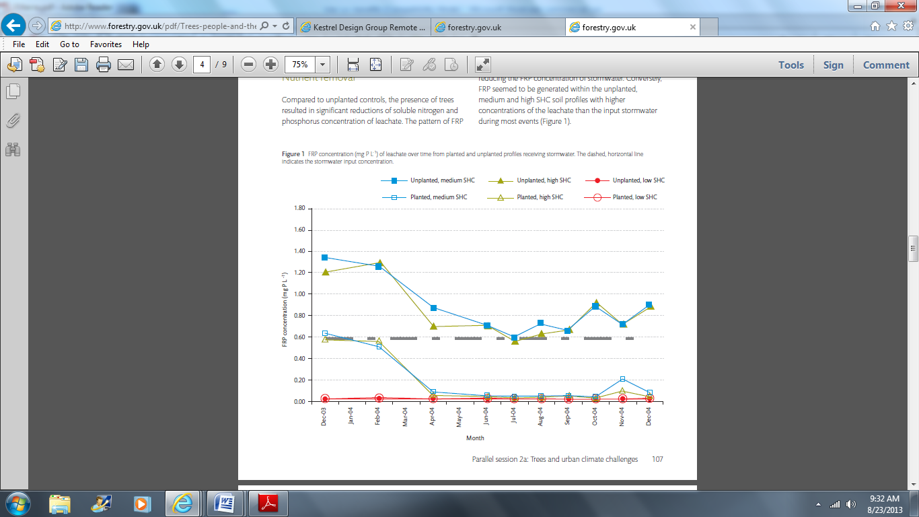
Figure 2.13.1: FRP concentration (mg P L-1) of leachate over time from planted and unplanted profiles receiving stormwater. The dashed, horizontal line indicates the stormwater input concentration. (Source: Denman et al 2011)
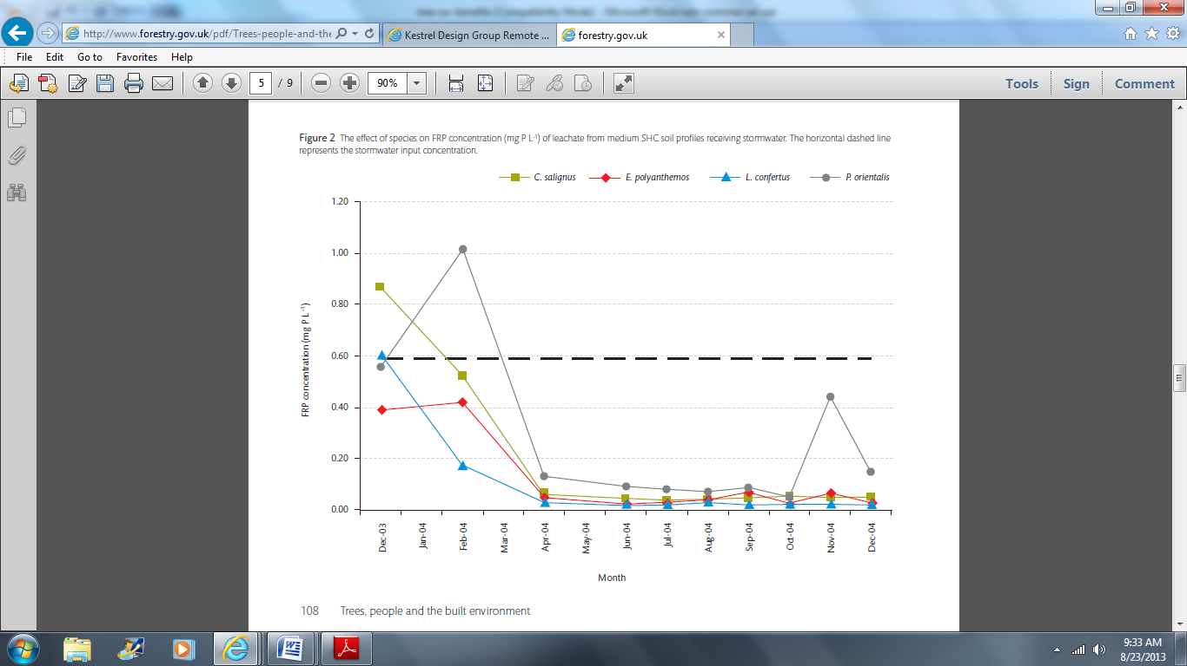

Figure 2: The effect of species on FRP concentration (mg P L-1) of leachate from medium SHC soil profiles receiving stormwater. The horizontal dashed line represents the stormwater input concentration. (Source: Denman et al 2011)

- “Newly planted biofiltration systems will initially behave largely as unvegetated systems, until the root systems have developed sufficiently to colonize large proportions of the filtration medium.” (Denman et al 2011).

Rock Based Structural Soil Studies

Xiao and McPherson (2008)

Performed lab studies on pollutant removal of 3 types of structural soils: Cornell University (CU) Structural Soil, Davis Soil, and Carolina Stalite (CS) Soil.

Soils were described as follows:

- The CU soil consisted of 80% stone and 20% soil, by weight, and hydrogel to mix the stone and soil. The stone size ranged from 1.9 to 3.8 cm (0.75 to 1.5 inches).
- The CS soil was a mixture of 80% Stalite, a porous expanded slate rock, and 20% sandy clay loam soil (by volume). The rock (Stalite) size used in this study was 1.9 cm (0.75 inches) in diameter.
- The Davis soil consisted 75% lava rock and 25% loam soil (by volume). The lava rock size was 1.9 cm (0.75 inches) in diameter.

Pollutants tested included nutrients (i.e., Total Kjehldahl Nitrogen (TKN), ammonia (NH₄), nitrate (NO₃), Phosphorus (P), and Potassium (K)), metals (zinc (Zn), copper (Cu), chromium (Cr), lead (Pb), iron (Fe), selenium (Se), nickel (Ni), mercury (Hg), and cadmium (Cd)), and conventional
physical properties such as pH, Electrical Conductivity (EC), and Total Dissolved Solids (TDS).

Results showed that:
- “The laboratory soil column tests indicated that all three soils “effectively reduced nutrients and metals from polluted surface runoff.”
- Nutrient removal rate of the structural soils decreased as the number of storm events increased; ie. the structural soils became saturated with pollutants after multiple storm events, and vegetation is needed to maintain pollutant removal capacity.

They tested runoff from natural runoff and synthetic runoff in single and multiple events. With natural runoff (runoff from a University of California Davis parking lot), soluble phosphorus reduction ranged from 11-96% for the single events (see Table 2), and from 15-95% reduction in the multiple events (see Table 3). Total phosphorus reduction was lower than dissolved phosphorus reduction and ranged from 0 to 82%for single storm events, and from 0 to 89% removal for multiple storm events. With synthetic runoff I (pollutant concentrations ten times higher than natural runoff), total phosphorus reduction for single storm events ranged from 0 to 100% reduction, and for multiple events it also ranged from 0 to 100% reduction (see Table 4). Standard deviation was very high for multiple storm events with synthetic runoff I. The authors noted that “the multiple test results indicated that the system’s pollutant removal rate decreased as the number of storms with high pollutant concentrations increased”… and vegetation is “needed for pollutants removing.”

Table 2: Pollutant Reduction from Natural Runoff Single Events (from Xiao and McPherson 2008)
 | Max |  |  | Min |  |  | Mean |  |  | STD |  |  | # of Samples
 | CS | CU | DS | CS | CU | DS | CS | CU | DS | CS | CU | DS | CS | CU | DS
P-Soluble | 96 |  | 95 | 13 |  | 11 | 62 |  | 59 | 26 |  | 25 | 16 |  | 19
Total P | 82 |  | 78 | 0 |  | 0 | 58 |  | 52 | 23 |  | 25 | 16 | 0 | 19

Table 3: Pollutant Reduction from Natural Runoff Multiple Storm Events (note, no CU measurements were reported) (from Xiao and McPherson 2008)
 | Max |  |  | Min |  |  | Mean |  |  | STD |  |  | # of Samples
 | CS | CU | DS | CS | CU | DS | CS | CU | DS | CS | CU | DS | CS | CU | DS
P-Soluble | 94 | 48 | 95 | 15 | 48 | 23 | 65 | 48 | 65 | 24 | N/A | 25 | 14 | 1 | 13
Total P | 89 | 0 | 86 | 0 | 0 | 0 | 55 | 0 | 55 | 29 | N/A | 25 | 15 | 0 | 13

Table 4: Pollutant Reduction from Synthetic Runoff I (from Xiao and McPherson 2008)
 | Single Event |  |  |  | Multiple Events
 | Mean | Max | Min | STD | Mean | Max | Min | STD
P | 71 | 100 | 0 | 35 | 59 | 100 | 0 | 49

Wilmington, NC, Suspended Pavement Study

A study monitoring stormwater runoff quality from 2 trees planted in suspended pavement with structural cells indicates that the trees are providing stormwater quality benefits at least as good as typical bioretention cells (see Table x 2 for water quality results from each of the 2 trees) (Jonathan Page, 2013, personal communication).

Table 5: Ann Street and Orange Street EMC and percent removal summary (units in mg/L) (Jonathan Page, 2013, personal communication).
 | Tree #1 |  |  |  | Tree #2
Pollutant |  | IN | OUT | Change | n | IN | OUT | Change
TKN | 21 | 0.75 | 0.22 | -71%T* | 18 | 1.99 | 0.33 | -84% T*
NO2,3-N | 21 | 0.08 | 0.05 | -35%T* | 18 | 0.17 | 0.07 | -60% T*
TAN | 21 | 0.11 | 0.03 | -73% T* | 18 | 0.33 | 0.08 | -76% T*
TN | 21 | 0.82 | 0.27 | -66% T* | 18 | 2.17 | 0.40 | -82% T*
O-PO4-3 | 20 | 0.03 | 0.01 | -70% T* | 19 | 0.18 | 0.03 | -82% T*
TP | 21 | 0.12 | 0.03 | -72% T* | 18 | 0.41 | 0.11 | -74% T*
TSS | 21 | 45 | 6 | -86% S* | 19 | 101 | 8 | -92% T*
Cuª | 21 | 14.3 | 2.1 | -85% T* | 19 | 10 | 1.4 | -86% T*
Pbª | 21 | 9.8 | 1.0 | -90% S* | 19 | 16 | 1.0 | -94% T*
Znª | 21 | 64 | 11 | -83% T* | 19 | 82 | 11 | -76% T*
*Significantly different (α=0.05)
ªHeavy metals concentrations in units of µg/L
^{S}Sign test used for statistical comparison
^{T}Paired t test used for statistical comparison
“-“ negative sign indicates a decrease in pollutant concentration

Virginia DEQ Technical Bulletin 6 Minimum Standard 3.11C
Minimum Standard 3.11C
FilterraTM Bioretention Filter System
(revised 11/01/02)

This standard gives the following credits for the Filterra tree system, based on bioretention studies performed to date and manufacturer’s lab studies. The Filterra system uses an engineered soil that has a much higher infiltration rate than traditional soils and bioretention media. According to Lenth et al (2010), “Laboratory scale testing results support media filtration rates of greater than 100 inches per hour. Results from field scale testing of hydraulic function of systems of a variety of ages support the current design flow rate recommendation of 100 to 140 inches per hour.” Traditional recommendations for bioretention media infiltration rates worldwide are about 10-100 times lower, and range from 0.5 to 12 inches per hour (Fassman 2013 literature review).

The goal of using a soil with such a high infiltration rate in the Filterra system is to increase the flow rate (& therefore the volume of stormwater) that can be filtered per cubic foot of soil, which is especially important for a BMP like Filterra, which has a very small footprint and low volume of soil. The increased infiltration rate does not appear to affect pollutant removal compared to bioretetention media with lower infiltration rates.

Expected Pollutant Removal (@ 0.33% filter surface area / drainage area)
Total Suspended Solids Removal = 85%
Total Phosphorous Removal = 74%
Total Nitrogen Removal = 68%
Total Metal Removal = 82%

Maximum Pollutant Removal Rates
Total Suspended Solids Removal = 90%
Total Phosphorous Removal = 80%
Total Nitrogen Removal = 65%
Total Metals Removal = 85%

REFERENCES

Breen, P., Denman, L., May, P. & Leinster, S. 2004, Street trees as stormwater treatment
measures, In 2004 International Conference on Water Sensitive Urban Design – Cities as
catchments 21-25 November 2004, 21-25 November 2004, Adelaide.

Davis, A.P; Hunt, W.F.; Traver, G.R.; Clar, M. (2009) Bioretention Technology: Overview of Current Practice and Future Needs. J. Environ. Eng-ASCE. 135(3): 109-117.

Denman, Liz. 2006. Are Street Trees And Their Soils An Effective Stormwater Treatment Measure? The 7th National Street Tree Symposium.

Denman, Elizabeth C., Peter B. May and Gregory M. Moore. 2011. The use of trees in urban stormwater
Management. Trees, people and the built environment Proceedings of the Urban Trees Research Conference 13–14 April 2011 Hosted by The Institute of Chartered Foresters At The Clarendon Suites, Edgbaston, Birmingham, UK Edited by Mark Johnston and Glynn Percival. Forestry Commission: Edinburgh.

Henderson, C.F.K. (2008) The Chemical and Biological Mechanisms of Nutrient Removal from Stormwater in Bioretention Systems. Thesis. Griffith School of Engineering, Griffith University.

Hong, E.; Seagren, E. A.; Davis, A. P. (2006) Sustainable Oil and Grease Removal from Synthetic Stormwater Runoff Using Bench-Scale Bioretention Studies. Water Environ. Res. 78 (2), 141-155.

Lenth, John and Rebecca Dugopolski (Herrera Environmental Consultants), Marcus Quigley, Aaron Poresky, and Marc Leisenring (Geosyntec Consultants). 2010. Filterra® Bioretention Systems: Technical Basis for High Flow Rate Treatment and Evaluation of Stormwater Quality Performance. Prepared for Americast, Inc.

Page, Jonathan. 2013. North Carolina State University.Personal communication.

Toronto and Region Conservation. 2009. Review of the Science and Practice of Stormwater Infiltration in Cold Climates. 2009. Downloaded December 2010 from http://www.sustainabletechnologies.ca/Portals/_Rainbow/Documents/SW_Infiltration%20Review_0809.pdf

Xiao, Qingfu and E. Greg McPherson. 2008. Urban Runoff Pollutants Removal Of Three Engineered Soils. USDA Center for Urban Forest Research and UC Davis Land, Air and Water Resources.

Zhang, L.; Seagren, E. A.; Davis, A. P.; Karns, J. S. (2010) The Capture and Destruction of Escherichia colifrom Simulated Urban Runoff Using Conventional Bioretention Media and Iron Oxide-coated Sand. Water Environ. Res. 82 (8): 701-714.

Please Note:

The Kestrel Design Group (including its employees and agents) assumes no responsibility for consequences resulting from the use of the information herein, or from use of the information obtained at linked Internet addresses, or in any respect for the content of such information, including (but not limited to) errors or omissions, the accuracy or reasonableness of factual or scientific assumptions, studies or conclusions, the defamatory nature of statements, ownership of copyright or other intellectual property rights, and the violation of property, privacy, or personal rights of others. The Kestrel Design Group is not responsible for, and expressly disclaims all liability for, damages of any kind arising out of use, reference to, or reliance on such information. No guarantees or warranties, including (but not limited to) any express or implied warranties of merchantability or fitness for a particular use or purpose, are made by the Kestrel Design Group with respect to such information.
The Kestrel Design Group does not endorse, approve, certify, or control references and Internet links included herein and does not guarantee the availability, accuracy, completeness, efficacy, timeliness, or correct sequencing of information in these references and links. No one should rely on the accuracy, completeness, efficacy, and timeliness of such information. Reference therein to any specific commercial product, process, or service by trade name, trademark, service mark, manufacturer, or otherwise does not constitute or imply endorsement, recommendation, or favoring by the Kestrel Design Group.

